Weekly Progress Report - Chart Analysis AI
Report Date | 2026-01-29
Author | That Le
Project | Chart Analysis AI V3
Current Phase | Phase 2 - Core Engine

1. Executive Summary
Chart Analysis AI project now in phase 2, focusing on building the core engine for structured data extraction from chart images. The system employs a hybrid AI approach combining: - Computer Vision (YOLO) for chart detection and localization - Geometric Analysis (OpenCV + NumPy) for precise value extraction - Small Language Model (SLM) for OCR correction and reasoning
Key Achievements This Week:
Phase | Status | Complete percent
Phase 1: Foundation | DONE | 100%
Phase 2: Core Engine | IN PROGRESS | ~70%
Phase 3: Optimization | TODO | 0%
Phase 4: Presentation | TODO | 0%

2. Data Collection Status

2.1. Academic Chart QA Dataset
Metric | Value
Total Chart Images | 2,852
Total QA Pairs | 13,297
Avg QA per Chart | 4.66
Source PDFs | 800+ papers (arXiv)
Generation Date | 2026-01-24

2.2. Chart Type Distribution
Chart Type | Count | Percentage
Line | 904 | 31.7%
Bar | 598 | 21.0%
Scatter | 409 | 14.3%
Other | 271 | 9.5%
Heatmap | 209 | 7.3%
Area | 187 | 6.6%
Histogram | 102 | 3.6%
Pie | 96 | 3.4%
Box | 76 | 2.7%

2.3. QA Type Distribution
Question Type | Count | Description
Structural | 2,852 (21.4%) | Title, labels, legend, axes
Counting | 2,833 (21.3%) | Counting elements
Comparison | 2,558 (19.2%) | Highest, lowest, differences
Reasoning | 2,534 (19.1%) | Trends, patterns, insights
Extraction | 2,520 (19.0%) | Specific data values

2.4. Data Quality Notes
Hiện trạng: Đang tiến hành lọc lại dữ liệu do khối lượng lớn và cần đảm bảo chất lượng cho training: - Loại bỏ ảnh nhiễu (diagrams, photos, logos đã bị lọc nhầm) - Kiểm tra lại classification accuracy - Chuẩn hóa format QA pairs

3. Pipeline Implementation Status

3.1. Overall Pipeline Architecture (5-Stage Model)

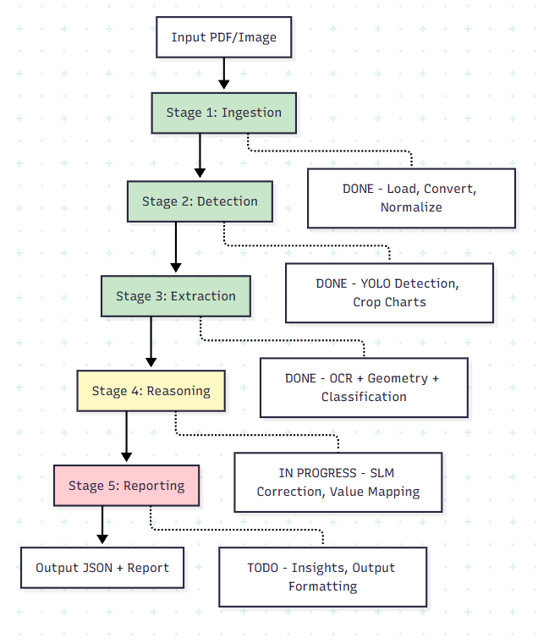3.2. Stage-by-Stage Status

Stage 1: Ingestion DONE
Component | Status | Description
PDF Processor | Done | PyMuPDF (fitz) integration
Image Loader | Done | PNG/JPG support
Quality Validation | Done | Resolution, blur detection
Normalization | Done | Resize, contrast enhancement
File: s1_ingestion.py

Stage 2: Detection DONE
Component | Status | Description
YOLO Integration | Done | Ultralytics YOLOv8/v11
Confidence Filtering | Done | Threshold-based filtering
Multi-chart Handling | Done | Crop multiple charts per image
BBox Storage | Done | Save coordinates for traceability
File: s2_detection.py

Stage 3: Extraction DONE (Week 1 Focus)
Submodules implemented:
Submodule | File | Status | Description
Preprocessor | preprocessor.py | Done | Negative image + adaptive threshold
Skeletonizer | skeletonizer.py | Done | Lee algorithm, keypoint detection
Vectorizer | vectorizer.py | Done | RDP algorithm, subpixel refinement
OCR Engine | ocr_engine.py | Done | EasyOCR with role classification
Geometric Mapper | geometric_mapper.py | Done | Axis calibration, pixel-to-value
Element Detector | element_detector.py | Done | Bars, markers, pie slices
ResNet Classifier | resnet_classifier.py | Done | 94.66% accuracy
ML Classifier | ml_classifier.py | Done | Production wrapper
Simple Classifier | simple_classifier.py | Done | Baseline fallback
Test Results (2026-01-29):
Metric | Value
Total Images Tested | 800+ (100 per type)
Classification Accuracy | 100% (all 8 types)
OCR Confidence | 91.5% (EasyOCR)
Overall Confidence | 92.6%
Avg Processing Time | ~7.6s per image
ResNet-18 Classifier Highlights:
Metric | Value
Test Accuracy | 94.66%
Integration Test | 93.75% (15/16 samples)
Training Time | 27 minutes (NVIDIA GPU)
ONNX Inference | 6.90ms (CPU), 144.9 img/sec
Model Size | 42.64 MB (ONNX)
Classes | 8 types
Explainability | Grad-CAM visualizations

Stage 4: Reasoning IN PROGRESS (Current Week)
Implemented Components:
Component | File | Status | Description
GeometricValueMapper | value_mapper.py | Done | Pixel-to-value conversion
GeminiPromptBuilder | prompt_builder.py | Done | Canonical Format prompts
ReasoningEngine | reasoning_engine.py | Done | Orchestrator class
GeminiEngine | gemini_engine.py | Done | Gemini API integration
Prompt Templates | prompts/ | Done | reasoning.txt, canonical_format.md
Unit Tests | test_s4_reasoning/ | Done | 36 test cases
Stage4Reasoning | s4_reasoning.py | Done | Main orchestrator
Local SLM | - | TODO | Qwen-2.5 / Llama-3.2
Architecture:
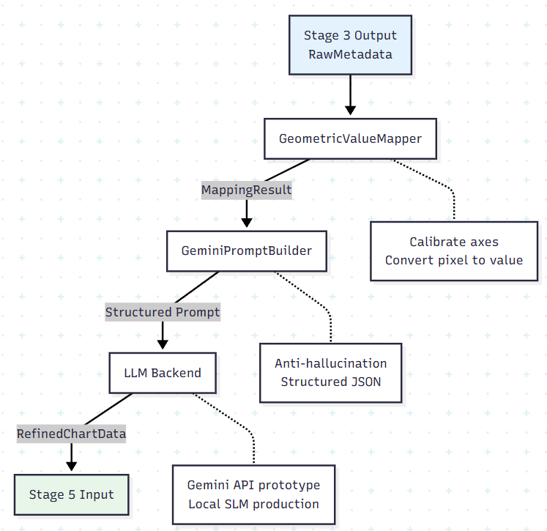Gemini API Configuration: - Model: gemini-3.0-flash-preview - Temperature: 0.3 (deterministic) - Max tokens: 2048
Known Issues: - PaddleOCR 3.3.x has compatibility issues on Windows → Switched to EasyOCR - Gemini API occasionally returns unparseable JSON → Fallback mechanism works

Stage 5: Reporting TODO
Planned Components:
Component | Description
Parallel Processing | ThreadPoolExecutor for batch processing
Insight Generation | Trend, comparison, anomaly, summary
JSON Validator | Schema validation (Pydantic)
Report Generator | Markdown + JSON output
Traceability Info | Source tracking

4. Code Structure Overview
src/core_engine/
├── __init__.py
├── pipeline.py # Main orchestrator
├── exceptions.py # Custom exceptions
├── schemas/
│ ├── common.py # BoundingBox, Color, SessionInfo
│ ├── enums.py # ChartType enum
│ ├── extraction.py # Extraction-specific schemas
│ ├── qa_schemas.py # QA pair schemas
│ └── stage_outputs.py # Stage1-5 Output schemas
├── stages/
│ ├── base.py # BaseStage abstract class
│ ├── s1_ingestion.py # Stage 1 implementation
│ ├── s2_detection.py # Stage 2 implementation
│ ├── s3_extraction/ # Stage 3 (12 files)
│ │ ├── s3_extraction.py
│ │ ├── preprocessor.py
│ │ ├── skeletonizer.py
│ │ ├── vectorizer.py
│ │ ├── ocr_engine.py
│ │ ├── geometric_mapper.py
│ │ ├── element_detector.py
│ │ ├── resnet_classifier.py
│ │ ├── ml_classifier.py
│ │ ├── simple_classifier.py
│ │ └── classifier.py
│ └── s4_reasoning/ # Stage 4 (7 files)
│ ├── s4_reasoning.py
│ ├── gemini_engine.py
│ ├── reasoning_engine.py
│ ├── prompt_builder.py
│ ├── value_mapper.py
│ └── prompts/
└── validators/ # Input validators

5. Testing Status
Test Suite | Files | Cases | Status
Schema Tests | test_schemas.py | ~20 | Pass
Stage 3 Tests | test_s3_extraction/ | 129 | Pass
Stage 4 Tests | test_s4_reasoning/ | 36 | Pass
Integration Tests | scripts/test_*.py | ~10 | Pass

6. Next Steps (Định hướng)

Immediate (This Week)
- Complete Stage 4 Integration Testing
  - Test full pipeline Stage 3 → Stage 4
  - Validate Gemini API output quality
  - Document edge cases
- Begin Stage 5 Implementation
  - Design parallel processing architecture
  - Implement insight generation module
  - Setup JSON schema validation

Short-term (Next 2 Weeks)
- Local SLM Training
  - Prepare training data from Gemini outputs
  - Fine-tune Qwen-2.5-1.5B or Llama-3.2-1B
  - Compare with Gemini baseline
- Performance Optimization
  - Batch processing implementation
  - Caching mechanism for repeated queries
  - Memory optimization for large documents

Medium-term (Month 2)
- Benchmarking
  - Compare with GPT-4V baseline
  - Evaluate on public chart datasets
  - Document accuracy metrics
- Demo & Documentation
  - Streamlit demo interface
  - API documentation (FastAPI)
  - Thesis chapter drafts

7. Technical Decisions Made
Decision | Rationale | Date
ResNet-18 over SimpleClassifier | 94.66% vs 37.5% accuracy | 2026-01-25
EasyOCR over PaddleOCR | Windows compatibility | 2026-01-26
Gemini API for prototyping | Fast iteration before local SLM | 2026-01-26
Canonical Format prompts | Anti-hallucination, structured | 2026-01-30
Stage 3 = Pure Geometry | No LLM dependency, reproducible | 2026-01-29

8. Risks & Mitigations
Risk | Impact | Mitigation
Gemini API rate limits | Slow development | Local SLM fallback
OCR accuracy on complex charts | Poor value extraction | Multi-engine fallback
Dataset bias (academic only) | Limited generalization | Plan diverse data collection
Training time for local SLM | Delay in production | Use distillation techniques

9. Resources

Documentation
- MASTER_CONTEXT.md - Project overview
- PIPELINE_FLOW.md - Pipeline architecture
- STAGE3_EXTRACTION.md - Stage 3 details
- STAGE4_REASONING.md - Stage 4 details

Models
- ResNet-18 Weights: models/weights/resnet18_chart_classifier_best.pt
- ONNX Export: models/onnx/resnet18_chart_classifier.onnx
- Grad-CAM: models/explainability/gradcam_*.png

Notebooks
- 00_quick_start.ipynb - Quick demo
- 03_stage3_extraction.ipynb - Stage 3 exploration
- 04_stage4_reasoning.ipynb - Stage 4 demo

10. Summary
What’s DONE: - Phase 1 complete với 2,852 classified charts và 13,297 QA pairs - Stage 1-3 fully implemented và tested (100% classification accuracy) - ResNet-18 classifier với 94.66% accuracy - Stage 4 core components implemented (ValueMapper, PromptBuilder, GeminiEngine)
What’s IN PROGRESS: - Stage 4 integration testing - Data quality refinement (lọc lại dataset) - Local SLM preparation
What’s PLANNED: - Stage 5: Reporting implementation - Local SLM training (Qwen-2.5 / Llama-3.2) - Benchmarking và optimization

Report created by That Le on 2026-01-29

