Mongo DB can import the json, csv and tsv files. You can download the dataset from the website <https://www.ncdc.noaa.gov/cdo-web/datasets>. This time, we would better use the specific dataset in order to finish your homework. Click the “search tool”. Then do as the picture indicates.

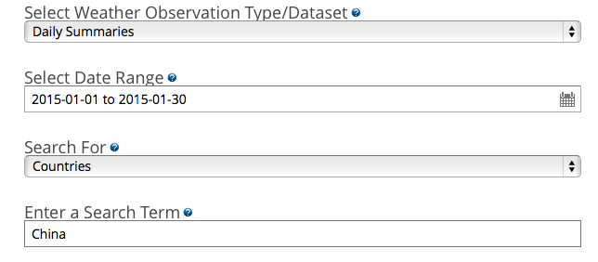

And then add the result to your cart and choose Custom GHCN-Daily CSV file to download. The choice as the picture indicates:

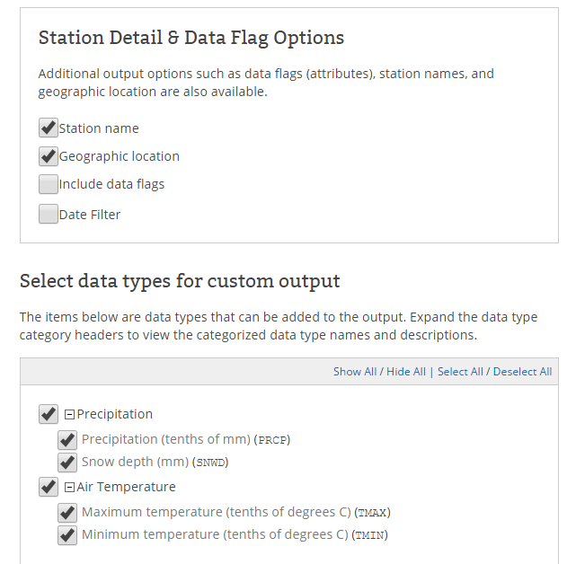

Absolutely, you can simply download the condition.csv file from the Download Handout link if you feel too complicated about that. You can import it into your local Mongo instance with this command（before this you should rename the file you download as condition.csv）:

mongoimport --db weather ––type csv ––headerline ––file temperature.csv

Make sure that the condition.csv is in the “bin” folder so that the shell can find it.(put file to current dos command path)

To confirm you are on the right track, here are some queries to run after you process the data with the correct answer shown:

Let us count the number of records we have:

> use weather

> db. temperature.count()

11780

The mongoDB will automatically create a collection named “temperature”.

This dataset holds some weather data including the highest and the lowest temperature of a city in the past 2 years everyday. You might want to start by inspecting it in the Mongo shell.

Let's see what the record looks like:

> db.temperature.findOne( )

{

"_id" : ObjectId("54ce63c196486d45f4b325de"),

"STATION" : "GHCND:CHM00059293",

"STATION_NAME" : "HEYUAN CH",

"ELEVATION" : 41,

"LATITUDE" : 23.8,

"LONGITUDE" : 114.733,

"DATE" : NumberLong(20140401),

"PRCP" : 76,

"SNWD" : "-9,999",

"TMAX" : 212,

"TMIN" : "-9,999"

}

homework:

> db.temperature.find({"_id" : ObjectId("54ce63c196486d45f4b325df")}).pretty()

answer:

{

"_id" : ObjectId("54ce63c196486d45f4b325df"),

"STATION" : "GHCND:CHM00059293",

"STATION_NAME" : "HEYUAN CH",

"ELEVATION" : 41,

"LATITUDE" : 23.8,

"LONGITUDE" : 114.733,

"DATE" : NumberLong(20140402),

"PRCP" : 353,

"SNWD" : "-9,999",

"TMAX" : 214,

"TMIN" : 169

}