South Africa Unemployment Rate Analysis Using Python
Student Name: Thato Mokgosi
Degree: Bachelor of Economic Science with Econometrics
Software Used: Python, Visual Studio Code, Microsoft Word
Date: 11 February 2026

1. Project Overview
This project analyses unemployment trends in South Africa using macroeconomic data retrieved from the World Bank database. The purpose of the project is to demonstrate data retrieval, cleaning, analysis, and visualisation skills using Python, which are essential for economic research and financial analytics roles.

2. Objectives of the Project
The objectives of this project are:
- To retrieve unemployment data using Python.
- To clean and prepare the dataset for analysis.
- To analyse unemployment trends over time.
- To visualise the data using a time series graph.
- To document the process professionally as a portfolio project.

3. Data Source and Description
The unemployment data was obtained from the World Bank database using the indicator Unemployment, total (percent of total labour force) for South Africa. The data covers the period from 1990 to 2023 and was accessed through the World Bank Application Programming Interface.

4. Tools and Technologies Used
- Python programming language
- pandas library for data manipulation
- requests library for data retrieval
- matplotlib library for visualisation
- Visual Studio Code for coding
- Microsoft Word for documentation

5. Methodology
5.1 Data Collection
Unemployment data was downloaded programmatically using the World Bank Application Programming Interface.
5.2 Data Cleaning and Processing
Missing values were removed, and the dataset was sorted chronologically by year.
5.3 Data Analysis
Descriptive analysis was performed to observe unemployment trends over time.
5.4 Data Visualisation
A time series line graph was created to illustrate unemployment rate changes.

6. Python Implementation
6.1 Data Download and Cleaning Code
import pandas as pd
import requests

url = "https://api.worldbank.org/v2/country/ZAF/indicator/SL.UEM.TOTL.ZS?date=1990:2023&format=json"
response = requests.get(url)
data = response.json()[1]

df = pd.DataFrame(data)[["date", "value"]]
df.columns = ["Year", "Unemployment_Rate"]

df["Year"] = df["Year"].astype(int)
df = df.sort_values("Year")
df = df.dropna()

df.to_excel("unemployment_sa.xlsx", index=False)
6.2 Visualisation Code
import matplotlib.pyplot as plt

plt.plot(df["Year"], df["Unemployment_Rate"])
plt.title("Unemployment Rate in South Africa")
plt.xlabel("Year")
plt.ylabel("Unemployment Rate (percent)")
plt.show()

7. Results
7.1 Trend Analysis
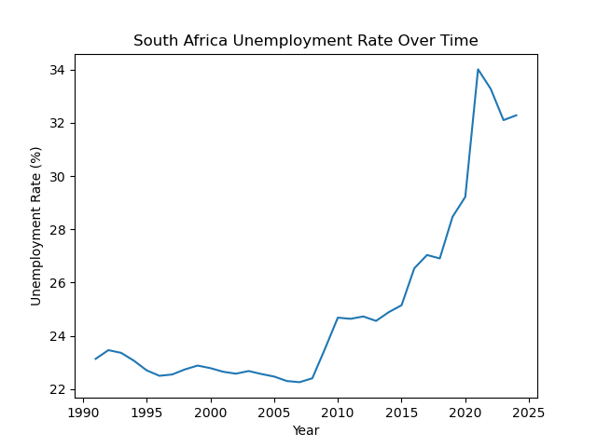
The results indicate fluctuations in unemployment over time, with periods of rising and declining unemployment linked to economic conditions.

7.2 Sample Data Table
Year | Unemployment Rate
1991 | 23.137
1992 | 23.463
1993 | 23.361
1994 | 23.067
1995 | 22.705
1996 | 22.500
1997 | 22.549
1998 | 22.739
1999 | 22.884

8. Interpretation and Economic Insights
South Africa’s unemployment rate exhibits persistent structural unemployment, reflecting labour market rigidities, skills mismatches, and slow economic growth. Economic shocks and policy interventions also influence fluctuations. This analysis demonstrates how macroeconomic data can be used to evaluate labour market performance.

9. Limitations of the Project
This project focuses only on national unemployment data and does not account for demographic breakdowns such as age, gender, or education level. Future work could include econometric modelling and forecasting.

10. Conclusion
This portfolio project demonstrates the ability to retrieve real-world economic data, perform data cleaning, conduct analysis, and present findings using Python. These skills are relevant for data analytics, economic research, and financial planning roles.
Appendix A: Full Python Script
import pandas as pd
import matplotlib.pyplot as plt
import requests

# World Bank API JSON link for South Africa unemployment
url = "https://api.worldbank.org/v2/country/ZAF/indicator/SL.UEM.TOTL.ZS?format=json"

# Download JSON data
response = requests.get(url)
data_json = response.json()

# Extract the actual data part
records = data_json[1]

# Convert to DataFrame
data = pd.DataFrame(records)

# Keep only Year and Value
data = data[["date", "value"]]

# Rename columns
data = data.rename(columns={"date": "Year", "value": "Unemployment_Rate"})

# Convert to numbers
data["Year"] = pd.to_numeric(data["Year"])
data["Unemployment_Rate"] = pd.to_numeric(data["Unemployment_Rate"])

# Remove missing values
data_clean = data.dropna()

# Sort by Year
data_clean = data_clean.sort_values("Year")

# Show sample table
print("Sample Data Table:")
print(data_clean.head(10))

# Save table to Excel
data_clean.to_excel("unemployment_table.xlsx", index=False)

# Plot graph
plt.plot(data_clean["Year"], data_clean["Unemployment_Rate"])
plt.xlabel("Year")
plt.ylabel("Unemployment Rate (%)")
plt.title("South Africa Unemployment Rate Over Time")
plt.savefig("unemployment_graph.png")
plt.show()

