CPSC 332 Spring 2019 Term Project

Yafu Deng (7938)

James Ku (1865)

Ying Lin Wen (4911)

Implementation Account: cs332s17

**DDL:**

CREATE TABLE PROFESSOR(SSN numeric(9) primary key NOT NULL, NAME varchar(50) NOT NULL, TELEPHONE numeric(10) NOT NULL, SEX enum('M', 'F') NOT NULL, TITLE varchar(20) NOT NULL, SALARY numeric(9) NOT NULL, ADDRESS varchar(255) NOT NULL);

CREATE TABLE PROFESSOR_DEGREES(PROF_SSN numeric(9) NOT NULL, DEGREENAME varchar(40) NOT NULL, primary key (PROF_SSN, DEGREENAME), foreign key (PROF_SSN) references PROFESSOR(SSN));

CREATE TABLE DEPARTMENT(DEPT_NO numeric(3) primary key NOT NULL, DEPT_NAME varchar(40) NOT NULL, DEPT_PHONE_NO numeric(10) NOT NULL, LOCATION varchar(40) NOT NULL, CHAIRPERSON_SSN numeric(9) NOT NULL UNIQUE, foreign key (CHAIRPERSON_SSN) references PROFESSOR(SSN));

CREATE TABLE COURSE(COURSE_NO numeric(3) primary key NOT NULL, COURSE_TITLE varchar(40) NOT NULL, TEXTBOOK varchar(100) NOT NULL, UNITS numeric(1) NOT NULL, DEPT_NUM numeric(3) NOT NULL, foreign key (DEPT_NUM) references DEPARTMENT(DEPT_NO));

CREATE TABLE SECTION(COURSE_NUM numeric(3) NOT NULL, SECTION_NO numeric(2) NOT NULL, CLASSROOM varchar(10) NOT NULL, NUMBER_OF_SEATS numeric(3) NOT NULL, MEETINGDAYS varchar(7) NOT NULL, BEGINTIME varchar(5) NOT NULL, ENDTIME varchar(5) NOT NULL, PROFESSOR_SSN numeric(9) NOT NULL, primary key (COURSE_NUM, SECTION_NO), foreign key (COURSE_NUM) references COURSE(COURSE_NO), foreign key (PROFESSOR_SSN) references PROFESSOR(SSN));

CREATE TABLE STUDENT(CWID numeric(9) NOT NULL, STUDENT_NAME varchar(50) NOT NULL, STUDENT_ADDRESS varchar(255) NOT NULL, STUDENT_PHONE numeric(10) NOT NULL, MAJOR numeric(3) NOT NULL, MINOR numeric(3), foreign key (MAJOR) references DEPARTMENT(DEPT_NO), foreign key (MINOR) references DEPARTMENT(DEPT_NO));

CREATE TABLE ENROLL(COURSE_NUMBER numeric(3) NOT NULL, SECTION_NUMBER numeric(2) NOT NULL, CAMPUSWIDEID numeric(9) NOT NULL, GRADE enum('A+', 'A', 'A-', 'B+', 'B', 'B-', 'C+', 'C', 'C-', 'D+', 'D', 'D-', 'F'), primary key (COURSE_NUMBER, SECTION_NUMBER, CAMPUSWIDEID), foreign key (COURSE_NUMBER, SECTION_NUMBER) references SECTION(COURSE_NUM, SECTION_NO));

CREATE TABLE PREREQ(CNUM numeric(3) NOT NULL, PREREQCNUM numeric(3) NOT NULL, primary key (CNUM, PREREQCNUM), foreign key (CNUM) references COURSE(COURSE_NO), foreign key (PREREQCNUM) references COURSE(COURSE_NO));

**SQL:**

Professors:

a. "SELECT COURSE_TITLE, CLASSROOM, MEETINGDAYS, BEGINTIME, ENDTIME FROM COURSE, SECTION, PROFESSOR WHERE PROFESSOR_SSN = SSN AND COURSE_NO = COURSE_NUM AND PROFESSOR_SSN = '".$_POST["ssn"]."';"

b. "SELECT GRADE, COUNT(*) FROM SECTION, ENROLL WHERE COURSE_NUM = COURSE_NUMBER AND SECTION_NO = SECTION_NUMBER AND COURSE_NUM = '".$_POST["course_num"]."' AND SECTION_NO ='".$_POST["section_no"]."' GROUP BY GRADE;"

Students:

a. "SELECT SECTION_NO, CLASSROOM, MEETINGDAYS, BEGINTIME, ENDTIME, COUNT(*) FROM SECTION, ENROLL WHERE COURSE_NUM = COURSE_NUMBER AND SECTION_NO = SECTION_NUMBER AND COURSE_NUM = '".$_POST["course_num"]."' GROUP BY SECTION_NO;"

b. "SELECT COURSE_NO, COURSE_TITLE, GRADE FROM COURSE, ENROLL WHERE COURSE_NO = COURSE_NUMBER AND CAMPUSWIDEID = '".$_POST["campuswideid"]."';"

**index.html:**

<!DOCTYPE html>

<html>

<head>

<link rel="stylesheet" href="https://use.fontawesome.com/releases/v5.7.0/css/all.css" integrity="sha384-lZN37f5QGtY3VHgisS14W3ExzMWZxybE1SJSEsQp9S+oqd12jhcu+A56Ebc1zFSJ" crossorigin="anonymous">

<link rel="stylesheet" href="include/styles.css">

<title>Home</title>

<style>

.buttonT {

background-color: #91A8d0;

border: none;

color: black;

padding: 18px 40px;

text-align: center;

text-decoration: none;

display: inline-block;

font-size: 16px;

margin: 4px 2px;

cursor: pointer;

box-shadow: 0 8px 16px 0 rgba(0,0,0,0.2), 0 6px 20px 0 rgba(0,0,0,0.19);

justify-content:center;

}

.buttonS {

background-color: #f7cac9;

border: none;

color: black;

padding: 18px 40px;

text-align: center;

text-decoration: none;

display: inline-block;

font-size: 16px;

margin: 4px 2px;

cursor: pointer;

box-shadow: 0 8px 16px 0 rgba(0,0,0,0.2), 0 6px 20px 0 rgba(0,0,0,0.19);

justify-content:center;

}

.center {

margin: auto;

width: 25%;

padding: 35px;

}

#h1{

text-align: center;

font-family:Lucida Console;

}

.button:hover {background-color: #3e8e41}

.button:active {

background-color: ;

box-shadow: 0 5px #666;

transform: translateY(4px);

</style>

</head>

<body>

<h1 id="h1" >

<i class="fas fa-cloud"></i>

Welcome to CSUF Database

<i class="fas fa-cloud"></i></h1>

<div class="center">

<a href="teachers.php" class="buttonT">Teacher Portal</a>

<br>

<br>

<a href="students.php" class="buttonS">Student Portal</a>

</div>

</body>

</html>

**styles.css:**

table, th, td {

border: 1px solid black;

border-collapse: collapse;

}

label {

float: left;

width: 120px;

}

#secret_menu {

height: 200px;

}

**teachers.php:**

<!DOCTYPE html>

<html>

<head>

<title>Teachers</title>

<link rel="stylesheet" href="include/styles.css">

<?php

$username = 'cs332s17';

$link = mysql_connect('mariadb', $username, 'atheiV0b');

if(!$link)

{

die("<!--Could not connect: ".mysql_error()."-->");

}

echo "<!--Connected successfully.-->";

mysql_select_db($username, $link);

?>

</head>

<body>

<a href="index.html">Home</a>

<h1>Teacher Portal</h1>

<br>

<h2>Entering a professor's social security number below will list the titles, classrooms, meeting days and time of his/her classes.</h2>

<form action="teachers.php" method="POST">

<label>Professor SSN:</label><input type="text" name="ssn" required/><br>

<input type="submit" />

</form>

<br>

<?php

if ($_POST["ssn"] != "")

{

$result = mysql_query("SELECT COURSE_TITLE, CLASSROOM, MEETINGDAYS, BEGINTIME, ENDTIME FROM COURSE, SECTION, PROFESSOR WHERE PROFESSOR_SSN = SSN AND COURSE_NO = COURSE_NUM AND PROFESSOR_SSN = '".$_POST["ssn"]."';", $link);

if(mysql_numrows($result) == 0)

{

echo "No results for SSN '".$_POST["ssn"]."' found in database.";

}

else

{

echo "<h4>Results for professor SSN: ".$_POST["ssn"]."</h4>";

echo "<table>";

echo "<tr>";

echo "<th>Course Title</th>";

echo "<th>Classroom</th>";

echo "<th>Meeting Days</th>";

echo "<th>Begin Time</th>";

echo "<th>End Time</th>";

echo "</tr>";

for($i = 0; $i < mysql_numrows($result); $i++)

{

echo "<tr>";

echo "<td>".mysql_result($result, $i, "COURSE_TITLE")."</td>";

echo "<td>".mysql_result($result, $i, "CLASSROOM")."</td>";

echo "<td>".mysql_result($result, $i, "MEETINGDAYS")."</td>";

echo "<td>".mysql_result($result, $i, "BEGINTIME")."</td>";

echo "<td>".mysql_result($result, $i, "ENDTIME")."</td>";

echo "</tr>";

}

echo "</table>";

}

}

?>

<h2>Entering a course # and a section # below will return a count of how many students received each distinct grade.</h2>

<form action="teachers.php" method="POST">

<label>Course #:</label><input type="text" name="course_num" required/><br>

<label>Section #:</label><input type="text" name="section_no" required/><br>

<input type="submit" />

</form>

<br>

<?php

if ($_POST["course_num"] != "")

{

$result = mysql_query("SELECT GRADE, COUNT(*) FROM SECTION, ENROLL WHERE COURSE_NUM = COURSE_NUMBER AND SECTION_NO = SECTION_NUMBER AND COURSE_NUM = '".$_POST["course_num"]."' AND SECTION_NO ='".$_POST["section_no"]."' GROUP BY GRADE;", $link);

if(mysql_numrows($result) == 0)

{

echo "No results for course #: '".$_POST["course_num"]."' and section #: '".$_POST["section_no"]."' found in database.";

}

else

{

echo "<h4>Results for course #: ".$_POST["course_num"]." and section #: ".$_POST["section_no"]."</h4>";

echo "<table>";

echo "<tr>";

echo "<th>Grade</th>";

echo "<th>Count</th>";

echo "</tr>";

for($i = 0; $i < mysql_numrows($result); $i++)

{

echo "<tr>";

echo "<td>".mysql_result($result, $i, "GRADE")."</td>";

echo "<td>".mysql_result($result, $i, "COUNT(*)")."</td>";

echo "</tr>";

}

echo "</table>";

}

}

mysql_close($link);

?>

</body>

</html>

**students.php:**

<!DOCTYPE html>

<html>

<head>

<title>Students</title>

<link rel="stylesheet" href="include/styles.css">

<?php

$username = 'cs332s17';

$link = mysql_connect('mariadb', $username, 'atheiV0b');

if(!$link)

{

die("<!--Could not connect: ".mysql_error()."-->");

}

echo "<!--Connected successfully.-->";

mysql_select_db($username, $link);

?>

</head>

<body>

<a href="index.html">Home</a>

<h1>Student Portal</h1>

<br>

<h2>Entering a course number below will list the sections of the course including the classrooms, meeting days and time, and the number of students enrolled in each section.</h2>

<form action="students.php" method="POST">

<label>Course #:</label><input type="text" name="course_num" required/><br>

<input type="submit" />

</form>

<br>

<?php

if ($_POST["course_num"] != "")

{

$result = mysql_query("SELECT SECTION_NO, CLASSROOM, MEETINGDAYS, BEGINTIME, ENDTIME, COUNT(*) FROM SECTION, ENROLL WHERE COURSE_NUM = COURSE_NUMBER AND SECTION_NO = SECTION_NUMBER AND COURSE_NUM = '".$_POST["course_num"]."' GROUP BY SECTION_NO;", $link);

if(mysql_numrows($result) == 0)

{

echo "No results for course #: '".$_POST["course_num"]."' found in database.";

}

else

{

echo "<h4>Results for course #: ".$_POST["course_num"]."</h4>";

echo "<table>";

echo "<tr>";

echo "<th>Section #</th>";

echo "<th>Classroom</th>";

echo "<th>Meeting Days</th>";

echo "<th>Begin Time</th>";

echo "<th>End Time</th>";

echo "<th># Students Enrolled</th>";

echo "</tr>";

for($i = 0; $i < mysql_numrows($result); $i++)

{

echo "<tr>";

echo "<td>".mysql_result($result, $i, "SECTION_NO")."</td>";

echo "<td>".mysql_result($result, $i, "CLASSROOM")."</td>";

echo "<td>".mysql_result($result, $i, "MEETINGDAYS")."</td>";

echo "<td>".mysql_result($result, $i, "BEGINTIME")."</td>";

echo "<td>".mysql_result($result, $i, "ENDTIME")."</td>";

echo "<td>".mysql_result($result, $i, "COUNT(*)")."</td>";

echo "</tr>";

}

echo "</table>";

}

}

?>

<h2>Entering a CWID below will list all courses the student took and the grades for those courses.</h2>

<form action="students.php" method="POST">

<label>CWID:</label><input type="text" name="campuswideid" required/><br>

<input type="submit" />

</form>

<br>

<?php

if ($_POST["campuswideid"] != "")

{

$result = mysql_query("SELECT COURSE_NO, COURSE_TITLE, GRADE FROM COURSE, ENROLL WHERE COURSE_NO = COURSE_NUMBER AND CAMPUSWIDEID = '".$_POST["campuswideid"]."';", $link);

if(mysql_numrows($result) == 0)

{

echo "No results for CWID: '".$_POST["campuswideid"]."' found in database.";

}

else

{

echo "<h4>Results for CWID: ".$_POST["campuswideid"]."</h4>";

echo "<table>";

echo "<tr>";

echo "<th>Course #</th>";

echo "<th>Course Title</th>";

echo "<th>Grade</th>";

echo "</tr>";

for($i = 0; $i < mysql_numrows($result); $i++)

{

echo "<tr>";

echo "<td>".mysql_result($result, $i, "COURSE_NO")."</td>";

echo "<td>".mysql_result($result, $i, "COURSE_TITLE")."</td>";

echo "<td>".mysql_result($result, $i, "GRADE")."</td>";

echo "</tr>";

}

echo "</table>";

}

}

mysql_close($link);

?>

</body>

</html>

**Homepage Link** [**http://ecs.fullerton.edu/~cs332s17/index.html**](http://ecs.fullerton.edu/~cs332s17/index.html)

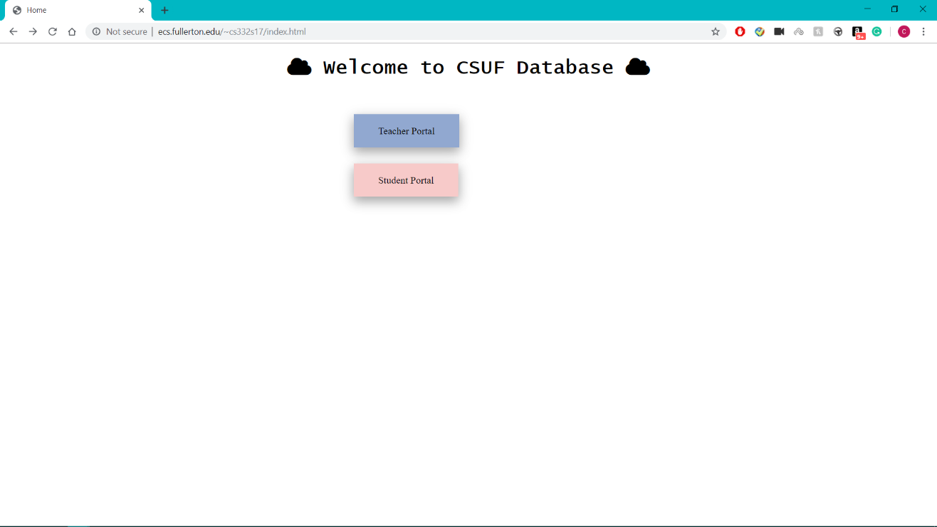

**Teacher Portal Side**

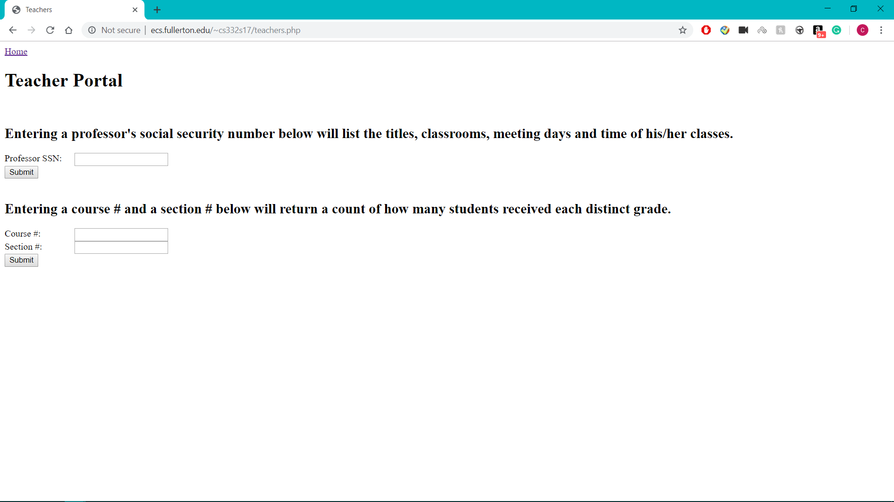

**Enter 141487219 for the Professor SSN to Search for Sections for courses.**

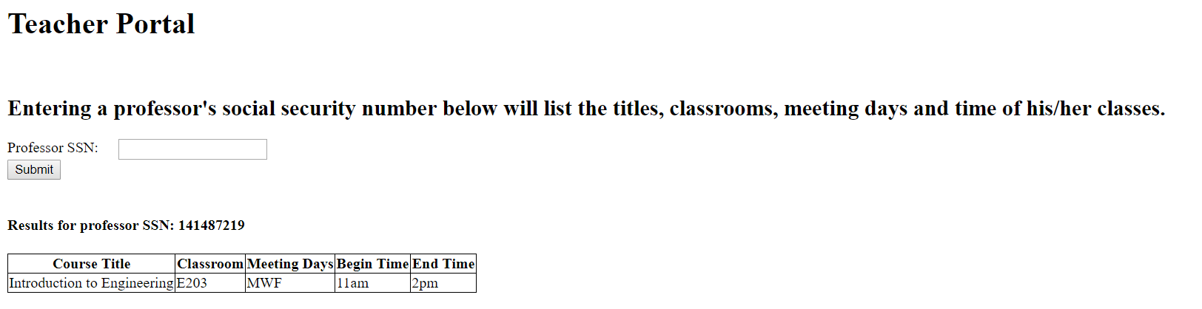

**Enter Course # 332 and Section # 01**

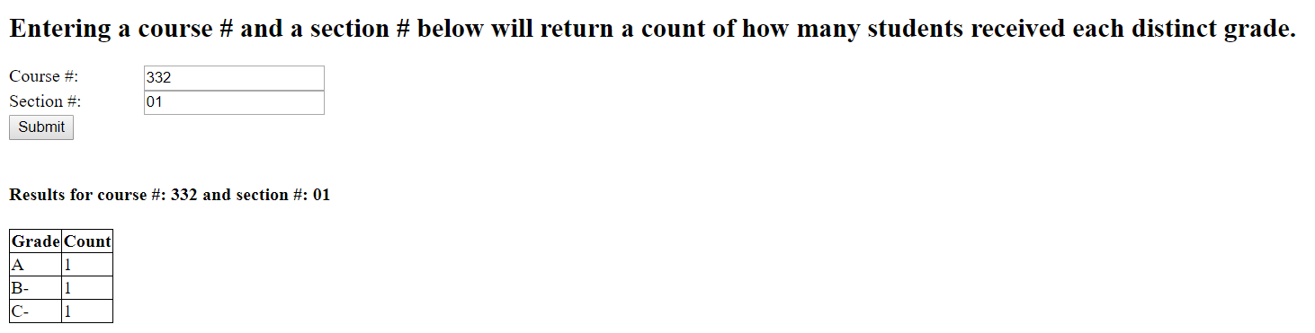

**Student Portal Side**

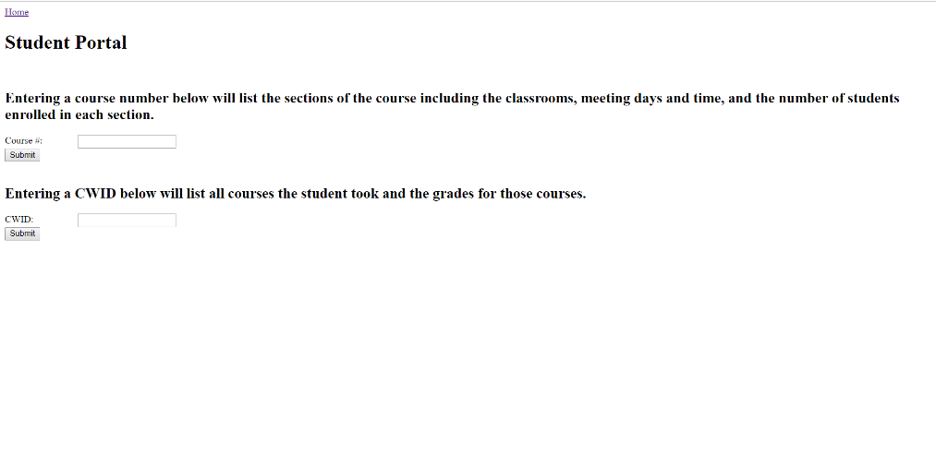

**Enter Course # and return the follow sections**

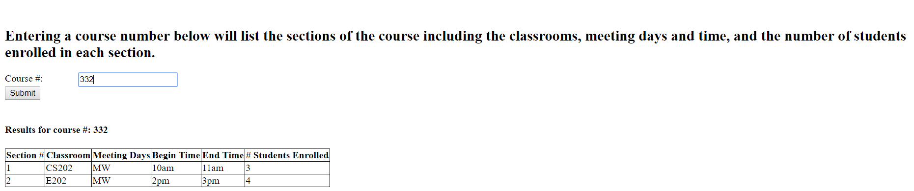

**Enter Student CWID and return grades for courses enrolled**

