Cover Page

Josh Dayan, Andy Yang, and Mark Aaron Sansgaard
April 26, 2012
CS 430: Database Systems
Pi Kappa Phi Fraternity Membership Database

Project Proposal

Initially, our team leader was Mark Aaron Sansgaard. Mark was our liaison to Pi Kappa Phi and was also on the fraternities membership committee. In short, Mark was responsible for keeping track of the Excel files that the organization used for keeping track of all members and all relationships that those members had. Mark spoke with his fraternity and they offered us the following project proposal:

Create a database that contains every member of Pi Kappa Phi since its founding at
Truman State, and include all of the real life relationships of each member.

Since Mark would be responsible for managing the completed database, and because only Mark would be using the database, we decided not to create a front end for our system.

Business Rules

- The database will not include sensitive personal information, such as student GPA or student transcripts.

We wanted to add more information about each member that would be relevant to the fraternity. However, by university policy, we were not allowed to include personal student information, such as GPAs or transcripts.

- The database will not include information that a member requests to be excluded.

Mark informed us that a very small number of individuals requested that some information be withheld from the database. However,as Mark left before we were able to finish adding his data to the database, we do not have any data from those members that requested this privacy.

Database Model
Last modified February 23rd, 2012.

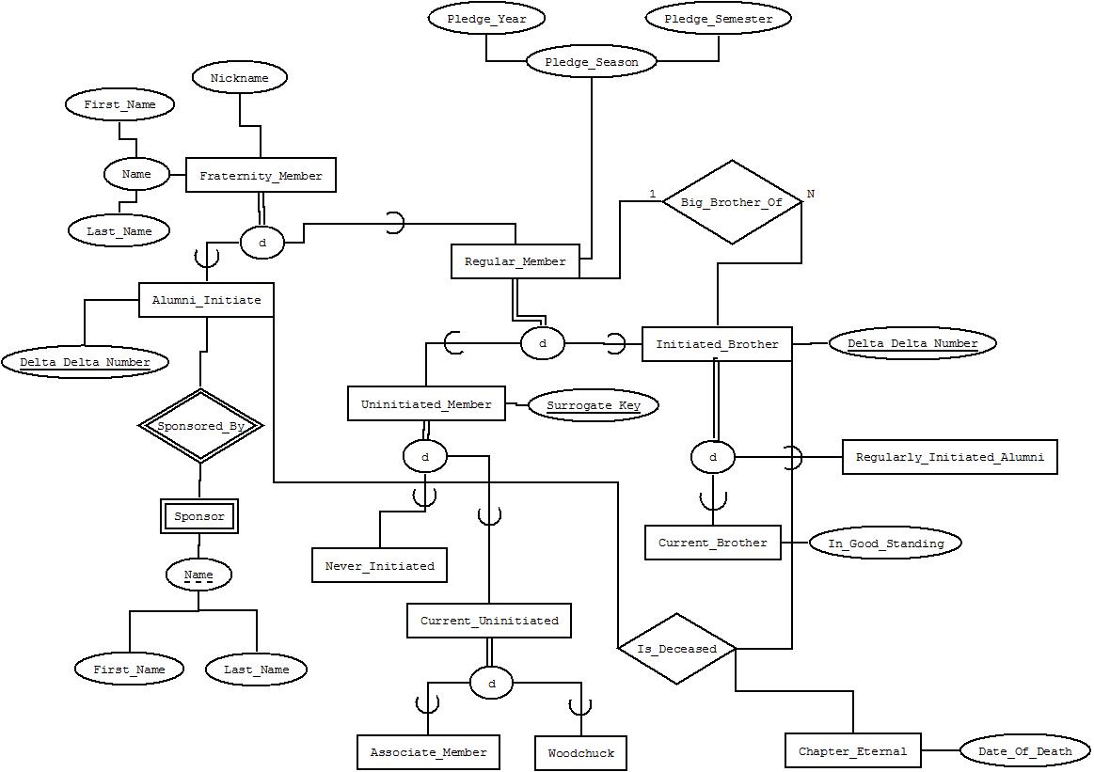

Database Design
Last modified April 25th, 2012.

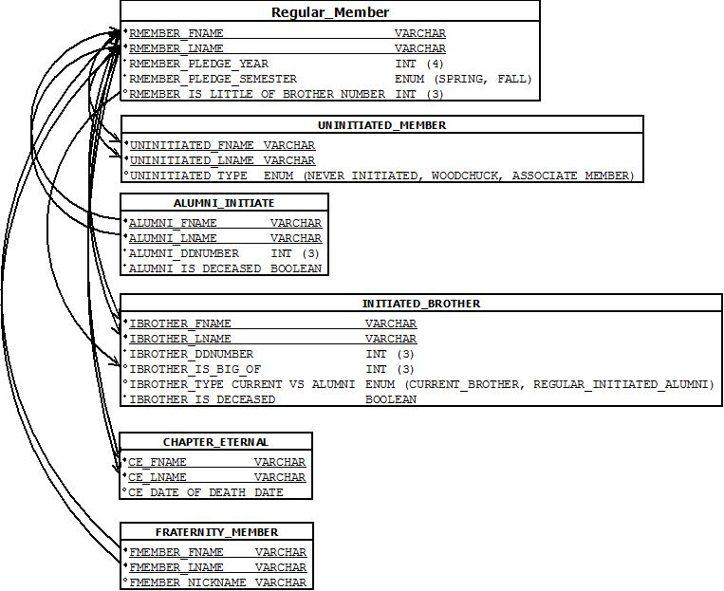

Database Contents
All data was last modified April 25th, 2012.

REGULAR_MEMBER
RMEMBER_FNAME | RMEMBER_LNAME | RMEMBER_PLEDGE_YEAR | RMEMBER_PLEDGE_SEMESTER | RMEMBER_IS_LITTLE_OF_BROTHER_NUMBER
Aaron | Bretz | 2008 | FALL | NULL
Aaron | Hawes | 2003 | SPRING | 729
Andrew | Jackoway | 2005 | FALL | 731
Andy | Hellwig | 2009 | SPRING | 728
Brandon | Carter | 2009 | FALL | 736
Brian | Krzyzanowski | 2007 | FALL | 727
Casey | Jovick | 2007 | FALL | NULL
Chris | Arwood | 2006 | SPRING | NULL
Chris | Peckham | 1999 | FALL | NULL
Chris | Zempel | 2009 | FALL | 727
Dan | Bradley | 1998 | SPRING | NULL
Dan | Gunn | 2009 | FALL | NULL
Dylan | Smith | 2010 | FALL | NULL
Greg | Cejas | 2009 | FALL | NULL
Jaidee | Moore | 2002 | FALL | NULL
Jared | McKinney | 1997 | FALL | NULL
Jeff | Wang | 2009 | FALL | NULL
Jesse | Groethe | 2005 | FALL | NULL
John | Van Huis | 2002 | FALL | NULL
Justin | Irish | 2005 | SPRING | NULL
Justin | Thompson | 2001 | FALL | NULL
Justin | Zhang | 2005 | FALL | NULL
Kevin | Foss | 2009 | FALL | NULL
Kevin | Rose | 2005 | FALL | NULL
Kyle | White | 2009 | FALL | NULL
Mark | Sansgaard | 2010 | FALL | 735
Nils | Carlsted | 2003 | FALL | NULL
Owen | McQuintonfall | 2003 | FALL | NULL
Paul | Witte | 2006 | SPRING | NULL
Phil | Norton | 2006 | SPRING | NULL

FRATERNITY_MEMBER
FMEMBER_LNAME | FMEMBER_FNAME | FMEMBER_NICKNAME
Brune | Zac | FRIENDZONE
Carter | Brandon | 6-FOOT HUGER THAN YOU
Chris | Zempel | TRIPLE LAYER FRIDGE SITTER
Foss | Kevin | DATELINE NBC'S STARGAZER
Gunn | Dan | MR.GORBACHEV, PUKE IN THESE SHOES
Helwig | Andy | DPS HATES DIABETES
Wang | Jess | UPSIDEDOWN VOMIT CHUGGING WATERWORKS
White | Kyle | WHOOMP! THERES MY 11 HERBS AND SPICES

UNINITIATED_MEMBER
UNINITIATED_FNAME | UNINITIATED_TYPE | UNINITIATED_LNAME
Aaron | WOODCHUCK | Bretz
Aaron | NEVER_INITIATED | Hawes
Andrew | NEVER_INITIATED | Jackoway
Andrew | ASSOCIATE_MEMBER | Robbins
Ben | ASSOCIATE_MEMBER | French
Casey | WOODCHUCK | Jovick
Casey | ASSOCIATE_MEMBER | Schdeal
Chris | NEVER_INITIATED | Arwood
Chris | NEVER_INITIATED | Peckham
Dan | NEVER_INITIATED | Bradley
Duncan | ASSOCIATE_MEMBER | Reynolds
Dylan | WOODCHUCK | Smith
Ian | ASSOCIATE_MEMBER | Cantrell
Jaidee | NEVER_INITIATED | Moore
Jared | NEVER_INITIATED | McKinney
Jesse | NEVER_INITIATED | Groethe
Joe | ASSOCIATE_MEMBER | Grothe
John | NEVER_INITIATED | Van Huis
Justin | WOODCHUCK | Irish
Justin | NEVER_INITIATED | Thompson
Justin | NEVER_INITIATED | Zhang
Kevin | NEVER_INITIATED | Rose
Nils | NEVER_INITIATED | Carlsted
Owen | NEVER_INITIATED | NcQuistonfall
Paul | NEVER_INITIATED | Witte
Phil | NEVER_INITIATED | Norton
Sean | NEVER_INITIATED | Larson
Steve | NEVER_INITIATED | Fries
Tim | NEVER_INITIATED | Brandt
Yohan | ASSOCIATE_MEMBER | French

INITIATED_BROTHER
IBROTHER_FNAME | IBROTHER_LNAME | IBROTHER_DDNUMBER | IBROTHER_IS_BIG_OF | IBROTHER_TYPE CURRENT VS ALUMNI | IBROTHER_IS_DECEASED
Andy | Hellwig | 729 | 702 | CURRENT_BROTHER | 0
Brandon | Carter | 736 | NULL | CURRENT_BROTHER | 0
Brian | Krzyzanowski | 702 | 735 | REGULAR_INITIATED_ALUMNI | 0
Chris | Zempel | 728 | NULL | CURRENT_BROTHER | 0
Dan | Gunn | 730 | NULL | CURRENT_BROTHER | 0
Greg | Cejas | 732 | NULL | CURRENT_BROTHER | 0
Jeff | Wang | 733 | NULL | CURRENT_BROTHER | 0
Kevin | Foss | 734 | 732 | CURRENT_BROTHER | 0
Kyle | White | 731 | NULL | REGULAR_INITIATED_ALUMNI | 0
Mark | Sansgaard | 751 | 727 | CURRENT_BROTHER | 0
Todd | Lesinski | 735 | 751 | CURRENT_BROTHER | 0
Zac | Brune | 727 | NULL | REGULAR_INITIATED_ALUMNI | 0

ALUMNI_INITIATE
ALUMNI_FNAME | ALUMNI_LNAME | ALUMNI_DDNUMBER | ALUMNI_IS_DECEASED
Dale | Tilford | 145 | 0
Gerold | Rennells | 30 | 0
Harry | Witzel | 12 | 0
Jason | Haxton | 144 | 0
Jerry | Casebolt | 19 | 0
John | Erhart | 7 | 0
John | Rodman | 16 | 0
Thomas | Rodman | 37 | 0
Thomas | Thompson | 106 | 0
Zelwin | Eaton | 74 | 0

CHAPTER_ETERNAL
CE_FNAME | CE_LNAME | CE_DATE_OF_DEATH
David | Schafer | NULL
Eric | White | NULL
Kurt | Moll | NULL
Ronald | Lamaster | NULL
Timothy | Ernst | NULL

Representative Queries

As this database is modelling membership in an organization, the queries for its use are fairly routine. However, Mark will be able to pull detailed information with relatively simple queries, and with aliases he can create output that is readable and informative; in this respect the database is very effective for its purpose.

- Find the first and last names of all members whose pledge season was in the fall of 2009.

SELECT `RMEMBER_FNAME` AS 'FIRST NAME', `RMEMBER_LNAME` AS 'LAST NAME'
FROM REGULAR_MEMBER
WHERE `RMEMBER_PLEDGE_YEAR` =2009
AND `RMEMBER_PLEDGE_SEMESTER` = 'FALL'

FIRST NAME LAST NAME
Brandon Carter
Chris Zempel
Dan Gunn
Greg Cejas
Jeff Wang
Kevin Foss
Kyle White
Todd Lesinski
Zac Brune

- Find the number of deceased members.

SELECT COUNT( * ) AS 'NUMBER OF DECEASED MEMBERS'
FROM CHAPTER_ETERNAL

NUMBER OF DECEASED MEMBERS
5

- Find the first and last name of the member whose grand little has a delta delta number of 751.

SELECT `IBROTHER_FNAME` AS 'FIRST NAME', `IBROTHER_LNAME` AS 'LAST NAME'
FROM INITIATED_BROTHER
WHERE IBROTHER_IS_BIG_OF = ( SELECT `IBROTHER_DDNUMBER`
FROM INITIATED_BROTHER
WHERE IBROTHER_IS_BIG_OF = 751 )

FIRST NAME LAST NAME
Brian Krzyzanowski

- Return all the initiated members and group them by their initiation semesters.

SELECT `RMEMBER_FNAME` AS 'FIRST NAME', `RMEMBER_LNAME` AS 'LAST NAME', `RMEMBER_PLEDGE_YEAR` AS 'PLEDGE YEAR', `RMEMBER_PLEDGE_SEMESTER` AS
'PLEDGE SEMESTER'
FROM REGULAR_MEMBER
GROUP BY `RMEMBER_PLEDGE_YEAR`, `RMEMBER_PLEDGE_SEMESTER`

FIRST NAME LAST NAME PLEDGE YEAR PLEDGE SEMESTER
Jared McKinney 1997 FALL
Dan Bradley 1998 SPRING
Sean Larson 1999 SPRING
Chris Peckham 1999 FALL
Justin Thompson 2001 FALL
Jaidee Moore 2002 FALL
Aaron Hawes 2003 SPRING
Nils Carlsted 2003 FALL
Tim Brandt 2004 FALL
Andrew Jackoway 2005 FALL
Chris Arwood 2006 SPRING
Brian Krzyzanowski 2007 FALL
Andy Hellwig 2009 SPRING
Brandon Carter 2009 FALL
Mark Sansgaard 2010 FALL

- Find the delta delta number of the member whose nickname is “Friendzone’.

SELECT `IBROTHER_DDNUMBER` AS 'DELTA DELTA NUMBER'
FROM INITIATED_BROTHER, FRATERNITY_MEMBER
WHERE `IBROTHER_FNAME` = `FMEMBER_FNAME` AND `IBROTHER_LNAME` =
`FMEMBER_LNAME` AND `FMEMBER_NICKNAME` = 'FRIENDZONE'

DELTA DELTA NUMBER
727

- Return all of the big/ little brother pairs between initiated brothers and regular members.

SELECT `IBROTHER_FNAME` AS 'BIG FIRST', `IBROTHER_LNAME` AS 'BIG LAST', RMEMBER_FNAME AS 'LITTLE FIRST', RMEMBER_LNAME AS 'LITTLE LAST'
FROM INITIATED_BROTHER
INNER JOIN REGULAR_MEMBER
ON INITIATED_BROTHER.IBROTHER_DDNUMBER =
REGULAR_MEMBER.RMEMBER_IS_LITTLE_OF_BROTHER_NUMBER

BIG FIRST BIG LAST LITTLE FIRST LITTLE LAST
Andy Hellwig Aaron Hawes
Kyle White Andrew Jackoway
Chris Zempel Andy Hellwig
Brandon Carter Brandon Carter
Zac Brune Brian Krzyzanowski
Zac Brune Chris Zempel
Todd Lesinski Mark Sansgaard
Brian Krzyzanowski Todd Lesinski

- List all of the active Woodchucks.

SELECT `UNINITIATED_FNAME` AS 'FIRST NAME', `UNINITIATED_LNAME` AS 'LAST
NAME'
FROM UNINITIATED_MEMBER
WHERE `UNINITIATED_TYPE` = 'WOODCHUCK'

FIRST NAME LAST NAME
Aaron Bretz
Casey Jovick
Dylan Smith
Justin Irish

- Find all the information about the member Mark Sansgaard.

SELECT `RMEMBER_FNAME` AS 'FIRST NAME', `RMEMBER_LNAME` AS 'LAST NAME',
`RMEMBER_PLEDGE_YEAR` AS 'PLEDGE YEAR', `RMEMBER_PLEDGE_SEMESTER` AS 'PLEDGE SEMESTER', `RMEMBER_IS_LITTLE_OF_BROTHER_NUMBER` AS 'LITTLE OF'
FROM REGULAR_MEMBER
WHERE `RMEMBER_LNAME` = 'SANSGAARD' AND `RMEMBER_FNAME` = 'MARK'

FIRST NAME LAST NAME PLEDGE YEAR PLEDGE SEMESTER LITTLE OF
Mark Sansgaard 2010 FALL 735

Discussion #1
Our implemented database can be utilized exactly as was intended in our project proposal. We decided, early on, that we did not need a front end for our system. The only person we wanted to access our database was the executive board member responsible for membership information, which for now is Mark Aaron. We did not want the information in the database to be able to be accessed or altered by other members of the fraternity.
This methodology is consistent with our original project proposal. The only data that we want stored in the database are the member’s names, nicknames, and the relationships between members such as the big-brother-of relationship. This information is not useful to individual members. In general, the information is only needed for bookkeeping purposes. In the beginning, we discussed adding additional information to the database, information such as student’s transcripts and GPAs. This information would allow our database to be used at the university level. An administrator in the fraternity would add the students names and relationships, while the university adds the students school information. In this design, a student’s Truman ID would be a primary key across the board. It was a nice and simple idea.
Unfortunately, we could not implement the idea. This was the first major problem we ran into designing the database. The university would not release any personal information about individual students. Instead, we were forced to use the student’s names as primary keys. This idea still works, but only as long as two people do not share the same name. We discussed that, if necessary in the future, we could generate ID’s to give to every member. These new ID’s would become the primary keys for all of our tables.
However, for now we are using a rather simplistic system. Tables are accessed by name and contain fraternity information like nicknames and big brothers. If Mark Aaron wants to access any information in the database, then he has the means to do so. Our representative queries section shows some examples of the types of queries Mark can make in our database, with our most complex search revolving around finding a grand little.

Discussion #2
The database will have to be regularly updated, as new members will be inducted every semester and members can potentially graduate every semester. Specifically, tuples will have to be added to UNINITIATED_MEMBER every semester, and those tuples will have to be updated into the other tables later in the semester after initiation. Along with this, members may graduate every semester, and those students become alumni members, so the IBROTHER_TYPE attribute in INITIATED_MEMBER will have to be updated for each graduating student. Finally, any members that pass away will have to be moved to the CHAPTER_ETERNAL table. This is only a brief overview of the usual maintenance needed by the database; there are other, more specific cases, that will need to be dealt with, such as students leaving Truman State University, students, leaving the fraternity, and other unusual cases.
Thus, there will need to be some sort of maintenance performed on a regular basis, to update the database (and possibly check for discrepancies). This job would most likely be handled by Mark, as it would be equivalent to his current duties. As Mark is a computer science student, he is qualified to work with the database and update it (again, this is the reason that we are not creating a graphical user interface for the database). However, this poses a problem for his successor - in the event that his successor is not qualified to use this database, there will be a cost associated with either training his successor, or changing the information system the fraternity uses. Also, another issue arises with the sheer volume of tuples that will be added - it may be difficult for a single person to maintain and update a database for a busy semester; however, it would be expensive for the fraternity to assign multiple members to this duty, so it may be left to one person. It is also important to note that a database administrator will not be needed for regular usage of the database: although there will be a great deal of maintenance in the way of insertions, there will be little other work done on the database, and as the database will only be used by Mark, there is little need for database security. Therefore, long-term usage of this database will not require a database administrator. All considered, the database may come with some large expenses for Mark, but it will also provide significant benefits over the old Excel spreadsheets, so it will be up to Mark and Pi Kappa Phi to decide if the database approach will be worth the maintenance costs.

Source Code

The file included on the flash drive is named “mas4114CS430.sql”, without the quotes. This file will create all tables of the project, and will insert all tuples into the created tables.
To import into mySQL, select a database and click on the “Import” tab at the top. Click the button to “Choose File”, and select “mas4114CS430.sql”. Make sure, under “Format of imported file”, that the bubble for SQL is checked. After all these are set, click the “Go” button at the bottom of the page to import all the tables and tuples of the project.

Miscellaneous

As we briefly mentioned earlier, originally we had a third member in our group, Mark Aaron Sansgaard, our group leader. Losing him was a challenge to our project for several reasons. One, Mark was our liaison to Pi Kappa Phi. He was a dedicated member and held an executive position. It was difficult communicating with the organization without him. Two, he had all of the information about the organization: previous milestones, membership information, Excel files, and other information - without this, we were unable to add the complete data set to the database, and we had to create fake data for a few tuples for the sake of having output for some of the queries. Three, he was the team leader. As this database was being designed for his use, he had been leading on its design. Without him, we had to quickly restructure our approach and create the database in our way, as we no longer knew what kinds of features he needed.

