Task 2: Test log
Description of test | Test data to be used (if required) | Expected outcome | Actual outcome | Comments and intended actions
Black box testing - Checking that  Placeholder link for the cart button works and does not break the page | None | Clicking the cart button keeps the user on the current page without throwing a 404 error | The link behaved as expected and clicking it does not redirect the user anywhere or cause a 404 error | The placeholder link will be updated with an actual page link ones the page has been built
Black box testing -Checking the global navigation bar and CSS3 hover transitions. | None | The navigation bar should display correctly at the top of the page. When hovering over the menu, the items should expand smoothly over 0.3 seconds due to the CSS transition | The navigation bar is displayed properly. The CSS transition works exactly as expected, animating smoothly without snapping or any unexpected behaviours | The Navbar works as expected. The external code snippet from the YouTube tutorial worked successfully
Black box testing - Checking that all grid box placeholder links work and do not break the page layout | None | Clicking each of the page boxes should keep the user on the current page without throwing a 404 error. The page should simply jump to the top due to the placeholder links. | All the links behave as expected and clicking them just makes the page jump to the top | The links causing the page to jump to the top is not an issue right now, as they are using # placeholders and will be routed to the related pages once they have been built.
Black box testing -Checking that the main GLH logo redirects to the homepage | None | Clicking the GLH logo from any page should successfully load the homepage without any 404 errors | The logo link behaves exactly as expected, successfully routing the user back to the homepage(I couldn’t add a screenshot with the mouse hovering over the button as neither snipping tool or natively taking a screenshot would include the mouse in the image)  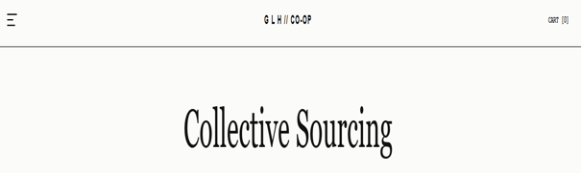 | The logo successfully acts as a global home button, improving site navigation.
Black box testing – To ensure the layout of the page is displayed as expected | None | The About Us section should display below the hero image with enough spacing, and the text should be readable and properly scaled for the page. | Code did run however the about us is too close to the hero image and the font itself is too small 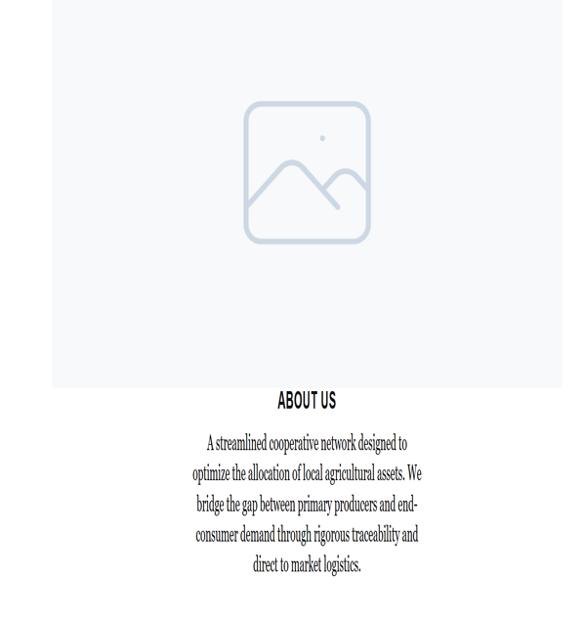 | I will add a margin bottom for the hero image and increase the about us text size. I will also change the font of the ‘about us’ text so that it matches the page header for continuity. I also plan on making both the about us heading and paragraph content a bit bigger so that it fills the page a bit more  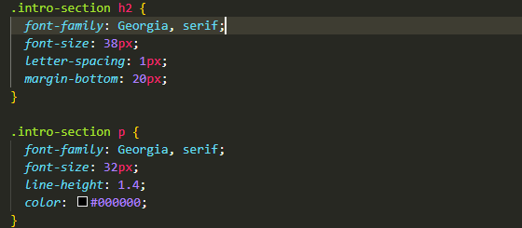
Regression testing: Checking if previous issue was fixed | None | The About Us section should display below the hero image with enough spacing, and the text should be readable and properly scaled for the page | 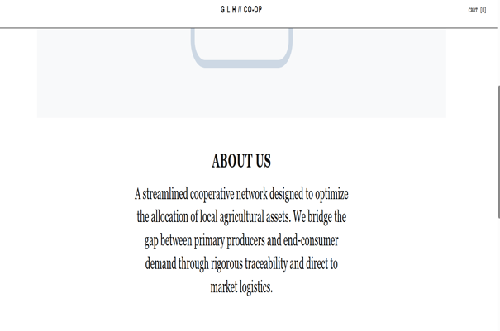 | The spacing is now correct, and the font matches the page header and is readable
Regression testing: Checking grid responsiveness and scaling | None | Grid boxes should contain all text elements within their borders, maintaining a professional and clean layout during window resizing. | The box-title text is overflowing the grid borders, causing a broken UI and unreadable content  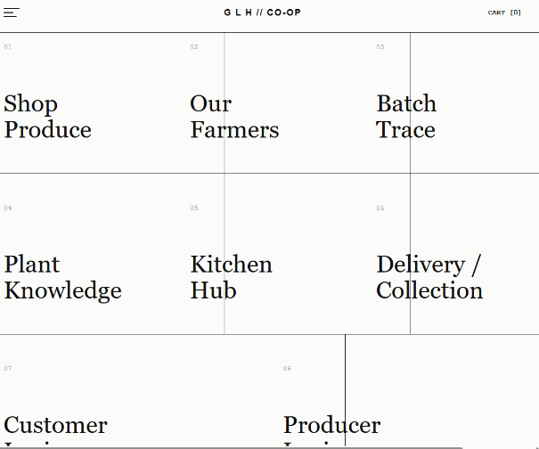 | The fixed 48px font size is too large for the current grid resolution causing the text to overflow the borders. I will replace the static value with a fluid typography approach using the CSS clamp() function. This allows the titles to scale dynamically between 32px and 48px based on the screen size, ensuring the text remains contained
Regression testing: Checking if grid text overflow was fixed. | None | All titles should be fully contained within the grid boxes across all screen resolutions | The fluid font worked, but the fixed 3/2 aspect ratio still caused overflow on mid-sized screens  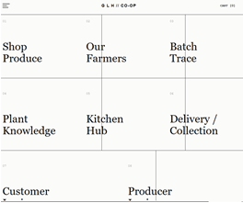 | I have changed the aspect ratio to auto and increased the min-height to 400px. This allows the boxes to expand vertically if the text wraps
Regression Testing: Final fix for grid text overflow. | None | Grid boxes should fully contain typography without text bleeding over the borders. | The update aspect ratio worked and there is no longer any overflow however some boxes no longer have borders between them  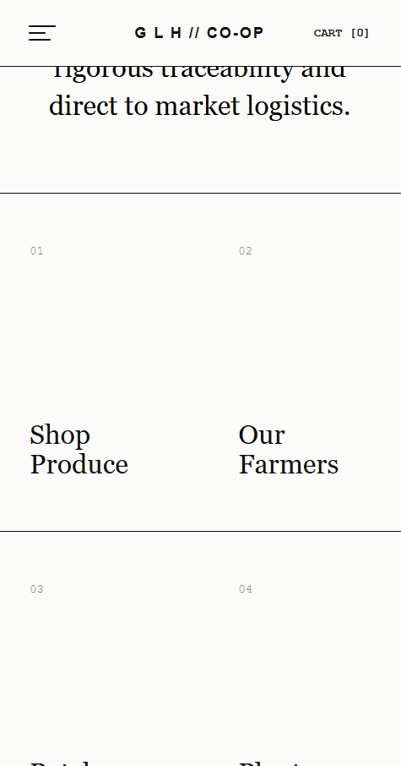 | I have updated the grid to a two column system WHEN minimised and increased the minimum height of the boxes to 400px. These changes allow the containers to expand vertically to accommodate text wrapping. I also implemented new border logic to fix the missing dividers, including manual overrides for the login boxes (07 and 08), to ensure the grid remains visually consistent.
Checking overall grid structural boundaries on desktop. | None | The portal grid should have a complete outer frame, explicitly enclosing the modules on all sides. | The grid lacked a left border, causing the first column of boxes to appear as if they were floating next to each other without a boundary.  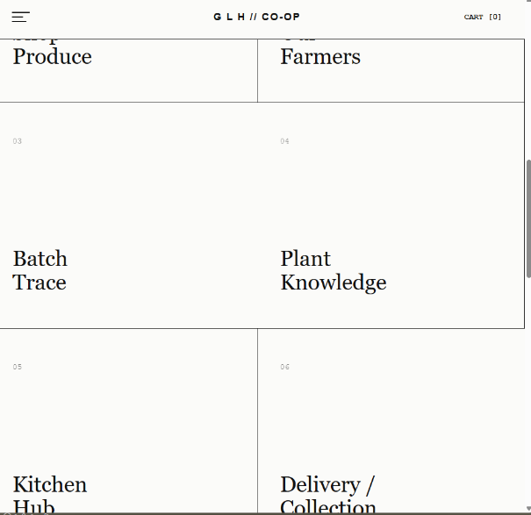 | I updated the. portal-grid class to include border-left: 1px solid #111111. This ensures consistency with the other solid lines.  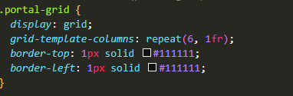
Regression Testing: overall grid structural boundaries | None | The portal grid should have a complete outer frame, explicitly enclosing the modules on all sides. | The left border has been added  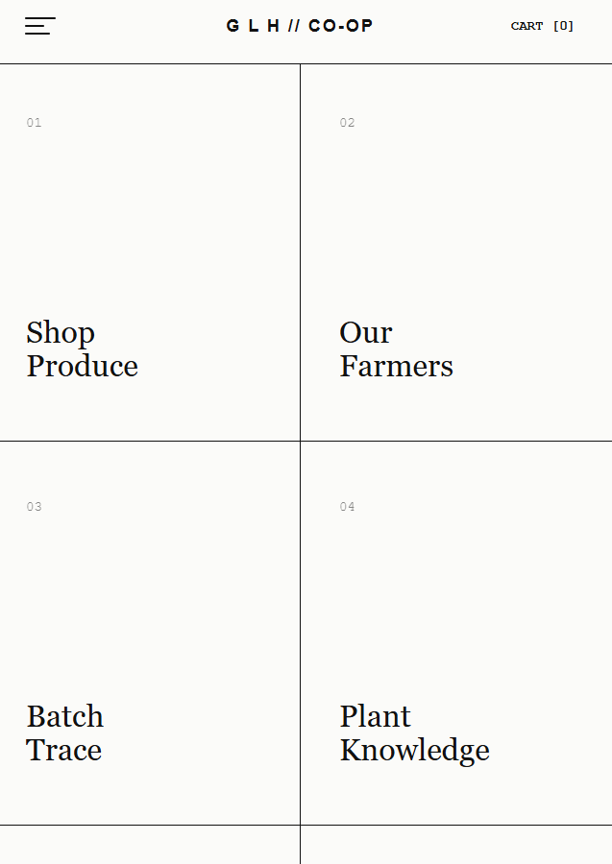 | The fix is successfully and the The left border has been added
Integration testing – Responsive scaling and border continuity at tablet width (1024px). | None | The grid should collapse into a balanced 2-column layout. A central vertical divider must separate the columns, and the bottom login boxes (07/08) should scale to 50% width each. | Desktop layout rules (span 3 and 3n) conflicted with the media query instructions. The grid failed to integrate the new 2-column logic, causing Box 03 to lose its border and Boxes 07/08 to overflow the container.  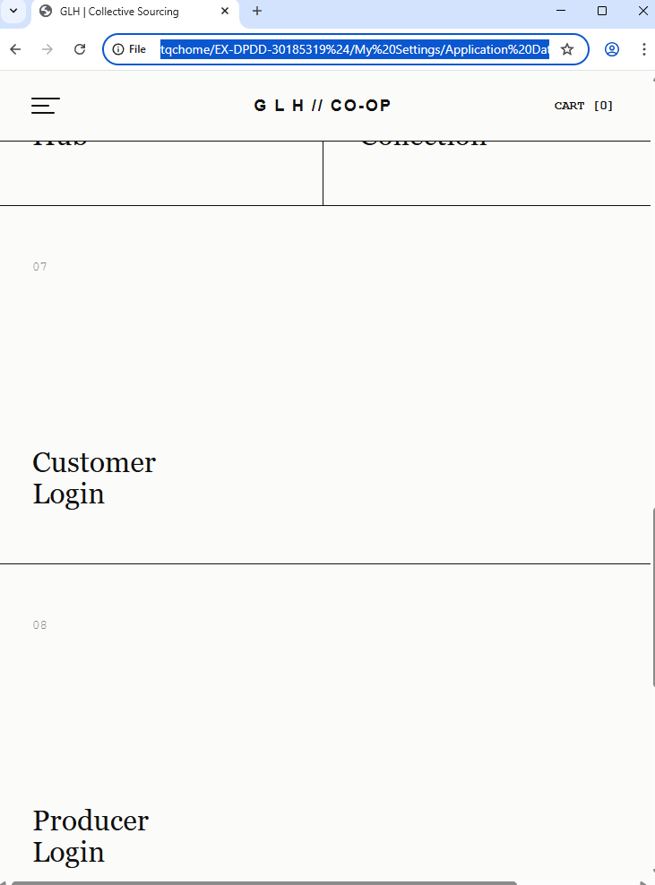 | I implemented !important flags to force the browser to prioritize the responsive media query over the high-specificity desktop math. This successfully integrated the 2-column compliance (span 1) and reset the vertical axis dividers.  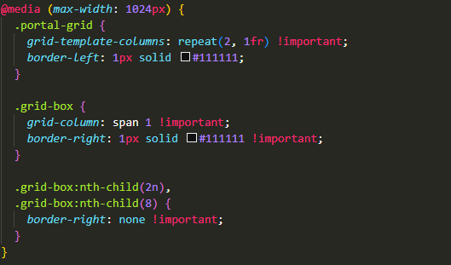
Regression testing – Desktop layout preservation. | None | Scaling the viewport back above 1024px must fully restore the 3-column top / 2-column bottom layout without any "bleeding" from tablet rules. | The desktop layout rendered with 100% accuracy; the !important responsive overrides remained correctly sandboxed within the media query.  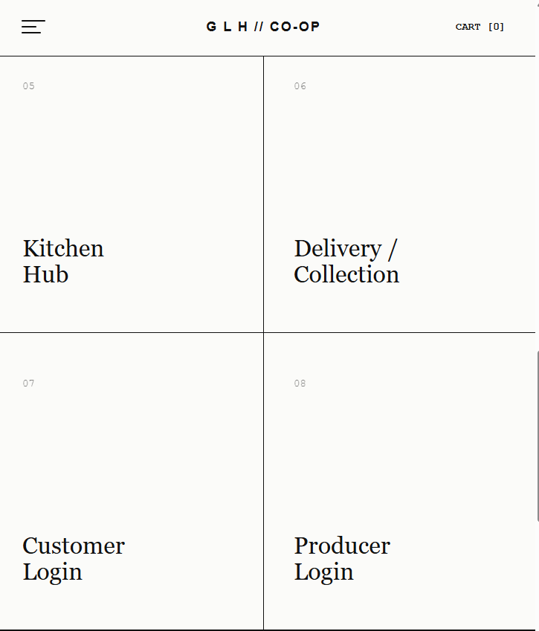 | The system successfully toggles between 6-unit and 2-unit column logic based on viewport width.
Black box testing – Mobile horizontal overflow and containment. | None | The mobile view should scroll only vertically, with all grid boxes fitting exactly within the screen width. | The mobile viewport suffered from horizontal overflow. The high specificity desktop aspect ratio: 9/4 and the 6 column grid geometry failed to collapse, exceeding the 100% viewport limit.  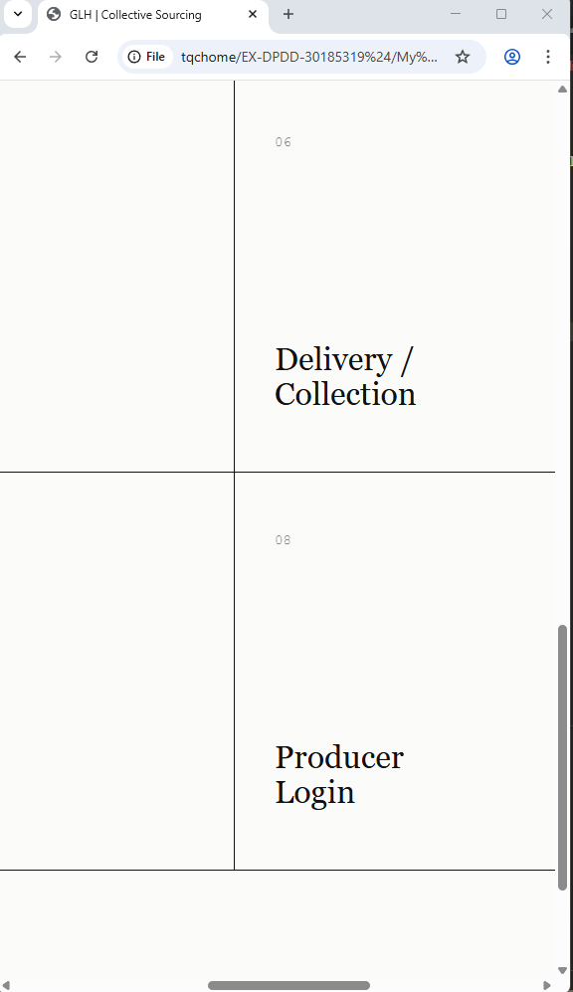 | I added border-bottom: 1px solid #111111 !important to the .grid-box class within the 600px media query. This ensures each item acts as a distinct, separated row.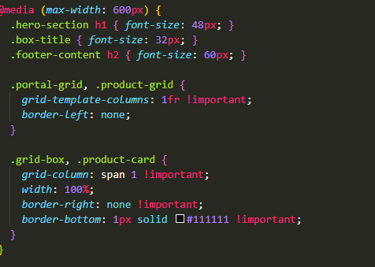
Regression testing – mobile overflow | None | Fluidly scaling from 320px to 1440px must trigger transitions without text overflow or retaining mobile only properties at larger sizes. | The page scaled dynamically without bleeding over the modular borders.  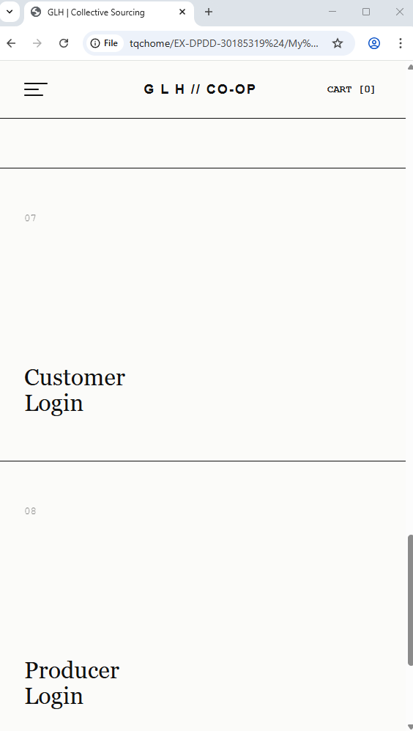 | The system successfully toggles between fluid vertical stacking for mobile and rigid geometric constraints for desktop.
Black box testing – Product image scaling and aspect ratio integrity. | None | Product asset images should scale to perfectly fill the .product-image-slot without distortion or excessive padding. | The product images inherited the .hero-image-container css properties resulting in the product image appearing incorrectly cropped  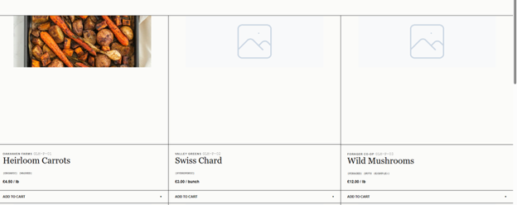 | I will add a new .product-image class to the html and css tags and deployed height: 100% with object-fit: cover to ensure container compliance.  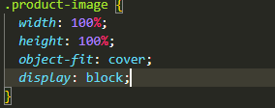
Regression testing – Product Image scalling | None | Creating the new .product-image class must not alter the layout of the page in any way and the image must cover 100% of the image card | The product image now fully fills the image container .  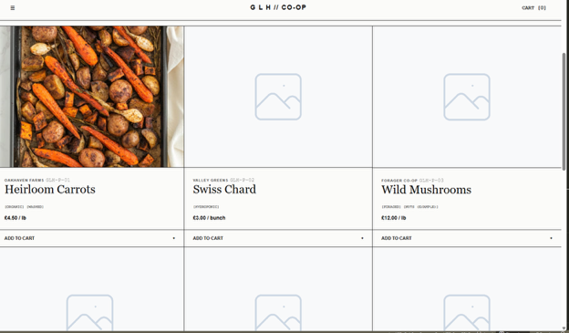 | The updated .product-image class worked as intended
White box testing – Checking the layout of the vendor name and product ID. | None | The vendor name and product ID should sit on the same line, pushed to opposite sides of the box. | The text stacked on top of each other and clumped together on the left side of the card.  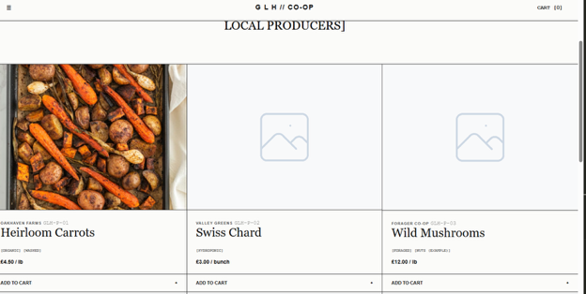 | I added display: flex and justify-content: space-between to the .product-header class to put the text on the same line and push it apart. I also added a bottom border for separation.  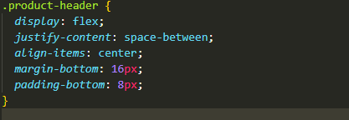
Regression testing – Checking text alignment on different screen sizes. | None | The vendor name and product ID should stay aligned on opposite sides and not overlap when the screen shrinks. | The text stayed perfectly aligned on all screen sizes with no overlapping or layout breaks.  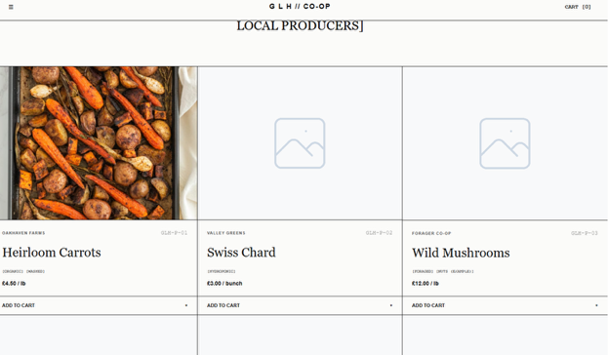 | Verified that the flexbox layout works correctly and does not break the rest of the grid layout.
Integration testing – Checking the product grid layout on tablet screens (1024px). | None | The product grid should change from 3 columns to 2 columns so the content does not get squeezed. | The product grid stayed locked at 3 columns on tablet screens, causing the cards to become too narrow, misaligned and the text to compress.  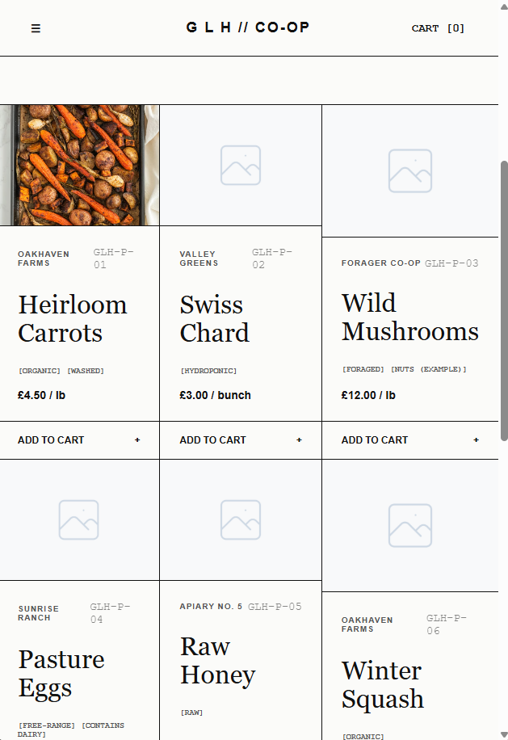 | I updated the 1024px media query to include the .product-grid and .product-card classes. This forces the layout to drop to 2 columns and fixes the missing border logic on mid-sized screens.  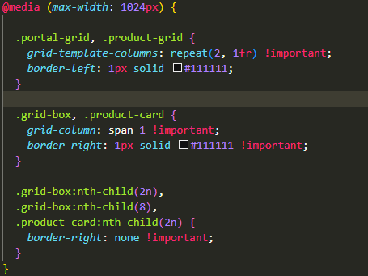
Regression testing – Checking the desktop layout after applying the tablet fix. |  | Expanding the screen back to desktop size should restore the 3-column product grid without any issues. | The desktop layout returned to exactly 2 columns with no visual errors when the window is shrunk and it also returns to the 3 grid orientation with no errors  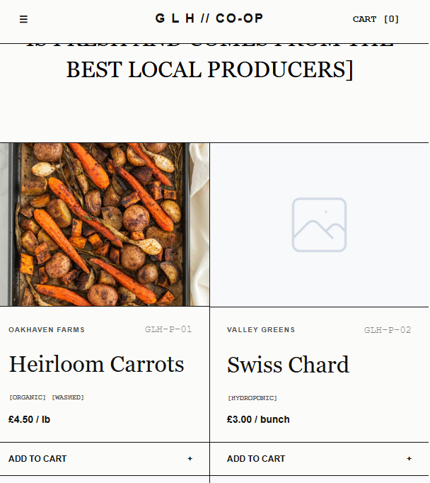 | Verified that adding the tablet rules did not break the main desktop design. The website successfully switches between 3 columns and 2 columns based on screen size.
Integration testing – Checking the alternating row alignment. | None | Every second row should automatically swap positions, placing the text on the left and the image on the right. | Standard HTML forced all rows to render the exact same layout (image left, text right) and vice versa for the next row  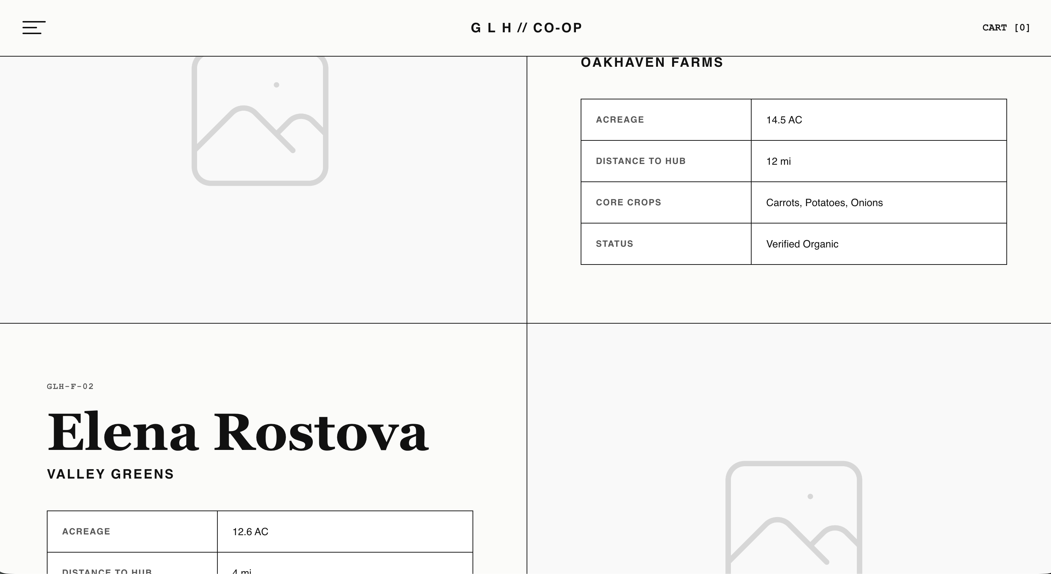
Black box testing – Checking the photographic asset dimensions. | None | The placeholder farmer photos must completely fill their half of the container, touching the borders seamlessly. | Images correctly filled their containers without stretching or leaving empty white gaps on the first load. | Worked perfectly because I included object-fit: cover in the base CSS, which automatically forces images to fill their grid space.
Black box testing – Checking the organization of the farmer statistics. | None | The specific farmer data (Acreage, Crops, etc.) should be organized in a bordered table. | The farmer data loaded perfectly as a structured, bordered table right from the start.  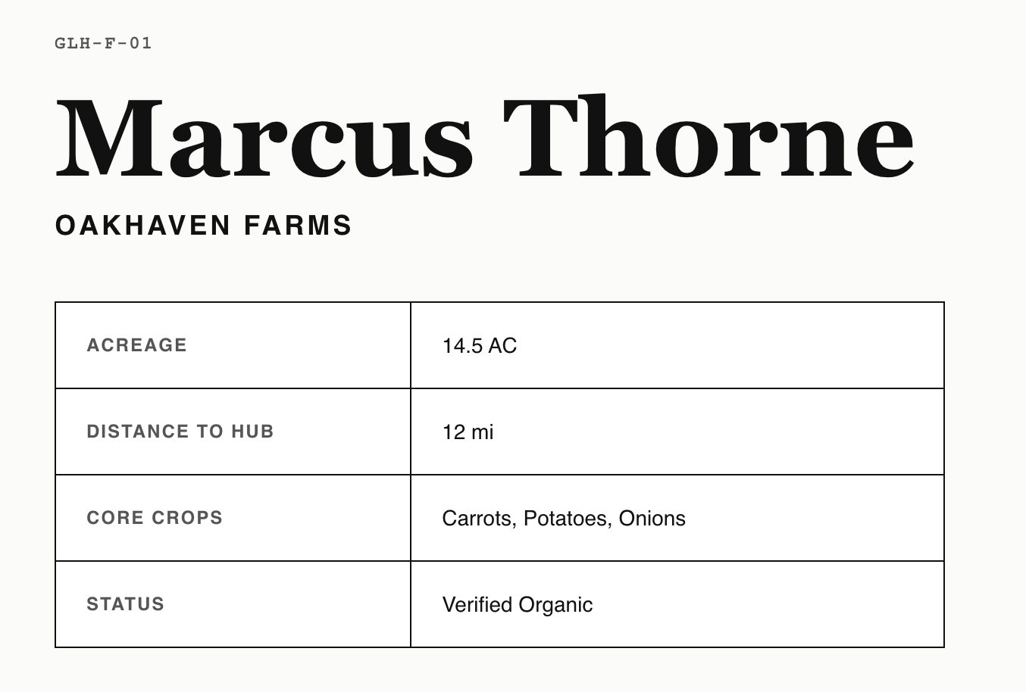 | Worked perfectly because we used standard HTML <table> tags and border-collapse: collapse. The browser naturally formats this correctly without needing extra CSS fi
Integration testing – Checking the layout on tablet and mobile screens (1024px). | None | The layout should change from a two-column split to a single vertical column, with the farmer's photo stacking above the text. | The design stayed split 50/50, causing the text to become unreadable. 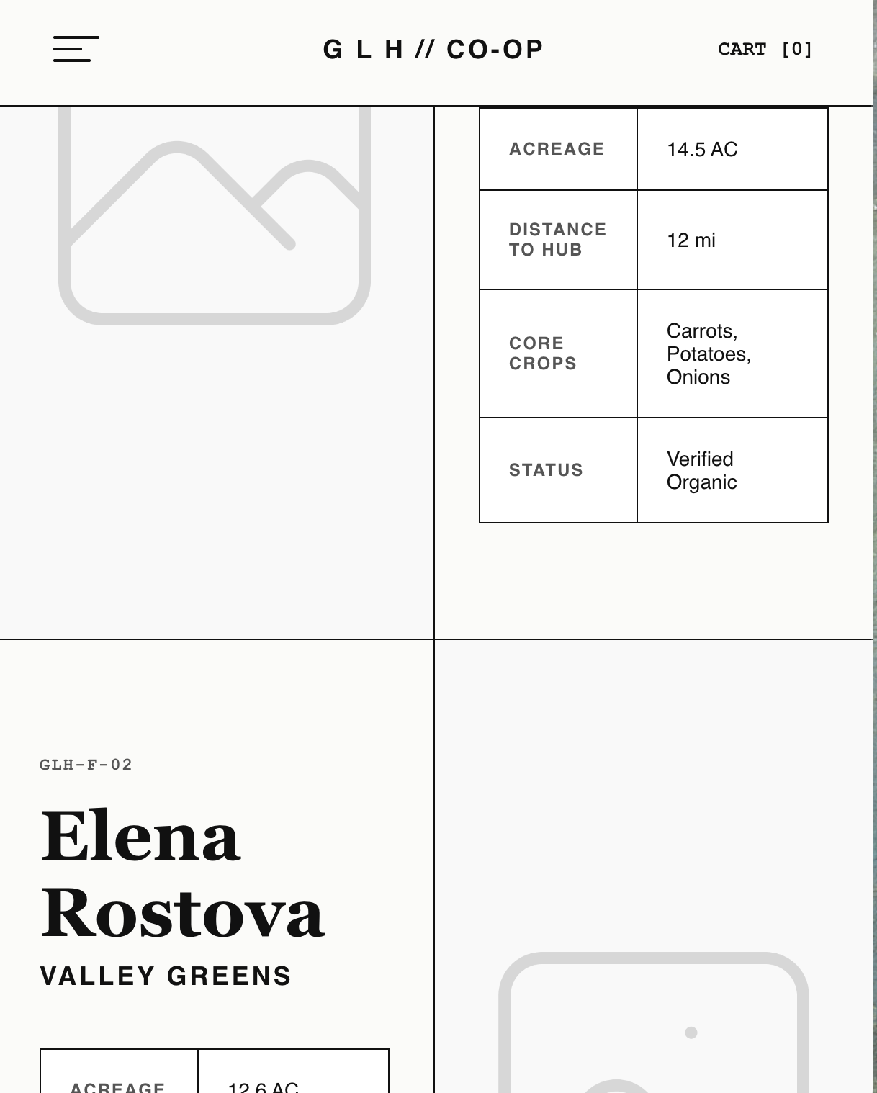 | I added a @media (max-width: 1024px) rule to force a 1-column grid. I used order: 1 !important on the images to guarantee they always stack on top, successfully overriding the desktop layout logic.
 |  | The layout should change from a two-column split to a single vertical column, with the farmer's photo stacking above the stext. | The desktop layout recovered instantly with no visual errors or stuck columns.  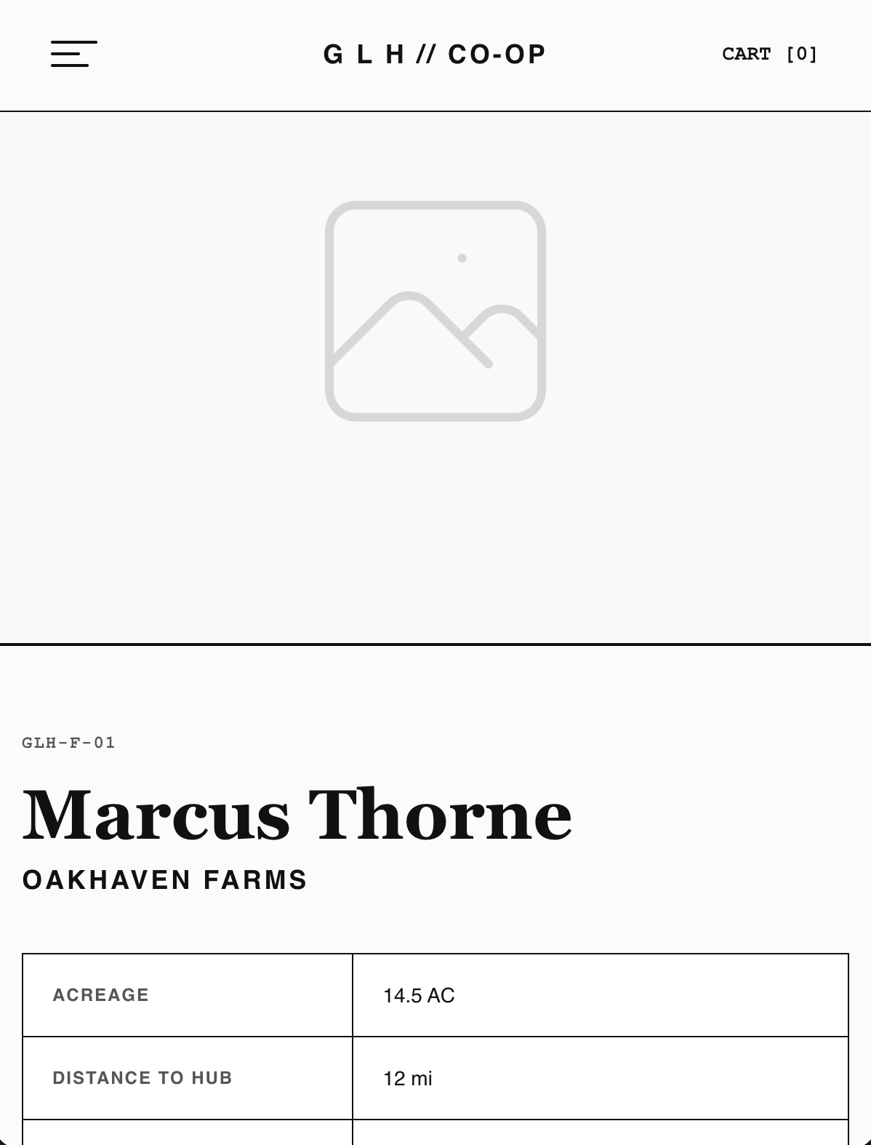 | Verified that the mobile !important flags work as expected and do not break the main desktop flexbox rules.
Black box testing – Checking form submission without back-end logic. | Null values (Empty form submission). | The system must block the form from submitting and visually alert the user that the identification and passkey fields are mandatory. | The browser successfully intercepted the submission, highlighting the empty fields with a native error prompt.  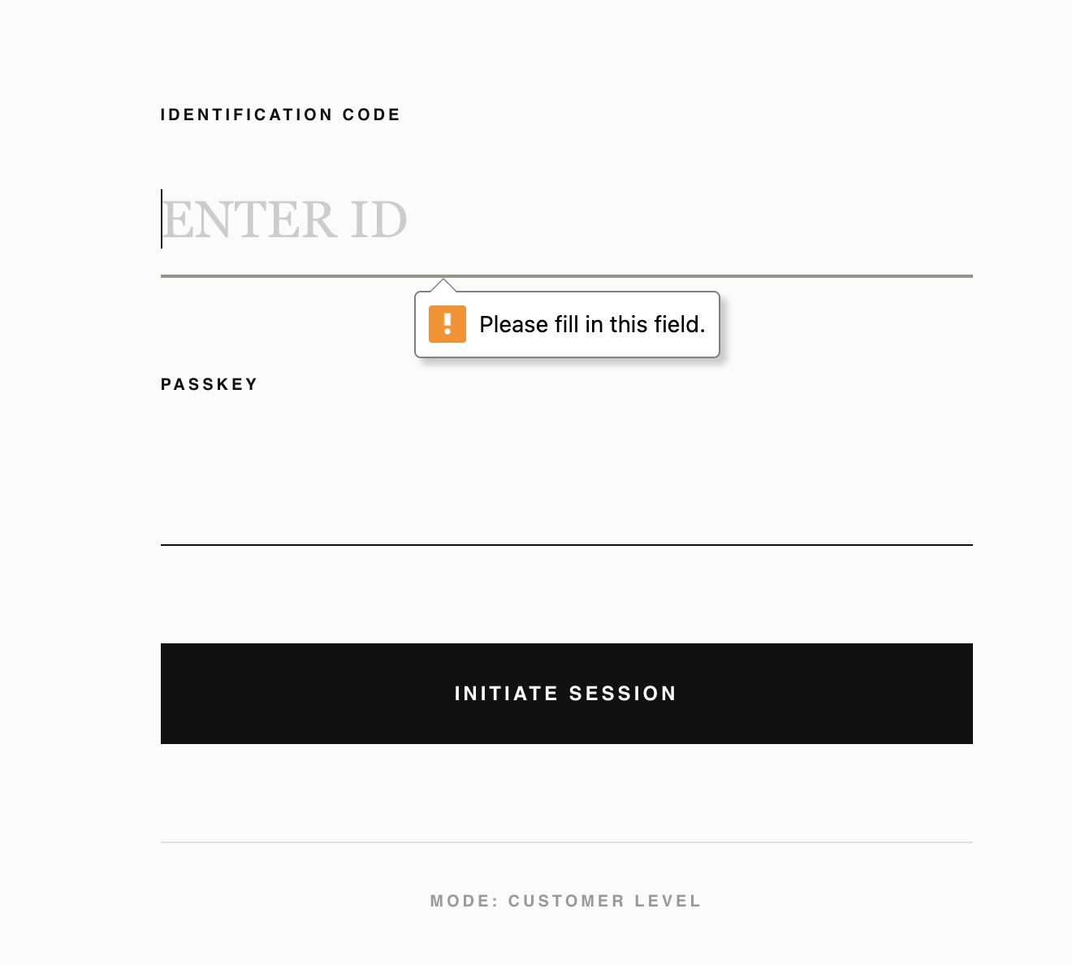 | This operates as intended based on the initial deployment. By applying the native HTML5 required attribute to both .auth-input fields, we enforce strict client-side validation without needing JavaScript or server-side error handling.
Integration testing – Checking the split-screen layout on tablet and mobile viewports (1024px). | None | The 50/50 vertical split must collapse into a single vertical column, with the "Context Panel" stacking directly above the "Form Panel". | The layout correctly snapped into a single column at the 1024px breakpoint, maintaining readability without horizontal scrolling.  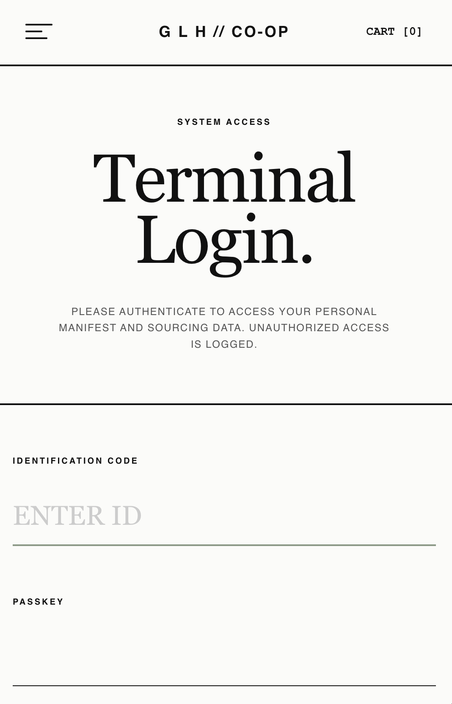 | This structural shift succeeded on the first pass because included .auth-terminal { grid-template-columns: 1fr !important; } within the mobile media query.
Black box testing – Checking UI consistency and usability of the password input field. | Null values (Empty form submission) | The password input field displays placeholder text to clearly guide the user on what to enter. | The placeholder text was missing, leaving the input field completely blank. | During a page inspection, I realised I had forgotten the placeholder text from the password fields.  I added the placeholder attribute to the HTML <input> tags to improve user experience and ensure the form matches my original wireframe designs.
Black box testing – Checking UI consistency | None | The massive "TRACEABLE. LOCAL. VERIFIED." text should scale fluidly and fit perfectly within the viewport boundaries without any letters getting cut off or causing a horizontal scrollbar. | The text scaling was slightly too large for the container, causing the 'E' at the edge of the footer to overflow the screen and become partially cut off on all pages. | During UI testing, I noticed the massive typography was exceeding the 100% viewport width limit.  I adjusted the CSS for the footer typography (using a clamp() function or reducing the font-size and letter-spacing) to ensure the text scales dynamically and remains fully contained within the screen bounds on all devices.
Regression testing – Verifying the footer typography scaling fix. | None | The massive "TRACEABLE. LOCAL. VERIFIED." text should now be fully visible on the screen without any letters being cut off or causing horizontal scrolling. | The footer text now scales fluidly, and the 'E' is perfectly visible and contained within the screen boundaries across all pages and different widths   | The CSS typography fix worked as expected. The visual impact of the massive footer is maintained without breaking the layout or causing horizontal overflow.  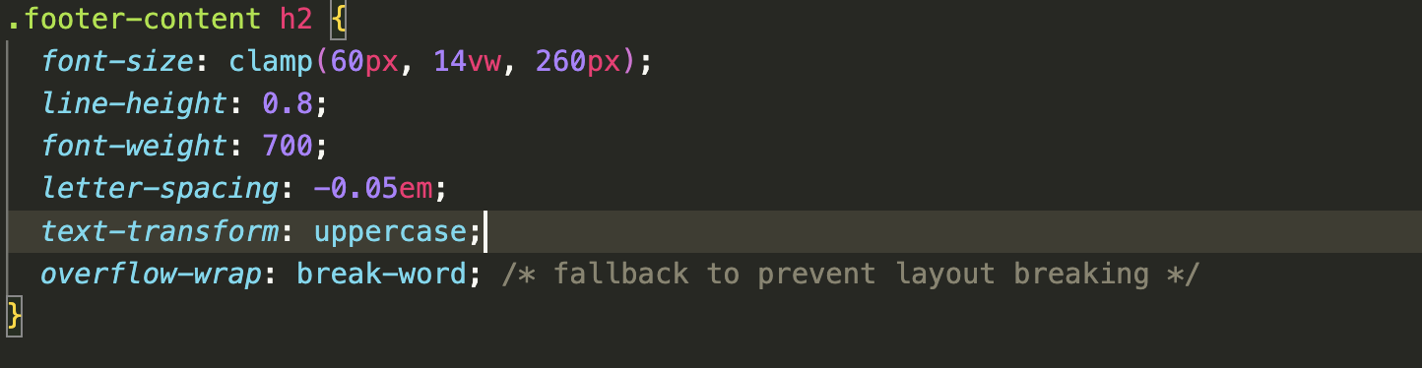
Black box testing / Functional testing – Checking the text rendering of the duplicated Producer form. | None | The interface should maintain the exact same structural CSS as the Customer login, but specifically display "LOGIN: PRODUCER" and "MODE: PRODUCER LEVEL" to clearly separate the B2B portal from the consumer portal. | The headings and mode identifiers successfully rendered the correct producer specific text while inheriting the global CSS layout.  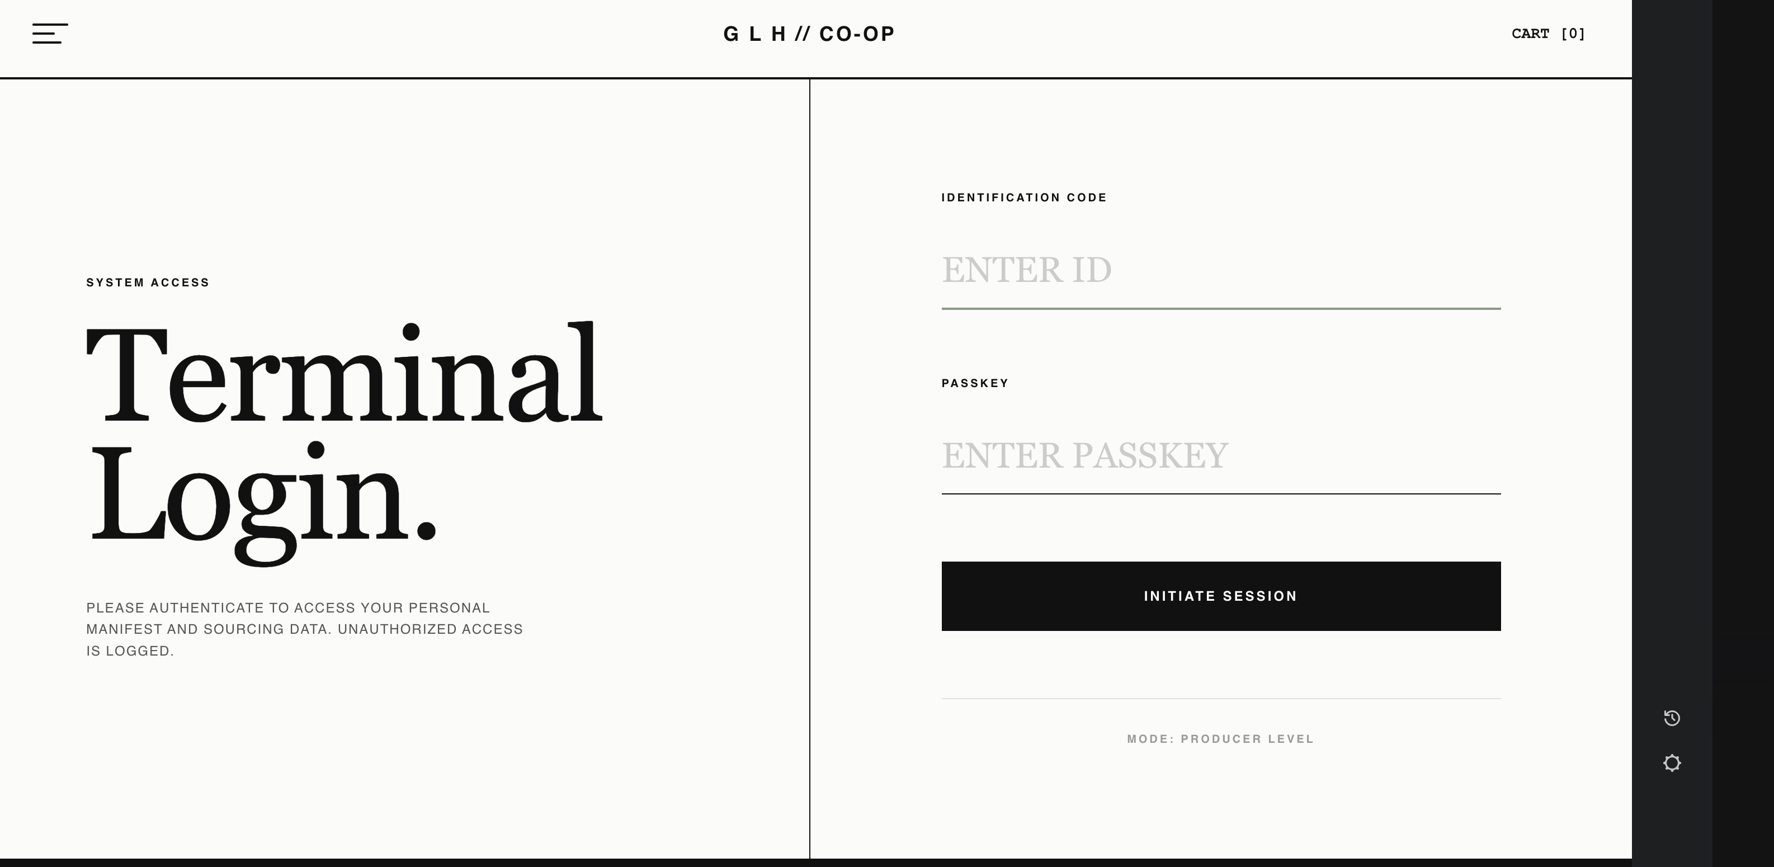 | Duplicating the core structure while changing the identifiers worked perfectly, ensuring a highly consistent UI across different user roles.
Black box testing - Integration testing,Checking the navigation to the Producer Terminal. | None | Clicking the "Producer Login" link on the portal grid should successfully route the user to the producer login page without any 404 errors. | The navigation link behaved as expected and successfully loaded the Producer Terminal interface. | The page is fully integrated into the site's navigation map.
Integration testing – Checking structural rendering against the approved wireframe schematic. | None | The page must render a strict two-column asymmetrical grid (2fr 1fr), placing the active cart items on the left and the order summary pinned to the right. | The elements rendered as standard full-width HTML blocks, stacking vertically and completely failing to match the wireframe's side by side split design.  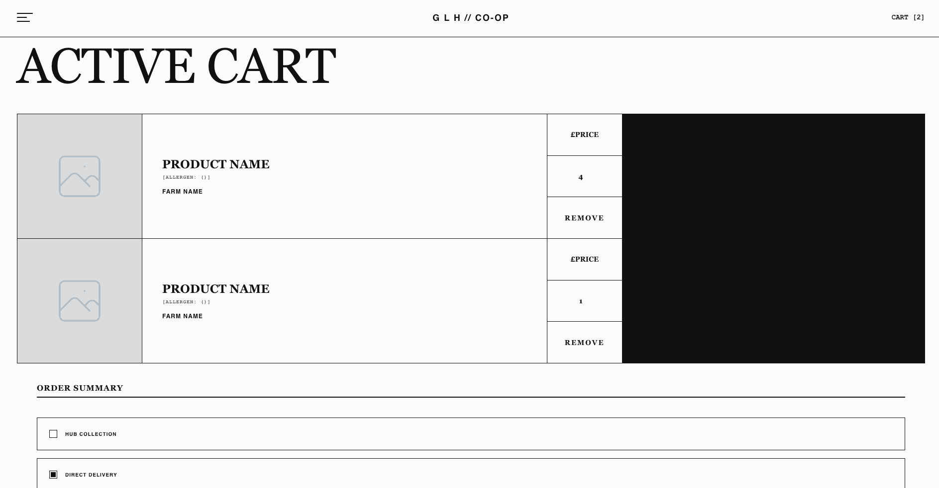 | During UI testing, I noticed the layout was acting like a standard webpage instead of a structured grid.  I updated the CSS to use a grid layout (2fr 1fr) and added a 1px gap technique to instantly generate the rigid internal borders required by the design.
Regression testing – Checking the layout and grid borders after applying the two-column fix. | None | The page must maintain the two-column split layout (cart items on the left, order summary on the right), and the 1px borders between the sections should remain crisp without images overlapping the lines when the window is resized. | The grid lines rendered perfectly across all screen sizes with no bleeding, overlapping, or visual errors.  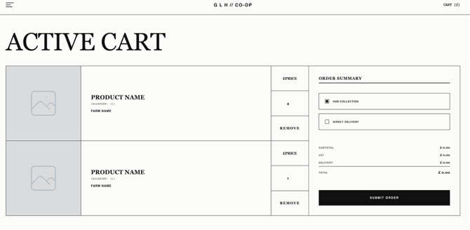 | The grid maintains the split-screen design and handles complex resizing smoothly without breaking the structural borders
Integration testing – Checking how the cart layout responds on tablet screens (1024px). | None | The side-by-side layout should collapse into a single vertical column so the content stays readable and doesn't get squished. | The grid stayed stuck in the desktop layout, forcing the content off the edge of the screen and causing a horizontal scrollbar.  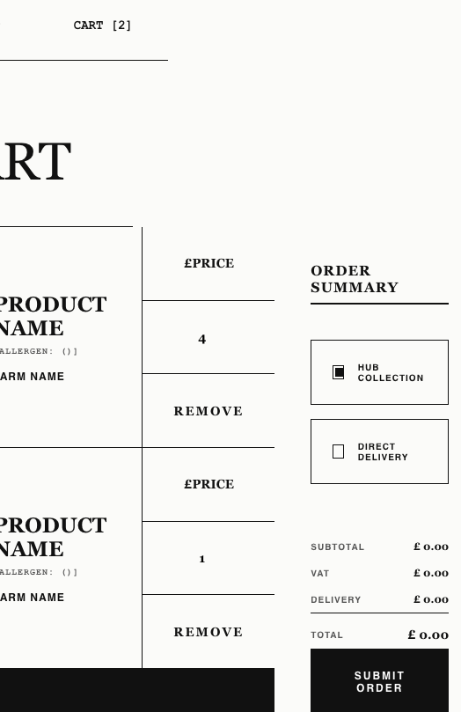 | I moved the cart routing logic inside the correct @media (max-width: 1024px) block so the layout properly drops to one column on smaller screens.  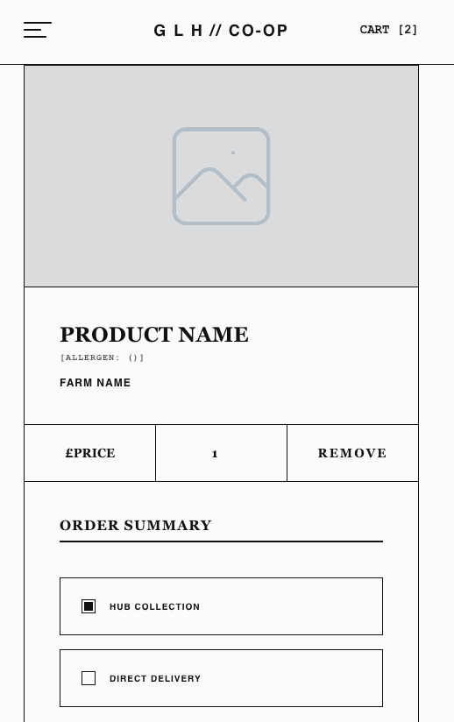
Black box testing – Checking the hover animation on the REMOVE button. | None | Hovering over the button should change its color to clearly warn the user they are about to delete an item. | The button successfully changed to a high-visibility red with white text when hovered over, animating smoothly.  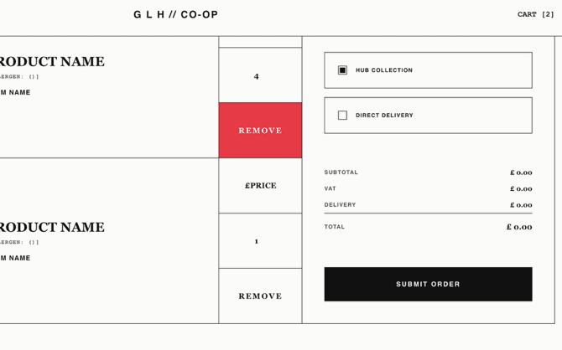 | Operating as intended. I added a :hover state to the button in the CSS to provide clear, immediate visual feedback without breaking the design.
Black box testing – Checking the responsive grid reflow for the batch trace module on mobile viewports (< 1024px). | None | The .batch-grid component should collapse from a 3 column layout to a 1column layout (grid-template-columns: 1fr). | The grid maintained a forced 3column layout (repeat(3, 1fr)) causing horizontal compression and unreadable data fields.  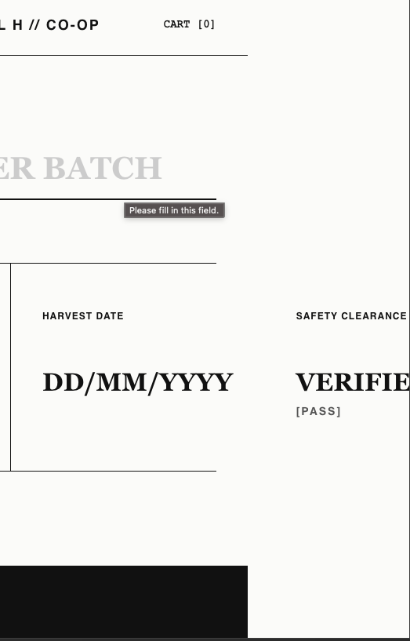 | I integrated .batch-grid and .batch-cell directives into the @media (max-width: 1024px) block, forcing a 1fr column template. The module now stacks vertically at 100% width.  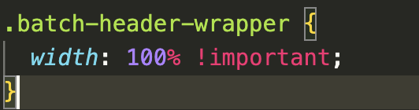
 | None | The .batch-grid component should collapse from a 3 column layout to a 1column layout (grid-template-columns: 1fr). | The grid successfully switched between the 3 column layout and 1 row layout in mobile.  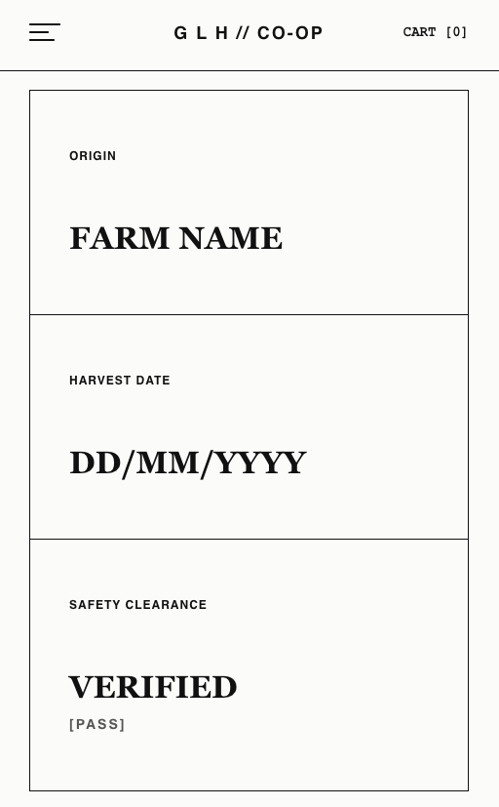 | The newly introduced mobile breakpoint logic successfully allows the page to switch between the two layouts when required and now matches the wireframes.  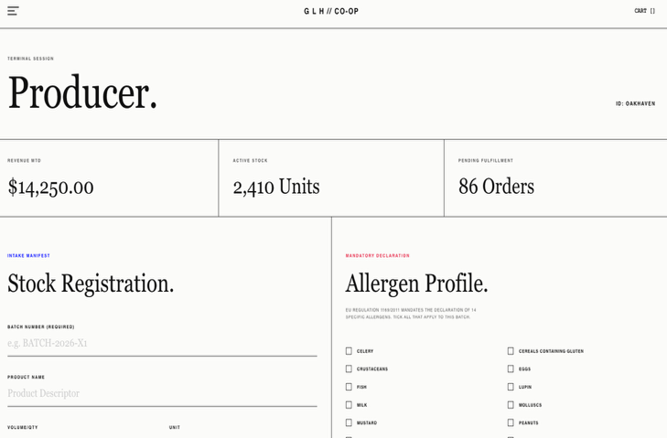
Black box testing/Integration testing – Checking the desktop layout of the metrics grid on viewports larger than 1024px. | width set to 1440px. | The metrics grid should render the three boxes side by side in a structured 3 column layout to utilize the wider screen space and match the layout of all the previous pages. | The grid stacked the metric boxes in a single vertical column, completely bypassing the intended desktop layout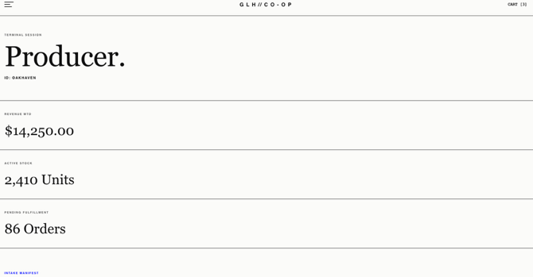 | I updated the CSS to deploy a 3 column grid matrix on the parent container, ensuring the layout correctly targets standard desktop viewports.
Regression testing – Checking the mobile responsive layout after applying the desktop structural fix. | Viewport width set to 800px. | Shrinking the screen down to mobile sizes should cause the grid to collapse back into a single vertical column to maintain readability | The grid correctly maintained its single-column vertical stack without any layout breaks or horizontal overflow.  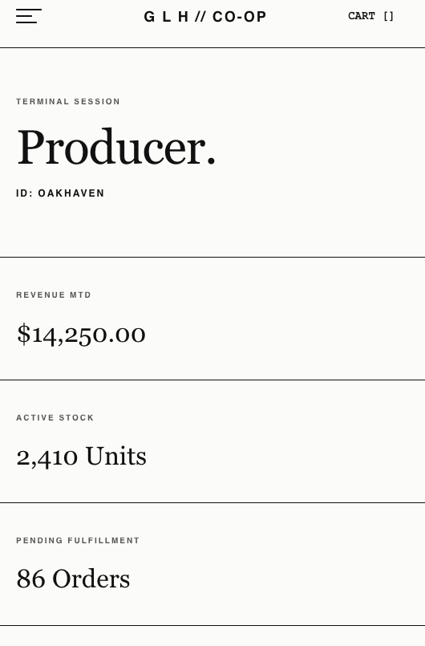 | Verified that the newly applied desktop structural fix was successfully isolated via media queries. It worked exactly as intended and did not disrupt the required mobile reflow logic.
Logic Review & UI testing – Reviewing the HTML allergen form against the planned backend validation for products with zero allergens (e.g., fresh carrots). | None | The HTML form should provide a way for farmers to accurately declare that a product is completely allergen-free before the backend validation processes it. | During UI development, I realised the wireframe and HTML only included the 14 mandatory allergens  . Because my planned Algorithm 3 is designed to block submissions if no boxes are ticked  , farmers selling raw vegetables would be completely blocked by the system or forced to submit false data.  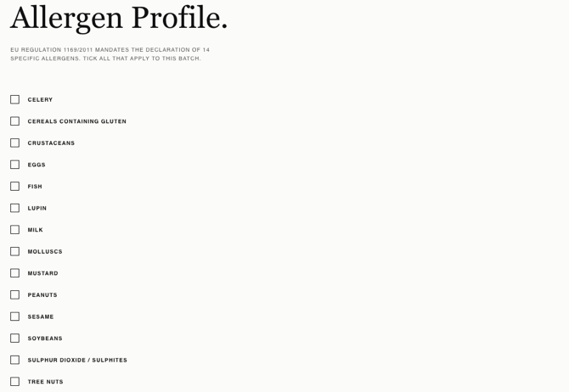 | Catching this logical flaw before coding the PHP backend saves significant development time. I improved the UI by adding a "No Allergens Present" checkbox to the HTML form. This directly improves usability and ensures that when the backend is built, farmers can legally verify their produce is safe without triggering false errors.  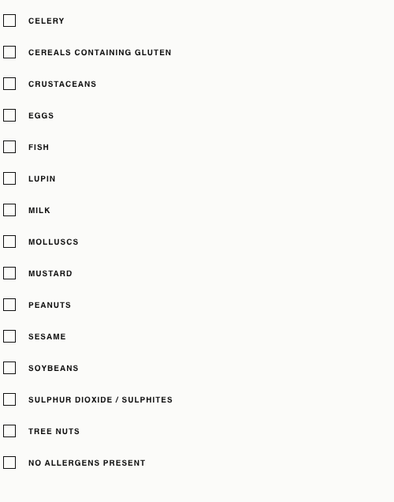
Black box testing – Checking the responsive reflow of the 'Order History' on the customer portal data table on mobile viewports | Viewport width scaled down to 400px. | The 5-column order history table should adapt to smaller screens without breaking the global layout or forcing the entire webpage to scroll horizontally. | During UI testing, the strict width of the 5-column table forced the content to overflow the screen boundaries, causing a broken mobile layout and horizontal scrolling on the entire page.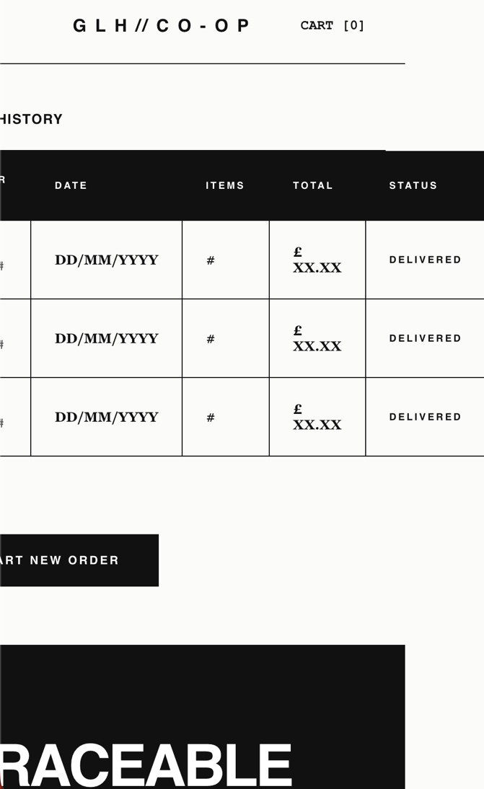 | To fix this, I wrapped the HTML <table> inside a new container <div> and applied the CSS rule overflow-x: auto;. This isolates the scrolling strictly to the table itself, allowing mobile users to swipe through their order history horizontally while keeping the rest of the dashboard layout perfectly locked in place. Regression test confirmed the fix worked.  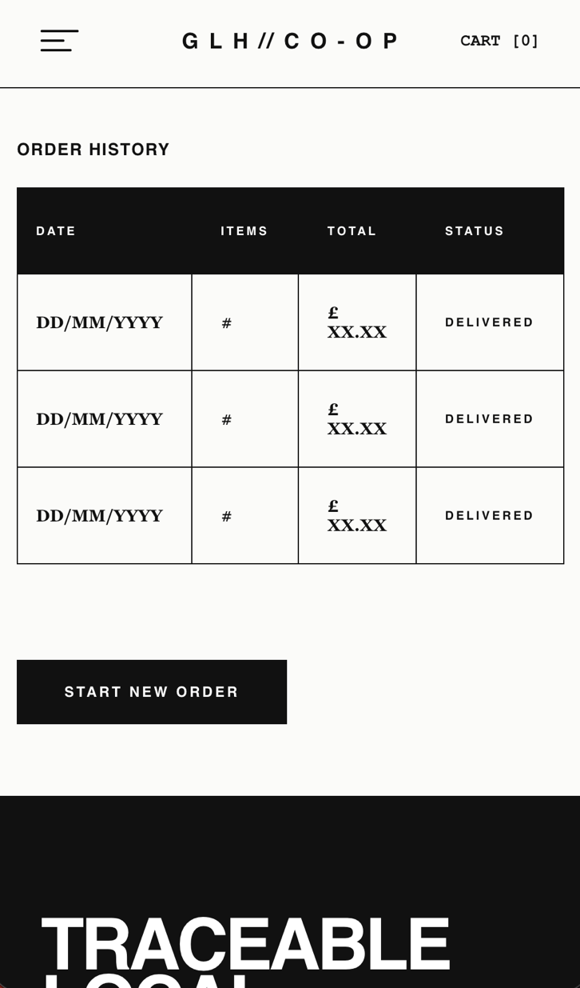
Black box testing -Checking the placeholder links and hover states for the 'Manage Account' and 'Start New Order' buttons | None | Hovering over the buttons should trigger a smooth CSS visual change. Clicking the buttons should keep the user on the current dashboard without throwing a 404 error. | The CSS hover transitions worked perfectly. Clicking the links behaved exactly as expected, keeping the user on the page without routing errors. | Operating as intended. The # placeholders allow for safe front-end UI testing  . These will be updated with the actual PHP routing links once the backend account management system and active cart are connected.
Black box testing -Checking form submission without back-end logic (Empty form submission) | Null values | The system must block the form from submitting and visually alert the user that the fields are mandatory | The browser successfully intercepted the submission, highlighting the empty fields with a native "Please fill in this field" error prompt.  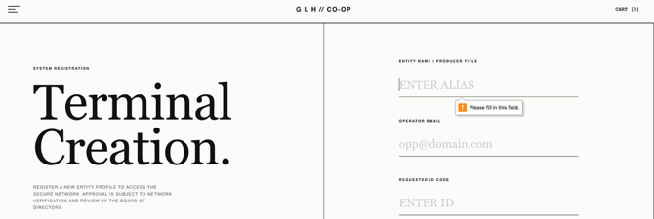 | Operating exactly as intended. By applying the native HTML5 required attribute to the input fields, I am enforcing strict client-side validation before I begin coding the backend
Black box testing -Checking email input format requirements. | Invalid email string without an '@' symbol | The system should recognize this is an email field and block the submission until a valid email format is used. | The browser intercepted the submission, displaying a prompt stating "Please include an '@' in the email address".  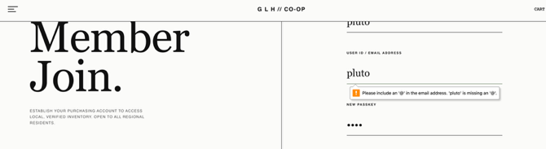 | Operating perfectly. Using the HTML type="email" attribute adds an immediate, reliable layer of front-end validation, preventing users from submitting badly formatted data
Black box/Integration testing - Checking the routing link to the Customer Login terminal. | None | Clicking the 'Login here' link at the bottom of the form should route the user directly to the Customer Login interface. | The link functioned perfectly, seamlessly routing the user back to the login terminal without any 404 errors. | The registration page is successfully integrated into the site's navigation loop, ensuring a smooth user experience
Black box/Integration testing – Checking the fully functional global navigation bar links | None | I will go through the navbar and test if all the correct pages are loaded. Clicking each link (like the Cart or the hamburger menu options) should load the corresponding page without throwing any 404 errors | The navigation bar is fully operational. Clicking the links successfully routes the user to the exact pages they describe | The Navbar works exactly as expected. The temporary # placeholders have been successfully replaced with functional relative paths, seamlessly connecting the entire front end.
Black box testing – Checking the responsive reflow of the menu bar | Viewport width scaled down to 400px. | The navigation bar should scale down proportionally with the page while maintaining appropriate horizontal padding on the right | When scaled down, the menu bar expanded to take up 100% of the viewport width, completely stripping away the intended side margins. This caused the menu to spread against the edges of the screen, creating a cramped and layout.  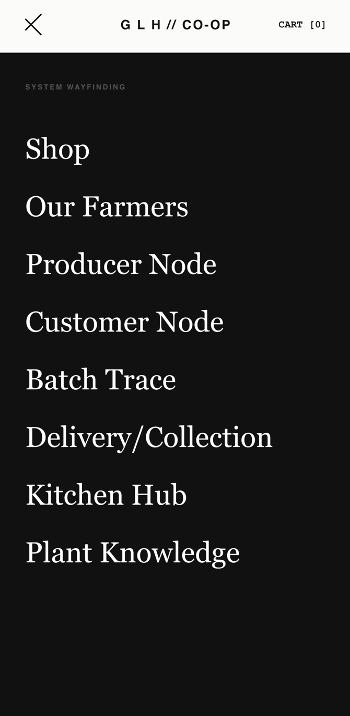 | By using width: calc(100% - 60px);, the drawer will now dynamically scale to the size of any mobile device while strictly reserving a 60-pixel vertical column of the .menu-shield on the right side.  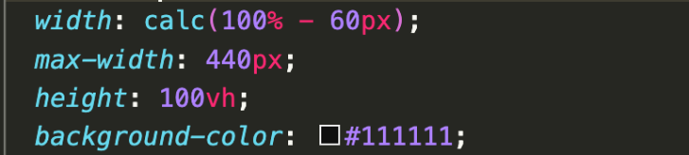
Regression testing – Verifying the menu bar reflow after applying the mobile width fix. | Viewport width scaled down to 400px. | The menu bar should now scale down smoothly while correctly leaving some of the current page visible to the right | The navigation bar scaled successfully retained its side padding, without bleeding into the edges of the screen.  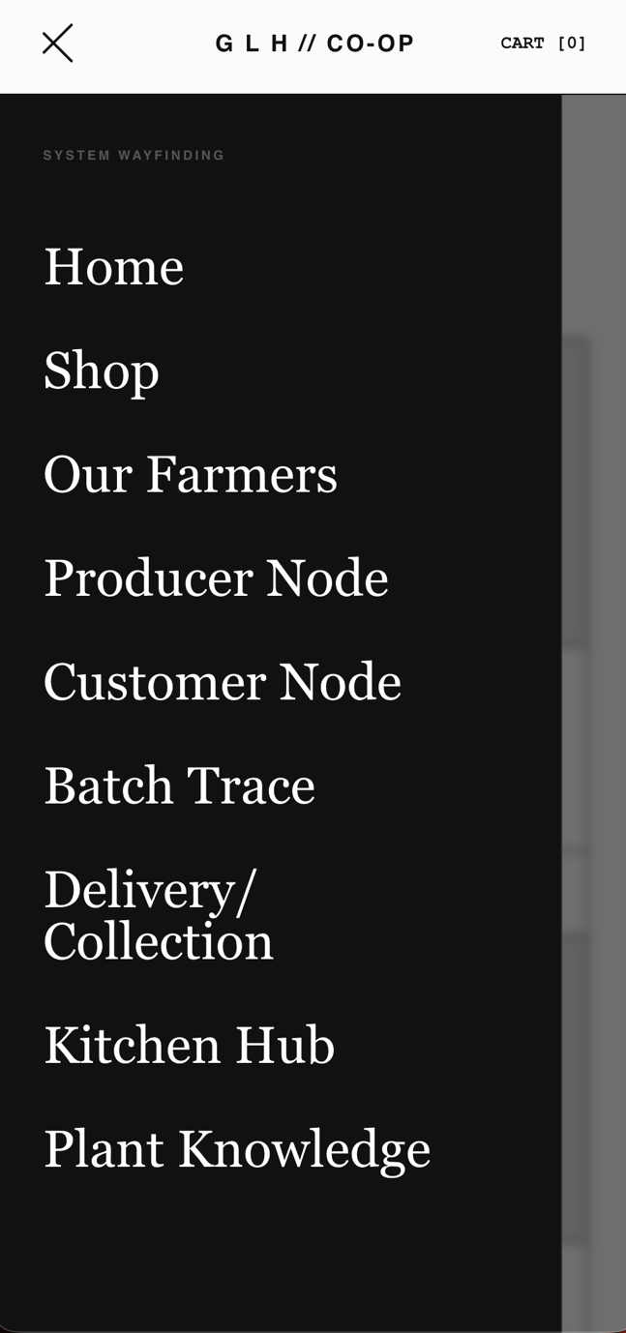 | Verified that the CSS width fix worked exactly as intended. The global menu is now fully mobile-responsive and maintains a useable layout across all device sizes.
Black box testing - Checking the default state of the consent checkboxes. | None(First time page load) | Under strict GDPR guidelines, consent must involve a "clear affirmative action". Therefore, the checkboxes for Analytics and Marketing must load entirely blank (not pre-ticked). | Operating perfectly. The form loaded with all optional tracking checkboxes unticked, allowing the the user to willingly opt-in or not.   | Successfully meets strict ePrivacy and GDPR regulations for positive opt-in and granular consent
Black box testing -Checking the responsive layout and CSS scaling of the cookie form across desktop and mobile viewports. | Viewport width scaled from desktop down to mobile resolution (< 600px). | The page should smoothly adapt the layout from a multi-column desktop view to a single-column mobile stack. Containers must resize proportionally without any horizontal overflow or clipping | The responsive flow operated perfetly on the first attempt. The grid collapsed into a clean vertical stack on mobile viewports exactly as intended, maintaining 100% structural integrity. | No CSS fixes required, the code worked as intended
Black box testing -> UI testing – Checking the structural and data consistency of the 'Our Farmers' HTML tables across multiple profiles. | Visual comparison of the left-aligned text cards (e.g., Elena Rostova) versus the right-aligned text cards (e.g., Oakhaven Farms | Regardless of whether the text block is positioned on the left or the right side of the alternating layout, all farm profile tables must contain the exact same row headers (Acreage, Distance to Hub, Core Crops, Hygiene Rating) to ensure UI consistency and accurately reflect the planned FARMS SQL database scheme | During a visual audit, I discovered a structural inconsistency tied to the alternating layout. The cards with text on the left successfully displayed the correct "Hygiene Rating" row, but the cards with text on the right replaced it with a "Status" row. This breaks global UI consistency and fails to map to the planned hygiene rating database column.  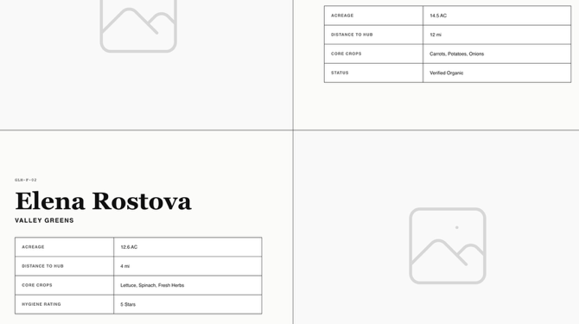 | I updated the HTML to standardise the data tables across both the left-aligned and right-aligned blocks. I replaced "Status" with the mandatory "Hygiene Rating" row on the right-side cards and moved the "Verified Organic" text to the Core Crops row. The frontend tables are now 100% consistent across the entire alternating layout and perfectly mirror the backend database design.  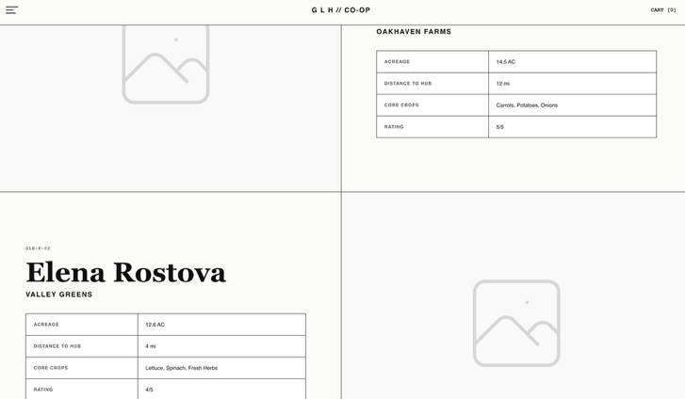
Black box testing Checking the layout and rendering of the new Product Availability labels on the 'Shop Produce' page, and verifying CSS class inheritance from the Producer Terminal. | Visually comparing the new labels on the 'Shop Produce' cards against the 'Current Ledger' table in the Producer Termina | The new availability tags (e.g., "IN STOCK", "LOW STOCK") should render cleanly within the product cards. By inheriting the CSS classes already built for the Producer Terminal's status column, they must perfectly match the established colour-coding (such as the high-visibility red for low stock) without breaking the card's grid layout or requiring new CSS rules. | The labels rendered flawlessly on the first attempt. The HTML spans successfully inherited the Producer Terminal's CSS styling, applying the correct visual hierarchy (e.g., the red "LOW STOCK" alert on the Swiss Chard and Winter Squash cards, and the black "IN STOCK" on the Heirloom Carrots). The tags fit perfectly in the top right corners, maintaining the structural whitespace of the product cards.  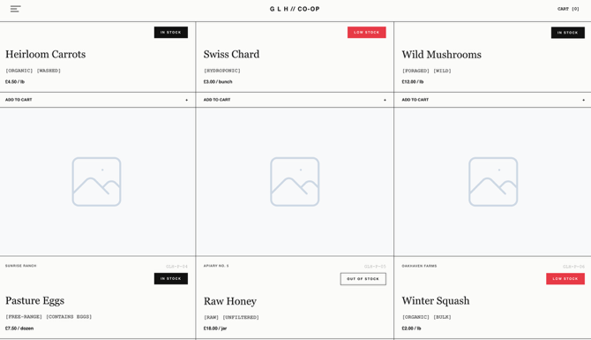 | Successfully meets the client brief's mandatory requirement to view products with "transparent availability"
Black box testing -Checking the rendering and usability of the new "Other Allergens / May Contain" text input field on the Producer stock upload form. | None | The new 16th input field should correctly inherit the global .auth-input CSS classes. | The input field rendered flawlessly, perfectly matching the styling of the other form elements. | This perfectly satisfies the latest food allergy research requirements. The front-end form is now fully prepared to pass this custom string data to the PHP backend, protecting both the cooperative and the consumer.
Black box testing-Verifying the layout and visual feedback of the new "[ Remove ]" action button within the Producer Terminal's Active Stock HTML table. | None | The new action button should fit cleanly inside the table cell. To prevent accidental deletions, it should utilise a CSS :hover state (e.g., turning high-visibility red) to warn the user. On mobile devices, it must not stretch the table beyond the viewport width, relying on the overflow-x: auto; table wrapper to maintain responsiveness. | The button rendered perfectly within the table structure. The CSS :hover state successfully worked and the table maintained its horizontal scroll capability on smaller screens  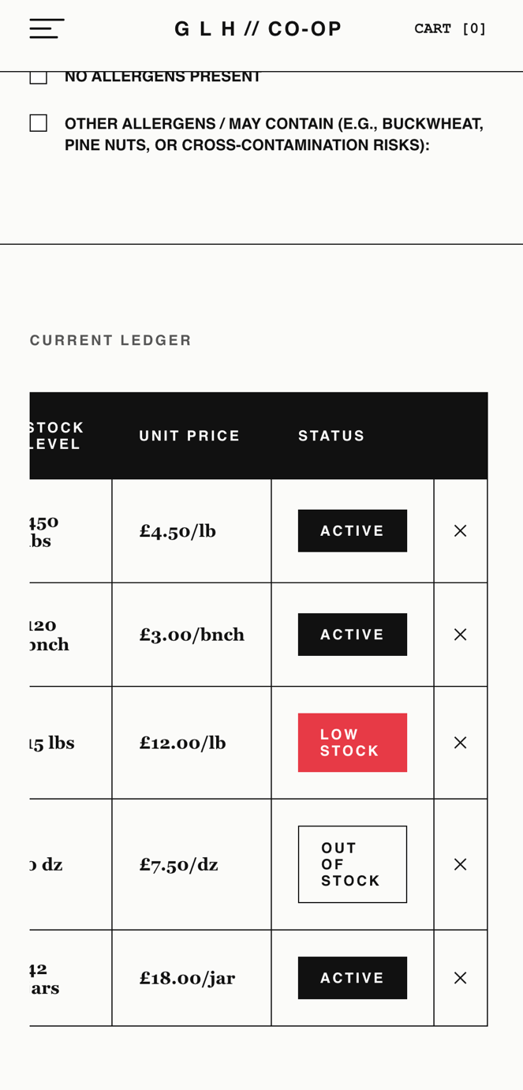 | The UI now directly satisfies the mandatory brief requirement allowing producers to "manage stock levels" by giving them full control to delete inventory.
Black box testing - Checking the form submission and UI rendering of the Producer Intake form before adding JavaScript validation and cache-busting | Batch Number: "90210"  Product Name: "TEST1"  Volume: 15  Price: 10  Unit: lbs  Allergens: None selected. | The system should enforce EU allergen compliance and prevent submission if no allergens are selected. If successful, the Active Ledger table should update immediately without a hard page reload. | The form successfully submitted without any allergen data, which violates compliance rules. Additionally, the Active Ledger table did not update to show the new stock because the browser cached the previous state.  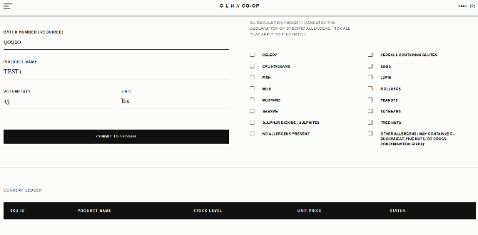 | This fails to satisfy EU Regulation requirements. I will add strict javascript validation to require allergen selection and a cache-busting parameter to ensure the UI updates correctly.
Black box testing - Verifying the updated Producer Intake form validation and performing regression testing on the Shop Produce page after applying the new JavaScript. | Batch Number: "90210"  Product Name: "TEST1"  Volume: 15  Price: 10  Unit: lbs  Allergens: None selected. | The form should block submission if allergens are empty and trigger an alert. With valid data it should submit, update the ledger table immediately, and the global shop produce page should still display all products correctly without errors. | The form did block the submission when there was missing allergern info, however with valid data the ledger did not update still.  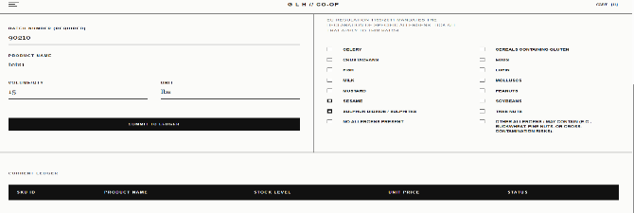  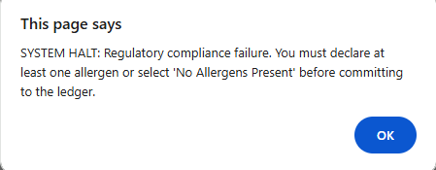 | This perfectly satisfies the EU regulatory requirements. My next action is to fix the ledger not updating.  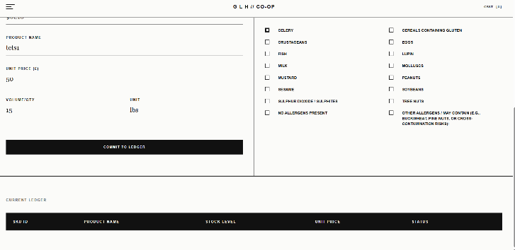  The ledger was not working due to incorrect database table logic and incorrect APIindentation
Integration testing – Checking full-stack data transmission from the Producer Intake Manifest to the database ledger. | Batch Number: "90210"  Product Name: "TEST1"  Volume: 15  Price: 10  Unit: lbs  Allergens: Celery . | The system should successfully process a POST request. The database must update the product_id, and the UI should instantly perform a GET request to refresh the ledger state | The product was successfully committed to the database. The UI instantly rendered the ledger table to display the new entry.  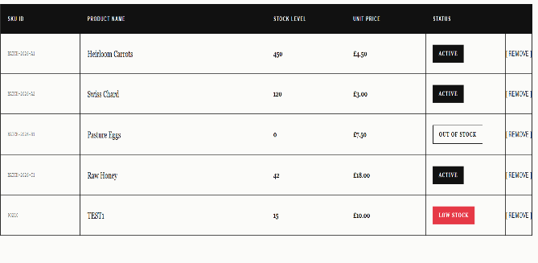 | Operating exactly as intended. Naming conventions (such as product_id) are now perfectly aligned across the backend API and the JavaScript bridge, ensuring full relational synchronization
Black box testing / Integration testing – Checking the backend deletion logic of the "[ Remove ]" action button. | Target: ("Pasture Eggs") | Clicking the "[ Remove ]" button should trigger a confirmation prompt, followed by a DELETE request to the API, safely removing the record from the active stock grid. | The UI remained completely static. no DELETE traffic was detected in the backend system logs. | I identified a logical flaw where the JavaScript function was improperly nested. Furthermore, the backend server lacked a dedicated DELETE handler and CORS pre-flight authorization. I will correct the JavaScript scoping and update the backend to authorise DELETE methods.
Regression testing – Verifying the corrected record deletion routing for the "[ Remove ]" button. | Target: ("Pasture Eggs") | The system should initiate a confirmation alert. Once authorised, the server must process a delete request at the specific endpoint and trigger an immediate state refresh on the UI. | The confirmation alert triggered as expected. The backend logs confirmed the deletion, and the row was immediately removed from the HTML.  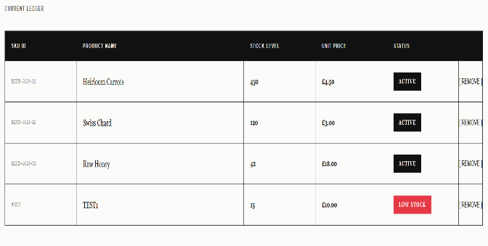 | The fix worked perfectly. CORS is now correctly configured to allow DELETE methods. The inventory system is now robust and fully functional
Integration testing – Verifying static HTML asset delivery vs. API JSON payload routing | Target: (/products.html endpoint) | The backend HTTP server should serve the compiled HTML document when the browser requests /products.html, allowing the UI to render. | The browser displayed raw JSON data text on the screen. The server intercepted the request as an API call rather than a static file request.  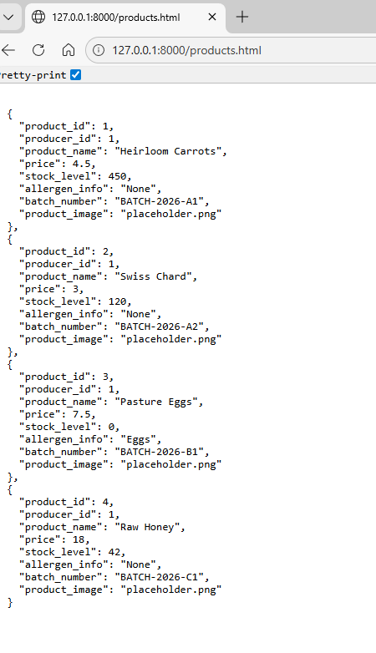 | I identified a routing collision in the Python do_GET handler. The loose matching (startswith('/products')) hijacked the .html extension. I will redo the handler to enforce strict endpoint boundaries.
Regression testing – Verifying the corrected strict routing logic for static assets. | Target: (/products.html endpoint) | The server must differentiate between the API endpoint (/products) and the static file (/products.html), returning the correct MIME type for each. | The HTML document rendered correctly. The network tab confirmed a 200 OK status for the HTML file, followed by a successful secondary fetch for the API payload. | The strict matching parameters successfully isolated the endpoints. The routing architecture is now stable and functioning as intended.
Black box testing – Validating client-side script execution on the Shop Produce node | Target: (Shop Produce UI / app.js) | The JavaScript data bridge should execute a fetch request on DOM load and dynamically populate the product grid. | The UI remained blank. Developer console flagged a fatal TypeError: Cannot read properties of null. The script aborted execution. | I identified a cross-page contamination error. The script attempted to bind a submit event to an intake form that only exists on the Producer node. I will implement null-check safeguards around node-specific logic.  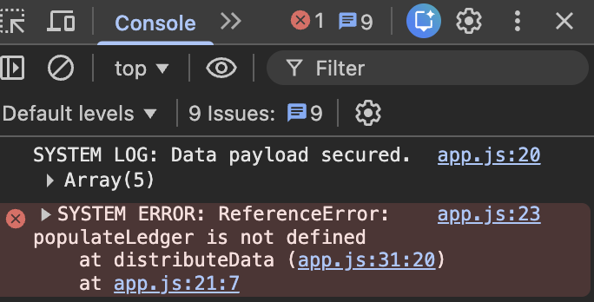
Regression testing – Verifying the isolated DOM safeguards across separate HTML nodes. | Target: (Shop Produce UI / app.js) | The script must recognize the absence of the intake form, bypass the event binding without throwing an exception, and proceed to render the product grid | The error was resolved. The console verified successful execution, and the product grid populated with live SQLite data.  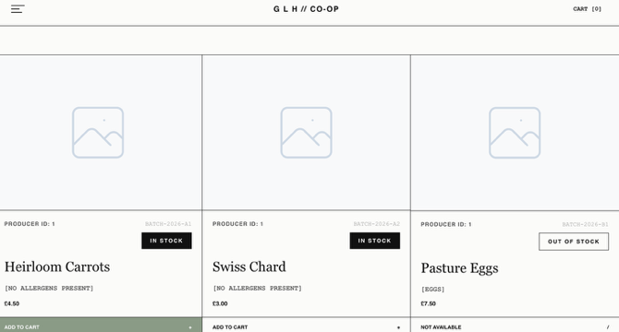 | The conditional logic successfully protected the execution thread. Cross-page JavaScript compatibility is now fully verified.
Component testing – Verifying the dynamic injection of the Active Ledger table on the Producer Dashboard. | Target: (producer-ledger-body) | Following a successful data ingestion, the active ledger must refresh and display the new stock in a table. | The table body remained completely empty. The console revealed a ReferenceError: populateLedger is not defined, resulting in an immediate execution halt.  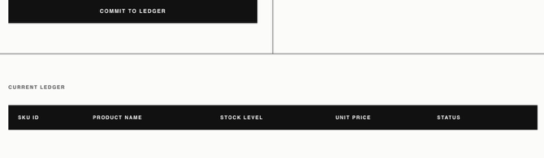 | I identified a structural regression where the populateLedger module was inadvertently truncated during a previous deployment. I will restore the unified script architecture and mandate a hard cache flush.
Regression testing – Verifying the restored UI rendering logic for the Producer Dashboard ledger. | Target: (producer-ledger-body) | The script must correctly resolve the populateLedger function and iterate through the JSON payload to construct the HTML table rows. | The Active Ledger instantly populated upon a hard refresh. System logs confirmed parallel execution of both rendering pipelines.  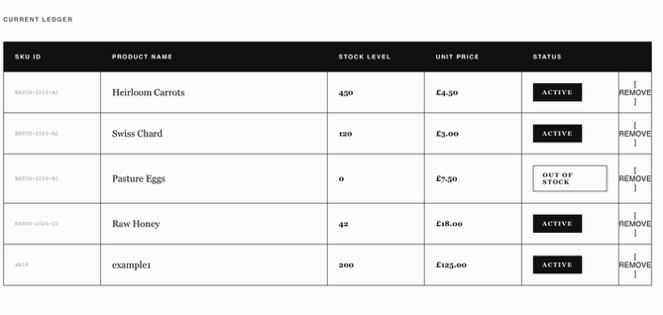 | The unified JavaScript architecture is restored. The client-side injection is fully operational and perfectly synchronized with the backend database state.
White box / Integration testing - Checking the cryptographic hashing and ledger commit during account creation. | {"full_name": "Test User", "email": "test@glhcoop.com", "password": "secure123", "role": "customer"} | The JSON payload should be ingested, the password secured via sha-256 encryption, and the record committed to the sqlite users table without storing them as plain text | the server threw a 500 internal server error. the terminal logged SYSTEM ERROR: Ingestion failure on /register. no such table: users. the python backend caught the missing table and prevented a fatal crash  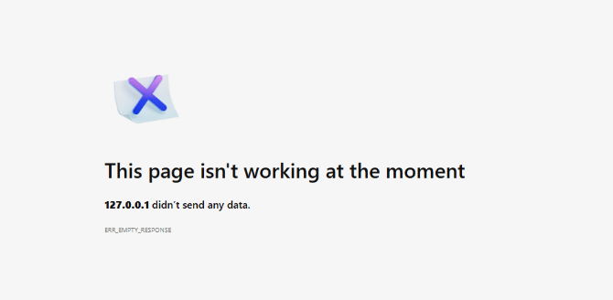 | dentified that the sqlite ledger had not been rebuilt to include the new iam schema. I will run the updated setup_database.py script to generate the missing table.
regression testing - verifying ledger schema update and successful user registration pipeline | {"full_name": "Test User", "email": "test@glhcoop.com", "password": "secure123", "role": "customer"} | after running the setup_database.py script, the users table must exist. the api must process the payload, return a 201 status code, and the ui should prompt a successful redirect. | the setup script successfully rebuilt the database. the subsequent registration request returned a 201 status. the terminal logged the successful hash and insertion. ui threw the success alert and redirected to the login node.  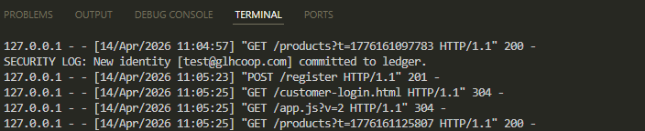 | the database schema is fully aligned with the backend endpoints. the login pipeline is now successfully integrated and operational. 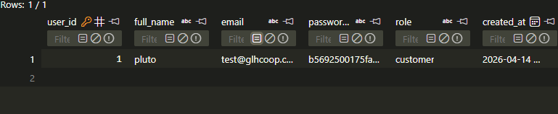
Integration testing - verifying system mitigation against duplicate email identity registration | {"email": "test@glhcoop.com"} | The sqlite uniqueness constraint must reject the payload, triggering a 409 Conflict response to prevent database corruption. | The system correctly intercepted the collision. The backend logged a security alert, and the ui presented a registration denied alert.  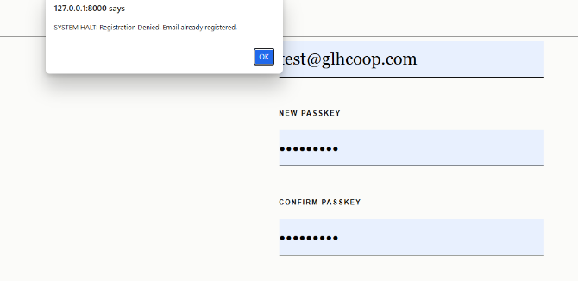 | The database constraints are fully operational, successfully preventing duplicate identities and maintaining ledger integrity.
Black box testing - validating client-side passkey confirmation logic on the frontend node. | Input: passkey = "pass123"  Input: passkey-confirm = "pass456" | The javascript execution thread should halt the POST request if the passkey and confirm passkey inputs do not match, immediately alerting the user. | The submission was aborted prior to API transmission. The UI successfully alerted the user of the mismatched passkey verification.  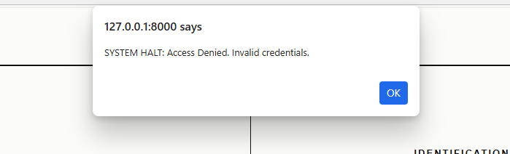 | The client-side validation is working perfectly, ensuring dirty data is caught locally before it consumes server resources.
Integration testing - Validating Role-Based Access Control (RBAC) and asymmetrical routing protocols. | {"email": "test@glhcoop.com", "password": "secure123"} (Account verified as 'customer') | Upon successful hash verification, the API must return a role specific redirect url (e.g., routing a customer strictly to products.html). | Authentication succeeded. The payload delivered the correct role string, and the client-side JavaScript successfully forced the redirect to the storefront node. | The Role-Based routing works exactly as expected, securely sandboxing customer traffic away from the producer terminal.
Black box / Security testing - Verifying the rejection of invalid cryptographic credentials. | Payload: {"email": "test@glhcoop.com", "password": "wrongpassword!"} | Providing an incorrect passkey must fail the SELECT query verification, returning a 401 Unauthorized status | The backend logged an unauthorized access attempt. The UI blocked the redirect, alerted the user, and cleared the passkey input field for retry.  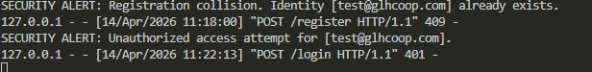 | The authentication gate is secure. Unauthorized access attempts are successfully intercepted and logged without breaking the frontend UI.
Black box / Security testing - Validating Producer Terminal access control against standard customer credentials. | Node: Producer Login  Payload: {"email": "test@glhcoop.com", "password": "secure123"} | The Producer Terminal should explicitly reject the customer credentials with an unauthorized alert, preventing session initialization. | The system authenticated the user redirected to the customer storefront (products.html). The terminal failed to hard-bounce the cross-node access attempt.  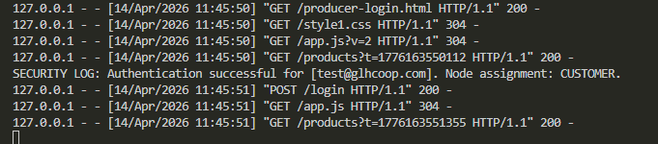 | Mitigation requires passing a requested_node parameter from the UI and enforcing strict asymmetrical ACL rules in the backend routing
Regression testing - Verifying strict ACL enforcement and hard-bounce logic on the Producer Node. | Node: Producer Login  Payload: {"email": "test@glhcoop.com", "password": "secure123", "requested_node": "producer"}  DB Role: customer | The API must intercept the context mismatch, abort the routing protocol, and return a 403 Forbidden status. The UI must alert the user of denied clearance. | The server correctly logged a security hard bounce and returned a 403 status code. The UI successfully intercepted the error, displayed the clearance denied alert, and halted the redirect.  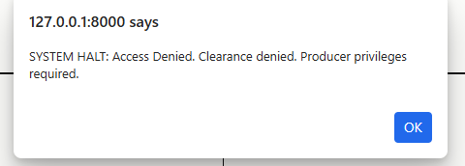 | The ACL patch successfully closed the authorization loophole. The Producer Terminal is now strictly fenced against customer credentials.
Integration testing – validating multi-tenant relational integrity. | Adding 6 producer accounts to the database | The shop grid must display items from multiple distinct producers simultaneously with zero data leakage. | The database correctly mapped each asset to its owner. the ui rendered all unique farm names in the shop grid. | The cod worked as expected
integration testing - verifying batch provisioning of the farmer directory identities. | Source: farmers list  Password: secure123  Role: producer | the ledger must accept all six unique email identities and hash their credentials without overwriting existing data. | script executed cleanly. 6 new producer identities committed. existing farm@glhcoop.com remains intact.  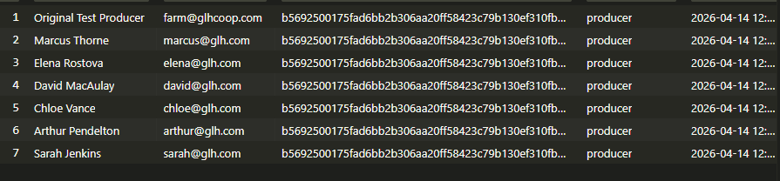 | the producer node is now scaled for multi- account directory testing.
regression testing - ensuring legacy producer accounts retain login clearance after schema expansion. | Login: farm@glhcoop.com  Node: producer-login.html | the original test producer must still be able to authenticate and access the terminal node | authentication successful. session data for user_id: 2 (or original ID) successfully populated. | Scaling the database had zero impact on legacy data.
black box testing - verifying unique state management for individual farmer sessions. | Login: marcus@glh.com  Login: elena@glh.com | each login must generate a unique session_user_id in localstorage to prevent data cross-contamination | browser stored unique IDs for each specific farmer. manifest uploads were correctly bound to the specific logged-in producer.  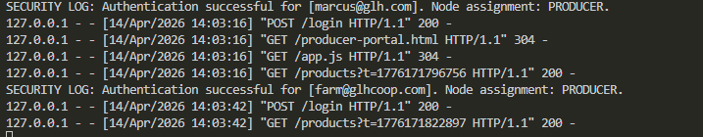 | state management is successfully isolating producer streams.
Black box testing - Checking that the "ADD TO CART" button serializes data to local storage. | None | Clicking the cart button updates the global navigation counter and saves the item in the browser's local storage array. | The button behaved as expected, the cart counter incremented, and the item persisted in memory after a page refresh.  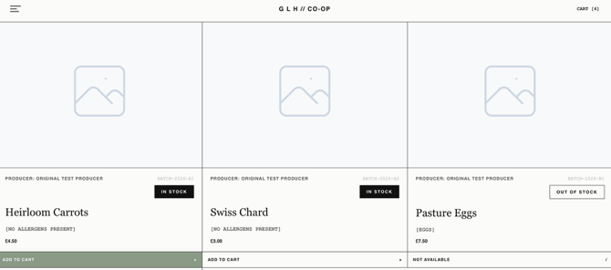 | The code worked as expected
White box testing - Checking that the system prevents users from requesting more stock than is available | Input an order quantity greater than the product stock level | The system should trigger a halt alert and force the input value back down to the maximum available stock limit. | The system successfully intercepted the invalid input, displayed the alert, and corrected the value to the maximum stock limit.  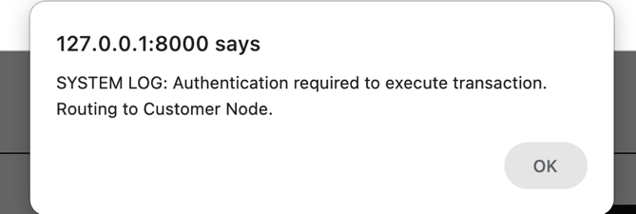 | The validation logic is structurally sound and effectively prevents overselling.
Black box testing - Checking that the active cart dynamically recalculates order totals and delivery fees. | None | Modifying item quantities or toggling the delivery radio buttons should instantly update the subtotal, apply a £5.00 delivery fee if selected, and output the correct grand total. | The mathematical rendering updated in real-time without requiring a page refresh. All calculations were accurate.  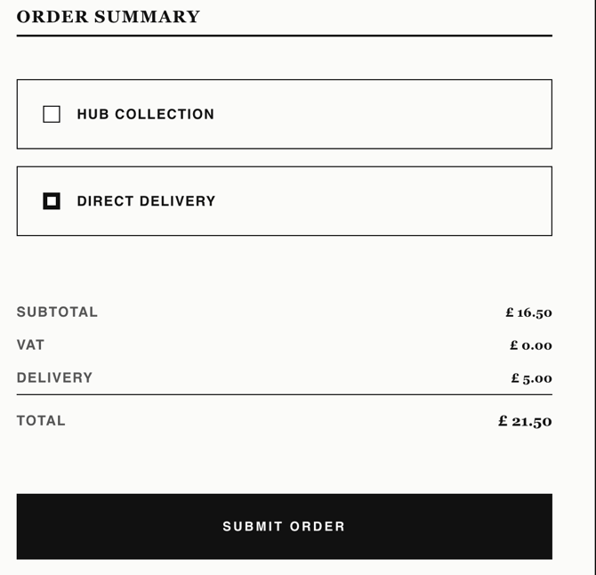 | The dynamic DOM bindings are functioning correctly for the final checkout payload.
Black box testing - Checking that the checkout endpoint enforces the authentication gate. | None | Clicking "SUBMIT ORDER" while unauthenticated or logged in as a producer should trigger an alert and route the user to the Customer Login node. | The system correctly blocked the transaction and routed the unauthenticated session to the login screen.  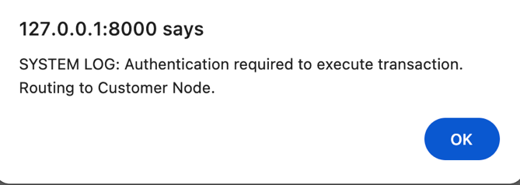 | The hard bounce logic protects the database from anonymous transaction injections.
Integration testing - Checking the end-to-end execution of the atomic checkout payload. | Valid customer credentials (test@glhcoop.com, secure123). | Submitting a valid cart payload should return a success status, alert the Order Ref ID, empty the cart, and route the user to the portal. | The backend returned a 201 Created status, the UI handled the success response perfectly, and the cart was purged.  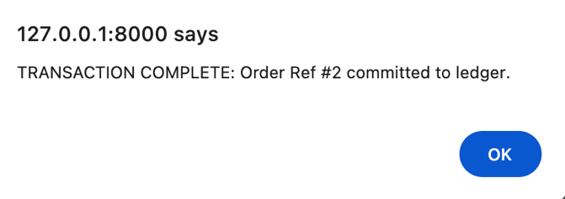 | The API bridge between the frontend cart and the Python backend is fully operational.
Regression testing — Verifying customer login routes to the Customer Portal, not the Storefront. | Email: test@glhcoop.com  Alias : pluto  Password: secure123  Node: Customer Login | Upon successful authentication, the API redirect_url must point to customer-portal.html, routing the user to their personal portal rather than the public storefront. | The API returned redirect_url: customer-portal.html. The client-side JS followed the redirect correctly and the Customer Portal loaded with the personalised welcome header.   | Previous behaviour sent customers to products.html. The fix updated the server side routing logic so the customer portal is the canonical post login destination, as specified in the UAC.
Black box testing — Verifying the Producer Terminal identity header displays the correct producer name and farm title after login. | Login as a registered producer account (marcus@glh.com). | The terminal header element must render PRODUCER: MARCUS THORNE . | After login, the header correctly displayed MARCUS THORNE as the producer ID  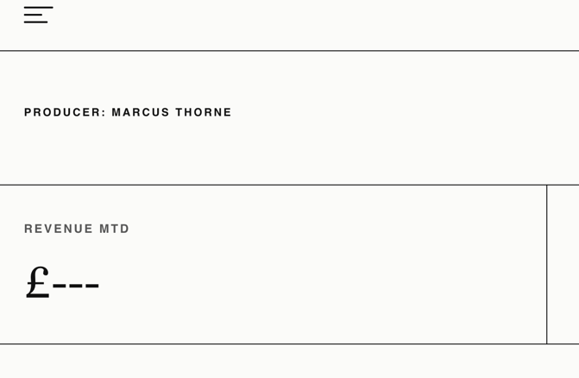 | The code behaved as expected.
Black box / Security testing — Verifying the page guard on the Customer Portal rejects unauthenticated visitors. | No session in localStorage. Navigate directly to customer-portal.html via the URL bar. | The initSessionUI guard must detect the missing session_user_id key and immediately redirect the browser to customer-login.html before any portal content is rendered. | The redirect fired correctly. The portal HTML was never visibly rendered. The browser landed on the login page with the MODE: CUSTOMER LEVEL footer visible. | This guard prevents anonymous users from bookmarking or directly accessing the portal URL, protecting personal order history from unauthorised view.
Black box testing — Verifying that an already-authenticated customer is automatically bounced away from the login page. | Active customer session in localStorage (session_user_id and session_role = customer). Navigate to customer-login.html. | The system must detect the valid customer session and redirect to customer-portal.html without displaying the login form. | The redirect fired on page load. The login form was never visible. The browser landed directly on the customer portal. | Prevents the confusion of a logged in user seeing the login form.
Black box testing — Verifying the Logout function clears all session state and routes the user to the homepage. | Active session in localStorage (session_user_id, session_role, session_full_name). Click the LOGOUT nav link. | All three session keys must be removed from localStorage and the browser must redirect to index.html. Subsequent navigation to the portal must trigger the page guard redirect. | Clicking LOGOUT cleared all three localStorage keys (confirmed via DevTools Application panel). The browser navigated to index.html. Attempting to revisit customer-portal.html immediately triggered the page guard and redirected back to the login page.  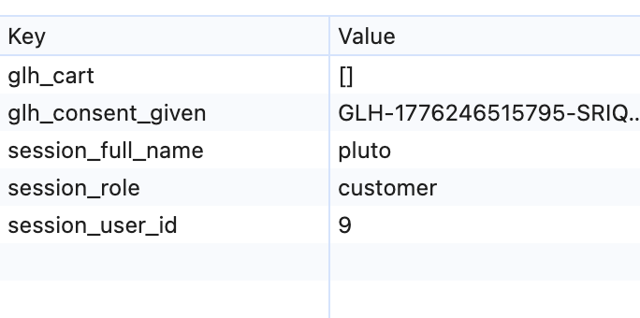The screenshot below is after logging out  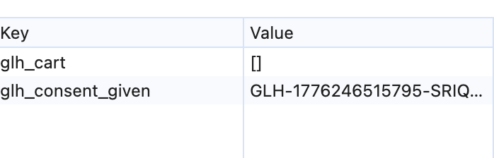 | Session termination is complete and tamper resistant. There is no residual state left in the browser after logout.
Integration testing — Verifying the account deletion endpoint removes the user record and all associated products from the database, then terminates the session. | Authenticated customer session. Open Manage Account modal, click DELETE ACCOUNT and confirm the system query dialog. | The frontend must fire DELETE /users/{user_id}. The API must execute DELETE FROM users and DELETE FROM products WHERE producer_id in a single transaction. The UI must then call logout(), clearing localStorage and redirecting to index.html. | The DELETE request returned a critical error  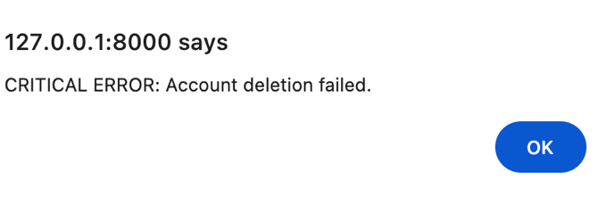  After inspecting the developer tools Identified that the server rejected the deletion  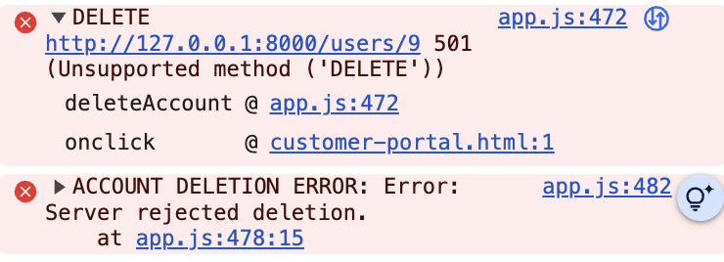 | The cause was the absence of the def do_DELETE(self): method declaration. The deletion body was orphaned inside do_PUT as floating code after the else clause, preceded only by a docstring. Python never registered a DELETE handler, so the server fell through to the default 501 response. Fix: restored def do_DELETE(self): as a proper independent class method at the correct indentation level.
Regression testing — Verifying the account deletion endpoint removes the user record and all associated products from the database, then terminates the session. | Authenticated customer session. Open Manage Account modal, click DELETE ACCOUNT and confirm the system query dialog. | The frontend must fire DELETE /users/{user_id}. The API must execute DELETE FROM users and DELETE FROM products WHERE producer_id in a single transaction. The UI must then call logout(), clearing localStorage and redirecting to index.html. | The DELETE request successfully returned HTTP 200 OK. Backend logs confirmed the handler executed correctly. Post-deletion, a login attempt with the removed credentials returned a 401 Unauthorised, and all associated product rows were removed from the database. The browser redirected to the homepage. | The structural fix worked perfectly. The endpoint is now correctly registered. Account deletion is fully cascading and leaves no product records, completely satisfying the GDPR right-to-erasure requirement.
White box testing — Verifying the POST /consent endpoint correctly logs GDPR preference data to the cookie_consent table. | Payload: {"token": "GLH-TEST-001", "analytics": true, "marketing": false} | The API must INSERT a row into cookie_consent with strictly_necessary=1, analytics=1, marketing=0, and a valid consented_at timestamp. The endpoint must return HTTP 201 Created. | The API returned {"status": "success"} with a 201 status code. A SELECT on the cookie_consent table confirmed the row was inserted with the correct flag values and a timestamped consented_at field. | The cookie_consent table is auto-created on first connection via the get_db_connection() helper, removing the need for a separate migration script. INSERT OR REPLACE ensures re-submissions update rather than duplicate.
Black box testing — Verifying that the GDPR consent modal does not reappear on subsequent visits to the homepage after consent has been given. | Accept the consent modal on the first visit. Close the browser tab. Reopen index.html in the same browser profile. | On the second visit, the consent overlay element (#consent-intercept) must be hidden on DOMContentLoaded without any user interaction. The glh_consent_given token must be present in localStorage. | The overlay was hidden immediately on page load. No consent modal appeared. The glh_consent_given key was confirmed present in localStorage via DevTools. | Consent is stored server-side in cookie_consent and client-side as a localStorage flag.
Regression testing — Verifying the ACCEPT ALL button sets both analytics and marketing flags to true in the database. | Visit index.html with no prior consent. Click ACCEPT ALL. | The submitConsent(true, true) function must post analytics=true and marketing=true to the API. The cookie_consent row must record analytics=1 and marketing=1. | The POST payload contained analytics: true, marketing: true. The database row confirmed analytics=1, marketing=1. The modal closed and glh_consent_given was written to localStorage. | Contrasts correctly with ACCEPT SELECTED, which only submits the checkboxes that are ticked. Both pathways terminate in the same overlay dismissal and localStorage write.
Integration testing — Verifying the Update Details form commits name and email changes via PUT /users/{id} and immediately reflects them in the UI. | Authenticated customer session. Open Manage Account > Update Details. Change full name to ‘Test User Updated’ and submit. | The frontend must fire PUT /users/{session_user_id} with the updated full_name and email. The API must UPDATE the users row. The response must return the new full_name. The session_full_name localStorage key and the portal welcome title must update live without a page reload. | The account update failed  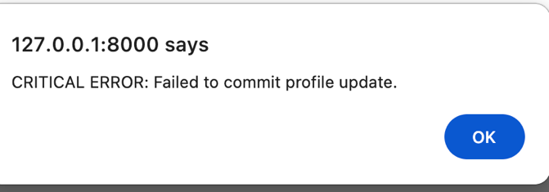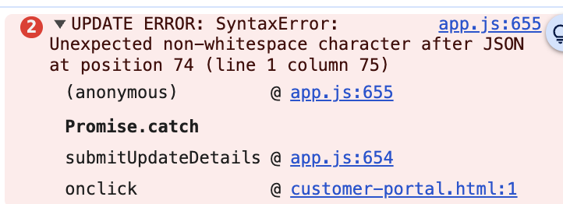
White box testing — Verifying that submitting the Update Details form with a blank password field does not overwrite the existing password hash. | Login to a verified account, open update details. change only the name field. leave the new passkey field blank and submit. | The API must execute UPDATE users SET full_name=?, email=? WHERE user_id=? (without a password_hash column) when the password field is empty. The existing SHA-256 hash must remain unchanged in the database. | The PUT handler correctly branched on the absence of a password value. A direct database inspection confirmed the password_hash column was unchanged. The user could still authenticate with their original passkey after the name update.  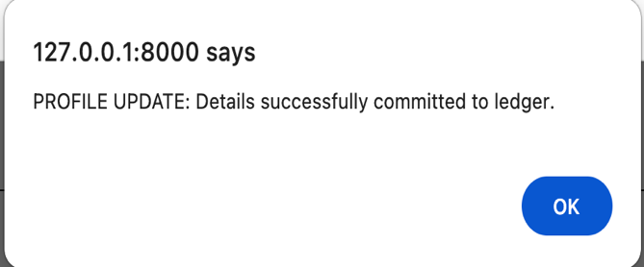 | This prevents accidental credential wipes. The conditional branch (if raw_password: ... else: ...) in the API handler is the key control. This was verified by reading the db row before and after the update.  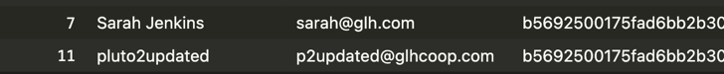
Black box / Security testing — Verifying the Producer Ledger only displays stock entries belonging to the currently authenticated producer. | Log in as Producer A (e.g. marcus@glh.com). Ensure Producer B (e.g. elena@glh.com) has at least one product in the database. | The ledger table must only render rows where product.producer_id matches the session_user_id stored in localStorage. Producer B’s products must be completely absent from the table. | The ledger rendered only Marcus’s products. Elena’s products were not visible. Inspecting the raw API response confirmed all products were returned from the server; the filtering occurred client-side in distributeData() before populateLedger() was called. | The fix added a .filter() in distributeData() comparing each item’s producer_id against parseInt(localStorage.getItem(session_user_id)). The shop grid remains unfiltered so all producers’ products are still visible to customers.
White box testing — Verifying the checkout endpoint performs a stock-level pre-flight check before committing any database writes. | Authenticated customer session.  Cart: 1 item (product_id=3, Pasture Eggs, stock_level=0).  Expected: rejection before any INSERT. | If any item’s requested quantity exceeds the available stock, the endpoint must rollback, return HTTP 400, and write no records to ORDERS or ORDER_ITEMS. | The API returned HTTP 400 with {"status": "error", "message": "Inventory depleted.” An inspection of the ORDERS and ORDER_ITEMS tables confirmed no rows were inserted  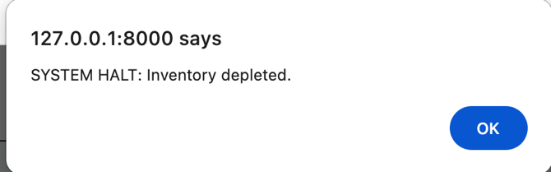 | The pre-flight SELECT runs before BEGIN TRANSACTION commits anything, ensuring the database is never left in a partially written state. The rollback is the key control preventing overselling.
Integration testing — Verifying POST /checkout correctly INSERTs a master receipt row into the ORDERS table with the correct customer_id and total_price. | Authenticated customer session (test@glhcoop.com).  Cart: 1x Swiss Chard (product_id=2, price=£3.00).  Delivery: Hub Collection (£0.00 fee).  Expected total: £3.00. | On successful checkout, the API must INSERT one row into the ORDERS table containing the correct customer_id, a valid order_time timestamp, and the total_price matching the submitted cart value. The response must return {"status": "success", "order_id": N}. | POST /checkout returned HTTP 201 with a valid order_id. A SELECT on the ORDERS table confirmed a new row was inserted with the correct customer_id, a non-null order_time timestamp, and total_price=3.0. The order_id matched the value returned in the response payload. | The INSERT uses customer_id and total_price from the JSON payload. order_time is auto-populated by the DEFAULT CURRENT_TIMESTAMP constraint. The order_id is captured via cursor.lastrowid and returned to the frontend so the alert displays the correct reference number.
Integration testing — Verifying POST /checkout correctly INSERTs one line-item row per cart product into the ORDER_ITEMS table, linked to the master order. | Same order as above (order_id=N).  Cart: 2 items — 1x Heirloom Carrots (product_id=1), 2x Swiss Chard (product_id=2).  Expected: 2 rows in ORDER_ITEMS. | The API must INSERT one row into ORDER_ITEMS for each distinct product in the cart, with the correct order_id foreign key, product_id, and quantity values. The order_id must match the master receipt inserted into ORDERS. | A SELECT on ORDER_ITEMS WHERE order_id=N returned 2 rows: (product_id=1, quantity=1) and (product_id=2, quantity=2). Both rows carried the correct order_id linking them to the ORDERS master receipt. No extra or duplicate rows were present. | The API loops over the cart array, executing one INSERT INTO order_items per item. The order_id foreign key is taken from cursor.lastrowid after the ORDERS INSERT, ensuring relational integrity between the two tables.
Integration testing — Verifying POST /checkout correctly decrements the stock_level in the PRODUCTS table for each purchased item, preventing overselling. | Pre-checkout stock: Heirloom Carrots (product_id=1) = 447, Swiss Chard (product_id=2) = 115.  Cart: 3x Carrots, 2x Chard.  Expected post-checkout stock: Carrots=444, Chard=113. | After a successful checkout, the PRODUCTS table must reflect reduced stock levels matching the quantities purchased. The UPDATE must use stock_level = stock_level - quantity (relative decrement, not absolute set) to be safe under concurrent requests. | A SELECT on PRODUCTS after checkout confirmed Heirloom Carrots stock_level=444 (decreased by 3) and Swiss Chard stock_level=113 (decreased by 2). Both decrements matched the cart quantities exactly. The relative UPDATE expression was verified by reading the SQL in the handler. | The UPDATE uses stock_level = stock_level - ? with the quantity as the bound parameter, executed inside the same atomic transaction as the ORDERS and ORDER_ITEMS INSERTs. If any step fails, all three operations roll back together, leaving the database in its pre-order state.
White box testing — Verifying the checkout transaction rolls back all three operations atomically if any step fails mid-transaction. | Simulated failure: valid cart payload referencing a non-existent product_id to force an exception during the ORDER_ITEMS INSERT loop after the ORDERS INSERT has already executed. | If the ORDER_ITEMS INSERT raises an exception, the entire transaction (ORDERS INSERT, ORDER_ITEMS INSERT, PRODUCTS UPDATE) must be rolled back. The ORDERS table must not retain the partially-written master receipt. The stock_level must remain unchanged. | The exception triggered the except block, which called connection.rollback(). A SELECT on ORDERS confirmed the partial receipt was absent. stock_level values were unchanged. The API returned HTTP 500. The database was left in the same state as before the request. | The entire checkout flow is wrapped in a single BEGIN TRANSACTION / commit() / rollback() block. The try/except/finally pattern ensures rollback fires on any exception and the connection is always closed via the finally clause.
Black box testing — Verifying the Customer Portal handles an account with no order history gracefully. | Authenticated customer session with zero orders.  Navigate to customer-portal.html. | When GET /orders/{customer_id} returns an empty array, the order history tbody must display a clean ‘NO ORDERS ON RECORD.’ message rather than an empty table or a JS error. | The portal loaded and the order history section displayed the text NO ORDERS ON RECORD. in the table body. No empty rows, no JS console errors, and no #### placeholders were visible.  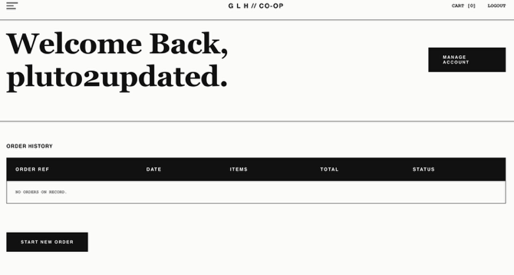 | The code behaved as expexted. This mirrors the empty cart pattern used in the cart page
Integration testing — Verifying the Customer Portal order history table renders live data from GET /orders/{customer_id} rather than hardcoded placeholders. | Authenticated customer session with at least 1prior order in the ORDERS table.  Navigate to customer-portal.html. | The order history body tbody must be populated by a fetch to GET /orders/{session_user_id}. Each row must display the correct GLH-formatted order reference, formatted date, item count, total price, and status. Placeholder #### rows must not appear. | The portal loaded and the order history tbody populated with 2 rows matching the database records. Order references were formatted as GLH-000004 Dates were formatted DD/MM/YYYY. Item counts and totals matched the ORDERS and ORDER_ITEMS tables. No #### placeholder rows were visible. | The portal is now fully functional and data driven.
Regression testing — Verifying that placing a second order with the same product does not double-decrement stock or corrupt prior ORDER_ITEMS records. | Place two separate orders each containing 1x Heirloom Carrots.  Baseline stock before first order: 447. | After the first order, stock must be 446. After the second order, stock must be 445. ORDER_ITEMS must contain two independent rows (one per order_id), not one row with quantity=2. | Stock after first order: 446. Stock after second order: 445. ORDER_ITEMS contained two separate rows, each with quantity=1 linked to different order_ids. No duplication or accumulation errors occurred.  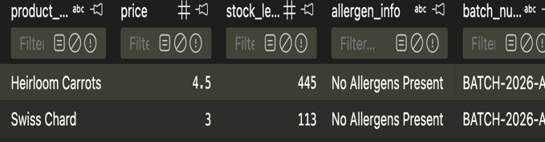  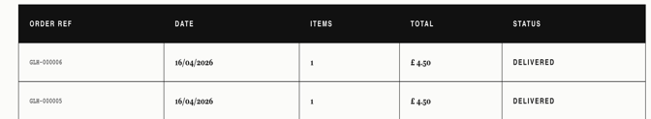 | Each checkout call opens its own connection and transaction. The relative UPDATE (stock_level - ?) ensures each call decrements from the current live value, not from a cached snapshot. The stock level in the database also updates as required
Add more rows and tables as required.

