Task 2: Test log
Description of test | Test data to be used (if required) | Expected outcome | Actual outcome | Comments and intended actions
Black box testing – To ensure the layout of the page is displayed as expected | None | The About Us section should display below the hero image with enough spacing, and the text should be readable and properly scaled for the page. | Code did run however the about us is too close to the hero image and the font itself is too small  | I will add a margin bottom for the hero image and increase the about us text size. I will also change the font of the ‘about us’ text so that it matches the page header for continuity. I also plan on making both the about us heading and paragraph content a bit bigger so that it fills the page a bit more  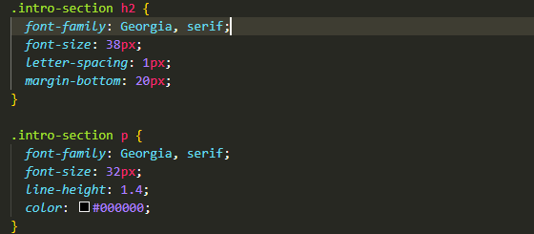
Regression testing: Checking if previous issue was fixed | None | The About Us section should display below the hero image with enough spacing, and the text should be readable and properly scaled for the page | 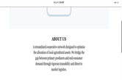 | The spacing is now correct, and the font matches the page header and is readable
Regression testing: Checking grid responsiveness and scaling | None | Grid boxes should contain all text elements within their borders, maintaining a professional and clean layout during window resizing. | The box-title text is overflowing the grid borders, causing a broken UI and unreadable content  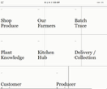 | The fixed 48px font size is too large for the current grid resolution causing the text to overflow the borders. I will replace the static value with a fluid typography approach using the CSS clamp() function. This allows the titles to scale dynamically between 32px and 48px based on the screen size, ensuring the text remains contained
Regression testing: Checking if grid text overflow was fixed. | None | All titles should be fully contained within the grid boxes across all screen resolutions | The fluid font worked, but the fixed 3/2 aspect ratio still caused overflow on mid-sized screens  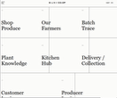 | I have changed the aspect ratio to auto and increased the min-height to 400px. This allows the boxes to expand vertically if the text wraps
Regression Testing: Final fix for grid text overflow. | None | Grid boxes should fully contain typography without text bleeding over the borders. | The update aspect ratio worked and there is no longer any overflow however some boxes no longer have borders between them  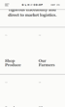 | I have updated the grid to a two column system WHEN minimised and increased the minimum height of the boxes to 400px. These changes allow the containers to expand vertically to accommodate text wrapping. I also implemented new border logic to fix the missing dividers, including manual overrides for the login boxes (07 and 08), to ensure the grid remains visually consistent.
Checking overall grid structural boundaries on desktop. | None | The portal grid should have a complete outer frame, explicitly enclosing the modules on all sides. | The grid lacked a left border, causing the first column of boxes to appear as if they were floating next to each other without a boundary.  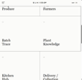 | I updated the. portal-grid class to include border-left: 1px solid #111111. This ensures consistency with the other solid lines.  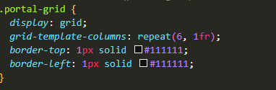
Regression Testing: overall grid structural boundaries | None | The portal grid should have a complete outer frame, explicitly enclosing the modules on all sides. | The left border has been added  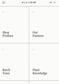 | The fix is successfully and the The left border has been added
Integration testing – Responsive scaling and border continuity at tablet width (1024px). | None | The grid should collapse into a balanced 2-column layout. A central vertical divider must separate the columns, and the bottom login boxes (07/08) should scale to 50% width each. | Desktop layout rules (span 3 and 3n) conflicted with the media query instructions. The grid failed to integrate the new 2-column logic, causing Box 03 to lose its border and Boxes 07/08 to overflow the container.  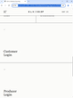 | I implemented !important flags to force the browser to prioritize the responsive media query over the high-specificity desktop math. This successfully integrated the 2-column compliance (span 1) and reset the vertical axis dividers. Regression confirmed: desktop layout fully restored above 1024px with no bleed from tablet rules.
Black box testing – Mobile horizontal overflow and containment. | None | The mobile view should scroll only vertically, with all grid boxes fitting exactly within the screen width. | The mobile viewport suffered from horizontal overflow. The high specificity desktop aspect ratio: 9/4 and the 6 column grid geometry failed to collapse, exceeding the 100% viewport limit.  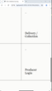 | I added border-bottom: 1px solid #111111 !important to the .grid-box class within the 600px media query. This ensures each item acts as a distinct, separated row.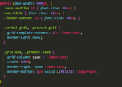
Regression testing – mobile overflow | None | Fluidly scaling from 320px to 1440px must trigger transitions without text overflow or retaining mobile only properties at larger sizes. | The page scaled dynamically without bleeding over the modular borders.   | The system successfully toggles between fluid vertical stacking for mobile and rigid geometric constraints for desktop.
Black box testing – Product image scaling and aspect ratio integrity. | None | Product asset images should scale to perfectly fill the .product-image-slot without distortion or excessive padding. | The product images inherited the .hero-image-container css properties resulting in the product image appearing incorrectly cropped  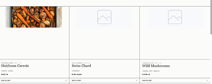 | I will add a new .product-image class to the html and css tags and deployed height: 100% with object-fit: cover to ensure container compliance.  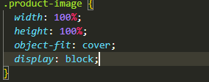
Regression testing – Product Image scalling | None | Creating the new .product-image class must not alter the layout of the page in any way and the image must cover 100% of the image card | The product image now fully fills the image container .  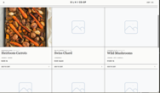 | The updated .product-image class worked as intended
White box testing – Checking the layout of the vendor name and product ID. | None | The vendor name and product ID should sit on the same line, pushed to opposite sides of the box. | The text stacked on top of each other and clumped together on the left side of the card.  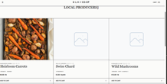 | I added display: flex and justify-content: space-between to the .product-header class to put the text on the same line and push it apart. I also added a bottom border for separation.  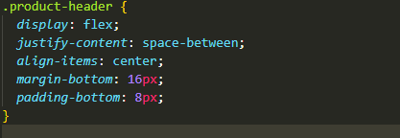
Regression testing – Checking text alignment on different screen sizes. | None | The vendor name and product ID should stay aligned on opposite sides and not overlap when the screen shrinks. | The text stayed perfectly aligned on all screen sizes with no overlapping or layout breaks.  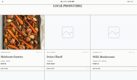 | Verified that the flexbox layout works correctly and does not break the rest of the grid layout.
Integration testing – Checking the product grid layout on tablet screens (1024px). | None | The product grid should change from 3 columns to 2 columns so the content does not get squeezed. | The product grid stayed locked at 3 columns on tablet screens, causing the cards to become too narrow, misaligned and the text to compress.  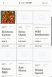 | I updated the 1024px media query to include the .product-grid and .product-card classes. This forces the layout to drop to 2 columns and fixes the missing border logic on mid-sized screens. Regression confirmed: 3-column product grid returned to desktop size with no visual errors.
Integration testing – Checking the layout on tablet and mobile screens (1024px). | None | The layout should change from a two-column split to a single vertical column, with the farmer's photo stacking above the text. | The design stayed split 50/50, causing the text to become unreadable. 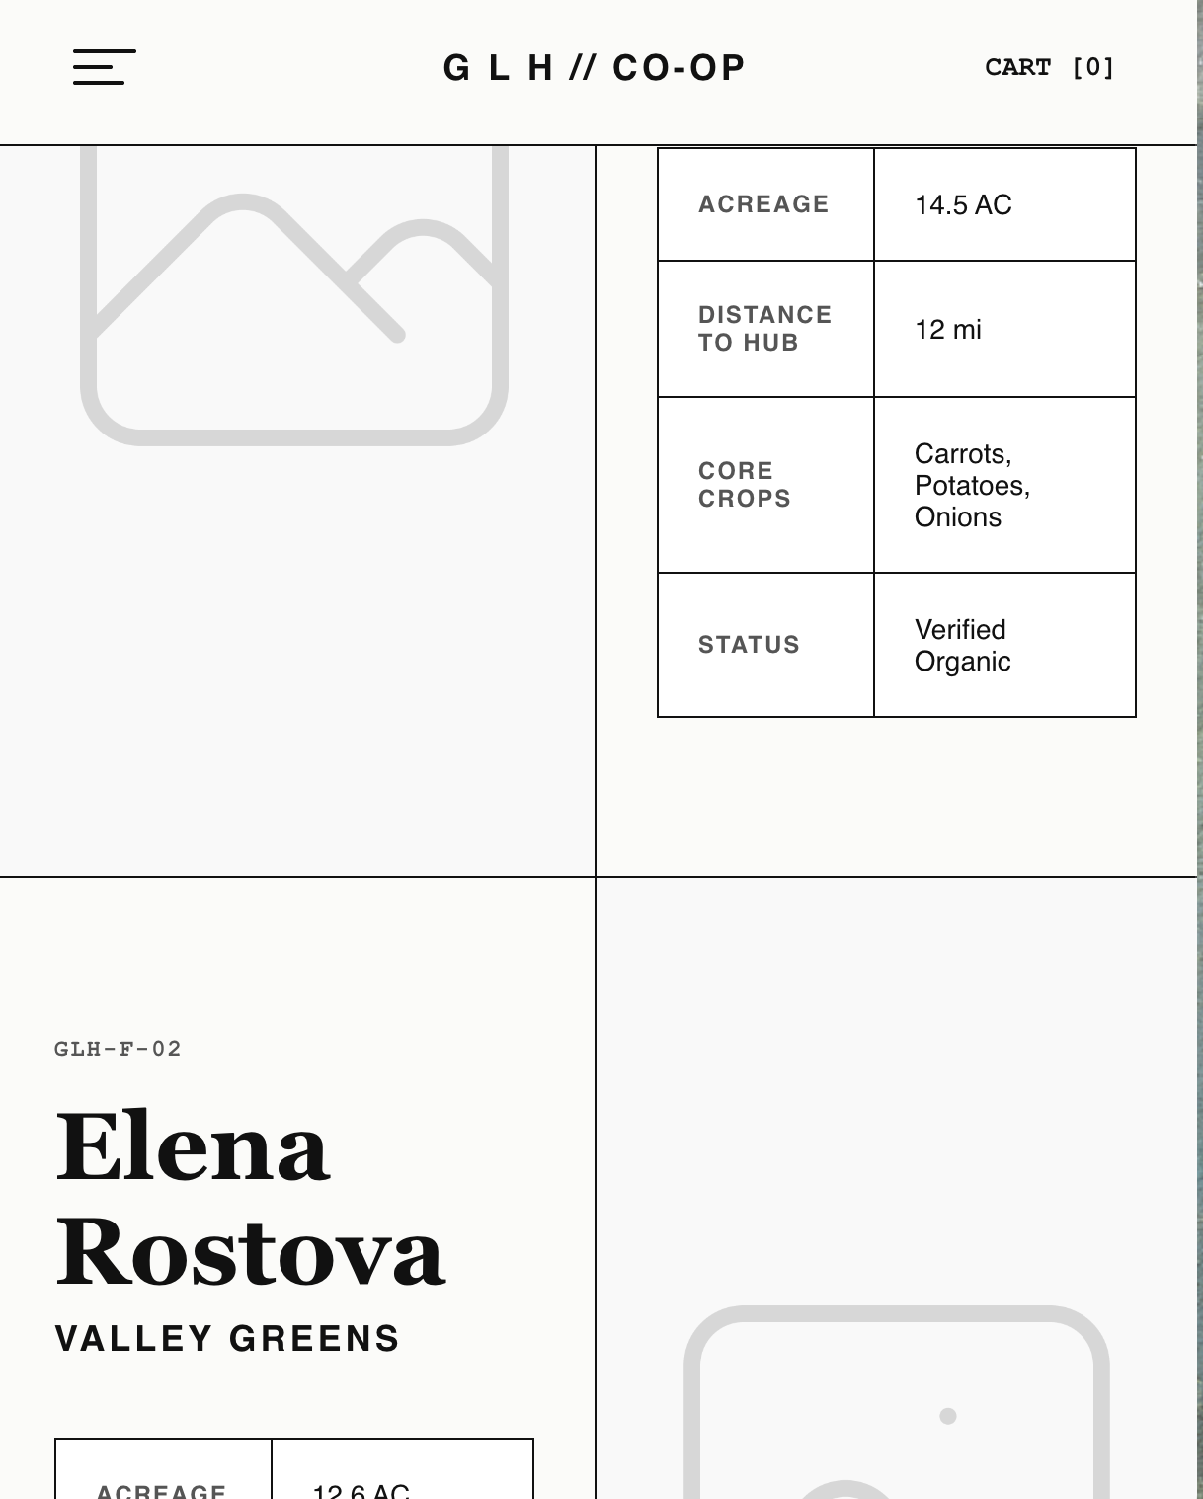 | I added a @media (max-width: 1024px) rule to force a 1-column grid. I used order: 1 !important on the images to guarantee they always stack on top, successfully overriding the desktop layout logic. Regression confirmed: single-column stack applies correctly on tablet and mobile.
Black box testing – Checking UI consistency | None | The massive "TRACEABLE. LOCAL. VERIFIED." text should scale fluidly and fit perfectly within the viewport boundaries without any letters getting cut off or causing a horizontal scrollbar. | The text scaling was slightly too large for the container, causing the 'E' at the edge of the footer to overflow the screen and become partially cut off on all pages. | During UI testing, I noticed the massive typography was exceeding the 100% viewport width limit.  I adjusted the CSS for the footer typography (using a clamp() function or reducing the font-size and letter-spacing) to ensure the text scales dynamically and remains fully contained within the screen bounds on all devices.
Regression testing – Verifying the footer typography scaling fix. | None | The massive "TRACEABLE. LOCAL. VERIFIED." text should now be fully visible on the screen without any letters being cut off or causing horizontal scrolling. | The footer text now scales fluidly, and the 'E' is perfectly visible and contained within the screen boundaries across all pages and different widths   | The CSS typography fix worked as expected. The visual impact of the massive footer is maintained without breaking the layout or causing horizontal overflow.  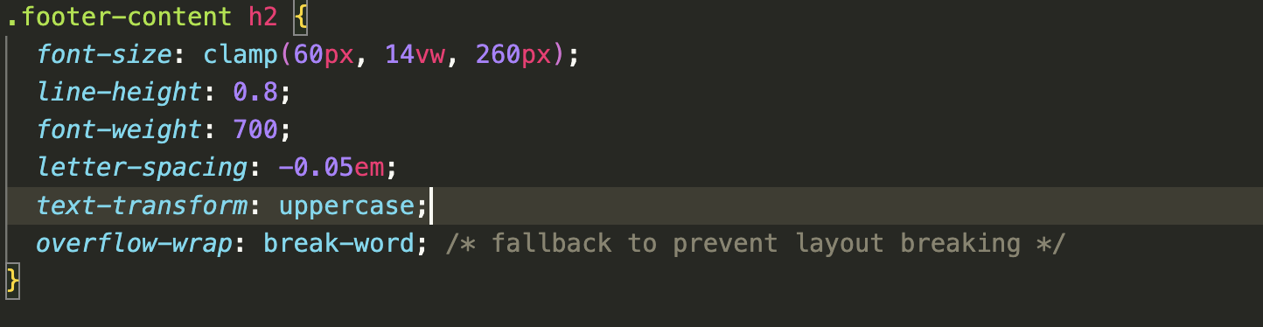
Integration testing – Checking the layout on tablet and mobile screens (1024px). | None | The layout should change from a two-column split to a single vertical column, with the farmer's photo stacking above the text. | The design stayed split 50/50, causing the text to become unreadable. | I added a @media (max-width: 1024px) rule to force a 1-column grid. I used order: 1 !important on the images to guarantee they always stack on top, successfully overriding the desktop layout logic.
Black box testing - Integration testing,Checking the navigation to the Producer Terminal. | None | Clicking the "Producer Login" link on the portal grid should successfully route the user to the producer login page without any 404 errors. | The navigation link behaved as expected and successfully loaded the Producer Terminal interface.  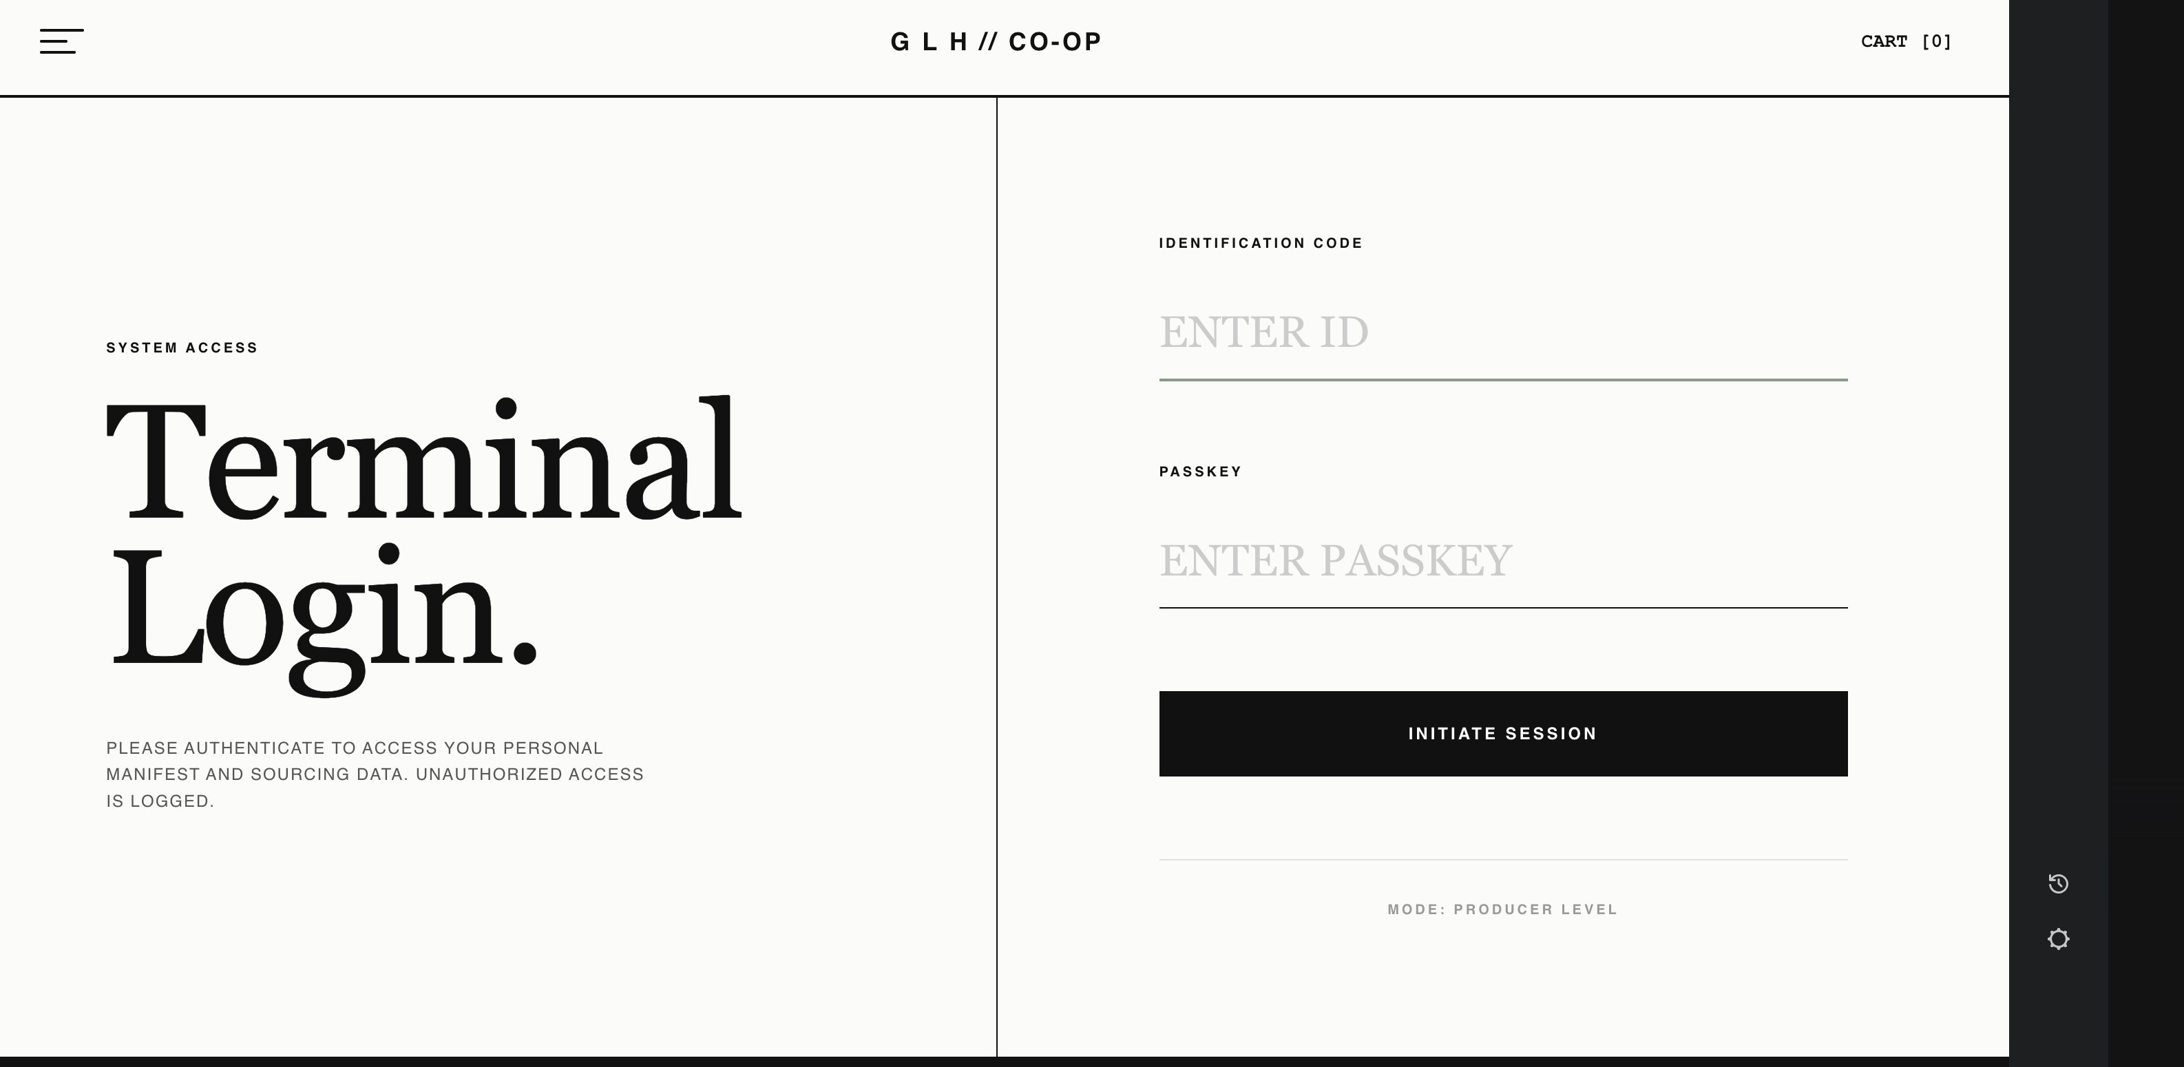 | The page is fully integrated into the site's navigation map.
Integration testing – Checking structural rendering against the approved wireframe schematic. | None | The page must render a strict two-column asymmetrical grid (2fr 1fr), placing the active cart items on the left and the order summary pinned to the right. | The elements rendered as standard full-width HTML blocks, stacking vertically and completely failing to match the wireframe's side by side split design.  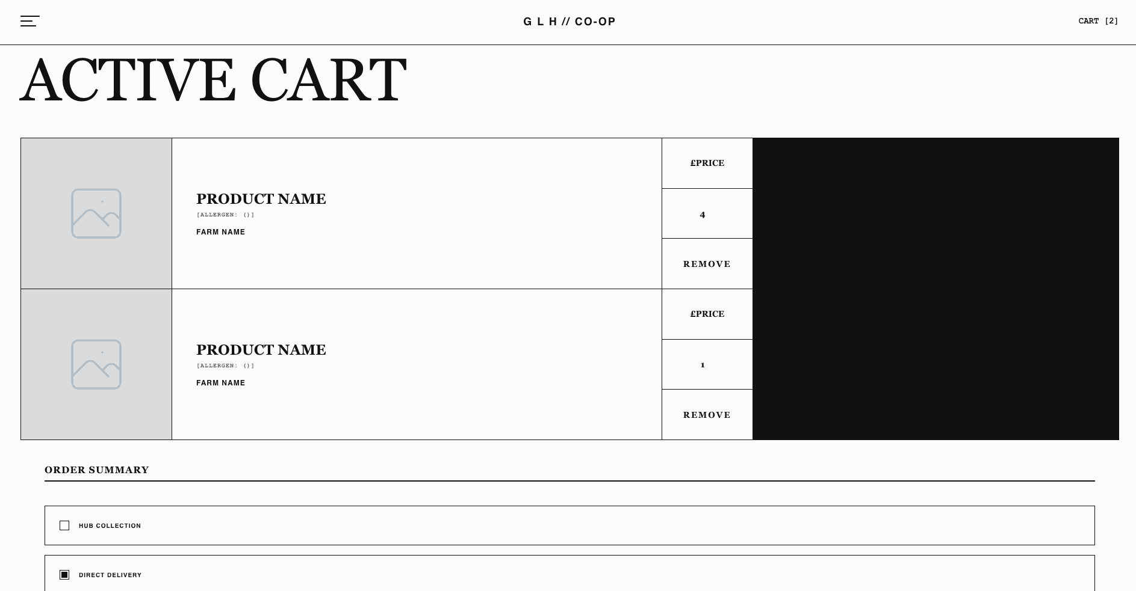 | During UI testing, I noticed the layout was acting like a standard webpage instead of a structured grid.  I updated the CSS to use a grid layout (2fr 1fr) and added a 1px gap technique to instantly generate the rigid internal borders required by the design.
Regression testing – Checking the layout and grid borders after applying the two-column fix. | None | The page must maintain the two-column split layout (cart items on the left, order summary on the right), and the 1px borders between the sections should remain crisp without images overlapping the lines when the window is resized. | The grid lines rendered perfectly across all screen sizes with no bleeding, overlapping, or visual errors.  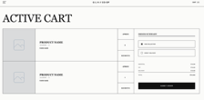 | The grid maintains the split-screen design and handles complex resizing smoothly without breaking the structural borders
Integration testing – Checking how the cart layout responds on tablet screens (1024px). | None | The side-by-side layout should collapse into a single vertical column so the content stays readable and doesn't get squished. | The grid stayed stuck in the desktop layout, forcing the content off the edge of the screen and causing a horizontal scrollbar.  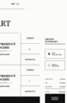 | I moved the cart routing logic inside the correct @media (max-width: 1024px) block so the layout properly drops to one column on smaller screens.  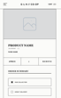
Black box testing – Checking the responsive grid reflow for the batch trace module on mobile viewports (< 1024px). | None | The .batch-grid component should collapse from a 3 column layout to a 1column layout (grid-template-columns: 1fr). | The grid maintained a forced 3column layout (repeat(3, 1fr)) causing horizontal compression and unreadable data fields.  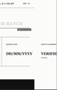 | I integrated .batch-grid and .batch-cell directives into the @media (max-width: 1024px) block, forcing a 1fr column template. The module now stacks vertically at 100% width.  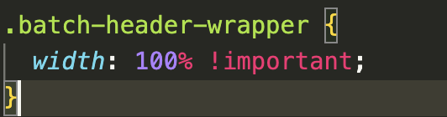
Regression testing: Checking the batch trace grid correctly switches between the 3-column desktop layout and the 1-column mobile layout. | None | The .batch-grid component should collapse from a 3 column layout to a 1column layout (grid-template-columns: 1fr). | The grid successfully switched between the 3 column layout and 1 row layout in mobile.  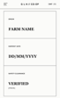 | The newly introduced mobile breakpoint logic successfully allows the page to switch between the two layouts when required and now matches the wireframes.  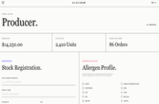
Black box testing/Integration testing – Checking the desktop layout of the metrics grid on viewports larger than 1024px. | width set to 1440px. | The metrics grid should render the three boxes side by side in a structured 3 column layout to utilize the wider screen space and match the layout of all the previous pages. | The grid stacked the metric boxes in a single vertical column, completely bypassing the intended desktop layout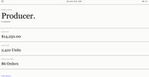 | I updated the CSS to deploy a 3 column grid matrix on the parent container, ensuring the layout correctly targets standard desktop viewports. Regression confirmed: metrics grid collapses to single-column vertical stack on mobile.
Logic Review & UI testing – Reviewing the HTML allergen form against the planned backend validation for products with zero allergens (e.g., fresh carrots). | None | The HTML form should provide a way for farmers to accurately declare that a product is completely allergen-free before the backend validation processes it. | During UI development, I realised the wireframe and HTML only included the 14 mandatory allergens  . Because my planned Algorithm 3 is designed to block submissions if no boxes are ticked  , farmers selling raw vegetables would be completely blocked by the system or forced to submit false data.   | Catching this logical flaw before coding the PHP backend saves significant development time. I improved the UI by adding a "No Allergens Present" checkbox to the HTML form. This directly improves usability and ensures that when the backend is built, farmers can legally verify their produce is safe without triggering false errors.  
Black box testing – Checking the responsive reflow of the 'Order History' on the customer portal data table on mobile viewports | Viewport width scaled down to 400px. | The 5-column order history table should adapt to smaller screens without breaking the global layout or forcing the entire webpage to scroll horizontally. | During UI testing, the strict width of the 5-column table forced the content to overflow the screen boundaries, causing a broken mobile layout and horizontal scrolling on the entire page.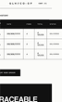 | To fix this, I wrapped the HTML <table> inside a new container <div> and applied the CSS rule overflow-x: auto;. This isolates the scrolling strictly to the table itself, allowing mobile users to swipe through their order history horizontally while keeping the rest of the dashboard layout perfectly locked in place. Regression test confirmed the fix worked.  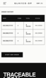
Black box testing – Checking the responsive reflow of the menu bar | Viewport width scaled down to 400px. | The navigation bar should scale down proportionally with the page while maintaining appropriate horizontal padding on the right | When scaled down, the menu bar expanded to take up 100% of the viewport width, completely stripping away the intended side margins. This caused the menu to spread against the edges of the screen, creating a cramped and layout.  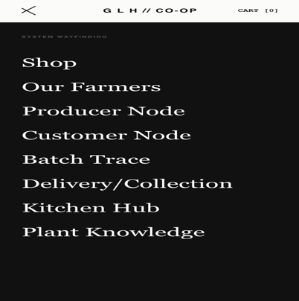 | By using width: calc(100% - 60px);, the drawer will now dynamically scale to the size of any mobile device while strictly reserving a 60-pixel vertical column of the .menu-shield on the right side.  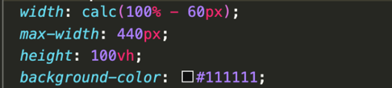
Regression testing – Verifying the menu bar reflow after applying the mobile width fix. | Viewport width scaled down to 400px. | The menu bar should now scale down smoothly while correctly leaving some of the current page visible to the right | The navigation bar scaled successfully retained its side padding, without bleeding into the edges of the screen.   | Verified that the CSS width fix worked exactly as intended. The global menu is now fully mobile-responsive and maintains a useable layout across all device sizes.
Black box testing -> UI testing – Checking the structural and data consistency of the 'Our Farmers' HTML tables across multiple profiles. | Visual comparison of the left-aligned text cards (e.g., Elena Rostova) versus the right-aligned text cards (e.g., Oakhaven Farms | Regardless of whether the text block is positioned on the left or the right side of the alternating layout, all farm profile tables must contain the exact same row headers (Acreage, Distance to Hub, Core Crops, Hygiene Rating) to ensure UI consistency and accurately reflect the planned FARMS SQL database scheme | The cards with text on the left successfully displayed the correct "Hygiene Rating" row, but the cards with text on the right replaced it with a "Status" row. This breaks global UI consistency and fails to map to the planned hygiene rating database column.  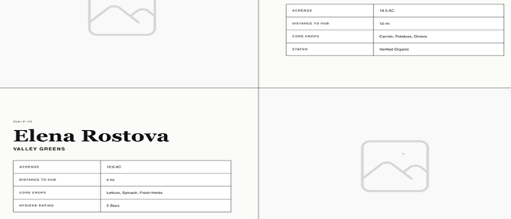 | I updated the HTML to standardise the data tables across both the left-aligned and right-aligned blocks. I replaced "Status" with the mandatory "Hygiene Rating" row on the right-side cards and moved the "Verified Organic" text to the Core Crops row. The frontend tables are now 100% consistent across the entire alternating layout and perfectly mirror the backend database design.  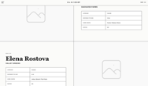
Black box testing - Checking the form submission and UI rendering of the Producer Intake form before adding JavaScript validation and cache-busting | Batch Number: "90210"  Product Name: "TEST1"  Volume: 15  Price: 10  Unit: lbs  Allergens: None selected. | The system should enforce EU allergen compliance and prevent submission if no allergens are selected. If successful, the Active Ledger table should update immediately without a hard page reload. | The form successfully submitted without any allergen data, which violates compliance rules. Additionally, the Active Ledger table did not update to show the new stock because the browser cached the previous state.  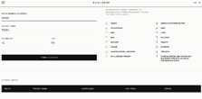 | This fails to satisfy EU Regulation requirements. I will add strict javascript validation to require allergen selection and a cache-busting parameter to ensure the UI updates correctly.
Black box testing - Verifying the updated Producer Intake form validation and performing regression testing on the Shop Produce page after applying the new JavaScript. | Batch Number: "90210"  Product Name: "TEST1"  Volume: 15  Price: 10  Unit: lbs  Allergens: None selected. | The form should block submission if allergens are empty and trigger an alert. With valid data it should submit, update the ledger table immediately, and the global shop produce page should still display all products correctly without errors. | The form did block the submission when there was missing allergern info, however with valid data the ledger did not update still.  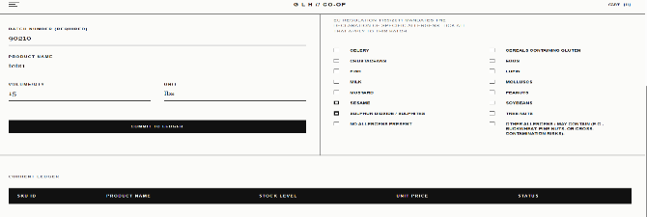  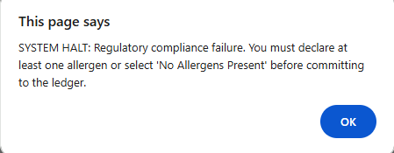 | This perfectly satisfies the EU regulatory requirements. My next action is to fix the ledger not updating.  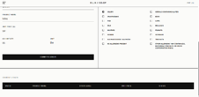  The ledger was not working due to incorrect database table logic and incorrect APIindentation
Integration testing – Checking full-stack data transmission from the Producer Intake Manifest to the database ledger. | Batch Number: "90210"  Product Name: "TEST1"  Volume: 15  Price: 10  Unit: lbs  Allergens: Celery . | The system should successfully process a POST request. The database must update the product_id, and the UI should instantly perform a GET request to refresh the ledger state | The product was successfully committed to the database. The UI instantly rendered the ledger table to display the new entry.  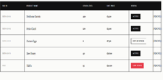 | Operating exactly as intended. Naming conventions (such as product_id) are now perfectly aligned across the backend API and the JavaScript bridge, ensuring full relational synchronization
Black box testing / Integration testing – Checking the backend deletion logic of the "[ Remove ]" action button. | Target: ("Pasture Eggs") | Clicking the "[ Remove ]" button should trigger a confirmation prompt, followed by a DELETE request to the API, safely removing the record from the active stock grid. | The UI remained completely static. no DELETE traffic was detected in the backend system logs. | I identified a logical flaw where the JavaScript function was improperly nested. Furthermore, the backend server lacked a dedicated DELETE handler and CORS pre-flight authorization. I will correct the JavaScript scoping and update the backend to authorise DELETE methods.
Regression testing – Verifying the corrected record deletion routing for the "[ Remove ]" button. | Target: ("Pasture Eggs") | The system should initiate a confirmation alert. Once authorised, the server must process a delete request at the specific endpoint and trigger an immediate state refresh on the UI. | The confirmation alert triggered as expected. The backend logs confirmed the deletion, and the row was immediately removed from the HTML.  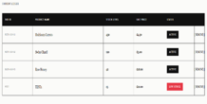 | The fix worked perfectly. CORS is now correctly configured to allow DELETE methods. The inventory system is now robust and fully functional
Integration testing – Verifying static HTML asset delivery vs. API JSON payload routing | Target: (/products.html endpoint) | The backend HTTP server should serve the compiled HTML document when the browser requests /products.html, allowing the UI to render. | The browser displayed raw JSON data text on the screen. The server intercepted the request as an API call rather than a static file request.  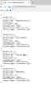 | I identified a routing collision in the Python do_GET handler. The loose matching (startswith('/products')) hijacked the .html extension. I will redo the handler to enforce strict endpoint boundaries. Regression confirmed: HTML file returns 200 OK with correct MIME type; API payload fetched separately.
Black box testing – Validating client-side script execution on the Shop Produce node | Target: (Shop Produce UI / app.js) | The JavaScript data bridge should execute a fetch request on DOM load and dynamically populate the product grid. | The UI remained blank. Developer console flagged a fatal TypeError: Cannot read properties of null. The script aborted execution. | I identified a cross-page contamination error. The script attempted to bind a submit event to an intake form that only exists on the Producer node. I will implement null-check safeguards around node-specific logic. Regression confirmed: app.js bypasses the intake form binding and product grid populates successfully.
Component testing – Verifying the dynamic injection of the Active Ledger table on the Producer Dashboard. | Target: (producer-ledger-body) | Following a successful data ingestion, the active ledger must refresh and display the new stock in a table. | The table body remained completely empty. The console revealed a ReferenceError: populateLedger is not defined, resulting in an immediate execution halt.  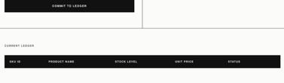 | I identified a structural regression where the populateLedger module was inadvertently truncated during a previous deployment. I will restore the unified script architecture and mandate a hard cache flush.
Regression testing – Verifying the restored UI rendering logic for the Producer Dashboard ledger. | Target: (producer-ledger-body) | The script must correctly resolve the populateLedger function and iterate through the JSON payload to construct the HTML table rows. | The Active Ledger instantly populated upon a hard refresh. System logs confirmed parallel execution of both rendering pipelines.  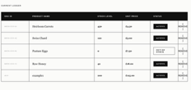 | The unified JavaScript architecture is restored. The client-side injection is fully operational and perfectly synchronized with the backend database state.
White box / Integration testing - Checking the cryptographic hashing and ledger commit during account creation. | {"full_name": "Test User", "email": "test@glhcoop.com", "password": "secure123", "role": "customer"} | The JSON payload should be ingested, the password secured via sha-256 encryption, and the record committed to the sqlite users table without storing them as plain text | the server threw a 500 internal server error. the terminal logged SYSTEM ERROR: Ingestion failure on /register. no such table: users. the python backend caught the missing table and prevented a fatal crash   | dentified that the sqlite ledger had not been rebuilt to include the new iam schema. I will run the updated setup_database.py script to generate the missing table.
regression testing - verifying ledger schema update and successful user registration pipeline | {"full_name": "Test User", "email": "test@glhcoop.com", "password": "secure123", "role": "customer"} | after running the setup_database.py script, the users table must exist. the api must process the payload, return a 201 status code, and the ui should prompt a successful redirect. | the setup script successfully rebuilt the database. the subsequent registration request returned a 201 status. the terminal logged the successful hash and insertion. ui threw the success alert and redirected to the login node.  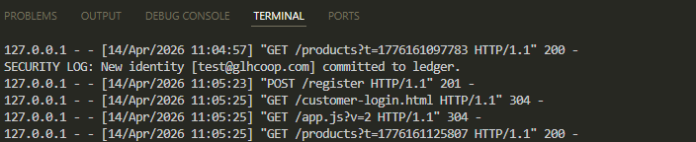 | the database schema is fully aligned with the backend endpoints. the login pipeline is now successfully integrated and operational. 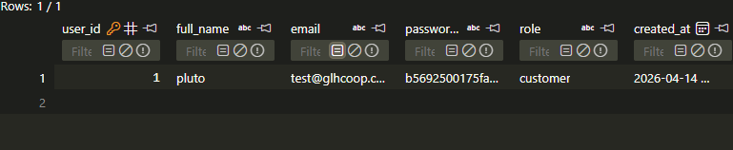
Integration testing - verifying system mitigation against duplicate email identity registration | {"email": "test@glhcoop.com"} | The sqlite uniqueness constraint must reject the payload, triggering a 409 Conflict response to prevent database corruption. | The system correctly intercepted the collision. The backend logged a security alert, and the ui presented a registration denied alert.  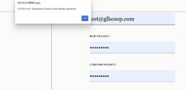 | The database constraints are fully operational, successfully preventing duplicate identities and maintaining ledger integrity.
Integration testing - Validating Role-Based Access Control (RBAC) and asymmetrical routing protocols. | {"email": "test@glhcoop.com", "password": "secure123"} (Account verified as 'customer') | Upon successful hash verification, the API must return a role specific redirect url (e.g., routing a customer strictly to products.html). | Authentication succeeded. The payload delivered the correct role string, and the client-side JavaScript successfully forced the redirect to the storefront node. | The Role-Based routing works exactly as expected, securely sandboxing customer traffic away from the producer terminal.
Black box / Security testing - Verifying the rejection of invalid cryptographic credentials. | Payload: {"email": "test@glhcoop.com", "password": "wrongpassword!"} | Providing an incorrect passkey must fail the SELECT query verification, returning a 401 Unauthorized status | The backend logged an unauthorized access attempt. The UI blocked the redirect, alerted the user, and cleared the passkey input field for retry.  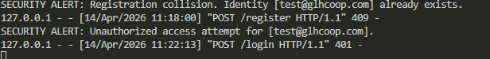 | The authentication gate is secure. Unauthorized access attempts are successfully intercepted and logged without breaking the frontend UI.
Black box / Security testing - Validating Producer Terminal access control against standard customer credentials. | Node: Producer Login  Payload: {"email": "test@glhcoop.com", "password": "secure123"} | The Producer Terminal should explicitly reject the customer credentials with an unauthorized alert, preventing session initialization. | The system authenticated the user redirected to the customer storefront (products.html). The terminal failed to hard-bounce the cross-node access attempt.  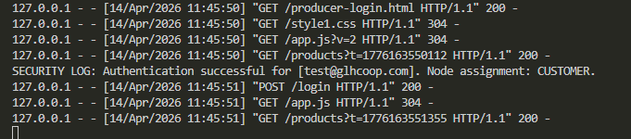 | Mitigation requires passing a requested_node parameter from the UI and enforcing strict asymmetrical ACL rules in the backend routing
Regression testing - Verifying strict ACL enforcement and hard-bounce logic on the Producer Node. | Node: Producer Login  Payload: {"email": "test@glhcoop.com", "password": "secure123", "requested_node": "producer"}  DB Role: customer | The API must intercept the context mismatch, abort the routing protocol, and return a 403 Forbidden status. The UI must alert the user of denied clearance. | The server correctly logged a security hard bounce and returned a 403 status code. The UI successfully intercepted the error, displayed the clearance denied alert, and halted the redirect.  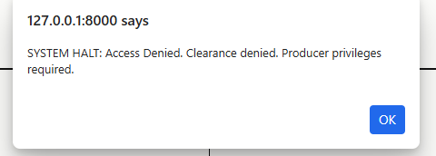 | The ACL patch successfully closed the authorization loophole. The Producer Terminal is now strictly fenced against customer credentials.
Integration testing – validating multi-tenant relational integrity. | Adding 6 producer accounts to the database | The shop grid must display items from multiple distinct producers simultaneously with zero data leakage. | The database correctly mapped each asset to its owner. the ui rendered all unique farm names in the shop grid. | The cod worked as expected
integration testing - verifying batch provisioning of the farmer directory identities. | Source: farmers list  Password: secure123  Role: producer | the ledger must accept all six unique email identities and hash their credentials without overwriting existing data. | script executed cleanly. 6 new producer identities committed. existing farm@glhcoop.com remains intact.  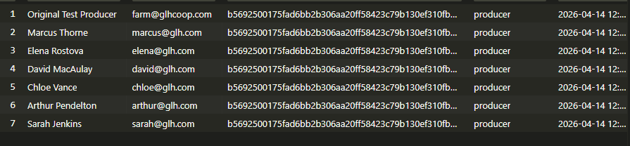 | the producer node is now scaled for multi- account directory testing. Regression confirmed: original producer authenticated and session data populated correctly.
Black box testing - Checking that the "ADD TO CART" button serializes data to local storage. | None | Clicking the cart button updates the global navigation counter and saves the item in the browser's local storage array. | The button behaved as expected, the cart counter incremented, and the item persisted in memory after a page refresh.  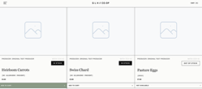 | The code worked as expected
White box testing - Checking that the system prevents users from requesting more stock than is available | Input an order quantity greater than the product stock level | The system should trigger a halt alert and force the input value back down to the maximum available stock limit. | The system successfully intercepted the invalid input, displayed the alert, and corrected the value to the maximum stock limit.  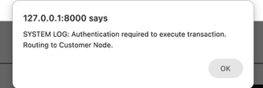 | The validation logic is structurally sound and effectively prevents overselling.
Black box testing - Checking that the active cart dynamically recalculates order totals and delivery fees. | None | Modifying item quantities or toggling the delivery radio buttons should instantly update the subtotal, apply a £5.00 delivery fee if selected, and output the correct grand total. | The mathematical rendering updated in real-time without requiring a page refresh. All calculations were accurate.  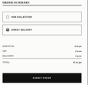 | The dynamic DOM bindings are functioning correctly for the final checkout payload.
Black box testing - Checking that the checkout endpoint enforces the authentication gate. | None | Clicking "SUBMIT ORDER" while unauthenticated or logged in as a producer should trigger an alert and route the user to the Customer Login node. | The system correctly blocked the transaction and routed the unauthenticated session to the login screen.  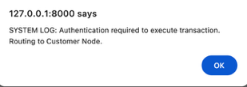 | The hard bounce logic protects the database from anonymous transaction injections.
Integration testing - Checking the end-to-end execution of the atomic checkout payload. | Valid customer credentials (test@glhcoop.com, secure123). | Submitting a valid cart payload should return a success status, alert the Order Ref ID, empty the cart, and route the user to the portal. | The backend returned a 201 Created status, the UI handled the success response perfectly, and the cart was purged.  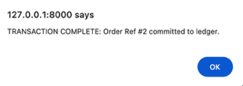 | The API bridge between the frontend cart and the Python backend is fully operational.
Regression testing: Checking customer login routes to the Customer Portal, not the Storefront. | Email: test@glhcoop.com  Alias : pluto  Password: secure123  Node: Customer Login | API redirect_url must point to customer-portal.html. | API returned redirect_url: customer-portal.html. Portal loaded with the personalised welcome header. | Previous behaviour sent customers to products.html. Server-side routing updated to the correct destination.
Black box testing: Checking the Producer Terminal identity header displays the correct producer name and farm title after login. | Login as a registered producer account (marcus@glh.com). | Terminal header must render TERMINAL // [NAME] and the producer ID span must show the full name. | Header correctly displayed TERMINAL // MARCUS THORNE. LOADING ARCHIVE placeholder was replaced immediately. | The code behaved as expected.
Black box / Security testing: Checking the page guard on the Customer Portal rejects unauthenticated visitors. | No session in localStorage. Navigate directly to customer-portal.html via the URL bar. | initSessionUI must detect missing session_user_id and redirect to customer-login.html before portal renders. | Redirect fired correctly. Portal HTML was never visible. Browser landed on the login page. | Prevents anonymous users from bookmarking or directly accessing the portal URL.
Black box testing: Checking the Logout function clears all session state and routes the user to the homepage. | Active session in localStorage (session_user_id, session_role, session_full_name). Click the LOGOUT nav link. | All three session keys must be removed from localStorage and browser must redirect to index.html. | Clicking LOGOUT cleared all three localStorage keys (confirmed via DevTools). Browser navigated to index.html. Revisiting the portal triggered the page guard redirect. | Session termination is complete. No residual state left in the browser after logout.
Integration testing: Checking the account deletion endpoint removes the user record and all associated products from the database, then terminates the session. | Authenticated customer session. Open Manage Account modal, click DELETE ACCOUNT and confirm the system query dialog. | DELETE /users/{id} must return HTTP 200 and log ACCOUNT DELETION LOG only. Session must clear and browser redirect. | FAIL. DELETE /users/{id} returned HTTP 501 on every attempt. No DELETE handler was reached. | Root cause: def do_DELETE(self): was missing. The deletion body was orphaned inside do_PUT as floating code. Python never registered a DELETE handler so the server returned 501. Fix: restored do_DELETE as its own independent class method.
Regression testing: Checking the account deletion endpoint removes the user record and all associated products from the database, then terminates the session. | Authenticated customer session. Open Manage Account modal, click DELETE ACCOUNT and confirm the system query dialog. | DELETE /users/{id} must return HTTP 200 and log ACCOUNT DELETION LOG only. Session must clear and browser redirect. | FAIL. DELETE /users/{id} returned HTTP 501 on every attempt. No DELETE handler was reached. | Root cause: def do_DELETE(self): was missing. The deletion body was orphaned inside do_PUT as floating code. Python never registered a DELETE handler so the server returned 501. Fix: restored do_DELETE as its own independent class method.
White box testing: Checking the POST /consent endpoint correctly logs GDPR preference data to the cookie_consent table. | Payload: {"token": "GLH-TEST-001", "analytics": true, "marketing": false} | API must INSERT into cookie_consent with strictly_necessary=1, analytics=1, marketing=0 and return HTTP 201. | API returned {"status": "success"} with HTTP 201. SELECT on cookie_consent confirmed the row with correct flags and a valid consented_at timestamp. | cookie_consent table auto-created on first connection. INSERT OR REPLACE ensures re-submissions update rather than duplicate.
Black box testing: Checking that the GDPR consent modal does not reappear on subsequent visits to the homepage after consent has been given. | Accept the consent modal on the first visit. Close the browser tab. Reopen index.html in the same browser profile. | On the second visit, the consent overlay element (#consent-intercept) must be hidden on DOMContentLoaded. The session-scoped key (glh_consent_{userId}) must be present in localStorage. | PARTIAL FAIL. The modal did not reappear, but this was because glh_consent_given was a single global key shared across all users and sessions. Logging out did not clear it. A different user on the same browser would never see the consent form, which is non-compliant behaviour. | Fix: consent key changed to glh_consent_{userId} for logged-in users and glh_consent_anon for anonymous visitors. logout() now removes the departing user's consent key. See regression row below.
Regression testing: Checking the ACCEPT ALL button sets both analytics and marketing flags to true in the database. | Visit index.html with no prior consent. Click ACCEPT ALL. | The submitConsent(true, true) function must post analytics=true and marketing=true to the API. The cookie_consent row must record analytics=1 and marketing=1. | COULD NOT TEST at this stage. glh_consent_given was already set in localStorage from a prior session, blocking the modal from appearing entirely. The ACCEPT ALL button was never accessible. See regression row below after the consent key bug was fixed. | This test was unblocked after the consent key was made session-scoped. The regression row below confirms ACCEPT ALL correctly fires POST /consent with analytics=true, marketing=true and both flags are set to 1 in the cookie_consent table.
Integration testing: Checking the Update Details form commits name and email changes via PUT /users/{id} and immediately reflects them in the UI. | Authenticated customer session. Open Manage Account > Update Details. Change full name to ‘Test User Updated’ and submit. | PUT /users/{id} must UPDATE the row and return the new full_name. session_full_name and welcome title must update live. | PUT /users/{id} returned HTTP 200 with updated full_name. localStorage updated. Welcome title refreshed without a page reload. | Failure was caused by do_DELETE body orphaned in do_PUT, silently deleting the account on every update. Fix: do_DELETE restored as its own method.
White box testing: Checking that submitting the Update Details form with a blank password field does not overwrite the existing password hash. | Login to a verified account, open update details. change only the name field. leave the new passkey field blank and submit. | API must run UPDATE SET full_name=?, email=? (no password_hash) when password field is empty. | PUT handler branched correctly on empty password. Database inspection confirmed password_hash unchanged. User still authenticated with original passkey. | Conditional branch (if raw_password: ... else: ...) is the key control. Verified by reading the db row before and after.
Black box / Security testing: Checking the Producer Ledger only displays stock entries belonging to the currently authenticated producer. | Log in as Producer A (e.g. marcus@glh.com). Ensure Producer B (e.g. elena@glh.com) has at least one product in the database. | Ledger must only render rows where product.producer_id matches session_user_id. | Ledger showed only Marcus's products. Elena's products were absent. Raw API confirmed all products returned server-side; filtering happened client-side in distributeData(). | Fix added a .filter() in distributeData() comparing producer_id against session_user_id. Shop grid remains unfiltered.
White box testing: Checking the checkout endpoint performs a stock-level pre-flight check before committing any database writes. | Cart: 1 item (Pasture Eggs, stock_level=0). Expected: rejection before any INSERT. | If quantity exceeds available stock, endpoint must rollback, return HTTP 400, and write nothing to ORDERS or ORDER_ITEMS. | API returned HTTP 400 with Insufficient stock for Pasture Eggs. ORDERS and ORDER_ITEMS confirmed no new rows. | Pre-flight SELECT runs before BEGIN TRANSACTION, ensuring the database is never left in a partially written state.
Integration testing: Checking POST /checkout correctly INSERTs a master receipt row into the ORDERS table with the correct customer_id and total_price. | Cart: 1x Swiss Chard (product_id=2, price=3.00). Delivery: Hub Collection. | API must INSERT one row into ORDERS with correct customer_id, order_time timestamp, and total_price. Response must return order_id. | POST /checkout returned HTTP 201 with valid order_id. SELECT on ORDERS confirmed correct customer_id, non-null order_time, and total_price=3.0. | INSERT uses customer_id and total_price from the payload. order_time auto-populated by DEFAULT CURRENT_TIMESTAMP.
Integration testing: Checking POST /checkout correctly INSERTs one line-item row per cart product into the ORDER_ITEMS table, linked to the master order. | Cart: 1x Heirloom Carrots (product_id=1), 2x Swiss Chard (product_id=2). | API must INSERT one row into ORDER_ITEMS per product with correct order_id FK, product_id, and quantity. | SELECT on ORDER_ITEMS returned 2 rows: (product_id=1, quantity=1) and (product_id=2, quantity=2). Both carried correct order_id. No duplicate rows. | API loops over the cart array, one INSERT per item. order_id FK taken from cursor.lastrowid after ORDERS INSERT.
Integration testing: Checking POST /checkout correctly decrements the stock_level in the PRODUCTS table for each purchased item, preventing overselling. | Pre-checkout stock: Carrots=447, Chard=115. Cart: 3x Carrots, 2x Chard. | PRODUCTS table must reflect reduced stock matching quantities purchased. UPDATE must use stock_level = stock_level - quantity. | SELECT on PRODUCTS confirmed Carrots=444 (decreased by 3) and Chard=113 (decreased by 2). | UPDATE uses stock_level = stock_level - ? inside the same atomic transaction as ORDERS and ORDER_ITEMS INSERTs.
White box testing: Checking the checkout transaction rolls back all three operations atomically if any step fails mid-transaction. | Simulated failure: valid cart referencing a non-existent product_id to force an exception after ORDERS INSERT. | If ORDER_ITEMS INSERT raises an exception, all three operations must roll back. ORDERS table must not retain the partial receipt. | Exception triggered connection.rollback(). SELECT on ORDERS confirmed partial receipt was absent. stock_level unchanged. API returned HTTP 500. | Entire checkout is wrapped in BEGIN TRANSACTION / commit() / rollback(). try/except/finally ensures rollback fires on any exception.
Integration testing: Checking the Customer Portal order history table renders live data from GET /orders/{customer_id} rather than hardcoded placeholders. | Authenticated customer session with at least 1prior order in the ORDERS table.  Navigate to customer-portal.html. | order-history-body tbody must be populated by GET /orders/{session_user_id}. Rows must show GLH-formatted reference, date, item count, total, and status. | Portal populated with 2 rows matching database records. References formatted as GLH-000004. Dates formatted DD/MM/YYYY. Item counts and totals matched. No #### placeholders. | The portal is now fully data-driven. Regression confirmed: stock decremented correctly per order; ORDER_ITEMS held independent rows.
Add more rows and tables as required.

