F O R M 2
THE PATENTS ACT, 1970
(39 of 1970)

COMPLETE SPECIFICATION
(See section 10 and rule 13)
- Title of the Invention:
‘Artificial Embedded Robotic Operational Nexus (AERON)’

Name of the Applicant:
PSG Institute of Technology and Applied Research
Address for communication:
The Principal
PSG Institute of Technology and Applied Research
Avinashi Road, Neelambur,
Coimbatore - 641 062, Tamil Nadu.
Phone No: 0422 3933400
&
Nationality:
INDIAN
- Preamble of the Description:
The following specification particularly describes the invention and the manner in which it is to be performed.

DESCRIPTION:
TITLE: Artificial Embedded Robotic Operational Nexus (AERON)
FIELD OF THE INVENTION
The present invention relates to the field of robotics, artificial intelligence, and emergency response technologies. More specifically, the invention pertains to an autonomous, edge AI-powered robotic system designed for deployment in disaster management scenarios. The invention combines advanced mobility, real-time environmental sensing, autonomous navigation, and human-interactive capabilities to support search and rescue missions, victim assistance, and situational awareness in hazardous or inaccessible environments. The system is capable of functioning with minimal connectivity, enabling intelligent operations in network-deprived, high-risk disaster zones.

BACKGROUND OF THE INVENTION
Disasters such as earthquakes, floods, and industrial accidents often create hazardous environments that hinder timely rescue efforts and endanger human responders. Existing robotic systems used in such scenarios are typically limited by their reliance on external connectivity, lack of autonomy, and inability to navigate unstructured terrain effectively.
Moreover, most current robots are task-specific and lack the capability to interact with victims. In disaster situations, victims may suffer from trauma or anxiety and require not just rescue, but also emotional support and communication.
There is a growing need for a robust, autonomous robotic system that can operate without network dependence, perform real-time sensing and navigation, and also function as a companion robot—capable of engaging with victims, providing reassurance, and aiding in information gathering during emergencies.

OBJECTIVE OF THE INVENTION
The principal object of the invention is to develop an autonomous, cost-effective, and rugged edge-AI-powered robotic system capable of assisting in disaster-struck areas by performing search and rescue operations, real-time environmental monitoring, and victim support, especially in situations where human intervention is limited or dangerous.
1 A further objective of the invention is to enable the robotic system to navigate autonomously in unstructured and hazardous environments such as collapsed buildings, debris fields, or flood-affected areas using on-board obstacle detection sensors, GPS-denied navigation techniques, and AI-based path planning algorithms.
2 Another objective of the invention is to integrate real-time edge computing capabilities, including computer vision, object detection, thermal sensing, and LiDAR/IR-based mapping, to ensure on-device decision-making with minimal latency and without dependence on external networks or cloud infrastructure.
3 Yet another objective of the invention is to implement a human-detection and recognition system that can identify victims through thermal signatures, motion tracking, or voice detection, enabling quick identification of trapped or injured individuals.
4 Still another objective of the invention is to enable Aeron to function as a psychological companion robot, offering interactive communication, emotional reassurance, and basic natural language processing (NLP) capabilities to calm and support disaster victims until human help arrives.
5 A further objective of the invention is to implement a text-to-speech and speech-to-text interface that allows Aeron to communicate bidirectionally with victims, respond to verbal questions, and provide guided instructions or reassurance in real time.
6 Yet another objective of the invention is to allow the robot to collect and transmit critical health and situational data of victims — including body temperature, consciousness level, environmental conditions, and GPS coordinates — to central command units or rescue teams for immediate action.
7 Still another objective of the invention is to act as a communication relay device in areas with damaged or unavailable network infrastructure by establishing localized mesh networks or temporary communication bridges for message transmission between victims and responders.
8 A further objective of the invention is to equip the robotic system with a modular and shock-resistant mechanical design, IP-rated protective casing, and multi-terrain mobility for reliable operation in extreme environmental conditions such as dust, water, heat, or narrow spaces.
9 Yet another objective of the invention is to enable multi-unit collaboration, allowing multiple Aeron robots to work together via wireless communication to cover larger areas, share mapping data, and perform coordinated search operations.
10 Still another objective of the invention is to provide an easy-to-use operator interface for pre-configuration, monitoring, and mission control, as well as integration with existing emergency response systems and cloud dashboards (where network is available).
11 A further objective of the invention is to provide a logging mechanism that securely stores time-stamped sensor data, interaction history, location trails, and audio logs during missions, with encryption standards applied for data integrity and privacy.
12 Yet another objective of the invention is to include an automated reporting system where the robot prints, uploads, or transmits summarized field reports or victim data immediately upon mission completion or network availability.

BRIEF DESCRIPTION OF PRIOR ART
Patent number: CN118377246A | Title: Unmanned vehicle system for earthquake disaster rescue and control method
Date Of Filing:19-03-2024 |  | Country: Canada | Status: Pending

This invention describes an AI-powered unmanned vehicle system for earthquake disaster relief. It includes ground vehicles, drones, small rescue robots, a rescue mechanical arm, and a first aid unit. The drones handle aerial scouting and communication setup, while robots conduct detection and material transport. Rescue operations and medical aid are carried out via vehicle-mounted units. The system can be remotely controlled or operate autonomously to improve rescue efficiency in disaster zones.
COMMENTS: A highly integrated and autonomous system that enhances disaster response efficiency through coordinated robotic units and AI.

Patent number: KR102771512B1 | Title: A cluster robot system for disaster rescue and a method of searching and transporting objects in a disaster environment using it.
Date Of Filing:19-11-2024 | Country: South Korea | Status: Published
This invention presents a swarm robot system for disaster relief, handling search, rescue, and material transport tasks. The system enables autonomous, efficient operation through coordinated interaction among multiple robot agents. It adapts to complex environments with minimal human intervention. A centralized control system ensures stability and reliability. The method includes identifying and transporting disaster-related objects. Overall, it offers a smart, scalable solution for disaster response.
COMMENTS: A highly adaptive and autonomous swarm robot system enhancing disaster relief efficiency through coordinated operations
Patent number: CN119818890A | Title: Fire-fighting robot-based fire-fighting rescue emergency treatment system.
Date Of Filing:21-02-2025 | Country: Canada | Status: Pending
This invention presents a firefighting and rescue emergency disposal system using intelligent firefighting robots. Each factory building is equipped with a monitoring system that sends real-time data to a central control room. The control room detects emergencies and directs the firefighting robot to respond. The robot autonomously inspects areas, identifies fire hazards, and takes appropriate actions. It also reports incidents back to the control room. This system enhances both early warning capabilities and emergency response efficiency in industrial settings.
COMMENTS: This patent showcases an intelligent firefighting system that enhances real-time monitoring and autonomous response in industrial environments. It significantly improves early detection and rapid intervention during fire emergencies. The integration of smart robots reduces human risk and increases overall factory safety.
Patent number: US20220410370A1 | Title: Autonomous Navigation and Collaboration of Mobile Robots in 5G/6G.
Date Of Filing: 24-05-2019 | Country: United States | Status: Published
This patent describes a system enabling fixed and mobile robots to autonomously identify nearby robots, determine their precise locations, and collaborate efficiently. It leverages 5G and 6G technologies to achieve faster, more accurate positioning than traditional satellite navigation. The system addresses challenges in robot-to-robot recognition and coordination. It ensures collision avoidance and communication efficiency among large groups of robots. Applications span across emergency and disaster management, healthcare, firefighting, agriculture, manufacturing, and logistics. This innovation enhances automation, safety, and coordination in complex environments.
COMMENTS: This patent introduces a highly scalable solution for autonomous robot coordination using advanced 5G/6G connectivity. It effectively addresses limitations in current localization and communication technologies. The approach significantly enhances multi-robot collaboration and safety in dynamic environments. Its applicability to disaster response, healthcare, and industrial automation makes it highly impactful and forward-looking.

Patent number: JP2023119271A | Title: Rescue support system and rescue support method.
Date Of Filing:16-02-2022 | Country: Japan | Status: Pending
This patent proposes a system that allows mobile workplace robots to be redirected for rescue operations. It includes a controller with a storage unit that tracks each robot’s current position and operational state. When a rescue request is received, the system uses this data to select the most suitable robot based on proximity and availability. A robot selection unit determines which robot should assist the person in need. The robot control unit then sends commands to guide the selected robot to the rescue location. This system enhances workplace safety by enabling dual-use of robots for both routine work and emergency response.
COMMENTS: This patent presents an intelligent control mechanism that enables mobile robots, originally assigned to workplace tasks, to be diverted for rescue operations in emergencies. By utilizing stored robot position and state information, along with the real-time location of individuals in need, the system autonomously selects and redirects the most suitable robot to assist. This innovation greatly enhances emergency responsiveness, optimizes robot usage, and improves overall workplace safety with minimal human intervention.

Patent number: CN105397817A | Title: Emergency rescue robot
Date Of Filing: 22-12-2015 | Country: China | Status: Pending
This patent introduces a multifunctional emergency rescue robot designed for high-efficiency operations in disaster scenarios. It comprises a chassis, hoisting arm, double front arms, and advanced components such as a hydraulic system and a head-shaped detection unit. The robot supports search and rescue operations, including excavation, crushing, lifting, grabbing, and more. It is capable of operating off-road and delivers high-speed responses with stable mobility. The system allows manual, remote, and computer-based control, enabling multi-mode communication between operators, victims, and other equipment. This robot enhances rescue effectiveness while reducing human risk in hazardous environments.
COMMENTS: This emergency rescue robot demonstrates a highly versatile and capable design suitable for complex disaster scenarios. Its multifunctionality and ability to operate in off-road conditions make it a strong asset in emergency response. The inclusion of multiple control modes and communication capabilities enhances operator flexibility. However, the complexity of the system may lead to high production and maintenance costs, which could limit widespread deployment.

Patent number: CN113144470B | Title: Fire-fighting emergency early warning treatment and fire extinguishing integrated control system.
Date Of Filing: 07-04-2021 | Country: China | Status: Published
This patent presents an integrated fire-fighting emergency response system comprising inspection robots, fire-fighting robots, an intelligent automatic water hose connector, a smart charging device, a 5G communication network, and a centralized intelligent scheduling and monitoring platform. The system enables unified management, scheduling, and inspection of fire-fighting robots, while leveraging 5G technology for real-time transmission of videos, images, and control signals. It supports multi-robot collaborative action with both early warning and fire suppression functions, allowing for swift response to initial fire outbreaks. This rapid intervention capability provides critical time for the arrival and deployment of full-scale fire-fighting resources.
COMMENTS: This invention offers a positive and promising advancement in fire-fighting technology by integrating 5G communication, intelligent scheduling, and robotic automation. The ability to detect and respond to fires in real time with coordinated multi-robot actions significantly enhances emergency response efficiency. Its early warning and rapid intervention features are particularly valuable in minimizing damage and saving lives. However, practical deployment may face challenges like infrastructure requirements for 5G and high initial costs.

SUMMARY OF THE INVENTION
The basic visual of this project is to establish an immediate Search and Rescue (SAR) operations in the area of natural calamities where it is impossible for rescuers to search and help people who are under debris and obstacles, and the robot is customized to be a companion to humans, our solution “AERON” solves these issues and surpasses all the present solutions to these problems in an efficient way.

The current invention reveals a multimodal AI-driven robotic system through speech, vision, physical control, and AR/VR. The invention comprises an autonomous robot—referred to as AERON (Autonomous Embedded Reasoning Operational Node)—that executes a lightweight large language model (LLM) on an edge computing device like NVIDIA Jetson Nano, facilitating contextual understanding, conversation management, task execution, and feedback generation without cloud inference.

One unique aspect of the invention is its employment of an extended reality (XR) interface, specifically the Meta Quest 3. The system employs the Meta Quest 3 as both the command input device and the visualization device, enabling user interaction with a simulated model of the robot in an augmented environment. Voice commands provided through the Quest 3 are locally processed through a miniature speech-to-text (STT) engine on the device or an attached computer, thereby preventing latency and ensuring privacy. The resulting text input is sent to an ESP32 microcontroller over a secure wireless protocol, which is also the interface for robot mobility, behavior selection, and sensor feedback loops.

The ESP32 module handles low-level control logic and communicates with peripheral devices such as ultrasonic sensors, IMUs, servo motors, and LED indicators. The robot natively supports detection, comprehension, and response to voice commands, and visual input, through a suite of sensors and cameras. Multimodal input parsing, where visual input, textual requests, and spatial data are fused to generate intelligent output, is facilitated through the onboard vision and the LLM integration. This enables AERON to execute dynamic real-world tasks such as object following, task delegation, affect-based interaction, and situational awareness. In addition, the system is constructed to operate in a cyclical control state machine, alternating between listening, interpreting, acting, and responding states. This keeps the robot in a state of readiness to receive new commands at all times while, at the same time, carrying out commands that have already been accepted. The integration of an on-device STT and light LLM provides complete autonomy without the need for internet access, and hence, it is ideal for mission-critical or offline applications. In addition to its primary functionality, the invention provides command input through a local mobile app or web interface hosted by the ESP32 on a local area network, thus offering greater flexibility and flexibility in different environments.

This technology is relevant to a wide range of applications—educational robotics and assistive technology, edge-AI research platforms, and intelligent companions. The module-based structure provides simple customization and scaling based on use-case demands, and the XR-based control and simulation interface brings an entirely new level of human-robot interaction, particularly in training, prototyping, or remote assistance. The system here is a breakthrough for embodied AI, integrating AR/VR, NLP, edge computing, and robotics into one seamless user experience.

BRIEF DESCRIPTION OF THE ACCOMPANYING DRAWING

The embodiment of the present invention is illustrated with the help of accompanying drawings.
Figure 1.1 Illustrates a flowchart of the working of the AERON , according to the present invention.
Figure 1.2 illustrates a diagram representing the design of the Artificial Embedded Robotic Operational Nexus ( AERON), according to the present invention.
Figure 1.21 illustrates the torso of the AERON robot where the torso is responsible for the overall area to accompany electronic components.
Figure 1.3 illustrates a diagram representing the external components of AERON, according to the present invention.
Figure 1.4 illustrates a diagram representing the internal components of AERON, according to the present invention.

DETAILED DESCRIPTION OF THE INVENTION

The invention is focused on an autonomous robotic assistant using artificial intelligence with multi-modal interaction capability, which is primarily intended to interact with users in a number of modes, such as voice, gesture, and digital control. It uses a light on-device language model (SLM) that is deployed on an edge device, i.e., the Jetson Nano, thus enabling offline natural language understanding and context-sensitive response generation. The system also has a new augmented reality/virtual reality (AR/VR) interface over the Meta Quest 3, enabling voice commands for communication by the users. The voice commands are locally processed with the support of an embedded speech-to-text (STT) model and streamed to an ESP32-based module via low-latency wireless communication. The ESP32 acts as a central aggregator for user inputs and robotic outputs, enabling movement, task execution, and feedback delivery mechanisms.

The robotic system includes a speaker and microphone configuration for direct interaction, thus facilitating its use as a standalone conversational assistant. The voice processing system includes onboard keyword recognition as well as emotional intonations to facilitate more anthropomorphic interaction experience. The large language model is also coupled with onboard computer vision to facilitate object detection, facial recognition, and gesture recognition in real-time. The overall system architecture is modular with physical buttons and tactile interfaces for facilitating alternate interaction modalities, especially useful for accessibility-focused applications. The robot's operational logic is implemented as a looped control-flow system, which facilitates smooth transition across idle, input, processing, and execution states, thus maintaining responsiveness to ongoing user interaction without relying on remote cloud services.

Claims:

I/We claim:
- A system for autonomous human-interactive robotic assistance and simulation, comprising:
- A uniquely designed AI-powered physical robot chassis (201);
- A Raspberry Pi or Jetson Nano-based processing unit for onboard computation (202);
- A lightweight custom-built Language Learning Model (LLM) for speech interaction and intent parsing (203);
- A speaker and microphone assembly for real-time audio interaction (204);
- An ESP32-based wireless microcontroller unit for data reception and peripheral control (205);
- A servo motor system integrated into robotic limbs for motion and gesture simulation (206);
- A set of sensors including ultrasonic and IMU modules for spatial awareness and balance (207);
- An onboard battery management system for power regulation and safety (208);
- A VR/AR interface hosted on Meta Quest 3 for immersive robot simulation and control (209);
- A wireless communication protocol stack (e.g., Wi-Fi/BLE) for real-time data transmission between the Meta Quest 3 and the robot (210);
- A digital avatar rendered inside the VR space for visualization and interaction (211);
- A speech-to-text (STT) engine integrated within Meta Quest 3 or the robot for parsing voice commands (212);
- A command routing engine for relaying processed intent from VR to ESP32 and subsequently to Jetson Nano (213);
- A feedback system with real-time status display and error logging (214);
- A gesture control module integrated with the Quest 3 for additional input modes (215);
- A modular software framework allowing plug-and-play functionality for future upgrades (216).

- A system for autonomous control of a physical robot via augmented reality, comprising a wearable AR device, an edge-deployed language model, and a microcontroller interfaced with robotic actuators.
- A method for interpreting natural language voice commands using a lightweight on-device transformer model and translating them into robotic movement instructions executed via a wireless control module.
- A real-time communication interface between an AR headset and a microcontroller, enabling low-latency bidirectional transfer of control data and sensor feedback without reliance on cloud services.
- A robotic control system comprising a speech recognition engine, a natural language parser, and a secure local communication bus for executing commands in offline mode.
- A framework for simulating robotic behavior in an augmented reality environment, allowing users to preview and debug physical actions through real-time virtual rendering.
- An educational interface integrating a small language model with AR visualization to assist users in understanding robotic actions, operations, and feedback through interactive dialogue.
- A command-processing system wherein the user’s voice input is converted to action tokens using a custom-trained intent classification engine optimized for edge devices.
- An AR-based robotic assistant system configured to render virtual overlays of robot actions synchronized with physical execution, enhancing user feedback and learning.
- A privacy-preserving language interaction module for edge robotics, designed to function entirely offline using pre-trained language models and local speech-to-text engines.
- A low-power robotic interface architecture utilizing ESP32 and Jetson Nano to create a local wireless control environment for executing spoken commands without internet connectivity.

Dated this _______Day of _______2025

Signature of the applicant

Dr. N. Saravanakumar
Principal,
PSG Institute of Technology and Applied Research

ABSTRACT
Title: Artificial Embedded Robotics Operational Nexus ( AERON)

The invention in the current context describes an artificial intelligence-based autonomous robotic system, designed for offline, real-time interaction through natural language processing, computer vision, and spatial perception. This system, known as AERON (Autonomous Embedded Reasoning Operational Node), integrates a light-weight large language model (LLM) run on an edge device, i.e., the Jetson Nano, with a control module based on a microcontroller (ESP32) for real-world task execution. It includes speech recognition, object recognition via vision, locomotion via servo-based motion, and augmented reality (AR) via the Meta Quest 3, thus providing user interaction with the robot in the form of voice, text, or simulated worlds.
The innovation enables interaction from multiple devices through a locally hosted web interface and voice control under non-internet conditions. Modular architecture facilitates seamless transition between multiple control states such as listening, running, and responding. AERON operates real-time independently, and it is perfect for assistive, educational, and research applications where responsive and smart edge-deployed behavior is required. The interplay of XR, embedded AI, and multimodal control is opening up new possibilities for personalized robotic systems.

Dated this _______Day of _______2025

Signature of the applicant

Dr. N. Saravanakumar
Principal,
PSG Institute of Technology and Applied Research

FIG 1.1 | FLOW CHART OF SYSTEM
FIG 1.2 | COMPONENTS OF EXTERNAL SYSTEM
FIG 1.3 | COMPONENTS OF INTERNAL SYSTEM

FLOW CHART OF THE SYSTEM

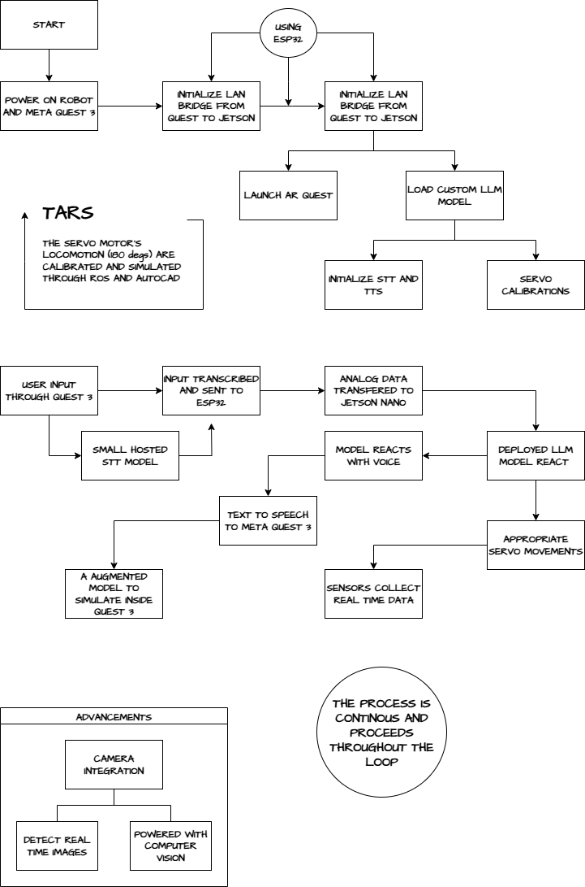
FIGURE 1.1

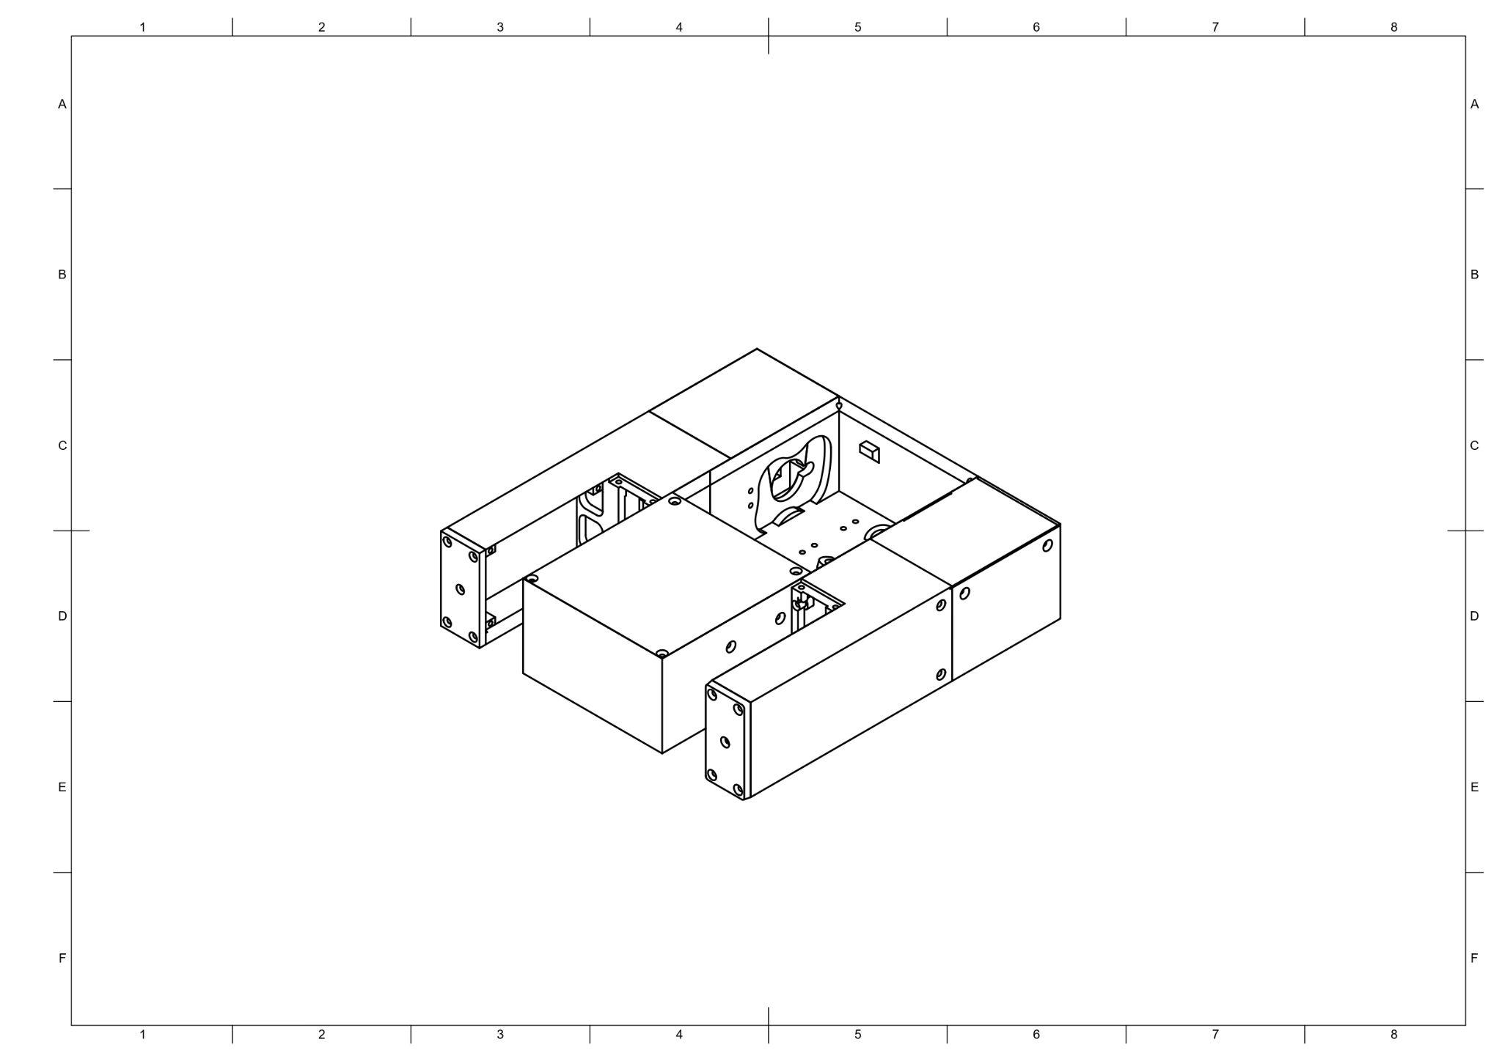
FIGURE 1.2

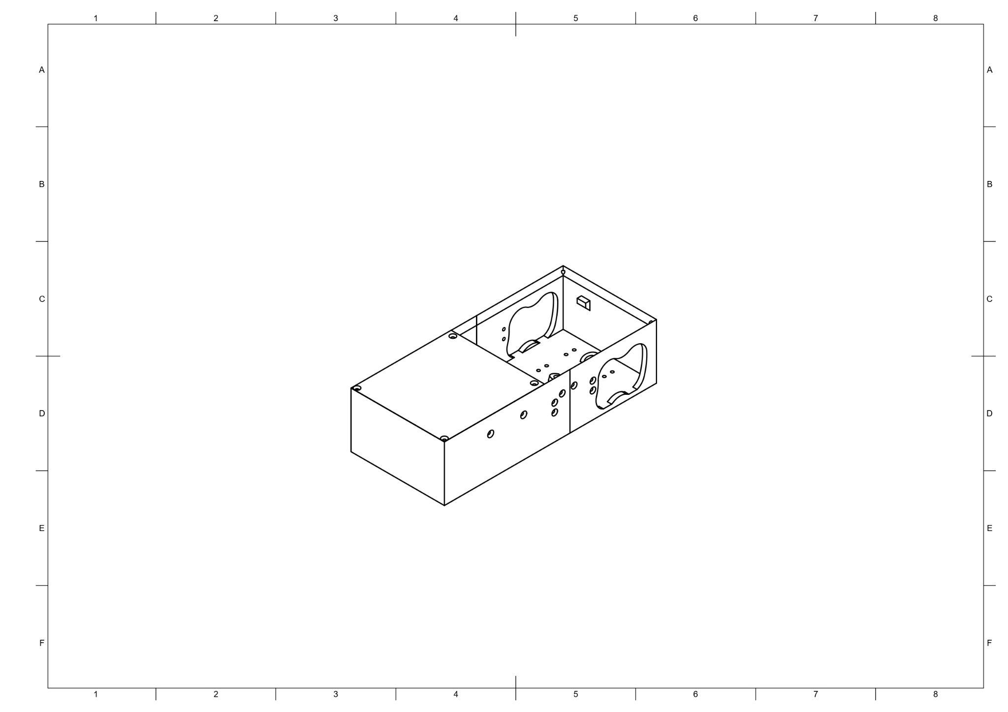
FIGURE 1.21

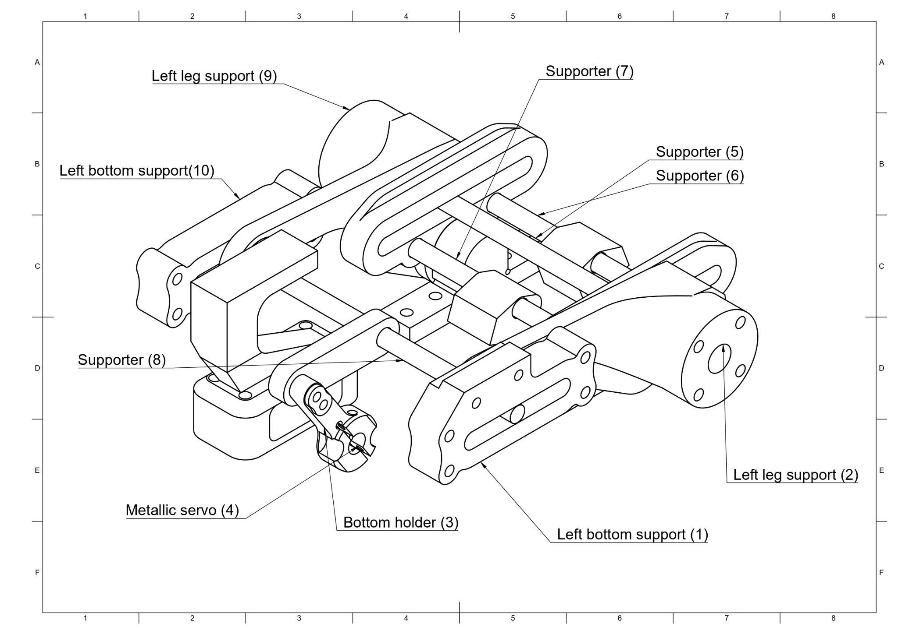
FIGURE 1.3

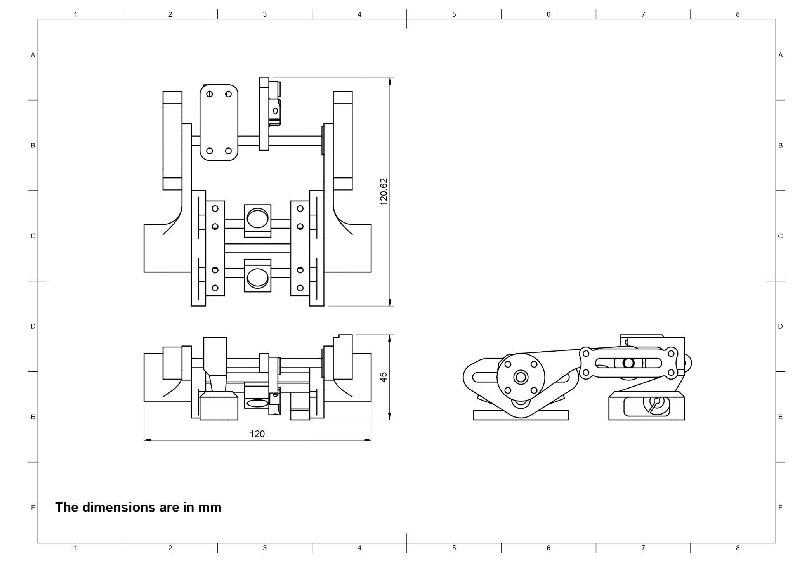
FIGURE 1.31

