Table of Contents

Table of Contents

1. Introduction 1

1.1 Purpose 1

1.2 Intended Audience 1

1.3 Product Scope 1

1.4 Document Convention 1

2. Overall Description 2

2.1 Product Perspective 2

2.2 Product Functions 2

2.3 User Classes and Characteristics 2

2.4 Operating Environment 2

2.5 Product Features 3

3. External Interface Requirements 6

3.1 User Interfaces 6

3.2 Hardware Interfaces 6

3.3 Software Interfaces 6

3.4 Communications Interfaces 6

4. Functional Requirementss 7

4.1 Major Functions of Forum 7

4.2 Major Functions of Login System 7

5. Other Nonfunctional Requirements 8

5.1 Performance Requirements 8

5.2 Safety Requirements 8

5.3 Security Requirements 8

# INTRODUCTION

## Purpose

The purpose of this software is to provide online registration of the bus pass. Passengers can fill the online form for the bus pass and then they will have to go to depot only with the registration number. At the depot the verifier will verify the documents and will generate the pass.

## Intended Audience

This document is intended to be used by the developers of this project, as well as the stakeholders of the project.

## Product Scope

The purpose of the online bus pass system is to ease the process of pass issuing and to create a convenient and easy-to-use application for passengers. The system will use a database server to store the data and the work of verifier will be reduced as the data (details) of the passenger will be already entered by passenger. It will be useful for both the passengers and the verifier.

## Document Conventions

* The term ‘This system’ is used to represent ‘The online bus pass system’.
* A verifier is the authorised person of GSRTC
* A passenger can be any person

# Overall Description

## Product Perspective

This system is meant to provide an extension for existing GSRTC website where the verifier is entering the details of passenger to issue a pass. Our system reduces the time of this process by making this process online.

## Product Functions

The system will provide online registration form for the passengers to issue the bus pass. The verifier will be able to see the filled form with the use of the registration number given to the passenger at the registration time. The verifier may cancel request if the documents are not as the requirements.

## User Classes and Characteristics

**Passengers –** Passengers are primary customers of the system. They register on the site for the pass.

**Verifier –** They have right to validate for pass for issuing.

**System administrators –** The system administrators maintain the system and they can add the verifiers.

## Operating Environment

The forum software is to be hosted on a Linux based Operating System requiring an initial size of 500 GB storage and 4GB memory. Since this system is to be used by unlimited number of people, the server is intended to be resource heavy

## Product Features

### E-R Diagram

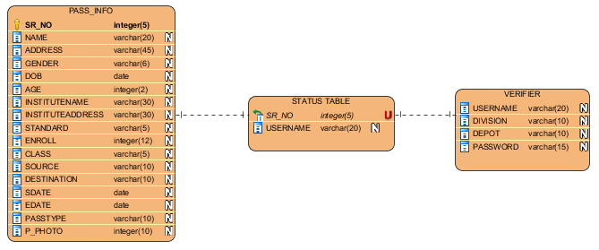

### Data Dictionary

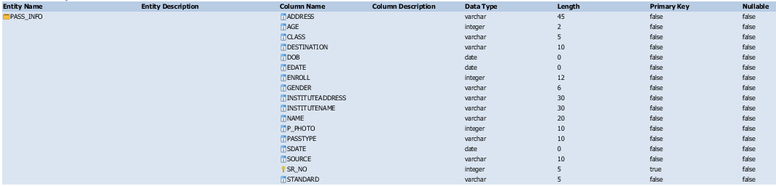





### Use Case

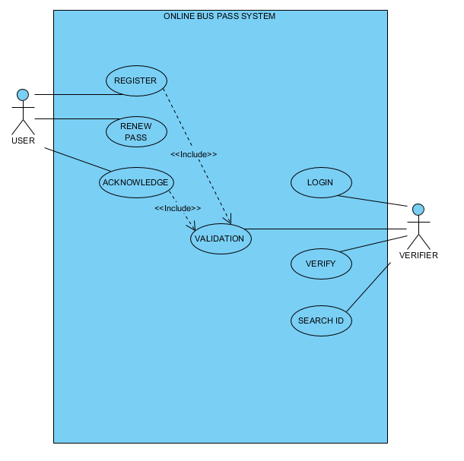

# External Interface Requirements

## User Interfaces

The new system shall provide a very intuitive and simple interface to the user and the administrator, so that the user can easily navigate through pages, functions and the administrator can easily manage verifiers.

## Hardware Interfaces

**Server side**

The web application will be hosted on a web server which is listening on the web standard ports, port 80 and port 443.

**Client side**

Monitor screen

The software shall display information to the user via the monitor screen

**Mouse**

The software shall interact with the movement of the mouse and the mouse buttons. The mouse shall activate areas for data input, command buttons and select options from menus.

**Keyboard**

The software shall interact with the keystrokes of the keyboard. The keyboard will input data into the active area of the database.

## Software Interfaces

**Server Side**

An Apache web server will accept all requests from the client and forward it accordingly. A database will be hosted centrally using MySQL. A PHP script connects the database to the client allowing the user to store data on database.

**Client side**

An OS that can run a modern web browser that supports JavaScript and HTML5.

## Communications Interfaces

The HTTP (port 80) and HTTPS (port 443) protocols will be used to facilitate communication between the client and server.

# Functional requirements

* Registering user
* Updating Information
* Generating Pass
* Renewing Pass
* Validation of User Details
* Authentication of Verifier
* Verifier Login

# Other Nonfunctional Requirements

* **Reliability:** The system should be reliable and should generate all updated information in correct order
* **Availability:** System will be available & working properly for all the time (24 Hour)
* **Security:** The system should resist accidental or deliberate intrusions, when users operate on the system.