USDA Farm Service Agency

Team 3 Project Status Report

Project Name: WeatherDash Application

Date: 11/21/2022

Project Manager: Matthew Wolf

1.0 Milestones and Schedule Dates
Milestones | Estimated Completion Date | Percent  Complete
Phase 1 Source | 11/22/22 | 100%
Flask Framework | 11/28/22 | 75%
API Connectivity | 11/28/22 | 90%
Login Functionality | 11/28/22 | 80%
Testing | 11/28/22 | 85%

2.0 Accomplishments This Period
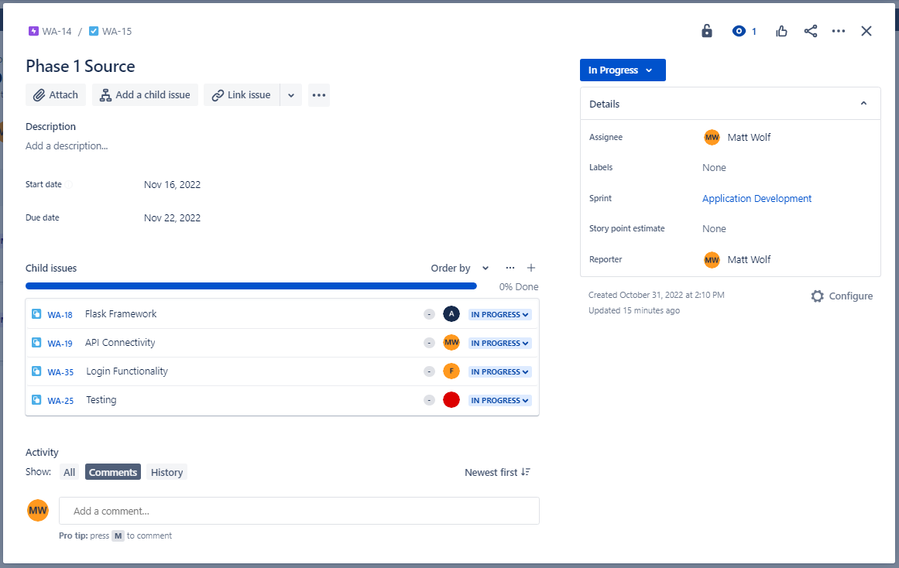

2.1 Activities
Flask Framework – Creating routes for account page and Dashboard page.
API Connectivity – Functions complete, getting json data from API source.
Login Functionality – Retrieving data from login form
Testing – Manual static code review, Manual unit testing of API functions

2.2 Activities Planned But Not Achieved
Flask Framework – Designing Login account page and dashboard page. Backend logic for data customization in databases.
API Connectivity – Accuracy with international zip code locations
Login Functionality – Issues with database connectivity and db writing.
Testing – Automated PyUnit testing framework skeleton.

2.3 Deliverables Completed
Phase 1 Source Package
Phase 1 Project Status Report

2.4 Deliverables Planned But Not Completed
N/A

3.0 Accomplishments Planned for Next Period 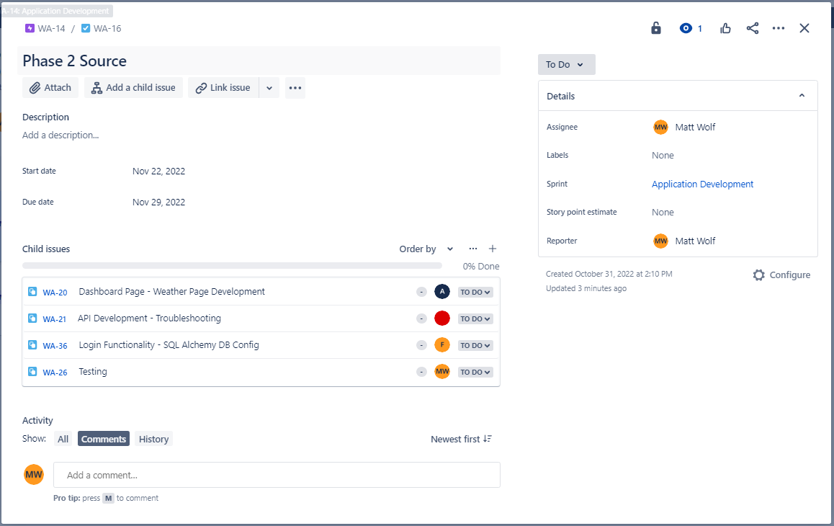

3.1 Activities
Flask Framework – Complete Account Login page and Dashboard page design.
API Connectivity – Resolve accuracy with international zip code location issues. Begin code to parse specific data from json fields.
Login Functionality – Resolve SQLAlchemy database configuration issues, confirm data is writing from login.
Testing – Automated PyUnit testing, Black-box Testing, White-Box testing, Static Code Reviews.

3.2 Deliverables
Phase 2 Source package
Phase 2 Project Status Report

4.0 Risks and Issues Summary

4.1 New

Risk/Issue # | Description | Action | Owner
I-1 | French zip codes returning US zipcodes | Investigate formatting issues | MW
I-2 | Canadian zip codes returning error | Investigate code structure/formatting | MW
I-3 | SQL Alchemy Database configuration | Ensure database is properly configured to be written to from application | FL

4.2 History
There are no prior risks or issues currently.
Risk/Issue # | Description | Status  (Open/Closed) | Owner

Change Request Summary
There are no pending change requests at this time, all project work has been according to provided plans and documentation. Code changes are managed and push through the project GitHub repository: https://github.com/thatwolfk1d/t3weatherapp/branches
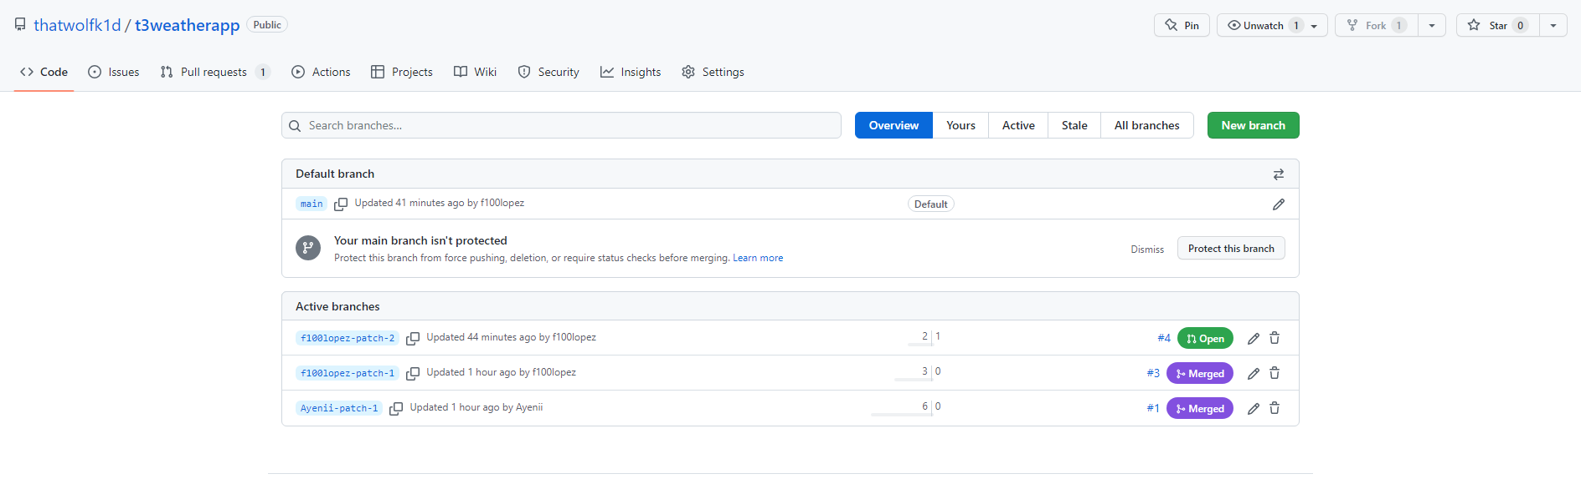
Change ID # | Description | Change Request Type  (Defect Repair, Enhancement, Addition, etc.) | Status

