USDA Farm Service Agency

Team 3 Project Status Report

Project Name: WeatherDash Application

Date: 11/29/2022

Project Manager: Matthew Wolf

1.0 Milestones and Schedule Dates
Milestones | Estimated Completion Date | Percent  Complete
Phase 2 Source | 11/29/22 | 100%
Flask Framework | 11/28/22 | 75%
API Connectivity | 11/28/22 | 95%
Login Functionality | 11/28/22 | 95%
Testing | 11/28/22 | 75%

2.0 Accomplishments This Period
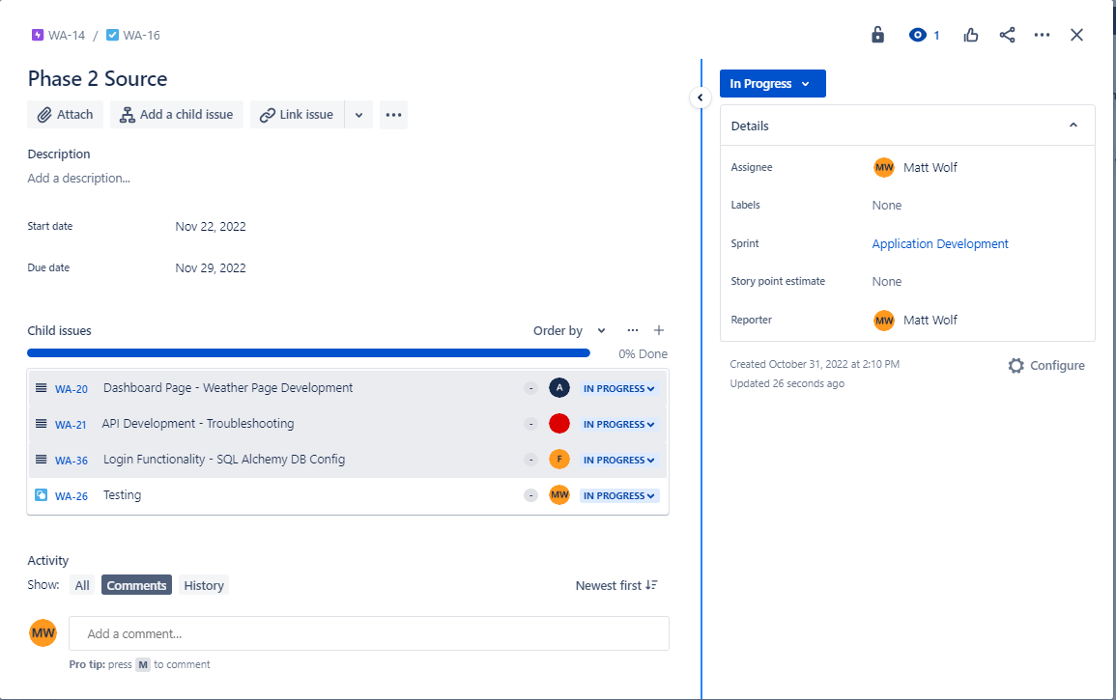

2.1 Activities
Flask Framework – Completed Account Login page and Dashboard page design.
API Connectivity – Resolved accuracy with international zip code location issues. Begin code to parse specific data from json fields.
Login Functionality – Resolved SQLAlchemy database configuration issues, confirm data is writing from login.
Testing – Automated unit testing, Static Code Review
2.2 Activities Planned But Not Achieved
Flask Framework – Virtual Environment bundling
API Connectivity – Additional json parsing
Login Functionality – Database functionality
Testing – Black-box testing, White-box testing.

2.3 Deliverables Completed
Phase 2 Source Package
Phase 2 Project Status Report

2.4 Deliverables Planned But Not Completed
N/A

3.0 Accomplishments Planned for Next Period
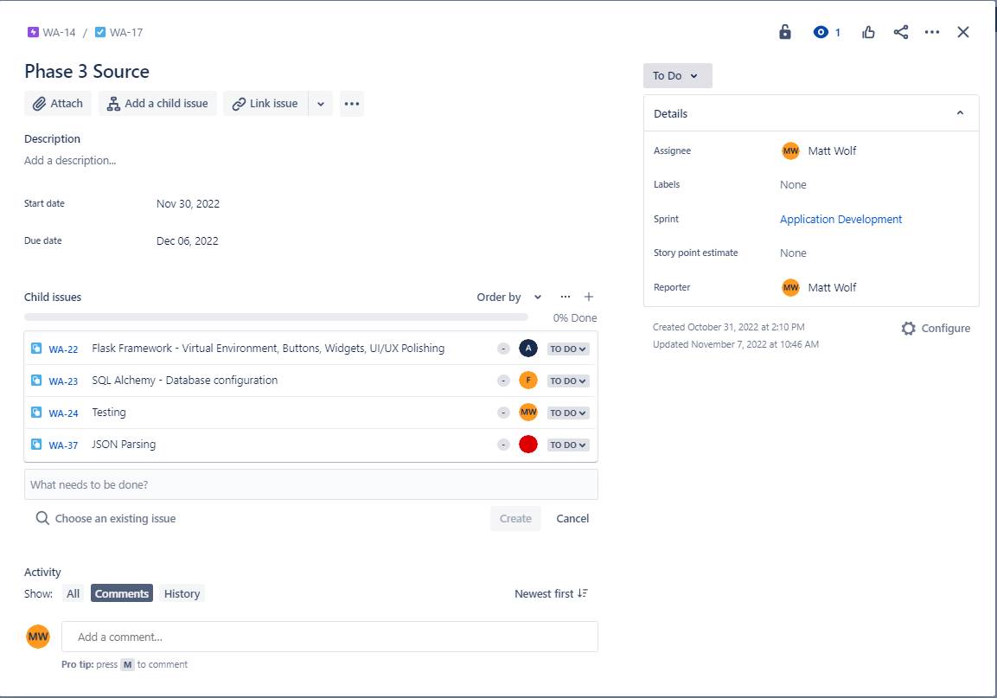

3.1 Activities
Flask Framework – Virtual Environment bundling, Buttons, Widgets, UI/UX Polishing
API Connectivity – JSON Parsing
SQL Alchemy – Database configuration
Testing – Black-box testing, White-box testing, End to End testing.

3.2 Deliverables
Phase 3 Source package
Phase 3 Project Status Report

4.0 Risks and Issues Summary

4.1 New

Risk/Issue # | Description | Action | Owner
I-4 | Virtual Environment import pointing to hard coded file paths | Investigate potential resolution | AS

4.2 History
List of previous issues currently closed/open.
Risk/Issue # | Description | Status  (Open/Closed) | Owner
I-1 | French zip codes returning US zipcodes | Investigate formatting issues – Closed – Resolved | MW
I-2 | Canadian zip codes returning error | Investigate code structure/formatting – Closed - Resolved | MW
I-3 | SQL Alchemy Database configuration | Ensure database is properly configured to be written to from application - Open | FL

Change Request Summary
There are no pending change requests at this time, all project work has been according to provided plans and documentation. Code changes are managed and push through the project GitHub repository: https://github.com/thatwolfk1d/t3weatherapp/branches
Change ID # | Description | Change Request Type  (Defect Repair, Enhancement, Addition, etc.) | Status

