Test explanation

A p value < .05 was chosen as significant.
Due to the multiple comparison the Benjamin-Hochberg method was applied to adjust the p-values.

Differences between blood types
The next experiment shows if the concentration of a lipid differs in the blood types. For that, the date and person categories were omitted, and all test samples of a blood type were used as one data set. All blood types were compared to each other. Each lipid, which was measured in both blood types in every person at all time points, was part of the analysis. As the lipid concentration of one person of different blood types are dependant a Wilcoxon signed-rank test was performed, eg.g a high value in Plasma should also lead to a high value in Serum.
For comparison were EDTA was one of the blood types the second date was not used in the Wilcoxon test.
The comparison was computed for every lipid individually and the number of times H₀ got rejected was counted. It is visible that Plasma and Serum are similar to each other in respect to lipid concentration. Additionally, DBS Finger and DBS Venous share similar concentrations. On the other hand Plasma and Serum are different to DBS Venous and DBS Finger. Blood EDTA has many lipids with a different distribution to each of the other blood types.

Negative
127 lipids were tested.

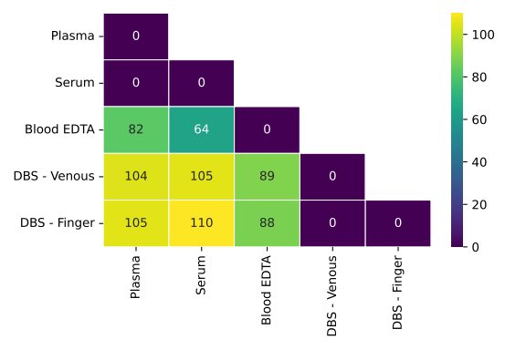
Positive

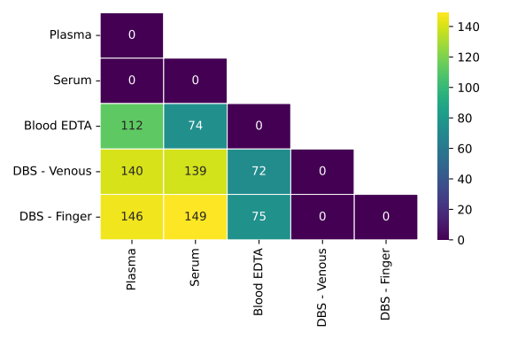
Positive = 197 lipids.

Differences between time points:
For the next experiment the person information was omitted and all samples at one time point were treated as one data set. The data sets are dependent, because the samples were taken from the same persons at different dates.
A Friedman test was used for all blood types, except Blood EDTA, because the measurements of three dates were compared. For Blood EDTA the Wilcoxon signed-rank test was used, because only two dates were available.
The statistical tests were performed per lipid and it was counted how often H₀ got rejected. No highly significant difference arose. A table with only zeros is kind of useless, maybe a textual explanation of the experiment is enough.
Caveat: The compared samples in this experiment are very small and only three repeated measurements were compared.
Table 1: Number of lipids where the H_0 hypothesis that all time points share the same mean could be rejected.
Blood Type | Positive | Negative
Plasma | 0 | 0
Serum | 0 | 0
Blood EDTA | 0 | 0
DBS - Venous | 0 | 0
DBS - Finger | 0 | 0

Generalised linear model

