Đề 2

Thiết kế Layout như hình sau: gồm 5 file index.hmtl, furniture.html, about.html, blog.html, contact.html (có liên kết đến các file trên menu)

Index.hmtl

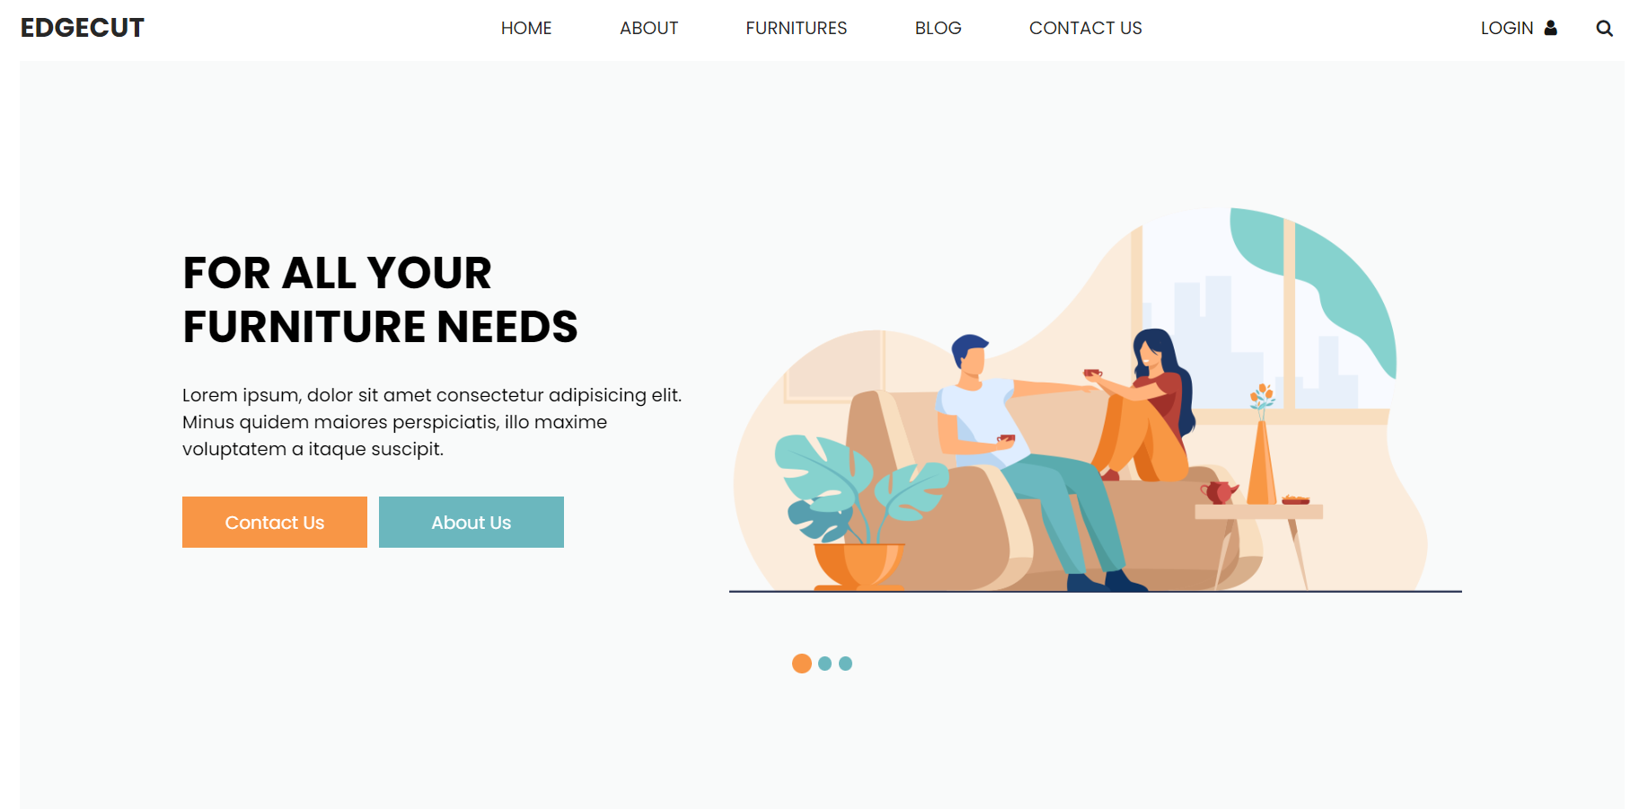

about.html

furniture.html

blog.html

Checkout.html

