Send => 02 04 5D C0 00 1B A3 A2

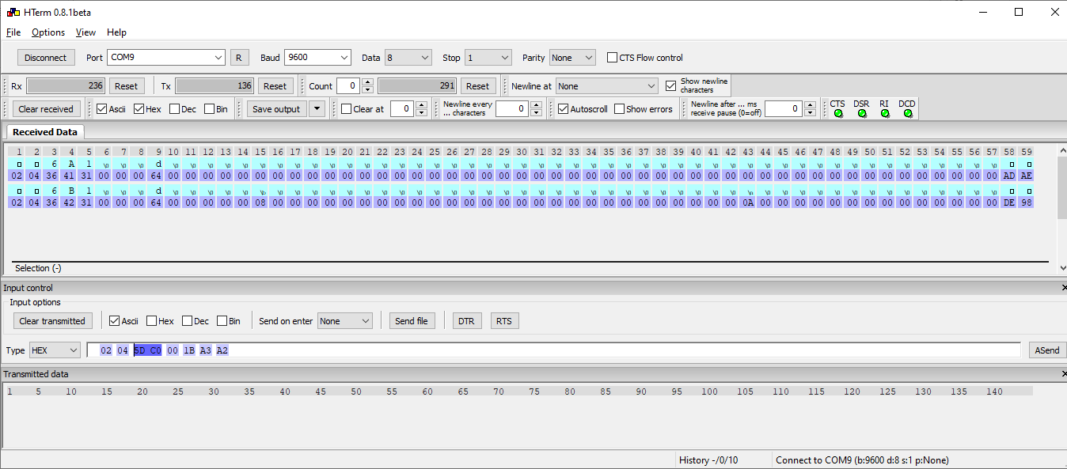

Address 24000 = 0x5DC0

Length = 2

Send => 02 04 5D C0 00 2 62 68

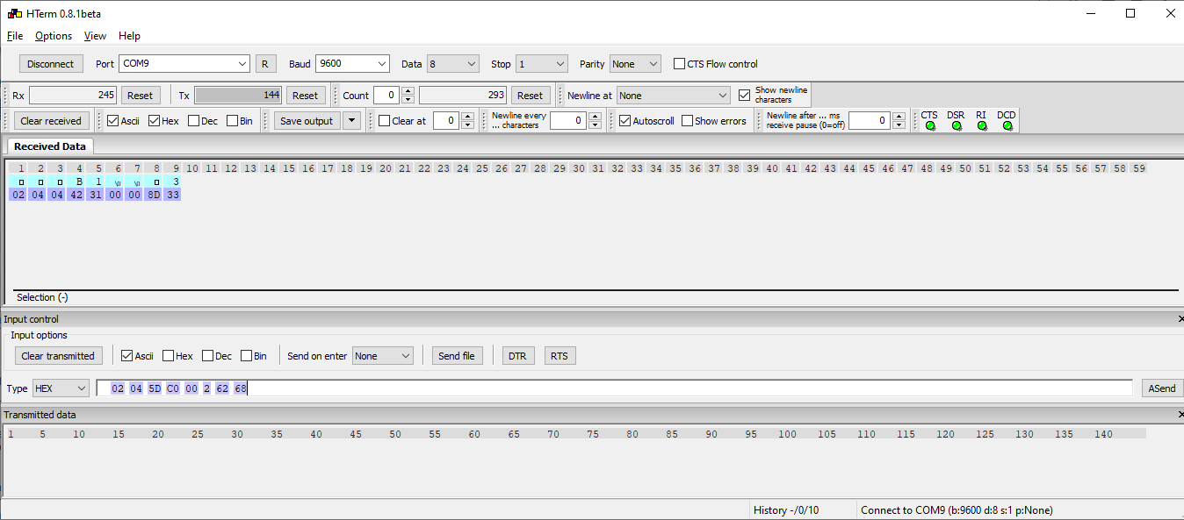

Set en mode 03

Send => 02 06 0F A0 00 03 CA CE

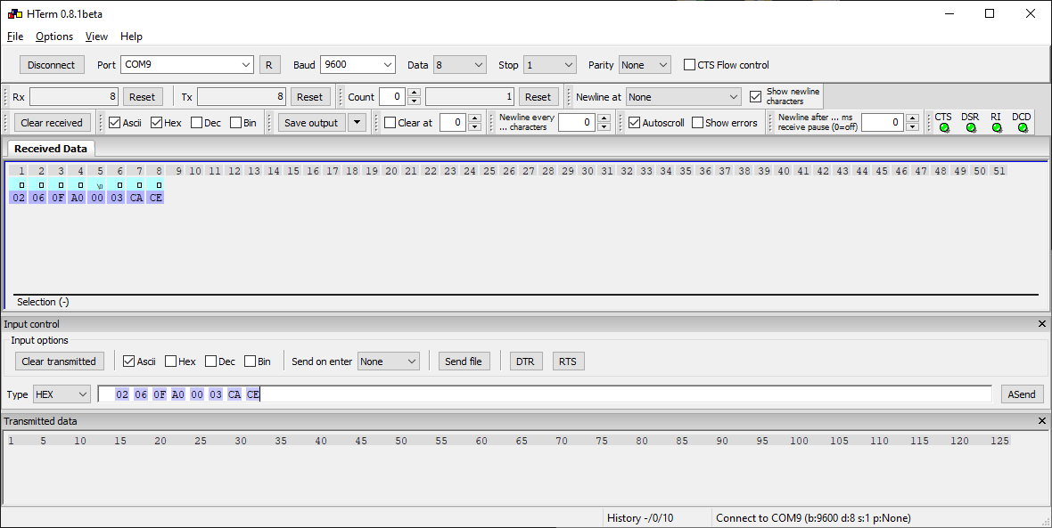

Set coil 20000

Send => 02 05 4E 20 FF 00 9A EB

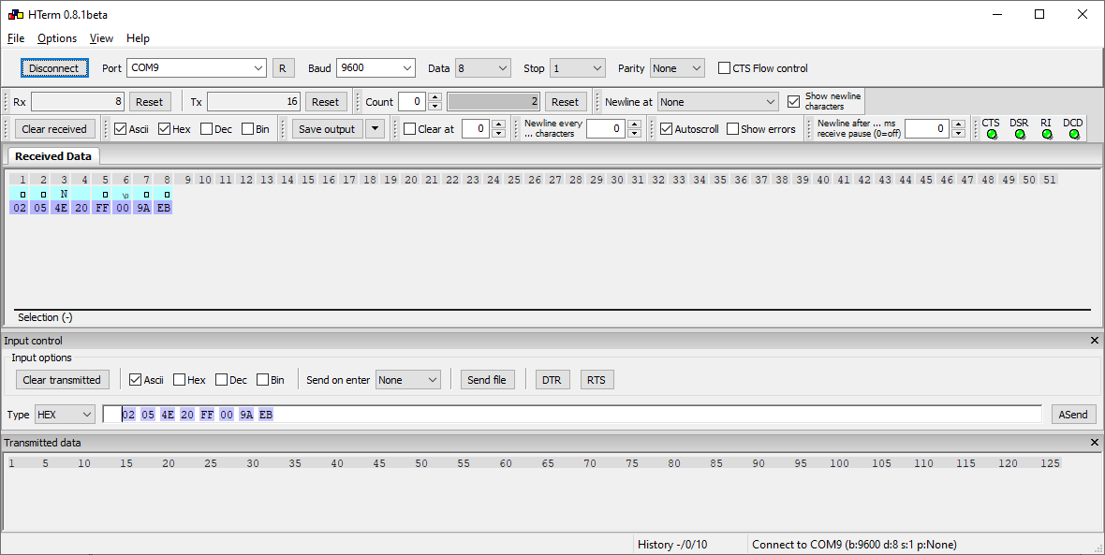

State A – B – C

Send => 02 04 5D C0 00 1B A3 A2

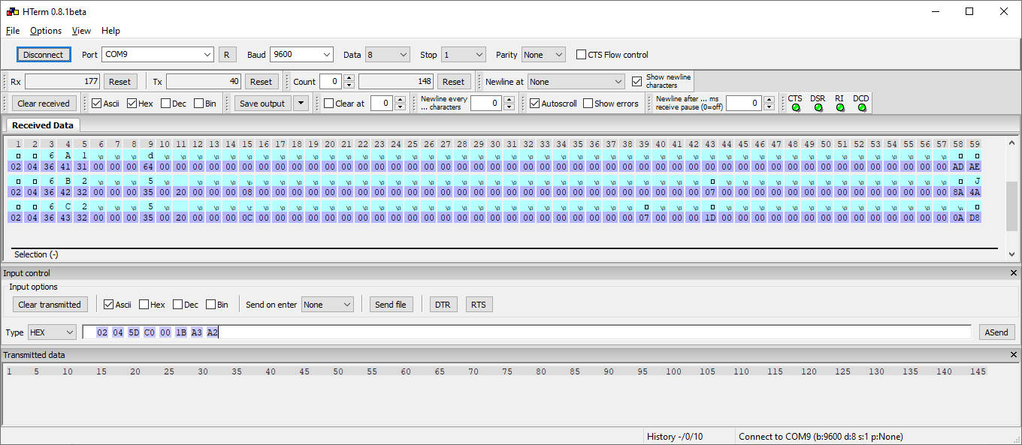

State A – B – C – B -A

Send => 02 04 5D C0 00 1B A3 A2

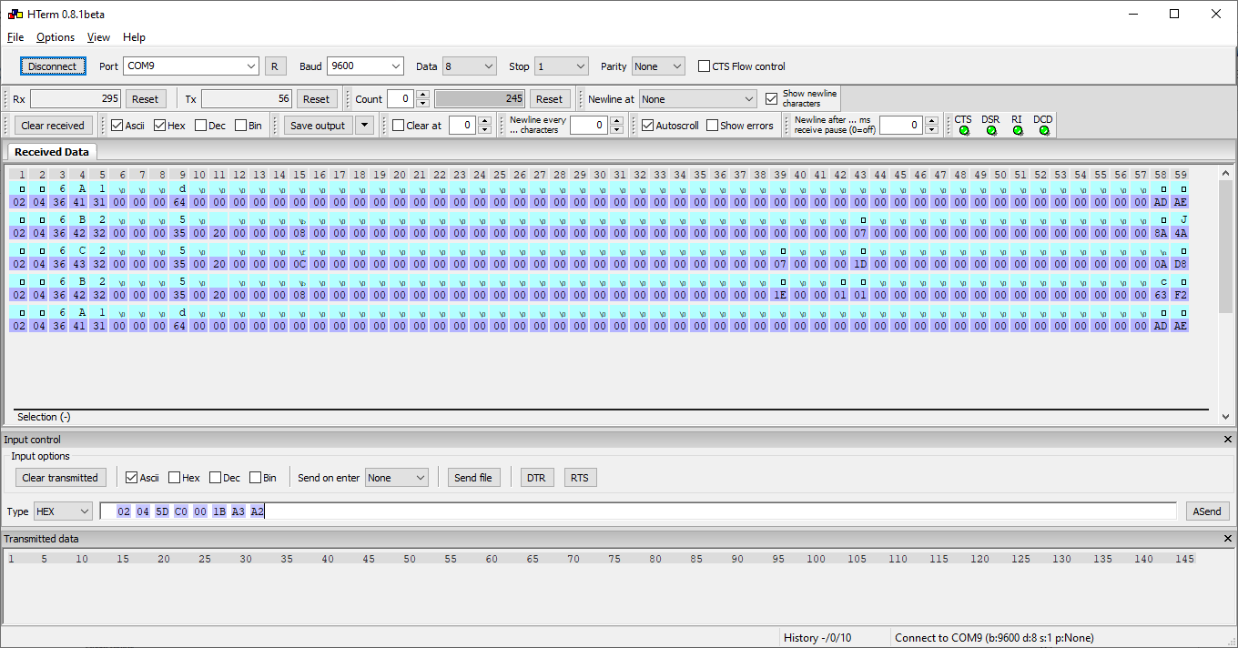

Address 24003

Send => 02 04 5D C3 00 02 92 68

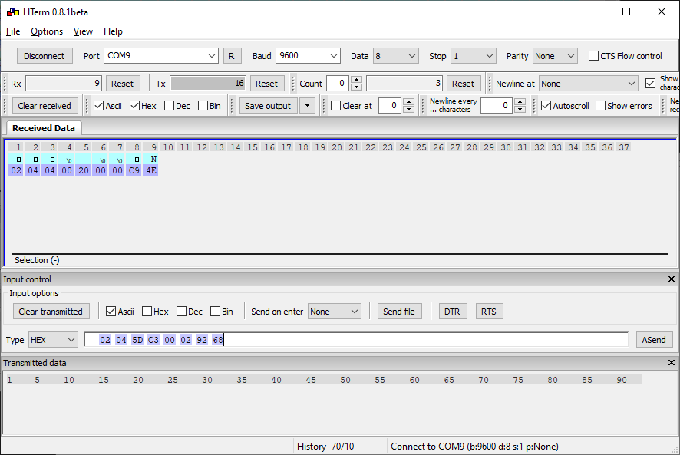

Address 24004

Send => 02 04 5D C4 00 02 23 A9

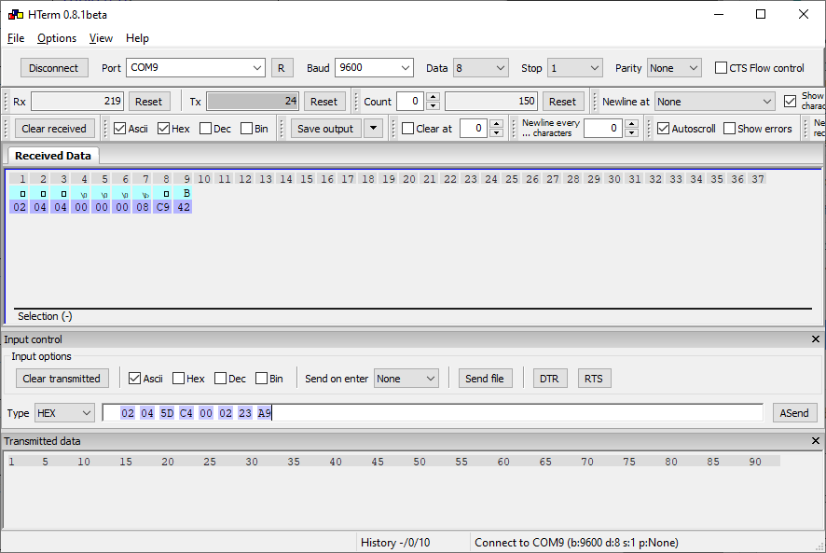

Address 24005

Send => 02 04 5D C5 00 02 72 69

State A

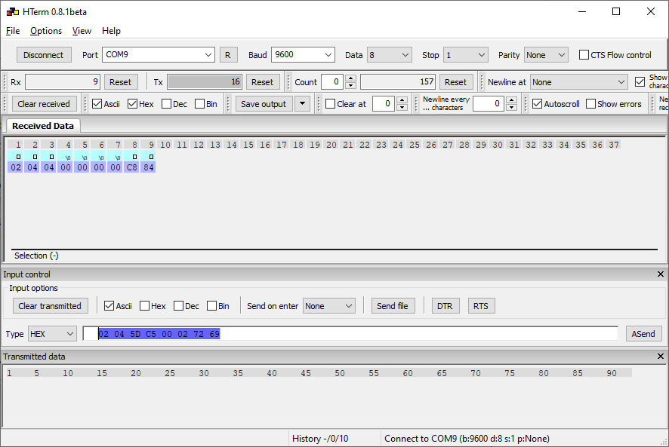

State B

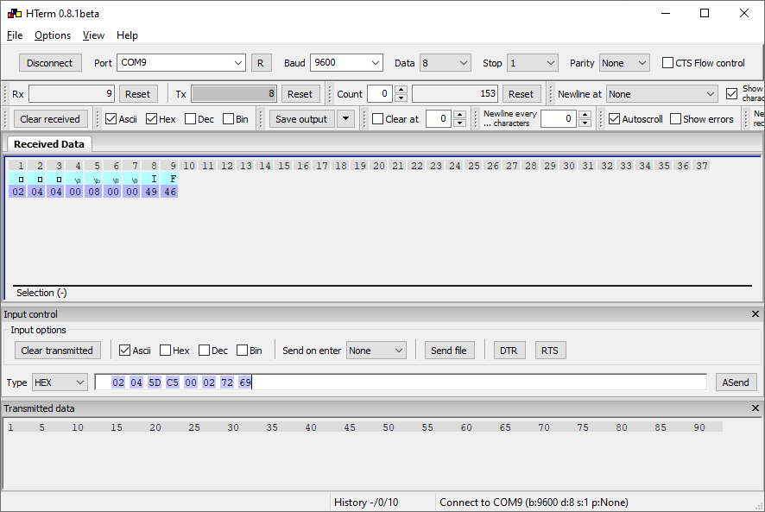

State C

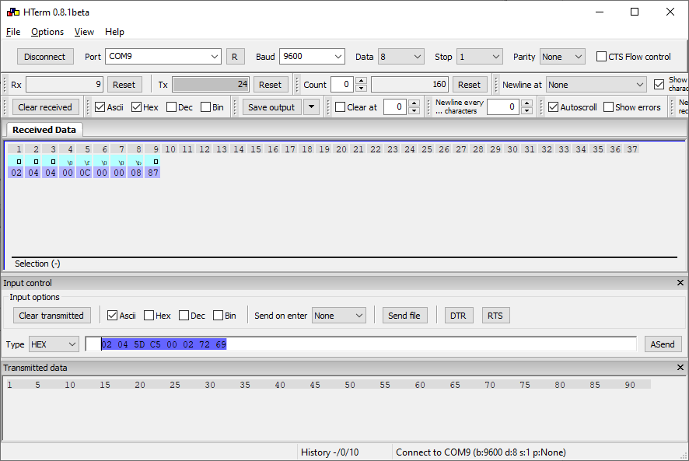

Address 24006

Send => 02 04 5D C6 00 02 82 69

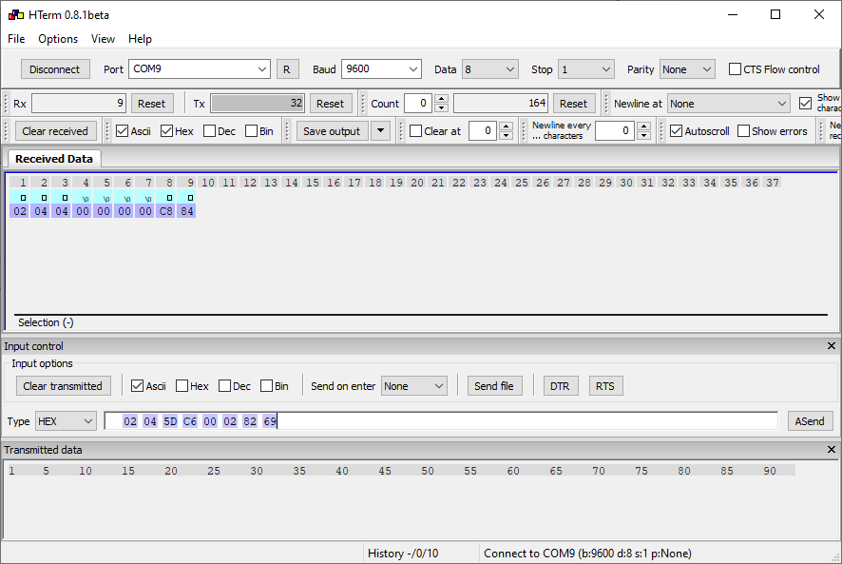

Address 1021 – 1026

Send => 02 04 03 FD 00 06 E1 8F

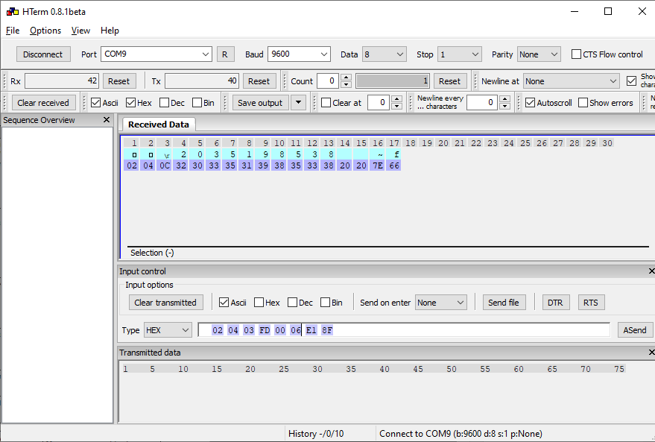

Address 22000

Send => 02 04 55 F0 00 01 20 06