Challenges



Contents

Introduction 1

Social learning 1

Challenges 1

Workflow 1

Create a survey 1

Create a challenge 1

Reward 3

Learning engagement 3

Teaching engagement 3

Survey 4

Deadline 5

Administering a challenge 6

Add to catalogue 6

Advertise / promote your challenge 6

Assign learning 6

Private versus Public challenges 6

Reporting on your challenge 6

User experience 7

# Introduction

## Social learning

Social Learning is the newest iteration of the Janison CLS. Its core focus is marketing and incentivising learning based on three key concepts:

* Learn -> everyone can learn something new.
* Teach -> everyone can teach something to others.
* Share -> everyone can stimulate a culture of learning.

If you would like to learn more about social learning please contact your Janison Account Manager.

## Challenges

A Challenge is a managed learning campaign targeted at learner groups with specific outcomes. A challenge is a set of engagement tasks which learners complete before a deadline to be eligible for rewards. Challenges can include learning, teaching, sharing and surveys and the rewards can be a combination of bonus points and tangible rewards.

## Workflow

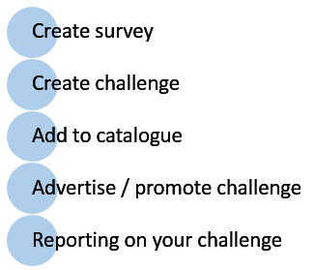

## Create a survey

If you would like to have users complete a survey as part of a challenge, then create the survey first. Refer to Design > Surveys for more information on creating Surveys.

More survey options are discussed further down in this guide in the next section, Create a challenge.

## Create a challenge

Before you create your challenge confirm you have the Default Enrolment Method set to an option other than Do not allow. This is found in Settings > Self Enrolment Settings. For more information, refer to Settings > Self Enrolment.

Browse to Manage Learning > Manage Learning Assets.

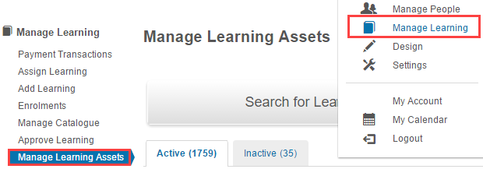

1. Select Add Learning Asset.

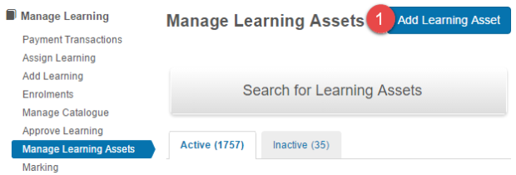

1. Select New Challenge.

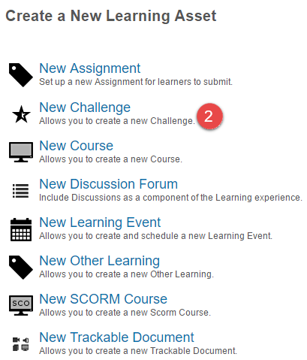

1. Enter a Name.
2. If required, modify the Identifier.
3. Enter an Approx Duration (Minutes).

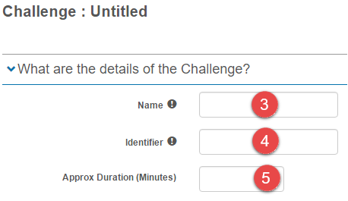

Reward

1. Select the type of reward to be associated with the Challenge. You can have both a points bonus and a tangible reward.

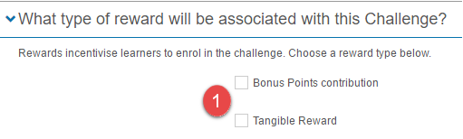

1. If you select Bonus Points contribution, then enter the number of Bonus Points to contribute.

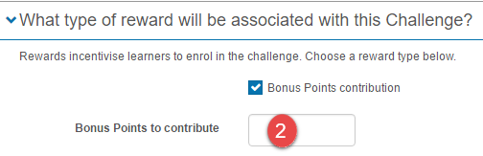

1. If you select Tangible Reward, then:
2. Enter a Reward Title.
3. Enter a Reward Description.
4. Select a Reward Photo.

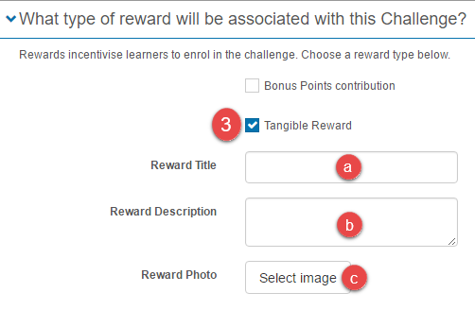

### Learning engagement

1. Select the learning items that are to be included in the challenge.

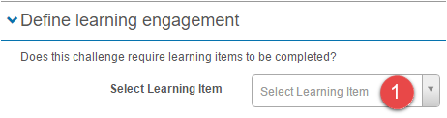

All items appear when you select the field and are filtered as you start typing.

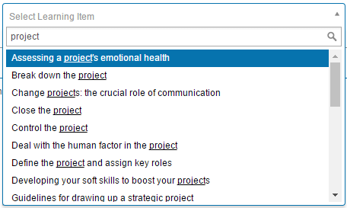

### Teaching engagement

1. Select the required teaching engagement items.

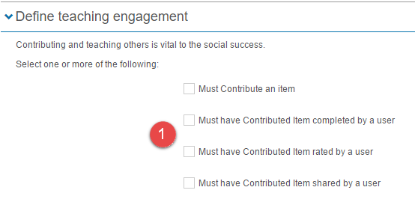

1. If you select Must contribute an item, then enter Additional information to give your participants more direction about the types of contributions you are looking for.

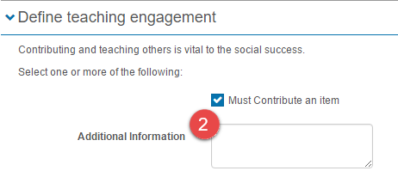

### Survey

1. If you want participants to complete a survey, then select the required survey.

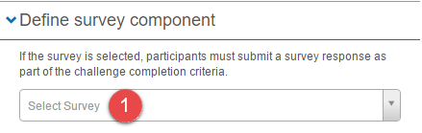

1. If you want the survey responses visible to challenge participants, select Submitted responses are visible to challenge participants.

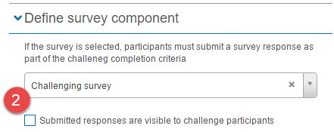

1. If survey responses are visible then select the required Teach and Share engagement options.

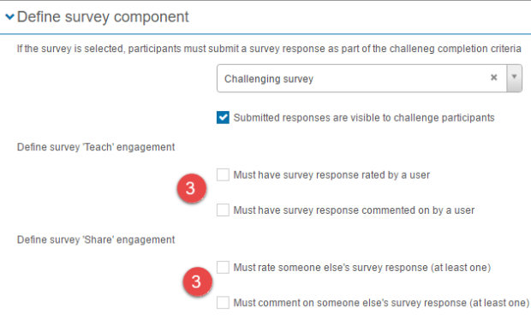

### Deadline

1. Select a Date and time as a deadline for the challenge. Challengers must complete the challenge before the due date to be eligible for the associated rewards.

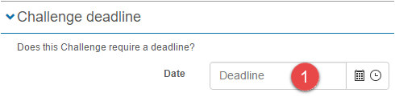

1. Select Save Challenge.



If there are required items that are not yet complete, the system will display these required items and not allow you to save.

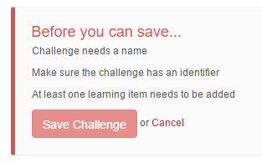

# Administering a challenge

## Add to catalogue

Like all Learning assets, a challenge needs to be added to a Catalogue item to allow users to access the challenge.

Refer to Learning > Manage Catalogue for details on how to create Catalogue items.

When you create the catalogue item it is recommended that you enter a good description that includes the details of the prize, for example, is it the first person only who gets a prize or everyone who completes within the timeframe. Also include any criteria you might consider, like the best comment or the highest rated item that was shared.

Any points put into the catalogue item will be ignored in favour of the points from the challenge.

## Advertise / promote your challenge

### Assign learning

If you would like to add users to the challenge yourself, browse to Learning > Assign Learning and follow the Assign Learning wizard to enrol users into the challenge. For the best result, make sure to select  in the Assign Learning wizard to notify learners that they are participating in a challenge.

### Private versus Public challenges

Consider if you want your challenge to be private and only available to invited users or public and open to all users. You can also set up your catalogue item with the challenge but leave the catalogue item set to private until you are ready to release the challenge.

## Reporting on your challenge

Progress reports on a challenge are done using Custom Reports. For more information on Custom Reports refer to **Learning** > **Customisable Reports**.

# User experience

1. Select Challenges in the left-hand menu.

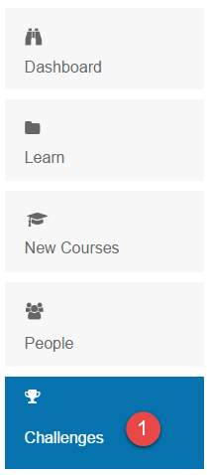

This will display the available challenges. When there are multiple current challenges the following view will be displayed. When there is only one challenge available it will be displayed in its detail view, like Customer challenge in step 3.

1. Select View.

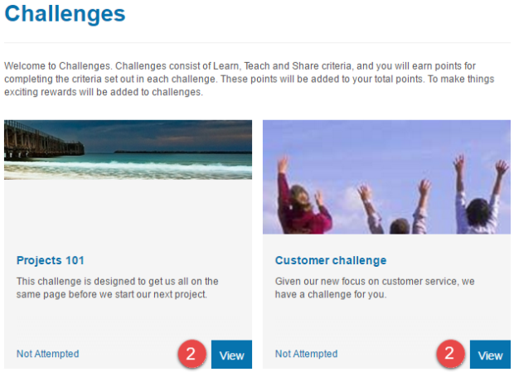

1. Select Join on the image or Join challenge.

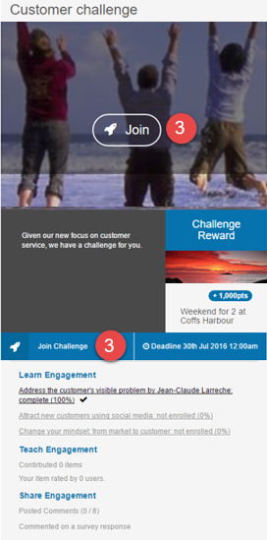

1. Select links in Learn Engagement to go to the corresponding courses. If there is a survey, select Open Survey to complete it.

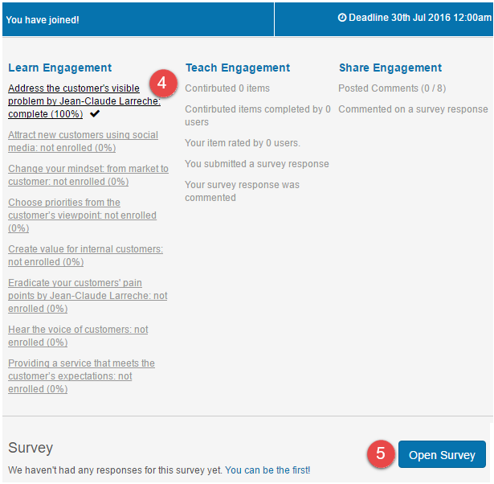

You can track your progress through a challenge by the Leaderboard or by the progress tracker built into the Engagement panel. This Leaderboard will only be displayed once there is some progress against the challenge. The Leaderboard will show the top 3 participants and your progress.

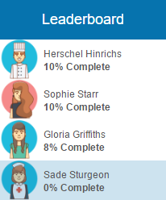

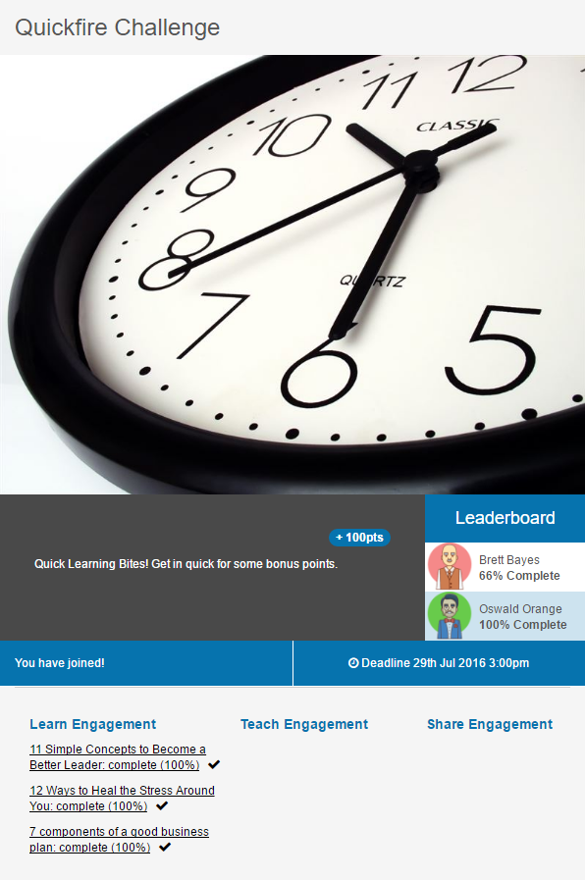

When you have completed a challenge the status will change in the Leaderboard to Complete. Any bonus points reward will be added to your account immediately. You can also see that the challenge has been completed on the Challenge’s tile.

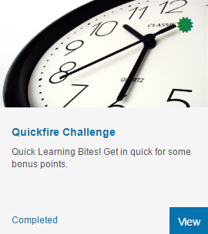

You can still complete a challenge after its deadline has passed, however, you will not be eligible for the associated rewards. You will still get your normal points for completing items.

The challenge tile will not be visible after its deadline to users who did not enrol in the challenge.