Masslak (مسلك)
Use Case and Data Flow Diagrams
How actors use the platform and how data moves inside it
Version | 1.0
Date | 3 October 2026
Source | Analysis and Design Study v2.5 (English edition) — the only source used
Contents | 11 use case diagrams (UML 2.5), 11 data flow diagrams (Gane & Sarson: context, two Level 1, eight Level 2), use case specifications, data store catalog, access matrix and traceability
Status | Ready for review

Contents
1. Introduction and notation
2. Actors
3. Use case diagrams
4. Key use case specifications
5. Data flow diagrams
6. Data store catalog
7. Process and data store access matrix
8. Traceability
9. Assumptions and notes

1. Introduction and notation

1.1 Purpose
This document shows who uses the Masslak platform and for what (use case diagrams), and how data moves between the actors, the platform's processes and its data stores (data flow diagrams). It is a companion to the Analysis and Design Study and helps business, technical and authority readers share one picture of the system before and during the build.

1.2 Source and scope
Every actor, use case, process, flow and data store is taken from the Analysis and Design Study v2.5 (English edition), and section numbers in the tables refer to that study. The diagrams cover the full target scope: scheduled intercity travel and shuttle transport, carrier and driver operations, integrated shipping, service partners and loyalty, administration and finance, security and compliance with the authorities, distribution channels, and accounting with e-invoicing. Use cases belonging to a later phase are labelled with that phase.

1.3 Use case notation (UML 2.5)
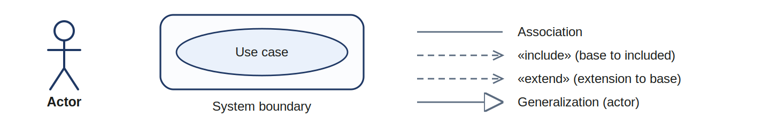
- Primary actors (people who start the use case) are on the left; secondary actors (external systems and devices) are on the right.
- «include»: the base use case always performs the included one. «extend»: the extension adds optional behaviour to the base.
- Each diagram has a system boundary named after the part of the platform it covers.

1.4 Data flow notation (Gane & Sarson)
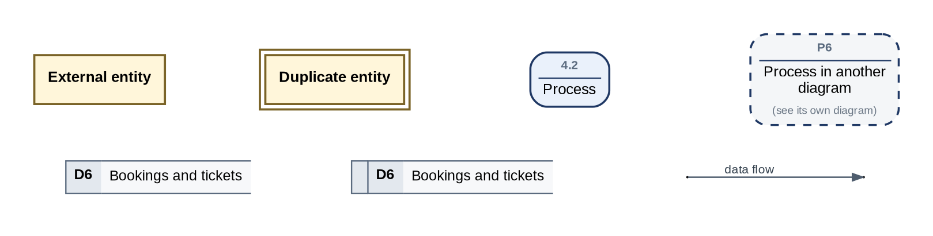
- External entity: a person, organization or system outside the platform. Process: a rounded box with its number. Data store: an open box with its D number.
- A dashed process belongs to another diagram and is shown for context. A duplicate symbol repeats an element to keep flows short.
- Levels: the context diagram (DFD-0) shows the platform as one process; Level 1 (DFD-1A and DFD-1B) splits it into 14 processes; Level 2 details the processes with the most data movement.

1.5 Numbering
Item | Format | Example
Use case diagram | UC-n | UC-2 Shuttle transport
Use case | UC-n.m | UC-2.8 Charge the next segment
Level 1 process | Pn | P8 Operate shuttle rides
Level 2 process | n.m | 8.4 Charge segment at departure
Data store | Dn | D10 Shuttle rides
Data flow diagram | DFD-n | DFD-8 (Level 2 of P8)

2. Actors
The platform has 30 primary actors (people in a role) and 11 secondary actors (external systems and devices).
Actor | Type | Description | Study
Visitor | Primary | Unregistered user who browses and compares scheduled trips | 3.1 a
Passenger | Primary | Registered customer who books scheduled trips, pays from the wallet and boards with a QR ticket | 3.1 d, 7.1
Shuttle passenger | Primary | Daily rider of shuttle lines who boards by scanning the vehicle sticker and pays station by station | 3.1 e, 7.3 a, 7.13
Carrier account owner | Primary | Owner of a transport company or individual vehicle owner; controls the company's users, fleet and finances | 3.3, 3.4
Trip scheduler | Primary | Carrier employee who creates and launches trips and assigns crews | 3.3
Company accountant | Primary | Carrier employee who follows receivables, settlements and withdrawals | 3.3
Driver / host | Primary | Crew member who runs the assigned trip from the driver app: tracking, boarding scans, stops, cash, SOS | 3.3, 7.3, 7.8
Shipper / store | Primary | Sender of parcels or consignments, including stores and importers | 3.1 h, 9.14
Recipient | Primary | Receiver of a shipment who controls delivery options from the tracking link | 9.16
Courier company / hub operator | Primary | Operator of a courier company, station or sorting hub that receives, sorts and loads shipments | 9.6, 9.18
Courier | Primary | Field courier who picks up and delivers shipments with proof of delivery | 9.17
Access point operator | Primary | Shop, locker, fuel station or rest stop acting as a drop-off and pickup point | 9.15
Fuel station attendant | Primary | Employee of a contracted fuel station who records refueling paid through the platform | 14.11
Rest stop / merchant | Primary | Contracted rest stop, restaurant or merchant accepting payment and points through the platform | 14.12, 14.13
Loyalty partner | Primary | Partner that funds or redeems points (airlines, retailers, other programs) | 5.13
Travel agency / sub-agent | Primary | Intermediary booking through the agent portal within its quota and deposit | 14.9
Corporate client | Primary | Company booking travel for its staff at contract rates | 14.3
Marketing affiliate | Primary | Partner referring customers through links for a referral commission | 14.3
Platform administrator | Primary | Platform staff who approve companies and partners and manage reference data and policies | 3.1 f
Platform finance | Primary | Staff in charge of bank reconciliation, settlements, payouts and refund approval | 3.3, 6.3
Support employee | Primary | Staff who handle complaints, claims and inquiries and decide compensation | 7.6
Marketing manager | Primary | Staff who define campaigns and offers within an approved budget | 5.12
Data Protection Officer | Primary | Reviews processing, consents, impact assessments and data incidents | 16.13
AI assistant supervisor | Primary | Maintains the assistant's knowledge and monitors conversations | 7.10
Compliance officer | Primary | Manages authority policies and adapters, official requests and security logs | 3.3, 8
Authority employee | Primary | Employee of a security, customs or crossing authority acting within its scope | 3.1 j, 8
Regulator | Primary | Reads the governance, tracking and alerts dashboard and sets delegated policies | 2.4, 2.5
Inspector | Primary | Field officer or authorized body checking tickets, vehicles and licenses | 7.3 c, 32.8
Document verifier | Primary | Anyone checking a printed booking or ticket on the public verification page | 16.25
Accounting integration officer | Primary | Maintains journal entries, mappings and synchronization with accounting systems | 3.3, 13
Payment gateway / bank | Secondary (system) | Card gateways, wallet providers and the bank holding customer funds | 6.3, 6.4, 6.7
Security & government authorities | Secondary (system) | Authorities connected through the Security & Compliance Hub (screening, orders, requests) | 8
Border systems | Secondary (system) | Crossing and customs systems exchanging manifest messages | 11
Government licensing systems | Secondary (system) | Sources that confirm vehicle and driver license validity | 4.18, 3.8
Tax authority | Secondary (system) | E-invoicing platform receiving invoices in clearance or reporting mode | 13.11
Accounting / ERP system | Secondary (system) | External accounting systems receiving journal entries and invoices | 13.5, 13.12
CRM help desk | Secondary (system) | Off-the-shelf help desk synchronized with cases by signed webhooks | 7.6 d
Global courier company | Secondary (system) | Partner such as FedEx, DHL, UPS or Aramex exchanging orders and updates by API | 9.22
Intermediary platform (OTA / GDS) | Secondary (system) | Aggregators and distribution systems searching and booking through the channel API | 14.2, 14.4
Notification providers | Secondary (system) | SMS, push and e-mail services delivering notifications | 34
Boarding gate device | Secondary (device) | QR/NFC validator at the bus door, working offline | 7.3 a

3. Use case diagrams

3.1 System overview (UC-0)
The overview groups the actors and shows which subsystem each group uses. Each subsystem is detailed in its own diagram below.
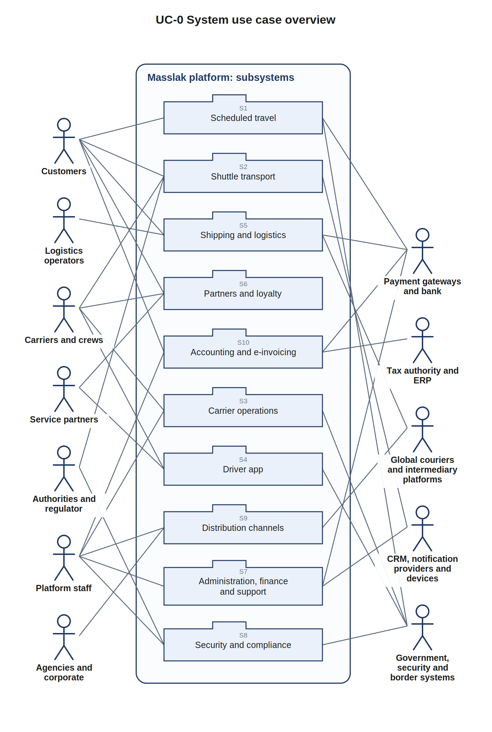
Figure UC-0. Actor groups and the platform's subsystems
Subsystem | Diagram | Main actors | External systems
S1 Scheduled trip booking | UC-1 | Visitor, Passenger | Payment gateway / bank, Security & government authorities
S2 Shuttle transport | UC-2 | Shuttle passenger, Driver / host, Inspector | Boarding gate device, Notification providers
S3 Carrier operations | UC-3 | Carrier account owner, Trip scheduler, Company accountant | Platform administrator, Government licensing systems
S4 Driver app | UC-4 | Driver / host | Security & government authorities, Fuel station attendant
S5 Shipping and logistics | UC-5 | Shipper / store, Recipient, Access point operator | Courier company / hub operator, Courier, Global courier company, Payment gateway / bank
S6 Service partners and loyalty | UC-6 | Carrier account owner, Passenger, Loyalty partner | Fuel station attendant, Rest stop / merchant
S7 Administration, finance and support | UC-7 | Platform administrator, Platform finance, Support employee, Marketing manager, Data Protection Officer, AI assistant supervisor | Payment gateway / bank, CRM help desk
S8 Security, compliance and authorities | UC-8 | Compliance officer, Authority employee, Regulator, Inspector, Document verifier | Security & government authorities, Border systems
S9 Distribution channels and agencies | UC-9 | Travel agency / sub-agent, Corporate client, Marketing affiliate, Platform administrator | Intermediary platform (OTA / GDS)
S10 Accounting and e-invoicing | UC-10 | Passenger, Accounting integration officer, Platform finance | Tax authority, Accounting / ERP system, Payment gateway / bank

3.2 UC-1 Scheduled trip booking
Boundary: Masslak: scheduled intercity travel. Primary actors: Visitor, Passenger. Secondary actors: Payment gateway / bank, Security & government authorities.
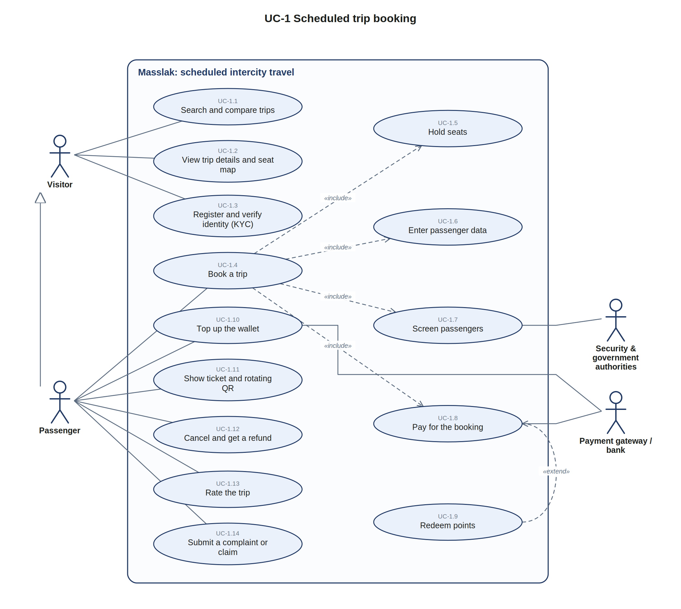
Figure UC-1. Scheduled trip booking
ID | Use case | Actors | Description | Study
UC-1.1 | Search and compare trips | Visitor | Search by origin, destination, date and passengers; compare carriers, times, prices, ratings and on-time rates | 7.1, P-01, P-02
UC-1.2 | View trip details and seat map | Visitor | Stops, fare ladder, rest stops, baggage rules and the seat map for the chosen pair | 4.12, P-03
UC-1.3 | Register and verify identity (KYC) | Visitor | Create an account and verify identity in the app; limits follow the KYC level | 3.8, 6.3
UC-1.4 | Book a trip | Passenger | Complete booking of one or more seats on a scheduled trip | 7.1
UC-1.5 | Hold seats | (included or extending) | Temporary seat lock for the chosen segments (10 minutes) | 7.1, 4.12 c
UC-1.6 | Enter passenger data | (included or extending) | Names as on the identity document, ID or passport, nationality, mobile | 7.1, 11.9
UC-1.7 | Screen passengers | Security & government authorities | Screening request per the authority's policy: ALLOW, REVIEW or DENY | 8.3, 8.4
UC-1.8 | Pay for the booking | Payment gateway / bank | Deduction from the wallet or card top-up into escrow with an idempotency key | 6.2, 7.1
UC-1.9 | Redeem points | (included or extending) | Use loyalty points for a partial or full discount | 5.13 b
UC-1.10 | Top up the wallet | Passenger, Payment gateway / bank | Card or transfer top-up through the payment provider adapter | 6.3
UC-1.11 | Show ticket and rotating QR | Passenger | Signed, short-lived QR shown at boarding | 7.3
UC-1.12 | Cancel and get a refund | Passenger | Refund per the fare brand's cancellation rules | 5.9, 6.2
UC-1.13 | Rate the trip | Passenger | Rating after completion, feeding the on-time and service score | 7.7
UC-1.14 | Submit a complaint or claim | Passenger | Case linked to the booking, with SLA by priority | 7.6

3.3 UC-2 Shuttle transport
Boundary: Masslak: shuttle lines. Primary actors: Shuttle passenger, Driver / host, Inspector. Secondary actors: Boarding gate device, Notification providers.
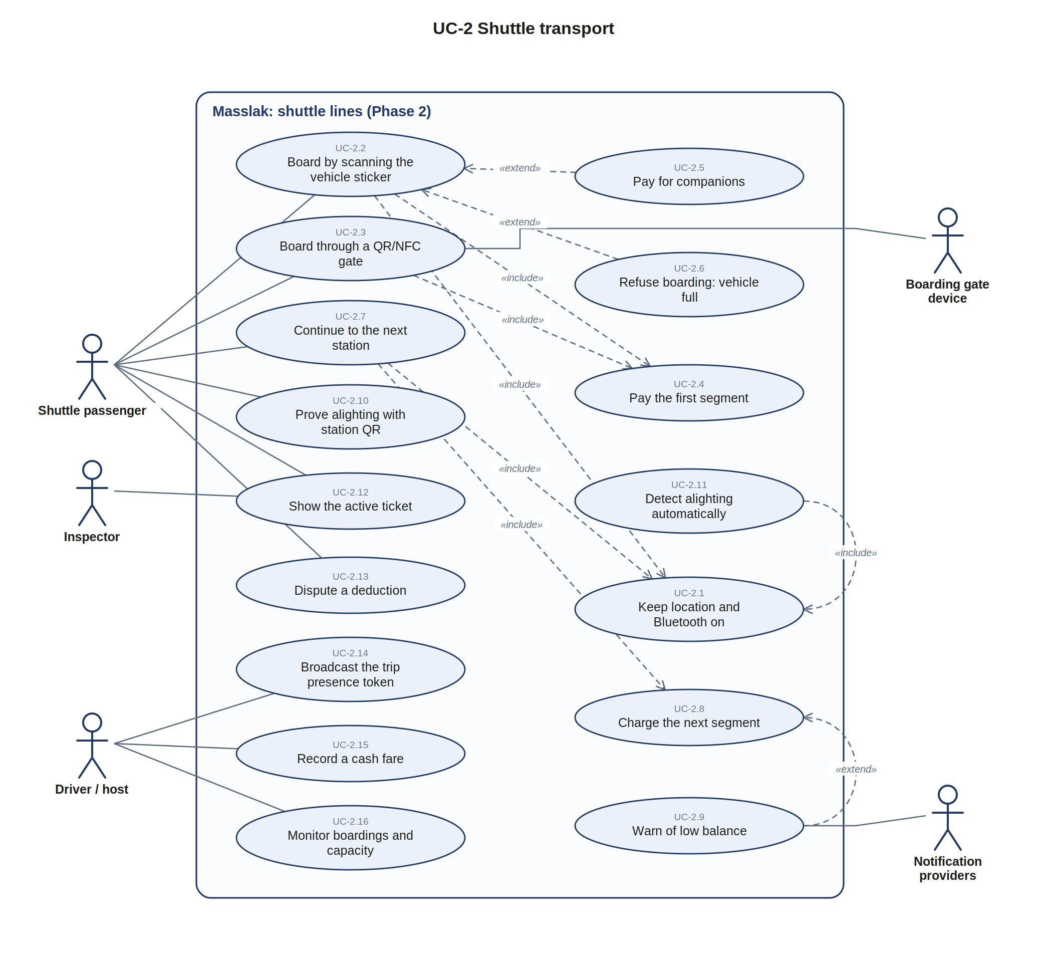
Figure UC-2. Shuttle transport
ID | Use case | Actors | Description | Study
UC-2.1 | Keep location and Bluetooth on (Phase 2) | (included or extending) | Location permission at all times and Bluetooth during a ride; otherwise the app locks (SOS stays available) | 7.13 a, b
UC-2.2 | Board by scanning the vehicle sticker (Phase 2) | Shuttle passenger | Scan the QR on the vehicle; the system identifies vehicle, line and direction and opens a ride | 7.3 a, 7.13 c
UC-2.3 | Board through a QR/NFC gate (Phase 2) | Shuttle passenger, Boarding gate device | Door validator reads the app code, an NFC phone or a prepaid card; works offline | 7.3 a
UC-2.4 | Pay the first segment (Phase 2) | (included or extending) | Fare of the first station, the fixed band or the whole line, deducted at boarding | 7.13 c
UC-2.5 | Pay for companions (Phase 2) | (included or extending) | Pay for two or more people in one scan | 7.3 d
UC-2.6 | Refuse boarding: vehicle full (Phase 2) | (included or extending) | At licensed capacity the scan is refused (VEHICLE_FULL) and the driver is alerted | 7.13 c, 4.13
UC-2.7 | Continue to the next station (Phase 2) | Shuttle passenger | Presence confirmed by Nearby proximity or moving together when the vehicle leaves a station | 7.13 b, c
UC-2.8 | Charge the next segment (Phase 2) | (included or extending) | Next segment fare, or the remainder after a fixed band, deducted with a notification | 7.13 c
UC-2.9 | Warn of low balance (Phase 2) | Notification providers | Before each station if the balance does not cover the next segment; continuing creates an outstanding amount | 7.13 c
UC-2.10 | Prove alighting with station QR (Phase 2) | Shuttle passenger | Scan the station QR to close the ride and get an immediate receipt | 7.13 c
UC-2.11 | Detect alighting automatically (Phase 2) | (included or extending) | Both presence signals lost for 90 s and 150 m: the ride closes | 7.13 c
UC-2.12 | Show the active ticket (Phase 2) | Shuttle passenger, Inspector | Animated code that changes every few seconds, verified offline by signature | 7.3 c
UC-2.13 | Dispute a deduction (Phase 2) | Shuttle passenger | Dispute within 48 hours with proximity log, positions and stop events as evidence | 7.13 c
UC-2.14 | Broadcast the trip presence token (Phase 2) | Driver / host | Signed BLE token from the driver's phone or a vehicle beacon, rotating every few minutes | 7.13 b
UC-2.15 | Record a cash fare (Phase 2) | Driver / host | Cash fare recorded under cash controls | 6.5, 7.3 a
UC-2.16 | Monitor boardings and capacity (Phase 2) | Driver / host | Instant boarding notifications, passenger counter and capacity alerts | 7.3 b

3.4 UC-3 Carrier operations
Boundary: Masslak: carrier (operator) portal. Primary actors: Carrier account owner, Trip scheduler, Company accountant. Secondary actors: Platform administrator, Government licensing systems.
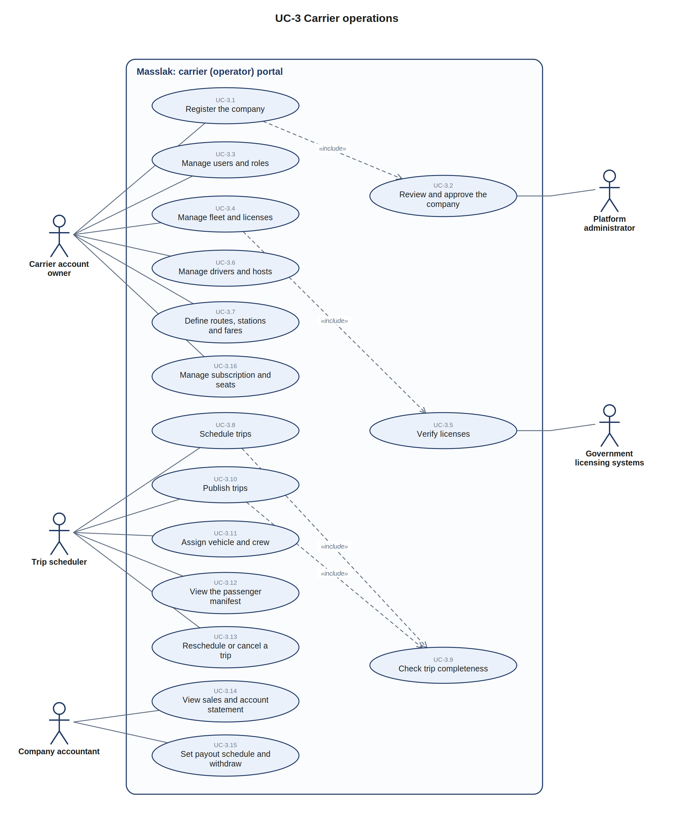
Figure UC-3. Carrier operations
ID | Use case | Actors | Description | Study
UC-3.1 | Register the company | Carrier account owner | Company or individual account with documents and transport license | 3.4 a, 7.2
UC-3.2 | Review and approve the company | Platform administrator | Administration review before the company can sell | 7.2
UC-3.3 | Manage users and roles | Carrier account owner | Invite users and set roles from the permission catalog; seats per agreement | 3.4 b, c
UC-3.4 | Manage fleet and licenses | Carrier account owner | Vehicles with chassis, plate, seats, ownership and license expiry dates | 4.3, 4.13, 4.17
UC-3.5 | Verify licenses | Government licensing systems | Locked entry with government update and field verification | 4.18
UC-3.6 | Manage drivers and hosts | Carrier account owner | Driver and host profiles and license classes | 4.3
UC-3.7 | Define routes, stations and fares | Carrier account owner | Lines with stations, rest stops and the fare ladder within the approved tariff | 4.12, 4.15
UC-3.8 | Schedule trips | Trip scheduler | Trip patterns (e.g. daily at 08:00) generating dated trips and trip numbers | 4.16, 7.2
UC-3.9 | Check trip completeness | (included or extending) | Licensed vehicle, valid driver, pricing in place and no conflict | 7.2
UC-3.10 | Publish trips | Trip scheduler | Trips appear to the public and to channels | 7.2
UC-3.11 | Assign vehicle and crew | Trip scheduler | No overlapping vehicle or crew assignments | 4.3
UC-3.12 | View the passenger manifest | Trip scheduler | Passenger list generated from tickets, sent to authorities when required | 7.3, 8
UC-3.13 | Reschedule or cancel a trip | Trip scheduler | Passengers are notified; refunds and compensation follow the policy | 7.9
UC-3.14 | View sales and account statement | Company accountant | Sales, settlements and payable balances | 6.6
UC-3.15 | Set payout schedule and withdraw | Company accountant | Payout frequency within the policy; settle cash owed first | 6.5, 6.6
UC-3.16 | Manage subscription and seats | Carrier account owner | Package, agreement, commission and billing | 5.10

3.5 UC-4 Driver app
Boundary: Masslak: driver app (operator portal). Primary actors: Driver / host. Secondary actors: Security & government authorities, Fuel station attendant.
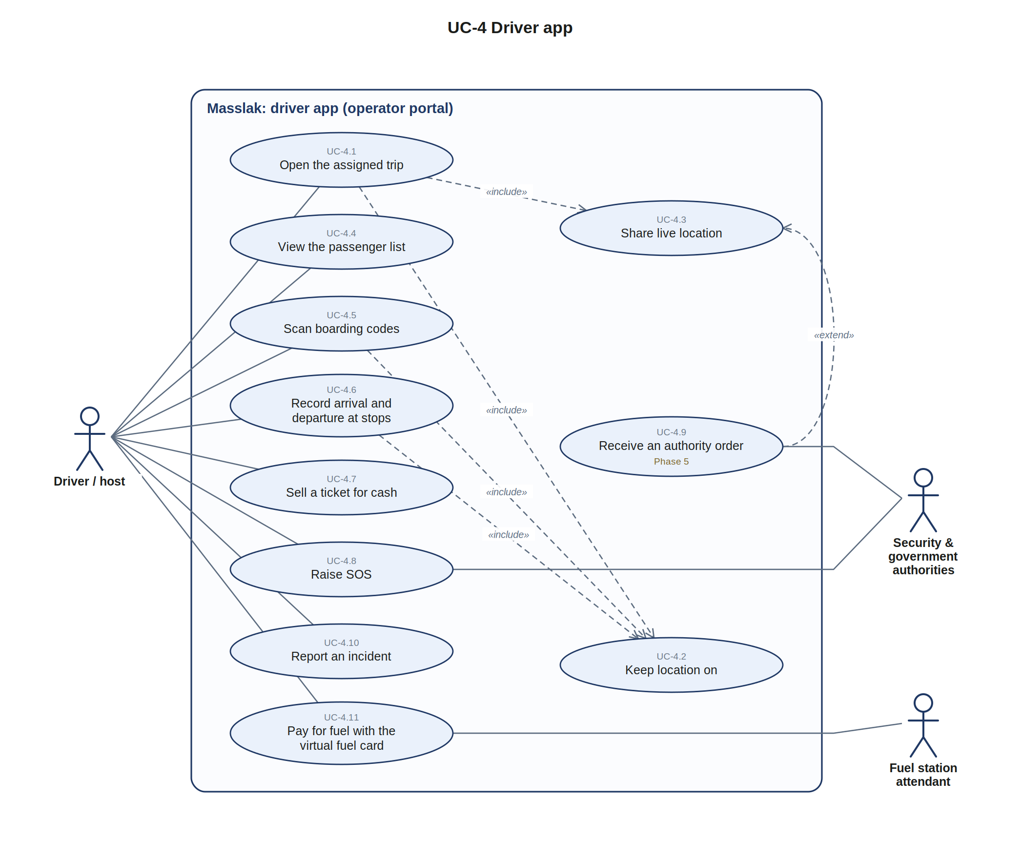
Figure UC-4. Driver app
ID | Use case | Actors | Description | Study
UC-4.1 | Open the assigned trip | Driver / host | Only trips assigned to the driver; the app locks if location is off | 7.13 a, D-01
UC-4.2 | Keep location on | (included or extending) | Continuous location permission; switching it off raises an immediate alert | 7.13 a, 7.8
UC-4.3 | Share live location | (included or extending) | Position about every 15 seconds; silence thresholds escalate to the company | 7.8
UC-4.4 | View the passenger list | Driver / host | Manifest with seats, names and boarding status | 7.3
UC-4.5 | Scan boarding codes | Driver / host | Verify the signed rotating QR, offline with later synchronization | 7.3
UC-4.6 | Record arrival and departure at stops | Driver / host | Stop events with delay; departure closes sales from that stop | 4.12 f
UC-4.7 | Sell a ticket for cash | Driver / host | Cash sale on the company's trips under cash controls | 6.5
UC-4.8 | Raise SOS | Driver / host, Security & government authorities | Emergency alert to the company and the authorities | 8.4
UC-4.9 | Receive an authority order (Phase 5) | Security & government authorities | Stop, divert or inspect orders received through the hub | 8.2, 8.4
UC-4.10 | Report an incident | Driver / host | Incident with evidence, vehicle suspension and continuity decision | 7.12
UC-4.11 | Pay for fuel with the virtual fuel card | Driver / host, Fuel station attendant | Rotating QR with company caps, matched to the station radius | 14.11 b, c

3.6 UC-5 Shipping and logistics
Boundary: Masslak: integrated shipping. Primary actors: Shipper / store, Recipient, Access point operator. Secondary actors: Courier company / hub operator, Courier, Global courier company, Payment gateway / bank.
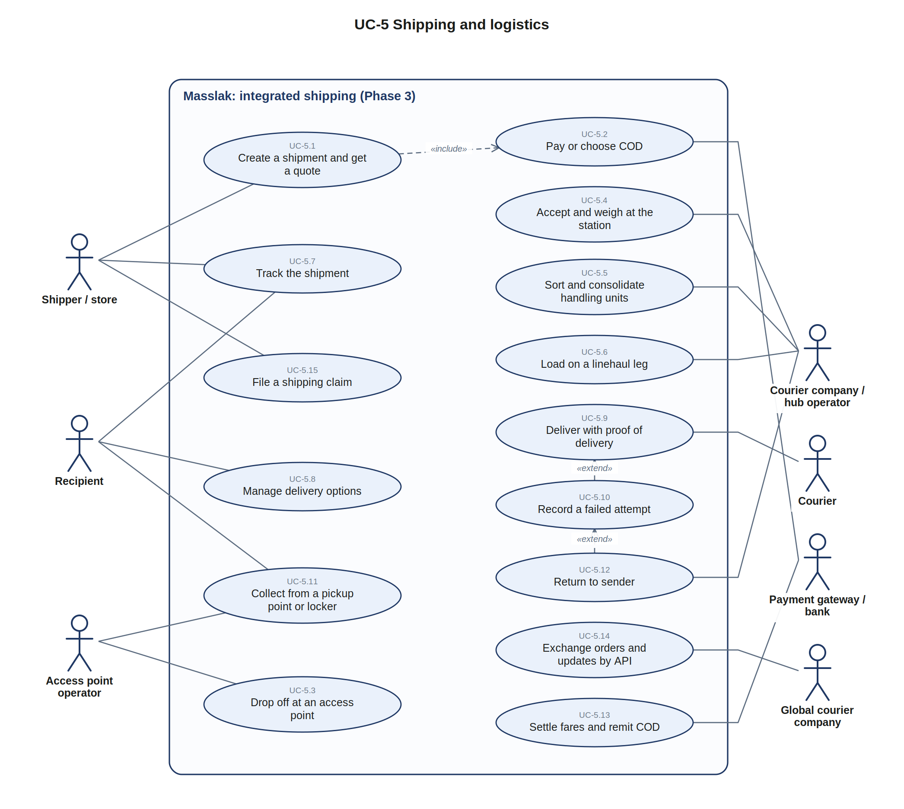
Figure UC-5. Shipping and logistics
ID | Use case | Actors | Description | Study
UC-5.1 | Create a shipment and get a quote (Phase 3) | Shipper / store | Origin, destination, parties, contents, weight and declared value; billable-weight pricing | 9.2, 9.13
UC-5.2 | Pay or choose COD (Phase 3) | Payment gateway / bank | Wallet payment into escrow, or cash on delivery | 9.2, 9.3
UC-5.3 | Drop off at an access point (Phase 3) | Access point operator | Prepaid label dropped at a shop, locker, fuel station or rest stop | 9.15
UC-5.4 | Accept and weigh at the station (Phase 3) | Courier company / hub operator | Actual weight, prohibited items screening, QR label and tracking number | 9.2
UC-5.5 | Sort and consolidate handling units (Phase 3) | Courier company / hub operator | Scan on arrival, next destination, consolidation, missort detection | 9.6
UC-5.6 | Load on a linehaul leg (Phase 3) | Courier company / hub operator | Bus hold, truck load or courier leg chosen by the routing engine | 9.6, 9.7
UC-5.7 | Track the shipment (Phase 3) | Shipper / store, Recipient | Unified tracking across legs, platform and external references | 9.8, 9.23
UC-5.8 | Manage delivery options (Phase 3) | Recipient | Reschedule, redirect, change address, hold, prepay COD, authorize a person | 9.16
UC-5.9 | Deliver with proof of delivery (Phase 3) | Courier | Signature level from photo to adult signature with ID; location radius check | 9.17 b
UC-5.10 | Record a failed attempt (Phase 3) | (included or extending) | Reason code and recipient options; up to three attempts | 9.17 c
UC-5.11 | Collect from a pickup point or locker (Phase 3) | Recipient, Access point operator | Pickup with OTP or ID within the holding period | 9.15
UC-5.12 | Return to sender (Phase 3) | Courier company / hub operator | Return after the last attempt or holding period, at the return charge | 9.17 c, 9.19
UC-5.13 | Settle fares and remit COD (Phase 3) | Payment gateway / bank | Fare released to the company minus commission; COD to the sender's wallet | 9.2
UC-5.14 | Exchange orders and updates by API (Phase 3) | Global courier company | Pre-alerts, creation orders and status updates with global partners | 9.22 b, 9.24
UC-5.15 | File a shipping claim (Phase 3) | Shipper / store | Loss or damage claim within the liability limit | 9.19

3.7 UC-6 Service partners and loyalty
Boundary: Masslak: partners and rewards. Primary actors: Carrier account owner, Passenger, Loyalty partner. Secondary actors: Fuel station attendant, Rest stop / merchant.
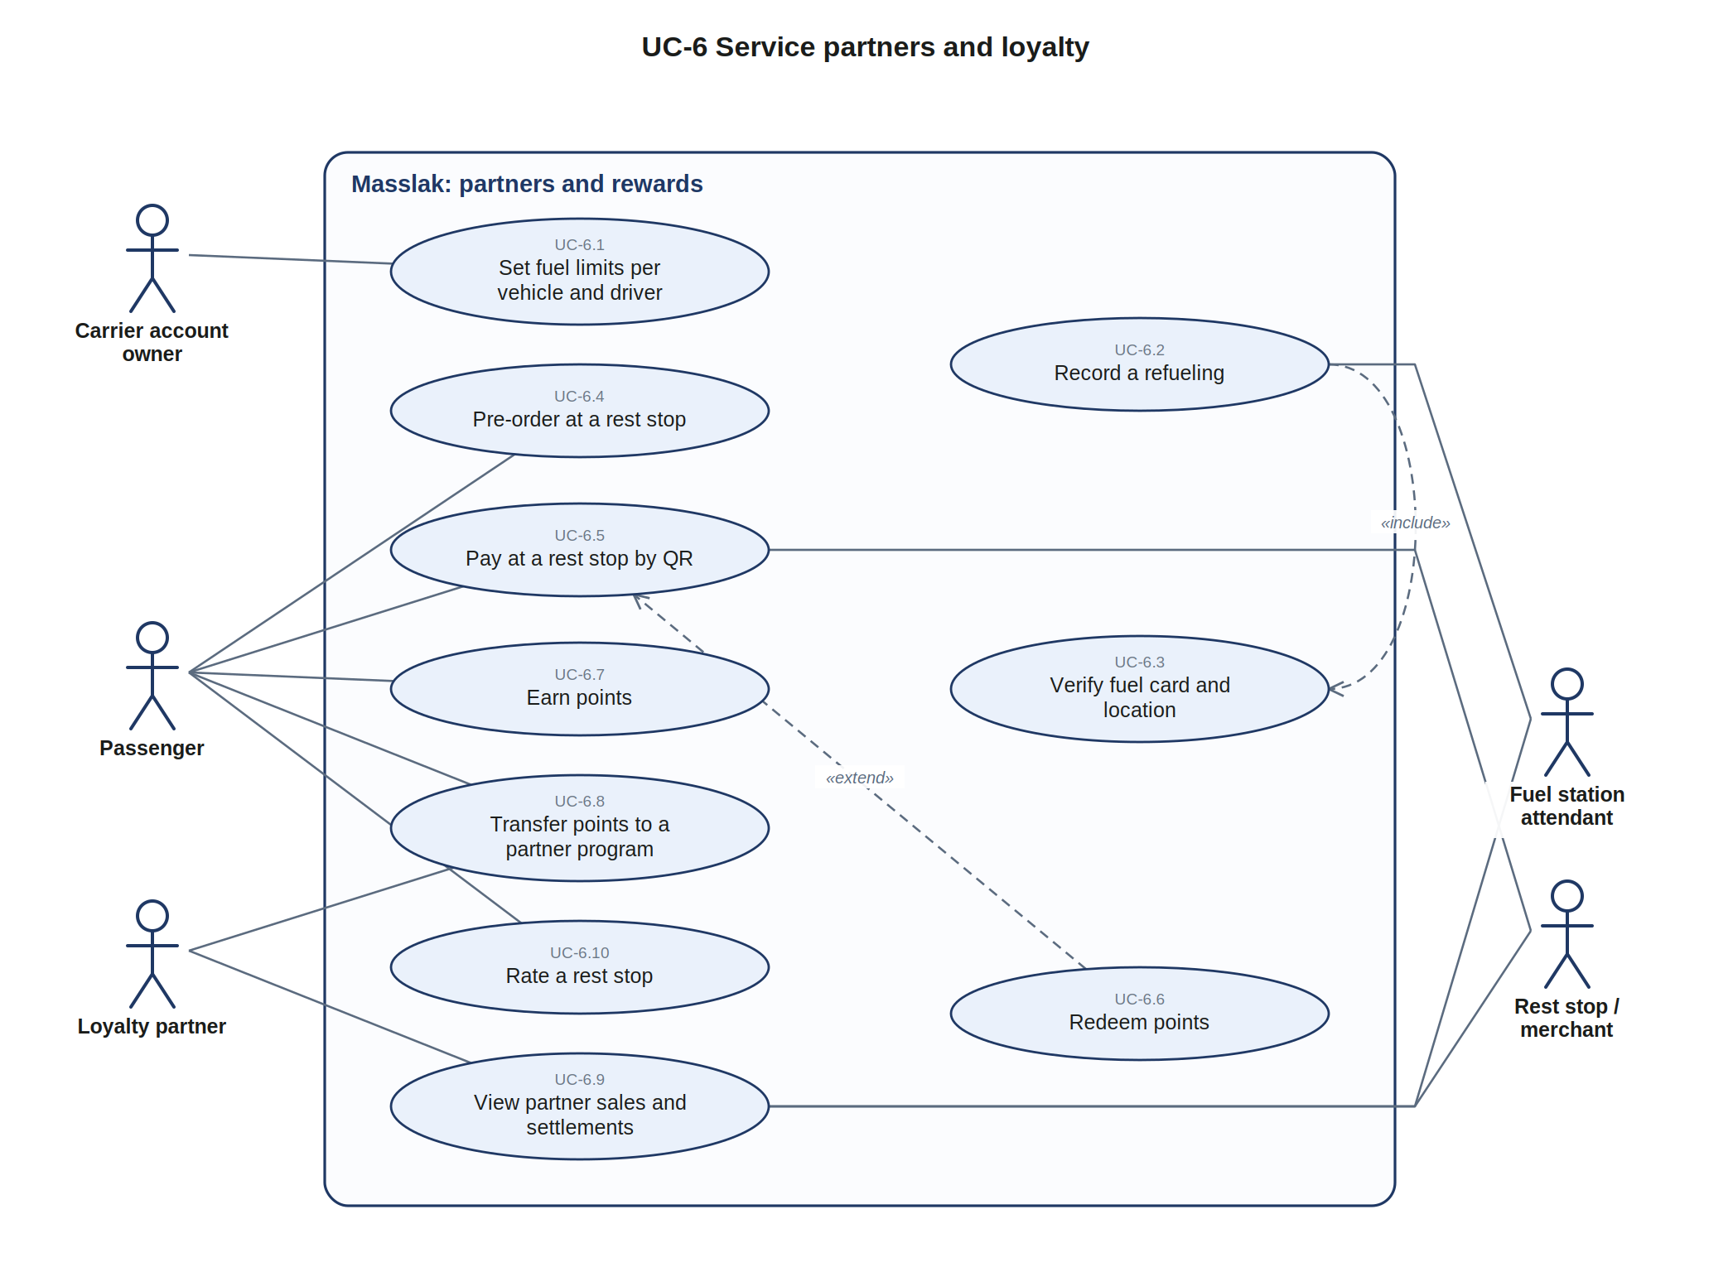
Figure UC-6. Service partners and loyalty
ID | Use case | Actors | Description | Study
UC-6.1 | Set fuel limits per vehicle and driver | Carrier account owner | Caps per vehicle, driver and day, fuel type and optional prior approval | 14.11 b
UC-6.2 | Record a refueling | Fuel station attendant | Quantity, unit price, amount, vehicle, driver and trip; no cash between driver and station | 14.11
UC-6.3 | Verify fuel card and location | (included or extending) | Rotating fuel QR and vehicle location within the station radius | 14.11 b, c
UC-6.4 | Pre-order at a rest stop | Passenger | Menu and offers before or during the trip, ready at the short stop | 14.12 b
UC-6.5 | Pay at a rest stop by QR | Passenger, Rest stop / merchant | Payment QR from the wallet, points or both, with an electronic receipt | 14.12 b
UC-6.6 | Redeem points | (included or extending) | Points redeemed at rest stops, for trips, upgrades or rewards | 5.13 b
UC-6.7 | Earn points | Passenger | Points after trip completion and on partner purchases | 5.13 a
UC-6.8 | Transfer points to a partner program | Passenger, Loyalty partner | Conversion to airline or other programs with consent and limits | 5.13 b
UC-6.9 | View partner sales and settlements | Loyalty partner, Fuel station attendant, Rest stop / merchant | Partner sales, commission and periodic settlement | 14.11, 14.12 c
UC-6.10 | Rate a rest stop | Passenger | Cleanliness, prices and speed of service ratings | 14.12 d

3.8 UC-7 Administration, finance and support
Boundary: Masslak: platform administration (web). Primary actors: Platform administrator, Platform finance, Support employee, Marketing manager, Data Protection Officer, AI assistant supervisor. Secondary actors: Payment gateway / bank, CRM help desk.
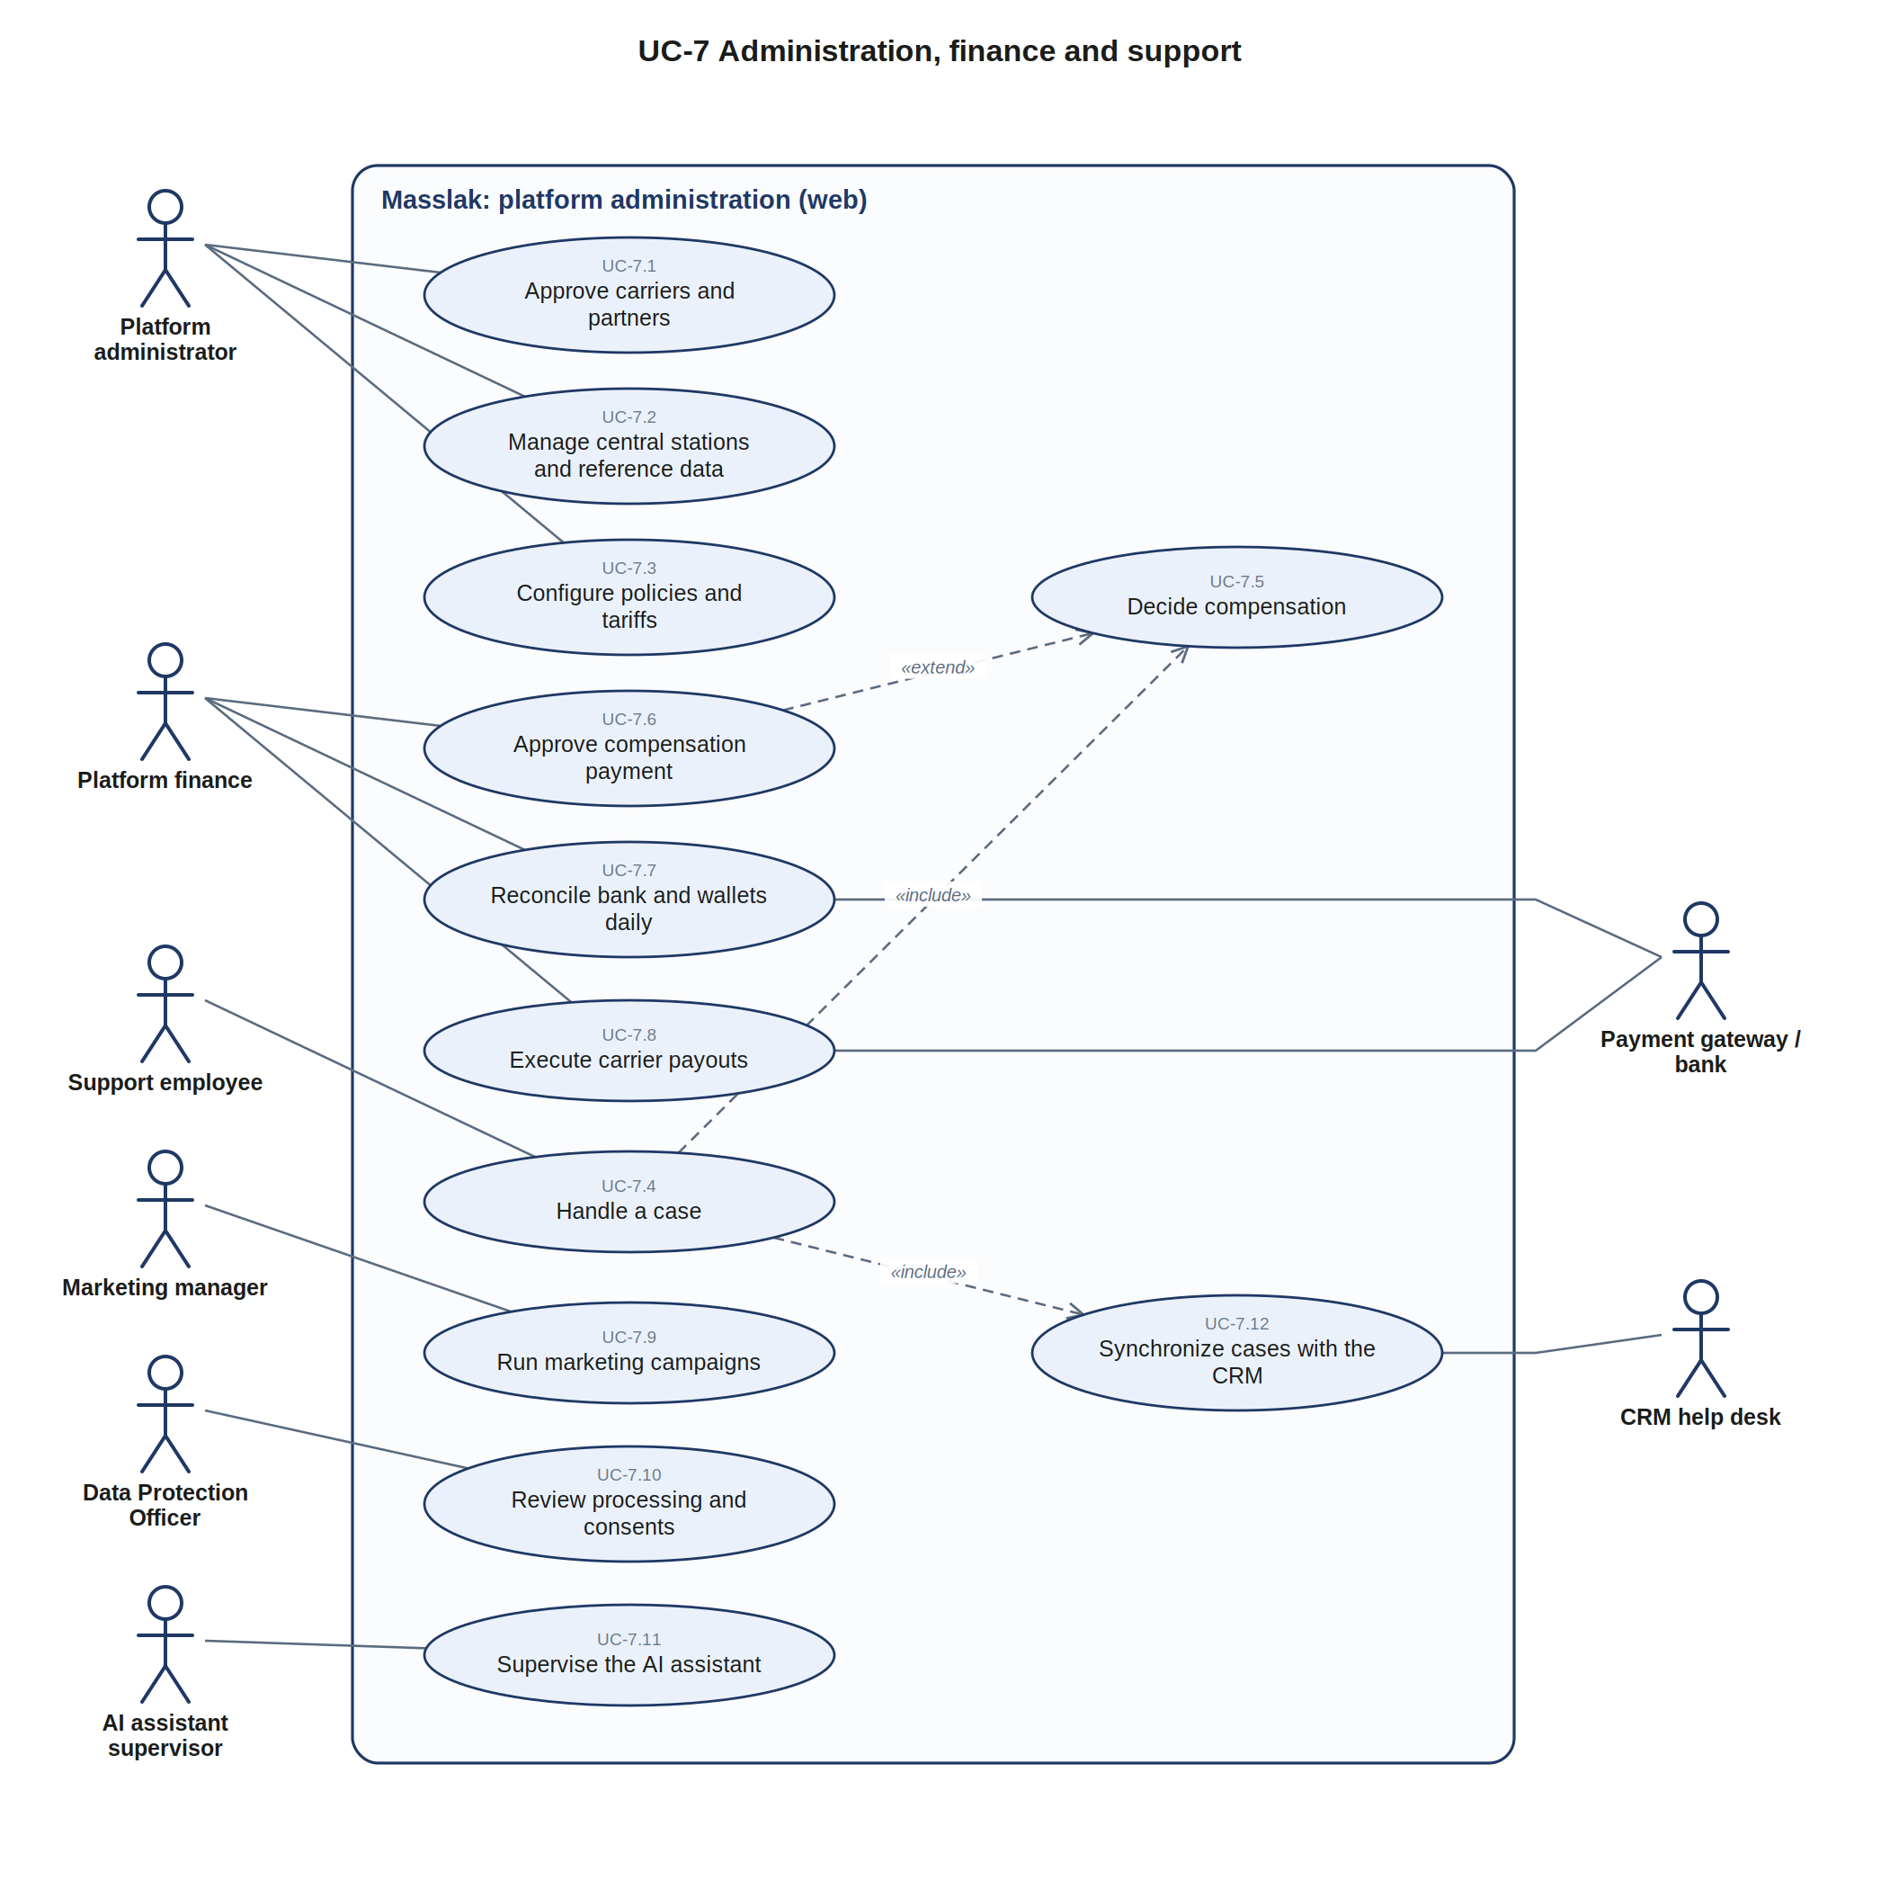
Figure UC-7. Administration, finance and support
ID | Use case | Actors | Description | Study
UC-7.1 | Approve carriers and partners | Platform administrator | Company, partner and point onboarding and status changes | 7.2, 14.11
UC-7.2 | Manage central stations and reference data | Platform administrator | Station register, cities, countries and codes | 4.11, 12.1
UC-7.3 | Configure policies and tariffs | Platform administrator | Policy authority matrix, approved tariffs, fare brands, fees | 2.5, 4.15, 5
UC-7.4 | Handle a case | Support employee | Complaints, claims and inquiries in one thread with internal notes | 7.6 b
UC-7.5 | Decide compensation | (included or extending) | Resolution, amount within the cap and the responsible party | 7.6 c
UC-7.6 | Approve compensation payment | Platform finance | Finance approval with two-factor verification, separate from the decision role | 7.6 c
UC-7.7 | Reconcile bank and wallets daily | Platform finance, Payment gateway / bank | Bank balance equals wallet balances plus receivables; differences alert | 6.3, 6.7
UC-7.8 | Execute carrier payouts | Platform finance, Payment gateway / bank | Per schedule and policy, after cash owed is settled | 6.6
UC-7.9 | Run marketing campaigns | Marketing manager | Campaigns and offers within the approved budget | 5.12
UC-7.10 | Review processing and consents | Data Protection Officer | Processing register, consents, DPIA and data incidents | 16.13
UC-7.11 | Supervise the AI assistant | AI assistant supervisor | Knowledge, evaluation and conversation monitoring | 7.10
UC-7.12 | Synchronize cases with the CRM | CRM help desk | Signed webhooks to an off-the-shelf help desk | 7.6 d

3.9 UC-8 Security, compliance and authorities
Boundary: Masslak: Security & Compliance Hub. Primary actors: Compliance officer, Authority employee, Regulator, Inspector, Document verifier. Secondary actors: Security & government authorities, Border systems.
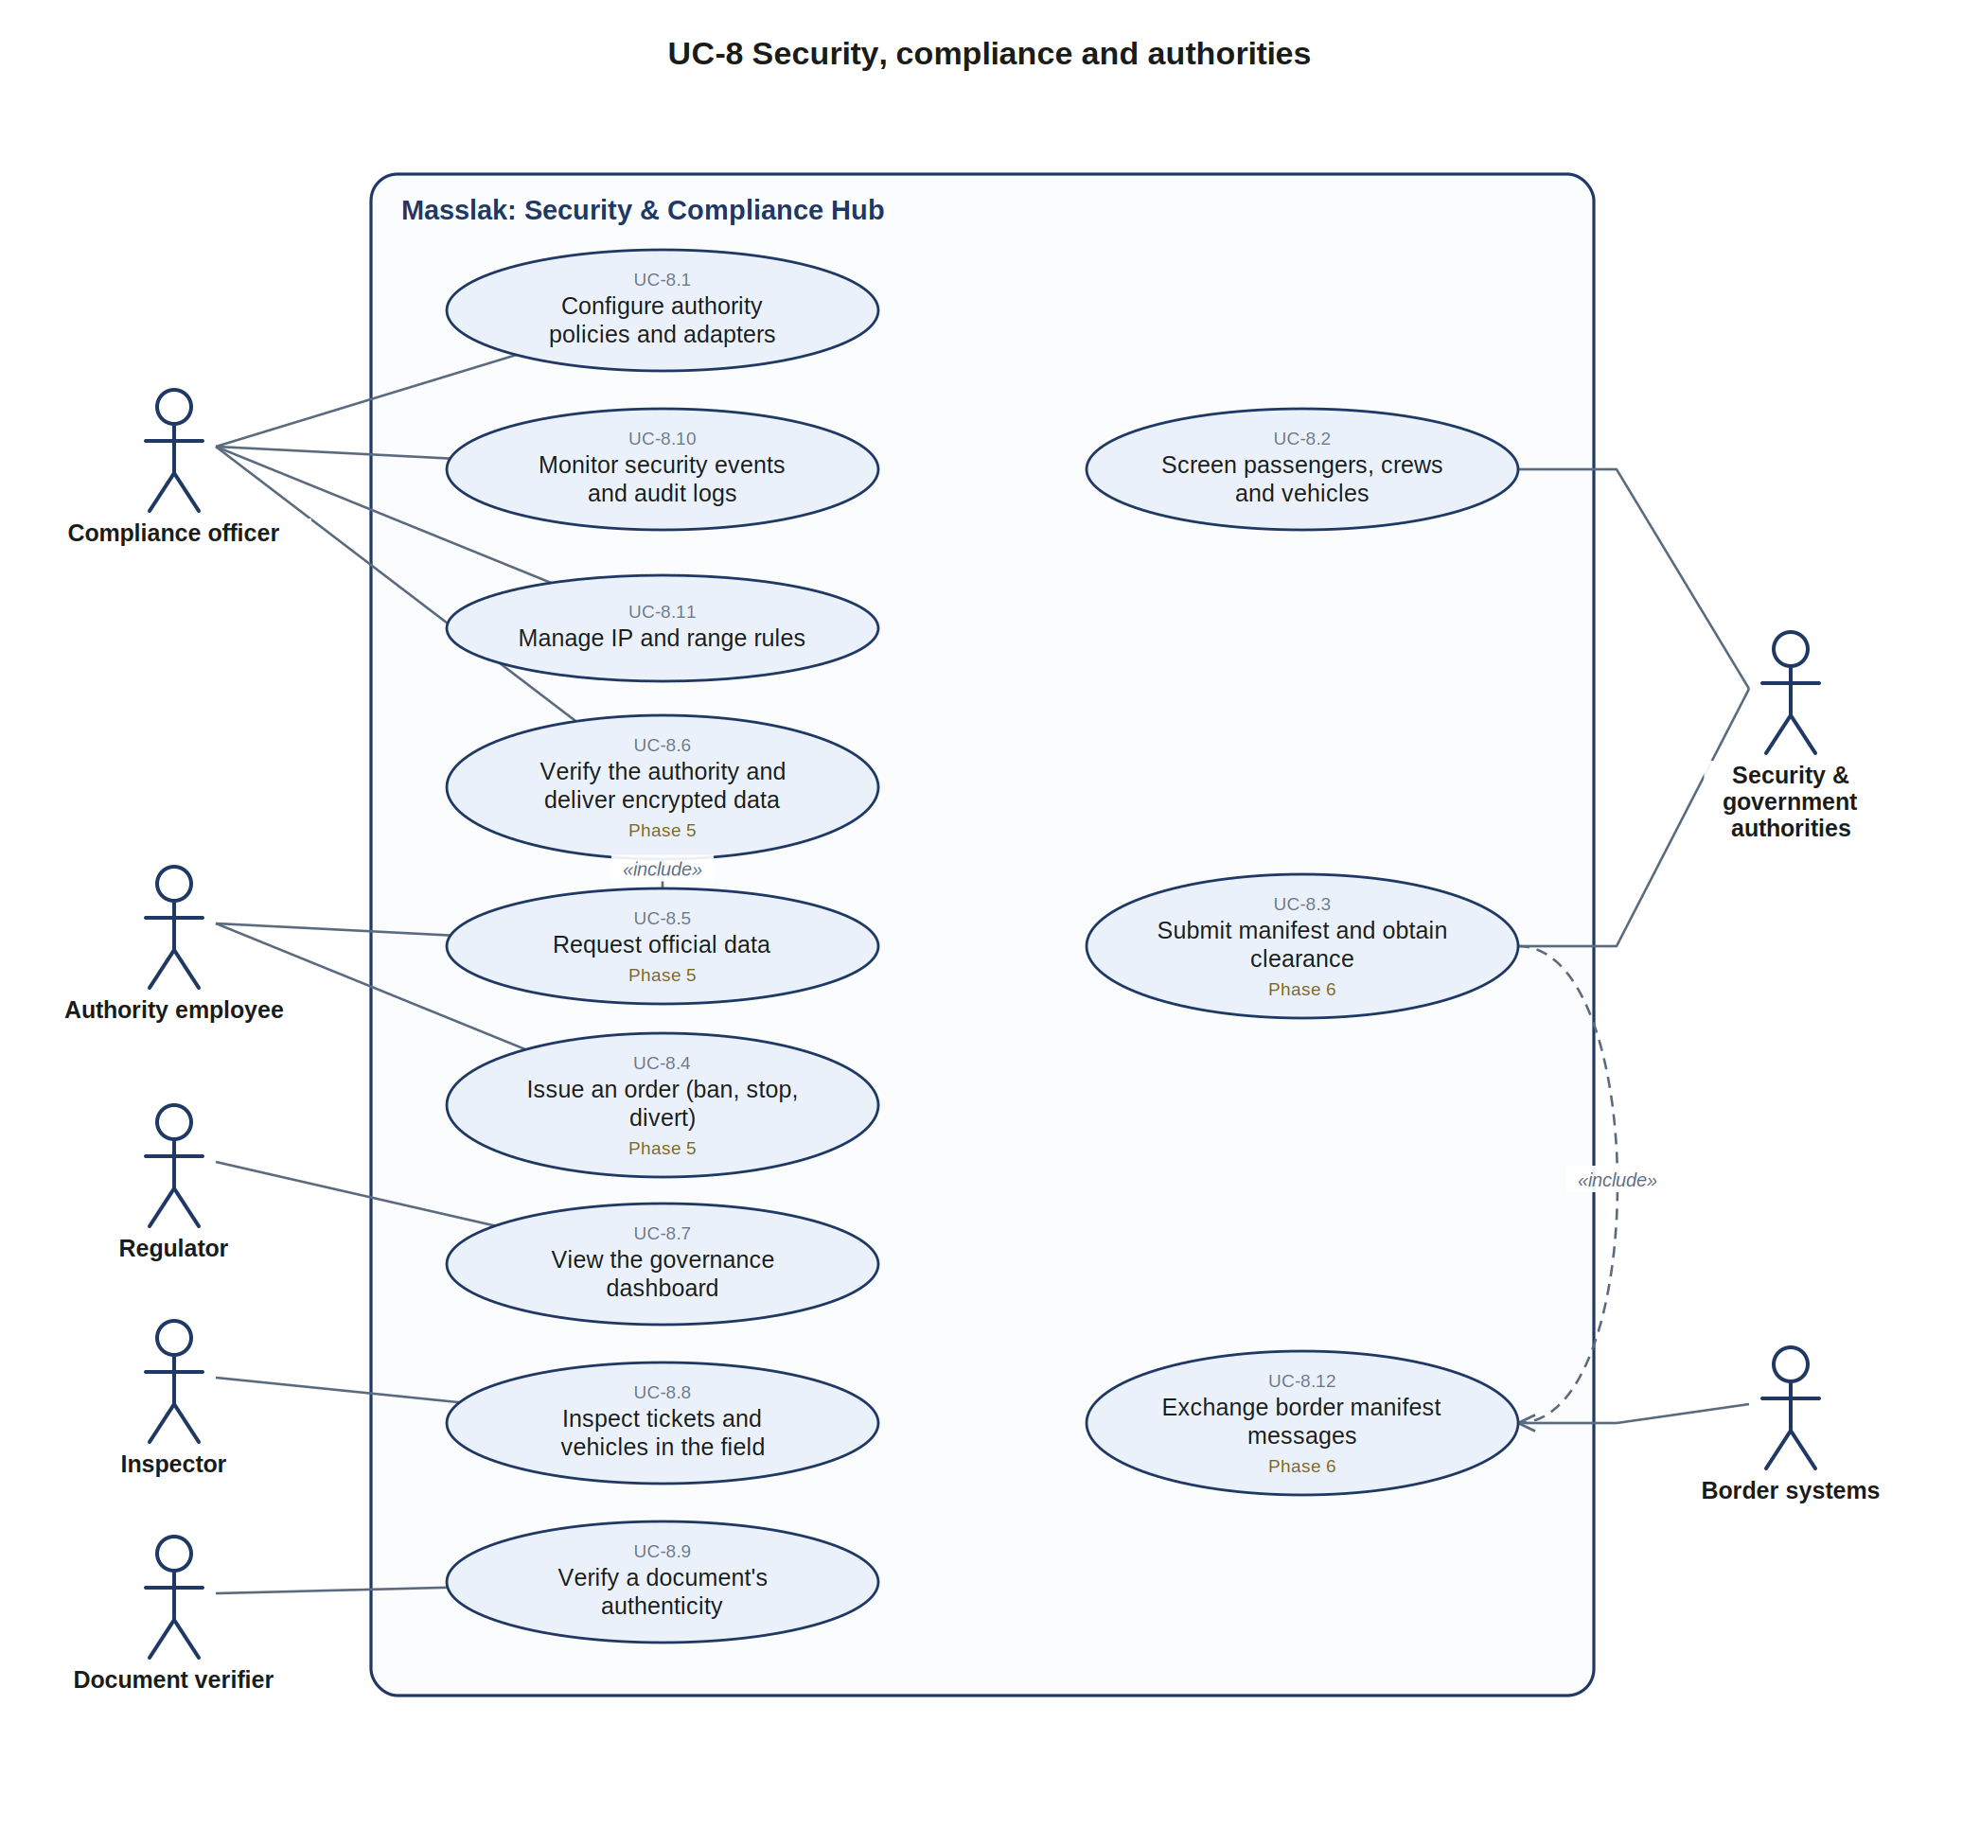
Figure UC-8. Security, compliance and authorities
ID | Use case | Actors | Description | Study
UC-8.1 | Configure authority policies and adapters | Compliance officer | Per-authority policy, exchange pattern and adapter configuration | 8.3
UC-8.2 | Screen passengers, crews and vehicles | Security & government authorities | Before booking: passenger, driver, host, vehicle and company | 8.4
UC-8.3 | Submit manifest and obtain clearance (Phase 6) | Security & government authorities | No transition to boarding before approval on lines subject to it | 8.4, 11.3
UC-8.4 | Issue an order (ban, stop, divert) (Phase 5) | Authority employee | Inbound orders applied to trips, vehicles or persons | 8.2
UC-8.5 | Request official data (Phase 5) | Authority employee | Request with a reference number within the authority's scope | 8.4
UC-8.6 | Verify the authority and deliver encrypted data (Phase 5) | Compliance officer | Authority verification, preparation, encrypted delivery and logging | 8.4, 8.5
UC-8.7 | View the governance dashboard | Regulator | Aggregated indicators without personal data; every view logged | 2.4
UC-8.8 | Inspect tickets and vehicles in the field | Inspector | Active ticket and license status checks, offline by signature | 7.3 c, 32.8
UC-8.9 | Verify a document's authenticity | Document verifier | Server-side answer that detects edited printouts | 16.25
UC-8.10 | Monitor security events and audit logs | Compliance officer | Sign-in and activity logs read through a separate audit connection | 16.6, 16.20
UC-8.11 | Manage IP and range rules | Compliance officer | Block, allow or throttle by IP, range, country or AS number | 16.17
UC-8.12 | Exchange border manifest messages (Phase 6) | Border systems | PRE_MANIFEST, FINAL_MANIFEST, RESPONSE, CROSSING_EVENT, DISCREPANCY | 11.3

3.10 UC-9 Distribution channels and agencies
Boundary: Masslak: distribution and agencies. Primary actors: Travel agency / sub-agent, Corporate client, Marketing affiliate, Platform administrator. Secondary actors: Intermediary platform (OTA / GDS).
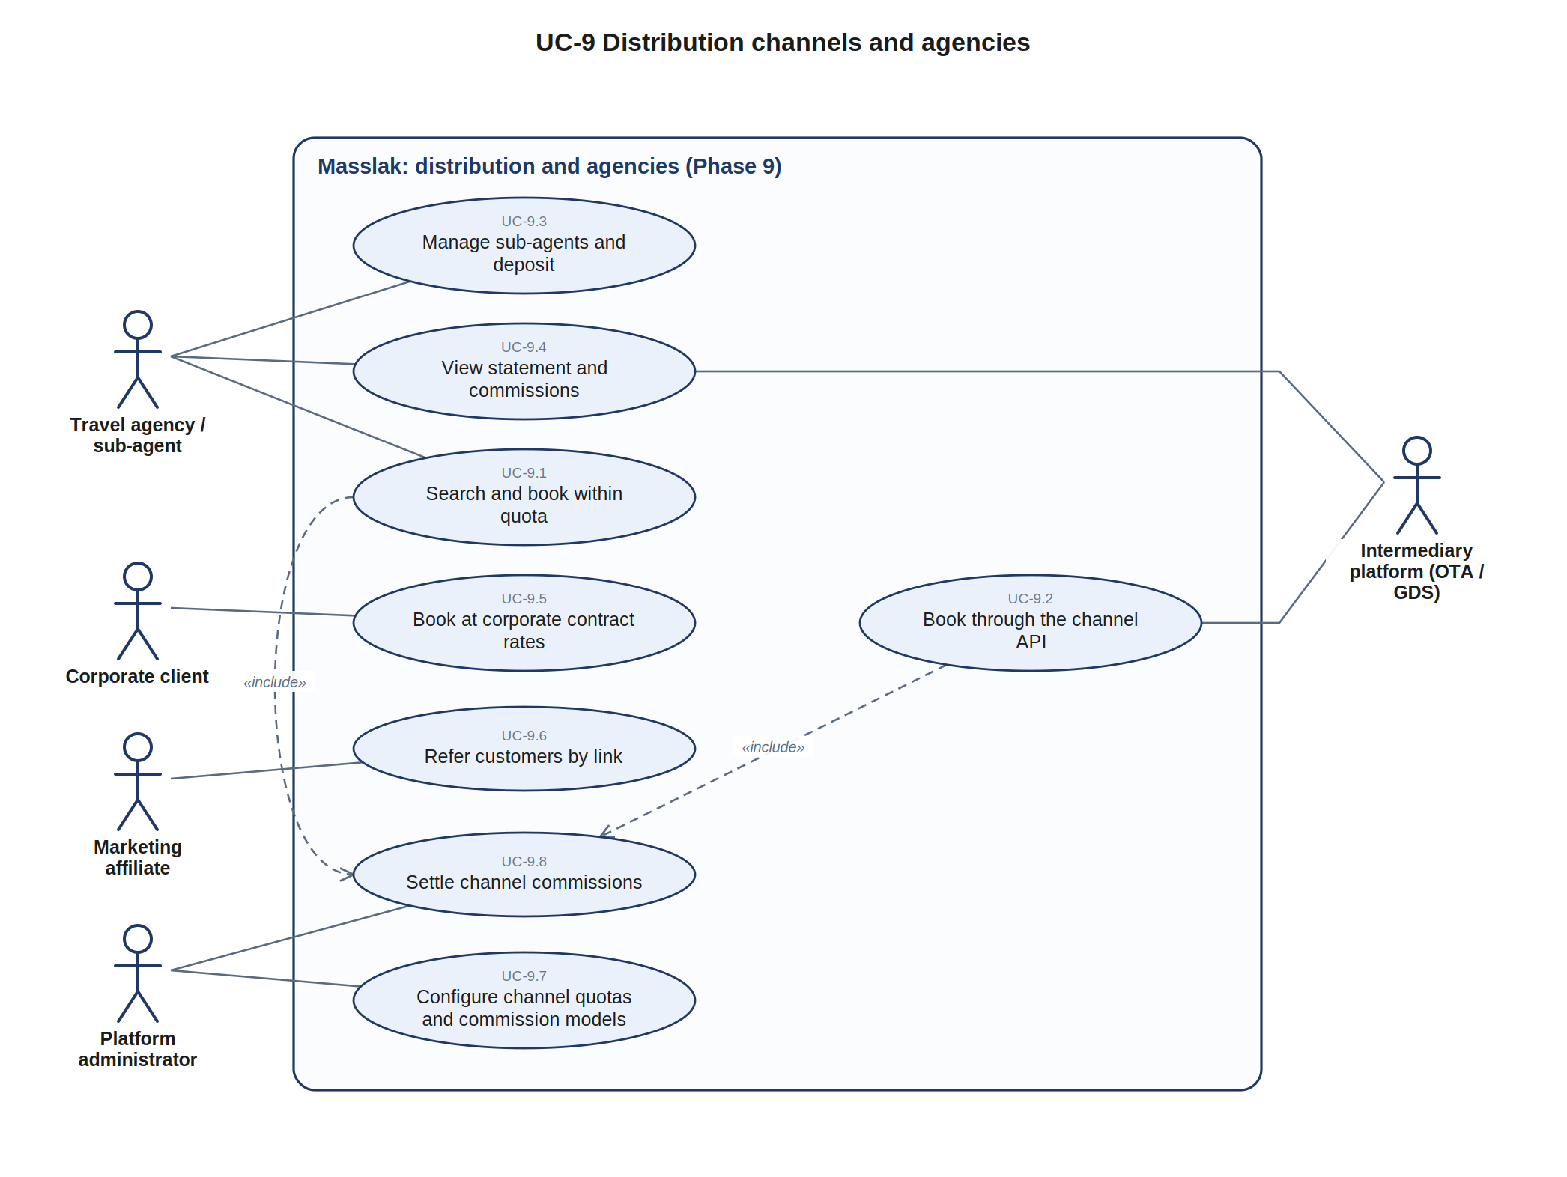
Figure UC-9. Distribution channels and agencies
ID | Use case | Actors | Description | Study
UC-9.1 | Search and book within quota (Phase 9) | Travel agency / sub-agent | Agent portal with deposit wallet or credit and preferred fares | 14.9
UC-9.2 | Book through the channel API (Phase 9) | Intermediary platform (OTA / GDS) | Availability, pricing and booking with certification and quotas | 14.4, 14.5
UC-9.3 | Manage sub-agents and deposit (Phase 9) | Travel agency / sub-agent | Sub-agents under the agency and their deposits | 14.9
UC-9.4 | View statement and commissions (Phase 9) | Travel agency / sub-agent, Intermediary platform (OTA / GDS) | Account statement and commission lines | 14.6
UC-9.5 | Book at corporate contract rates (Phase 9) | Corporate client | Contract rates, possibly with a service fee | 14.3
UC-9.6 | Refer customers by link (Phase 9) | Marketing affiliate | Referral commission for affiliates | 14.3
UC-9.7 | Configure channel quotas and commission models (Phase 9) | Platform administrator | Commission models by configuration, quotas and look-to-book controls | 14.3, 14.5
UC-9.8 | Settle channel commissions (Phase 9) | Platform administrator | Periodic financial settlement with channels | 14.6

3.11 UC-10 Accounting and e-invoicing
Boundary: Masslak: accounting core and integration hub. Primary actors: Passenger, Accounting integration officer, Platform finance. Secondary actors: Tax authority, Accounting / ERP system, Payment gateway / bank.
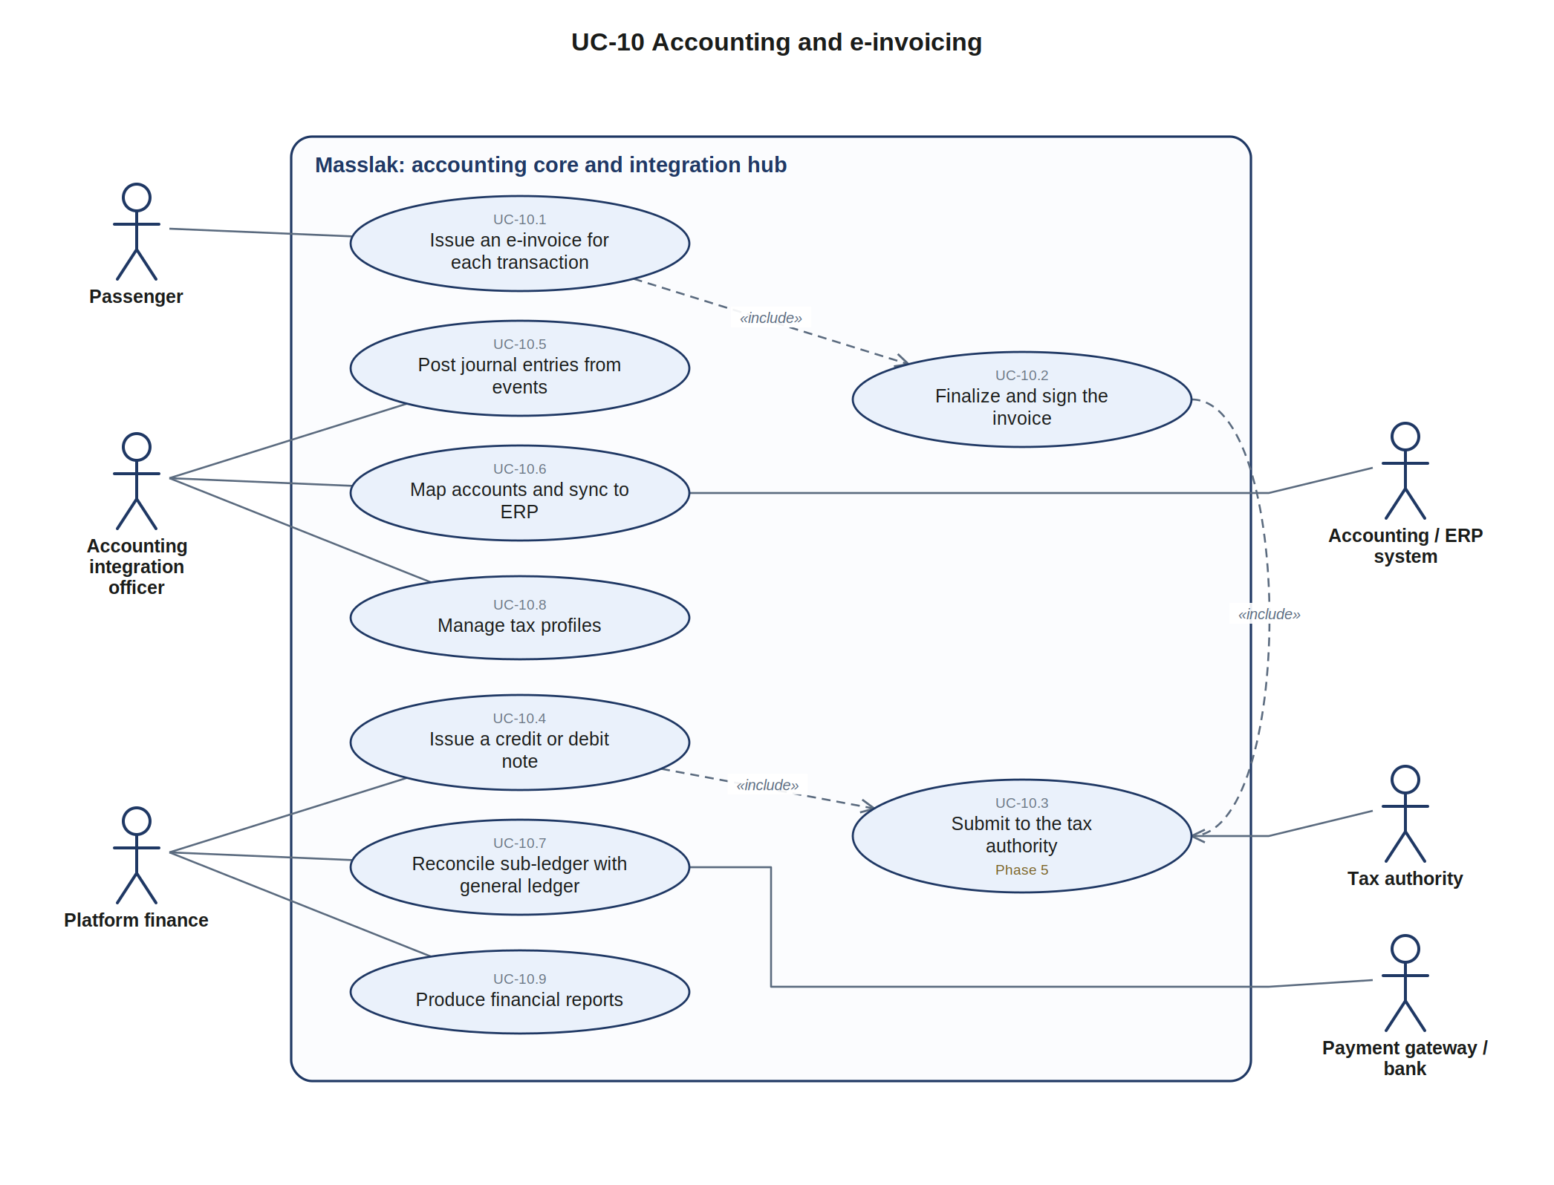
Figure UC-10. Accounting and e-invoicing
ID | Use case | Actors | Description | Study
UC-10.1 | Issue an e-invoice for each transaction | Passenger | One or more invoices per booking, shipment, freight contract, subscription or partner service | 13.11 a
UC-10.2 | Finalize and sign the invoice | (included or extending) | Gapless number, UUID, hash chain, signature, QR, XML and PDF at payment | 13.11 b
UC-10.3 | Submit to the tax authority (Phase 5) | Tax authority | Clearance or reporting mode; responses stored and the invoice fully locked | 13.11 b
UC-10.4 | Issue a credit or debit note | Platform finance | Corrections only through linked documents | 13.11 a
UC-10.5 | Post journal entries from events | Accounting integration officer | Posting rules convert module events into balanced entries | 13.4
UC-10.6 | Map accounts and sync to ERP | Accounting integration officer, Accounting / ERP system | Adapters push entries and invoices to accounting systems via API | 13.5, 13.12
UC-10.7 | Reconcile sub-ledger with general ledger | Platform finance, Payment gateway / bank | Daily summary entries from the wallet ledger with automatic reconciliation | 13.4
UC-10.8 | Manage tax profiles | Accounting integration officer | Seller and buyer tax profiles per country pack | 13.13, 12.4
UC-10.9 | Produce financial reports | Platform finance | Statements and reports for finance and governance | 35

4. Key use case specifications
The following use cases carry the most money, risk or regulatory weight, so they are specified step by step. The numbered steps are the main success scenario; alternative flows refer to the step they branch from.

4.1 UC-1.4 Book a trip
Primary actor | Passenger
Secondary actors | Security and government authorities (through the hub); payment gateway (top-up only)
Preconditions | • The passenger is signed in and the KYC level allows the amount (3.8, 6.3).  • On the mobile app, location permission is granted (7.13 a).  • The trip is published and on sale for the chosen pair (4.12).
Trigger | The passenger selects a trip from the search results.
Main flow | 1. The system shows the seat map for the boarding and alighting pair.  2. The passenger selects seats; the system locks them on every segment of the pair for 10 minutes.  3. The passenger enters each passenger's names exactly as on the identity document, the document, nationality, date of birth and mobile.  4. The system sends a screening request according to the authority's policy and receives ALLOW.  5. The system applies the calculation layers and the fare brand, and saves the price snapshot and allocation lines.  6. The passenger confirms; the system moves the total from the wallet to escrow with an idempotency key.  7. The system commits the seats atomically, issues tickets with a rotating QR and sends a notification.  8. The system finalizes and locks the e-invoice for the paid booking.
Alternative flows | 2a. A seat was just taken: the hold is refused as a whole and the seat map is refreshed.  4a. REVIEW or DENY: the booking does not proceed until resolved according to the authority's policy (8.3).  6a. Insufficient balance: the passenger tops up the wallet (UC-1.10) and continues.  6b. The passenger redeems points for part or all of the fare (UC-1.9).  6c. The hold expired: the passenger chooses seats again.
Postconditions | Booking confirmed, tickets issued, funds held in escrow, e-invoice finalized.
Study references | 7.1, 4.12 c, 5.1, 5.7, 5.9, 6.2, 8.3, 13.11

4.2 UC-2.2 / 2.7 Ride a shuttle line (station-by-station charging)
Primary actor | Shuttle passenger
Secondary actors | Driver / host (presence token), notification providers
Preconditions | • Location permission at all times and Bluetooth are on (7.13 a, b).  • The balance or subscription covers the first fare and there is no outstanding fare (7.13 c).  • The vehicle has not reached its licensed capacity (4.13).
Trigger | The passenger scans the QR sticker on the vehicle (or passes a gate).
Main flow | 1. The system identifies the vehicle, line and direction.  2. The system checks the vehicle's capacity and opens a ride from the boarding station.  3. The system deducts the fare of the first station, the fixed band or the whole-line fare.  4. Each time the vehicle leaves a station with the passenger present (Nearby or moving together), the system deducts the next segment or its remainder and notifies the passenger.  5. The passenger alights: presence is lost for 90 seconds with 150 meters of separation, or the passenger scans the station QR.  6. The system closes the ride, stops further charges and sends a receipt with the boarding station, alighting point and each segment.
Alternative flows | 2a. Vehicle full: the scan is refused (VEHICLE_FULL) and the driver is alerted.  4a. The balance does not cover the next segment: the app warns before the station; continuing records an interest-free outstanding amount recovered from the next top-up.  4b. Location or Bluetooth is switched off: the app locks; the rest of the line is charged unless a station QR proves alighting.  5a. The phone shuts down: segments are charged only up to the last departure with confirmed presence and the ride is flagged for review.  6a. The passenger disputes a deduction within 48 hours; the evidence is the proximity log, positions and stop events.
Postconditions | Ride closed, segment charges posted, capacity counter updated.
Study references | 7.3 a, 7.13 a to c, 4.13, 6.8

4.3 UC-4.5 Scan boarding codes
Primary actor | Driver / host
Secondary actors | Passenger
Preconditions | • The trip is assigned to the driver and location is on (7.13 a).  • Departure clearance has been obtained on lines subject to it (8.4).
Trigger | A passenger presents the rotating QR at boarding.
Main flow | 1. The driver scans the code in the driver app.  2. The app verifies the digital signature and validity window, offline if needed.  3. The system records the boarding event and marks the ticket boarded.  4. The boarding counter and the manifest are updated.
Alternative flows | 2a. The code was already used, belongs to another trip or is invalid: boarding is refused with the reason.  2b. No connectivity: the scan is stored and synchronized later.
Postconditions | Boarding recorded; the final manifest is available when boarding closes (11.3).
Study references | 7.3, 8.4, 11.3

4.4 UC-5.9 Deliver with proof of delivery
Primary actor | Courier
Secondary actors | Recipient, shipper
Preconditions | • The shipment has arrived and is on the courier's daily route (9.17 a).
Trigger | The courier reaches the delivery address.
Main flow | 1. The app shows the required signature level for the shipment.  2. The courier collects the proof: photo, signature, OTP or ID depending on the level.  3. The system checks that the courier's location is within the set radius of the address.  4. If COD applies, the amount is collected or confirmed as prepaid.  5. The system records the delivery with proof and notifies the shipper and the recipient; a signed proof can be downloaded.
Alternative flows | 2a. Delivery fails: the courier records a reason code and the recipient receives the control options (9.16); after the last attempt the shipment is held at a pickup point, then returned to the sender.  3a. The location is outside the radius: the scan is rejected or flagged for review.  5a. Offline: scans and proofs are stored and synchronized later with a device timestamp.
Postconditions | Shipment delivered with proof; settlement and COD transfer can proceed.
Study references | 9.16, 9.17, 9.19, 16.25

4.5 UC-6.2 Record a refueling
Primary actor | Fuel station attendant
Secondary actors | Driver, carrier owner
Preconditions | • The station is a contracted partner and the company has set fuel limits (14.11 b).
Trigger | The driver presents the virtual fuel card QR at the pump.
Main flow | 1. The attendant scans the code and enters fuel type, quantity and amount.  2. The system checks the caps and that the vehicle is within the station's radius.  3. The amount is deducted from the company wallet or recorded as a receivable.  4. The system records the partner sale with station, vehicle, driver, trip, fuel type, quantity, unit price and amount, and issues a receipt.  5. Periodically, the system nets fuel receivables against the company's payables and settles the station.
Alternative flows | 2a. The location does not match: an alert is raised.  2b. A cap is exceeded: the purchase is refused or needs prior approval.  3a. The company's credit limit is exceeded: the service is suspended.
Postconditions | Partner sale recorded; no cash passed between driver and station.
Study references | 14.11

4.6 UC-7.4 Handle a claim and pay compensation
Primary actor | Support employee
Secondary actors | Platform finance, CRM help desk
Preconditions | • A claim is open and linked to a booking; only one open claim per booking (7.6 c).
Trigger | A customer submits a claim.
Main flow | 1. The case is categorized and prioritized with its SLA.  2. The customer, company and support employee correspond in one thread; internal notes stay separate.  3. The support employee decides the resolution, the amount within the cap, and the responsible party.  4. Platform finance approves the payment with two-factor verification.  5. The system posts the compensation from the responsible party's wallet to the customer's wallet once.  6. The case is resolved and closed, and the events are sent to the CRM by signed webhook.
Alternative flows | 5a. The responsible party's balance is insufficient: execution is rejected so another party can be chosen or settlement awaited.
Postconditions | Compensation paid without duplication; the case log is immutable.
Study references | 7.6

4.7 UC-8.5 Request official data
Primary actor | Authority employee
Secondary actors | Compliance officer
Preconditions | • The authority is registered with a defined scope (8.3).
Trigger | The authority submits a request with a reference number.
Main flow | 1. The system records the request and its reference.  2. The compliance officer verifies the authority and that the request is within its scope.  3. The system prepares the requested record (for example the trip record, boardings and GPS route).  4. The data is delivered encrypted to the authority.  5. The access is recorded in the security audit log.
Alternative flows | 2a. The request is outside the authority's scope: it is refused and recorded.
Postconditions | Official request fulfilled and fully traceable.
Study references | 8.4, 8.5

4.8 UC-10.1 Issue an e-invoice
Primary actor | System (on payment); Passenger as buyer
Secondary actors | Tax authority
Preconditions | • A booking, shipment or service has a price allocation (5.7).
Trigger | The sale is created (draft) and then paid (final).
Main flow | 1. The system builds a draft invoice from the allocation lines and taxes, without a number or QR.  2. On payment, the system assigns the gapless number and UUID, chains the hash, signs, and generates the QR, XML and PDF.  3. The invoice is pushed to the tax authority immediately in clearance mode or within the period in reporting mode.  4. The authority's response is stored and the invoice is fully locked.
Alternative flows | 1a. The hold expires without payment: the draft is cancelled and consumes no number.  3a. Before integration is activated: the finalized invoice is final with a local QR and full archiving.  4a. Rejected: the invoice stays stored with the reasons and a corrected linked document is issued.  4b. Accepted with warnings: locked as confirmed and the warnings escalated to finance.
Postconditions | Locked e-invoice, confirmed by the authority where integration is active.
Study references | 13.11, 13.12

5. Data flow diagrams

5.1 DFD-0 Context diagram
The context diagram shows the whole platform as a single process and every external entity that sends data to it or receives data from it.
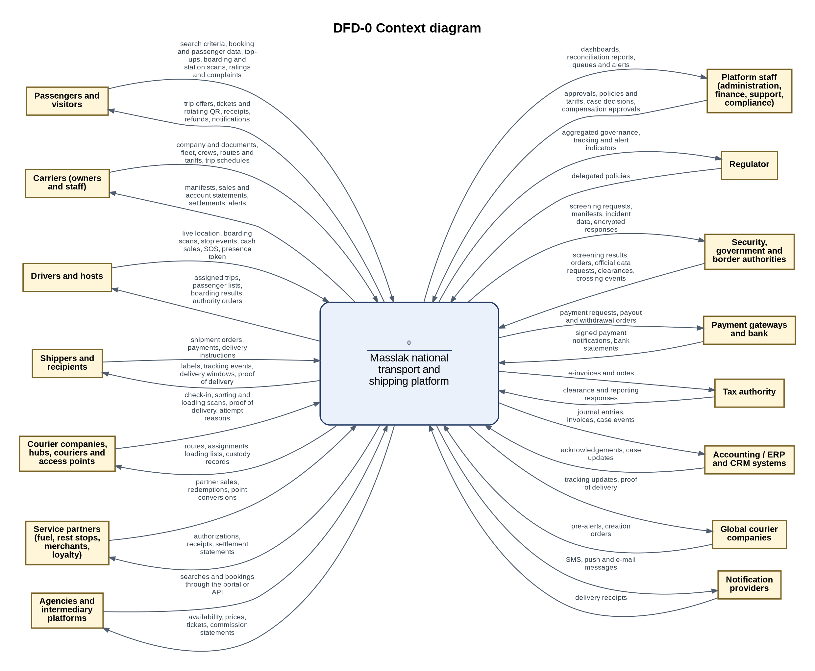
Figure DFD-0. Context diagram

External entities and their flows
External entity | Data into the platform | Data from the platform
Passengers and visitors | search criteria, booking and passenger data, top-ups, boarding and station scans, ratings and complaints | trip offers, tickets and rotating QR, receipts, refunds, notifications
Carriers (owners and staff) | company and documents, fleet, crews, routes and tariffs, trip schedules | manifests, sales and account statements, settlements, alerts
Drivers and hosts | live location, boarding scans, stop events, cash sales, SOS, presence token | assigned trips, passenger lists, boarding results, authority orders
Shippers and recipients | shipment orders, payments, delivery instructions | labels, tracking events, delivery windows, proof of delivery
Courier companies, hubs, couriers and access points | check-in, sorting and loading scans, proof of delivery, attempt reasons | routes, assignments, loading lists, custody records
Service partners (fuel, rest stops, merchants, loyalty) | partner sales, redemptions, point conversions | authorizations, receipts, settlement statements
Agencies and intermediary platforms | searches and bookings through the portal or API | availability, prices, tickets, commission statements
Platform staff (administration, finance, support, compliance) | approvals, policies and tariffs, case decisions, compensation approvals | dashboards, reconciliation reports, queues and alerts
Regulator | delegated policies | aggregated governance, tracking and alert indicators
Security, government and border authorities | screening results, orders, official data requests, clearances, crossing events | screening requests, manifests, incident data, encrypted responses
Payment gateways and bank | signed payment notifications, bank statements | payment requests, payout and withdrawal orders
Tax authority | clearance and reporting responses | e-invoices and notes
Accounting / ERP and CRM systems | acknowledgements, case updates | journal entries, invoices, case events
Global courier companies | pre-alerts, creation orders | tracking updates, proof of delivery
Notification providers | delivery receipts | SMS, push and e-mail messages

5.2 DFD-1A Level 1: passenger transport core
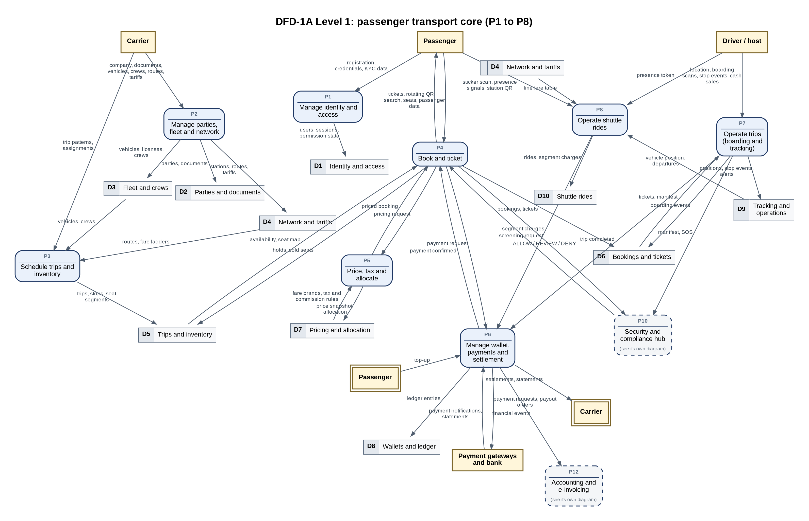
Figure DFD-1A. Processes P1 to P8

5.3 DFD-1B Level 1: logistics, compliance, partners, finance and channels
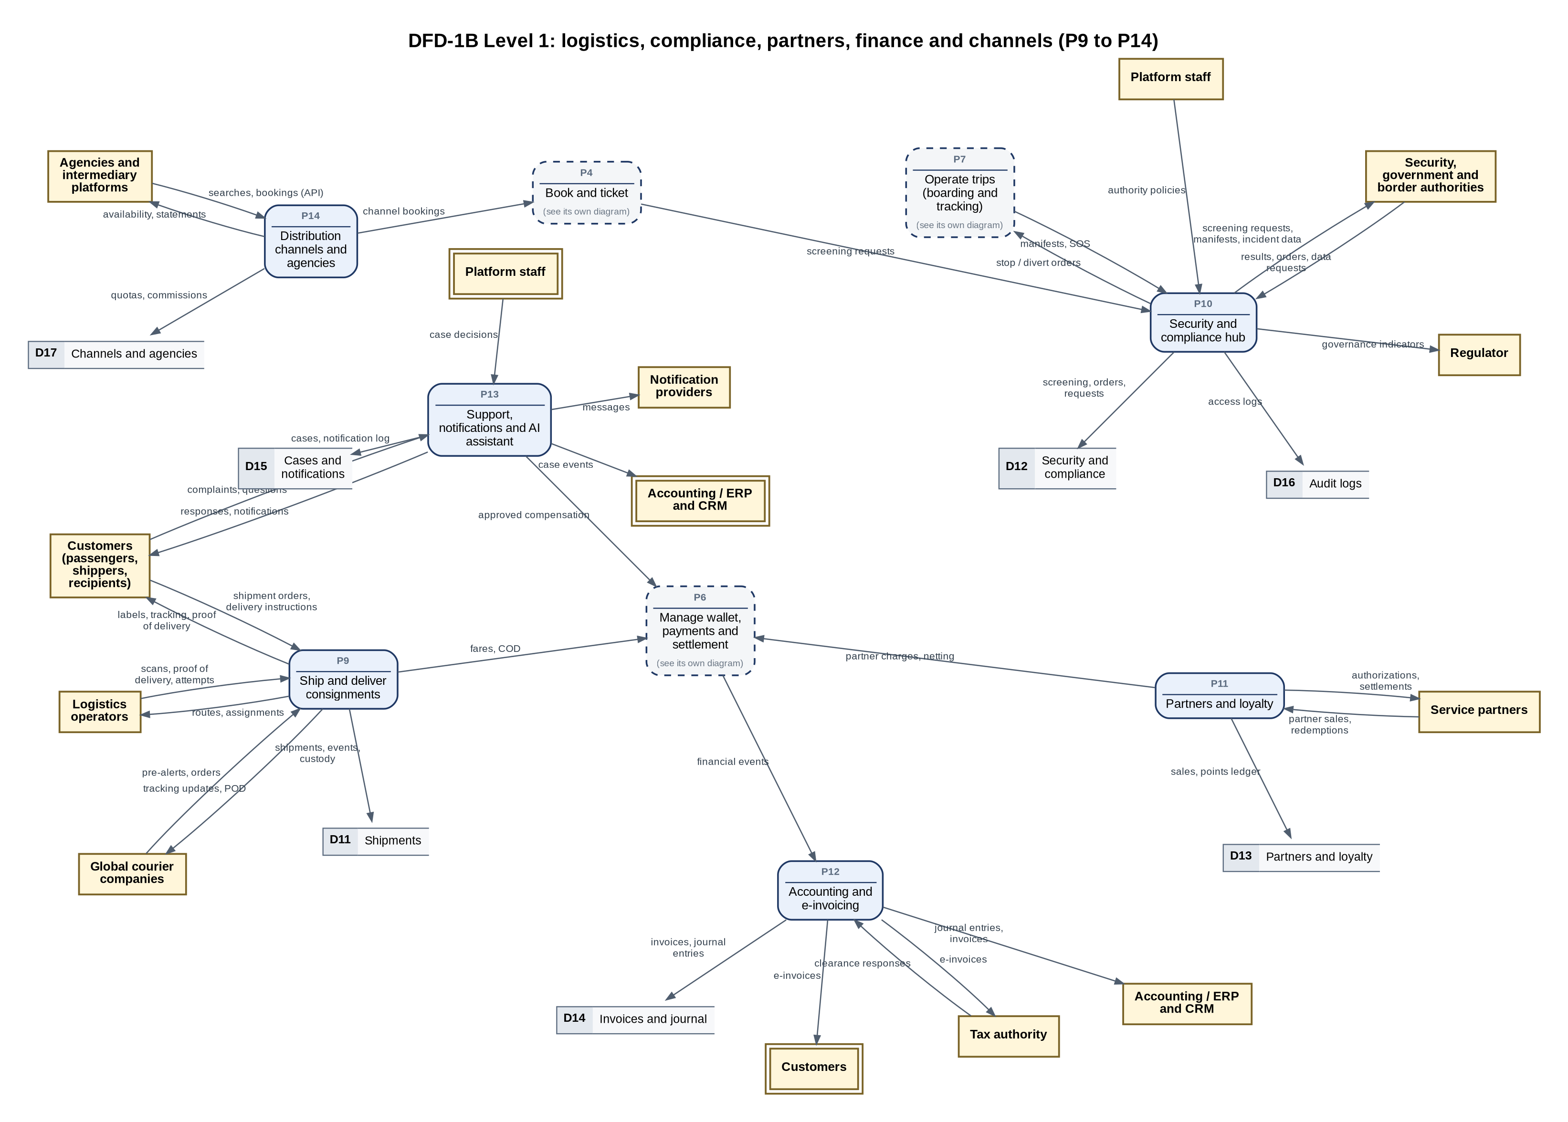
Figure DFD-1B. Processes P9 to P14

Level 1 processes
Process | Name | What it does | Diagram | Level 2 | Study
P1 | Manage identity and access | Registration, sign-in for each portal, sessions, roles and permissions, KYC levels, and the device's location and Bluetooth permission state that the apps require. | DFD-1A | - | 3.4, 3.5, 3.8, 7.13 a, 16.18
P2 | Manage parties, fleet and network | Onboarding of companies and individuals with documents, vehicles with licenses and ownership, crews, the station register, lines and approved tariffs. | DFD-1A | - | 3.4, 4.2 to 4.4, 4.11, 4.13 to 4.18
P3 | Schedule trips and inventory | Trip patterns, generated trips with stops and trip numbers, crew and vehicle assignment, and seat inventory per segment. | DFD-1A | - | 4.12, 4.16, 7.2
P4 | Book and ticket | Search, seat holds, passenger data, screening, pricing, payment, ticket issue with rotating QR, and cancellation with refund. | DFD-1A | DFD-4 | 7.1, 4.12, 5.9
P5 | Price, tax and allocate | Calculation layers, central or free pricing, fare brands, taxes, fees, commissions and the price allocation tree saved with each booking. | DFD-1A | - | 5.1 to 5.11
P6 | Manage wallet, payments and settlement | Wallets, top-up and withdrawal, escrow, release on completion, refunds, cash clearing, carrier payouts and daily reconciliation in a double-entry ledger. | DFD-1A | DFD-6 | 6.1 to 6.8
P7 | Operate trips (boarding and tracking) | Driver app tracking, boarding scans, stop events, alerts and escalation, route adherence and trip completion. | DFD-1A | DFD-7 | 7.3, 7.8, 4.15, 7.12
P8 | Operate shuttle rides | Shuttle boarding by sticker or gate, presence by Nearby proximity and moving together, station-by-station charging, alighting detection and capacity. | DFD-1A | DFD-8 | 7.3 a, 7.13
P9 | Ship and deliver consignments | Shipment creation and pricing, acceptance at stations and access points, routing and sorting, linehaul, last-mile delivery with proof, delivery options, settlement and global partner exchange. | DFD-1B | DFD-9 | 9.1 to 9.25
P10 | Security and compliance hub | Screening, manifests and clearance, authority orders, official data requests, SOS and incidents, border manifest messages and governance indicators. | DFD-1B | DFD-10 | 8, 11, 2.4
P11 | Partners and loyalty | Contracted fuel stations, rest stops and merchants, loyalty earning and redemption, and partner netting and settlement. | DFD-1B | DFD-11 | 14.11 to 14.13, 5.13
P12 | Accounting and e-invoicing | E-invoices for every transaction, submission to the tax authority, posting rules to the general ledger, ERP synchronization and reconciliation. | DFD-1B | DFD-12 | 13
P13 | Support, notifications and AI assistant | Complaints, claims and inquiries with SLAs, compensation with segregation of duties, notifications, CRM synchronization and the AI assistant. | DFD-1B | - | 7.6, 7.10, 7.11, 34
P14 | Distribution channels and agencies | Agencies, sub-agents, corporate clients, affiliates and intermediary platforms booking through the portal or API, with quotas and commission settlement. | DFD-1B | - | 14.1 to 14.10

5.4 DFD-4 Level 2: P4 Book and ticket
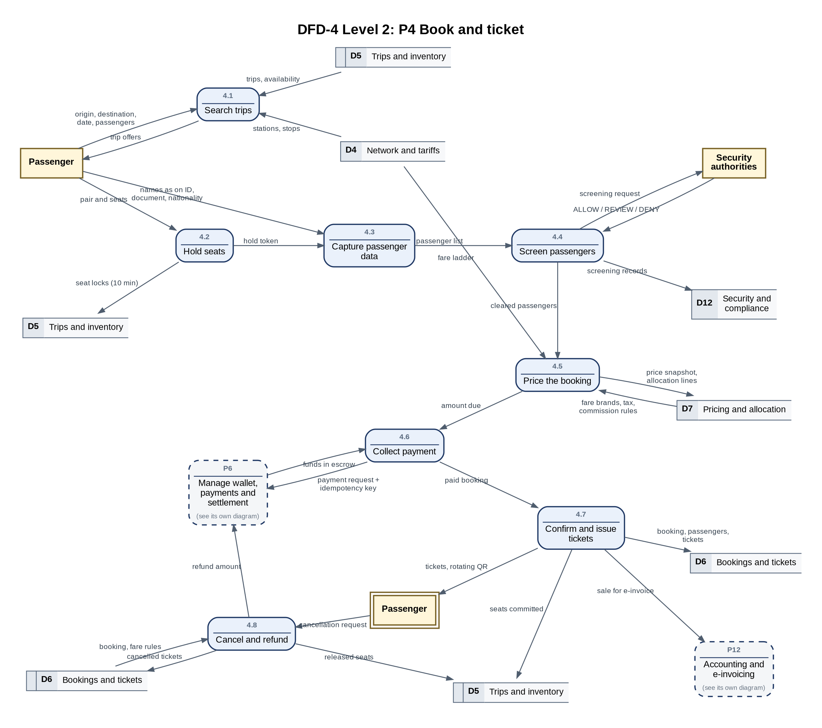
Figure DFD-4. P4 Book and ticket
Process | Name | What it does
4.1 | Search trips | Returns trips between two cities on a date with the pair price, times, carrier and available seats.
4.2 | Hold seats | Locks the chosen seats on every segment of the pair for 10 minutes; nothing is half-locked.
4.3 | Capture passenger data | Collects names exactly as on the identity document, the document, nationality, date of birth and mobile.
4.4 | Screen passengers | Sends the screening request according to the authority's policy and records ALLOW, REVIEW or DENY.
4.5 | Price the booking | Applies the calculation layers and fare brand, and saves the price snapshot and allocation lines.
4.6 | Collect payment | Requests payment from the wallet into escrow with an idempotency key.
4.7 | Confirm and issue tickets | Commits the seats atomically, issues tickets with a rotating QR, notifies, and passes the sale to e-invoicing.
4.8 | Cancel and refund | Applies the fare brand's cancellation rules, releases the seats and returns the refundable amount.
Data stores used: D4, D5, D6, D7, D12.

5.5 DFD-6 Level 2: P6 Manage wallet, payments and settlement
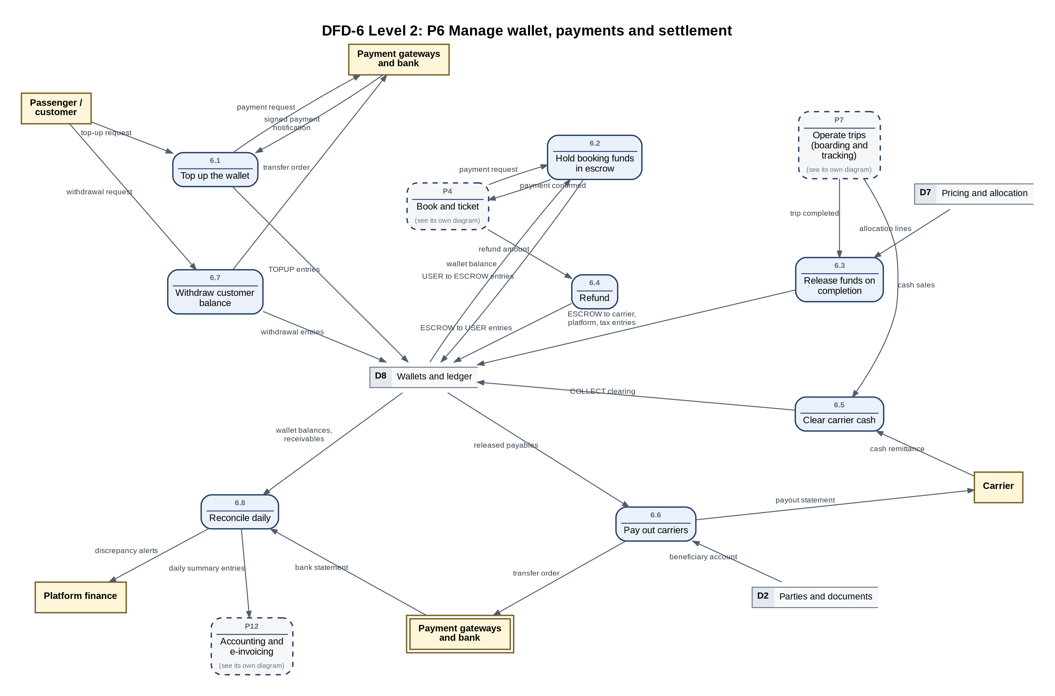
Figure DFD-6. P6 Manage wallet, payments and settlement
Process | Name | What it does
6.1 | Top up the wallet | Card or transfer top-up through the provider adapter; the signed notification is the source of truth.
6.2 | Hold booking funds in escrow | Moves the booking amount from the customer's wallet to escrow.
6.3 | Release funds on completion | Splits escrow by the allocation lines: carrier net, taxes, platform share and intermediary commissions.
6.4 | Refund | Returns refundable amounts from escrow to the customer's wallet.
6.5 | Clear carrier cash | Clears cash sold by drivers against the carrier's entitlements and records cash remittances.
6.6 | Pay out carriers | Transfers released payables on the carrier's schedule after any cash owed is settled.
6.7 | Withdraw customer balance | Pays out to a verified bank account within daily limits.
6.8 | Reconcile daily | Checks that the bank balance equals wallet balances plus receivables and alerts on any difference.
Data stores used: D2, D7, D8.

5.6 DFD-7 Level 2: P7 Operate trips (boarding and tracking)
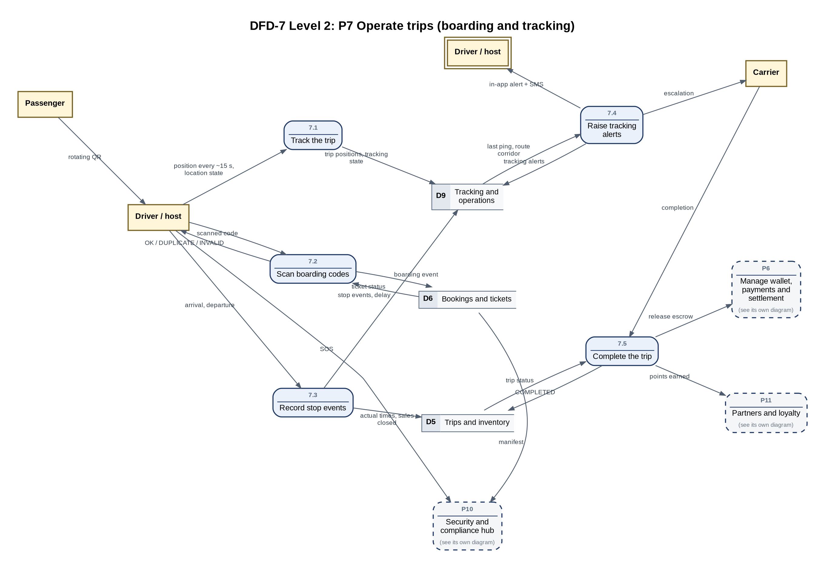
Figure DFD-7. P7 Operate trips (boarding and tracking)
Process | Name | What it does
7.1 | Track the trip | Receives the driver's position about every 15 seconds and the location state.
7.2 | Scan boarding codes | Verifies the signed rotating QR, offline if needed, and records the boarding event.
7.3 | Record stop events | Records arrival and departure with delay; departure closes sales from that stop.
7.4 | Raise tracking alerts | Detects silence or tracking off, alerts the driver in the app and by SMS, and escalates to the company.
7.5 | Complete the trip | Closes the trip, triggers escrow release and loyalty points.
Data stores used: D5, D6, D9.

5.7 DFD-8 Level 2: P8 Operate shuttle rides
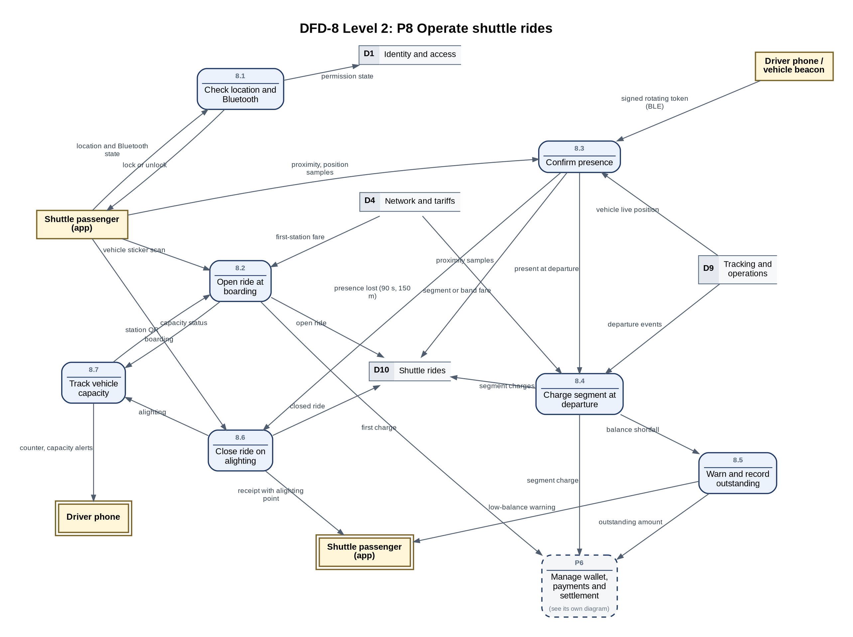
Figure DFD-8. P8 Operate shuttle rides
Process | Name | What it does
8.1 | Check location and Bluetooth | Locks the app when location or the permission is off, or Bluetooth during a ride; SOS stays available.
8.2 | Open ride at boarding | Identifies vehicle, line and direction from the sticker, checks capacity and deducts the first fare.
8.3 | Confirm presence | Combines Nearby proximity to the signed trip token with moving together with the vehicle.
8.4 | Charge segment at departure | When the vehicle leaves a station with the passenger present, deducts the next segment or the remainder.
8.5 | Warn and record outstanding | Warns before each station when the balance is short; a continued segment becomes an interest-free outstanding amount.
8.6 | Close ride on alighting | Closes the ride on lost presence (90 s, 150 m) or a station QR and sends the receipt.
8.7 | Track vehicle capacity | Counts open rides within the licensed capacity and alerts the driver; a full vehicle refuses boarding.
Data stores used: D1, D4, D9, D10.

5.8 DFD-9 Level 2: P9 Ship and deliver consignments
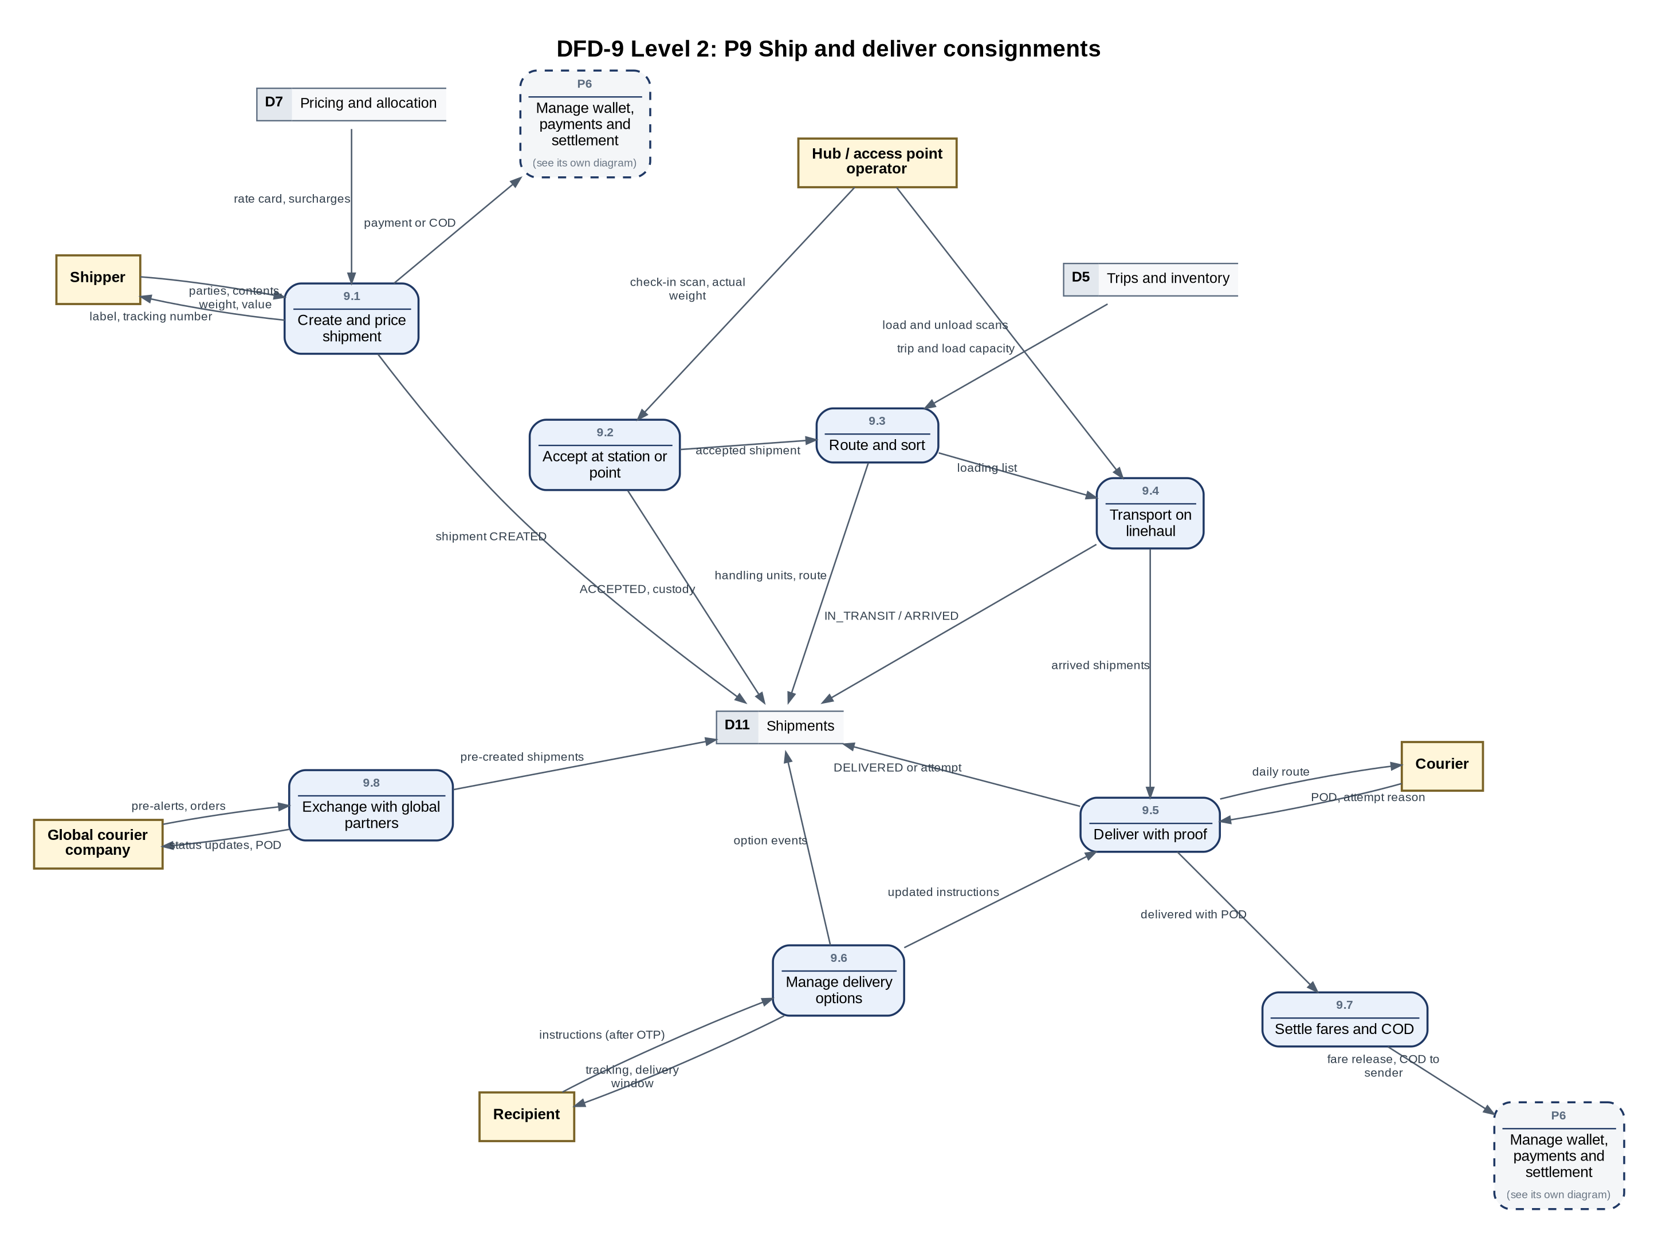
Figure DFD-9. P9 Ship and deliver consignments
Process | Name | What it does
9.1 | Create and price shipment | Captures parties, contents, weight and value, prices by billable weight and takes payment or COD.
9.2 | Accept at station or point | Weighs, screens for prohibited items, labels and starts the chain of custody.
9.3 | Route and sort | Chooses the leg by service level, deadline and capacity, and consolidates handling units.
9.4 | Transport on linehaul | Records loading and unloading scans on bus, truck or courier legs.
9.5 | Deliver with proof | Builds the courier's route and records delivery with the required proof or a failed attempt.
9.6 | Manage delivery options | Lets the recipient reschedule, redirect, hold or prepay COD after OTP verification.
9.7 | Settle fares and COD | Releases the fare minus commission and transfers COD to the sender's wallet.
9.8 | Exchange with global partners | Receives pre-alerts and orders and pushes status updates and proof of delivery by API.
Data stores used: D5, D7, D11.

5.9 DFD-10 Level 2: P10 Security and compliance hub
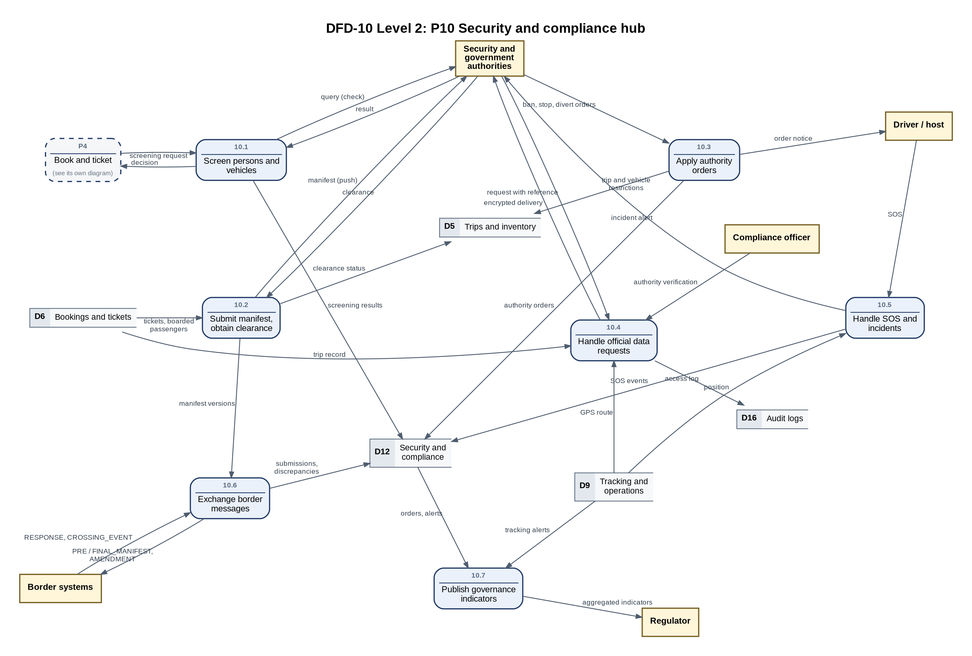
Figure DFD-10. P10 Security and compliance hub
Process | Name | What it does
10.1 | Screen persons and vehicles | Queries the authority before the action and records the result.
10.2 | Submit manifest, obtain clearance | Pushes the manifest before departure; lines subject to clearance wait for approval.
10.3 | Apply authority orders | Applies ban, stop or divert orders to trips, vehicles or persons and notifies the driver.
10.4 | Handle official data requests | Verifies the authority and scope, prepares the record, delivers it encrypted and logs access.
10.5 | Handle SOS and incidents | Forwards SOS alerts and incident data with the position.
10.6 | Exchange border messages | Sends manifest versions and receives responses, crossing events and discrepancies.
10.7 | Publish governance indicators | Aggregates indicators without personal data for the regulator.
Data stores used: D5, D6, D9, D12, D16.

5.10 DFD-11 Level 2: P11 Partners and loyalty
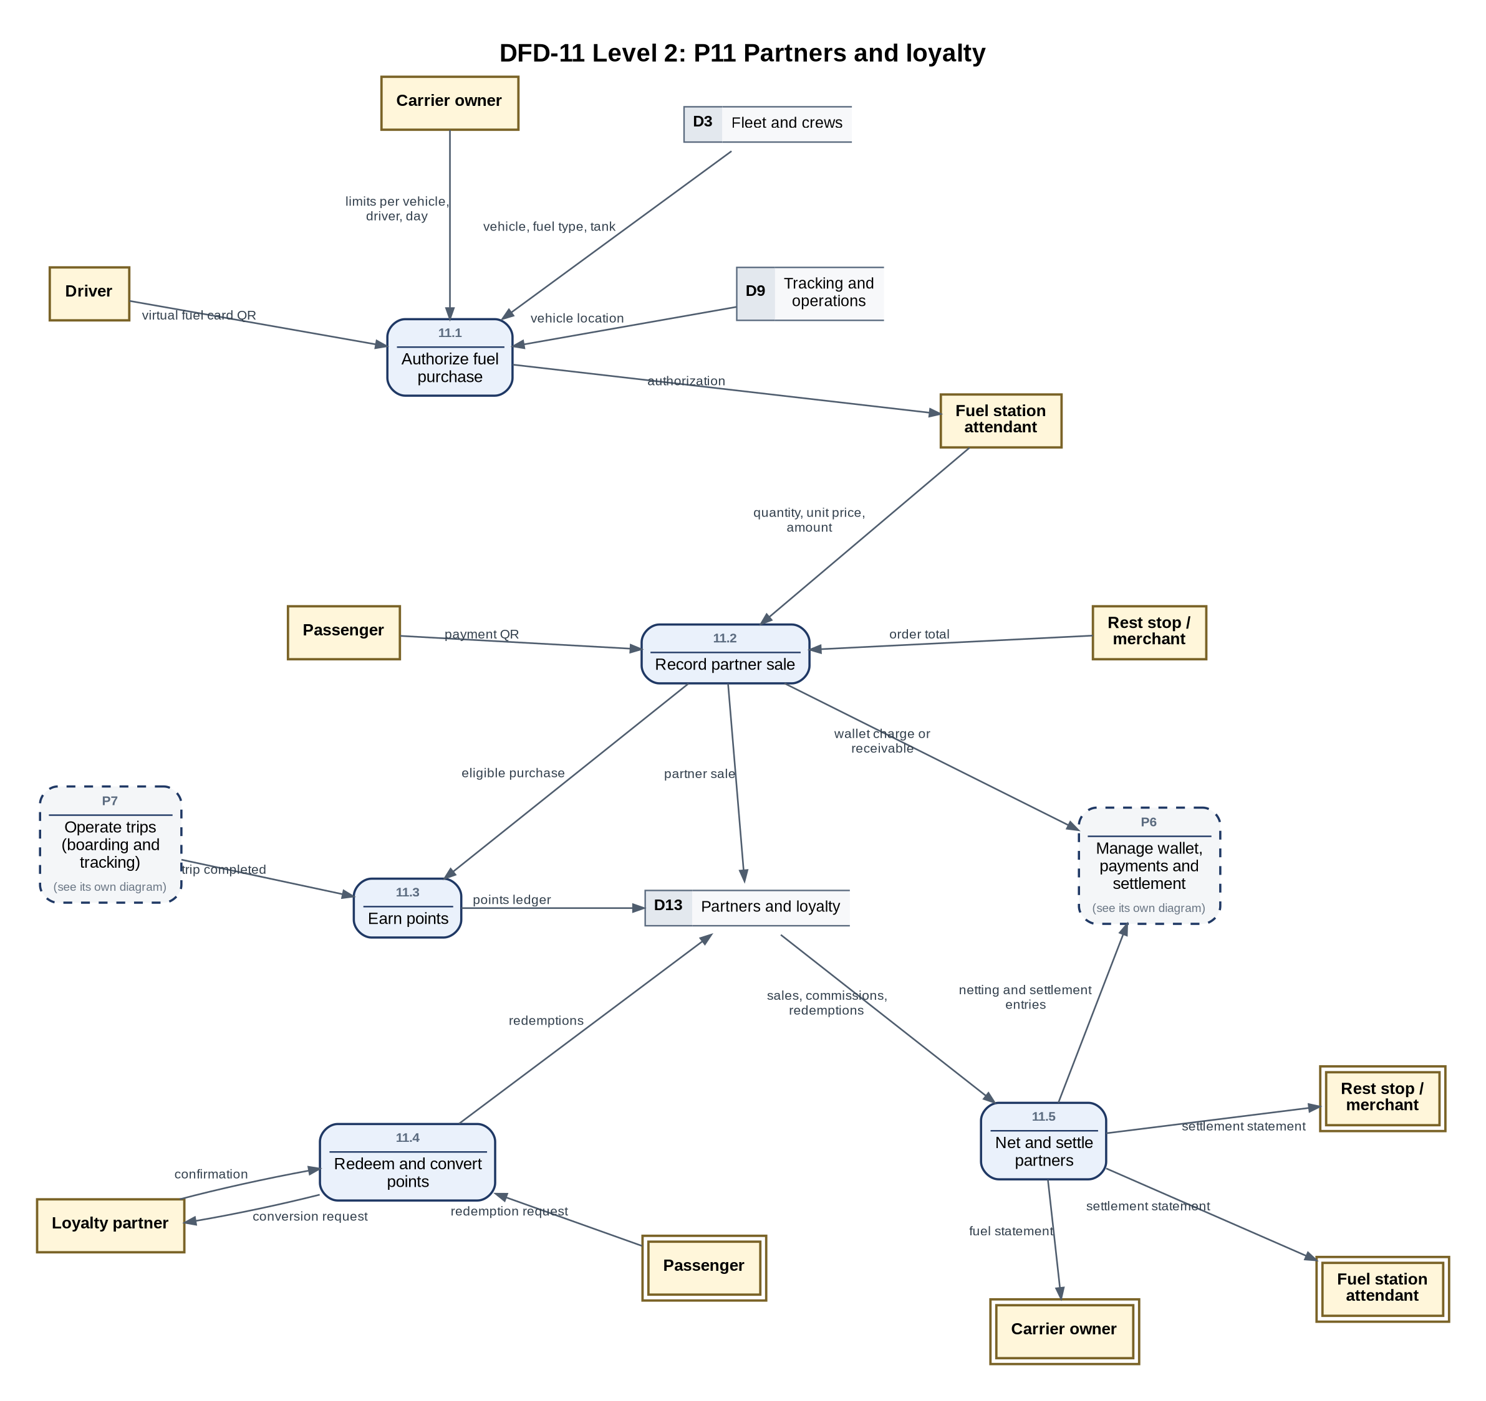
Figure DFD-11. P11 Partners and loyalty
Process | Name | What it does
11.1 | Authorize fuel purchase | Checks the rotating fuel QR, the company's caps and that the vehicle is within the station radius.
11.2 | Record partner sale | Records fuel, rest stop or merchant sales charged to a wallet or as a receivable.
11.3 | Earn points | Credits points after trip completion and on eligible purchases.
11.4 | Redeem and convert points | Redeems points at partners or for trips and converts points with partner programs.
11.5 | Net and settle partners | Nets partner sales, commissions and redemptions and issues settlement statements.
Data stores used: D3, D9, D13.

5.11 DFD-12 Level 2: P12 Accounting and e-invoicing
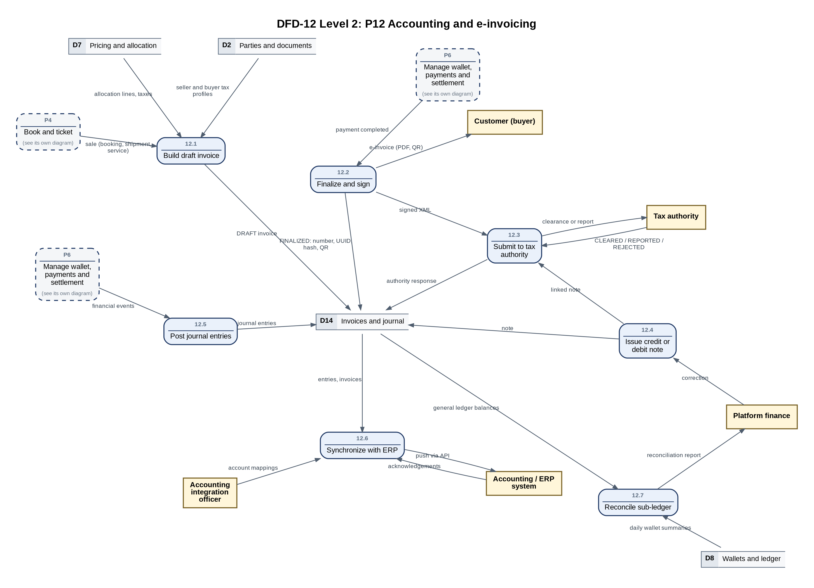
Figure DFD-12. P12 Accounting and e-invoicing
Process | Name | What it does
12.1 | Build draft invoice | Builds invoice lines from the allocation lines, taxes and tax profiles when the sale is created.
12.2 | Finalize and sign | At payment assigns the gapless number and UUID, chains the hash, signs, and generates QR, XML and PDF.
12.3 | Submit to tax authority | Submits in clearance or reporting mode and stores the authority's response.
12.4 | Issue credit or debit note | Corrects a locked invoice only through a linked note.
12.5 | Post journal entries | Converts module events into balanced journal entries through posting rules.
12.6 | Synchronize with ERP | Pushes entries and invoices to accounting systems through adapters.
12.7 | Reconcile sub-ledger | Reconciles daily wallet summaries with general ledger balances.
Data stores used: D2, D7, D8, D14.

6. Data store catalog
Each data store groups related tables of the platform's database. Writers create or update its data; readers only read it.
Store | Name | Main entities | Written by | Read by | Protection
D1 | Identity and access | app_user, user_session, role, permission, device and location permission state | P1, P8 | P1 | Hashed passwords, opaque session tokens, RLS
D2 | Parties and documents | party, company, party_role, document, KYC records, bank_account | P2 | P2, P6, P12 | Encrypted document numbers
D3 | Fleet and crews | vehicle, license_record, ownership, crew_profile | P2 | P2, P3, P11 | Locked license dates (4.18)
D4 | Network and tariffs | city, station, route, route_stop, approved line, tariff, line_fare_table | P2 | P3, P4, P8 | Versioned tariffs
D5 | Trips and inventory | trip, trip_stop, seat_segment, crew_assignment, trip pattern | P3, P4, P7, P10 | P4, P7, P9, P14 | Atomic seat locks
D6 | Bookings and tickets | booking, passenger, ticket, boarding_event | P4, P7 | P4, P7, P10, P13 | Personal data minimized
D7 | Pricing and allocation | fare_brand, price_snapshot, price_allocation, tax and commission rules | P4, P5 | P4, P5, P6, P9, P12 | Snapshot per booking
D8 | Wallets and ledger | wallet, ledger_transaction, ledger_entry, payment, payout, cash_remittance | P6 | P6, P12 | Double entry, idempotency keys
D9 | Tracking and operations | trip_position, tracking_state, tracking_alert, stop events, incidents | P7 | P7, P8, P10, P11 | 7-day position retention
D10 | Shuttle rides | shuttle_ride, ride_segment_charge, proximity_sample, presence_beacon | P8 | - | 7-day proximity retention
D11 | Shipments | shipment, handling unit, tracking event, proof of delivery, access point, partner reference | P9 | - | Chain of custody
D12 | Security and compliance | screening_request/result, watchlist, manifest_submission, authority_order, data request, sos_event | P4, P10 | P10 | Restricted, audited access
D13 | Partners and loyalty | partner, partner_sale, partner_settlement, points account and ledger, reward catalog | P11 | P11 | Netting against payables
D14 | Invoices and journal | e-invoice document, journal entry, posting rule, account mapping, sync log | P12 | P12 | Immutable once locked
D15 | Cases and notifications | case, case_event, notification log, assistant conversation log | P13 | P13 | Internal notes separated
D16 | Audit logs | auth_event, activity_log, data_access_log, row_change, log_seal | All processes | P10 | Append-only, sealed
D17 | Channels and agencies | channel, agency, sub-agent, quota, commission model | P14 | P14 | API keys per channel

7. Process and data store access matrix
W = the process creates or updates data in the store; R = the process reads it. The matrix is derived from the data flow diagrams.
Process | D1 | D2 | D3 | D4 | D5 | D6 | D7 | D8 | D9 | D10 | D11 | D12 | D13 | D14 | D15 | D16 | D17
P1 Manage identity and access | WR |  |  |  |  |  |  |  |  |  |  |  |  |  |  | W
P2 Manage parties, fleet and network |  | WR | WR | W |  |  |  |  |  |  |  |  |  |  |  | W
P3 Schedule trips and inventory |  |  | R | R | W |  |  |  |  |  |  |  |  |  |  | W
P4 Book and ticket |  |  |  | R | WR | WR | WR |  |  |  |  | W |  |  |  | W
P5 Price, tax and allocate |  |  |  |  |  |  | WR |  |  |  |  |  |  |  |  | W
P6 Manage wallet, payments and settlement |  | R |  |  |  |  | R | WR |  |  |  |  |  |  |  | W
P7 Operate trips (boarding and tracking) |  |  |  |  | WR | WR |  |  | WR |  |  |  |  |  |  | W
P8 Operate shuttle rides | W |  |  | R |  |  |  |  | R | W |  |  |  |  |  | W
P9 Ship and deliver consignments |  |  |  |  | R |  | R |  |  |  | W |  |  |  |  | W
P10 Security and compliance hub |  |  |  |  | W | R |  |  | R |  |  | WR |  |  |  | WR
P11 Partners and loyalty |  |  | R |  |  |  |  |  | R |  |  |  | WR |  |  | W
P12 Accounting and e-invoicing |  | R |  |  |  |  | R | R |  |  |  |  |  | WR |  | W
P13 Support, notifications and AI assistant |  |  |  |  |  | R |  |  |  |  |  |  |  |  | WR | W
P14 Distribution channels and agencies |  |  |  |  | R |  |  |  |  |  |  |  |  |  |  | W | WR

8. Traceability
Each use case diagram maps to the data flow processes that carry its data and to the diagrams that detail them.
Use case diagram | DFD processes | Detailed in | Main study sections
UC-1 Scheduled trip booking | P1, P4, P5, P6, P10 | DFD-4, DFD-6 | 3.8, 4.12 c, 4.12, 5.13 b, 5.9, 6.2, 6.3, 7.1, 7.3, 7.6
UC-2 Shuttle transport | P1, P8, P6 | DFD-8 | 4.13, 6.5, 7.3 b, 7.13 b, 7.3 d, 7.3 c, 7.13 c, 7.3 a, 7.13 a, b
UC-3 Carrier operations | P1, P2, P3, P6 | DFD-1A | 3.4 b, 3.4 a, 4.3, 4.12, 4.13, 4.15, 4.16, 4.17, 4.18, 5.10
UC-4 Driver app | P7, P10, P11 | DFD-7, DFD-10 | 4.12 f, 6.5, 7.13 a, 7.3, 7.8, 7.12, 8.2, 8.4, 14.11 b, c
UC-5 Shipping and logistics | P9, P6 | DFD-9 | 9.17 b, 9.17 c, 9.22 b, 9.2, 9.3, 9.6, 9.7, 9.8, 9.13, 9.15
UC-6 Service partners and loyalty | P11, P6 | DFD-11 | 5.13 b, 5.13 a, 14.12 b, 14.12 c, 14.11 b, 14.12 d, 14.11, c
UC-7 Administration, finance and support | P2, P5, P6, P13 | DFD-6, DFD-1B | 2.5, 4.11, 4.15, 5, 5.12, 6.3, 6.6, 6.7, 7.6 c, 7.6 d
UC-8 Security, compliance and authorities | P10, P1 | DFD-10 | 2.4, 7.3 c, 8.2, 8.3, 8.4, 8.5, 11.3, 16.6, 16.17, 16.20
UC-9 Distribution channels and agencies | P14, P4, P6 | DFD-1B | 14.3, 14.4, 14.5, 14.6, 14.9
UC-10 Accounting and e-invoicing | P12, P6 | DFD-12 | 12.4, 13.11 b, 13.11 a, 13.4, 13.5, 13.12, 13.13, 35

9. Assumptions and notes
- All content is derived from the Analysis and Design Study v2.5 (English edition); section numbers in the tables refer to that study.
- The diagrams show the complete target scope. Use cases of later phases are labelled with their phase; anything without a label belongs to Phase 1.
- Notifications are a cross-cutting service (Notification Catalog, Section 34) and appear only where they are part of the use case.
- DFD processes describe logical data movement, not the deployment of services; the platform is a modular monolith in the early phases (2.2).
- Duplicate symbols (a double border for an external entity, an extra bar for a data store) repeat the same element to keep flows short.
- The access matrix (Section 7) is derived from the diagrams, plus a few reads implied by the use cases that are not drawn (for example sign-in reading D1 and the security console reading D16).
- Audit logging (D16) is written by every process on each sign-in and state-changing request; to keep the diagrams readable it is drawn only where it is the purpose of the flow.

