DIGITAL ELECTRONICS
HARDWARE PROJECT
Design and Implementation of a
2-Bit Digital Counter
A practical exploration using a 555 timer and logic gates
HACKATHON PROJECT DOCUMENTATION
Submitted by
Thayamithra M • Danushri N • Ragul N S
Department of Electronics and Communication
Bannari Amman Institute of Technology
ELECTROX’26 | Academic Year 2026–2027
Date: 08 September 2026
PROJECT STATUS
Clock circuit and 1-bit counter demonstrated • 2-bit integration proposed

Project at a glance
Stage | Outcome
555 timer clock | Constructed; output observed successfully
1-bit counter | Constructed and demonstrated
Second counter stage | Explored as part of the planned 2-bit design
Integrated 2-bit counter | Not demonstrated during the hackathon
7-segment display interface | Planned extension; not demonstrated

Abstract
This project explored the design of a 2-bit digital counter using a 555 timer and basic logic integrated circuits. The work was carried out by a three-member team during ELECTROX’26, with the aim of learning how clock signals and logic circuits can be combined to produce sequential binary states.
The team successfully assembled a 555 timer-based clock circuit and demonstrated a 1-bit counter using NAND and NOT gate ICs. The complete 2-bit counter and its planned seven-segment display interface were not demonstrated within the available time. The work nevertheless provided practical experience in breadboard assembly, IC connections, circuit testing, and troubleshooting, while establishing a clear starting point for completing the intended design.

1. Project aim
To explore the construction of a 2-bit digital counter using discrete logic ICs, beginning with a working clock source and a demonstrated 1-bit counter.

Project objectives
- Build and test a clock source using a 555 timer IC and passive components.
- Explore counter logic using NAND and NOT gate ICs.
- Understand the intended 2-bit sequence: 00 → 01 → 10 → 11 → 00.
- Practise breadboard wiring, individual-stage testing, and systematic troubleshooting.
- Explore how a suitable display interface could present the count numerically.

2. How the counter is intended to work
A digital counter changes its stored binary state in response to clock events. A 1-bit counter has two states, 0 and 1. A 2-bit counter has four states because two binary digits can represent 00, 01, 10, and 11.
Clock count | Q1 | Q0 | Binary state | Decimal value
0 | 0 | 0 | 00 | 0
1 | 0 | 1 | 01 | 1
2 | 1 | 0 | 10 | 2
3 | 1 | 1 | 11 | 3
4 | 0 | 0 | 00 | 0

This table describes the expected sequence of the proposed 2-bit design; it is not a record of a completed 2-bit test. The team demonstrated the 1-bit counter only.

Main circuit stages
Stage | Role in the design | Project status
Clock generator | Creates repeating timing pulses using a 555 timer. | Built and observed
Counter logic | Uses logic-gate arrangements to switch and retain binary states. | 1-bit stage demonstrated; 2-bit integration incomplete
Display interface | Would convert the binary count into a readable digit. | Planned extension

3. Components

Clock circuit
Component | Quantity | Purpose
555 timer IC | 1 | Generates the clock signal
0.1 µF capacitor | 1 | Supports the timing circuit
1 kΩ resistor | 1 | Part of the timing network
330 Ω resistor | 1 | Used in the circuit connections
1 MΩ resistor | 1 | Helps determine timing
Non-polarised capacitor | 1 | Supports timing operation
LED | 1 | Visual indication of clock output
Breadboard and jumper wires | As required | Assembly and interconnection

Counter and proposed display
Circuit section | Components noted in the project
Each counter bit | 1 NOT gate IC and 2 NAND gate ICs
Two-bit design total | 2 NOT gate ICs and 4 NAND gate ICs planned across both stages
Display logic | 1 NOT gate IC, 1 OR gate IC, 1 AND gate IC, 1 seven-segment display, and current-limiting resistors

The display connections depend on the type of seven-segment display and the required segment-control logic. The complete display interface was not tested as part of the integrated counter.

4. Circuit diagrams
The following diagrams are included to document the design stages. The proposed counter and display diagrams represent the intended design and should not be read as proof that the complete system was working.

4.1 555 timer clock generator
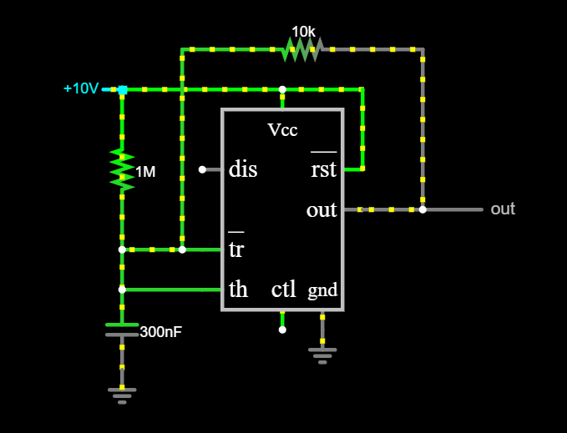
Figure 1. Circuit diagram of the 555 timer-based clock generator.
The 555 timer circuit generated the clock output observed during the project. This provided the timing source needed for counter experiments.

4.2 Proposed counter logic
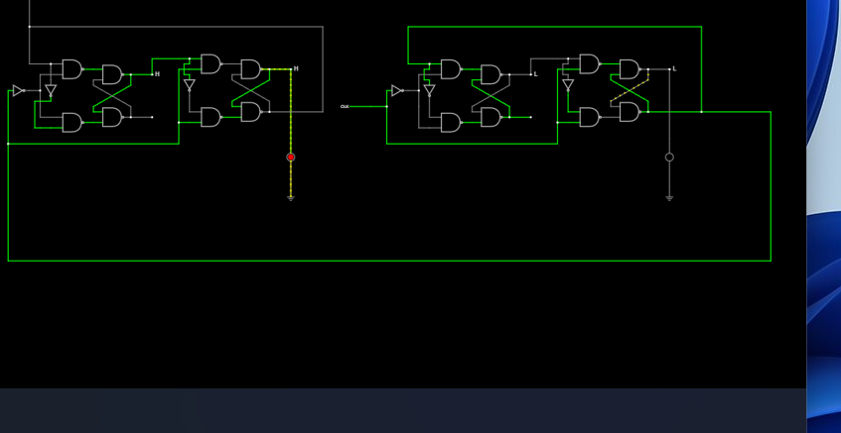
Figure 2. Logic arrangement for the intended 2-bit counter.
The first bit was used in the demonstrated 1-bit counter. The second stage was part of the proposed extension, but the complete two-stage sequence was not demonstrated.

4.3 Proposed seven-segment interface
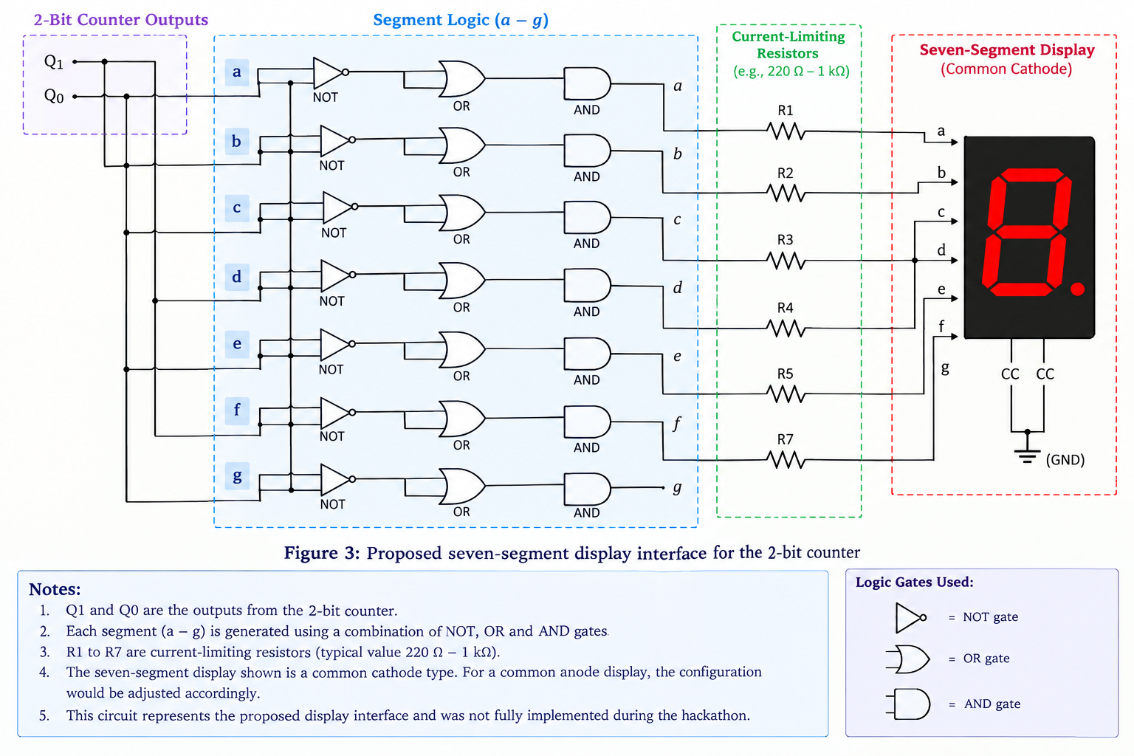
Figure 3. Proposed seven-segment display interface.
The display stage was planned to make the count easier to read. Its integration and output were not demonstrated during the hackathon.

5. Hardware implementation

5.1 Clock circuit
The clock circuit was assembled on a breadboard using a 555 timer IC, resistors, capacitors, an LED, and jumper wires. The output was observed successfully, confirming that the clock stage operated.
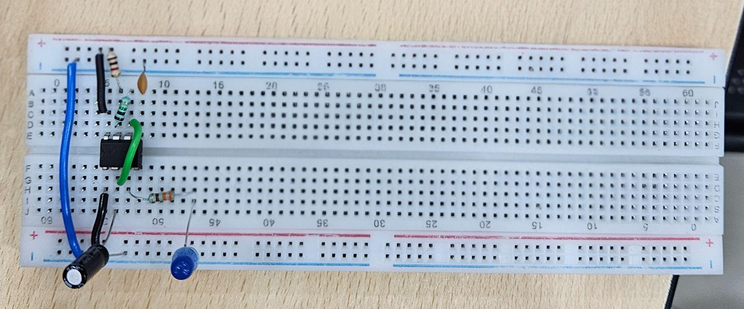
Figure 4. Hardware photograph of the 555 timer-based clock circuit.

5.2 One-bit counter
The first counter stage used one NOT gate IC and two NAND gate ICs. With the clock signal applied, the circuit was demonstrated as a 1-bit counter, representing the two binary states 0 and 1.
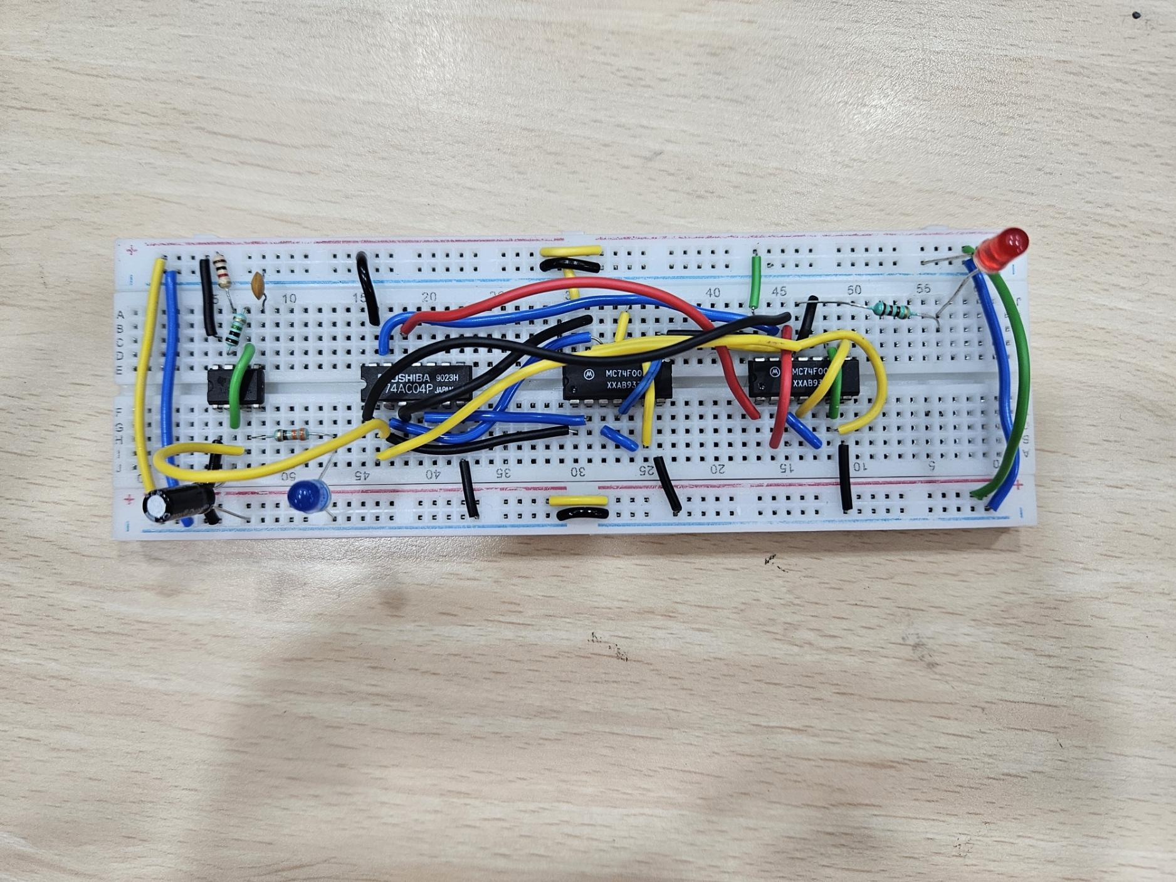
Figure 5. Hardware photograph of the demonstrated one-bit counter.

5.3 Extension toward two bits
The intended next step was to connect a second logic stage so that the outputs could represent four states. The integrated 2-bit counter was not demonstrated during the event. The seven-segment interface also remained a planned extension.

Implementation note
Testing the circuit in separate stages helped isolate what was working and what still needed attention. In future work, each stage should be checked independently before final integration, with the clock, state outputs, and display verified one at a time.

6. Testing and results
Test item | Observed result | Status
555 timer clock output | Clock circuit was constructed and its output was observed. | Successful
1-bit counter | Counter was demonstrated with two binary states. | Successful
Second counter stage | Part of the proposed two-bit design; full operation not demonstrated. | Incomplete
Integrated 2-bit sequence | Four-state sequence was the expected behaviour, not a measured result. | Not demonstrated
Seven-segment display | Display interface was planned but not tested as an integrated output. | Not demonstrated

7. Challenges and learning
The main challenge was completing the integration of the counter stages within the time available. The project required attention to IC pin connections, wiring, clock input, and the interaction between logic stages.

What the team learned
- A clock source is an essential timing reference for sequential circuits.
- Logic ICs must be wired carefully, and individual connections should be checked systematically.
- Building and testing a smaller circuit first can make a larger design easier to understand and debug.
- A circuit diagram, a proposed design, and a verified hardware result are different kinds of evidence and should be documented separately.
- Team coordination and time allocation matter during practical hardware projects.

Next steps
- Complete and verify the second counter stage.
- Test the full 00 → 01 → 10 → 11 → 00 sequence against the expected table.
- Check the seven-segment display type and design a compatible segment-driving circuit.
- Test the display separately, then integrate it with the counter.
- Record clear photographs or a short demonstration video of each verified stage.

8. Conclusion
The project introduced the team to practical digital electronics through the development of a clock circuit and counter logic. The 555 timer clock was successfully constructed, and a 1-bit counter was demonstrated using NAND and NOT gate ICs. The complete 2-bit counter and seven-segment display interface were not demonstrated during the hackathon.
Although the full target was not reached, the working stages gave the team practical experience with circuit assembly, clock signals, logic ICs, and troubleshooting. The project also clarified the next steps required to complete and verify the intended two-bit design. It was a useful foundation for further experimentation and more systematic hardware integration.

Team
Team member | Department / institution
Thayamithra M | Electronics and Communication — Bannari Amman Institute of Technology
Danushri N | Electronics and Communication — Bannari Amman Institute of Technology
Ragul N S | Electronics and Communication — Bannari Amman Institute of Technology

