Report of Group B 2/7/03
J. Hanna, G. Martinez, S.Mahajan

We are pleased to report the dismantling, cleaning, and reassembly of the roughing and foreline valves in the vacuum system, as well as a functional check of the roughing pump. We removed the four Allen-head screws from each valve faceplate, scrubbed the valve assemblies in ethanol, and air dried them at room temperature. After a lapse of some days, we lubricated the rubber components with Dow vacuum grease, inserted the valves into the guide sleeves, and then fixed the screws in place. One item that we had not anticipated was that there are two miniature polymer semi-lunate parts within each valve that guide the stem as it is turned by the operator. Reassembling these proved to be a bit of a challenge until one of us (JH) suggested holding them in place with vacuum grease. That worked well. The valves themselves are of a standard accordion type, where the travel of the stem screw serves to displace the far end of a cylinder that then occludes a flow. The stem of the foreline valve bends as it exits the faceplate: the aperture is misaligned. An exploded side view of a valve follows; the lunate parts are within the accordion body; the bellows are slightly dented.

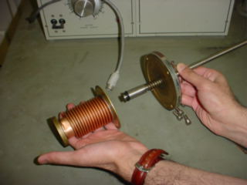

Figure 1. Expanded side view of a valve.

The roughing pump oil was checked and filled, and pressure-checked to 10 Torr. We used a cork and a vacuum gauge to limit the flow and measure the pressure in absolute units. The pump made the anticipated gurgling sound as it drew down the atmosphere, and there was no untoward noise in the machinery. The pump, pictured below, is a standard belt-driven Welch pump of the 1300 series, having a fractional horsepower motor driven by 120V single-phase current. We anticipate no difficulties with this unit, nor with any of the valves, and expect that they will be fully functional components of a refurbished evaporator system.

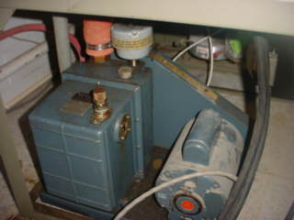

Figure 2. Welch roughing pump.

