Pristine Image Wellness
TikTok Competitor & Content Benchmark Review
Capture date: August 4, 2026 | Platform in scope: TikTok only | Founder: Troy Wallace, Tyler, TX

Executive Summary
- Three accounts were reviewed as content benchmarks. They were selected for their content systems and niche relevance, not because all three compete for the same Tyler, Texas clients.
- The reviewed content from all three accounts was predominantly face-led educational video rather than static graphics, and all three taught in plain language with strong on-screen clarity.
- The repeatable system — one clear idea per video, a recurring series, and a single consistent call to action — is what PIW should copy.
- What PIW should not copy: fear-first organ messaging, cure claims, unapproved product claims, and insulin-resistance-led positioning.
- This review covered TikTok only. It cannot show how these accounts perform on other platforms, and no conversion data was available.

Scope and Method
This is a TikTok-only competitor review carried out in a single live session on August 4, 2026. Instagram, Facebook, LinkedIn, Pinterest and YouTube were out of scope. Research was observation-only.
All metrics are point-in-time and change daily. Follower counts were verified via live user search. Post metrics come from live search and browse surfaces. Where a figure was not visible it is written as not publicly visible.
Some direct profile deep-links intermittently returned a wait or error state under rate limits during the session.
Market context note: These accounts lean heavily on insulin and glucose education. That is documented here as competitive market reality. PIW content strategy still prefers non-IR-led entry points — plateau, fatigue, myths and progress beyond the scale — until Troy directs otherwise.

Selected Competitor and Content Benchmarks
These accounts were selected for their content systems and niche relevance. They do not all directly compete for the same Tyler, Texas clients.

1. Metabolic Boss (Dana Estelle)
Classification: Closest strategic competitor / niche benchmark
Profile: @metabolicboss
Audience size: 343.3K followers · 2.4M likes (live user search, 2026-08-04)
Recurring patterns: Face-led root-cause education; condition bridges (kidney, blood pressure, fatty liver, diabetes tags); keyword-comment calls to action; heavy hashtag SEO; urgency paired with hope. Frequency: multi-post library.
PIW takeaway: The call-to-action system and face-led education are transferable. Avoid the organ-fear framing and cure claims.

2. Justin / Stop Spiking Sugar
Classification: Top niche content benchmark
Profile: @insulinresistant1
Audience size: 1.9M followers · 17.7M likes (live user search, 2026-08-04)
Recurring patterns: Continuous glucose monitor and food-experiment series ("X and my blood sugar"); recipes that "won't spike"; food-order tests; product and affiliate mentions on some posts; high-volume experiment library.
PIW takeaway: Proof and experiment storytelling is powerful. Stay compliance-safe and make no unapproved product claims.

3. Glucose Goddess (Jessie Inchauspé)
Classification: Admired authority page / large-scale content benchmark
Profile: @glucosegoddess_
Audience size: 632.8K followers · 3M likes (live user search, 2026-08-04)
Recurring patterns: Polished science storytelling; one idea per video; myth and mechanism corrections; collaboration clips; high brand consistency; less hard keyword CTA and more authority plus book and brand funnel.
PIW takeaway: Plain-language mechanism education with high production clarity.
Also observed, outside the three benchmarks: a Philippine clinician education cluster (Doc Alvin, Dr Kilimanguru) producing strong local-language metabolism content under a different geography and offer model.

Post Analysis
Six posts were reviewed across the three accounts. Screenshots for each are held in the evidence appendix at the end of this report so they do not interrupt the analysis.

Post 1 — Metabolic Boss (@metabolicboss)
Link: https://www.tiktok.com/@metabolicboss/video/7582752998460329224
Visible metrics: Likes 7,874 | Comments 284 | Bookmarks 2,690 | Shares not publicly visible
Source of metrics: Visible on the live post page during browse, 2026-08-04
Why this post worked: Keyword-comment call to action appears designed to move viewers from educational content into a DM conversation. A condition-bridge entry hooks a feared problem and then points to a single root-cause narrative, backed by face-led authority.
Trends used: Keyword-comment CTA; root-cause bridge; condition-specific entry (#ckd); original sound voiceover; face-to-camera education.
PIW takeaway: Learn the CTA system, not the fear-first organ claims. READY maps cleanly to assessment invites without cure language.

Post 2 — Metabolic Boss (@metabolicboss)
Link: https://www.tiktok.com/@metabolicboss/video/7580134306190839058
Visible metrics: Search-card views 6,532. Likes and comments not publicly visible during live open.
Source of metrics: TikTok search video results card, 2026-08-04
Why this post worked: Stacks several high-anxiety health tags into one short education post, maximising multi-search discovery. A minimal caption relies on hashtag SEO. The pattern is one mechanism opening many doors.
Trends used: Hashtag stacking; multi-condition discovery; short educational clip; insulin-resistance narrative (documented as market context, not a PIW lead pillar).
PIW takeaway: Hashtag discipline is worth copying. The insulin-resistance framing is not recommended as a PIW lead pillar.

Post 3 — Justin / Stop Spiking Sugar (@insulinresistant1)
Link: https://www.tiktok.com/@insulinresistant1/video/7558942292866829586
Visible metrics: Comments 248 | Search-card views 22.9K. Likes not publicly visible as a separate counter.
Source of metrics: Comments visible during live browse; view count from TikTok search card, 2026-08-04
Why this post worked: A practical recipe combined with a glucose promise produces save-and-share content. Personal experiment branding builds trust without a clinic setting, and the series library encourages viewers to binge similar tests.
Trends used: Recipe-as-proof; blood sugar and glucose series; CGM-adjacent education; personal experiment format.
PIW takeaway: Series structure and everyday practicality transfer well. Skip the glucose-outcome promise.

Post 4 — Justin / Stop Spiking Sugar (@insulinresistant1)
Link: https://www.tiktok.com/@insulinresistant1/video/7164164024437837061
Visible metrics: Search-card views 194.8K, labelled Top liked. Likes and comments not publicly visible.
Source of metrics: TikTok search card on account video search, 2026-08-04
Why this post worked: The highest observed search-card view in his recent listing set during this session. The food-order idea is immediately usable and highly shareable, and series numbering encourages watch-next behaviour.
Trends used: Food-order series; proof experiment; Top-liked evergreen; multi-tag niche SEO.
PIW takeaway: Evergreen, immediately usable ideas earn repeat search traffic. Keep claims educational.

Post 5 — Glucose Goddess (@glucosegoddess_)
Link: https://www.tiktok.com/@glucosegoddess_/video/7623496212469009677
Visible metrics: Likes 7,403 | Comments 39 | Bookmarks 3,039 | Shares not publicly visible
Source of metrics: Visible on the live post page during browse, 2026-08-04
Why this post worked: A single simple habit hook combined with science-brand authority. The high bookmark-to-comment ratio suggests strong save-for-later utility, and the conversation framing adds social proof.
Trends used: One-trick education; podcast and collaboration clip style; original educational sound.
PIW takeaway: One idea per video, plus collaboration formats, are directly transferable.

Post 6 — Glucose Goddess (@glucosegoddess_)
Link: https://www.tiktok.com/@glucosegoddess_/video/7662040024573168910
Visible metrics: Search-card views 45.8K, labelled Top liked. Likes and comments not publicly visible.
Source of metrics: TikTok search card on account video search, 2026-08-04
Why this post worked: Corrects a common nutrition belief with a precise mechanism in plain language. Curiosity plus correction drives comments and shares among health-interested audiences.
Trends used: Myth and mechanism explainer; nutrition science short; plain-language biochemistry.
PIW takeaway: Myth-and-mechanism correction is the single most transferable format in this report.

Summary

Where these accounts are most active
TikTok is a major visible short-form education channel for all three accounts, with live follower counts of 343.3K, 1.9M and 632.8K. Content is face-led video rather than static graphics. Cross-platform presence likely exists — Metabolic Boss on Facebook was noted in a prior PIW review — but that was out of scope for this TikTok-only deliverable.

The most common post types
- Root-cause and condition-bridge education with keyword calls to action (Metabolic Boss).
- Food-experiment series and spike-friendly recipes (Justin / Stop Spiking Sugar).
- Science micro-lessons, myth corrections and one-habit tricks (Glucose Goddess).
All three rely on plain-language teaching supported by on-screen clarity.

The trends they use
Keyword-comment calls to action; series and experiment formats; hashtag stacking for multi-condition search; food-order and post-meal habit ideas; myth-versus-mechanism explainers; collaboration and podcast clips; original educational sounds.

What to Copy and What to Avoid
Copy the system | Do not copy
Face-led education | Fear-first organ messaging
One clear idea per video | Cure claims or medical guarantees
Keyword calls to action, mapped to READY | Unapproved product or supplement claims
Recurring series and consistent formats | Insulin-resistance-led positioning before Troy approves it
Plain-language explanations | Extreme or urgent promise framing
Search-aware captions and hashtag discipline  Myth and mechanism explainers | Borrowed patient stories or unverified transformations

Implications for Pristine Image Wellness
- Copy the repeatable content system, not the medical claims. That is the strongest and most defensible conclusion in this report.
- Adopt one clear idea per video with a single consistent call to action, mapping every CTA to READY for the Free Metabolic Health Assessment.
- Open on plateau, fatigue, myths and progress beyond the scale. These reach the same audience without leading on insulin resistance.
- Build recurring series. All three benchmarks rely on series consistency rather than one-off posts.
- Treat every figure here as point-in-time. No conversion or revenue data was available, so none of these accounts can be described as proven lead generators.

Evidence Appendix — Post Evidence
Screenshots captured during the live research session on August 4, 2026 are included where the exported image matches the cited post. Each item lists the creator, post, research date, and source of the displayed metric. For Post 4, the source note is retained without an image because the exported screenshot did not verify the cited video.

Post 1 — Metabolic Boss (@metabolicboss)
Post: https://www.tiktok.com/@metabolicboss/video/7582752998460329224
Research date: August 4, 2026 (live session). Metrics are point-in-time and change daily.
Displayed metric and where it came from: Likes 7,874 | Comments 284 | Bookmarks 2,690 | Shares not publicly visible — Visible on the live post page during browse, 2026-08-04

Post 2 — Metabolic Boss (@metabolicboss)
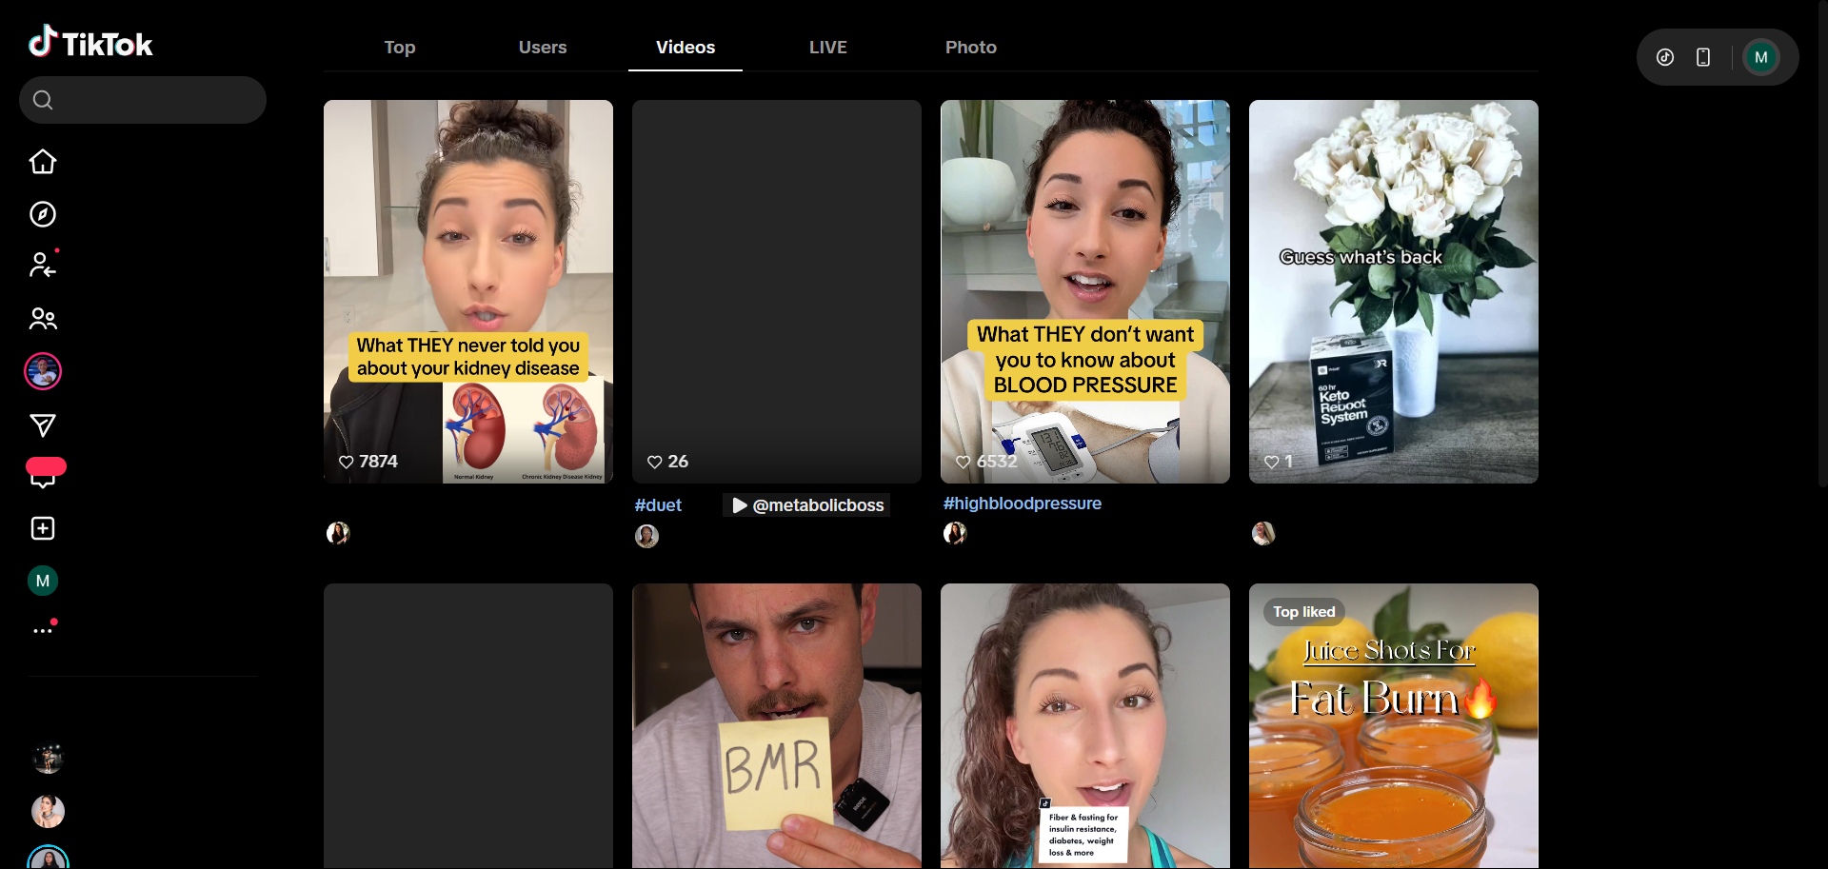
Post: https://www.tiktok.com/@metabolicboss/video/7580134306190839058
Research date: August 4, 2026 (live session). Metrics are point-in-time and change daily.
Displayed metric and where it came from: Search-card views 6,532. Likes and comments not publicly visible during live open. — TikTok search video results card, 2026-08-04

Post 3 — Justin / Stop Spiking Sugar (@insulinresistant1)
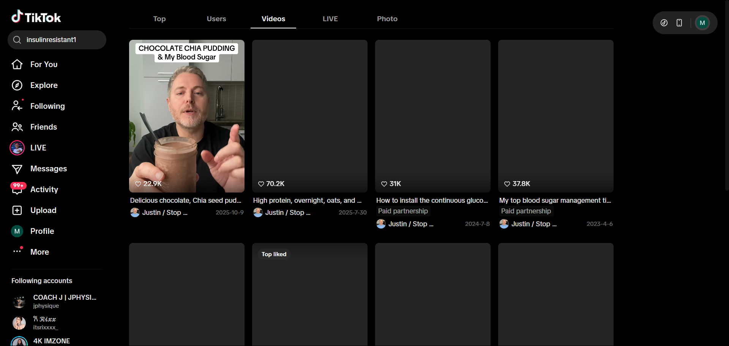
Post: https://www.tiktok.com/@insulinresistant1/video/7558942292866829586
Research date: August 4, 2026 (live session). Metrics are point-in-time and change daily.
Displayed metric and where it came from: Comments 248 | Search-card views 22.9K. Likes not publicly visible as a separate counter. — Comments visible during live browse; view count from TikTok search card, 2026-08-04

Post 4 — Justin / Stop Spiking Sugar (@insulinresistant1)
Evidence note: The available exported image showed a user-search screen rather than the cited video, so it was removed. The metric remains attributed to the TikTok search card observed during the live session.
Post: https://www.tiktok.com/@insulinresistant1/video/7164164024437837061
Research date: August 4, 2026 (live session). Metrics are point-in-time and change daily.
Displayed metric and where it came from: Search-card views 194.8K, labelled Top liked. Likes and comments not publicly visible. — TikTok search card on account video search, 2026-08-04

Post 5 — Glucose Goddess (@glucosegoddess_)
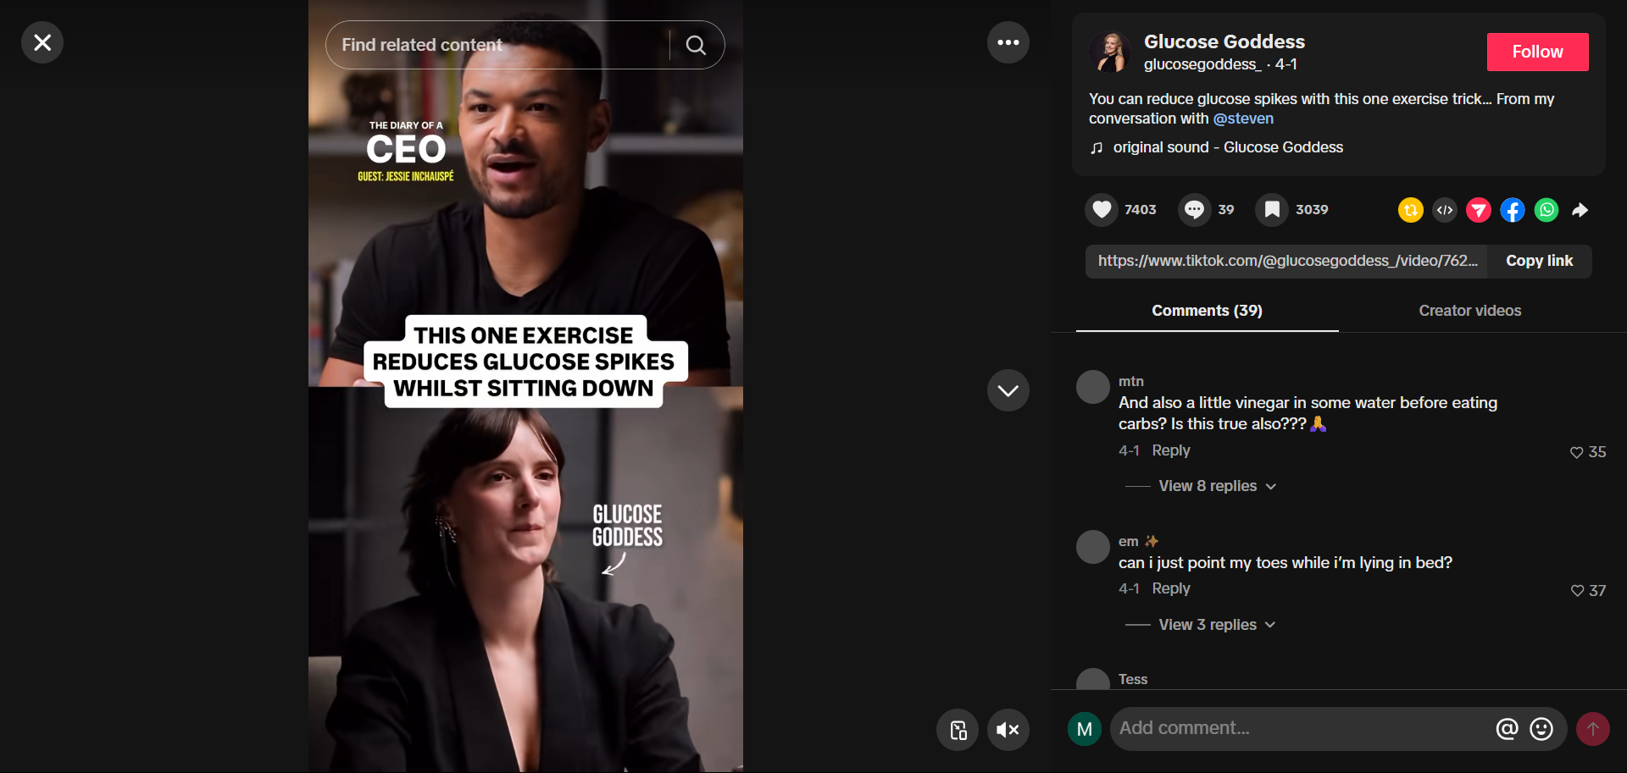
Post: https://www.tiktok.com/@glucosegoddess_/video/7623496212469009677
Research date: August 4, 2026 (live session). Metrics are point-in-time and change daily.
Displayed metric and where it came from: Likes 7,403 | Comments 39 | Bookmarks 3,039 | Shares not publicly visible — Visible on the live post page during browse, 2026-08-04

Post 6 — Glucose Goddess (@glucosegoddess_)
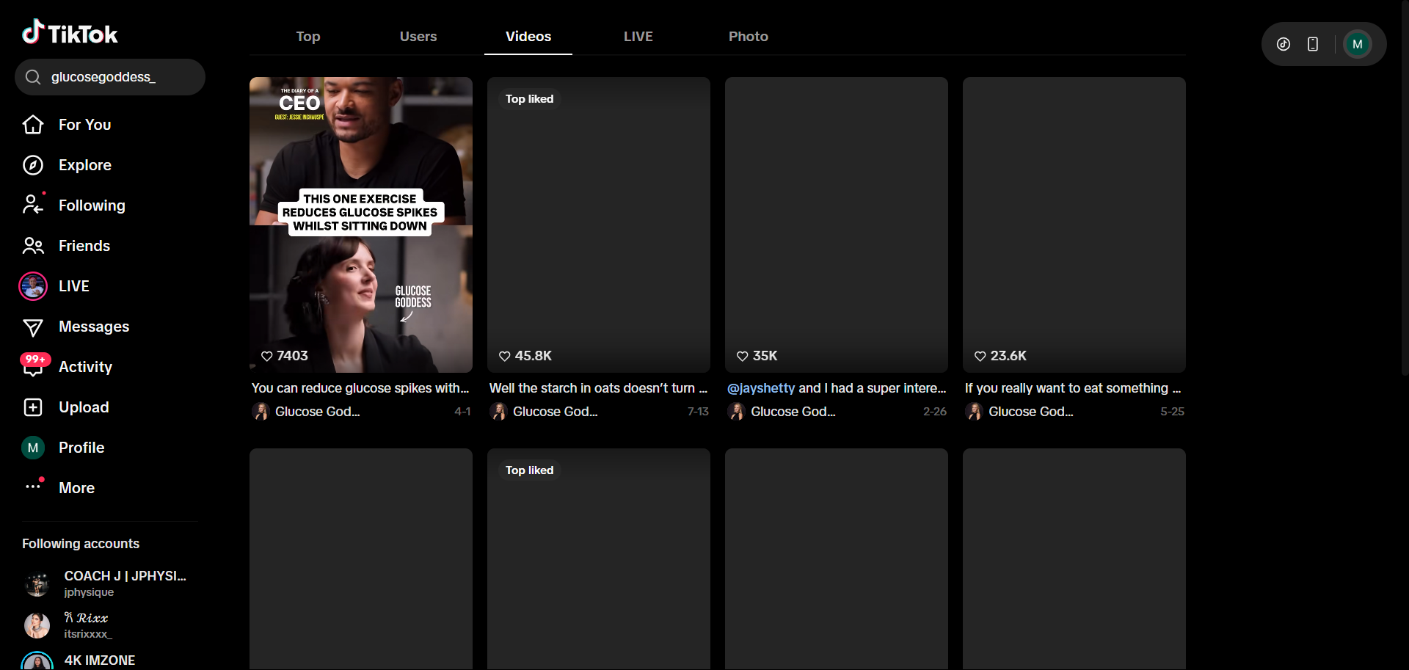
Post: https://www.tiktok.com/@glucosegoddess_/video/7662040024573168910
Research date: August 4, 2026 (live session). Metrics are point-in-time and change daily.
Displayed metric and where it came from: Search-card views 45.8K, labelled Top liked. Likes and comments not publicly visible. — TikTok search card on account video search, 2026-08-04

Supporting evidence retained in the internal research folder. Branding standardized across the three-report research set. No invented metrics. This file: PIW_TikTok_Competitor_Research_Troy_Ready_FINAL_2026-08-04.docx

