Social Media Competitor Research
Scope: TikTok only, per TIKTOK+ Project 1 brief. Capture date/time: 2026-07-30 06:15:52 (metrics are point-in-time and change daily). Founder: Troy Wallace / Pristine Image Wellness. Screenshots: post video + open Comments panel + likes/share icons (no left sidepanel).

Keywords
- Keyword #1: insulin resistance
- Keyword #2: reverse insulin resistance
- Keyword #3: prediabetes
- Keyword #4: type 2 diabetes education
- Keyword #5: metabolic health
- Keyword #6: blood sugar balance
- Keyword #7: fatty liver
- Keyword #8: stubborn belly fat
- Keyword #9: weight loss plateau
- Keyword #10: glucose spikes

Google Search
Top Competitors:
- Metabolic Boss (Dana Estelle) — TikTok @metabolicboss
- Justin / Stop Spiking Sugar — TikTok @insulinresistant1
- Glucose Goddess (Jessie Inchauspé) — TikTok @glucosegoddess_
- Alex Lucic — TikTok @metaboliccowboy (reviewed; not Top 3)
- That Metabolic Guy — lighter TikTok vs Top 3
- Dr Ben Bikman ecosystem — science education reference

TikTok

Top Competitors
- Metabolic Boss (Dana Estelle) (@metabolicboss) — https://www.tiktok.com/@metabolicboss — Followers: 343.3K | Total likes: 2.4M
- Justin / Stop Spiking Sugar (@insulinresistant1) — https://www.tiktok.com/@insulinresistant1 — Followers: 1.9M | Total likes: 17.7M
- Glucose Goddess (Jessie Inchauspé) (@glucosegoddess_) — https://www.tiktok.com/@glucosegoddess_ — Followers: 630.4K | Total likes: 3M

Top Post Examples

Competitor 1 - Post #1
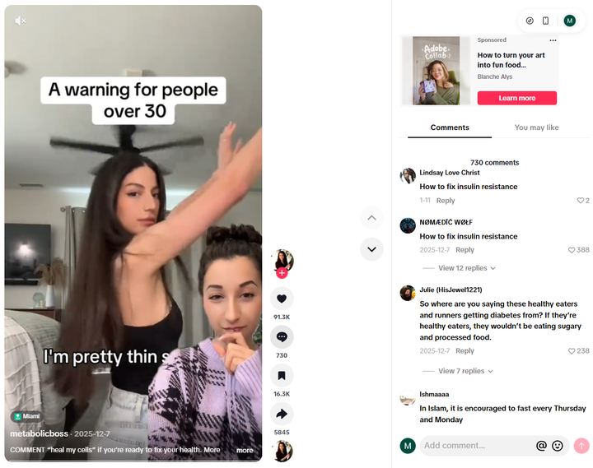

Post Metrics:
- Likes = 91.3K | Shares = 5845 | Views = 1.3M
- Comments = 730

Why this post worked: Identity interrupt (fit people getting type 2 diabetes) plus a single keyword CTA (“heal my cells”). Face-to-camera teaching with clear niche hashtags. Caption: “COMMENT “heal my cells” if you’re ready to fix your health. More and more active, fit people are being diagnosed with type 2 diabetes. Here…” Post URL: https://www.tiktok.com/@metabolicboss/video/7580865969317285128
Trends Used: Keyword-comment CTA; #type2diabetes #insulinresistance #healthtips; educational voiceover.
Competitor 1 recurring patterns (Metabolic Boss): Content types = face-led educational explainers, condition bridges (fatty liver, neuropathy, diabetes risk → insulin resistance), keyword-comment CTAs. Posting frequency = high (dense recent grid). Time of day = not publicly visible on grid without creator analytics. Repeated hooks/formats = symptom/organ doorway → root-cause insulin resistance; checklist close; one keyword CTA.
Competitor 1 - Post #2
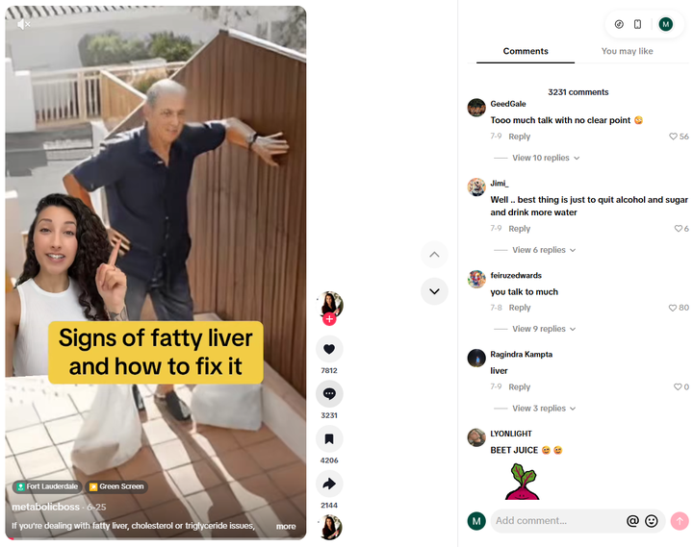

Post Metrics:
- Likes = 7812 | Shares = 2144 | Views = 471.8K
- Comments = 3231

Why this post worked: Condition-bridge (fatty liver / cholesterol / belly fat) into insulin resistance as root cause. Anti-detox mythbust. High comments relative to likes (comment-engineered). Caption: “If you're dealing with fatty liver, cholesterol or triglyceride issues, belly fat, blood sugar issues, low energy, or you've been told your…” Post URL: https://www.tiktok.com/@metabolicboss/video/7655100242890689800
Trends Used: Condition-bridge; myth vs mechanism; #fattyliver #triglycerides #bellyfat; educational checklist.

Competitor 2 - Post #3
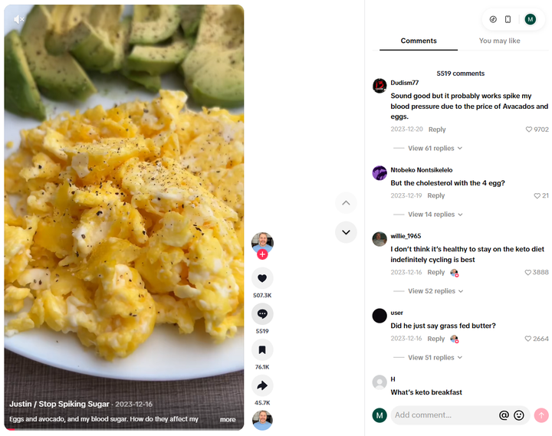

Post Metrics:
- Likes = 507.3K | Shares = 45.7K | Views = 16.1M
- Comments = 5519

Why this post worked: Proof-first CGM food experiment (eggs + avocado). Simple, repeatable question format with on-screen proof. Caption: “Eggs and avocado, and my blood sugar. How do they affect my glucose levels? #eggs #avocado #bloodsugar #glucoselevels #insulinresistant1” Post URL: https://www.tiktok.com/@insulinresistant1/video/7312956535917890821
Trends Used: CGM food-test series; “How do they affect my glucose levels?” template; #bloodsugar #glucoselevels.
Competitor 2 recurring patterns (insulinresistant1): Content types = CGM meal tests, food challenges, habit/supplement checks. Posting frequency = high-volume experiment library. Time of day = not publicly visible without analytics. Repeated hooks/formats = “[Food] and my blood sugar…” → eat → show CGM → conclusion.
Competitor 2 - Post #4
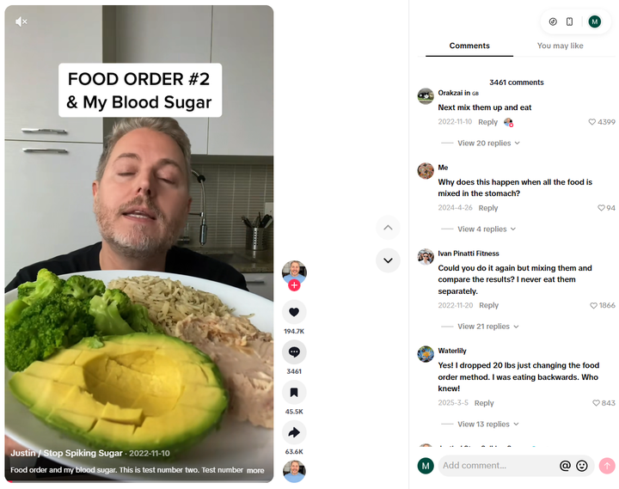

Post Metrics:
- Likes = 194.7K | Shares = 63.6K | Views = 3.3M
- Comments = 3461

Why this post worked: Food-order method experiment — practical hack plus personal CGM proof. High shares (send-to-family content). Caption: “Food order and my blood sugar. This is test number two. Test number one is here @ #bloodsugar # #insulinresistance # #prediabetes # #foodor…” Post URL: https://www.tiktok.com/@insulinresistant1/video/7164164024437837061
Trends Used: Food-order / glucose-hack; #insulinresistance #prediabetes #foodorder; series format.

Competitor 3 - Post #5
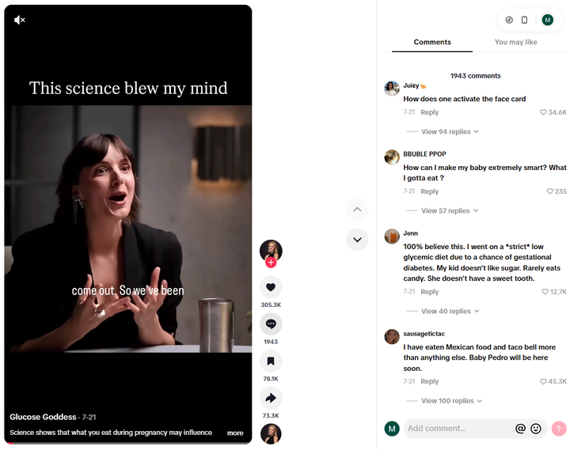

Post Metrics:
- Likes = 305.3K | Shares = 73.3K | Views = 3.6M
- Comments = 1943

Why this post worked: Polished science storytelling with high share value. Clean educator brand and clear educational payoff. Caption: “Science shows that what you eat during pregnancy may influence how your baby’s genes behave for the rest of their life. How crazy is that. …” Post URL: https://www.tiktok.com/@glucosegoddess_/video/7664659813053238541
Trends Used: Science-explainer short-form; high-share educational storytelling; original educational sound.
Competitor 3 recurring patterns (Glucose Goddess): Content types = mechanism explainers, nutrition science, curiosity educational hooks. Posting frequency = consistent branded educational library. Time of day = not publicly visible without analytics. Repeated hooks/formats = plain-English science chain; one idea per video; visual/diagram + talking-head style.
Competitor 3 - Post #6
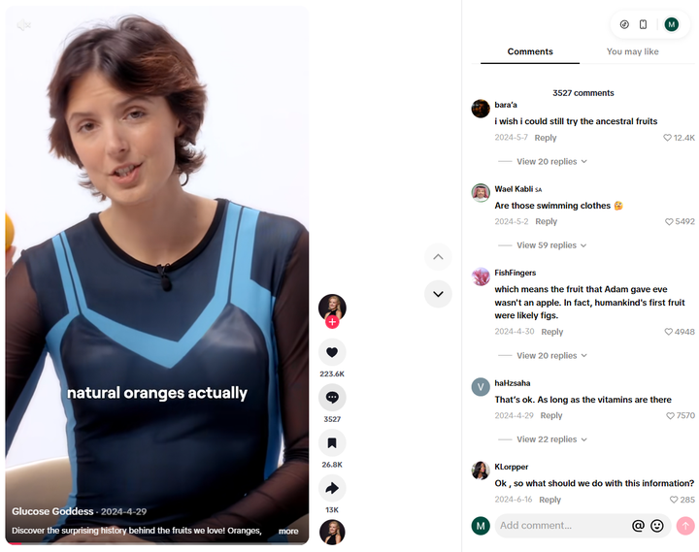

Post Metrics:
- Likes = 223.6K | Shares = 13K | Views = 3.2M
- Comments = 3527

Why this post worked: Curiosity education (fruit/nutrition history) with a clear teaching payoff. Strong comment activity. Caption: “Discover the surprising history behind the fruits we love! Oranges, bananas, and apples as we know them today are far from their wild ances…” Post URL: https://www.tiktok.com/@glucosegoddess_/video/7363295968487410990
Trends Used: Curiosity educational hook; #nutrition #fruit; one-idea explainer.

Summary

Where are competitors most active: TikTok (this project’s only in-scope platform). Live profile stats at 2026-07-30 06:15:52: @metabolicboss 343.3K followers / 2.4M likes; @insulinresistant1 1.9M followers / 17.7M likes; @glucosegoddess_ 630.4K followers / 3M likes.

What are the most common posts used by competitors: Face-to-camera educational explainers; condition-bridge videos (fatty liver / diabetes risk → insulin resistance); CGM food experiments; practical one-hack tips (food order); myth vs mechanism (anti-detox); keyword-comment CTA clips.

What are the trends used by competitors: Root-cause insulin narrative; 1–3s pattern-interrupt hooks; plain-English science; original educational voiceovers; niche hashtags (#insulinresistance #diabetes #fattyliver #bloodsugar); comment-gate CTAs; proof-first CGM storytelling; identity interrupts. Founder takeaway: run PIW TikTok on one root narrative (insulin resistance), condition entry points, face-led short video, and one CTA per post (e.g. comment ASSESS → free assessment).

