SOP

Title: Automation Workflow( Systeme.io) – SOP

Frequency: One-Time Setup per Funnel Launch

Outcome:
- The automation workflow triggers correctly when a contact submits the Lead Magnet form.
- Contacts are tagged appropriately and enter the pre-consult email nurture sequence.
- All delays, email sends, and actions are properly configured and tested.

Steps:
- Log in to Systeme.io – Access the account where the funnel and Lead Magnet page are located.
- Create or open workflow – Navigate to Automations → Workflows → Select “Lead Magnet Subscribe” or create a new workflow.
- Add Trigger – Click “+ Add Trigger” → select Funnel step form subscribed → choose the correct funnel and Lead Magnet page.
- Add Tag – Click “+ Add Action” → Add a tag → create “Lead Magnet Signup” → confirm action is attached to trigger.
- Add Wait Step – Click “+ Add Action” → Wait 1 day → place between each email to space out nurture sequence.
- Add Email Sends – For each email in the 4–5 day Pre-Consult nurture sequence:
- Click “+ Add Action” → Send Email → select appropriate content (or placeholder if not finalized).
- Confirm it’s set to send to tagged contacts.
- Add Wait 1 day after each email.
- Final Tag – After the last email, optionally add a tag: “Pre-Consult Nurture Complete.”
- Review Workflow – Double-check triggers, tags, wait times, and email order. Ensure everything is active or paused for testing.

Reference Materials:
- https://www.loom.com/share/fe9770c4739048b0914631aa3d3ac226
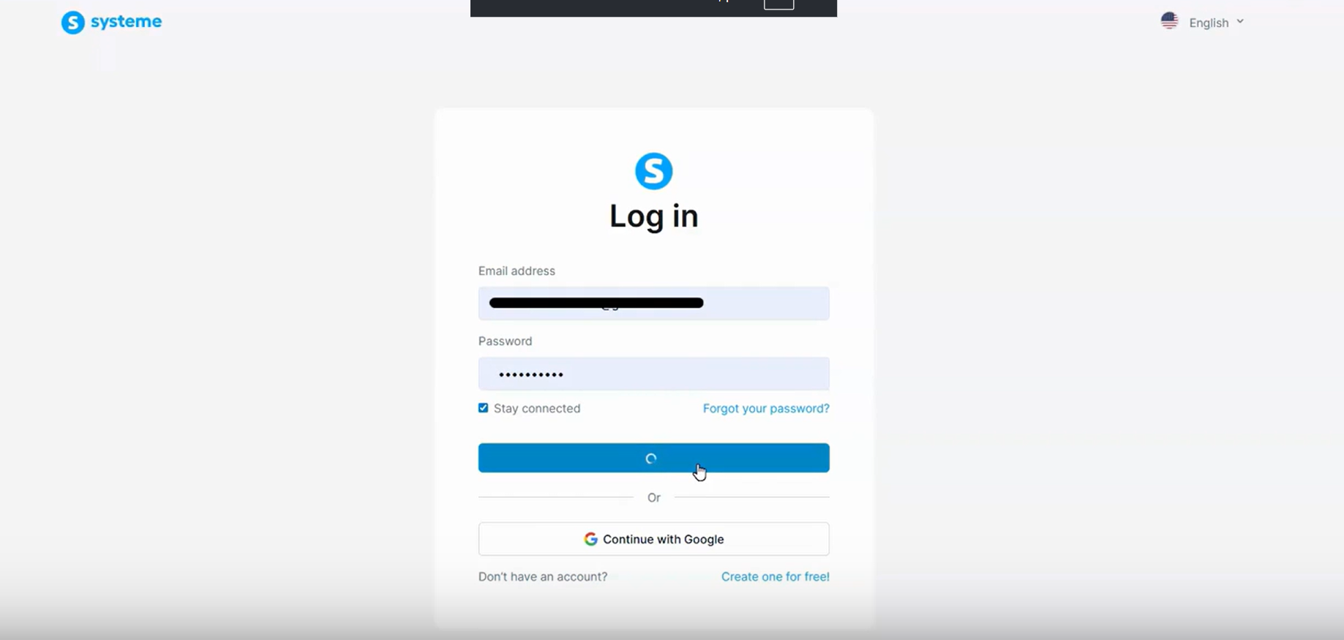
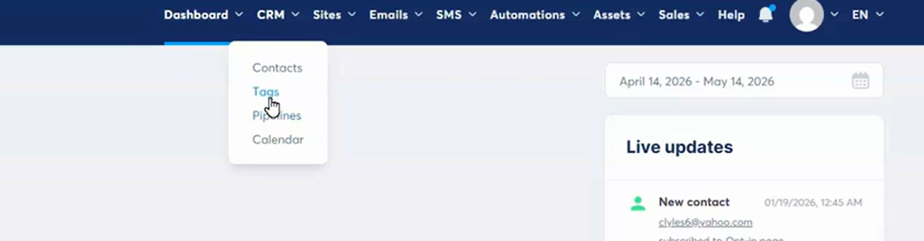
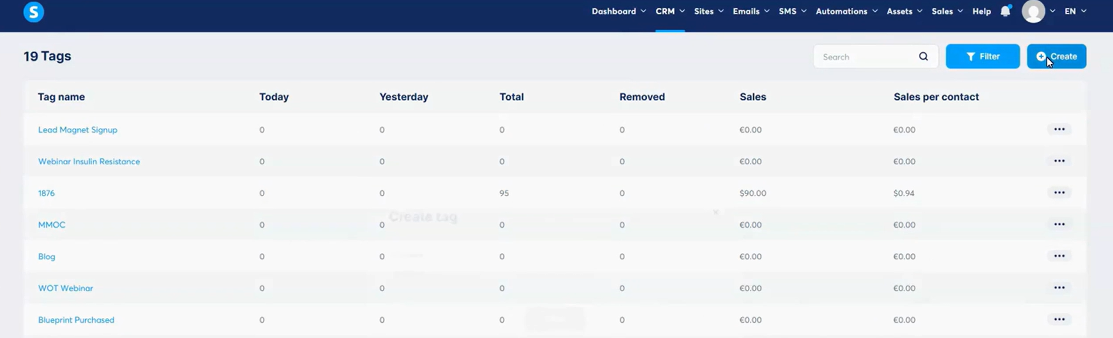
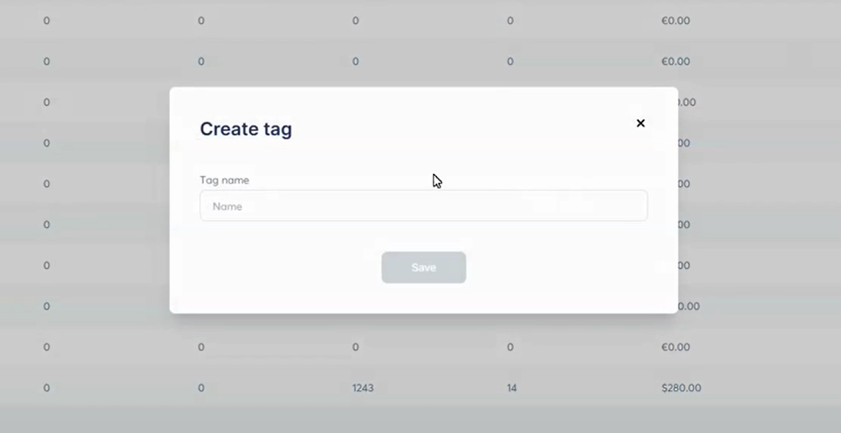
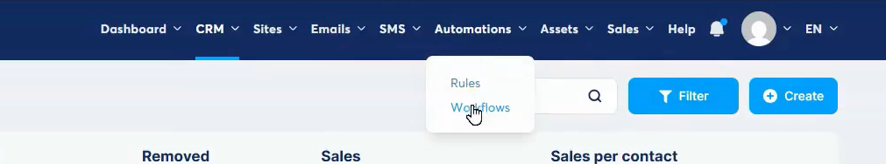
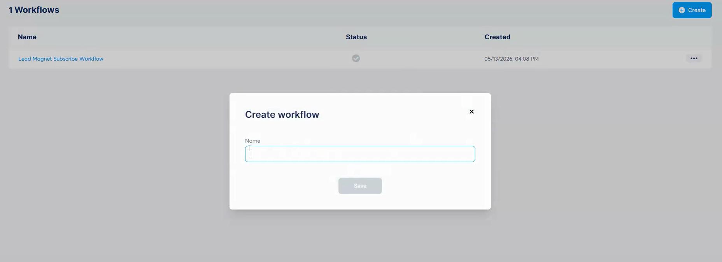
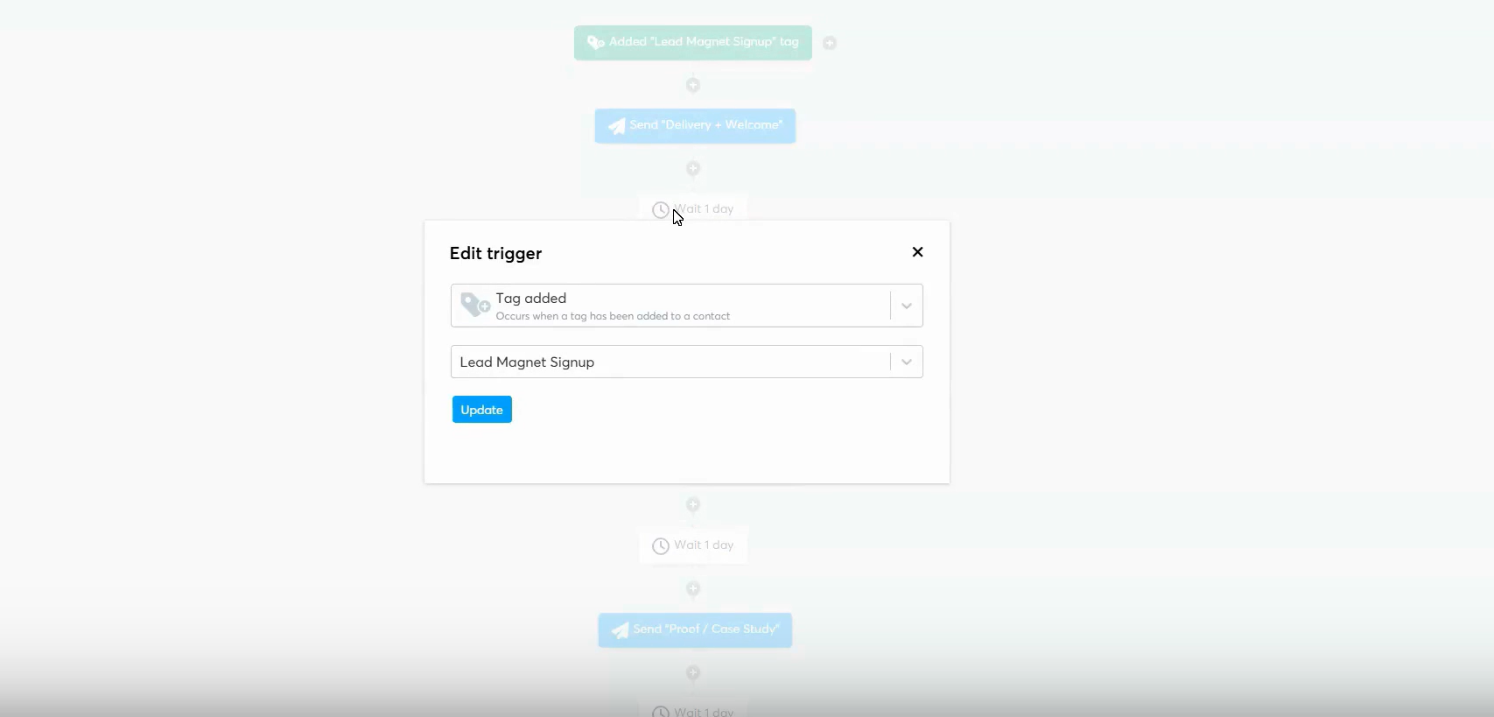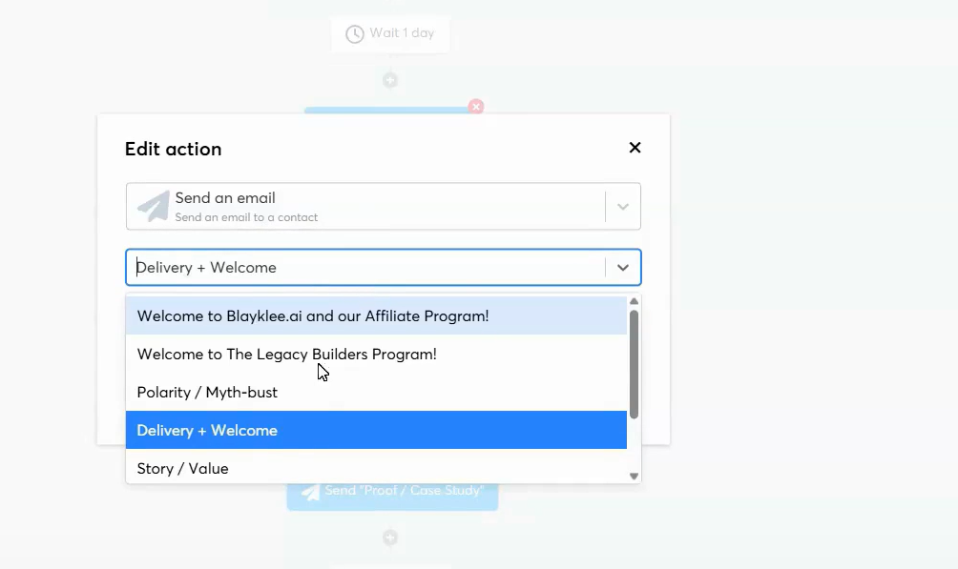
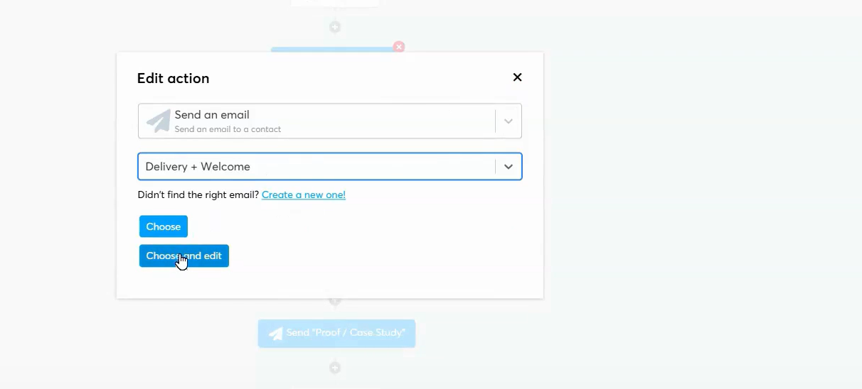
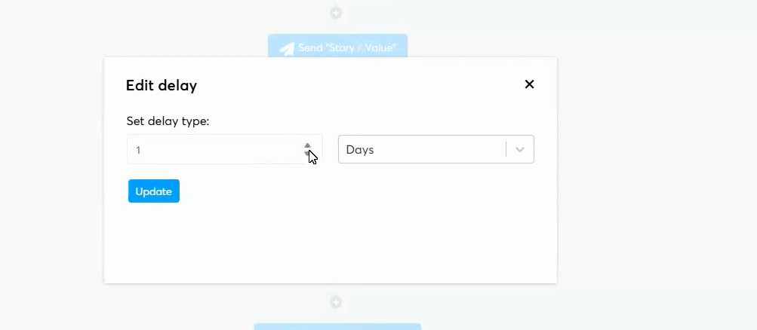

Owner: Mar Thayne

Folder/Category: Marketing

