SOP

Title: embed calendar – SOP

Frequency: Per Client / Per Launch

Outcome:
- Zoom Scheduler is embedded into the funnel page.
- Visitors can book appointments directly from the page.
- Booking widget displays correctly on desktop and mobile.

Steps:
- Log in to Zoom.
- Open Scheduler.
- Select the booking page to embed.
- Click Share.
- Click Add to Website.
- Copy the embed code.
- Log in to Systeme.io.
- Open the desired funnel page.
- Click Edit Page.
- Drag the Raw HTML element onto the page.
- Click Edit Code.
- Paste the Zoom embed code.
- Click Save.
- Save the page.
- Preview the page.
- Test the booking widget.
- Verify desktop and mobile display.
Note: The Zoom Scheduler may appear broken, cut off, or misaligned inside the Systeme.io editor. This is normal and does not affect functionality. Use the Preview button to verify the final display. The booking widget will render correctly on the live page and in preview mode.

Reference Materials:

Checklist
- ☐ Zoom Scheduler page created
- ☐ Correct booking page selected
- ☐ Share button clicked
- ☐ Add to Website option selected
- ☐ Embed code copied successfully
- ☐ Systeme.io funnel page opened
- ☐ Raw HTML element added to page
- ☐ Embed code pasted into Raw HTML element
- ☐ Code saved successfully
- ☐ Funnel page saved
- ☐ Page preview tested
- ☐ Booking widget displays correctly
- ☐ Desktop view checked
- ☐ Mobile view checked
- ☐ Zoom booking page loads successfully
- ☐ Test booking completed
- ☐ Appointment appears in Zoom Scheduler
- ☐ Integration ready for publishing
Screenshots 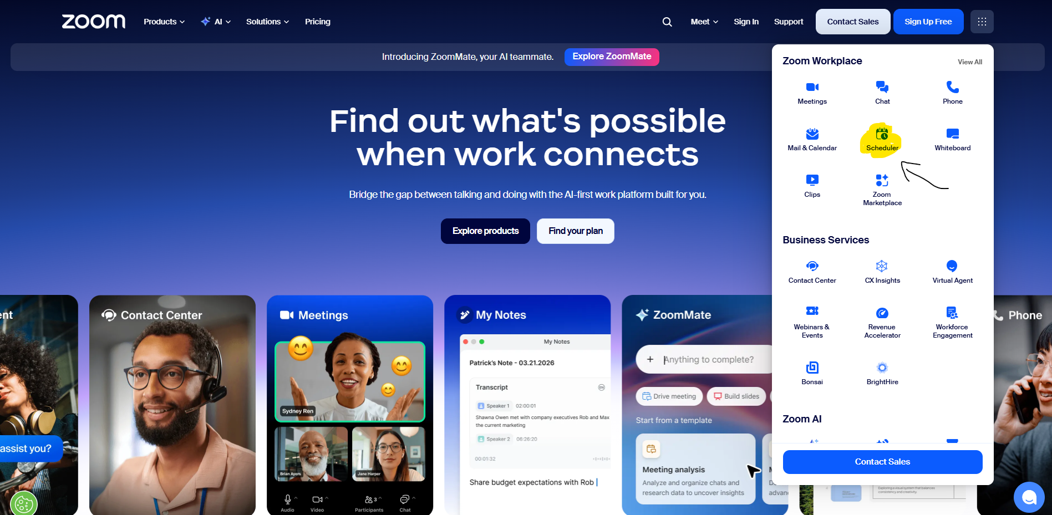
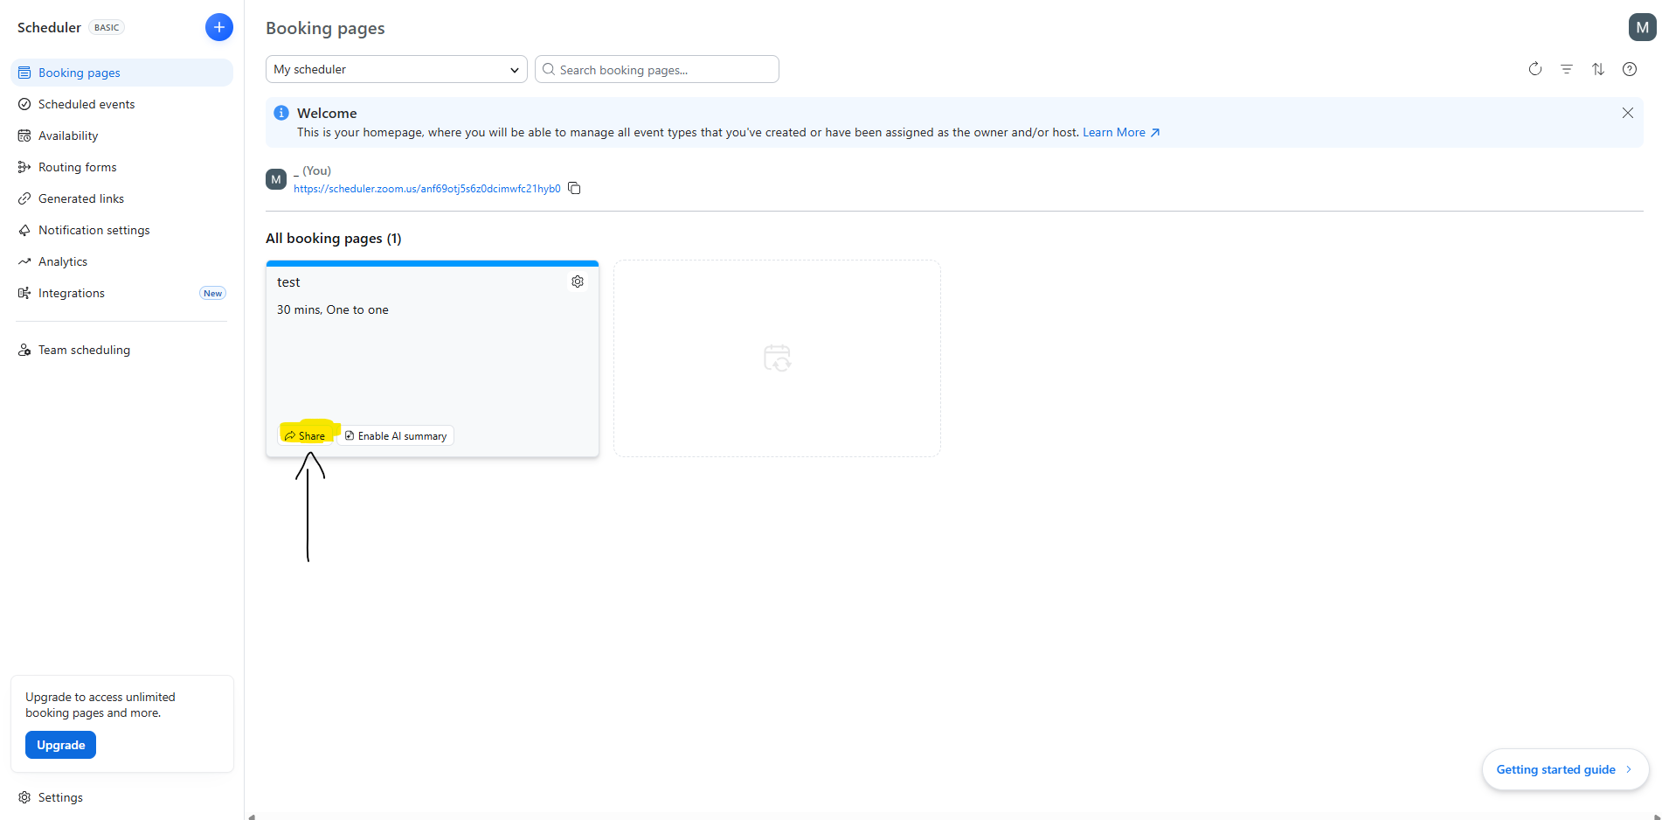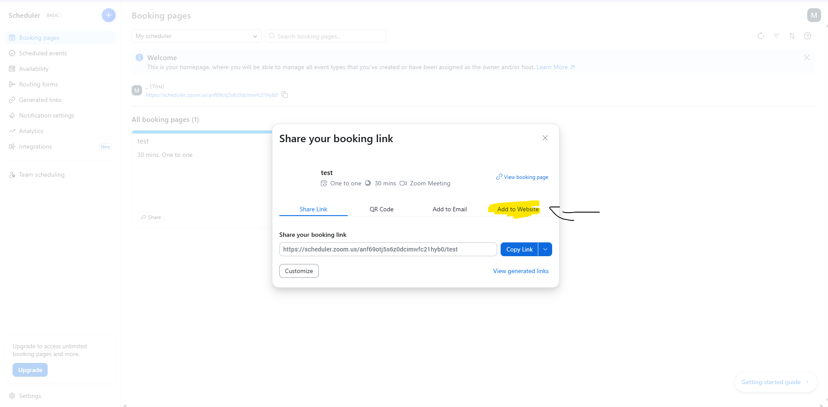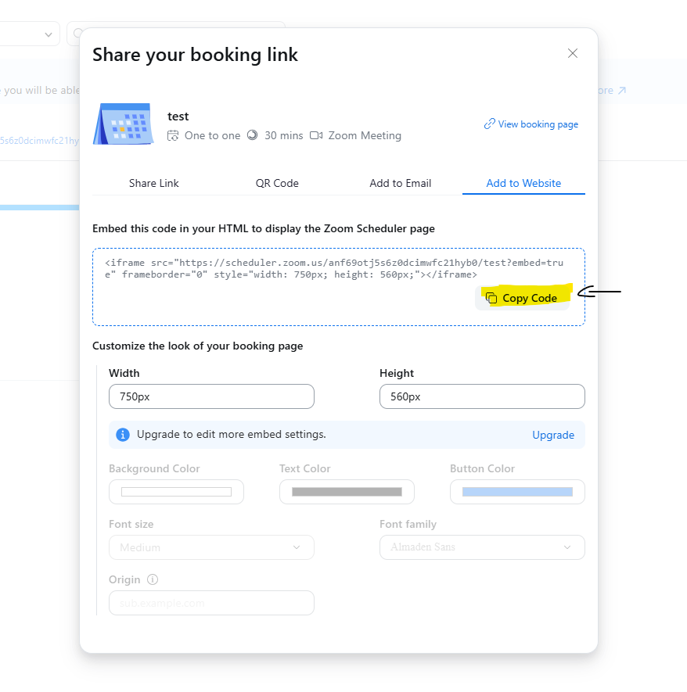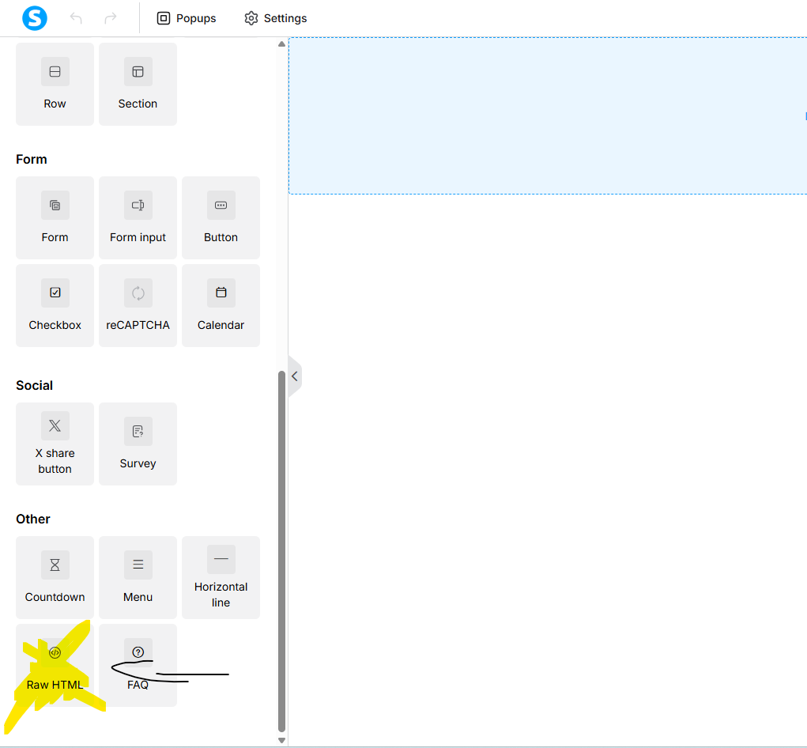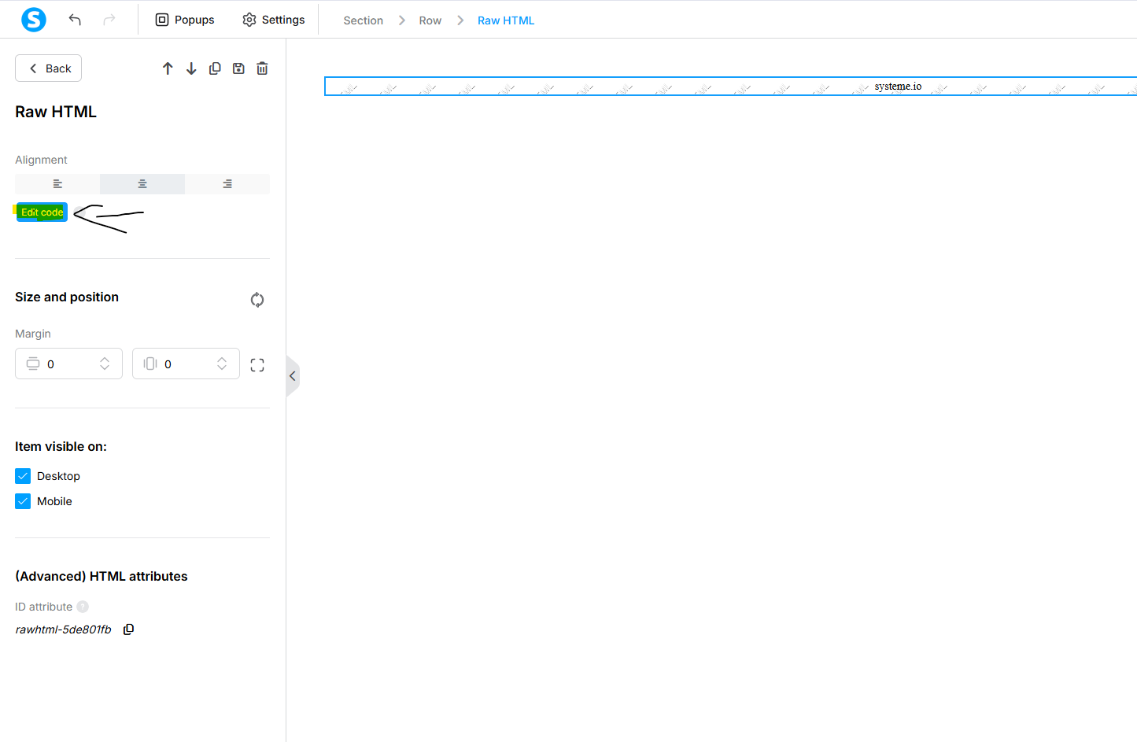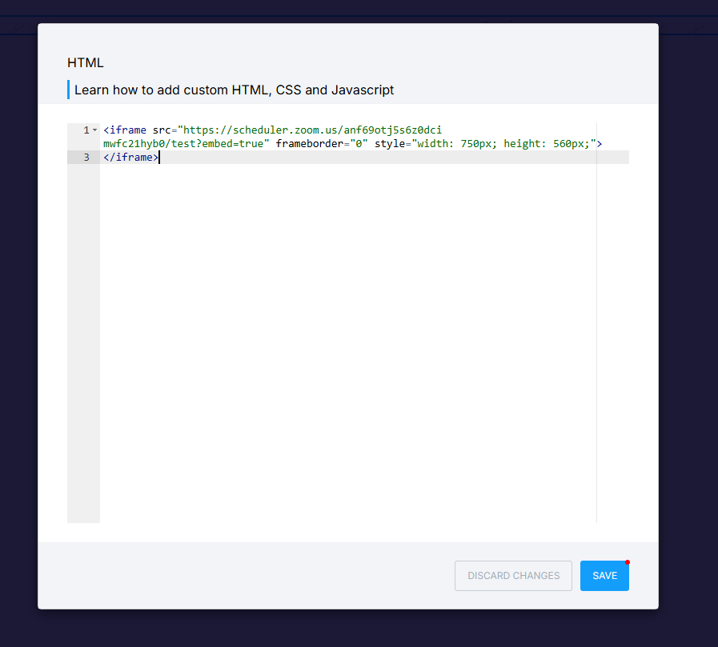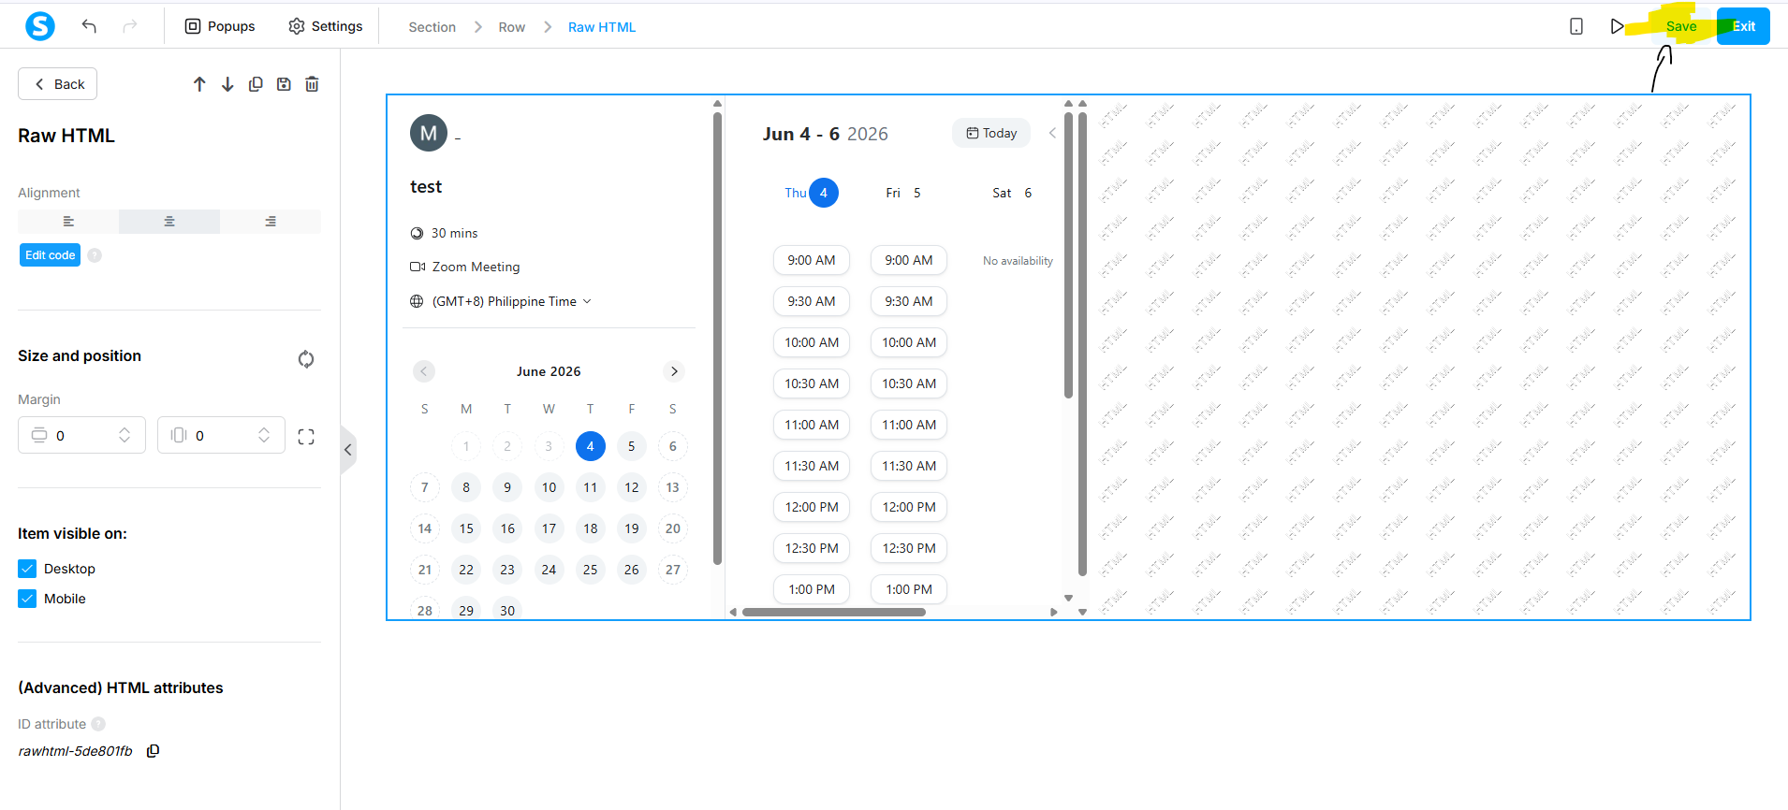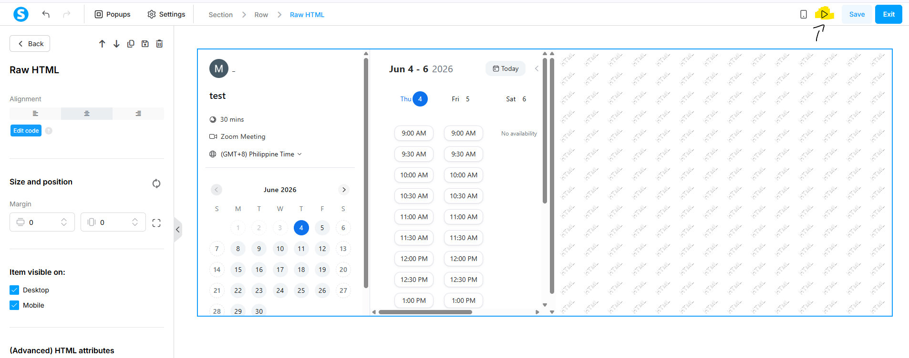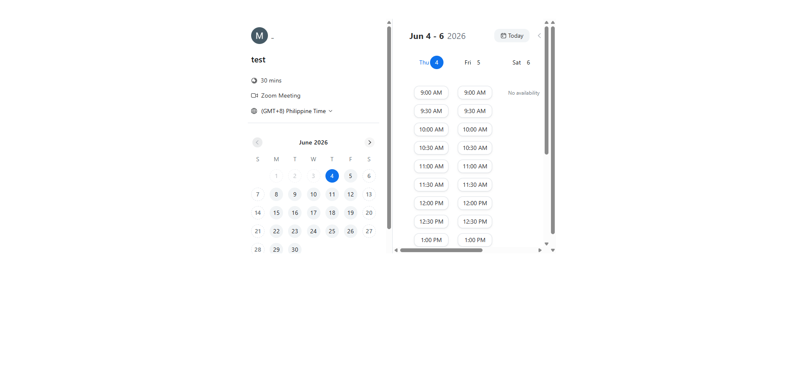
Owner: Mar Thayne (Doer)

Folder/Category: Marketing

