**Reflection**

This project develops a front-end website for Canberra Art Biennial Festivals to attract the public attentions. The designed website consists of HTML, CSS and JavaScript to support interactive communication with target audiences. This website considers three core sections that include navigation bar, body and footer.

In order to ensure the website consistency, the designed navigation bar and footer are the same to support the best user experience. To consider the different devices and screen sizes, it is necessary to develop mobile-friendly website to support the different user groups. These improvements can enhance the user experience when they are browsing the website and interface.

To consider the real-world requirement, audience may want to book group reservations for different festivals and events. The designed booking page can support the audience to make group reservations with specific requirements.

During the evolution of the design and development process, it is important to separate the HTML code and CSS code to make the entire coding document clear to understand and view.

1. Navigation Bar

The navigation bar contains four different functions that include home page, contact page, festivals page and booking page.

- Home Page - Description about the Canberra Art Biennial Sponsors that also list the popular events

- Contact Us Page - To leave the special request about event booking

- Festivals - List the festival timetable and prices

- Booking Page - Leave the special requirements for group booking on special events

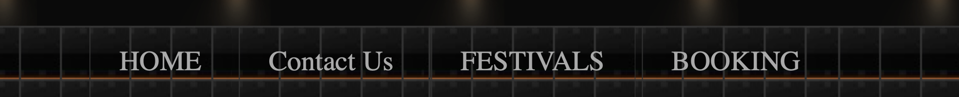

2. Footer

The designed footer considers the Canberra Art Festivals

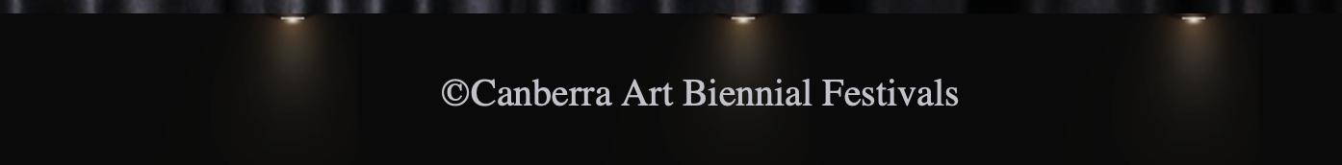

3. Mobile Friendly

This project considers the multiple devices with different screen size.

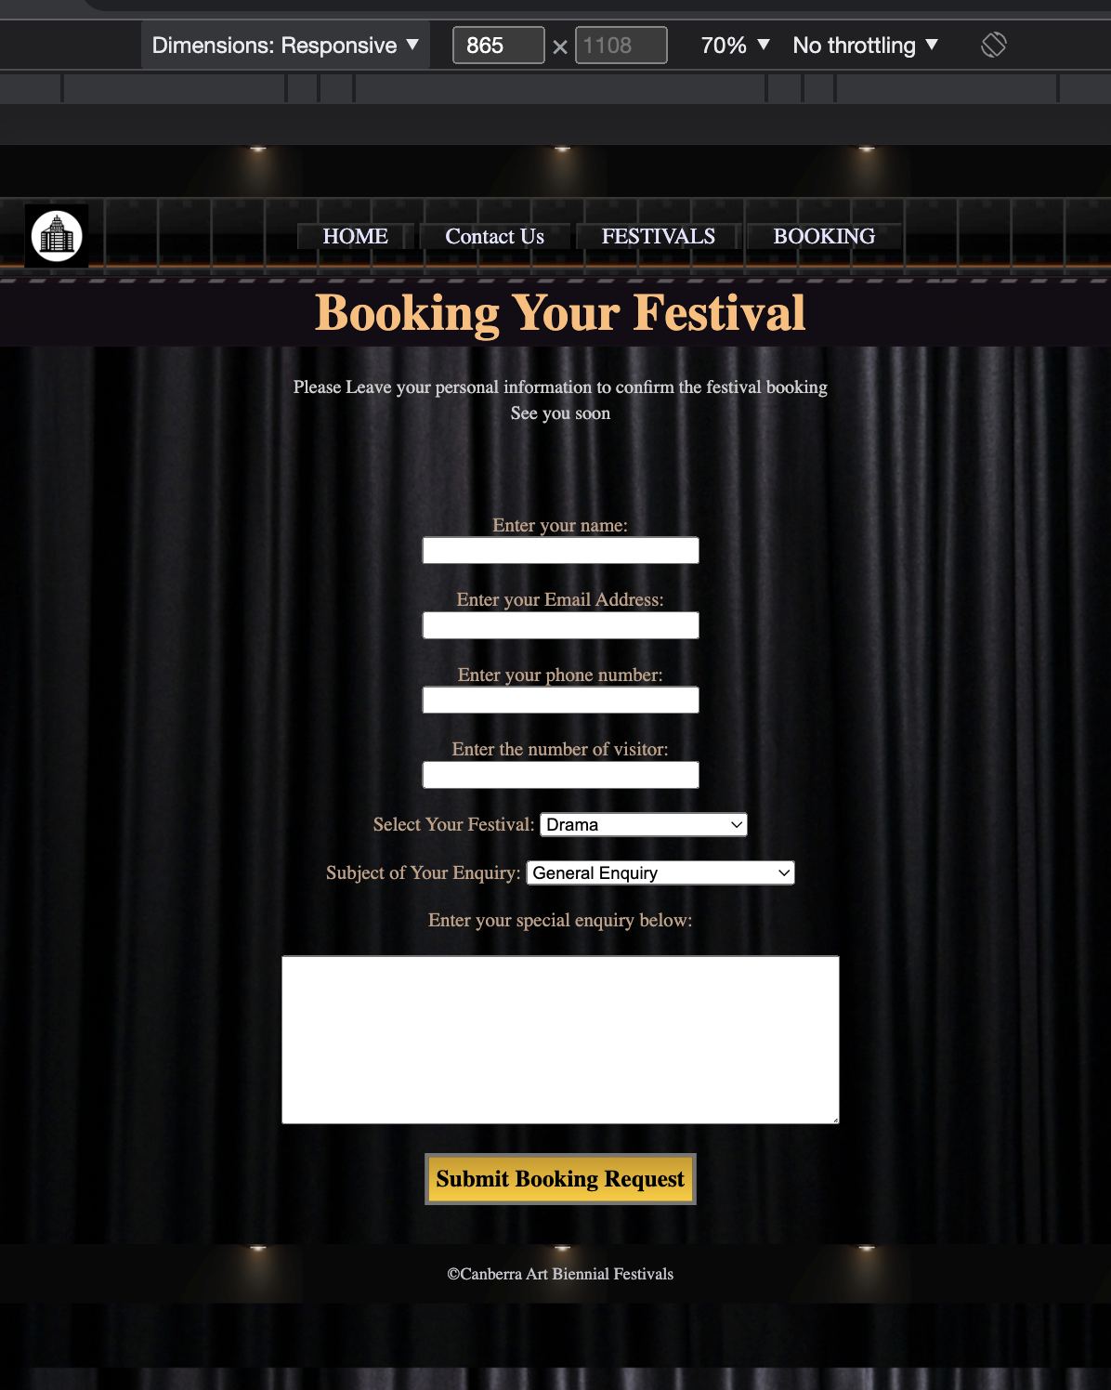

Therefore, the completed website can be viewed by users based different devices with best user experience and usability.