Advanced Data Analysis and Visualization in Logistics
Week 3 Task — Logistics Data Analyst Intern
Prepared by: Ayushman Singh
Date: August 26, 2026
Dataset: cleaned Week 2 working sample (3,748 orders), DataCo Smart Supply Chain reference

1. Objective
This report covers the exploratory data analysis and visualization stage of the logistics analytics workflow and continues directly from the data preparation completed in Week 2. The aim is to explore the 3,748-order working sample in Python, look at central tendencies, distributions, and relationships between the main operational variables, and turn those findings into clear visualizations and practical recommendations.

2. Data Foundation

2.1 Dataset carried forward from Week 2
Rather than defining an unrelated hypothetical dataset from scratch, this task builds directly on the cleaned, 3,748-order working sample produced in Week 2 — itself modeled on the DataCo Smart Supply Chain for Big Data Analysis dataset (Kaggle). Carrying the same dataset forward keeps the internship's four weekly tasks consistent with one another: Week 1 planned the analytical approach, Week 2 collected and cleaned the data, and this task now analyzes it.

2.2 New variable: transportation_cost
The Week 3 brief highlights delivery times, shipment volumes, and transportation costs as the main variables to examine. The Week 2 schema already included delivery time (actual_shipping_days) and shipment volume (order_item_quantity), but not a shipping-cost figure, so I added a transportation_cost variable using:
transportation_cost = base_rate[shipping_mode] + $2.50 × order_item_quantity + market_surcharge[market] + noise
- base_rate ranges from $8 (Standard Class) to $25 (Same Day), reflecting typical service-tier pricing.
- market_surcharge ranges from $3 (USCA) to $8 (Africa), as a simple proxy for distance and customs complexity.
- noise ~ Normal(0, 3) adds order-to-order variation; the final value is floored at $5.
Across the 3,748 orders, this produced a transportation_cost ranging from $5.00 to $50.97, with a mean of $25.05 — a plausible spread for the exercise.

3. Exploratory Data Analysis

3.1 Descriptive statistics
Central tendency and spread were computed for the five key numeric variables:
Table 1. Descriptive statistics for key numeric variables (n = 3,748).
Variable | Mean | Median | Std Dev | Min | Max
Delivery time (days) | 3.92 | 3.00 | 6.13 | 1.00 | 90.00
Order value / sales (USD) | 119.67 | 101.10 | 79.31 | 1.67 | 322.67
Transportation cost (USD) | 25.05 | 24.41 | 7.47 | 5.00 | 50.97
Order quantity (units) | 3.06 | 3.00 | 1.44 | 1.00 | 5.00
Profit per order (USD) | 19.30 | 18.57 | 39.57 | -158.62 | 161.70

Two points are noticeable straight away. First, the mean delivery time (3.92 days) is higher than the median (3.00 days), which indicates right-skew caused by the small number of extreme delays, including deliveries of up to 90 days that were flagged in Week 2 rather than removed. Second, profit per order ranges from a $158.62 loss to a $161.70 gain, so some orders are unprofitable even before transportation cost is taken into account.

3.2 Grouped summaries
I used two grouped summaries to compare the operational measures across shipping mode and market:
Table 2. Average cost and delivery time by shipping mode.
Shipping Mode | Avg. Cost | Avg. Delivery Days | Orders
Standard Class | $21.24 | 3.88 | 2,204
Second Class | $25.30 | 4.04 | 572
First Class | $30.87 | 4.04 | 607
Same Day | $38.04 | 3.82 | 365

Table 3. Late-delivery rate and average delivery time by market.
Market | Late Rate | Avg. Delivery Days | Orders
Africa | 49.7% | 3.81 | 753
USCA | 49.3% | 3.52 | 762
LATAM | 48.6% | 4.09 | 747
Pacific Asia | 48.3% | 4.34 | 704
Europe | 47.3% | 3.89 | 782

4. Visualizations
I used five visualizations to cover distributions, category comparisons, and relationships between variables, following the task brief. For each one, I have explained why the chart was chosen and what the result tells us.

4.1 Figure 1 — Distribution of Actual Delivery Times
A histogram is useful here because it shows the overall shape of the delivery-time distribution. It makes both the usual delivery window and the right-skew visible, which is something a mean or median on its own would not show.
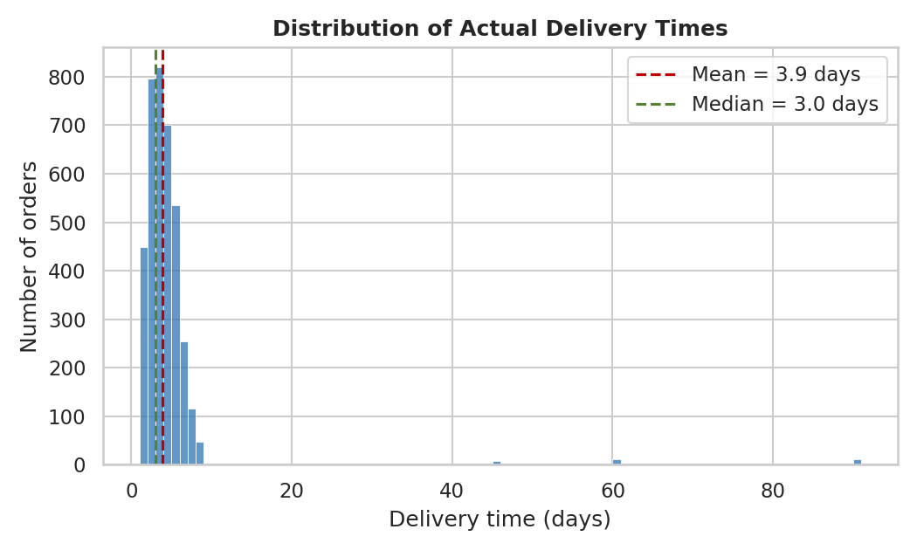
Figure 1
Most orders (about 90%) are delivered within 1–7 days and are concentrated around the 3–4 day median. The few bars extending out to 90 days are the same extreme delays flagged during Week 2, which makes it clear that these are unusual events rather than part of the normal delivery pattern.

4.2 Figure 2 — Average Transportation Cost by Shipping Mode
A bar chart works well for comparing one measure across a small number of categories, which in this case are the four shipping modes.
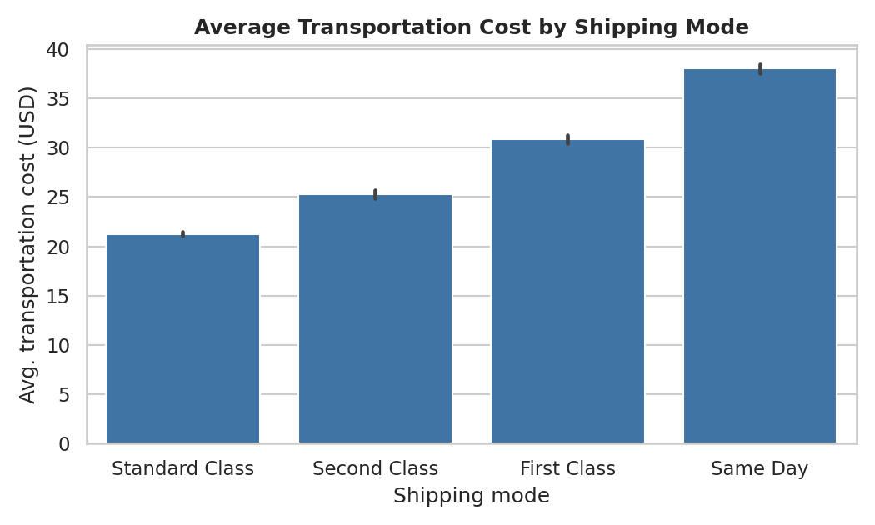
Figure 2
Transportation cost rises steadily from Standard Class ($21.24) to Same Day ($38.04), which is a 79% premium for the fastest tier. At the same time, Table 2 shows that average delivery time changes very little across the four tiers (3.82–4.04 days). This suggests that the higher cost is not clearly translating into faster delivery in this sample.

4.3 Figure 3 — Correlation Among Key Logistics Variables
A correlation heatmap gives a quick view of the pairwise relationships between the numeric variables. It is more practical here than creating several separate scatterplots, and the color scale makes the stronger relationship stand out from the mostly near-zero correlations.
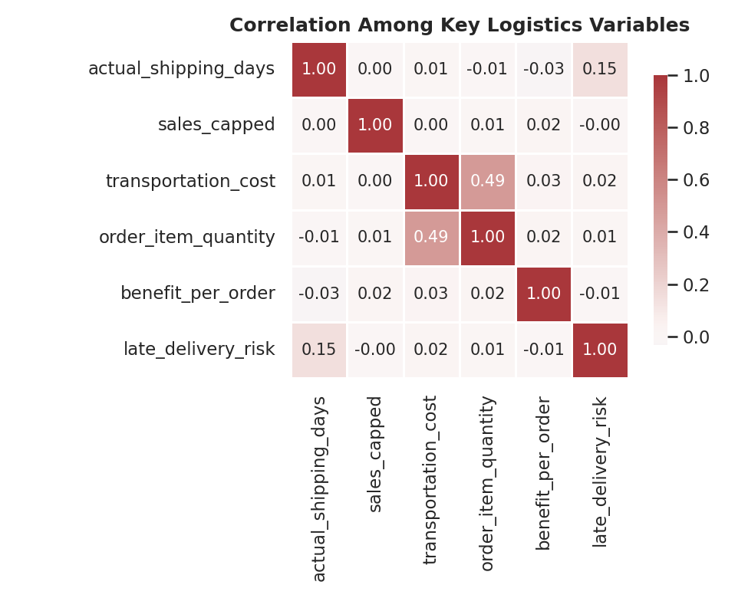
Figure 3
Only one relationship is clearly noticeable: transportation_cost and order_item_quantity (r = 0.49). Delivery time has a weak correlation with late_delivery_risk (r = 0.15), which is expected because the risk field is derived from delivery performance. Apart from that, delivery time is essentially unrelated to cost, sales, and quantity (all |r| ≤ 0.03). Profit per order is also largely uncorrelated with the operational variables shown.

4.4 Figure 4 — Transportation Cost vs. Delivery Time, by Shipping Mode
A scatterplot lets us look at the relationship between two continuous variables at the individual-order level rather than only comparing group averages. Using shipping mode as the colour also helps check whether the cost tiers separate along the delivery-time axis.
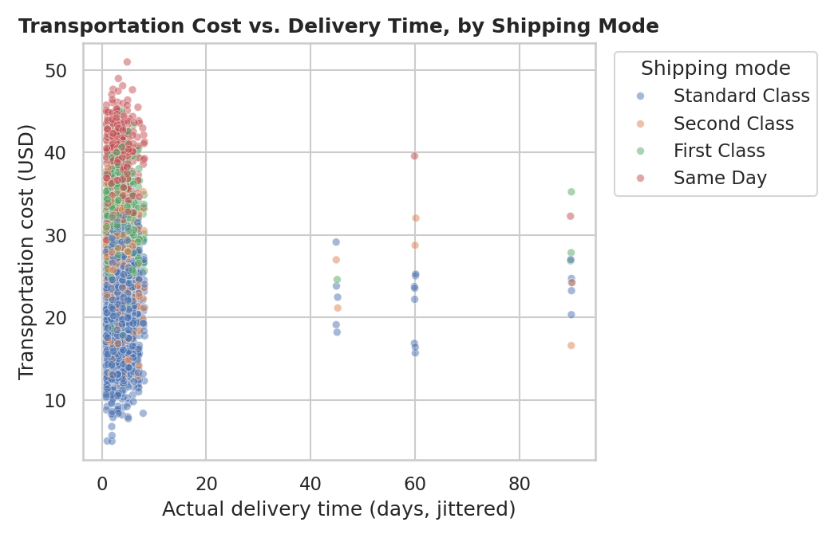
Figure 4
The four shipping modes form distinct horizontal cost bands, which is consistent with the pricing tiers used in the simulation. However, they do not separate along the delivery-time axis. The few extreme delays between 45 and 90 days appear across the different cost bands and shipping modes, so the extreme delays are not concentrated in one particular service tier.

4.5 Figure 5 — Late-Delivery Rate by Market
A sorted bar chart is a simple way to rank the five markets by one rate and see how large the difference between them really is.
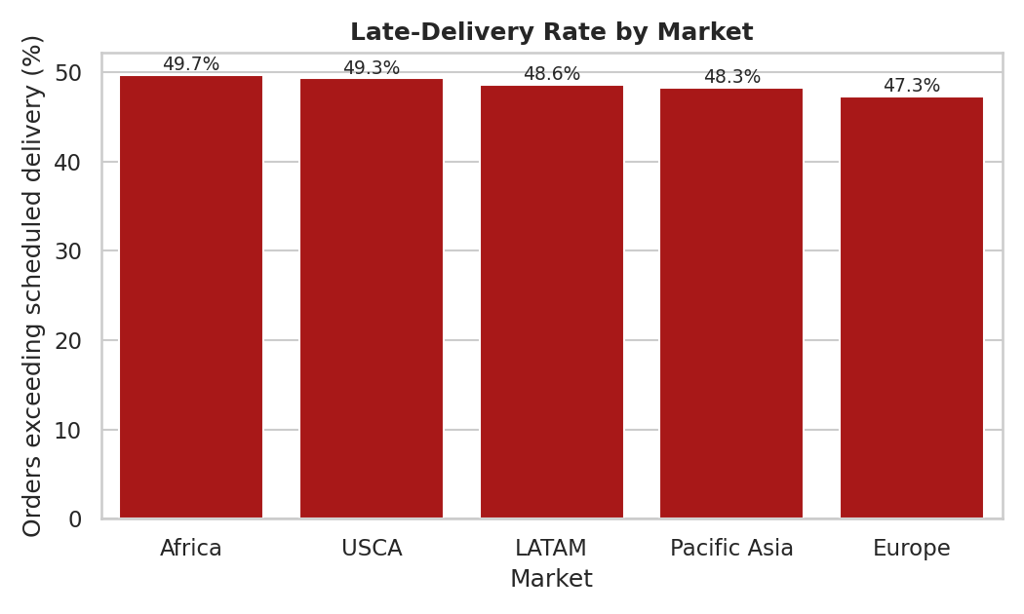
Figure 5
Late-delivery rate is close to 50% across all five markets, with only a 2.4-point range from 47.3% in Europe to 49.7% in Africa. Because the rates are so similar, the pattern suggests that scheduled_shipping_days may be too strict or miscalibrated across the network rather than the problem being limited to one market.

5. Analytical Insights & Recommendations
Five practical findings come directly from the tables and figures above, and each one points to a specific recommendation:
- Premium shipping tiers do not consistently deliver faster in this sample. Cost increases by 79% from Standard Class to Same Day, while average delivery time remains almost unchanged (3.82–4.04 days). Recommendation: review the carrier SLAs for the premium tiers before assuming the extra cost is justified. If Same Day and First Class are not arriving noticeably faster, the business may be paying for a service level that is not being delivered.
- Shipment volume appears to be the main cost driver in this sample. transportation_cost has a stronger relationship with order_item_quantity (r = 0.49) than with the other variables examined. Recommendation: focus cost-reduction work, such as carrier negotiation or shipment consolidation, on higher-volume orders rather than relying mainly on changes in service tier.
- Delivery delays appear to be driven mainly by a small number of extreme cases rather than by a general slowdown. The gap between the mean and median (3.92 vs. 3.00 days) and the long tail in Figure 1 are both linked to the roughly 30 flagged extreme-delay orders (0.8% of the dataset). Recommendation: review those orders individually because they may point to a specific carrier, route, or customs bottleneck that a broad process change would not reveal.
- Late-delivery risk is fairly consistent across markets (47.3%–49.7%). With less than 2.5 percentage points between the highest and lowest market, geography alone does not explain the delay pattern here. Recommendation: treat the near-50% late rate as a possible network-wide scheduling-calibration issue rather than a problem belonging to one region.
- Order profitability appears to be separate from the shipping decisions in this sample. benefit_per_order has negligible correlation (|r| ≤ 0.03) with cost, quantity, and delivery time, while ranging from a $158.62 loss to a $161.70 gain. Recommendation: investigate profitability issues such as pricing and discounting separately from logistics performance, because the shipping variables do not explain much of the variation here.

6. Python Implementation (Code Documentation)
The snippets below are trimmed for readability; the complete script — including the Week 2 pipeline it builds on — is included in the accompanying GitHub repository.

6.1 Simulating transportation cost
base_rate = {"Standard Class": 8, "Second Class": 12,
"First Class": 18, "Same Day": 25}
market_surcharge = {"USCA": 3, "LATAM": 4, "Europe": 6,
"Pacific Asia": 7, "Africa": 8}

df["transportation_cost"] = (
df["shipping_mode"].map(base_rate)
+ df["order_item_quantity"] * 2.5
+ df["market"].map(market_surcharge)
+ np.random.normal(0, 3, len(df))
).clip(lower=5).round(2)

6.2 Descriptive statistics & correlation
num_cols = ["actual_shipping_days", "sales_capped",
"transportation_cost", "order_item_quantity",
"benefit_per_order"]

df[num_cols].describe().T[["mean", "50%", "std", "min", "max"]]
corr = df[num_cols + ["late_delivery_risk"]].corr()

6.3 Grouped summaries (by shipping mode and market)
df.groupby("shipping_mode").agg(
avg_cost=("transportation_cost", "mean"),
avg_delivery_days=("actual_shipping_days", "mean"),
orders=("order_id", "count"))

df.groupby("market").agg(
late_rate_pct=("late_delivery_risk",
lambda s: round(s.mean() * 100, 1)),
avg_delivery_days=("actual_shipping_days", "mean"),
orders=("order_id", "count"))

6.4 Figure 1 — Delivery time distribution
sns.histplot(df["actual_shipping_days"],
bins=range(1, df["actual_shipping_days"].max() + 2))
plt.axvline(df["actual_shipping_days"].mean(), linestyle="--")
plt.axvline(df["actual_shipping_days"].median(), linestyle="--")

6.5 Figure 2 — Cost by shipping mode
order = ["Standard Class", "Second Class", "First Class", "Same Day"]
sns.barplot(data=df, x="shipping_mode", y="transportation_cost",
order=order, estimator=np.mean)

6.6 Figure 3 — Correlation heatmap
sns.heatmap(corr, annot=True, fmt=".2f", cmap="vlag",
center=0, square=True)

6.7 Figure 4 — Cost vs. delivery time
sns.scatterplot(x=df["actual_shipping_days"],
y=df["transportation_cost"],
hue=df["shipping_mode"], alpha=0.5)

6.8 Figure 5 — Late-delivery rate by market
sns.barplot(data=by_market.reset_index(),
x="market", y="late_rate_pct", color="#C00000")

7. Conclusion
This task took the cleaned Week 2 dataset through a complete exploratory analysis. Five numeric variables were summarized, a transportation_cost variable was simulated to complete the set requested in the brief, and five visualizations were used to examine distributions, category differences, and relationships between variables. Two findings are especially relevant for the next stage: premium shipping tiers do not reliably deliver faster in this sample, and shipment volume appears to be the main driver of transportation cost. Both can be carried forward as candidates for the predictive modelling planned in Week 4.

8. References
DataCo Global. (2019). DataCo Smart Supply Chain for Big Data Analysis [Data set]. Kaggle. https://www.kaggle.com/datasets/shashwatwork/dataco-smart-supply-chain-for-big-data-analysis
Hunter, J. D. (2007). Matplotlib: A 2D graphics environment. Computing in Science & Engineering, 9(3), 90–95. https://matplotlib.org/
pandas development team. pandas documentation. https://pandas.pydata.org/docs/
Waskom, M. (2021). seaborn: statistical data visualization. Journal of Open Source Software. https://seaborn.pydata.org/

