YUVA INTERN | LOGISTICS DATA ANALYTICS
WEEK 4 PROJECT REPORT
Predictive Modeling and Optimization in Logistics Systems
Case study: SwiftCart Logistics (fictional academic scenario)
Target: actual_shipping_days
Data: cleaned Week 2 working sample based on DataCo reference structure
Prepared by: Ayushman
All model results are from the simulated academic working sample.

1. Problem Definition and Objective
The Week 4 question is whether delivery time can be predicted early enough to help a logistics team identify orders that may need attention. The target variable is actual_shipping_days. The predictors include scheduled shipping days, order quantity, sales, transportation cost, shipping mode, market, customer segment, and product category.
The aim is not to replace operational judgement with a model. The model is intended as an early-warning tool: when a predicted delivery time is above the scheduled window, the order can be reviewed earlier for carrier assignment, fulfilment, route planning, or customer communication.
2. Data Foundation and Target Variable
The analysis uses the cleaned Week 2 working sample with 3,748 records. Using the same working sample keeps Week 4 connected to the cleaning and EDA decisions made earlier.
Variable | Role
actual_shipping_days | Prediction target
scheduled_shipping_days | Planned service duration
order_item_quantity | Shipment volume indicator
sales_capped | Order value after Week 2 treatment
benefit_per_order | Profitability indicator
transportation_cost | Simulated logistics cost variable
shipping_mode | Service tier
market | Operating region
customer_segment | Customer grouping
category_name | Product category

late_delivery_risk is excluded from the predictor set because it is derived from delivery performance. Including it would create target leakage and make the model appear more accurate than it would be in a real forecasting setting.
3. Data Preparation for Modeling
The modelling pipeline performs numeric imputation and scaling and one-hot encodes categorical variables inside the preprocessing pipeline. This keeps the transformation steps consistent between training and test data.
numeric_pipe = Pipeline([
("imputer", SimpleImputer(strategy="median")),
("scaler", StandardScaler()),
])
categorical_pipe = Pipeline([
("imputer", SimpleImputer(strategy="most_frequent")),
("onehot", OneHotEncoder(handle_unknown="ignore")),
])
The dataset was split into 80% training and 20% testing records using random_state=42. The test set was not used during model fitting.
4. Model Selection
Linear Regression was used as a simple baseline because it is easy to interpret. Random Forest Regressor was used as the stronger non-linear model because delivery time may depend on combinations of shipment quantity, service mode, market, cost, and product category.
Model | Why it was included
Linear Regression | Simple and interpretable benchmark
Random Forest | Captures non-linear relationships and interactions
Tuned Random Forest | Checks whether selected hyperparameters improve generalization

5. Training and Evaluation
Three metrics were used. MAE gives the average absolute error in days, RMSE gives more weight to large mistakes, and R² indicates how much variation in the target is explained by the model.
Model | MAE (days) | RMSE (days) | R²
Linear Regression | 1.598 | 6.258 | 0.040
Random Forest | 1.809 | 6.480 | -0.029
Tuned Random Forest | 1.801 | 6.471 | -0.026

The selected model on the held-out test set is Linear Regression. Its MAE is 1.598 days, RMSE is 6.258 days, and R² is 0.040. In practical terms, the MAE means the prediction is typically about 1.60 days away from the observed delivery time.
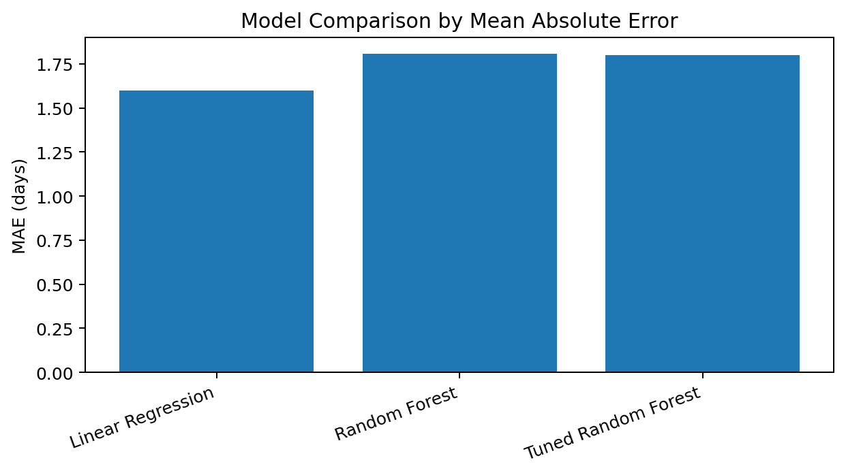
Figure 1. Model comparison using test-set MAE.
6. Cross-Validation and Hyperparameter Tuning
The Random Forest pipeline was checked with 5-fold cross-validation on the training data. The average CV MAE was 1.929 days and the average CV RMSE was 6.107 days.
GridSearchCV tested n_estimators, max_depth, and min_samples_leaf. The selected settings were {'model__max_depth': 12, 'model__min_samples_leaf': 2, 'model__n_estimators': 300}. The tuned model was then evaluated once on the held-out test set.
7. Model Diagnostics
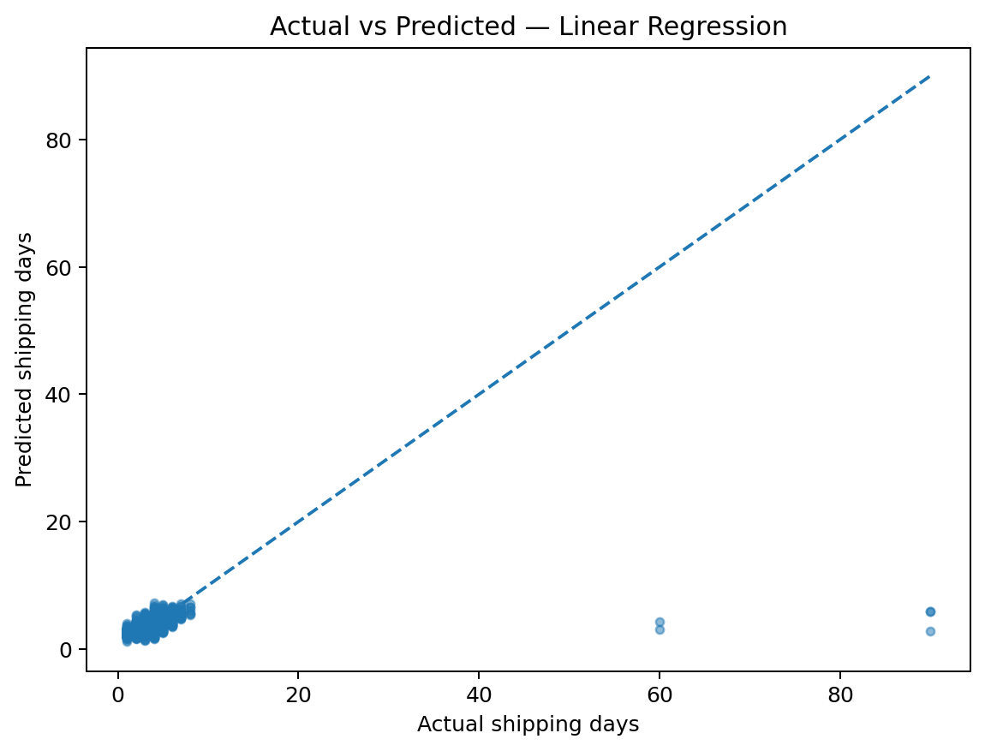
Figure 2. Actual versus predicted shipping time — Linear Regression.
The diagonal line represents perfect predictions. Points closer to that line indicate smaller errors. This plot is useful for seeing whether the model is broadly tracking the actual delivery times.
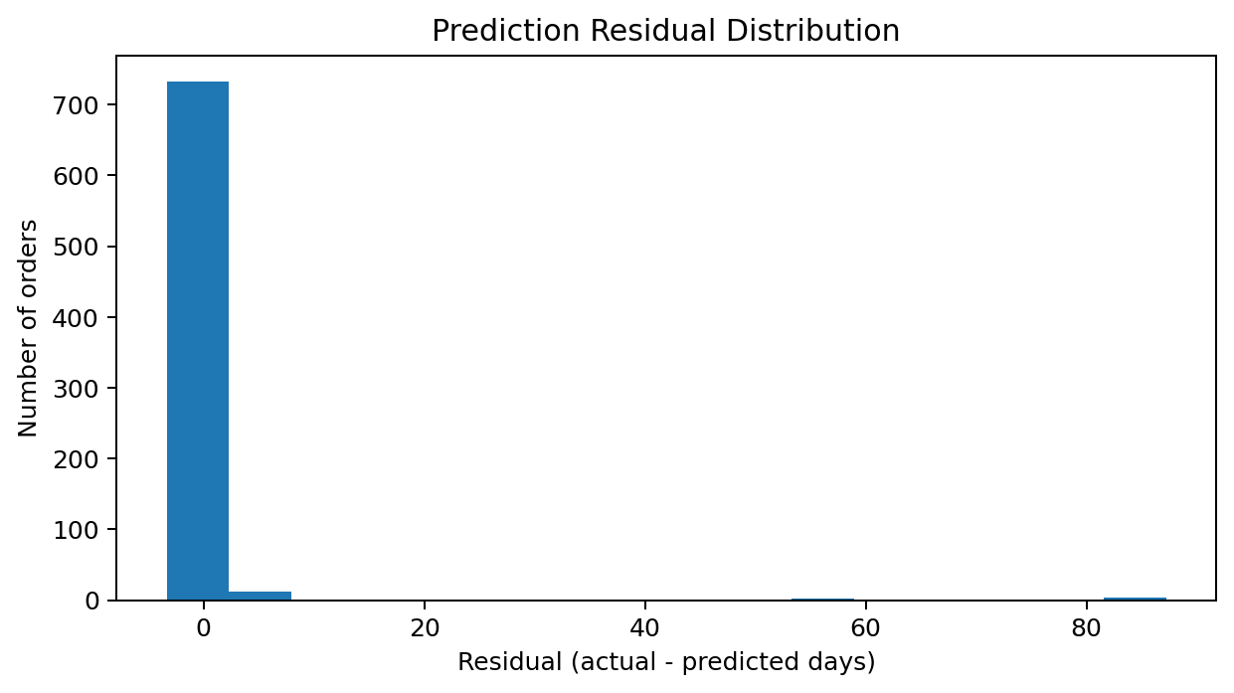
Figure 3. Prediction residual distribution.
Residuals are the difference between actual and predicted delivery time. A residual distribution centred near zero is preferable because it indicates less overall bias.
8. Model Signals
Feature / signal | Importance
num__scheduled_shipping_days | 1.1703
cat__shipping_mode_Same Day | 0.6358
cat__category_name_Electronics | 0.4735
num__transportation_cost | 0.4180
num__order_item_quantity | 0.3896
cat__category_name_Men's Footwear | 0.3722
cat__shipping_mode_Second Class | 0.3515
cat__shipping_mode_Standard Class | 0.3170
cat__market_USCA | 0.2318
num__benefit_per_order | 0.1798

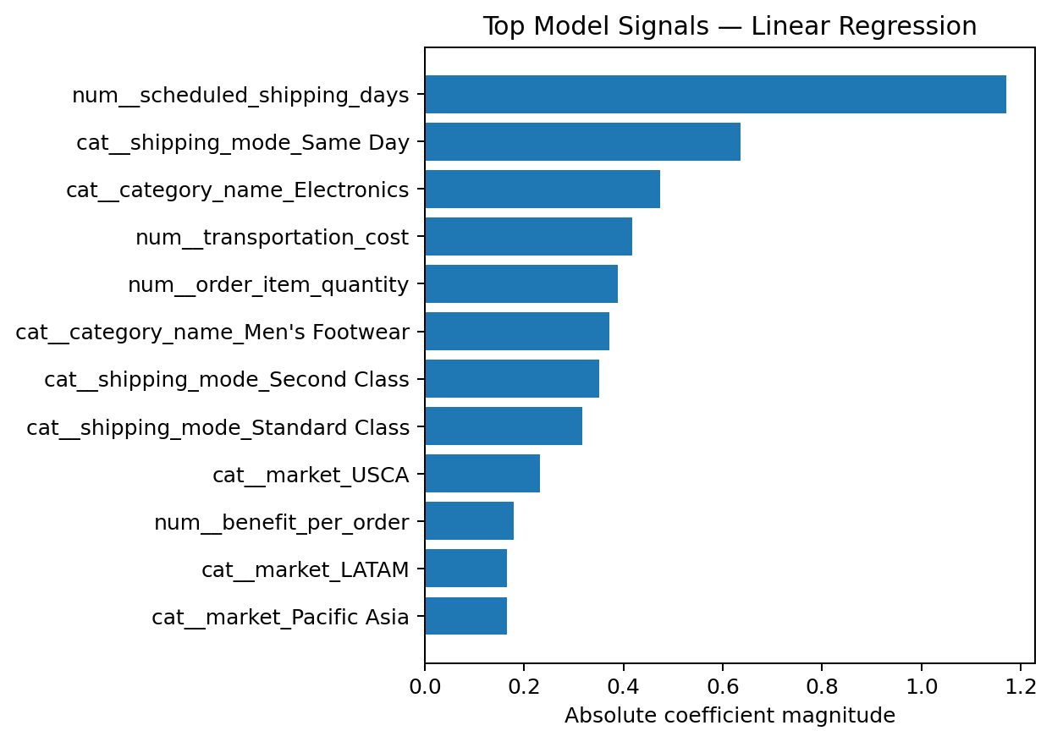
Figure 4. Top model signals — Linear Regression.
For Random Forest, the values are feature importance scores. For Linear Regression, they represent the absolute magnitude of the fitted coefficients. These values describe model behaviour and should not be treated as proof of causation.
9. Turning Predictions into an Operational Signal
To make the prediction easier to use operationally, predicted shipping time was compared with scheduled shipping days. Test orders were grouped into three simple risk bands.
Risk band | Orders | Share of test set
On/within schedule | 3 | 0.4%
Moderate risk | 236 | 31.5%
High risk | 511 | 68.1%

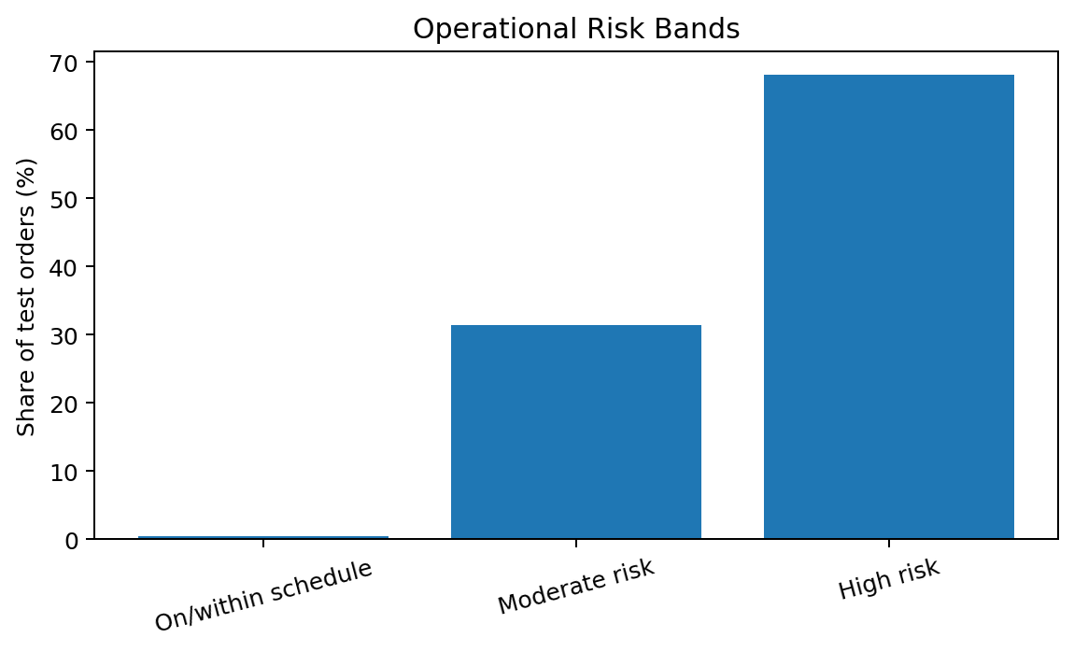
Figure 5. Operational risk bands based on predicted delivery time relative to schedule.
Orders predicted to stay within schedule can follow the standard process. Moderate-risk orders can be monitored, while high-risk orders can be flagged for early review.
10. Optimization Strategies
- Create an early-warning queue for high-risk orders so the team can investigate before the delivery promise is missed.
- Review high-risk orders by shipping mode and market to look for carrier, service-tier, or geography patterns.
- Use predicted delivery time to support proactive customer communication.
- Review fulfilment location, carrier allocation, and handling time for repeatedly high-risk order profiles.
- Track model error over time and retrain when business conditions or data distributions change.
11. Python Implementation
The code is integrated with the analysis: the same train/test split, model training, evaluation, cross-validation, and tuning steps produced the numbers reported above.
X_train, X_test, y_train, y_test = train_test_split(
X, y, test_size=0.20, random_state=42
)
rf_model.fit(X_train, y_train)
pred = rf_model.predict(X_test)
mae = mean_absolute_error(y_test, pred)
rmse = np.sqrt(mean_squared_error(y_test, pred))
r2 = r2_score(y_test, pred)
cv = KFold(n_splits=5, shuffle=True, random_state=42)
cv_mae = -cross_val_score(
rf_model, X_train, y_train,
cv=cv, scoring="neg_mean_absolute_error"
)
grid = GridSearchCV(
tune_pipe, param_grid,
cv=3, scoring="neg_mean_absolute_error"
)
grid.fit(X_train, y_train)
12. Limitations and Responsible Use
- The dataset is a simulated academic working sample, so the reported model performance is not production performance.
- transportation_cost is a simulated variable created for the project rather than a direct observed DataCo field.
- A real forecasting system should consider a time-based split so future information cannot influence earlier training data.
- Model signal/importance does not prove that a variable causes delivery delays.
- The model should be monitored and retrained as logistics conditions change.
13. Conclusion
Week 4 moved the project from descriptive analysis into predictive decision support. I defined actual_shipping_days as the target, compared Linear Regression with tree-based ensemble models, evaluated performance using MAE, RMSE, and R², and used cross-validation and hyperparameter tuning to check model stability. The selected model was Linear Regression, with a test MAE of 1.598 days. The practical value is the early-warning signal: predictions can be turned into risk bands so that high-risk orders receive attention earlier. The next step would be to validate this workflow on real historical logistics data and monitor performance over time.
14. References
- DataCo Global. DataCo Smart Supply Chain for Big Data Analysis [Data set]. Kaggle.
- pandas documentation — data preparation and analysis.
- scikit-learn documentation — preprocessing, model selection, ensemble methods, cross-validation, and metrics.
- Week 2 Project Report — Data Collection, Cleaning, and Preprocessing for Logistics Analysis.
- Week 3 Project Report — Advanced Data Analysis and Visualization in Logistics.

