**Question 1**

**Please describe the most sophisticated computer programs that you have written so far.**

Oh I know I good at answering this question. It was a course named is “**軟體定義網路及網路功能虛擬化” the teach teacher is** Prof. Chien-Chao Tseng（曾建超）**.** And its finial project is very very very hard. I never forget that it was 2024/12/31 midnight lots of student stuck at the engineering building 3’s 6 floor. For ask TA how to develop and deal with that project. The finial project is about used to automate the deployment and configuration of a Software-Defined Networking (SDN) environment. This script can create and manage Docker containers, including the ONOS controller, BGP routers (FRRouting), and hosts, and set up the Open vSwitch (OVS) network topology. Its complexity lies in the precise handling of network namespaces, Veth pairs, OVS bridge configuration, IP address allocation within containers (supporting both IPv4 and IPv6 dual stack), and the mounting of FRRouting configuration files. Furthermore, this program also implements OVS QoS for traffic limiting to simulate bandwidth constraints in real networks and handles complex OVS interface naming rules to ensure correct connections and communication across multiple network entities. This is not just a deployment tool, but a comprehensive automated solution that integrates network virtualization, routing protocols, and traffic engineering.

**Question 2**

**Please list the programming languages that you have any experience in.**

* **Python: written a couple programs to learn and research federated learning.**
* **C++: Learning for graduate from high school**
* **Java: For pass the course of above “軟體定義網路及網路功能虛擬化”**

**Question 3**

**What computer system do you have for schoolwork?**

**I am now using the windows os computer but I can also use that kinda no GUI’s Ubuntu server.**

**My windows laptop GPU is GTX 1050 laptop version. CPU is intel i7 9750H, RAM is 16GB.**

**Exercise 4**

**Set up your Jupyter Lab/Notebook environment for the work of this class.**

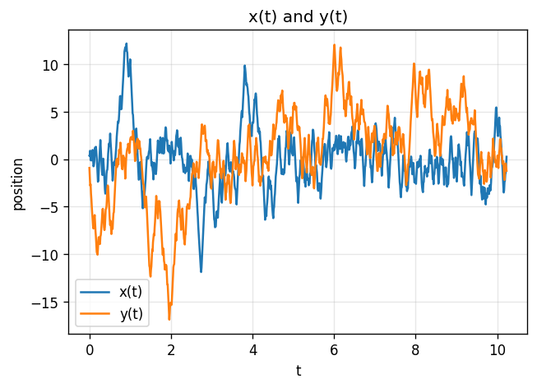

一張含有 文字, 圖表, 行, 繪圖 的圖片

AI 產生的內容可能不正確。

時間範圍約 0:00–10秒多。x(t)、y(t) 呈現隨時間的連續變化，分布圖看起來像是十字架。