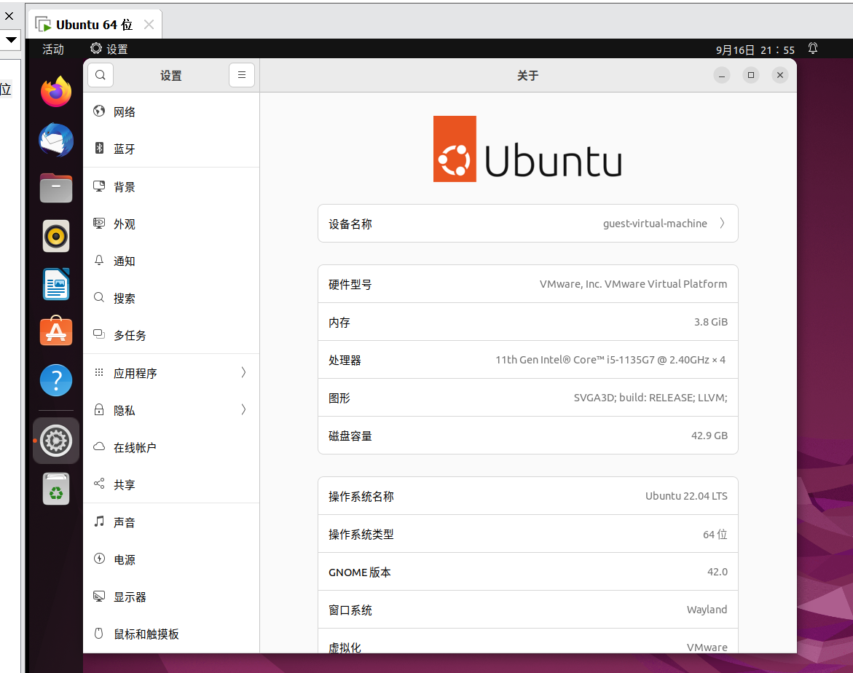

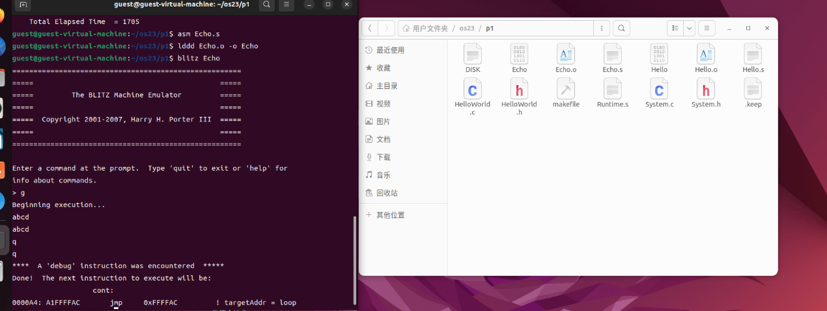

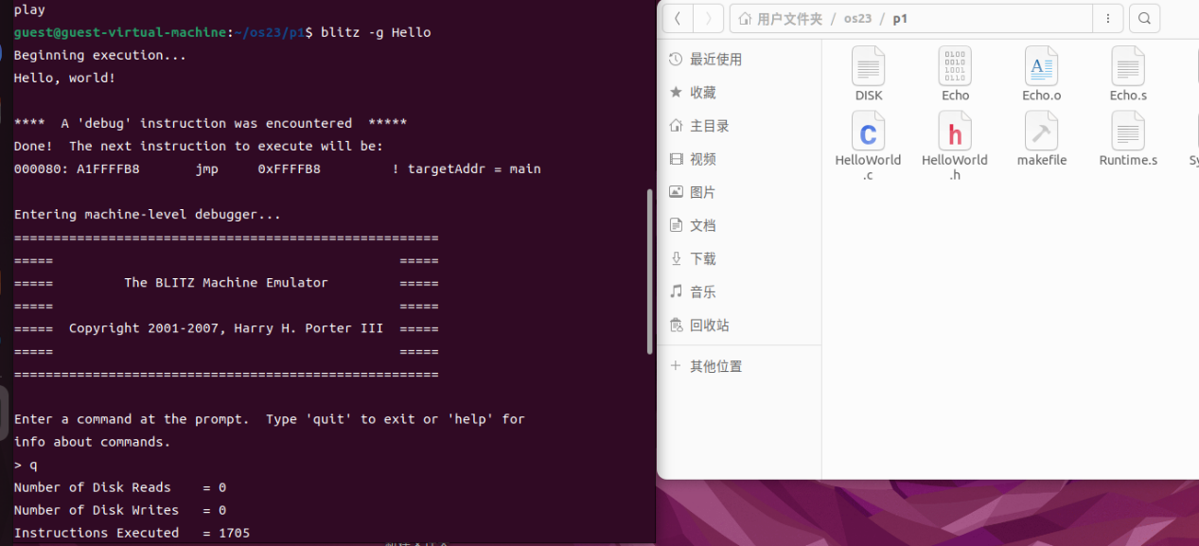

when type “g”

>g

Beginning execution...

The value of b is 13

\*\*\*\* A ‘debug’ instruction was encountered \*\*\*\*\*

Done! The next instruction to execute will be:

0028A4:8B1EFFF0 load [r14+0xFFF0],r1 ! decimal:-16