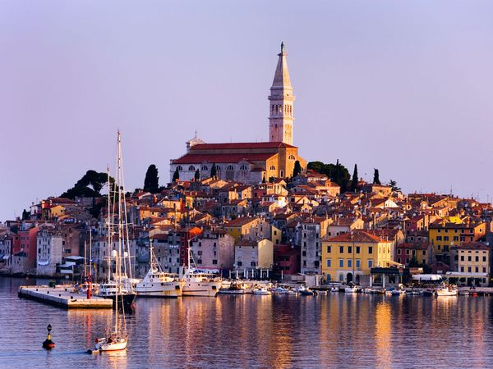

WELCOME TO ROVINJI 31st of August to 5th of September 2015!

Come to Rovinji 2015! Bring your family, spouses, children, grandchildren, cousins – and why not your favorite collegue. While you and your collegue enjoy the IAGP Congress your family will have the best of time in this lovely fishing village. – Rovinji is a town everyone will enjoy – so add an extra week of vacation before or after the congress!

How come I am so positive and so sure you and your family will enjoy this little town? Because it is a lively little town where you see people of all ages enjoying their stay. We were there two years ago and we truely enjoyed it, the town in itself, the excursions to the islands etc.! – Rovinji is a twin town of Venice. Some of my friends are planning a holiday first in Venice and then they will take the ferry over to Rovinj to join the congress.

Register now! 1st of Feb is the deadline for ”Early Bird” and for submissions of abstracts.

Welcome!

Eva Fahlström Borg
Lifetimemember of IAGP, member of the IAGP Board 2003-2012.
Co-chair of Preconference Rome 2009.

