Bokförlaget Karnac, https://www.karnacbooks.com/, gör reklam för nya titlar inom gruppterapi och har ”special offer” på 15 % rabatt.



New Titles in Group Therapy
SPECIAL OFFER - SAVE 15% ON FEATURED PAPERBACKS BEFORE 22ND DECEMBER BY USING DISCOUNT CODE KARNACNEWGRP AT THE CHECKOUT.
Code must be used by midnight 21st December UK time / code not valid for eBook editions

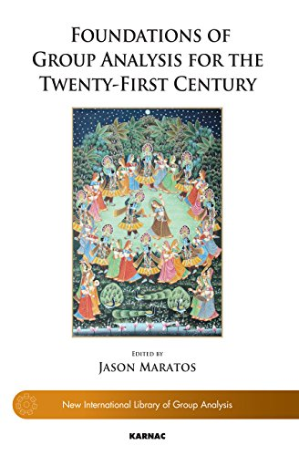

Foundations of Group Analysis for the Twenty-First Century
Editor : Jason Maratos

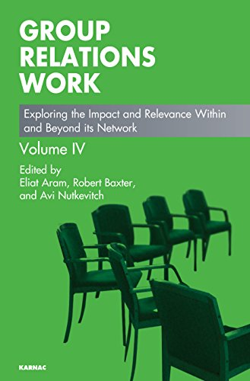

Group Relations Work: Exploring the Impact and Relevance Within and Beyond its Network
Editor : Eliat Aram , Editor : Robert Baxter , Editor : Avi Nutkevitch

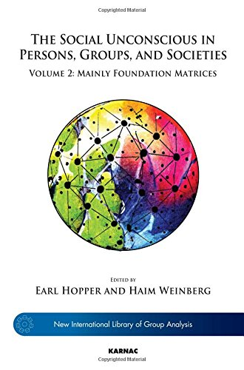

The Social Unconscious in Persons, Groups, and Societies: Volume 2: Mainly Foundation Matrices
Editor : Earl Hopper , Editor : Haim Weinberg

View all Group Psychotherapy Titles...

Home | New Titles | Forthcoming | Karnac Titles | Series | Journals | Events
Karnac Book's Privacy Policy : http://www.karnacbooks.com/Privacy.asp
All contents copyright Karnac Books. E&OE

