ERHS535 - Homework 2
Christopher Tsz Hin Choi
2025-09-24
library(ggplot2)
## Warning: package 'ggplot2' was built under R version 4.2.3
library(sf)
## Warning: package 'sf' was built under R version 4.2.3
## Linking to GEOS 3.9.3, GDAL 3.5.2, PROJ 8.2.1; sf_use_s2() is TRUE
library(terra)
## Warning: package 'terra' was built under R version 4.2.3
## terra 1.7.71
library(maptools)
## Warning: package 'maptools' was built under R version 4.2.3
## Loading required package: sp
## Please note that 'maptools' will be retired during October 2023,
## plan transition at your earliest convenience (see
## https://r-spatial.org/r/2023/05/15/evolution4.html and earlier blogs
## for guidance);some functionality will be moved to 'sp'.
## Checking rgeos availability: TRUE

Section 1: Description of Data:
Content: This data is a raster of the relativised differenced normalized burn severity (RdNBR), a burn severity metric, for the 2020 CZU fire in California. RdNBR is derived derived normalized burn severity pre- and post-fire generated from satellite remote sensing imagery (Landsat OLI 7-8) in Google Earth Engine.
Research questions trying to answer: * How much of redwoods canopy was damaged by fire (inferred from RdNBR)? * How do fire histories influence burn severity?
Format: * The data is in a geoTIFF format. This type of data can be opened in an image viewer or geographic information systems (GIS) programs. This type of data has values (can be multiple as a raster with multiple bands) associated with spatial positioning.

Section 2: Reading the data into R:
Read in data * I used the terra::rast() function to read in the data. The data was converted to a data frame from a raster for analysis and display
rdnbr = terra::rast('data/CZU_rdnbr_DOY275-305.tif') |> as.data.frame(xy=T)

Characteristics of the data:
Data exploration
rows = nrow(rdnbr)
cols = ncol(rdnbr)
columnNames = colnames(rdnbr)
- This dataframe has rows rows and cols columns.
- The names of the columns are: columnNames
- Each row measures an individual RdNBR value at a location.
knitr::kable(rdnbr[1:10,],
caption = "First 10 rows of RdNBR table")
First 10 rows of RdNBR table
 | x | y | rdnbr
178 | -122.2922 | 37.27204 | 31.2882271
179 | -122.2919 | 37.27204 | 33.7442894
180 | -122.2917 | 37.27204 | 10.8776579
181 | -122.2914 | 37.27204 | -28.9334145
182 | -122.2911 | 37.27204 | -34.2540894
183 | -122.2908 | 37.27204 | -34.2540894
184 | -122.2906 | 37.27204 | -8.8454962
185 | -122.2903 | 37.27204 | -0.1143823
186 | -122.2900 | 37.27204 | -20.0971718
187 | -122.2898 | 37.27204 | -9.8343763
- The “x” column is degrees longitude
- The “y” column is degrees latitude
- The “rdnbr” column is RdNBR burn severity (unitless)

Section 4: Summary statistics
summary.rdnbr = summary(rdnbr)
summary.rdnbr
## x y rdnbr
## Min. :-122.3 Min. :37.02 Min. :-5507.9
## 1st Qu.:-122.3 1st Qu.:37.11 1st Qu.: 139.1
## Median :-122.2 Median :37.16 Median : 351.8
## Mean :-122.2 Mean :37.15 Mean : 339.8
## 3rd Qu.:-122.2 3rd Qu.:37.20 3rd Qu.: 539.5
## Max. :-122.1 Max. :37.27 Max. : 2710.8

Section 5: Visualizing the data
mean.rdnbr = rdnbr$rdnbr |> mean()
ggplot(data = rdnbr) +
geom_histogram(aes(x = rdnbr), binwidth = 10, color = 'darkgrey', fill = 'black', alpha = 0.3) +
scale_x_continuous(limits = c(-200, 1000), breaks = seq(-200, 1000, by = 100)) +
geom_vline(aes(xintercept = mean.rdnbr), color = 'darkred', size = 1, alpha = 0.5, linetype = "dashed") +
geom_text(aes(x = mean.rdnbr + 50, label = "Mean", y = 7500), colour = "darkred") +
labs (x = "RdNBR (Burn Severity)",
y = "Count (Pixels: 30m^2)",
title = "Statistical Plot: Distribution of Burn Severity Across the CZU Fire") +
theme_minimal()
## Warning: Using `size` aesthetic for lines was deprecated in ggplot2 3.4.0.
## ℹ Please use `linewidth` instead.
## This warning is displayed once every 8 hours.
## Call `lifecycle::last_lifecycle_warnings()` to see where this warning was
## generated.
## Warning in geom_text(aes(x = mean.rdnbr + 50, label = "Mean", y = 7500), : All aesthetics have length 1, but the data has 394189 rows.
## ℹ Please consider using `annotate()` or provide this layer with data containing
## a single row.
## Warning: Removed 565 rows containing non-finite outside the scale range
## (`stat_bin()`).
## Warning: Removed 2 rows containing missing values or values outside the scale range
## (`geom_bar()`).
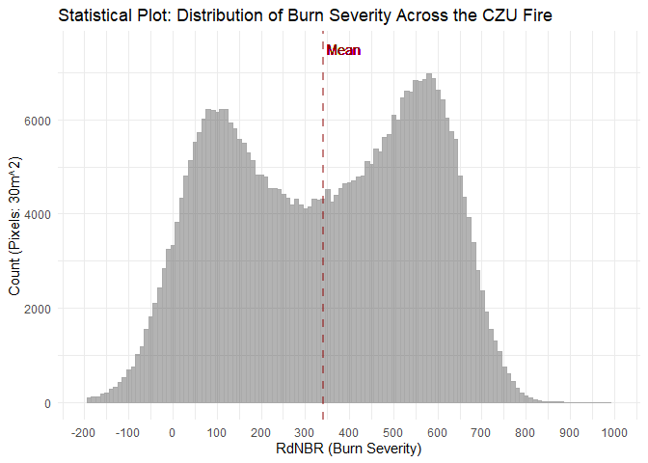
- This plot helps to learn more about the nature of the fire that took place. We can compare this distribution to RdNBR distributions of other fires to see if this pattern is typical of fires in this region or to evaluate the ability of remotely sensed burn severity metrics to capture actual ecosystem effects.
- This plot follows the rules of good plot making because it 1) has high data-ink ratio by using the ggplot::theme_minimal() function we reduce clutter, and 2) it includes useful references by including a mean value represented with a ggplot::vline().
ca.counties = sf::read_sf('data/cb_2018_us_county_500k/cb_2018_us_county_500k.shp') |>
dplyr::filter(STATEFP == "06") |>
sf::st_transform(terra::crs(terra::rast('data/CZU_rdnbr_DOY275-305.tif')))
ggplot(data = rdnbr) +
geom_sf(data = ca.counties, color = 'black', fill = 'tan', alpha = 0.5) +
# geom_sf_text(data = ca.counties, aes(label = NAME)) +
geom_raster(aes(x=x, y=y, fill = rdnbr)) +
scale_fill_gradientn(colors = c("white", "yellow", "red", "brown", "black"), limits = c(-200, 1000)) +
coord_sf(xlim = c(min(rdnbr$x), max(rdnbr$x)),
ylim = c(min(rdnbr$y), max(rdnbr$y))) +
scale_x_continuous(breaks = seq(-123, -122, by = 0.1)) +
scale_y_continuous(breaks = seq(37, 38, by = 0.05)) +
labs (x = "Longitude",
y = "Latitude",
title = "Statistical Plot: Distribution of \nBurn Severity Across the CZU Fire") +
ggspatial::annotation_scale(dist = 5, width_hint = 0.23) +
theme_minimal()
## Warning in ggspatial::annotation_scale(dist = 5, width_hint = 0.23): Ignoring
## unknown parameters: `dist`
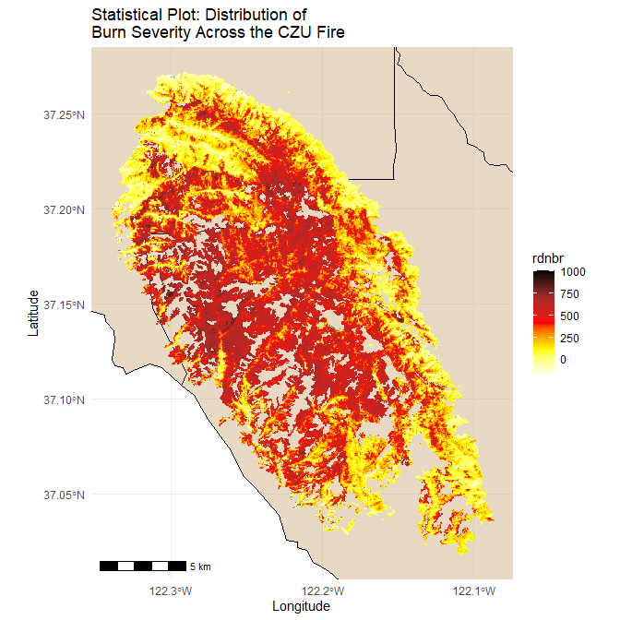
- This visualization helps us to understand the scale of the fire. By plotting the fire against other fires we can begin to understand whether there may be spatial relationships between fires (ie autocorrelation) and what other environemntal/topographical variables could be influencing burn severity.
- THis is a non-statistical geom because it displays x (longitude), y (latitude) data. This plot follows the rules of good plot making because it 1) has high data-ink ratio by using the ggplot::theme_minimal() function we reduce clutter, and 2) it includes useful references by including a counties basemap in the background and a scale bar.

