ERHS535 Homework 3
Christopher Tsz Hin Choi
2025-10-10
library(tidyr)
library(stringr)
library(ggplot2)
library(broom)
library(tibble)
library(knitr)
library(forcats)
library(cowplot)
library(elevatr)
## elevatr v0.99.0 NOTE: Version 0.99.0 of 'elevatr' uses 'sf' and 'terra'. Use
## of the 'sp', 'raster', and underlying 'rgdal' packages by 'elevatr' is being
## deprecated; however, get_elev_raster continues to return a RasterLayer. This
## will be dropped in future versions, so please plan accordingly.
library(terrainr)
##
## Attaching package: 'terrainr'
## The following object is masked from 'package:elevatr':
##
## merge_rasters
library(readr)
library(knitr)

Question 1
Complete your homework in an RMarkdown document and knit it to either Word or PDF to submit. Change your global options so that no warnings, messages, or errors are printed out, but that so all code and results are printed. (10 points)

Question 2
Select one of the figures you created for the last homework. You will be improving that figure in this part of the homework.
rdnbr = terra::rast('data/CZU_rdnbr_DOY275-305.tif') |> as.data.frame(xy=T)
Go through the six guidelines for good graphics we discussed in Chapter 4. Re-create the same plot you created in the last homework and, in a paragraph or two, list which of these elements you currently have in the plot and how these elements help make the plot more effective. (10 points)
mean.rdnbr = rdnbr$rdnbr |> mean()
ggplot(data = rdnbr) +
geom_histogram(aes(x = rdnbr), binwidth = 10, color = 'darkgrey', fill = 'black', alpha = 0.3) +
scale_x_continuous(limits = c(-200, 1000), breaks = seq(-200, 1000, by = 100)) +
geom_vline(xintercept = mean.rdnbr, color = 'darkred', size = 1, alpha = 0.5, linetype = "dashed") +
geom_text(aes(x = mean.rdnbr + 50, y = 7500), label = "Mean", colour = "darkred") +
labs (x = "RdNBR (Burn Severity)",
y = "Count (Pixels: 30m^2)",
title = "Statistical Plot: Distribution of Burn Severity Across the CZU Fire") +
theme_minimal()
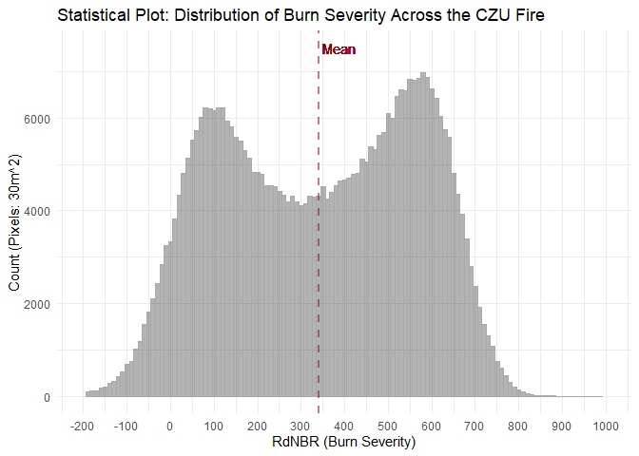
- Above is the original plot from the last homework. I had written then with the following: “This plot follows the rules of good plot making because it 1) has high data-ink ratio by using the ggplot::theme_minimal() function we reduce clutter, and 2) it includes useful references by including a mean value represented with a ggplot::vline().” I did not include that I also included the rule 3) Use clear, meaningful labels with the use of the “Mean” label
Select three of these guidelines for which you either aren’t using them in the current graph or could add to what you currently have in the plot. Create a new version of the plot based on your choice. Include a paragraph explaining how these changes make the plot more effective and how you added them. (20 points)
- To further implement the guidelines to this graph, I 1) added useful references to the graph by categorizing RdNBR values into low, moderate, and high severity (each category 1/3 of the range of RdNBR values) as reference. This information was added with 2) making order meaningful in mind by placing this information in the background and using graduated colors to make level of severity intuitive. I also provided another 3) useful reference by adding a comma serperator in the y-axis notation for increased legilibility. Finally 4) small multiples were used to facet the data by severity class so that their distributions could be compared independently.
## we will first remove the upper and lower 5% of the distribution to remove outliers
rdnbr = rdnbr|>
dplyr::filter(
rdnbr >= quantile(rdnbr, 0.01, na.rm = TRUE),
rdnbr <= quantile(rdnbr, 0.99, na.rm = TRUE)
)
mean.rdnbr = mean(rdnbr$rdnbr)
rdnbr.min = min(rdnbr$rdnbr, na.rm = TRUE)
rdnbr.max = max(rdnbr$rdnbr, na.rm = TRUE)
## find range of values
rdnbr.range = (max(rdnbr$rdnbr) - min(rdnbr$rdnbr))
## breaks for seperating each severity class
breaks = c(rdnbr.min,
rdnbr.min + rdnbr.range/3,
rdnbr.min + 2*rdnbr.range/3,
rdnbr.max)
## Convert to df and add labels
severity.bg = data.frame(
xmin = breaks[-length(breaks)],
xmax = breaks[-1],
fill = factor(c("Low", "Moderate", "High"),
levels = c("Low", "Moderate", "High"))
)
p1 = ggplot(data = rdnbr) +
# Rectangles severity levels
geom_rect(data = severity.bg,
aes(xmin = xmin, xmax = xmax, ymin = 0, ymax = Inf, fill = fill),
alpha = 0.05) +
# Histogram of RdNBR
geom_histogram(aes(x = rdnbr), binwidth = 10, color = 'black', fill = 'black', alpha = 0.4) +
# Rectangles severity levels (outlines)
geom_rect(data = severity.bg,
aes(xmin = xmin, xmax = xmax, ymin = 0, ymax = Inf, fill = fill),
alpha = 0.2) +
# Mean line
geom_vline(aes(xintercept = mean.rdnbr), color = 'black', size = 1.5, linetype = "dashed") +
geom_text(aes(x = mean.rdnbr + 50, y = Inf, label = "Mean"),
colour = "black", vjust = 1.5) +
# Scales and labels
# scale_x_continuous(limits = c(-200, 1000), breaks = seq(-200, 1000, by = 100)) +
scale_fill_manual(values = c("Low" = "yellow", "Moderate" = "orange", "High" = "darkred")) +
labs(x = "RdNBR (Burn Severity)",
y = "Count (Pixels: 30m²)",
title = "Statistical Plot: Distribution of Burn Severity Across the CZU Fire",
fill = "Burn Severity Class") +
scale_y_continuous(labels=function(x) format(x, big.mark = ",", scientific = FALSE)) +
theme_minimal() +
theme(legend.position = "bottom")
## Add classes of severity to the dataset for facetting
rdnbr = rdnbr |>
dplyr::mutate(Severity = dplyr::case_when(
rdnbr < breaks[2] ~ "Low",
(rdnbr >= breaks[2]) & (rdnbr < breaks[3]) ~ "Moderate",
rdnbr >= breaks[3] ~ "High"
) |>
as.factor())
rdnbr$Severity = forcats::fct_relevel(rdnbr$Severity, "Low", "Moderate", "High")
p2 = ggplot(data = rdnbr) +
geom_histogram(aes(x = rdnbr, fill = Severity), binwidth = 10, color = 'black', alpha = 0.7) +
facet_wrap(vars(Severity), ncol = 1) +
scale_fill_manual(values = c("Low" = "yellow", "Moderate" = "orange", "High" = "darkred")) +
scale_y_continuous(labels=function(x) format(x, big.mark = ",", scientific = FALSE)) +
theme_minimal() +
theme(legend.position = "none",
axis.title.x = element_blank(),
axis.title.y = element_blank())
cowplot::plot_grid(p1, p2, ncol = 2)
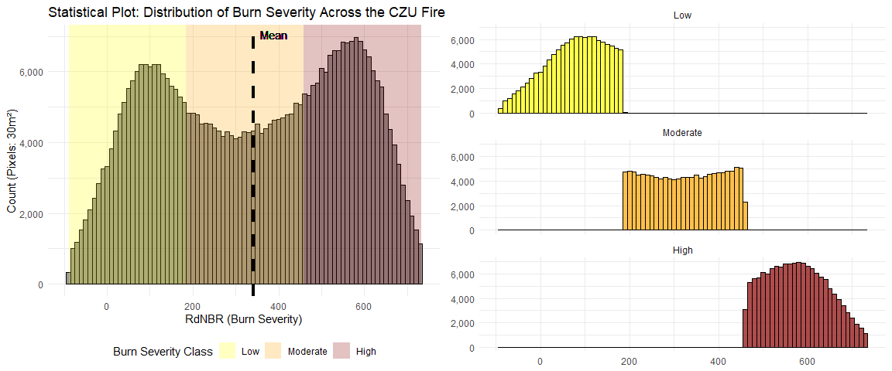

Question 3
In the titanic package (available on CRAN), there’s a titanic_train dataset we’ll use for this question. Load that dataset and create a dataframe object limited to the columns Survived and Age. Change the labeling for the Survived column so that it says “Survived” instead of “1” and “Died” instead of “0”. Print out the oldest five people who survived and who died (so, you’ll be printing out 10 rows total). (10 points)
# install.packages("titanic")
library(titanic)
data("titanic_train")
titanic_train_2 = as.data.frame(titanic_train) |>
dplyr::transmute(Survived = ifelse(Survived == 1, "Survived", "Died"),
Age)
titanic_oldest_survived = titanic_train_2 |>
dplyr::filter(Survived == "Survived") |>
dplyr::arrange(-Age) |>
dplyr::slice(1:5)
titanic_oldest_died = titanic_train_2 |>
dplyr::filter(Survived == "Died") |>
dplyr::arrange(-Age) |>
dplyr::slice(1:5)
knitr::kable(titanic_oldest_survived,
caption = "Oldest Survived on Titanic")
Oldest Survived on Titanic
Survived | Age
Survived | 80
Survived | 63
Survived | 63
Survived | 62
Survived | 62
knitr::kable(titanic_oldest_died,
caption = "Oldest Died on Titanic")
Oldest Died on Titanic
Survived | Age
Died | 74.0
Died | 71.0
Died | 71.0
Died | 70.5
Died | 70.0
Create a histogram of the ages of people in this dataset, faceted by whether or not they survived. Arrange these so that they are vertically aligned rather than side by side (Hint: check the nrow option when faceting). Change the label on the y-axis to be something that more precisely describes what’s being shown (rather than “count”) and add a title to the plot. (10 points)
ggplot(titanic_train_2) +
geom_histogram(aes(x = Age, fill = Survived), binwidth = 5, color = 'darkgrey') +
facet_wrap(vars(Survived), nrow = 2) +
scale_fill_manual(values = c("Survived" = "darkgreen", "Died" = "brown")) +
labs(x = "Age",
y = "Number of People",
title = "Distribution of Ages Aboard the Titanic") +
theme_minimal() +
theme(legend.position = 'none')
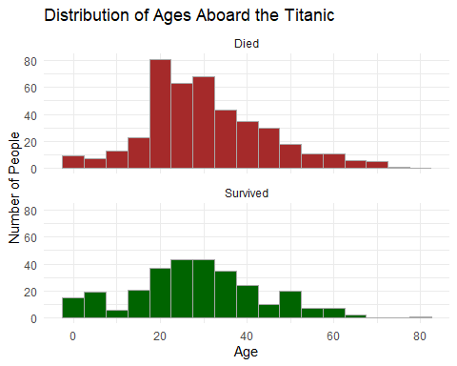
Determine the mean age for each group (survived and died) for everyone who has a non-missing age, as well as the total number of people in the group and the number of people with age information missing for the group. Print out a two-row dataframe with this summary information (it should have columns for (1) which group (survived / died); (2) the mean age of people in the group with non-missing age data; (3) the total number of people in the group; and (4) the number of people in the group with missing age data). (15 points)
## Mean age of survived
mean_survived = titanic_train_2 |>
dplyr::filter(Survived == "Survived",
is.na(Age) == F) |>
dplyr::pull(Age) |> ## turn to vector
mean()
## Mean age of died
mean_died = titanic_train_2 |>
dplyr::filter(Survived == "Died",
is.na(Age) == F) |>
dplyr::pull(Age) |>
mean()
## number of survived
n_survived = titanic_train_2 |>
dplyr::filter(Survived == "Survived") |>
nrow()
## number of dead
n_died = titanic_train_2 |>
dplyr::filter(Survived == "Died") |>
nrow()
## number of survvived with no age
n_survived_no_age = titanic_train_2 |>
dplyr::filter(Survived == "Survived",
is.na(Age) == T) |>
nrow()
## number of dead with no age
n_died_no_age = titanic_train_2 |>
dplyr::filter(Survived == "Died",
is.na(Age) == T) |>
nrow()
## format as df
summary_df = data.frame(
Group = c("Survived", "Died"),
Mean_Age = c(mean_survived, mean_died),
Total_Count = c(n_survived, n_died),
Missing_Age_Count = c(n_survived_no_age, n_died_no_age)
)
summary_df
## Group Mean_Age Total_Count Missing_Age_Count
## 1 Survived 28.34369 342 52
## 2 Died 30.62618 549 125
Run a statistical test of whether there is a difference in the mean ages between the two groups (Hint: you might want to google something like “test difference two means”). You can run this test either using a simple statistical test or by fitting a linear regression—you may take either approach. (15 points)

Question 4
There’s a radio show on National Public Radio called “Weekend Edition”, and each week they have a “Sunday Puzzle”. The puzzle for the week ending August 5, 2018 was this: “I said think of a familiar two-word phrase in eight letters with four letters in each word. The first word starts with M. And I said move the first letter of the second word to the end, and you get a regular eight-letter word, which, amazingly, other than the M, doesn’t share any sounds with the original two-word phrase. What phrase is it?”. The winner had this to say about how he solved the problem: “I went to the National Puzzlers’ League website and pulled up a list of eight-letter words that start with the letter M and just started scanning through it…’. You can solve this puzzle using R (some of the stringr functions, like str_count and str_sub, will be particularly helpful). Write R code to solve this puzzle. (10 points)
Hint 1: Work backwords. Start with eight-letter words, and apply a backwards transform to the one described to transform them into two four-letter words. Hint 2: This link might prove very useful: https://github.com/dwyl/english-words.
# Import words
words = read_csv(
"https://raw.githubusercontent.com/dwyl/english-words/refs/heads/master/words.txt",
col_names = "word",
show_col_types = FALSE) |>
dplyr::mutate(word = str_to_lower(word))
## Convert to list
word_set = unique(words$word)
# Frequency list (top ~5000 common English words)
freq <- read_csv(
"https://raw.githubusercontent.com/first20hours/google-10000-english/master/google-10000-english.txt",
col_names = "word", show_col_types = FALSE
) |>
dplyr::mutate(word = stringr::str_to_lower(word)) |>
dplyr::mutate(rank = dplyr::row_number())
# words that start with m and are 8 letters long
m8 = words |>
dplyr::filter(str_length(word) == 8, str_starts(word, "m")) |>
dplyr::pull(word)
# split and transform
results = tibble(word8 = m8) |>
dplyr::mutate(
first4 = str_sub(word8, 1, 4), ## first 4 letters
second4 = str_sub(word8, 5, 8), ## last 4 letters
rearranged_second = paste0(str_sub(second4, 4, 4), str_sub(second4, 1, 3)), ## move last letter of second word to front
new_word = paste0(first4, rearranged_second),
valid_first = first4 %in% word_set, ## is first word in the original word set
valid_second = rearranged_second %in% word_set, ## is second word in the original word set
valid_new_word = new_word %in% word_set,
valid_rearranged = rearranged_second %in% word_set
) |>
dplyr::filter(valid_first, valid_second, valid_rearranged)#, ## keep only words that exist
# Join resulting words with common words
results_freq <- results |>
dplyr::left_join(freq |> dplyr::select(word, rank), by = c("first4" = "word")) |>
dplyr::rename(rank_first = rank) |>
dplyr::left_join(freq |> dplyr::select(word, rank), by = c("rearranged_second" = "word")) |>
dplyr::rename(rank_second = rank) |>
dplyr::filter(!is.na(rank_first), !is.na(rank_second)) |>
dplyr::mutate(total_rank = rank_first + rank_second) |> ## 9999 means that NAs get high number
dplyr::arrange(total_rank)
# 6. Keep only reasonably common words (both in top ~5000)
common_phrases <- results_freq |>
dplyr::filter(!is.na(rank_first), !is.na(rank_second)) |>
dplyr::select(word8, first4, rearranged_second, rank_first, rank_second, total_rank)
knitr::kable((common_phrases |> dplyr::select(word8, first4, rearranged_second)),
caption = "4+4 phrases starting with M")
4+4 phrases starting with M
word8 | first4 | rearranged_second
mustache | must | each
maintops | main | stop
miniated | mini | date
missends | miss | send
missorts | miss | sort
missteps | miss | step
minikins | mini | skin
misstops | miss | stop
miscites | misc | site
maillots | mail | slot
mustardy | must | yard
misseats | miss | seat
miscript | misc | trip
missuits | miss | suit
mailings | mail | sing
mustiest | must | ties
markings | mark | sing
meetings | meet | sing
meanings | mean | sing
massiest | mass | ties
metaxite | meta | exit
mooniest | moon | ties
mattings | matt | sing
meshiest | mesh | ties
milkiest | milk | ties
massages | mass | sage
meatiest | meat | ties
milliken | mill | nike
millings | mill | sing
massager | mass | rage
mileages | mile | sage
mealiest | meal | ties
mintiest | mint | ties
maskings | mask | sing
moodiest | mood | ties
millages | mill | sage
mintages | mint | sage
millvale | mill | eval
messiest | mess | ties
moldings | mold | sing
moldiest | mold | ties
mossiest | moss | ties
messages | mess | sage
```

