**Exercises 1**

**Q1**. Write a C language program,   
which provides following options to the user.

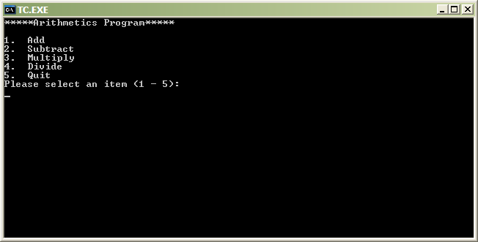

After selecting the desired option (Except 5) the user should asked to enter 2 numbers and the program should display the result according to the option selected by the user. The program should come to end once the user select option 5

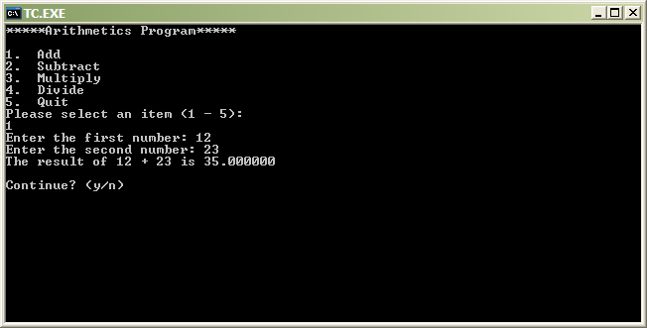

Then, the user should be asked he/she wants to continue or not. If he/she select ‘y’, the program begins again, otherwise, the program ends.

**Q2**. Write a program in C language, which will receive 10 numbers from the user and   
display the received numbers in descending order

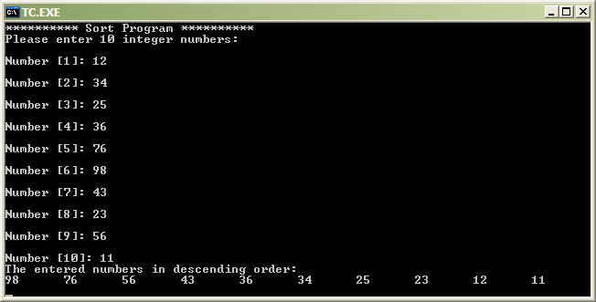

**Q3.** Write a program in C language.   
The program should do the following tasks:

1. Ask the user to enter a positive number.
2. After entering each number the program should ask the user   
   whether he/she wants to enter more number (press y/n).
3. If the user presses y then it should repeat the task no 1 again.
4. If the user presses n then the program should display the   
   numbers entered by the user and the greatest number among the numbers entered by the user.

