

WAY4 POS

OPERATION

|  |  |
| --- | --- |
| Prepared for : | OCB |
| Version of Document : | 0.1 |
| Status : | Initial Draft |
| Release Date : | 9 April 2018 |
| Prepared by : | OpenWay International |
| Author : | Lam Bich Chau |
| Owner : | OpenWay International |

Contents

**1.** **Create New Client** 2

**1.1 Set Client Type** 2

**1.2 New Client** 2

**2.** **Create New Acquiring contract** 3

**3.** **Create New POS Device contract** 5

# **Create New Client**

## **1.1 Set Client Type**

Go to Menu path: ROOT\OpenWay\Acquiring\Acquiring Contracts\Set Client Type

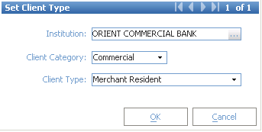

Then, click [OK]

## **1.2 New Client**

Go to Menu Path: ROOT\OpenWay\Acquiring\Acquiring Contracts\Client - New (Corporate)

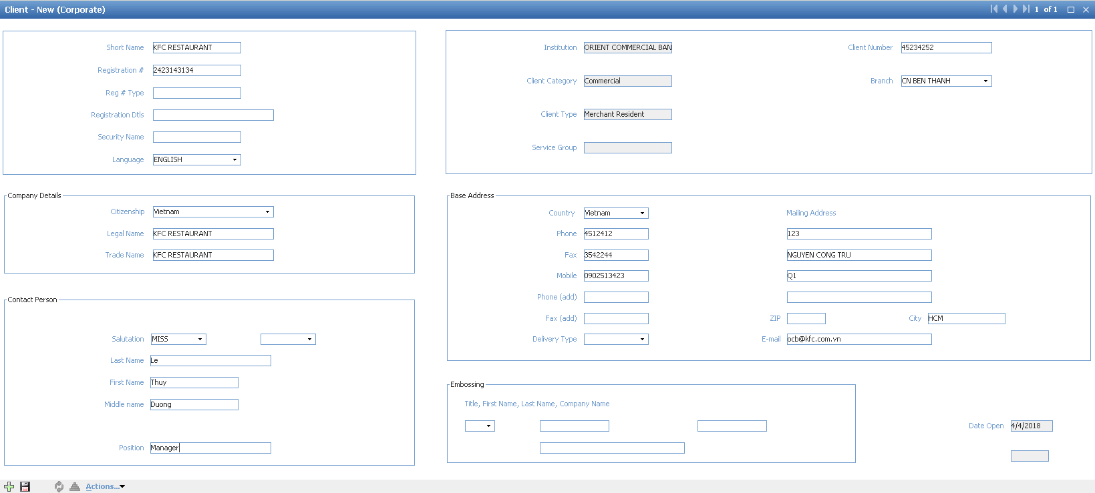

|  |  |  |
| --- | --- | --- |
| **Field Name** | **Data Input Type** | **Note** |
| **Merchant Identification** | | |
| Short Name | Text | Merchant Unique Name |
| Registration # | Text | Company Tax Code/Business Registration Number |
| Reg # Type | Dropdown List | Registration Type |
| Client Number | Number | Customer ID in Corebanking |
| Branch | Dropdown List | Bank Branch at which merchant signed contract |
| **Company Details** | | |
| Citizenship | Dropdown List | Company Citizenship |
| Legal Name | Text | Company Legal Name |
| Trade Name | Text | Company Trade Name |
| **Contact Person (Main Contact Point)** | | |
| Salutation | Dropdown List |  |
| Last Name | Text |  |
| First Name | Text |  |
| Middle Name | Text |  |
| Position | Text |  |
| **Base Address** | | |
| Country | Dropdown List |  |
| Phone | Number |  |
| Fax | Number |  |
| Mobile | Number |  |
| Phone (Add) | Number | Additional Phone Number |
| Fax (Add) | Number | Additional Fax |
| **Mailing Address** | | |
| Line 1 | Text | Company Mailing Address |
| Line 2 | Text |
| Line 3 | Text |
| Line 4 | Text |
| City | Text | Company’s City |
| Email | Text | Company’s email |

Then, click [Actions] 🡪 Check



# **Create New Acquiring contract**

Choose [Acq Cntr] button on Client screen to create new acquiring contract:

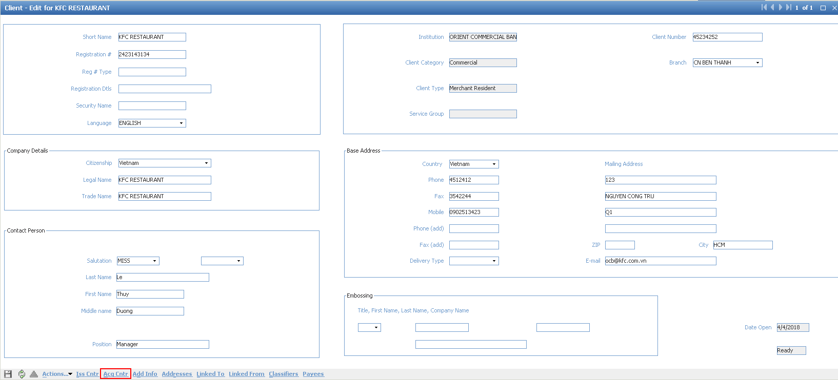

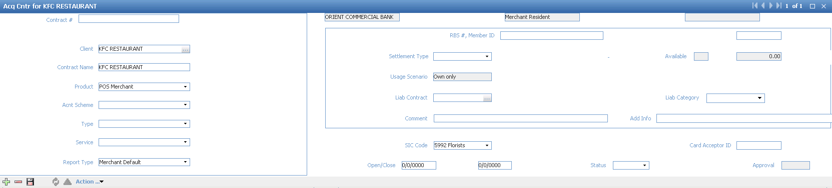

Choose Product for Acq contract: POS Merchant

Report Type: Merchant default

SIC code: Merchant category code

Then, choose [Action] button at the bottom of the screen 🡪 Approve

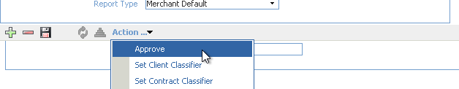

The pop-up window will show as below:

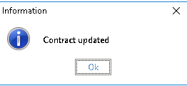

Click OK to confirm and other information will be filled

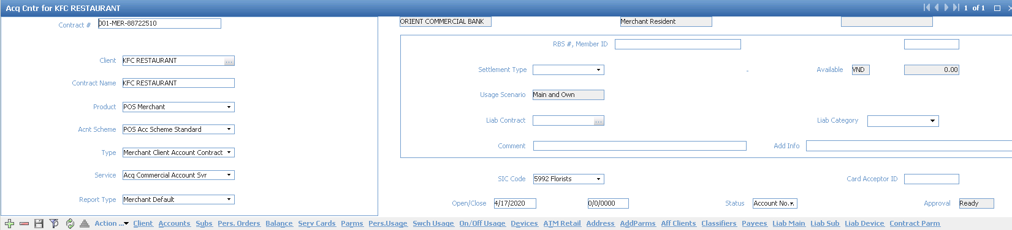

# **Create New POS Device contract**

Choose the button [Devices] from Acquiring contract:

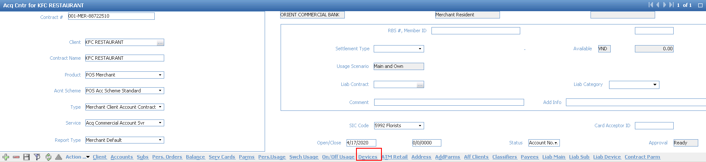

Click [+] to add new device:

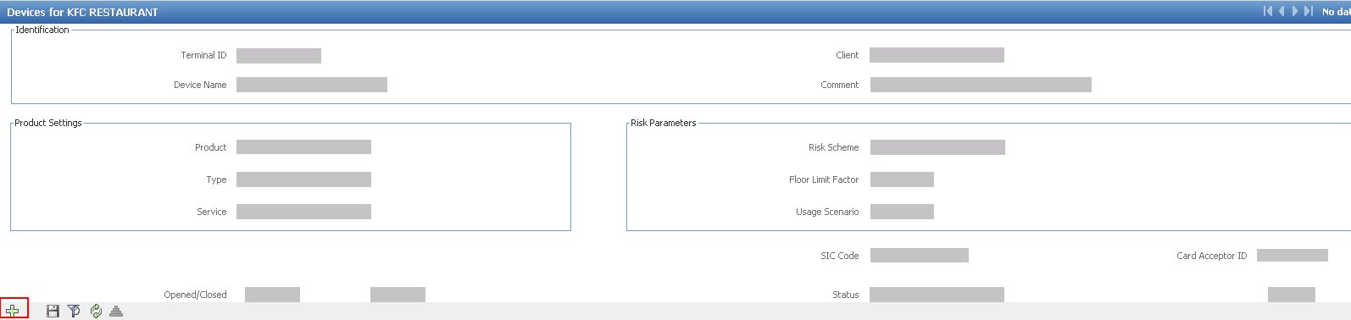

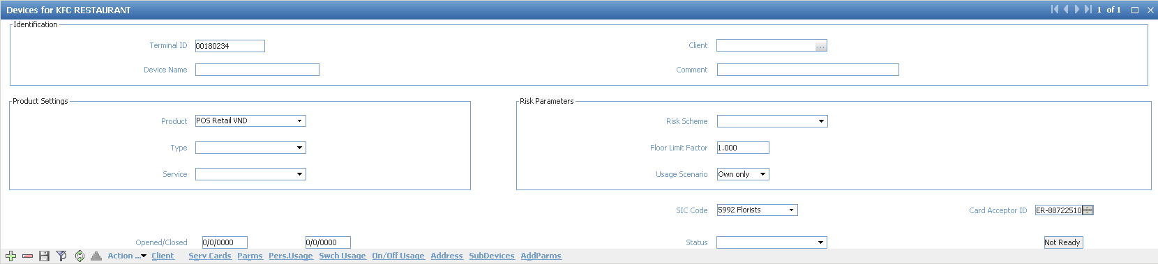

* Terminal ID: Fill Terminal ID with 8 digits
* Product: choose product from dropdown list for Device contract. For example: POS Retail VND
* SIC Code: Merchant Category Code
* Add Card Acceptor ID to the screen

Click button [Address] from Device contract to add Address for payment scheme

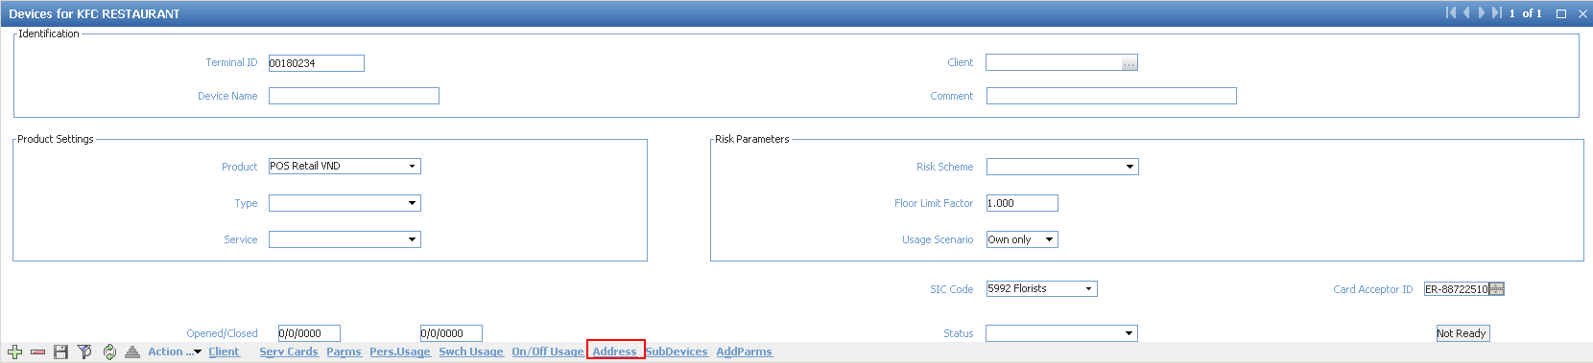

Click [+] to add new address data:

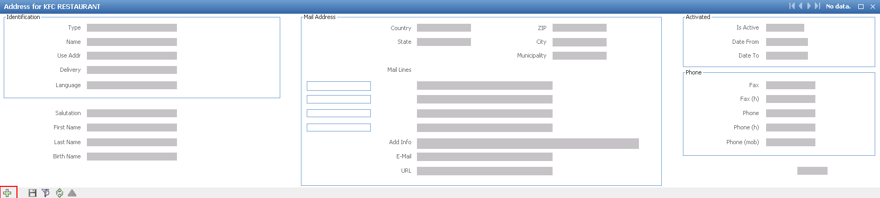

Fill in address data:

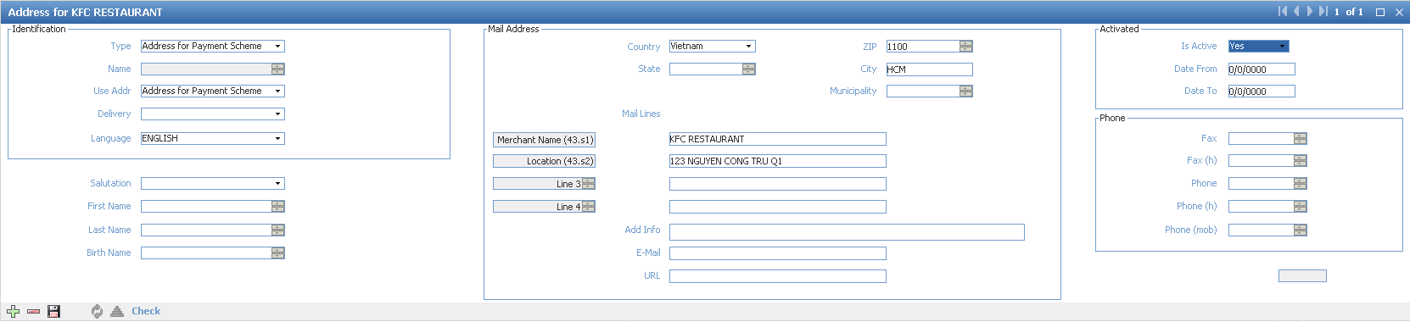

* Type: Address for Payment Scheme
* Use Addr: Address for Payment Scheme
* Country: Vietnam
* ZIP: Zip number
* City: text
* Merchant Name: tex
* Location: Physical address of POS
* Is Active: Yes

Then, click [Check]

Status will be changed to ‘Ready’:

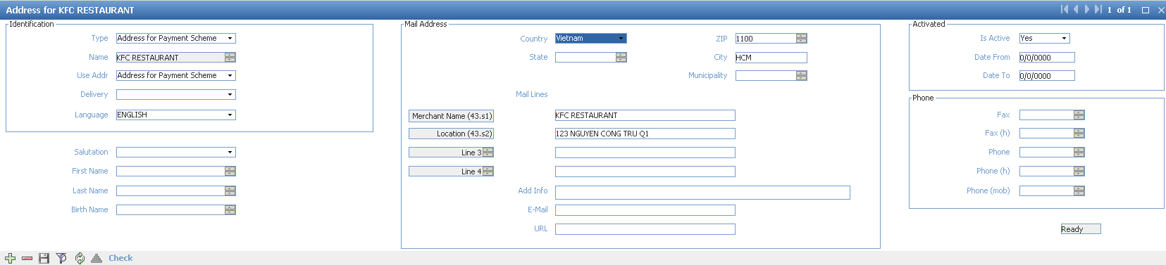

Close this from and come back to Device contract

Then, save all information and choose [Action] 🡪 Approve, we will get the error “Missing Device Type-*****” as following:

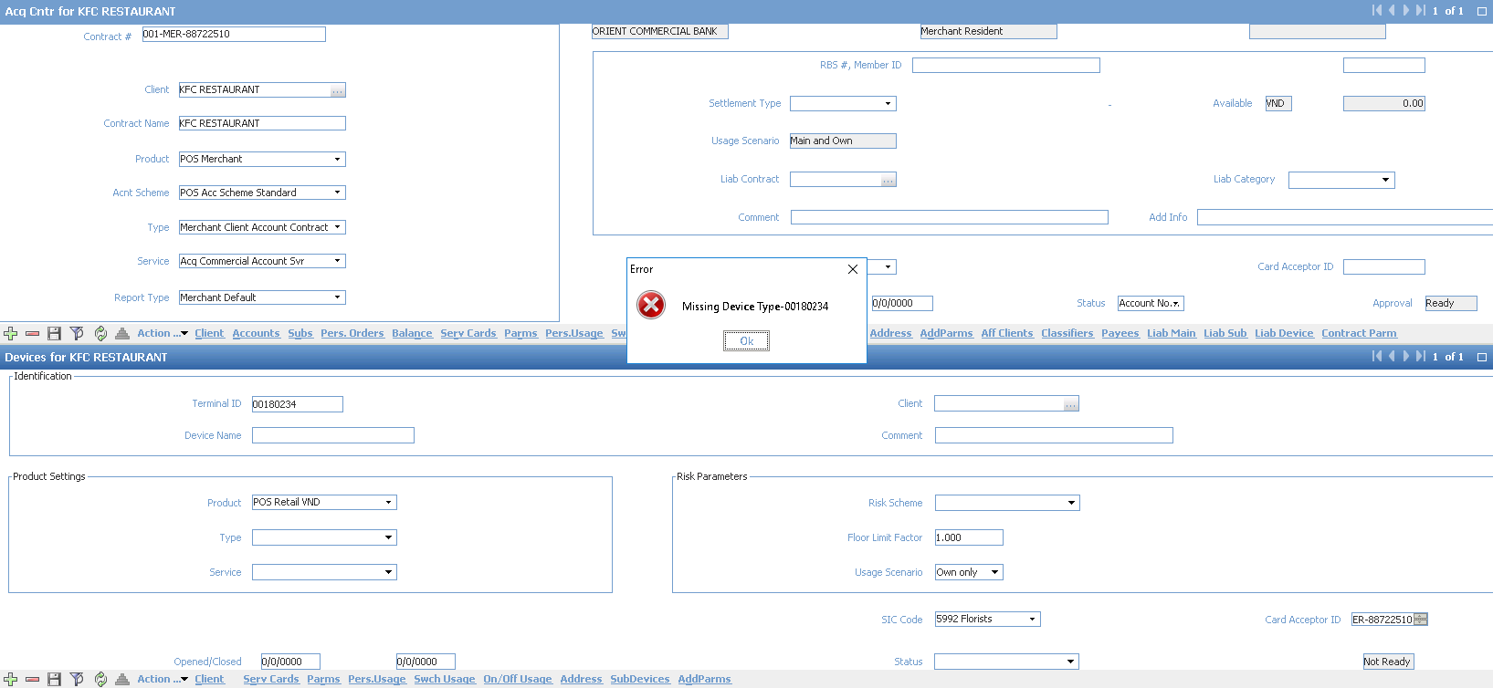

Click OK

Select “POS” tab from Device contract to configure for new device:

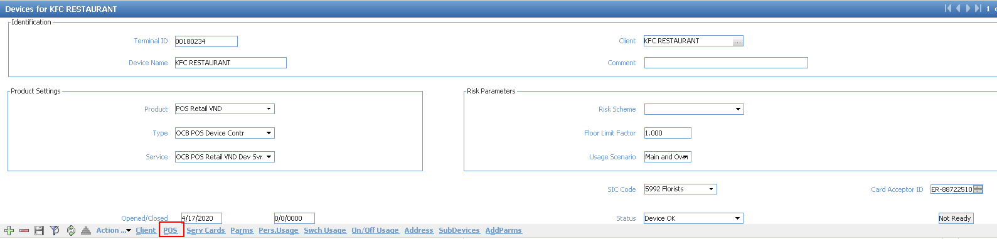

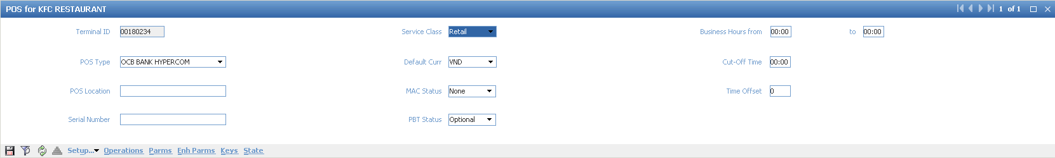

* POS Type: OCB BANK HYPERCOM
* Service Class: choose from dropdown list
* Default Curr: choose from dropdown list
* MAC Status: None
* PBT Status: Optional

Choose [Keys] button from POS screen:

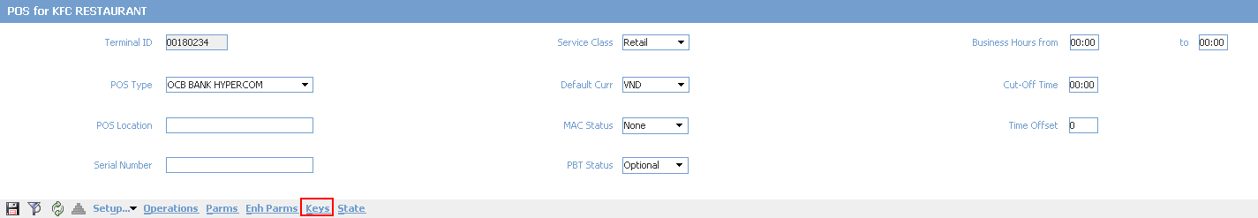

Click [+] to add new key for device:



Add key value for TMK in ‘DES Key’ field and check value in ‘Key Check’ field.

Then, choose:

* [Action] 🡪 Check and Fill

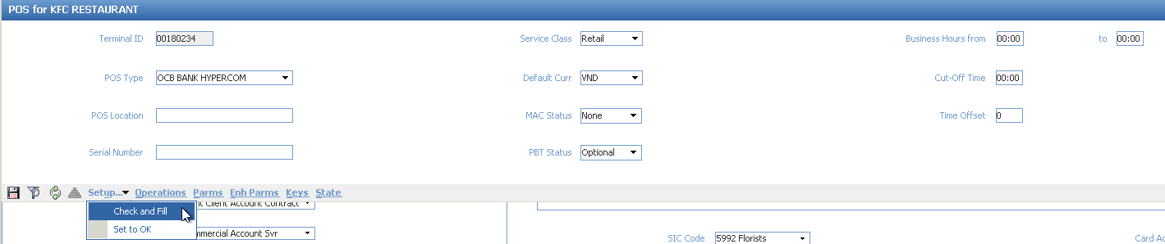

Information will show:

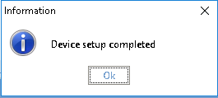

* [Action] 🡪 Set to OK

Information will show:

