Discovery Report

Volume 4. VCCS Issuing

Orient Commercial Bank

Version 1.0

Status: Final

Date: 09.03.2020

Prepared by: OpenWay

Author: Tu B. Nguyen

Approved By: Tu B. Nguyen

1. Table of Contents

1. Table of Contents 2

2. History of changes 3

3. Introduction 4

3.1. Notations 4

4. Introduction 5

4.1. Overview 5

5. VCCS Issuing Product Requirement 6

5.1. REQC001. VCCS Issuing Product 6

5.1.1. Business Requirement 6

5.1.2. Technical Details 6

5.2. REQC002. Client/Contract Hierarchy 7

5.2.1. Business Requirement 7

5.2.2. Technical Details 7

5.3. REQC003. VCCS Card Personalization 7

5.3.1. Business Requirement 7

5.3.2. Technical Details 9

5.4. REQC004. VCCS Card Operation 9

5.4.1. Business Requirement 9

5.4.2. Technical Details 9

5.5. REQC005. VCCS Card Fee Charges 10

5.5.1. Business Requirement 10

5.5.2. Technical Details 10

5.6. REQC006. VCCS Card Usage Limiters 10

5.6.1. Business Requirement 10

5.6.2. Technical Details 10

5.7. REQC007. VCCS Card-less transaction Limiter 11

5.7.1. Business Requirement 11

5.7.2. Technical Details 11

5.8. REQC008. VCCS Card Transaction Reconciliation 12

5.8.1. Business Requirement 12

5.8.2. Technical Details 12

6. Reports 13

1. History of changes

|  |  |  |  |
| --- | --- | --- | --- |
| version | date | Description | author |
| 0.1 | 17.08.2020 | Initial Version | Tu B. Nguyen |
| 1.0 | 03.09.2020 | Final Version | Tran Hoang Sang |
|  |  |  |  |
|  |  |  |  |
|  |  |  |  |

**Copyright**

© OpenWay Asia Limited 2020. All rights reserved.

The Copyright of this complete document and every part it belongs to OpenWay Asia Limited. Proprietary material, brand or product names of other parties or trademarks remain with their respective owners. You may not, except with our express written permission, distribute or commercially exploit the content. Nor may you transmit it or store it in any other website or other form of electronic retrieval system. Any sample data used in examples below are completely fictitious unless otherwise noted.

**Disclaimer**

This document and the OpenWay Asia software it describes are furnished by OpenWay Asia Limited under a Software Licensing Agreement, Consultancy Agreement, Variation Request or Confidentiality Agreement, and may be used or copied only in accordance with the terms of such Agreement. Neither this document nor the OpenWay Asia software it describes may be used, sold, transferred, copied, translated, reproduced or transmitted in any form or by any means, electronic or mechanical, for any purpose, in whole or in part, other than in accordance with the terms of such Agreement, or otherwise without prior written consent of OpenWay Asia Limited.

This document describes a generic product or service and should be read in conjunction with other documents relevant to the configuration of any specific system. The licensee of OpenWay software or user of OpenWay Asia services is responsible for ensuring that the product or service described herein meets its own requirements

**Confidentiality**

The information contained in this Document is the property of OpenWay Asia Ltd and contains CONFIDENTIAL information that is produced solely for the benefit of the receiving party named on the front page of this document. The recipient should keep this document and all its information confidential. On no account should this document, in whole or in part, be used, sold, transferred, copied, translated, reproduced or transmitted in any form or by any means, electronic or mechanical, or disclosed or disseminated to any third party, without the express written permission of OpenWay Asia Ltd.

1. Introduction

This document contains the Configuration Details which the WAY4 VCCS Issuing will be configured with in order to meet the Business Requirements of Orient Commercial Bank. It covers the different sections of the WAY4 VCCS Issuing needed to be done in them.

In case a Business Requirements cannot be solved by a system configuration then the same will have to be solved as an Enhancement to the System. Enhancements to the system configuration must be explicitly stated herewith, otherwise configurations described or referenced by this document are assumed to be standard. Enhancements shall not include optional configurations.

* 1. Notations

Notations used in this document are listed in the table below.

***Table 1. Notations***

| Notation | Description |
| --- | --- |
| N | Numeric digits 0 through 9 |
| AN | Alphabetic and Special Characters |
| DT | Date + Format in field description |
| B | Binary representation of data |
| NVAR | Variable length data up to nn characters. There will be two or three character length (depending upon whether maximum data length is 99 or 999) at the beginning of the element to identify the number of positions following to the end of the data element |
| M | Mandatory |
| O | Optional |
| C | Conditional |
| NPA | NAPAS (National Payment Switch) |
| LC | Local Card |
| VCCS | Vietnam Chip Card Specificaiton |
| OCB | Orient Commercial Bank |
| OPW | OpenWay |

1. Introduction

## Overview

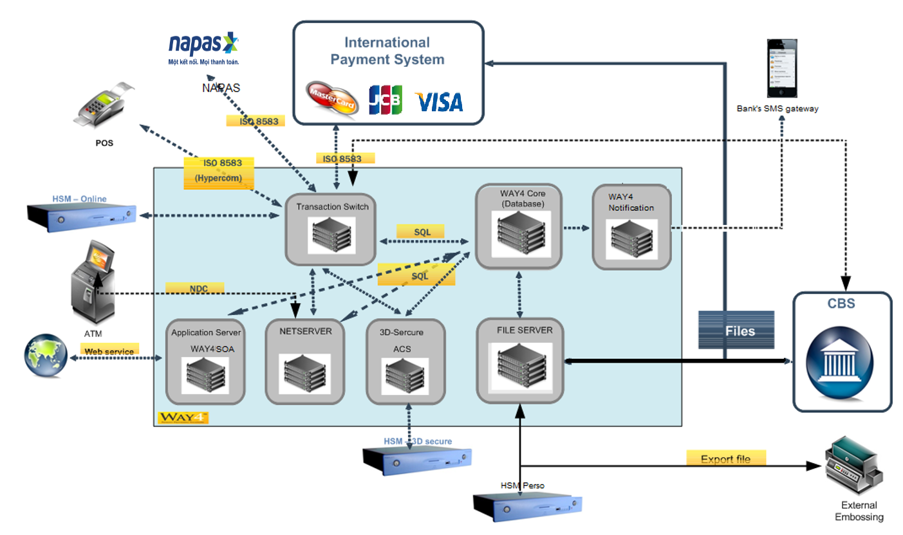WAY4 system was implement on the year 2018. All cardholder and merchant data were migrated from legacy system to WAY4 system. WAY4 system is running until now.

All local card is issued in magnetic strip card. On 5th of November 2018, State bank of Vietnam (SBV) officially published 10 local Specifications (TCCS) contenting technical requirements for domestic chip payment card of Vietnam. In order to adapt with mandate of Napas, OCB corporate with Openway to issue VCCS card.

1. VCCS Issuing Product Requirement

## REQC001. VCCS Issuing Product

### Business Requirement

OCB requests VCCS Issuing Product with following characteristics.

* VCCS Dual interface (Chip Contact and Contactless interfaces) Card
* VCCS must be Contactless enabled
* Magnetic stripe should contain Track data for VCCS
* PIN should be constructed based on Bank’s Local Card PAN
* Transaction conditions for contactless transaction:
  + From 0 VND to 2,000,000 VND and Number of transactions under 3, online transaction without CVM
  + Above 2,000,000 VND, online CVM based transactions
  + CVM limit may be changed from time to time based on business policy
* Supported transaction:
  + Contact chip Transaction: Online Only
  + Magnetic Stripe Transaction: Track 2 is mandatory; Track 1 is optional.
  + Fall-back Transaction: Disallow
* Transaction Acceptance:
  + ATM:
    - Balance Inquiry
    - Cash Withdraw
    - Mini Statement
    - PIN Change
  + POS:
    - Purchase/Sale
    - Balance Inquiry
    - PIN Change
    - Cash advance

### Technical Details

WAY4 will support the setup and configuration for the VCCS Contact/Contactless Chip Card features supported based on current Local Card products in Bank.

* All billing, accounting, Service pack and statement generation as well as the interest calculation will be inherited from current existing Local Card products in WAY4.
* New usage limiters (if required) for contactless transactions will be added to current service packs of Local Card products.
* New chip scheme will be defined for VCCS Contact/Contactless and to support contact and contactless features.
* New card can be accepted in BANK’s ATM, POS and in Napas Acquirers included Napas Contactless Acquirer.
* OpenWay will support BANK to do certification with Napas.

## REQC002. Client/Contract Hierarchy

### Business Requirement

It is required by OCB for VCCS Issuing products to have the same hierarchy as current Local Issuing products in Bank. Below is list of current local card products.

VCCS Credit Products:

|  |  |  |  |  |  |
| --- | --- | --- | --- | --- | --- |
| No | ISS contract code | name | bin | min | max |
| 1 | LCMM001 | Local Mag Credit Account | 970448 | 1400000000 | 1499999999 |

VCCS Debit Products:

|  |  |  |  |  |  |
| --- | --- | --- | --- | --- | --- |
| No | ISS contract code | name | bin | min | max |
| 1 | IDLM001 | Local Debit Gold | 970448 | 0000000000 | 1299999999 |
| 2 | IDLM002 | Local Debit Gold Priority | 970448 | 0000000000 | 1299999999 |
| 3 | IDLM003 | Local Debit Standard | 970448 | 0000000000 | 1299999999 |
| 4 | IDLM004 | Local Debit Standard BHD | 970448 | 0000000000 | 1299999999 |

VCCS Prepaid Products:

|  |  |  |  |  |  |
| --- | --- | --- | --- | --- | --- |
| No | ISS contract code | name | bin | min | max |
| 1 | IPLM001 | Local Prepaid | 970448 | 1300000000 | 1399999999 |

### Technical Details

Way4 will support to integrate new VCCS Issuing products from current Local Issuing product with new chip scheme template following the requirements from Bank.

## REQC003. VCCS Card Personalization

### Business Requirement

BANK will generate personal data like: PIN, (PVV), CVV/CVC, CVV2/CVC2 and iCVV/Chip CVC security values. EMV Keys diversification will be also performed by 3d Party Personalisation Bureau.

BANK needs to be able to provide some EMV parameters like velocity checking parameters for instance to the 3rd party personalization bureau. The following will be embossed on the cards:

* PAN
* Emboss Name
* Expiry Date
* CVC2 printed on back side of the card.

Bank needs a new menu to convert file for NAPAS with the same format of JCB.

**Perso File Specification**

|  |  |  |  |
| --- | --- | --- | --- |
| **Field description** | **Type** | **Length** | **Note** |
| Track 1 Length | N | 02 | Mandatory field.  The field contain the length of the track 1 data. |
| Track 1 Data | AN | 79 | Mandatory field.  The field contain track 1 data and will have fixed length of 79 bytes, but the above length field will denote the exact length of the track data |
| * Start track 1 indicator | <AN> | <01> | Fixed value ‘%’. |
| * Track 1 separator 1 | <AN> | <01> | Fixed value ‘B’ |
| * Track 1 Card number | <AN[n]> | <19> | The field can contain track one card number to store at magnet stripe with maximum length of 19. |
| * Track 1 separator 2 | <AN> | <01> | Fixed value ‘^’. |
| * Track 1 card embossing name | <AN> | <26> | The field will contains the track 1 card holder embossing name |
| * Track 1 separator 3 | <AN> | <01> | Fixed value ‘^’. |
| * Track 1 card expiry date | <N> | <04> | The field and contains card expiry date without century in YYMM format. Example : 0612 |
| * Service Code | <N> | <03> | Mandatory field and contains below values :  Non-EMV card will be “101”.  EMV card will be “201”. |
| * PVV key indicator | <N> | <01> | PVV key indicator. Default zero. |
| * PVV | <N> | <04> | PVV value. Default all zeroes. |
| * Visa Reserved | <N> | <02> | Visa reserved Field |
| * CVV1 Value | <N> | <03> | The field contains CVV 1 value. |
| * Zero fill | <N> | <02> | Always fill with zero. |
| * ACI | <AN> | <01> | Authorization Control Indicator. Valid value is A to Z or zero. |
| * Zero fill | <N> | <03> | Always fill with zero. |
| * End of Track 1 indicator | <AN> | <01> | Fixed value “?”. |
| Track 1 |  |  | Example: %B3565050000147724^NGUYEN/QUANG HAI.MR ^2003201000000000000000166000000? |
| Track 2 Length | N | 02 | Mandatory field.  The field contain the length of the track 2 data. |
| Track 2 Data | AN | 40 | Mandatory field.  The field contain the track 2 data and will have fixed length of 40 bytes, but the above length field will denote the exact length of the track data |
| * Start of Track 2 indicator | <AN> | <01> | Fixed value “;” |
| * Track 2 Card number | <AN[n]> | <19> | The field can contain track two card number to store at magnet stripe  with maximum length of 19. |
| * Track 2 separator 1 | <AN> | <01> | Fixed value “=” |
| * Track 2 card expiry date | <N> | <04> | Mandatory field and contains card expiry date without century in YYMM.  Example : 0612 |
| * Service Code | <N> | <03> | Mandatory field and contains below values :  Non-EMV card will be “101”.  EMV card will be “201”. |
| * PVV key indicator | <N> | <01> | PVV key indicator. Default zero. |
| * PVV | <N> | <04> | PVV value. Default all zeroes. |
| * CVV1 Value | <N> | <03> | The field contains CVV 1 value. |
| * End of Track 2 indicator | <AN> | <01> | Fixed value “?”. |
| Embossing header | AN | 06 | Mandatory field.  Fixed value “;5f25=” |
| System date | AN | 06 | Mandatory field contains current system date without century in below  format : YYMMDD  Example : 061213 |
| System date trailer | AN | 01 | Mandatory field. Fixed value “;” |
| ICVV value | N | 03 | Mandatory field contains ICVV value. |

Example: 

### Technical Details

Currently, there is interface of personalization data between WAY4 and 3rd party. It works fine for magnetic strip card.

If we change the existing interface then it requires customization to convert WAY4 Personalization file format to 3d Party Personalization file format.

## REQC004. VCCS Card Operation

### Business Requirement

This section describes OCB’s VCCS Card Operation requirements.

* Card Numbering, Expiration Date, PIN Mailer
  + The same requirement with existing Local Card.
  + Update expiration date: 72 months.
* Card Activation
  + The same requirement with existing Local Card.
* Card Renewal/Replacement
  + The same requirement with existing Local Card.
* Card Customer Service
  + The same requirement with existing Local Card.
* Card Upgarde
  + Add new Production Event code to upgrade Card.

### Technical Details

It keeps the existing functions. No change is required.

## REQC005. VCCS Card Fee Charges

### Business Requirement

This section describes OCB’s VCCS Card Fee Charging requirements.

* Transaction based Fees
  + The same requirement with existing Local Card.
* Misc Fees (non-transaction fees)
  + The same requirement with existing Local Card.
  + Add Card upgrade fee: 50.000 VND.

### Technical Details

It keeps the existing functions. No change is required.

## REQC006. VCCS Card Usage Limiters

### Business Requirement

This section describes OCB’s VCCS Card Usage limiters requirements.

* The same requirement with existing Local Card.

### Technical Details

It keeps the existing functions. No change is required.

## REQC007. VCCS Card-less transaction Limiter

### Business Requirement

This section describes OCB’s VCCS No-CVM required transaction management requirements.

* Way4 will maintain a No CVM Count and No CVM Threshold per card issued. Both the No CVM Count and No CVM Threshold may be shared by both the contact and contactless interface. The No CVM Count is incremented by one or by transaction amount for every transaction approved without CVM. If the No CVM Count is greater than the No CVM Count Threshold for No CVM transaction is greater than the No CVM Count Threshold, Way4 should decline the transaction and request Online Encrypted PIN and the device should prompt for PIN and restart a new chip transaction with the same AID as the original transaction.
* The No CVM Count for No CVM transaction are reset to zero whenever an Online Encrypted PIN transaction has successfully verified by Way4. The Online Encrypted PIN transaction may be at POS such as Purchase/Sale, Balance Inquiry, PIN Change use VCCS contact and contactless card; at ATM such as Cash withdrawal, Balance Inquiry, Mini-statement, PIN Change use VCCS contactless card.
* Below is example of Napas’s rule. The table below provides a detail sample use case of the No CVM Count and No CVM Threshold:

CVM Limit: VND 2,000,000.00; No CVM Count: 0; No CVM Threshold: 3

|  |  |  |  |  |  |  |
| --- | --- | --- | --- | --- | --- | --- |
| SEQ | trans amount | online pin | online pin veification | trans outcome | no cvm count | remarks |
| 1 | 1,000,000 | No | NA | Approve | 1 | Increment no CVM count |
| 2 | 800,000 | No | NA | Approve | 2 | Increment no CVM count |
| 3 | 2,100,000 | Yes | Success | Approve | 0 | Reset no CVM count |
| 4 | 2,200,000 | Yes | Success | Approve | 0 | Reset no CVM count |
| 5 | 500,000 | No | Na | Approve | 1 | Increment no CVM count |
| 6 | 2,100,000 | Yes | Fail | Decline | 1 | Do not update no CVM count |
| 7 | 2,100,000 | Yes | Success | Approve | 0 | Reset no CVM count |
| 8 | 800,000 | No | NA | Approve | 1 | Increment no CVM count |
| 9 | 900,000 | No | NA | Approve | 2 | Increment no CVM count |
| 10 | 1,000,000 | No | NA | Approve | 3 | Increment no CVM count |
| 11 | 1,100,000 | No | NA | Decline | 3 | Do not update no CVM count  Request online encrypted PIN |
| 12 | 1,100,000 | Yes | Success | Approve | 0 | Reset no CVM count |

### Technical Details

Way4 support fully this requirement.

## REQC008. VCCS Card Transaction Reconciliation

### Business Requirement

This section describes OCB’s VCCS Card Transaction Reconciliation requirements.

* The same requirement with existing Local Card. Bank already have Napas transaction reconciliation.

### Technical Details

It keeps the existing functions. No change is required.

1. Reports

No report is requested.