Discovery Report

Volume 5. VCCS Acquiring

Orient Commercial Bank

Version 1.0

Status: Final

Date: 03.09.2020

Prepared by:

Author:

Approved By: Tu B. Nguyen

1. Table of Contents

1. Table of Contents 2

2. History of changes 4

3. Introduction 5

3.1. Notations 5

4. Introduction 7

4.1. Overview 7

5. VCCS Acquiring Product Requirement 8

5.1. REQC001. POS Product 8

5.1.1. Business Requirement 8

5.1.2. Technical Details 9

5.2. REQC002. ATM Product 10

5.2.1. Business Requirement 10

5.2.2. Technical Details 10

6. EMV Contact Transaction 11

6.1. Introduction 11

6.1.1. EMV Contract Transaction 11

6.1.2. EMV Fallback Transaction 11

6.1.3. No CVM Required Transaction Management 12

6.2. REQC003. POS Napas EMV Contact Transaction 13

6.2.1. Business Requirement 13

6.2.2. Technical Details 13

6.3. REQC004. ATM Napas EMV Contact Transaction 14

6.3.1. Business Requirement 14

6.3.2. Technical Details 15

7. EMV Contactless Transaction 16

7.1. Introduction 16

7.1.1. EMV Contactless Transaction 16

7.1.2. No CVM Required Transaction Management 17

7.2. REQC005. POS NAPAS Contactless Chip Transactions 18

7.2.1. Business Requirement 18

7.2.2. Technical Details 18

8. NAPAS Certification 19

8.1. Introduction 19

8.1.1. Host Certification 19

8.2. REQC006. Host Certification 20

8.2.1. Business Requirement 20

8.2.1. Technical Details 20

8.3. REQC007. Device Certification 21

8.3.1. Business Requirement 21

8.3.2. Technical Details 21

8.4. REQC008. NAPAS Interface 22

8.4.1. Business Requirement 22

8.4.2. Technical Details 22

9. Reconciliation 23

1. History of changes

|  |  |  |  |
| --- | --- | --- | --- |
| version | date | Description | author |
| 0.1 | 17.08.2020 | Initial Version | Tu B. Nguyen |
| 0.2 | 28.08.2020 | Update POS Requirement  And ATM Requirement | Chau, Lam Bich  Quan, Nguyen Minh |
| 1.0 | 03.09.2020 | Final version | Chau, Lam Bich |
|  |  |  |  |
|  |  |  |  |

**Copyright**

© OpenWay Asia Limited 2020. All rights reserved.

The Copyright of this complete document and every part it belongs to OpenWay Asia Limited. Proprietary material, brand or product names of other parties or trademarks remain with their respective owners. You may not, except with our express written permission, distribute or commercially exploit the content. Nor may you transmit it or store it in any other website or other form of electronic retrieval system. Any sample data used in examples below are completely fictitious unless otherwise noted.

**Disclaimer**

This document and the OpenWay Asia software it describes are furnished by OpenWay Asia Limited under a Software Licensing Agreement, Consultancy Agreement, Variation Request or Confidentiality Agreement, and may be used or copied only in accordance with the terms of such Agreement. Neither this document nor the OpenWay Asia software it describes may be used, sold, transferred, copied, translated, reproduced or transmitted in any form or by any means, electronic or mechanical, for any purpose, in whole or in part, other than in accordance with the terms of such Agreement, or otherwise without prior written consent of OpenWay Asia Limited.

This document describes a generic product or service and should be read in conjunction with other documents relevant to the configuration of any specific system. The licensee of OpenWay software or user of OpenWay Asia services is responsible for ensuring that the product or service described herein meets its own requirements

**Confidentiality**

The information contained in this Document is the property of OpenWay Asia Ltd and contains CONFIDENTIAL information that is produced solely for the benefit of the receiving party named on the front page of this document. The recipient should keep this document and all its information confidential. On no account should this document, in whole or in part, be used, sold, transferred, copied, translated, reproduced or transmitted in any form or by any means, electronic or mechanical, or disclosed or disseminated to any third party, without the express written permission of OpenWay Asia Ltd.

1. Introduction

This document contains the Configuration Details which the WAY4 VCCS Acquiring will be configured with in order to meet the Business Requirements of Orient Commercial Bank. It covers the different sections of the WAY4 VCCS Acquiring needed to be done in them.

In case a Business Requirements cannot be solved by a system configuration then the same will have to be solved as an Enhancement to the System. Enhancements to the system configuration must be explicitly stated herewith, otherwise configurations described or referenced by this document are assumed to be standard. Enhancements shall not include optional configurations.

* 1. Notations

Notations used in this document are listed in the table below.

***Table 1. Notations***

| Notation | Description |
| --- | --- |
| N | Numeric digits 0 through 9 |
| AN | Alphabetic and Special Characters |
| DT | Date + Format in field description |
| B | Binary representation of data |
| NVAR | Variable length data up to nn characters. There will be two or three character length (depending upon whether maximum data length is 99 or 999) at the beginning of the element to identify the number of positions following to the end of the data element |
| M | Mandatory |
| O | Optional |
| C | Conditional |
| NPA | NAPAS (National Payment Switch) |
| LC | Local Card |
| VCCS | Vietnam Chip Card Specificaiton |
| OCB | Orient Commercial Bank |
| OPW | OpenWay |
| CCD | Common Core Definitions |
| CDA | Combined DDA/Application Cryptogram Generation |
| CB | Certification Body |
| CDOL | Card Risk Management Data Object List |
| DDOL | Dynamic Data Authentication Data Object List |
| DOL | Data Object List |
| IAC | Issuer Action Code |
| IADOL | Issuer Application Data Object List |
| PDOL | Processing Options Data Object List |
| PIN | Personal Identification Number |
| UCOL | Upper Consecutive Offline Limit |
| UN | Unpredictable Number |
| RID | Registered Application Provider Identifier |
| PSN | PAN Sequence Number |
| PK | Public Key of a asymmetric key pair |
| CVM | Cardholder Verification Method |

1. Introduction

## Overview

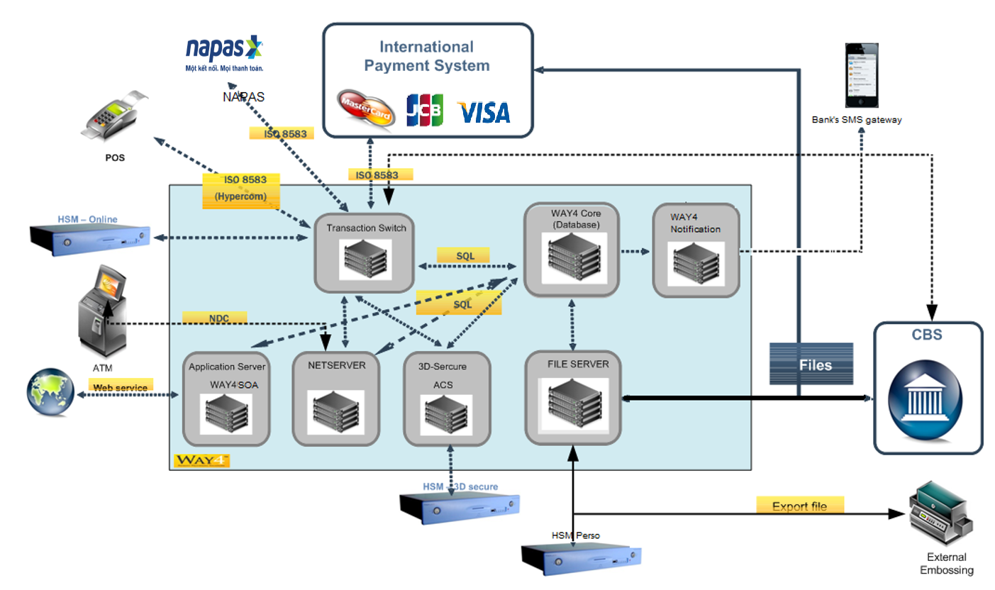WAY4 system was implement on the year 2018. All cardholder and merchant data were migrated

On 5th of November 2018, State bank of Vietnam (SBV) officially published 10 local Specifications (TCCS) contenting technical requirements for domestic chip payment card of Vietnam.

Currently the Bank already accept NAPAS magstripe transactions, NAPAS VCCS Acquiring project is upgrade ATM/POS device contract accept NAPAS EMV Contact and contactless Cards, so Bank can reuse almost of Acquiring(ACQ) production configuration or create new for separate the old ACQ product with new Acquiring product.

Project could be included below stages:

* Review POS Acquiring product.
* Review ATM Acquiring product.
* Upgrade NAPAS host to host interface support EMV
* Intergraded POS functions accept on-us EMV Bank’s Cards (Contact/Contactless).
* Intergraded POS functions accept NAPAS’s EMV Cards (Contact/Contactless).
* Intergraded ATM functions accept on-us Bank’s Cards (EMV Contact).
* Intergraded ATM functions accept NAPAS’s EMV Cards (EMV Contact).
* NAPAS ATM/POS EMV Acquiring Certification (Host – Same NIV)
* NAPAS POS Device Certification (Same MTIP/ADVT)
* NAPAS ATM Device Certification (Same MTIP/ADVT)

1. VCCS Acquiring Product Requirement

## REQC001. POS Product

### Business Requirement

Currently, OCB is applying POS Product list:

|  |  |  |
| --- | --- | --- |
| No | ACQ DEVICE code | name |
| 1 | APCVND001 | POS Cash VND |
| 2 | APSVND001 | POS Retail VND |
| 3 | APCUSD001 | POS Cash USD |
| 4 | APRUSD001 | POS Retail USD |

OCB requests POS Acquiring Product with following characteristics.

* POS Product Configuration
  + Keep the same structure of contract
* POS Type Configuration
  + Bank can reuse current POS type if Bank already support VISA/MC EMV chip Card
* POS Contract Subtype Configuration
  + Bank can reuse current POS contract subtype
* POS Accounting Scheme
  + Bank can reuse the current POS product accounting scheme
* POS Service Package
  + Bank can reuse the current POS product service packs then add more service prevent or limit contactless/fallback transaction for manage NAPAS EMV transactions.
  + Way4 will support to disable/ enable fallback transactions of local chip card.
  + By default fallback service will set [Service Allowed] in “Always” for support NAPAS cards fallback transaction, in case Bank wants disable this service can set [Service Allowed] to “Never”.
* POS Usage Limiter
  + Because NAPAS EMV Card can has: EMV contact, EMV Contactless, EMV Fallback transaction so Bank can create usage limiter for manage NAPAS EMV transactions.
  + Maximum amount of transaction
  + Daily limit on total amount of transactions
  + Periodic limit on total amount of transactions

|  |  |  |  |  |  |
| --- | --- | --- | --- | --- | --- |
| No | card type | trans type | usage tye | single value | max value |
| 1 | NAPAS MAG Cards | Retail | Transaction | 1.000.000 | 30.000.000 |
| 2 | NAPAS Fallback Cards | Retail | Transaction | 500.000 | 10.000.000 |
| 3 | NAPAS EMV Cards | Retail | Transaction | 10.000.000 | 500.000.000 |
| 4 | NAPAS EMV Contactless | Retail | Transaction | 10.000.000 | 500.000.000 |

### Technical Details

WAY4 will support the setup and configuration for the POS Acquiring Product features.

## REQC002. ATM Product

### Business Requirement

It is required by OCB for VCCS ATM products to have the same hierarchy as current ATM products in Bank. Below is list of current ATM products.

|  |  |  |  |  |  |
| --- | --- | --- | --- | --- | --- |
| No | ACQ DEVICE code | name | prefix | min | max |
| 1 | AATMM001 | ATM Local Machine |  |  |  |
| 2 | AATMS001 | ATM Service Card |  |  |  |

* ATM Type
  + Bank can reuse current ATM type.
* ATM Contract Subtype
  + Bank can reuse current ATM contract subtype
* ATM Accounting Scheme
  + Bank can reuse current ATM contract subtype
* ATM Service Package
  + Bank can reuse current service packs and add more usage limiter or service for prevent EMV risk transaction (ex: not allow fallback).
* ATM Usage Limiter
  + Because EMV Card can has EMV transaction or fallback transaction so Bank can add more Usage limiter for manage risk transaction (like fallback – allow or not allow).
  + Maximum amount of transaction
  + Daily limit on total amount of transactions
  + Periodic limit on total amount of transactions

|  |  |  |  |  |  |
| --- | --- | --- | --- | --- | --- |
| No | card type | trans type | usage tye | single value | max value |
| 1 | NAPAS MAG Cards | ATM | Transaction | Same old product | Same old product |
| 2 | NAPAS Fallback Cards | ATM | Transaction | Same old product | Same old product |
| 3 | NAPAS EMV Cards | ATM | Transaction | Same old product | Same old product |

### Technical Details

Way4 will support to integrate new feature to current ATM and POS Product.

1. EMV Contact Transaction

## Introduction

### EMV Contract Transaction

EMV transactions will execute all mandatory functions defined in the EMV specifications  
and may execute optional EMV functions.

* Card Insertion [mandatory]
* Application Selection [mandatory]
* Initiate Application Processing [mandatory]
* Read Application Data [mandatory]
* Processing Restrictions [mandatory]
* Offline Data Authentication [optional]
* Cardholder Verification [optional]
* Terminal Risk Management [mandatory]
* Terminal Action Analysis [mandatory]
* Card Action Analysis [mandatory]
* Online Processing [optional]
* Issuer Script Processing [optional]
* Completion [mandatory]

Approved EMV Transactions should result in generation of a Transaction Certificate (TC). Note  
that single-message and host-capture systems will pass the Authorization Request Cryptogram  
(ARQC) rather than the Transaction Certificate (TC) in the clearing file.

### EMV Fallback Transaction

When reading a card via the magnetic stripe reader, contact chip capable devices must check the Service Code on the magnetic stripe to determine if the card is chip enabled (2xx or 6xx). If the Service Code indicates that the card is chip enabled, the device must prompt the cardholder or merchant to insert the card into the contact chip reader.

When the transaction cannot be completed by reading the chip, the device may allow the  
transaction to be completed by reading the magnetic stripe. This transaction is known as Fallback transaction.

Fallback transactions are allowed only in the following conditions:

* Chip is not functioning
* Chip reader is not functioning
* The Application Candidate List is empty, and the Chip is not blocked
* EMV commands processing cannot be completed successful

Fallback transactions are not allowed in the following conditions:

* SELECT command fails with SW1 SW2 = ‘6283’ (Application is blocked)
* GET PROCESSING OPTIONS command fails with SW1 SW2 = ‘6985’ (Service is not allowed)
* PIN entry failed (PIN bypass, PIN entry time-out)
* Offline PIN verification failed
* Premature card withdrawal
* Transaction is successfully completed, and the card declines the transaction  
  Fallback transactions have a zero floor limit and are processed as Magnetic Stripe transactions and must be authorized online by Issuers.

### No CVM Required Transaction Management

At ATMs, all transactions require Online Encrypted PIN to authenticate the cardholder to ensure that the cardholder is legitimate, and the card has not lost or stolen.

At POS Terminals that do not support No CVM for low value transactions, all transactions require Online Encrypted PIN to authenticate the cardholder to ensure that the cardholder is legitimate, and the card has not lost or stolen.

At POS Terminals that support No CVM for low value transaction, if the transaction amount is to or greater than the CVM Limit (Terminal), Online Encrypted PIN is required to authenticate the cardholder to ensure that the cardholder is legitimate and the card has not lost or stolen. If the transaction amount is equal to or less than the CVM Limit (Terminal), no cardholder verification is required for the transaction.

This CVM Limit is set at POS Device/Terminal through TMS.

## REQC003. POS Napas EMV Contact Transaction

### Business Requirement

* List of POS contact transaction requirement:

**Purchases (EMV Payment)**:

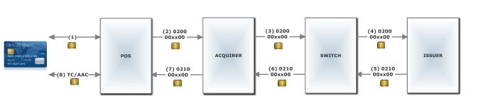Purchase allows a cardholder to buy goods or services and pay from the account associated with the card. The POS obtains an online authorization (0200/0210) for that purchase amount.

**Balance Inquiry (Non-Payment)**:

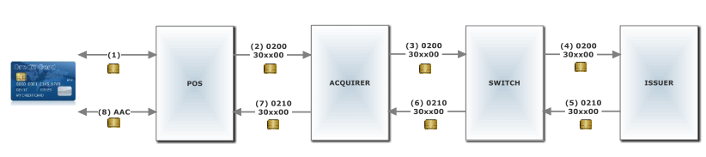Balance Inquiry allows a cardholder to access the balance information of the cardholder account. The POS submits an online authorization (0200/0210) of zero amounts.

* Requirement of CVM

When receive RC 85- No CVM Threshold exceeded, enter PIN (Decline)from NAPAS or internal, host will convert to response code 1A and send to POS, POS will enable function for PIN entering from cardholder.

### Technical Details

WAY4 will support to configure all necessary parameter for POS EMV contact transaction.

## REQC004. ATM Napas EMV Contact Transaction

### Business Requirement

List of ATM EMV contact transaction requirement:

**On-us transaction**

#### Cash Withdrawal (EMV Payment):

Cash Withdrawal allows a cardholder to request cash from the account associated with the chip card.

#### Balance Inquiry (EMV Payment):

Balance Inquiry allows a cardholder to access the balance information of the cardholder account.

#### PIN Change (Non-Payment):

PIN Change allows a cardholder to change the Online PIN with the chip card. The ATM/CDM submits an online authorization of zero amounts with the new PIN entered by the cardholder, which is formatted into the supported PIN block format and is then encrypted.

#### Mini Statement (EMV-Payment):

Mini Statement allows a cardholder to access the previous transactions of the cardholder account

#### Fund transfer (EMV-Payment):

Fund transfer allows a cardholder to move funds from one account associated with the card to another account.

**Off-us transaction**

Cash Withdrawal (EMV Payment):

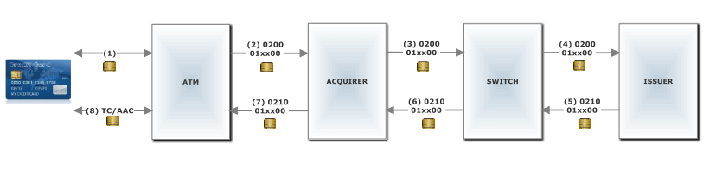Cash Withdrawal allows a cardholder to request cash from the account associated with the card. The ATM obtains an online authorization for that withdrawal amount. Partial approval is not allowed for a Cash Withdrawal.

Balance Inquiry (Non-Payment):

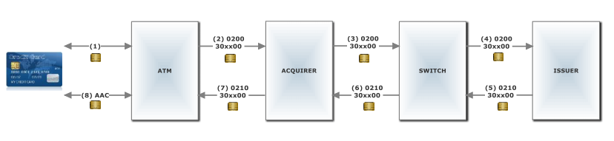Balance Inquiry allows a cardholder to access the balance information of the cardholder account. The ATM submits an online authorization of zero amounts.

**Receipt**

The ATM receipts can be different for transaction, onus and offus card

The receipt must be showed the following information:

* The ATM ‘s name
* The card number in mask
* Transaction type
* Description of Response code
* Transaction ID
* Transaction date
* Transaction amount, available amount
* Details of the number of notes for each denomination
* Application ID – AID
* VCCS Application name
* Authorization Request Cryptogram - ARQC

### Technical Details

WAY4 will support to configure all necessary parameter for ATM EMV contact transaction.

1. EMV Contactless Transaction

## Introduction

### EMV Contactless Transaction

Contactless POS Terminals have the following transaction flow:

* Terminal Request Analysis
* Preliminary Transaction Processing
* Protocol Activation
* Combination Selection
* Kernel Activation  
  o Transaction Initialization [mandatory]  
  o Read PDE [optional]  
  o Update PDE [optional]

o Initiate Application Processing [mandatory]  
o Update PDE [optional]  
o Read Application Data [mandatory]  
o Offline CAM Selection [optional]  
o Processing Restrictions [optional]  
o Cardholder Verification Method Processing [optional]  
o Terminal Risk Management [optional]  
o Terminal Action Analysis [mandatory]  
o Card Action Analysis [mandatory]  
o Update PDE [optional]  
o Card Balance Retrieval [optional]  
o Offline CAM Checking [optional]  
o Kernel De-Activation [mandatory]

- Outcome Processing

During Terminal Request Analysis, the Terminal Application activates the Contactless Reader to  
initiate a new transaction.  
After activation of the Contactless Reader, the Contactless Reader performs the following:

- Preliminary Transaction Processing  
- Protocol Activation  
- Combination Selection  
- Kernel Activation

After activation of the Contactless Kernel, the Contactless Reader waits for the result of the  
transaction processing. The Contactless Reader communicates result to the Terminal Application  
using final outcome messages.  
The Contactless Reader may communicate the following final outcome messages:

- Online Request (final outcome message)  
- Approved (final outcome message)  
- Declined (final outcome message)  
- Try Another Interface (final outcome message)  
- End Application (Start = N/A) (final outcome message)

The Terminal Application processes each final outcome message. The processing of a final  
outcome message may result in the re-activation of the Contactless Reader.  
At the completion of an online authorization, the Terminal Application should re-activate the  
Contactless Reader to process the online authorization response received from the Issuer

Authorization Host

After re-activation of the Contactless Reader, the Terminal Application waits for the result of the  
new transaction processing.

When the transaction is processed online, the Terminal Application completes the transaction  
based on the Response Code (DE 39) in the Authorization Response received from the Issuer  
Authorization Host.

The contactless reader communicates result using second final outcome messages.  
The contactless reader may communicate the following second final outcome messages:

- Approved (second final outcome message)  
- Declined (second final outcome message)  
- End Application (second final outcome message)

The Terminal Application has to process each second final outcome message.  
At any time, the Terminal Application may request the contactless reader to cancel the  
transaction.

### No CVM Required Transaction Management

During Pre-Processing function, if the transaction amount is greater than the Reader CVM Required Limit, Online Encrypted PIN is required to authenticate the cardholder to ensure that the cardholder is legitimate, and the card has not lost or stolen. If the transaction amount is equal to or less than the Reader CVM Required Limit, no cardholder verification is required for the transaction.

## REQC005. POS NAPAS Contactless Chip Transactions

### Business Requirement

List of POS contactless transaction requirement:**Purchases (EMV Payment):**

Purchase allows a cardholder to buy goods or services and pay from the account associated  
with the card. The POS obtains an online authorization (0200/0210) for that purchase amount.

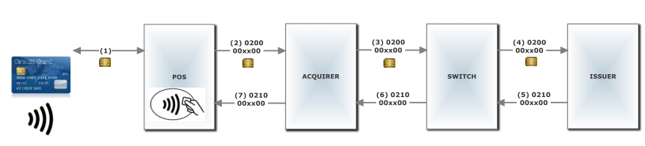

**Balance Inquiry (Non-Payment):**

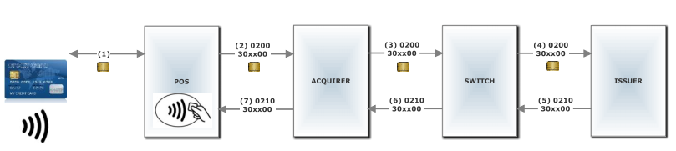Balance Inquiry allows a cardholder to access the balance information of the cardholder account. The POS submits an online authorization (0200/0210) of zero amounts.

* Requirement of CVM

The same as chip contact transactions, when receive RC 85- No CVM Threshold exceeded, enter PIN (Decline)from NAPAS or internal, host will convert to response code 1A and send to POS, POS will enable function for PIN entering from cardholder.

### Technical Details

WAY4 will support to configure all necessary parameter for POS EMV contactless transaction.

1. NAPAS Certification

## Introduction

### Host Certification

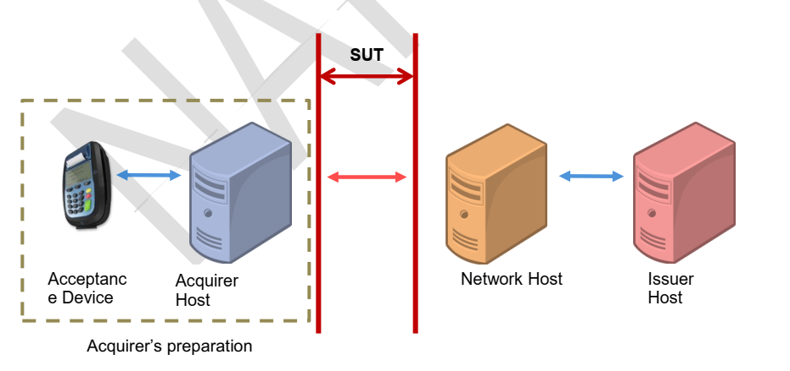The connection diagram for ACQ host certification:

## REQC006. Host Certification

### Business Requirement

NAPAS VCCS ACQ host certification has connection diagram as above and the process is same with NIV of MasterCard.

Although the System Under Test (SUT) is the messaging interface between Acquirer Host and Network Host, to ensure the messaging context and content, the Acquirer should prepare an Acquirer an Acceptance Device which is already approved for generating the transactions.

### Technical Details

Because NAPAS is using SUT for test directly with Bank so don’t have offline testing, Openway will on-behalf Bank process host certification.

## REQC007. Device Certification

### Business Requirement

The connection for certify is same as above (the process as MasterCard’s MTIP or VISA’s ADVT), Device certification will be process by Device vendor.

For POS: bank will apply testing with 2 POS vendor: Pax (S80,S90) and Igenico (Move2500)

For ATM: bank will apply testing with 2 POS vendor: Diebold (procash, aptiva), NCR(SS22E).

### Technical Details

OpenWay will upgrade ATM configuration support accept NAPAS EMV Card, after that ATM vendor can process ATM certification.

OpenWay will support POS and ATM vendor (as listing above) troubleshot issuer at appear in OpenWay system and specification (in case POS vendor using Openway POS spec).

## REQC008. NAPAS Interface

### Business Requirement

The VCCS project must be implement on New NAPAS Specification 1.0.

### Technical Details

Openway will upgrade NAPAS Interface to adapt with New NAPAS Specification 1.0.

1. Reconciliation

Bank have already got reconciliation so Bank upgrade their own reconciliation software.