Vocational Training Development Institute
School of Applied Technology
Department of ICT
Introduction to Object-Oriented Programming II

Module No.
Assignment #

Due:- Total marks: 50 Marks
- Date: 23/2/2022
- Time: 5:30pm - 8:30pm Lecturer: Doron Williams

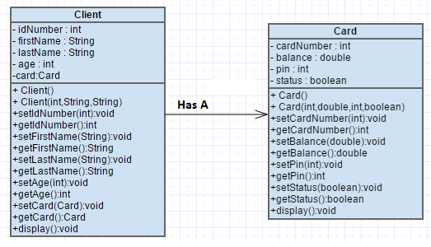

Implement both classes in IntelliJ based on the UML diagram above. Place both classes in a package called “domain”.
(10 + 10 Marks)

In your main method complete the following tasks:

- Create the classes based on the UML diagram above (10 Marks)
- Create an object of type Client called Obj1. (5 Marks)
- Prompt the user and accept all information for Obj1 (Client & Card info) (10 Marks)
- Display all the contents of the Client object Obj1 . (5 Marks)
- Display only the card information for Obj1. (10 Marks)
- Set the card status to true and card number to 45678 for Obj1. (10 Marks)

**Hint - Use the Java Util Scanner class shown below to implement a User Prompt

import java.util.Scanner; // import the Scanner class

class MyClass {
public static void main(String[] args) {
Scanner myObj = new Scanner(System.in);
String userName;

// Enter username and press Enter
System.out.println("Enter username");
userName = myObj.nextLine();

System.out.println("Username is: " + userName);
}
}

