**VISVESVARAYA TECHNOLOGICAL UNIVERSITY**

**Jnana Sangama, Belagavi, Karnataka 590018**

**INTERNSHIP REPORT ON**

## “Assignment management system”

*Submitted in partial fulfilment of the requirements for the conferment of Degree of*

### BACHELOR OF ENGINEERING

**in**

### COMPUTER SCIENCE ENGINEERING

**Submitted by**

## Prakhyat

## 1BY18CS108

*Under the Guidance of Under the Guidance of*

Prof. Durga Bhavani A, Mr Binod Adhikari

Assoc. Professor, CSE web application developer

BMSIT&M InfiData Technologies 

DEPARTMENT OF COMPUTER SCIENCE & ENGINEERING

**BMS INSTITUTE OF TECHNOLOGY & MANAGEMENT**

BENGALURU-560 64 2021-22

**VISVESVARAYA TECHNOLOGICAL UNIVERSITY**

## BMS INSTITUTE OF TECHNOLOGY & MANAGEMENT

YELAHANKA, BENGALURU - 560064

## DEPARTMENT OF COMPUTER SCIENCE & ENGINEERING





**CERTIFICATE**

This is to certify that the Internship entitled **“”** is carried out by **Mr. Prakhyat, 1BY18CS108** for the partial fulfilment for the award of **Bachelor of Engineering Degree in Information Science and Engineering of the Visvesvaraya Technological University, Belagavi** during the academic year 2021-22. The internship report has been approved as it satisfies the academic requirements in respect of Internship (18CSI85) prescribed for the B.E. Degree.

______________ _______________ ______________

Signature of external guide Signature of Internal guide Signature of the HOD Mr Binod Adhikari Mrs Durga Bhavani A Dr Thippeswamy G

Web application dev Assc professor professor and HOD

InfiData technologies BMSIT & M BMSIT&M

Examiners Name Signature with Date

1.

2.

**DECLARATION**

I hereby declare that the Internship report entitled “**Developing of assignment management system**” submitted to the BMS Institute of Technology & Management, Yelahanka, Bengaluru has been carried out by me and submitted in partial fulfillment of the course requirements for the award of degree in Bachelor of Engineering in Computer Science and Engineering of Visvesvaraya Technological University, Belagavi, during the academic year 2021 - 2022. The matter embodied in this report has not been submitted to any other university or institution for the award of any other degree.

***Signature of the Student***

### Prakhyat

### 1BY18CS108

# ACKNOWLEDGEMENT

I am happy to present this Internship Seminar after completing it successfully. This Internship would not have been possible without the guidance, assistance and suggestions of many individuals. I would like to express my deep sense of gratitude and indebtedness to each and everyone who has helped me to make this Internship a success.

I heartily thank our **Principal, Dr. Mohan Babu G. N, BMS Institute of Technology & Management** for his constant encouragement and inspiration in taking up this Internship work.

I heartily thank our **Head of Department DrThippeswamy G, Dept. of Computer Science and Engineering, BMS Institute of Technology& Management** for her constant encouragement and inspiration in taking up this Internship work.

I heartily thank our external guide, **Mr. Binod Adhikari , InfiData Technologies**

for his constant support and guidance throughout the course of the Internship work.

I heartily thank our Internal guide **Mrs. Durga Bhavani A Asst. Professor, Dept. of Computer science and Engineering,** for her constant follow-up and advice throughout the course of the Internship work.

Special thanks to all the Computer Science Department staff members for their help and kind co-operation.

Lastly, I thank my parents and friends for their encouragement and support given to me in order to finish this precious work.

### Prakhyat

**1BY18CS108**

**INTERNSHIP LETTER**

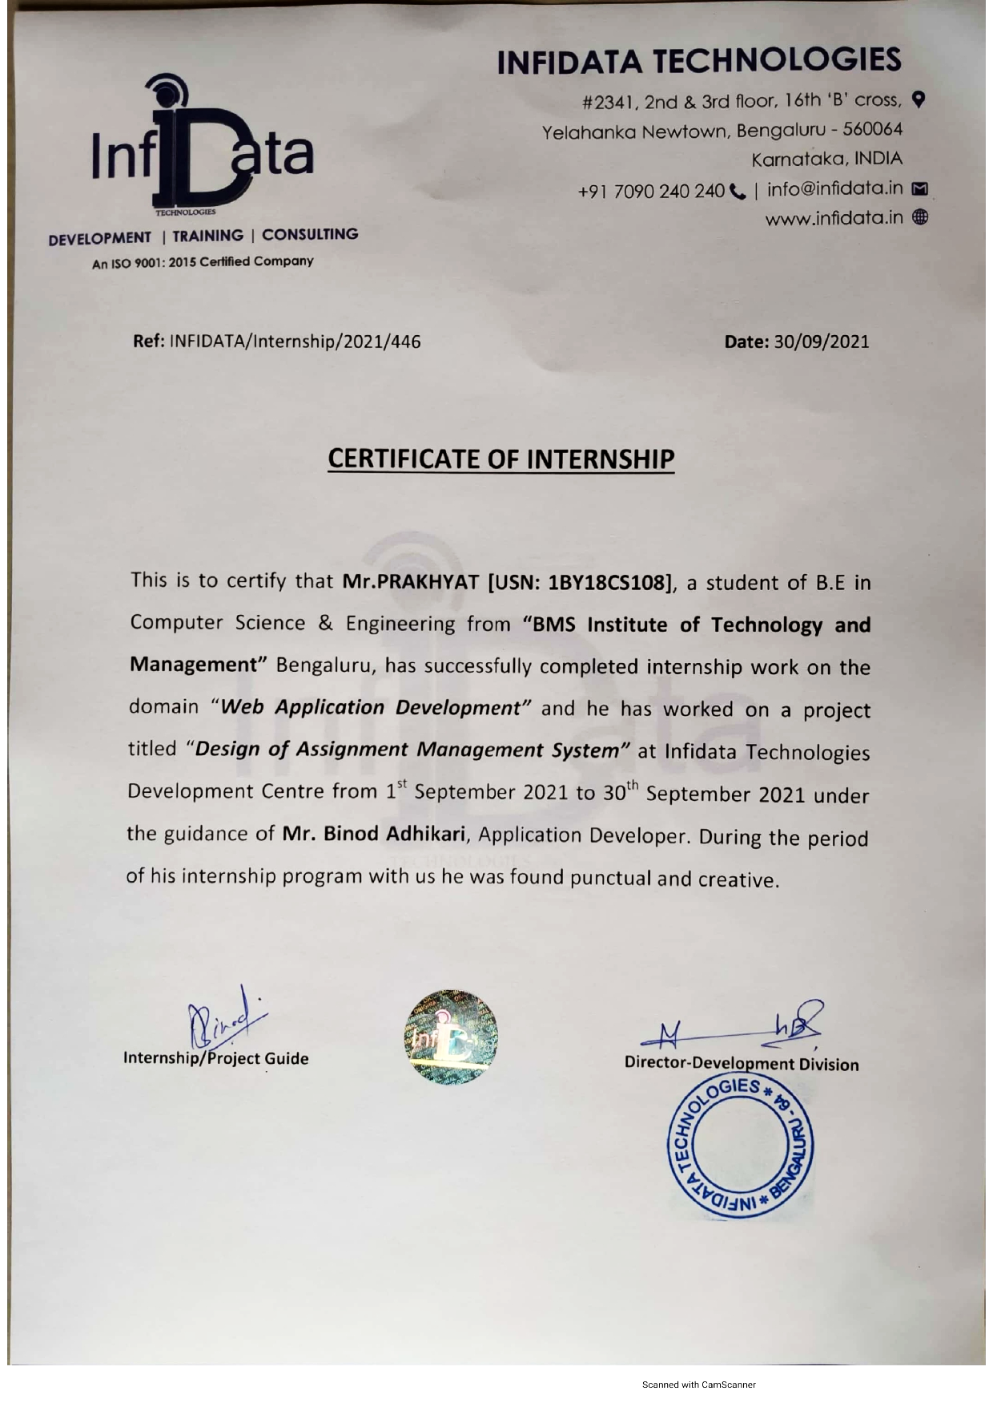

**ABSTRACT**

Traditional assignment management is becoming obsolete due to its inconvenience, inefficiency, and low accuracy. Currently, web-based management systems have been widely implemented due to the development of Web and CGI technologies. This project introduces a new web-based Assignment Management System, which combines all useful features in other commercial systems and implements new functions that are practical in assignment management. Its powerful features and friendly user interfaces allow instructors and students to handle their assignments in a convenient, efficient, and systematical way. In addition, this system also has very good portability and extensibility, and the system security has been strongly enhanced by multiple security strategies.

**TABLE OF CONTENTS**

**1.ACKNOWLEDGEMENT I**

**2.INTERNSHIP CERTIFICATE II**

**3.ABSTRACT III**

**4.TABLE OF CONTENTS IV**

**CONTENTS**

Chapter 1:Company profile

Chapter 2:Internship Domain Chapter 3:Tasks Performed

Chapter 4:Activities

Chapter 5:Specific Outcomes

Chapter 6:Conclusion