Species-specific effects of the Urban Heat Island on tree growth across Berlin

Alexander G. Hurley, Ingo Heinrich, …

*Geoforschungszentrum Potsdam, Section 4.3, Germany*

* Corresponding author: [hurley@gfz-potsdam.de](mailto:hurley@gfz-potsdam.de)

22 October, 2020

**This document outlines the rationale for an analysis of tree growth (potential) and its relationship with the Urban Heat Island (UHI) effect in Berlin using an extensive, publicly available data set. It introduces preliminary results and provides an outlook for up-coming and potential work.**

# 1 Introduction

Berlin features the most intense Urban Heat Island (UHI) in Germany due to its large extent and development intensity (Kuttler et al., 2015), with temperature increases of up to during day-time and on average for night-times (2001-2010, Fenner et al., 2014) in urban rural areas. Consequently, urban green (infrastructure) systems are subjected to increased heat more frequently, potentially affecting their process dynamics - either positively or adversely. Their performance and health, however, is closely tied to local energy budgets (Grimmond et al., 1996 ; Hertel and Schlink, 2019), which in turn are decisive for controlling human wellbeing (e.g. Maras et al., 2016), amongst other factors. Assessing the effect of increased temperatures on green infrastructure, as part of the urban landscape, is therefore instrumental for understanding, and ultimately mitigating, the potential impact of future warming on increasingly urban societies (Norton et al., 2015).

Trees, in particular, provide shading as well as transpirative cooling in their vicinity (Endlicher et al., 2016; Gillner et al., 2015; Oke, 1982), and therefore can reduce ambient temperatures, infrastructure power-consumption and (human) thermal discomfort (e.g. Gulyás et al., 2006; Akbari et al., 2001; Hoyano, 1988; Mayer and Höppe, 1987); simultaneously, they provide numerous other environmental, cultural and psychological services and/or benefits (see Tzoulas et al., 2007 for review). Further, recent tree growth dynamics as a proxy for on-going and future warming may provide an additional line of evidence to support the growing knowledge base on future climate-vegetation dynamics (Zhao et al., 2016) and may aid in mitigation and adaptation efforts (Brune, 2016; Pretzsch et al., 2017).

Trees and green infrastructure in urban areas show a tendency for enhanced growth rates and/or productivity compared to rural counterparts (Jia et al., 2018; Pretzsch et al., 2017), yet feature a broad range of effect size ranges and, in some cases, signs specific to species and locality. Zhao et al. (2016) showed that growth rates increased within urban clusters as urbanization intensifies using remotely sensed vegetation indices. Similarly, for Berlin, Dahlhausen et al. (2018), identified positive growth modulation in highly urbanized environments (using growth increments) for *Tilia cordata* Mill, the most abundant tree of the city, which they attributed to the UHI effect, while intermediate development intensity showed indications of being least favorable for tree growth. Further, Moser-Reischl et al. (2019) identified positive associations between air temperature and radial growth for two species commonly selected by urban planners (*T. cordata*, *Rubinia pseudoacacia*) in Munich. By contrast, Gillner et al. (2014) highlight decreased growth for *Acer* species (*A. platanoides* and *pseudoplatanus*), *Platanus x hispanica* and *Quercus rubra* with higher summer temperatures of the preceding year, especially when compounded with drought, in another German metropolis (Dresden). Differences in growth trends may result from contrasting species-specific characteristics, but are indeed affected by other processes and factors, such as water availability, pollution and road-salt loading, structural impedance through infrastructure or management, etc. (Pauleit et al., 2002; Quigley, 2004; Randrup et al., 2001; Rhoades and Stipes, 1999). Under climate change, atmospheric drought will likely be compounded with high temperatures - and intensified UHIs - more frequently, adding further stress to current urban disturbance regimes (Roloff et al., 2009).

Conditions affecting tree growth can vary greatly within urban areas or regions, and need to be accounted for when establishing relationships with pertinent drivers, such as the UHI effect. This typically complicates the extrapolation from individual sampling sites toward predicting effect sizes across entire urban areas and tree stocks. This is especially the case for studies reliant on labour-intensive methods which are limited logistically by sampling effort, reducing sample sizes, as well as species and spatial coverage.

To complement (existing) detailed dendroecological analyses of climate-growth relationships in Berlin for key species, we propose inferring growth modulation from a large data set in excess of 650000 individuals covering 94 genera and at least 600 species and/or cultivars provided by the Berlin Senate Administration (Senatsverwaltung). This data set contains information on location, species, trunk diameter (at breast height; ; see Tab.??), and height, amongst other variables for the majority of street and park trees.

In a space-for-time substitution, growth of individual species can be assessed across the entire city of Berlin, and related to effects of the UHI, while accounting for other location-specific factors, such as street characteristics, development intensity, available soil volume, etc. Comparable applications are found, for example, in Quigley (2004) and Pretzsch et al. (2017). The former inferred absolute growth potential for species across successional groups (early, mid, late stage), and between rural and urban conspecifics, yet lacked spatially-explicit effect size estimates across the urban-rural space and was limited to comparatively small sample sizes per group ( divided in 15 species, 3 groups and 2 locations). Pretzsch et al. (2017) applied linear hierarchical models to infer growth modulation on annual basis for different time periods and urban rural locations while accounting for stand-level variability; however, for Berlin only 145 individuals of one species (*T. cordata*) were assessed. As mentioned previously, climate-growth relationships can vary substantially between species, and in fact, Quigley (2004) and Pretzsch et al. (2017) report contrasting results regarding average tree diameter, i.e. smaller or larger for urban rural trees of same age. Consequently, this variability of effect sizes and directions calls for a more comprehensive assessment across species and with greater spatial coverage throughout Berlin.

**We therefore propose applying a statistical model that is fully spatially explicit, while also allowing to account for the nested nature of the data set (e.g. streets and districts) as well as other pertinent factors using hierarchical, generalized additive models (see Section2). As a result, the absolute growth potential of a species can be inferred given, for example, a specific location, age or UHI magnitude. Further, the impact of UHI loading can be predicted for a single species across all of Berlin as a continuous surface.** The inclusion of independent, tree-level growth data, however, is paramount as it allows:

1. validating the publicly-available Senate dataset () while providing a more reliable estimate of tree age,
2. applying the model with annual basal area as a response (enabling incorporating effects of varying climate/UHI intensities over time), and
3. comparing (Senate data) and basal area-derived models for a subset of locations and species, increasing confidence in Berlin-wide predictions.

# 2 Proposed methods and data requirements

## 2.1 General analyses

The proposed statistical method is from the class of hierarchical, generalized additive models (GAM, or GAMM for mixed models/hierarchical models). In these models combinations of continuous and categorical predictor variables can be summed to estimate a response. In particular, continuous variables that are linearly, as well as non-linearly related to the response can be represented by applying a transfer function, typically termed “smoothing function” (Wood, 2017); these are constructed using a number of base functions of varying complexity and form, which provides a high degree of flexibility, ideal for fitting ecosystem dynamics which are rarely linear (Pedersen et al., 2019), or correctly represented with deterministic functional forms (e.g. quadratic equations). In general, a GAM can be written as:

and

where is taken from an appropriate distribution and corresponding link function , is the intercept and represents a smooth function of a predictor (Pedersen et al., 2019), and . Note, that consists of a smooth (e.g. spline) constructed via basis functions of different form and complexity, multiplied by a coefficient:

Nested data structures (e.g. due to similar road [type]) can be accounted for by introducing random effects (Wood, 2017), while spatial dependence between observations can be included by constructing smoothing functions with e.g. northings and eastings, as for example done in (Augustin et al., 2009). Ultimately, the implementation of a such a GAMM will allow for establishing continuous prediction surfaces of growth potential (approximated via ) for individual species across urban areas (including parks) of Berlin.

Currently, has been modeled using a hierarchical linear model (linear mixed effects model) with lme4 (Bates et al., 2015) in R Core Team (2020) (see Section3). The general form of this model is:

where is the intercept with its random component , and the slope with its random component . The random errors are assumed i.i.d. and distributed as . The model for which results are presented in Figure3.5 estimates from tree age and the local UHI intensity as continuous covariates with random slopes and intercepts for each species; note, that for computational efficiency each genera was modeled separately. Further, models were established for the three most abundant species per genera with at least 1000 individuals.

## 2.2 Available and required data

Additional remote sensing data for local context, higher resolution UHI data, and most important, temporally-resolved tree growth data are still required and/or would greatly improve the confidence in effect size estimates (see Section1). See Tab.?? for details on data sets.

# 3 Preliminary results

Tree locations are clustered and structured based on their category, i.e. riparian, street and park trees (Fig.3.1). Planting in space and time shows species-specific patterns (by districts), often related to major events, such as the start and end of armed and/or political conflict. Table?? shows the binned distribution of genera across age classes.

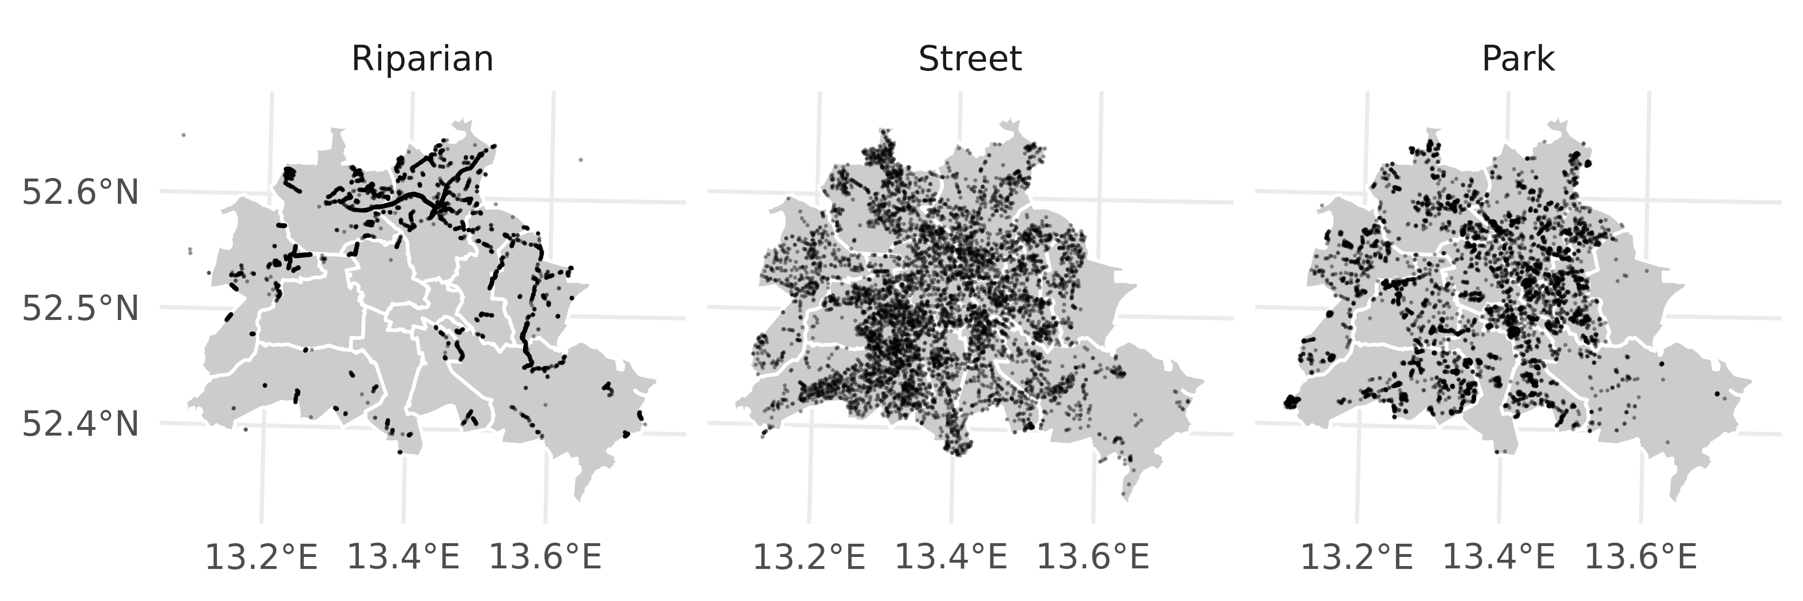

Figure 3.1: Individual tree locations for three categories available in Berlin Senate urban tree data set. Note, that for each category 7000 observations were subsampled from the available pool to facilitate visualization.

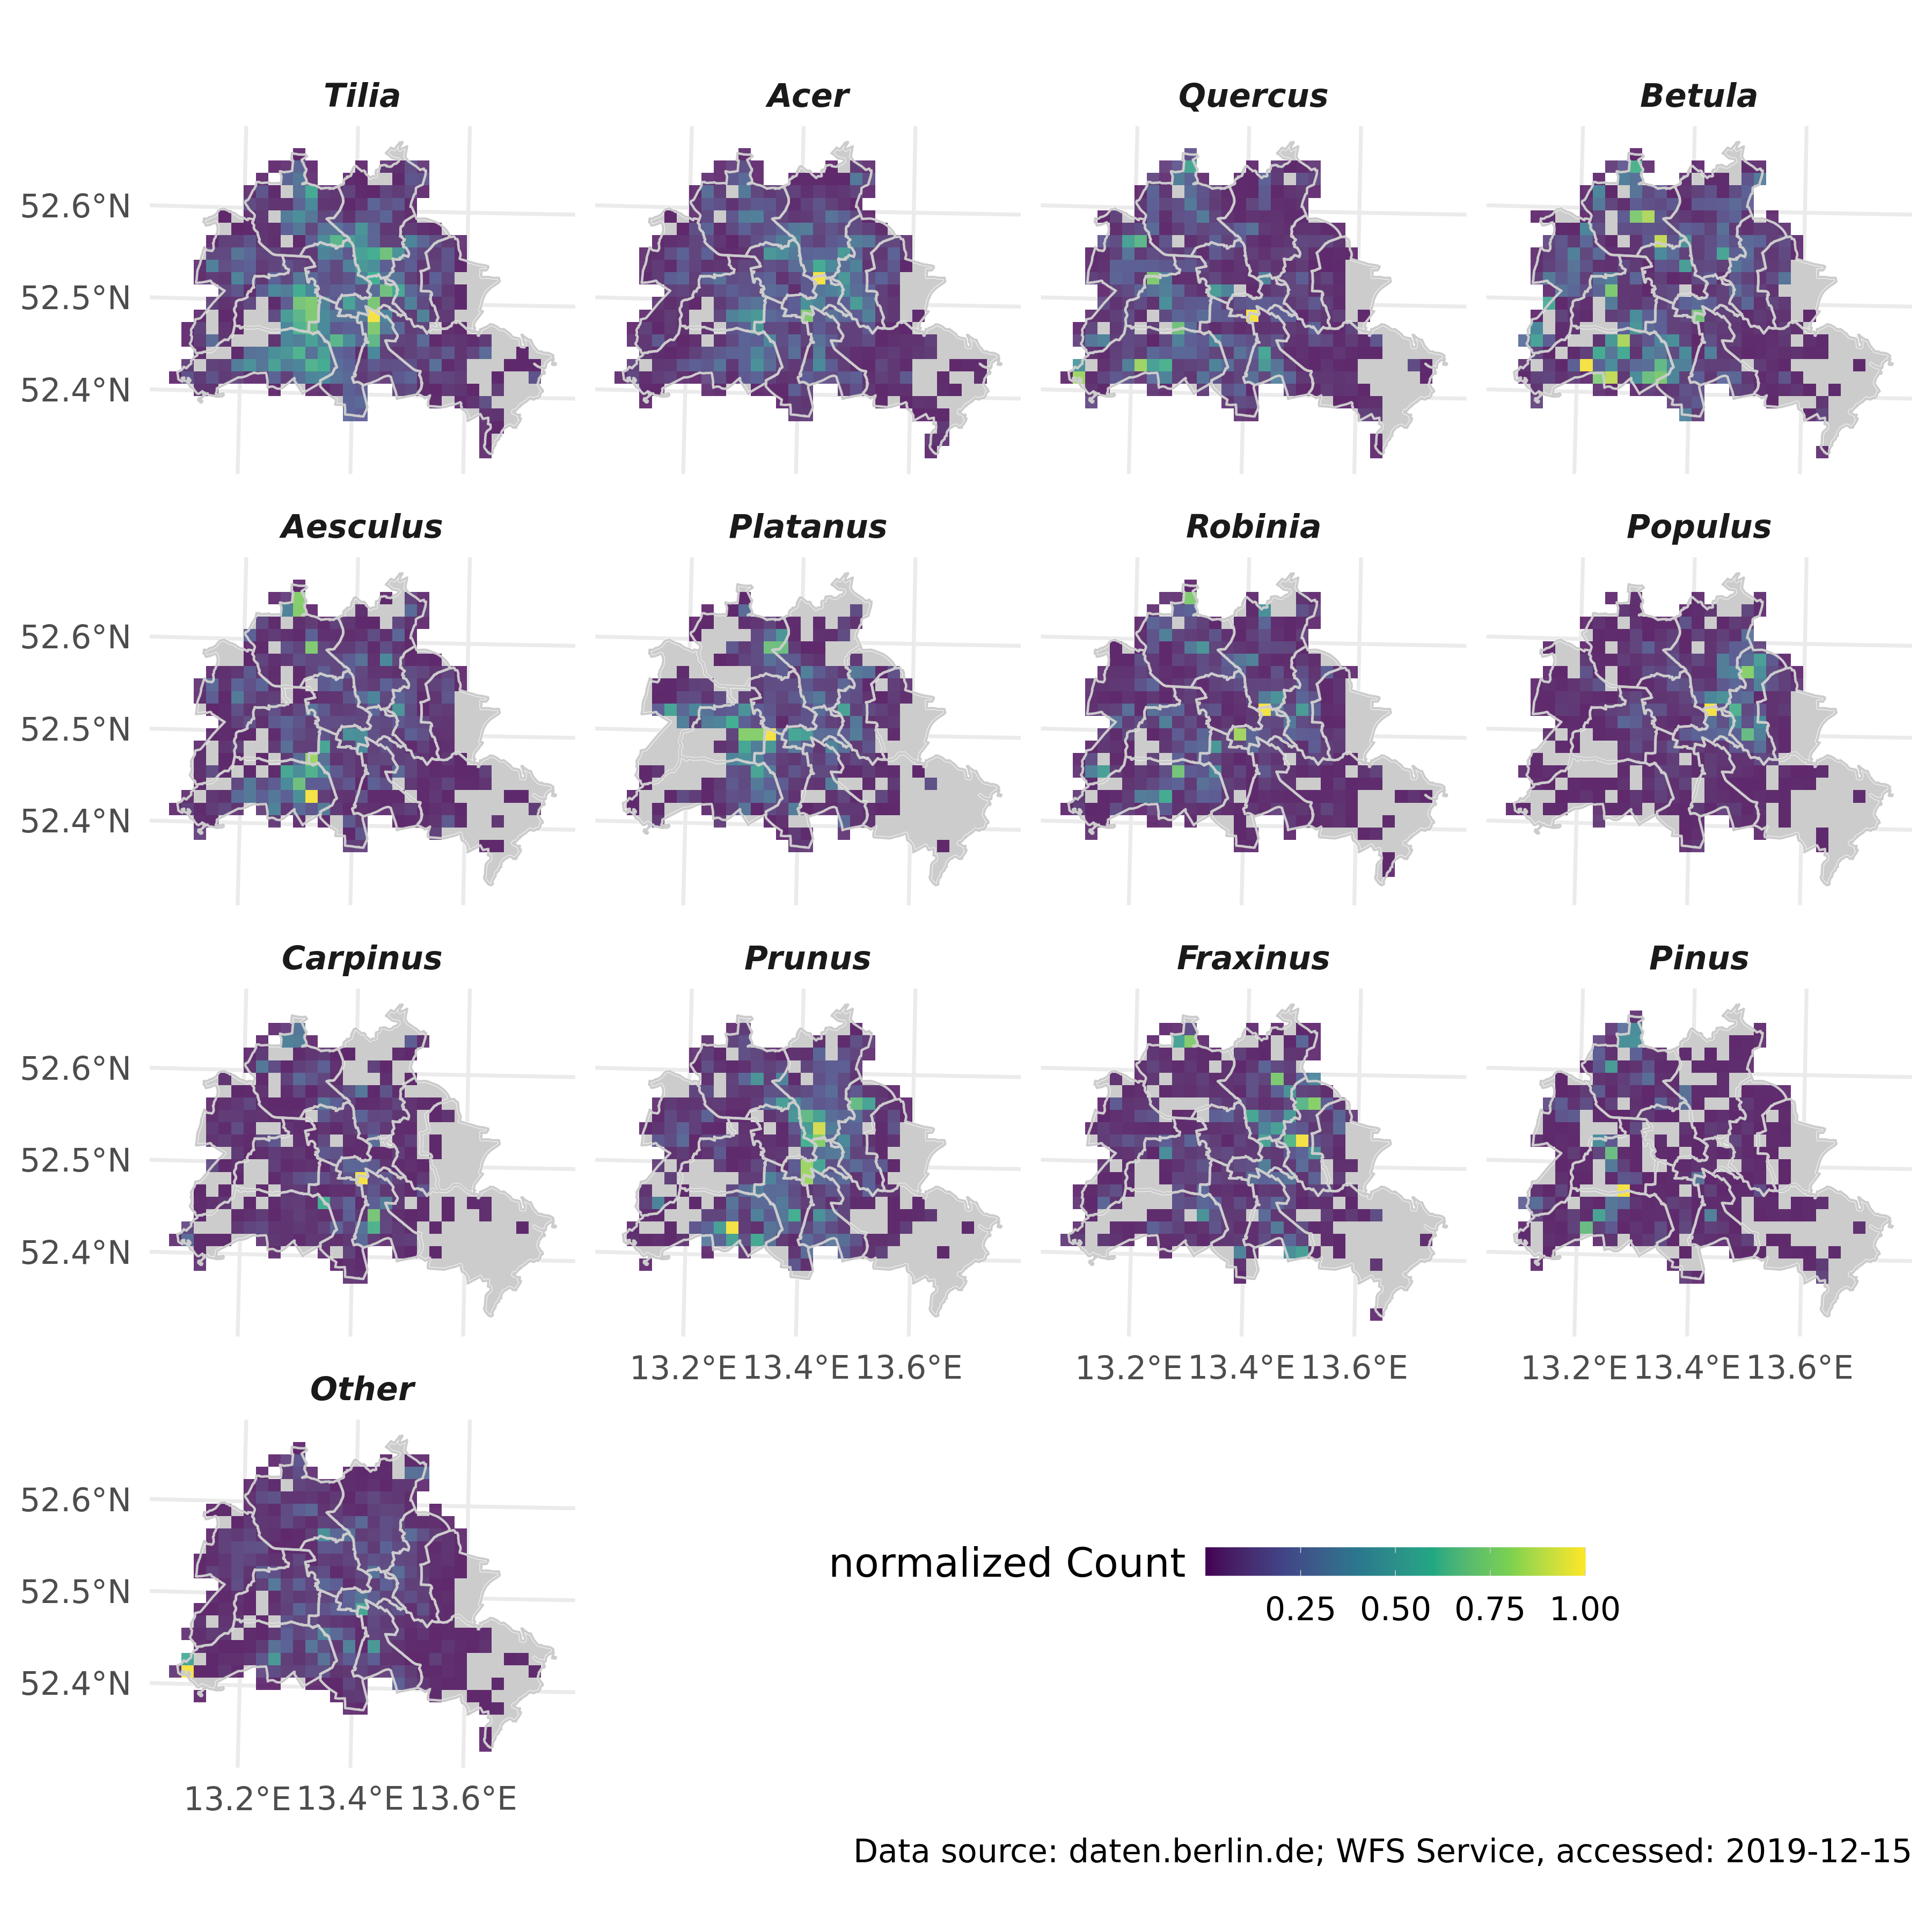

Figure 3.2: Gridded counts for the 11 most frequent genera, as well as *Pinus* and remaining genera. Note, that counts are standardized to unity for individual genera.

The distribution of the UHI effect is highly irregular and clustered in space (Fig.3.3), and also shows variability through time (data not shown, refer to the [urban heat island explorer](https://yceo.users.earthengine.app/view/uhimap)).

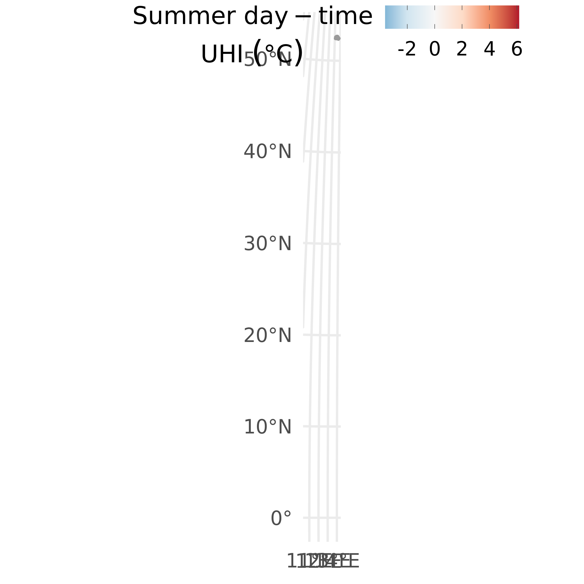

Figure 3.3: Estimate of UHI intensity based on the algorithm in (Chakraborty and Lee, 2019), comparing urban with rural pixels within the greater metropolitan cluster. Presented values are averaged over the summer of 2007.

The exposure to increased heat-loading of individual genera (and consequently species) is highly uneven throughout the city (Fig.3.4). Street and park trees of most genera are clustered in urban areas with intermediate to high UHI loading, while riparian trees, and some street and park trees of other genera tend to be spread more evenly across Berlin’s UHI range.

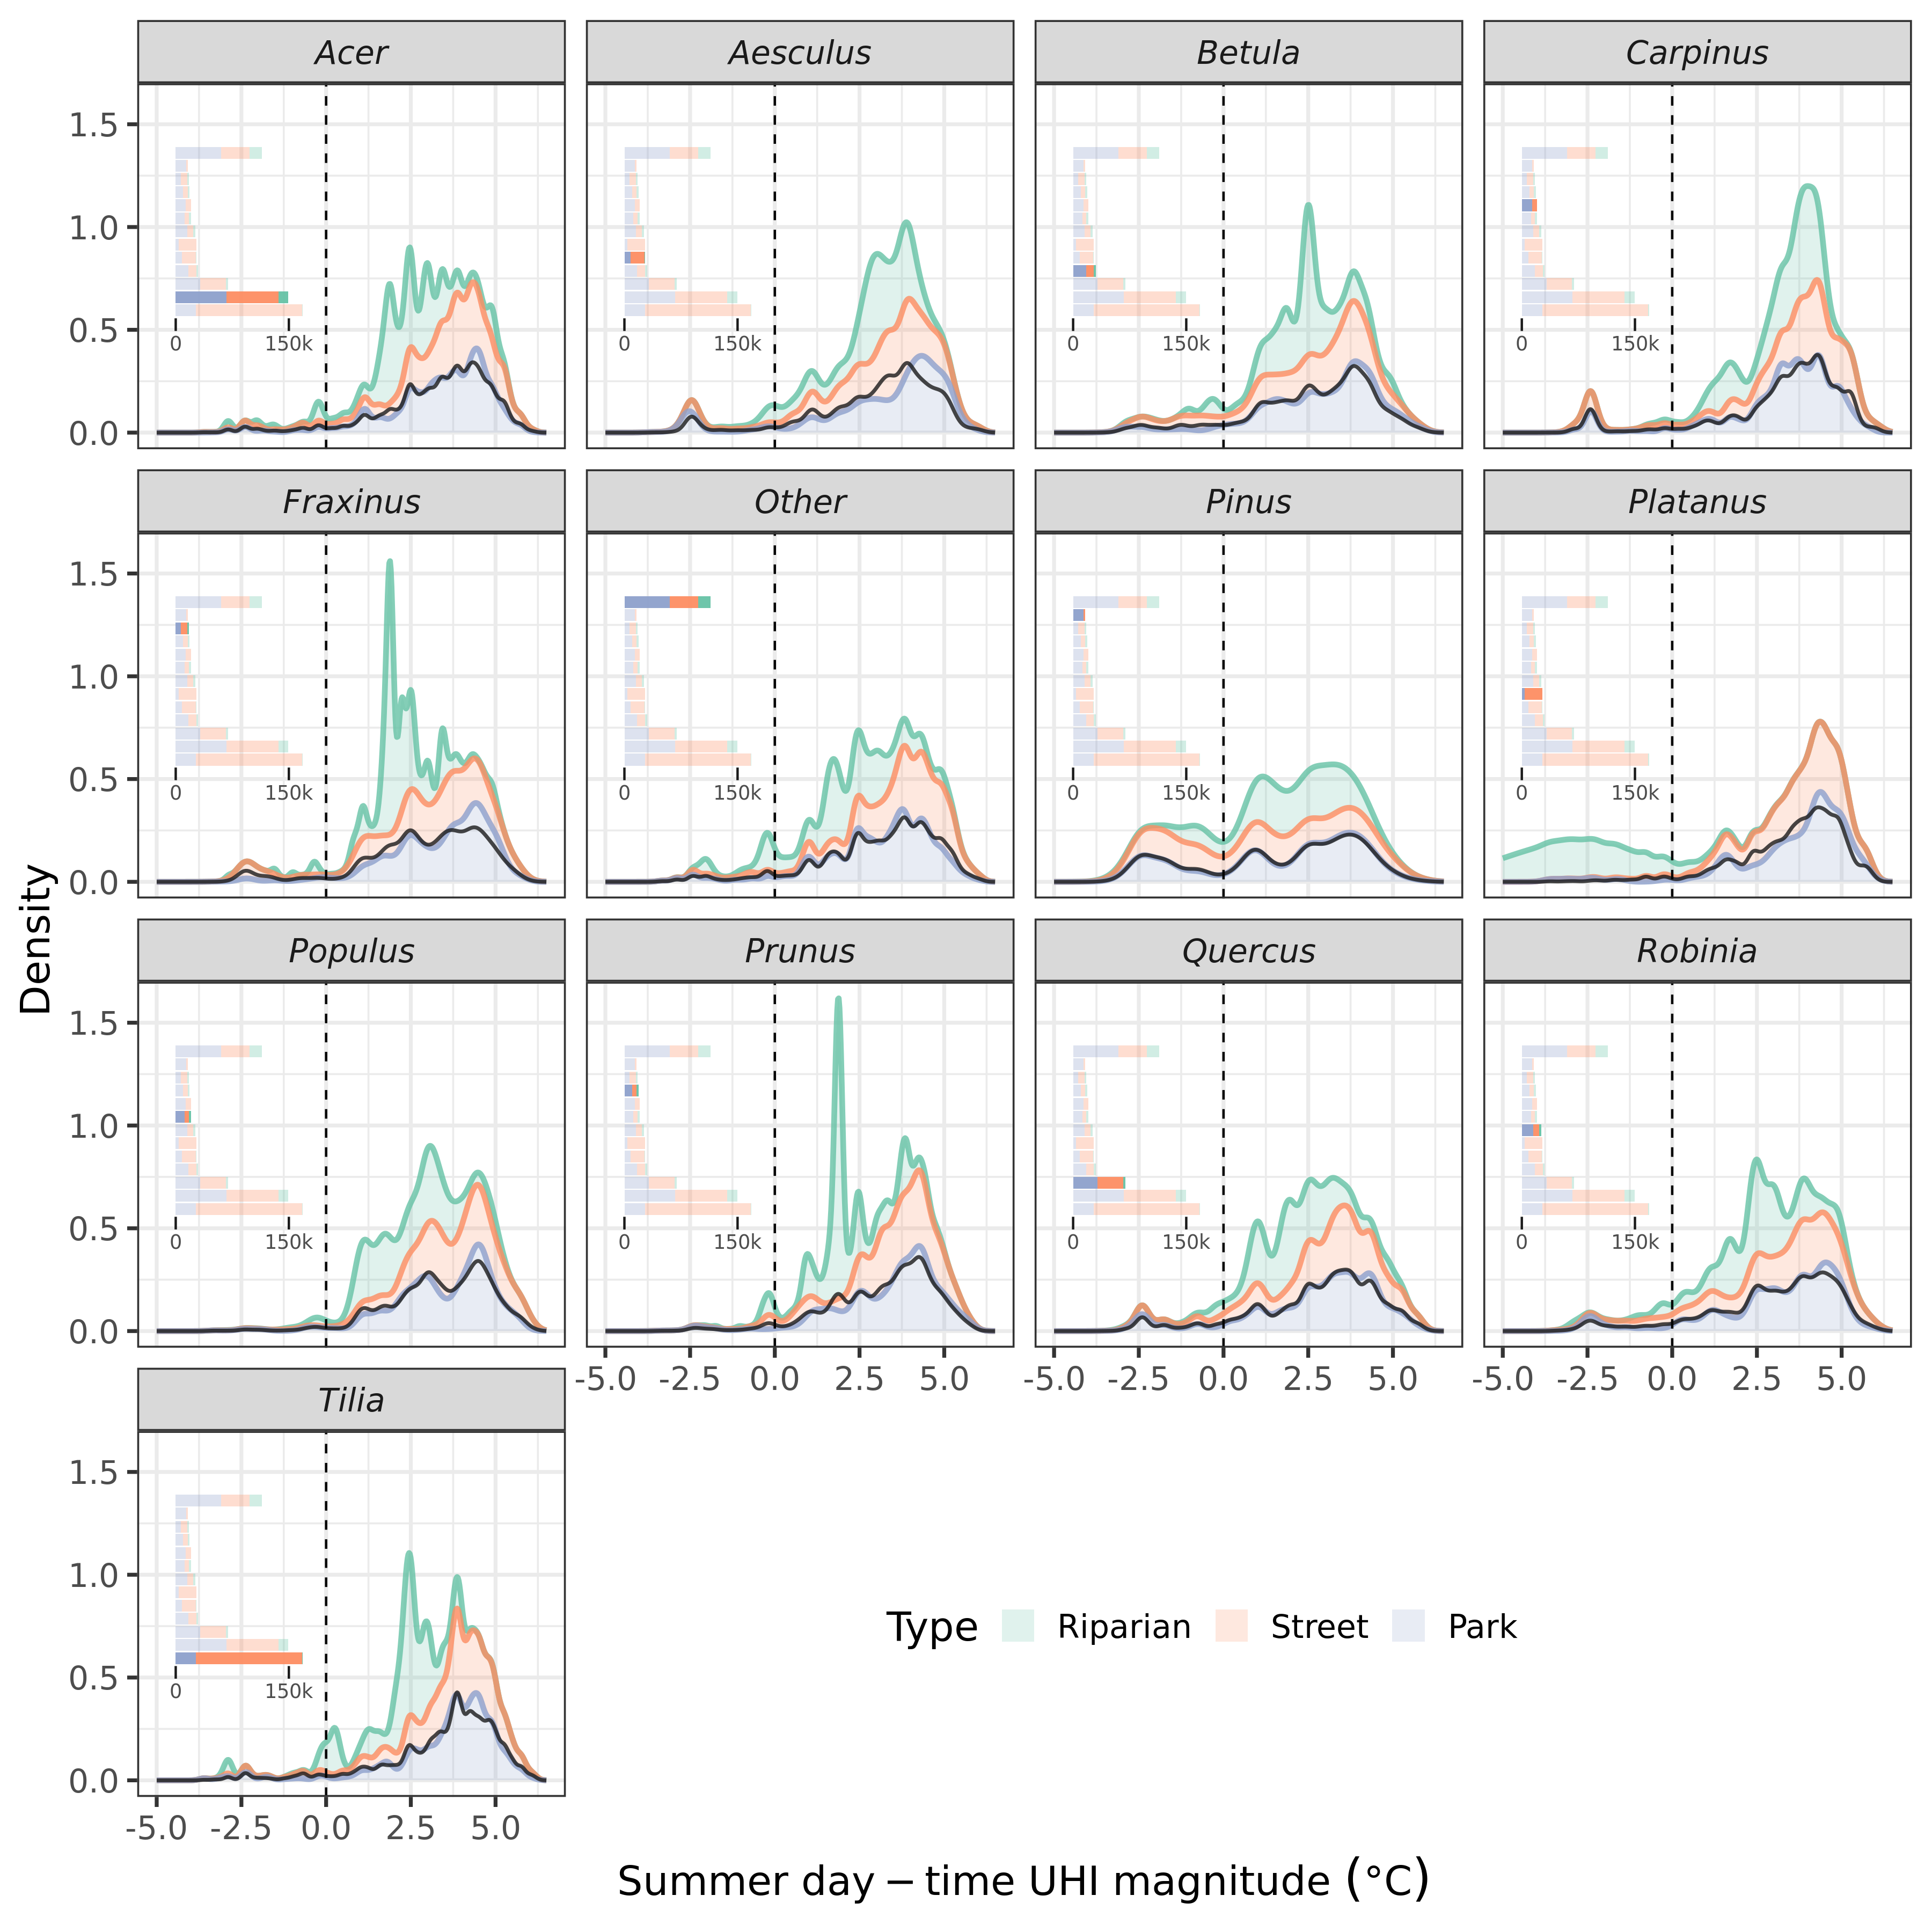

Figure 3.4: Empirical density distribution of all individuals within the presented genera along the UHI continuum. UHI intensities were extracted for each tree location, and the distribution hence represents the first detailed overview of the exposure of Berlin’s trees to urban heat loading. The black line is the density across all three categories. Insets show corresponding tree totals.

**Note, that results below are preliminary and should be considered as a template for future outputs, rather than used for inference.** The effect of UHI loading on absolute growth potential varies between genera and species (Fig.3.5). Most notably, *Quercus*, the 3rd-most frequent genera, shows decreased absolute growth with increasing UHI loading, while the most frequent genera, *Tilia*, features contrasting relationships between species. The estimated effect sizes presented here are linear. However, temperature may exert a non-linear control on absolute growth and, hence, applying a method able to capture such dynamics may result in somewhat different effect sizes / behavior. Additionally, if temperatures increase in the future under climate warming, any non-linear effects may become more enhanced, stressing the need for a more flexible model fit and structure (i.e. using GAMM over linear models-).

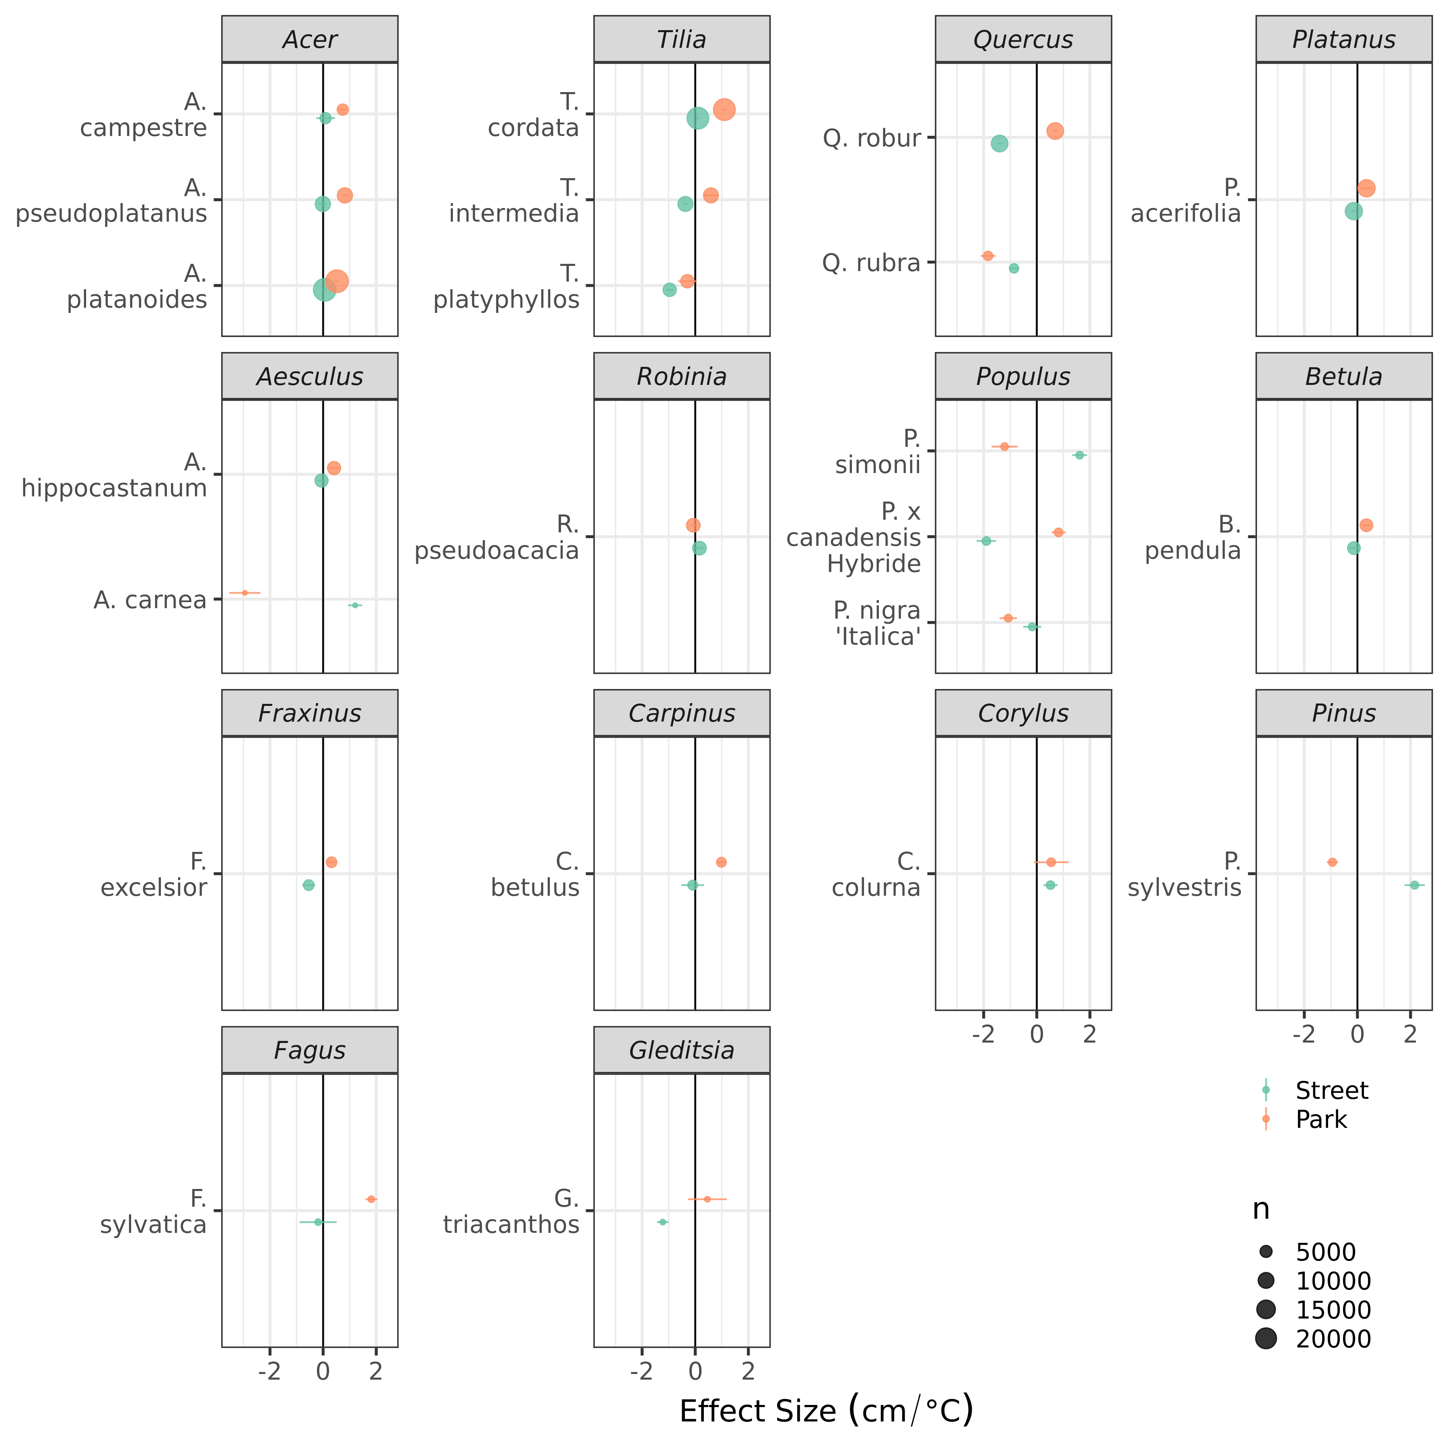

Figure 3.5: Impact of UHI loading on tree diameter (), accounting for age and inter-specific differences from the linear mixed model (via random slopes and intercepts). Line-ranges are standard errors of predicted effect sizes (i.e. slopes). Differences between street and park trees are considerable for some species, and may be due to local clustering and/or spatial under-representation across the UHI continuum. Further investigations need to address the degree of spatial autocorrelation and account for it where required in linear mixed models, and with smoothing interactions in a GAMM implementation.

# 4 Outlook

We seek to build upon and improve the current analysis by:

* validating the database with independent observations
* incorporating more pertinent covariates as dependent variables in the linear mixed model
* testing multiple model structures with formal model selection procedures
* checking model residuals for spatial auto-correlation and accounting for it where necessary to ensure unbiased estimates of effect sizes
* repeating the above with a hierarchical GAM (i.e. GAMM) to allow for:
  + estimating continuous prediction surfaces for UHI impacts on individual species’ growth (similar to results in Figure3.5) under recent conditions
  + estimating absolute, species-specific growth potential under increased temperatures and UHI loading under climate change, ideally based on climate simulations (otherwise step-wise increases based on RCP scenarios) for the key species. Note, that complications presented by ‘out-of-sample’ predictions will be addressed.
  + assess potential age-dependent UHI impacts on individual species.
  + repeating the above (GAMM) with total and incremental basal area as responses

# 5 References

Akbari, H., Pomerantz, M., Taha, H., 2001. Cool surfaces and shade trees to reduce energy use and improve air quality in urban areas. Solar Energy, Urban Environment 70, 295–310. <https://doi.org/10.1016/S0038-092X(00)00089-X>

Augustin, N.H., Musio, M., von Wilpert, K., Kublin, E., Wood, S.N., Schumacher, M., 2009. Modeling Spatiotemporal Forest Health Monitoring Data. Journal of the American Statistical Association 104, 899–911. <https://doi.org/10.1198/jasa.2009.ap07058>

Bates, D., Mächler, M., Bolker, B., Walker, S., 2015. Fitting linear mixed-effects models using lme4. Journal of Statistical Software 67, 1–48. <https://doi.org/10.18637/jss.v067.i01>

Brune, M., 2016. Urban trees under climate change. Potential impacts of dry spells and heat waves in three German regions in the 2050s (No. Report 24). Climate Service Center Germany, Hamburg.

Chakraborty, T., Lee, X., 2019. A simplified urban-extent algorithm to characterize surface urban heat islands on a global scale and examine vegetation control on their spatiotemporal variability. International Journal of Applied Earth Observation and Geoinformation 74, 269–280. <https://doi.org/10.1016/j.jag.2018.09.015>

Dahlhausen, J., Rötzer, T., Biber, P., Uhl, E., Pretzsch, H., 2018. Urban climate modifies tree growth in Berlin. Int J Biometeorol 62, 795–808. <https://doi.org/10.1007/s00484-017-1481-3>

Endlicher, W., Scherer, D., Büter, B., Kuttler, W., Mathey, J., Schneider, C., 2016. Stadtnatur fördert gutes Stadtklima, in: Ökosystemleistungen in Der Stadt – Gesundheit Schützen Und Lebensqualität Erhöhen, 3.1. TEEB DE. TU Berlin, UFZ Leipzig, Berlin, Leipzig, pp. 51–63.

Fenner, D., Meier, F., Scherer, D., Polze, A., 2014. Spatial and temporal air temperature variability in Berlin, Germany, during the years 2001–2010. Urban Climate, ICUC8: The 8th International Conference on Urban Climate and the 10th Symposium on the Urban Environment 10, 308–331. <https://doi.org/10.1016/j.uclim.2014.02.004>

Gillner, S., Bräuning, A., Roloff, A., 2014. Dendrochronological analysis of urban trees: Climatic response and impact of drought on frequently used tree species. Trees 28, 1079–1093. <https://doi.org/10.1007/s00468-014-1019-9>

Gillner, S., Vogt, J., Tharang, A., Dettmann, S., Roloff, A., 2015. Role of street trees in mitigating effects of heat and drought at highly sealed urban sites. Landscape and Urban Planning 143, 33–42. <https://doi.org/10.1016/j.landurbplan.2015.06.005>

Grimmond, C., Souch, C., Hubble, M., 1996. Influence of tree cover on summertime surface energy balance fluxes, San Gabriel Valley, Los Angeles. Clim. Res. 6, 45–57. <https://doi.org/10.3354/cr006045>

Gulyás, Á., Unger, J., Matzarakis, A., 2006. Assessment of the microclimatic and human comfort conditions in a complex urban environment: Modelling and measurements. Building and Environment 41, 1713–1722. <https://doi.org/10.1016/j.buildenv.2005.07.001>

Hertel, D., Schlink, U., 2019. Decomposition of urban temperatures for targeted climate change adaptation. Environmental Modelling & Software 113, 20–28. <https://doi.org/10.1016/j.envsoft.2018.11.015>

Hoyano, A., 1988. Climatological uses of plants for solar control and the effects on the thermal environment of a building. Energy and Buildings 11, 181–199. <https://doi.org/10.1016/0378-7788(88)90035-7>

Jia, W., Zhao, S., Liu, S., 2018. Vegetation growth enhancement in urban environments of the Conterminous United States. Global Change Biology 24, 4084–4094. <https://doi.org/10.1111/gcb.14317>

Kuttler, W., Miethke, A., Dütemeyer, D., Barlag, A.-B. (Eds.), 2015. Das klima von essen = the climate of essen. Westarp Wiss., Hohenwarsleben.

Maras, I., Schmidt, T., Paas, B., Ziefle, M., Schneider, C., 2016. The impact of human-biometeorological factors on perceived thermal comfort in urban public places. <https://doi.org/http://dx.doi.org/10.18452/18162>

Mayer, H., Höppe, P., 1987. Thermal comfort of man in different urban environments. Theor Appl Climatol 38, 43–49. <https://doi.org/10.1007/BF00866252>

Moser-Reischl, A., Rahman, M.A., Pauleit, S., Pretzsch, H., Rötzer, T., 2019. Growth patterns and effects of urban micro-climate on two physiologically contrasting urban tree species. Landscape and Urban Planning 183, 88–99. <https://doi.org/10.1016/j.landurbplan.2018.11.004>

Norton, B.A., Coutts, A.M., Livesley, S.J., Harris, R.J., Hunter, A.M., Williams, N.S.G., 2015. Planning for cooler cities: A framework to prioritise green infrastructure to mitigate high temperatures in urban landscapes. Landscape and Urban Planning 134, 127–138. <https://doi.org/10.1016/j.landurbplan.2014.10.018>

Oke, T.R., 1982. The energetic basis of the urban heat island. Quarterly Journal of the Royal Meteorological Society 108, 1–24. <https://doi.org/10.1002/qj.49710845502>

Pauleit, S., Jones, N., Garcia-Martin, G., Garcia-Valdecantos, J.L., Rivière, L.M., Vidal-Beaudet, L., Bodson, M., Randrup, T.B., 2002. Tree establishment practice in towns and cities – Results from a European survey. Urban Forestry & Urban Greening 1, 83–96. <https://doi.org/10.1078/1618-8667-00009>

Pedersen, E.J., Miller, D.L., Simpson, G.L., Ross, N., 2019. Hierarchical generalized additive models in ecology: An introduction with mgcv. PeerJ 7, e6876. <https://doi.org/10.7717/peerj.6876>

Pretzsch, H., Biber, P., Uhl, E., Dahlhausen, J., Schütze, G., Perkins, D., Rötzer, T., Caldentey, J., Koike, T., Con, T. van, Chavanne, A., Toit, B. du, Foster, K., Lefer, B., 2017. Climate change accelerates growth of urban trees in metropolises worldwide. Scientific Reports 7, 1–10. <https://doi.org/10.1038/s41598-017-14831-w>

Quigley, M.F., 2004. Street trees and rural conspecifics: Will long-lived trees reach full size in urban conditions? Urban Ecosystems 7, 29–39. <https://doi.org/10.1023/B:UECO.0000020170.58404.e9>

Randrup, T.B., McPherson, E.G., Costello, L.R., 2001. A review of tree root conflicts with sidewalks, curbs, and roads. Urban Ecosystems 5, 209–225. <https://doi.org/10.1023/A:1024046004731>

R Core Team, 2020. R: A language and environment for statistical computing. R Foundation for Statistical Computing, Vienna, Austria.

Rhoades, R.W., Stipes, R.J., 1999. Growth of trees on the Virgina Tech Campus in response to various factors 7.

Roloff, A., Korn, S., Gillner, S., 2009. The Climate-Species-Matrix to select tree species for urban habitats considering climate change. Urban Forestry & Urban Greening 8, 295–308. <https://doi.org/10.1016/j.ufug.2009.08.002>

Tzoulas, K., Korpela, K., Venn, S., Yli-Pelkonen, V., Kaźmierczak, A., Niemela, J., James, P., 2007. Promoting ecosystem and human health in urban areas using Green Infrastructure: A literature review. Landscape and Urban Planning 81, 167–178. <https://doi.org/10.1016/j.landurbplan.2007.02.001>

Wood, S.N., 2017. Generalized additive models: An introduction with R. CRC press.

Zhao, S., Liu, S., Zhou, D., 2016. Prevalent vegetation growth enhancement in urban environment. PNAS 113, 6313–6318. <https://doi.org/10.1073/pnas.1602312113>

##### 5.0.0.0.1 pagebreak

### 5.0.1 Colophon

This report was generated on 2020-10-22 14:17:26 using the following computational environment and dependencies:

#> ─ Session info ───────────────────────────────────────────────────────────────  
#> setting value   
#> version R version 4.0.2 (2020-06-22)  
#> os Ubuntu 20.04.1 LTS   
#> system x86_64, linux-gnu   
#> ui X11   
#> language (EN)   
#> collate en_US.UTF-8   
#> ctype en_US.UTF-8   
#> tz Europe/Berlin   
#> date 2020-10-22   
#>   
#> ─ Packages ───────────────────────────────────────────────────────────────────  
#> ! package * version date lib source   
#> P abind * 1.4-5 2016-07-21 [?] CRAN (R 4.0.0)  
#> P assertthat 0.2.1 2019-03-21 [?] CRAN (R 4.0.0)  
#> P backports 1.1.10 2020-09-15 [?] CRAN (R 4.0.2)  
#> P base64url 1.4 2018-05-14 [?] CRAN (R 4.0.0)  
#> P blob 1.2.1 2020-01-20 [?] CRAN (R 4.0.0)  
#> P bookdown * 0.21 2020-10-13 [?] CRAN (R 4.0.2)  
#> P boot 1.3-25 2020-04-26 [?] CRAN (R 4.0.0)  
#> callr 3.5.1 2020-10-13 [1] CRAN (R 4.0.2)  
#> P ckanr * 0.5.0 2020-07-30 [?] CRAN (R 4.0.2)  
#> P class 7.3-17 2020-04-26 [?] CRAN (R 4.0.0)  
#> P classInt 0.4-3 2020-04-07 [?] CRAN (R 4.0.0)  
#> cli 2.1.0 2020-10-12 [1] CRAN (R 4.0.2)  
#> P codetools 0.2-16 2018-12-24 [?] CRAN (R 4.0.0)  
#> P colorspace 1.4-1 2019-03-18 [?] CRAN (R 4.0.0)  
#> P crayon 1.3.4 2017-09-16 [?] CRAN (R 4.0.0)  
#> P crul 1.0.0 2020-07-30 [?] CRAN (R 4.0.2)  
#> P curl 4.3 2019-12-02 [?] CRAN (R 4.0.0)  
#> P data.table * 1.13.2 2020-10-19 [?] CRAN (R 4.0.2)  
#> P DBI * 1.1.0 2019-12-15 [?] CRAN (R 4.0.0)  
#> P dbplyr 1.4.4 2020-05-27 [?] CRAN (R 4.0.0)  
#> P desc 1.2.0 2018-05-01 [?] CRAN (R 4.0.0)  
#> P devtools 2.3.2 2020-09-18 [?] CRAN (R 4.0.2)  
#> digest 0.6.26 2020-10-17 [1] CRAN (R 4.0.2)  
#> P dplyr * 1.0.2 2020-08-18 [?] CRAN (R 4.0.2)  
#> P drake * 7.12.6 2020-10-10 [?] CRAN (R 4.0.2)  
#> e1071 1.7-4 2020-10-14 [1] CRAN (R 4.0.2)  
#> P ellipsis 0.3.1 2020-05-15 [?] CRAN (R 4.0.0)  
#> P evaluate 0.14 2019-05-28 [?] CRAN (R 4.0.0)  
#> P extrafont * 0.17 2014-12-08 [?] CRAN (R 4.0.0)  
#> P extrafontdb 1.0 2012-06-11 [?] CRAN (R 4.0.0)  
#> P fansi 0.4.1 2020-01-08 [?] CRAN (R 4.0.0)  
#> P filelock 1.0.2 2018-10-05 [?] CRAN (R 4.0.0)  
#> P forcats * 0.5.0 2020-03-01 [?] CRAN (R 4.0.0)  
#> P fs 1.5.0 2020-07-31 [?] CRAN (R 4.0.2)  
#> P furrr * 0.2.0 2020-10-12 [?] CRAN (R 4.0.2)  
#> P future * 1.19.1 2020-09-22 [?] CRAN (R 4.0.2)  
#> P future.callr * 0.5.0 2019-09-28 [?] CRAN (R 4.0.0)  
#> P generics 0.0.2 2018-11-29 [?] CRAN (R 4.0.0)  
#> P ggplot2 * 3.3.2 2020-06-19 [?] CRAN (R 4.0.2)  
#> P git2r 0.27.1 2020-05-03 [?] CRAN (R 4.0.0)  
#> P globals 0.13.1 2020-10-11 [?] CRAN (R 4.0.2)  
#> P glue 1.4.2 2020-08-27 [?] CRAN (R 4.0.2)  
#> P gtable 0.3.0 2019-03-25 [?] CRAN (R 4.0.0)  
#> P here * 0.1 2017-05-28 [?] CRAN (R 4.0.0)  
#> P highr 0.8 2019-03-20 [?] CRAN (R 4.0.0)  
#> P htmltools 0.5.0 2020-06-16 [?] CRAN (R 4.0.2)  
#> P httpcode 0.3.0 2020-04-10 [?] CRAN (R 4.0.2)  
#> P httr * 1.4.2 2020-07-20 [?] CRAN (R 4.0.2)  
#> igraph 1.2.6 2020-10-06 [1] CRAN (R 4.0.2)  
#> P jsonlite 1.7.1 2020-09-07 [?] CRAN (R 4.0.2)  
#> P kableExtra * 1.2.1 2020-08-27 [?] CRAN (R 4.0.2)  
#> P KernSmooth 2.23-17 2020-04-26 [?] CRAN (R 4.0.0)  
#> knitr 1.30 2020-09-22 [1] CRAN (R 4.0.2)  
#> P lattice 0.20-41 2020-04-02 [?] CRAN (R 4.0.0)  
#> P lifecycle 0.2.0 2020-03-06 [?] CRAN (R 4.0.0)  
#> P listenv 0.8.0 2019-12-05 [?] CRAN (R 4.0.0)  
#> P lme4 * 1.1-23 2020-04-07 [?] CRAN (R 4.0.0)  
#> P lwgeom 0.2-5 2020-06-12 [?] CRAN (R 4.0.2)  
#> P magrittr * 1.5 2014-11-22 [?] CRAN (R 4.0.0)  
#> P MASS 7.3-53 2020-09-09 [?] CRAN (R 4.0.2)  
#> P Matrix * 1.2-18 2019-11-27 [?] CRAN (R 4.0.0)  
#> P memoise 1.1.0 2017-04-21 [?] CRAN (R 4.0.0)  
#> P minqa 1.2.4 2014-10-09 [?] CRAN (R 4.0.0)  
#> P munsell 0.5.0 2018-06-12 [?] CRAN (R 4.0.0)  
#> P nlme 3.1-149 2020-08-23 [?] CRAN (R 4.0.2)  
#> P nloptr 1.2.2.2 2020-07-02 [?] CRAN (R 4.0.2)  
#> P pillar 1.4.6 2020-07-10 [?] CRAN (R 4.0.2)  
#> P pkgbuild 1.1.0 2020-07-13 [?] CRAN (R 4.0.2)  
#> P pkgconfig 2.0.3 2019-09-22 [?] CRAN (R 4.0.0)  
#> P pkgload 1.1.0 2020-05-29 [?] CRAN (R 4.0.0)  
#> P prettyunits 1.1.1 2020-01-24 [?] CRAN (R 4.0.0)  
#> P processx 3.4.4 2020-09-03 [?] CRAN (R 4.0.2)  
#> P ps 1.4.0 2020-10-07 [?] CRAN (R 4.0.2)  
#> P purrr * 0.3.4 2020-04-17 [?] CRAN (R 4.0.0)  
#> P R6 2.4.1 2019-11-12 [?] CRAN (R 4.0.0)  
#> P raster * 3.3-13 2020-07-17 [?] CRAN (R 4.0.2)  
#> P Rcpp 1.0.5 2020-07-06 [?] CRAN (R 4.0.2)  
#> P remotes 2.2.0 2020-07-21 [?] CRAN (R 4.0.2)  
#> renv 0.12.0 2020-08-28 [1] CRAN (R 4.0.2)  
#> P rgdal * 1.5-18 2020-10-13 [?] CRAN (R 4.0.2)  
#> P rlang * 0.4.8 2020-10-08 [?] CRAN (R 4.0.2)  
#> P rmarkdown * 2.5 2020-10-21 [?] CRAN (R 4.0.2)  
#> P rprojroot 1.3-2 2018-01-03 [?] CRAN (R 4.0.0)  
#> P rstudioapi 0.11 2020-02-07 [?] CRAN (R 4.0.0)  
#> P Rttf2pt1 1.3.8 2020-01-10 [?] CRAN (R 4.0.0)  
#> P rvest 0.3.6 2020-07-25 [?] CRAN (R 4.0.2)  
#> P scales * 1.1.1 2020-05-11 [?] CRAN (R 4.0.0)  
#> P sessioninfo 1.1.1 2018-11-05 [?] CRAN (R 4.0.0)  
#> P sf * 0.9-6 2020-09-13 [?] CRAN (R 4.0.2)  
#> P sp * 1.4-4 2020-10-07 [?] CRAN (R 4.0.2)  
#> P stars * 0.4-3 2020-07-08 [?] CRAN (R 4.0.2)  
#> P statmod 1.4.35 2020-10-19 [?] CRAN (R 4.0.2)  
#> storr 1.2.4 2020-10-12 [1] CRAN (R 4.0.2)  
#> P stringi 1.5.3 2020-09-09 [?] CRAN (R 4.0.2)  
#> P stringr * 1.4.0 2019-02-10 [?] CRAN (R 4.0.0)  
#> P testthat 2.3.2 2020-03-02 [?] CRAN (R 4.0.0)  
#> P tibble * 3.0.4 2020-10-12 [?] CRAN (R 4.0.2)  
#> P tidyselect 1.1.0 2020-05-11 [?] CRAN (R 4.0.0)  
#> P txtq 0.2.3 2020-06-23 [?] CRAN (R 4.0.2)  
#> P units 0.6-7 2020-06-13 [?] CRAN (R 4.0.2)  
#> P usethis 1.6.3 2020-09-17 [?] CRAN (R 4.0.2)  
#> P vctrs 0.3.4 2020-08-29 [?] CRAN (R 4.0.2)  
#> P viridisLite 0.3.0 2018-02-01 [?] CRAN (R 4.0.0)  
#> P webshot 0.5.2 2019-11-22 [?] CRAN (R 4.0.2)  
#> P withr 2.3.0 2020-09-22 [?] CRAN (R 4.0.2)  
#> xfun 0.18 2020-09-29 [1] CRAN (R 4.0.2)  
#> P xml2 * 1.3.2 2020-04-23 [?] CRAN (R 4.0.0)  
#> P yaml 2.2.1 2020-02-01 [?] CRAN (R 4.0.0)  
#>   
#> [1] /home/hurley/_work/renv/berlin.trees/R-4.0/x86_64-pc-linux-gnu  
#> [2] /usr/lib/R/site-library  
#> [3] /usr/lib/R/library  
#> [4] /tmp/RtmpECuCVo/renv-system-library  
#>   
#> P ── Loaded and on-disk path mismatch.

The current Git commit details are:

#> Local: master /home/hurley/_work/p_024_GFZ_berlin_trees/berlin.trees  
#> Remote: master @ origin (https://github.com/the-Hull/berlin.trees)  
#> Head: [2e305b2] 2020-10-21: add baumscheiben join