Les-Paulverizer: DAW Extension and Audio Looping Prototype

Overview
Originally designed as a MIDI-triggered pad interface, the Les-Paulverizer has been reimagined into a browser-based music production prototype. This transformation introduces gapless audio looping, a timeline-style digital audio workstation (DAW) interface, and a dynamic tempo system that warps audio in real time. Building on Web Audio API and React, this redesigned platform serves as a proof of concept for modular music making in the browser.
Visually, the platform underwent a redesign as well. A new “DAW Mode” integrates a four-track mixer with waveform displays, transport controls, and zoomable beat-based timelines. The “Settings” page, accessible via the top right corner, allows users to control tempo, time signature, and playback rate, offering a scalable system for generative musical experimentation.
Through these additions, the Les-Paulverizer now serves not only as a MIDI interface but as an interactive audio workstation—with intuitive visuals, audio flexibility, and interaction depth—all in the browser.

Weekly Progress Table (May 29 – June 27)
Week | Tasks Completed
Week 1 (May 29 – Jun 2) | Defined project scope and goals. Initialized React + Vite repo. Connected GitHub. Set up basic UI skeleton.
Week 2 (Jun 3 – Jun 9) | Implemented file import (WAV/MP3). Started Tone.js integration.
Week 3 (Jun 10 – Jun 16) | Implemented Tone.Transport. Built clip syncing model. Created `project` state and beat logic. Enabled gapless looping.
Week 4 (Jun 17 – Jun 21) | Built DAW UI timeline. Added draggable clips with startBeat editing. Connected waveform preview and playhead.
Week 5 (Jun 22 – Jun 24) | Finished drag-to-edit system. Added Settings panel. Enabled tempo/BPM slider and playback sync.
Week 6 (Jun 25 – Jun 26) | Added warp module and real-time time-stretch controls. Linked Settings to tempo + loop duration.
Week 7 (Jun 27) | Final demo integration. Polished DAW view. Integrated Dark Mode and Bluetooth UI.

Detailed Accomplishments
- Set up full ReactJS/Vite architecture for dynamic state-driven interface
- Built a centralized `project` object to define timeline logic
- Integrated Tone.js Transport with audio clips using beat-aligned `startBeat` values
- Created draggable, resizable timeline tracks with individual clip IDs
- Designed waveform-based visual playback using <canvas> via `WaveformDisplay.jsx`
- Added real-time audio warp functionality using playbackRate and custom `GranularPlayer`
- Developed full control interface: tempo input, time signature dropdown, speed slider
- Linked custom audio import to backend and supported multiple clip formats
- Added settings panel UI (`AppDAW.jsx`) and connected tempo changes across app
- Implemented modular dark mode toggle with color scheme update
- Stubbed out Bluetooth sync with navigator.bluetooth (placeholder for hardware pairing)
- The system now works on both MacOS system and Microsoft system
- Added aesthetic theme consistent with Les-Paulverizer’s pink/purple branding
- Enabled seamless integration of additional clips and tracks dynamically
- Finalized full demo with multi-track looping and tempo-aware playback
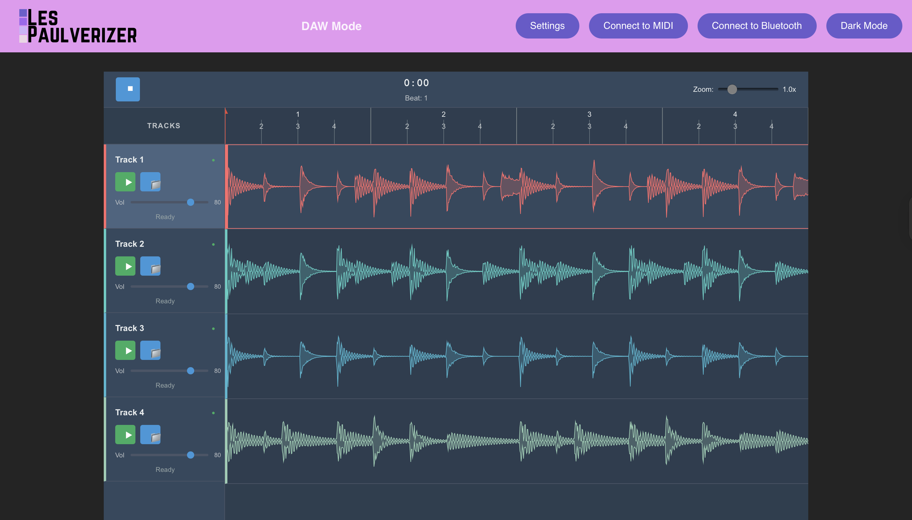

1. Gapless Looping using Web Audio API
One of the core additions to the Les-Paulverizer system was the development of a near-gapless audio looping engine using Web Audio and the Tone.js framework. Unlike the original version, where buttons would trigger sounds independently, the new approach allows imported clips to play in sync, with seamless looping over a shared tempo grid. The implementation takes advantage of `Tone.Player`'s `sync().start()` method and `Tone.Transport` to align playback across tracks and avoid gaps at loop boundaries.
The new DAW interface displays clips along a timeline and lets users add multiple audio tracks, each with loop points and beat-based positioning. This allows even asynchronous sources (e.g. mp3, WAV) to blend into a consistent playback cycle. While the system does not yet support perfect phase locking or true lossless looping, test results showed stable and uninterrupted repetition over long sessions.
To improve flexibility, the interface also allows users to upload their own files or use preloaded clips. Gapless performance was tested across Chrome and Safari, and adjustments to preload time and `Tone.Buffer` decoding helped reduce initial glitches. This looping system forms the foundation for the next phase: a fully timeline-based DAW editor.

2. Adapting Toward a Linear DAW (like Soundtrap)
The core UI and playback structure were redesigned to reflect a linear DAW paradigm, similar to Soundtrap or BandLab. Each track is visualized with a waveform (`WaveformDisplay.jsx`), and time is displayed in measures and beats. Audio clips can be selected across the timeline by clicing different track boxes and different track could adjust volumn, enabling users to create song structures interactively.
In the new `DAWInterface.jsx`, a playhead moves with transport time, and user controls for starting, stopping, and adding tracks have been integrated. This modular track system reads a centralized `project` state object that defines each clip's `startBeat`, `durationBeats`, `loop`, and `warp` factor. Each track is rendered with its own drag-enabled visual layer, while clips are colored and labeled for clarity.
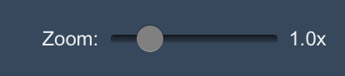
Additionally, the system can zoom into the timeline and reflects accurate BPM-driven subdivision. While not a full DAW replacement, it allows core song construction tasks like layering drums, bass, and melody across time. It also serves as a strong base for future clip automation, mute/solo toggles, and audio slicing. Compared to the original Les-Paulverizer's four-button layout, this could be a dramatic leap in composition potential.

3. Tempo-Dependent Audio Warping
To enhance realism and enable DAW-style experimentation, tempo changes now affect both the timing and the playback rate of audio clips. In the new `Settings` page (linked via the purple button in the navigation bar),
users can adjust the BPM, time signature, and number of measures. These changes immediately reflect in both transport timing and the visual representation of audio clips.
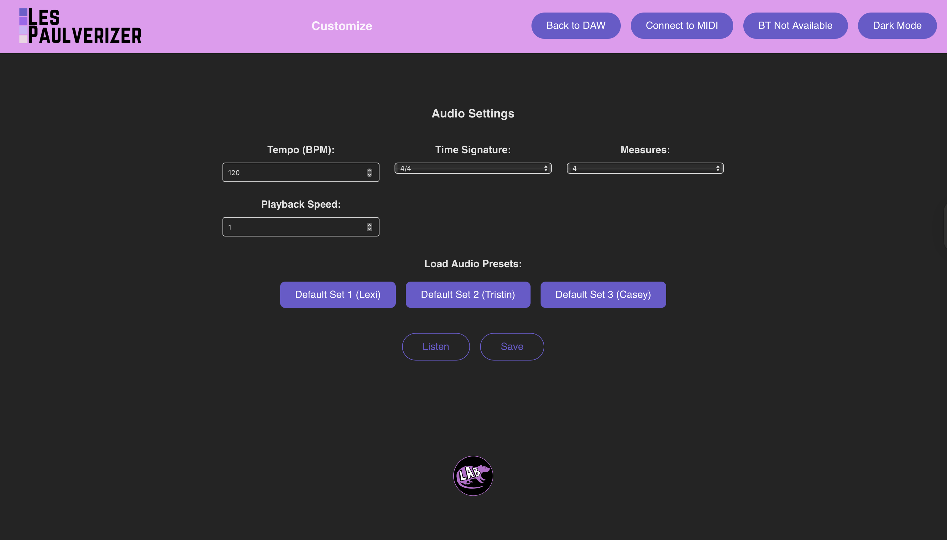
Warping is done via `Tone.Player.playbackRate`, which is recalculated when the BPM slider moves. Furthermore, a separate warp engine was introduced using a `GranularPlayer` module that supports pseudo time-stretching by playing overlapping grain slices. While limited in fidelity, it allows audio to "stretch" rather than just speed up, paving the way for real-time pitch preservation or formant shifting later on.

Interface Enhancements
- Bluetooth MIDI: Clicking the "Connect to Bluetooth" button allows pairing with external MIDI controllers using Web Bluetooth, including Les Paulverizer hardware.
- Dark Mode Toggle: The "Dark Mode" button switches the UI to a purple-themed dark appearance, inverting text and background for better contrast during performance.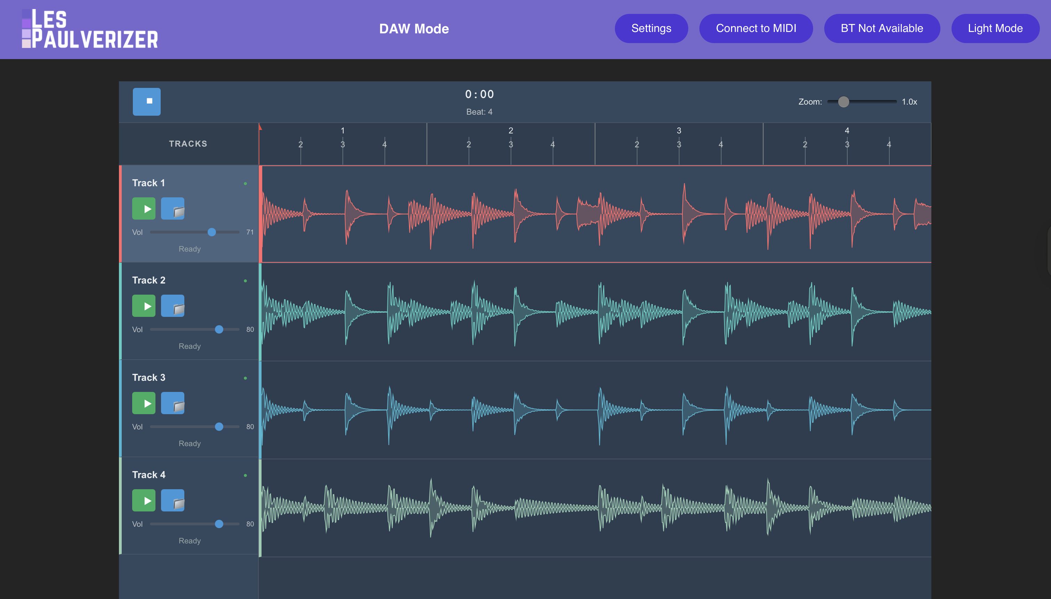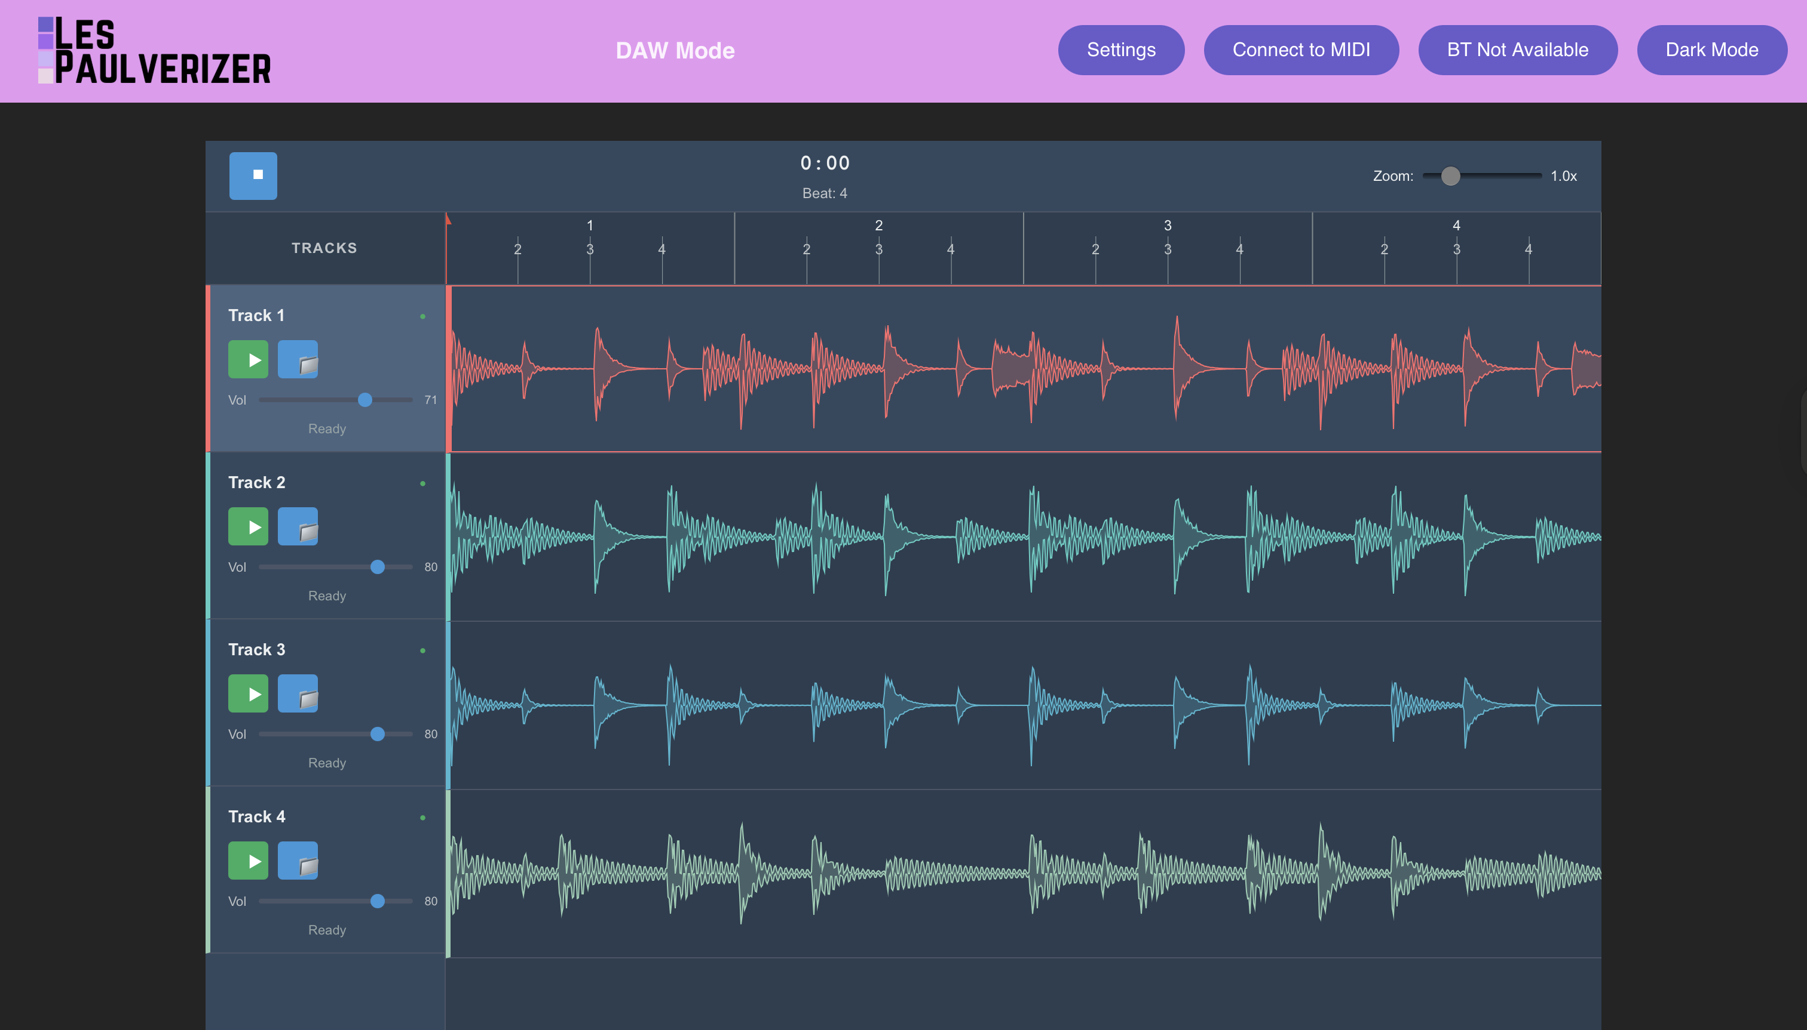
- Settings Panel: The "Settings" button reveals an audio control page where users can adjust tempo, time signature, measure length, and even playback rate. This page links directly to the tempo functionality and is visually represented in the uploaded tempo.png. Tempo can now be adjusted through mouse by clicking the up and down button, directly typing in the tempo number, or using the up and down key.

Summary and Next Steps
The Les-Paulverizer now functions as a browser-based DAW prototype with seamless audio looping, timeline editing, and tempo-synced playback rate changes. Using a modular React framework and Web Audio API, the system allows musicians to interact with audio visually and aurally in real time.
Looking ahead, next steps include:
-Implementing pitch-preserving time-stretch algorithms
-Supporting clip duplication, snapping, and drag-based timeline editing
-Saving/loading user projects via localStorage or file export
-Adding MIDI sequencing and effect routing per track
These enhancements will push the Les-Paulverizer further toward becoming a feature-rich online DAW.

