# Data Structures Project

Dataset Used: General Relativity and Quantum Cosmology collaboration network

Total Nodes: 5242

Total Nodes: 28980

Sink Nodes: 0

Source Nodes: 0

From this it can be concluded that there are no separate nodes or Isolated nodes and all the nodes are connected to each other somehow.

Degree Distribution: All the degree distributions wether they are In or out are evenly distributed and all of them are very low as all of them have values greater than 2 decimal places

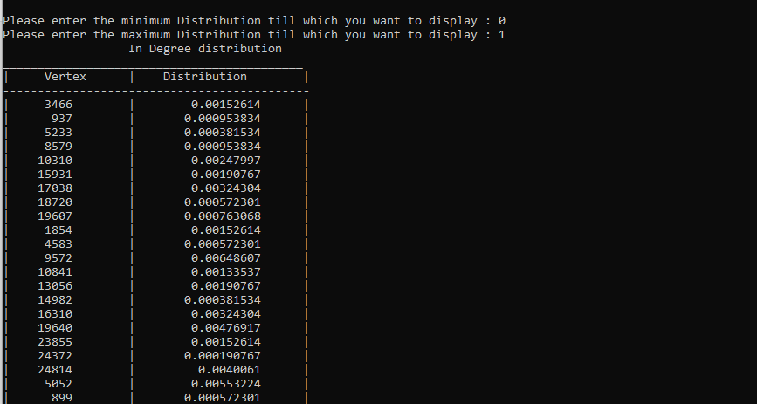

Shortest Paths Distribution: Most of the shortest paths have a length of 6 and most of the paths lie in the range of 4 to 8. The greatest length of shortest path (or the diameter of graph) is 17.

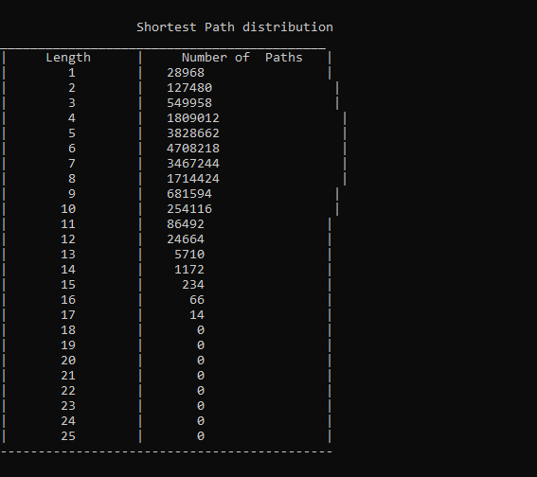

Connected Components:

There is only one Weakly connected component which is of Size 5242 means that whole graph resides in it and due to being a very large data it was impossible to calculate the Strongly connected components of this graph with the normal processing power.