Assignment 4: Packet Capturing Using Wireshark

Simrat Singh Chhabra 11010165

N M Harsha 11010144

Part A : Initial

7. Take a screenshot of this result. How many packets were transmitted from the IITG web server to your client in this.

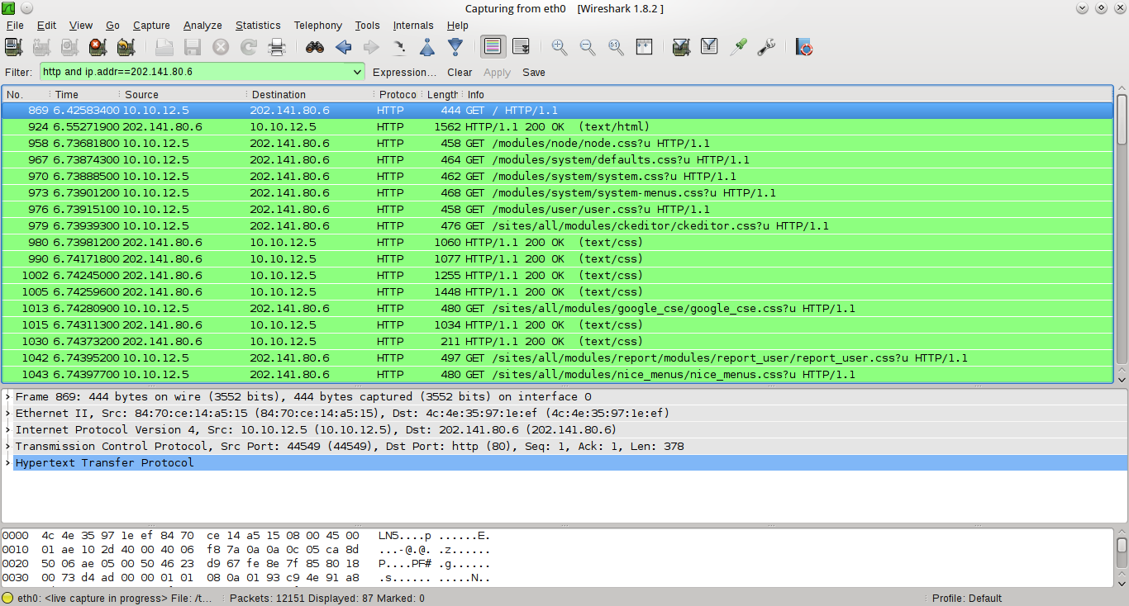
Packets belonging to the http session between host and IITG web server
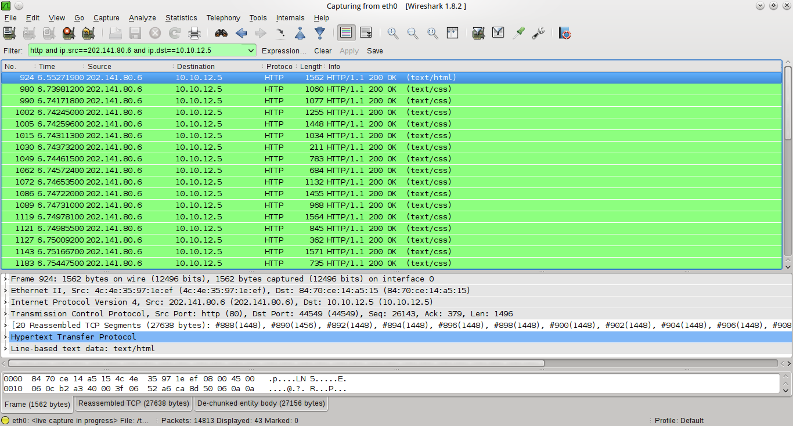
Packets sent from IITG web server to client

43 packets were transmitted from IITG web server to client.

Part B : HTTP

I. The Basic HTTP GET/response Interaction

Request

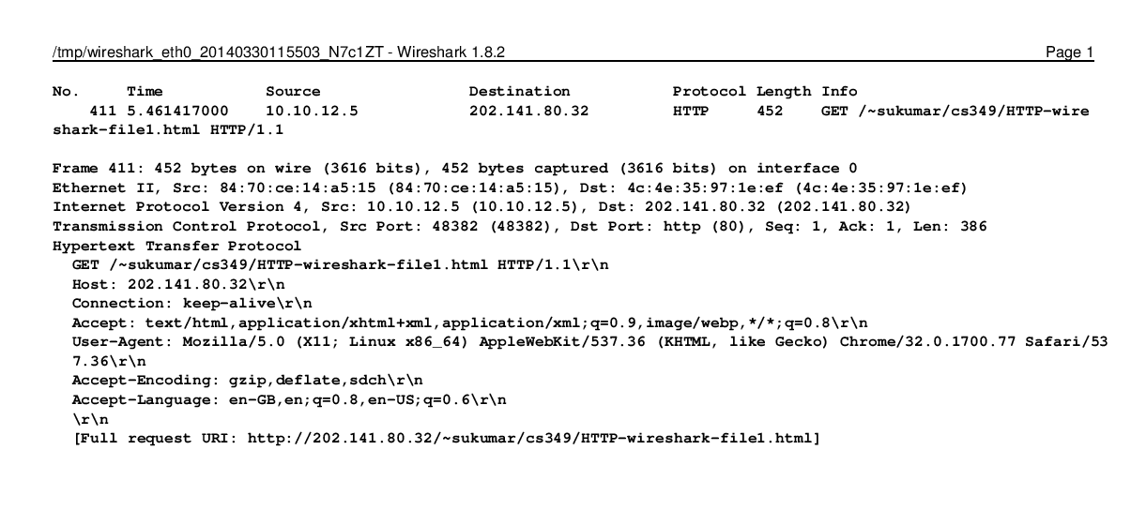
Response
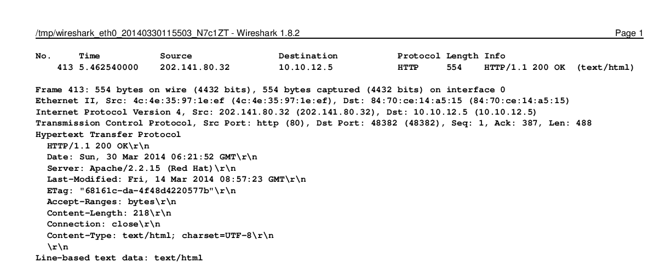
1. Is your browser running HTTP version 1.0 or 1.1? What version of HTTP is the
server running?

Ans : My browser is running HTTP version 1.1.
[GET /~sukumar/cs349/HTTP-wireshark-file1.html HTTP/1.1\r\n]

The server is also running HTTP 1.1.
[ HTTP/1.1 200 OK\r\n]

2. What languages (if any) does your browser indicate that it can accept to the
server?

Ans : The browser indicates that it can accept the following languages :
English (United Kingdom), English, English (United States)
[Accept-Language: en-GB,en;q=0.8,en-US;q=0.6\r\n]

3. What is the IP address of your computer?

Ans : The IP address of my computer is 10.10.12.5
[Internet Protocol Version 4, Src: 10.10.12.5 (10.10.12.5), Dst: 202.141.80.32 (202.141.80.32)]

4. What is the status code returned from the server to your browser?

Ans: The status returned from the server to my browser is 200 OK which means 'The request has succeeded.'
[HTTP/1.1 200 OK\r\n]
5. When was the HTML file that you are retrieving last modified at the server?

Ans : The HTML file was last modified on Fri, 14 Mar 2014 08:57:23 GMT.
[Last-Modified: Fri, 14 Mar 2014 08:57:23 GMT\r\n]

6. How many bytes of content are being returned to your browser?

Ans : 218 bytes are returned to the browser.
[Content-Length: 218\r\n]

7. By inspecting the raw data in the packet content window, do you see any headers within the data that are not displayed in the packet-listing window? If so, name one.

Ans :

II. The HTTP CONDITIONAL GET/response Interaction

First GET Message

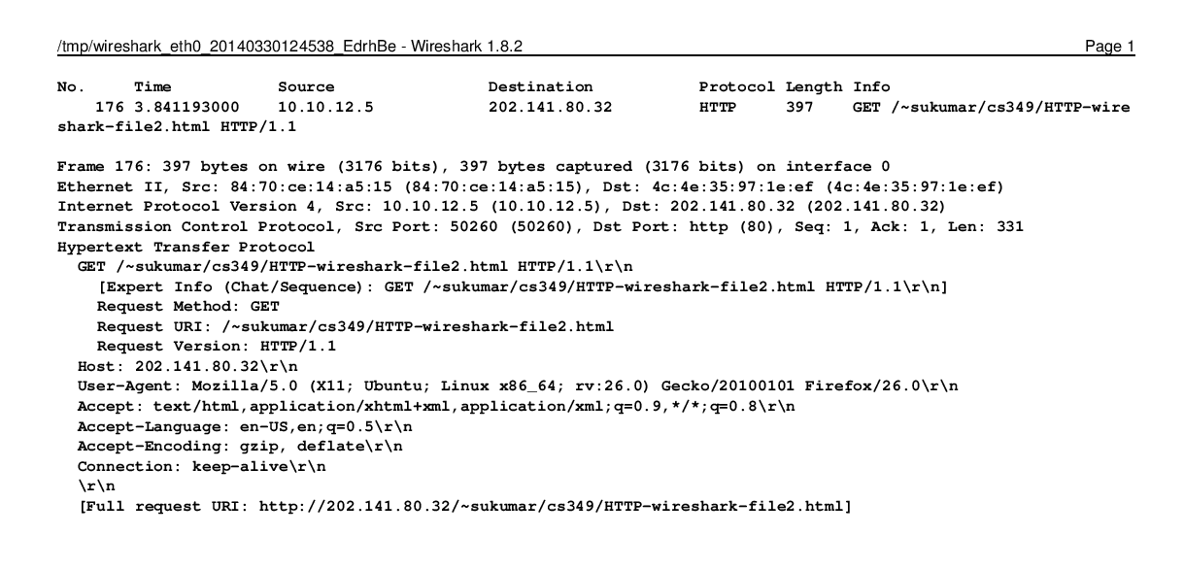

First Response

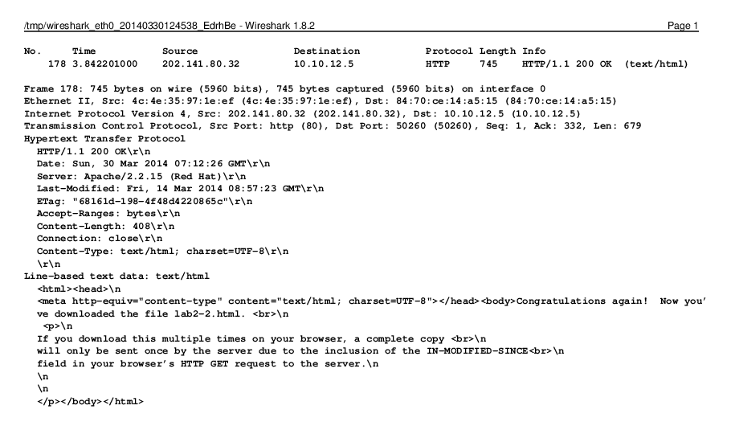
Second GET Message
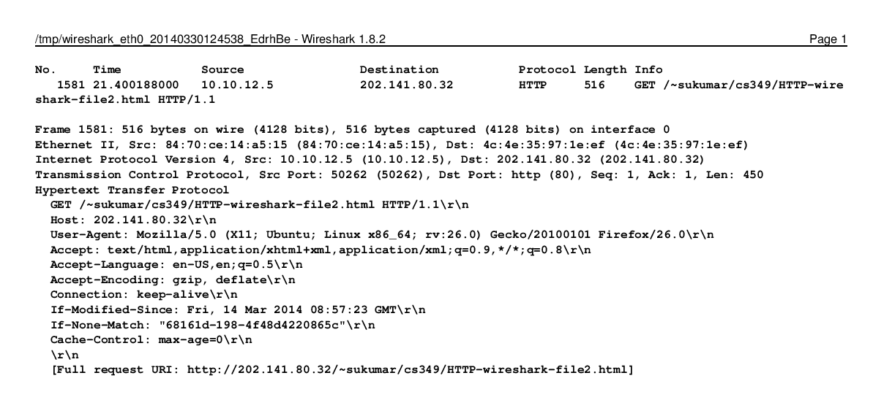

Second Response
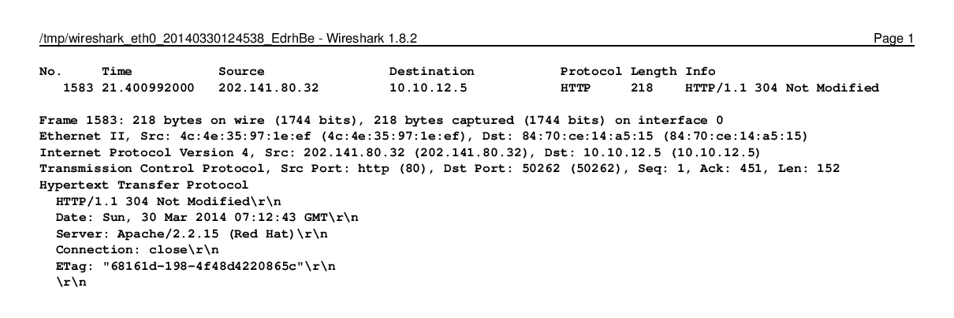

1. Inspect the contents of the first HTTP GET request from your browser to the
server. Do you see an “IF-MODIFIED-SINCE” line in the HTTP GET?

Ans : No, there is no “IF-MODIFIED-SINCE” line in the first HTTP GET request.

2. Inspect the contents of the server response. Did the server explicitly return the contents of the file? How can you tell?

Ans : Yes. The server returned the contents of the file.
We can see this here:

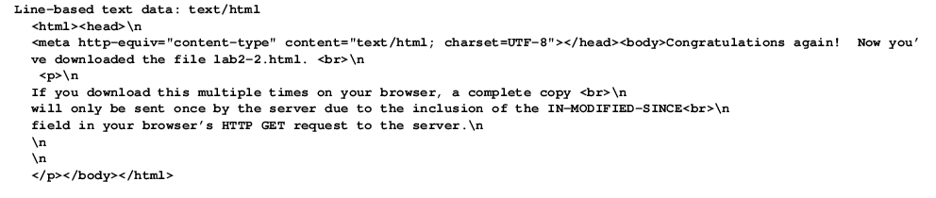
3. Now inspect the contents of the second HTTP GET request from your browser to the server. Do you see an “IF-MODIFIED-SINCE:” line in the HTTP GET? If so, what information follows the “IF-MODIFIED-SINCE:” header?

Ans : Yes, there is an “IF-MODIFIED-SINCE:” line in the second HTTP GET request.
[If-Modified-Since: Fri, 14 Mar 2014 08:57:23 GMT\r\n]
It tells the server that it should only return the contents of the file again if they have changed since Fri, 14 Mar 2014 08:57:23 GMT. (The last modified time of the file).

4. What is the HTTP status code and phrase returned from the server in response to this second HTTP GET? Did the server explicitly return the contents of the file? Explain.

Ans : The server returned the HTTP status code 304 along with the phrase Not Modified.
[HTTP/1.1 304 Not Modified\r\n]
The contents of the file were not explicitly returned.
The reason for this is that the second GET request was a conditional GET request with the header If-Modified-Since. As the contents of the file on the server has not been modified after Fri, 14 Mar 2014 08:57:23 GMT, the server returned a Not Modified response to indicate to the client that the file had not been modified and hence sending the contents again was not required.

