8/11/2018 Atul Gupta_KNIT
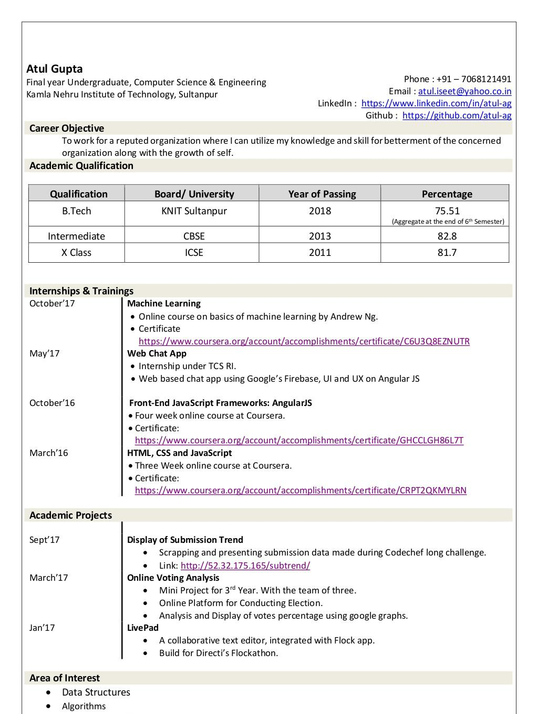

https://www.slideshare.net/slideshow/embed_code/key/dQ6yJ9ZNeRykF1 1/3

8/11/2018 Atul Gupta_KNIT
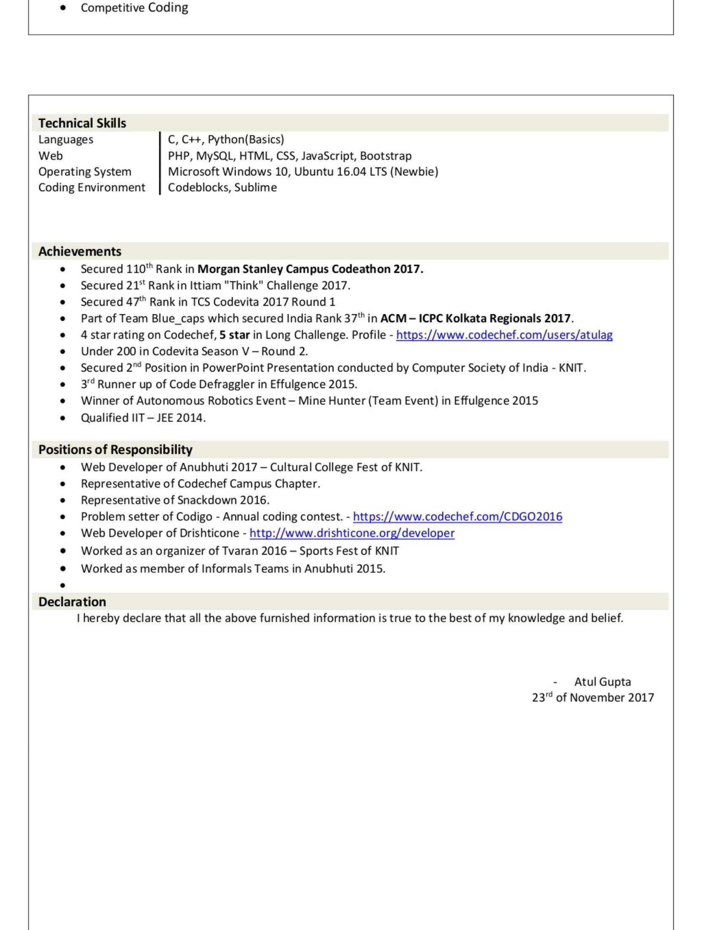

https://www.slideshare.net/slideshow/embed_code/key/dQ6yJ9ZNeRykF1 2/3

8/11/2018 Atul Gupta_KNIT


1 of 2

Like this slideshow? Why not share!

Share

Email

AI and Machine Learning Demystified... AI and Machine Learning Demystified... by Carol Smith 2479742 views
The AI Rush The AI Rush by Jean-Baptiste Dumont 668261 views
10 facts about jobs in the future 10 facts about jobs in the future by Pew Research Cent... 385036 views
2017 holiday survey: An annual anal... 2017 holiday survey: An annual anal... by Deloitte United S... 640452 views
Harry Surden - Artificial Intellige... Harry Surden - Artificial Intellige... by Harry Surden 339993 views Inside Google's Numbers in 2017 Inside Google's Numbers in 2017 by Rand Fishkin 897161 views

https://www.slideshare.net/slideshow/embed_code/key/dQ6yJ9ZNeRykF1 3/3

