AIML Narrative: Owen

**#1 Email**

[bradley.whitaker1@montana.edu](mailto:bradley.whitaker1@montana.edu)

**#2 Students**

Joseph Cartwright (undergraduate student intern)

**#11: Narrative for 1.4.4.a1, Milestone 1.**

Joey has been working on a sentiment analysis related to prescribed fires. In particular, Joey has been exploring Reddit data in metropolitan areas and sentiments related wildfire, as a means of better understanding the data and the spatial resolution of the analysis.

Our first step was to understand the Reddit data and the best way to acquire the data. We explored several options but ended up choosing access through the Reddit API. I also consulted with Dr. Ryan James, a local Reddit employee, to ascertain the best way to acquire location information for the data.

Once we decided on the means of acquiring data, Joey worked to download wildfire-relevant data and explore different option for sentiment analysis. He started by using VADER (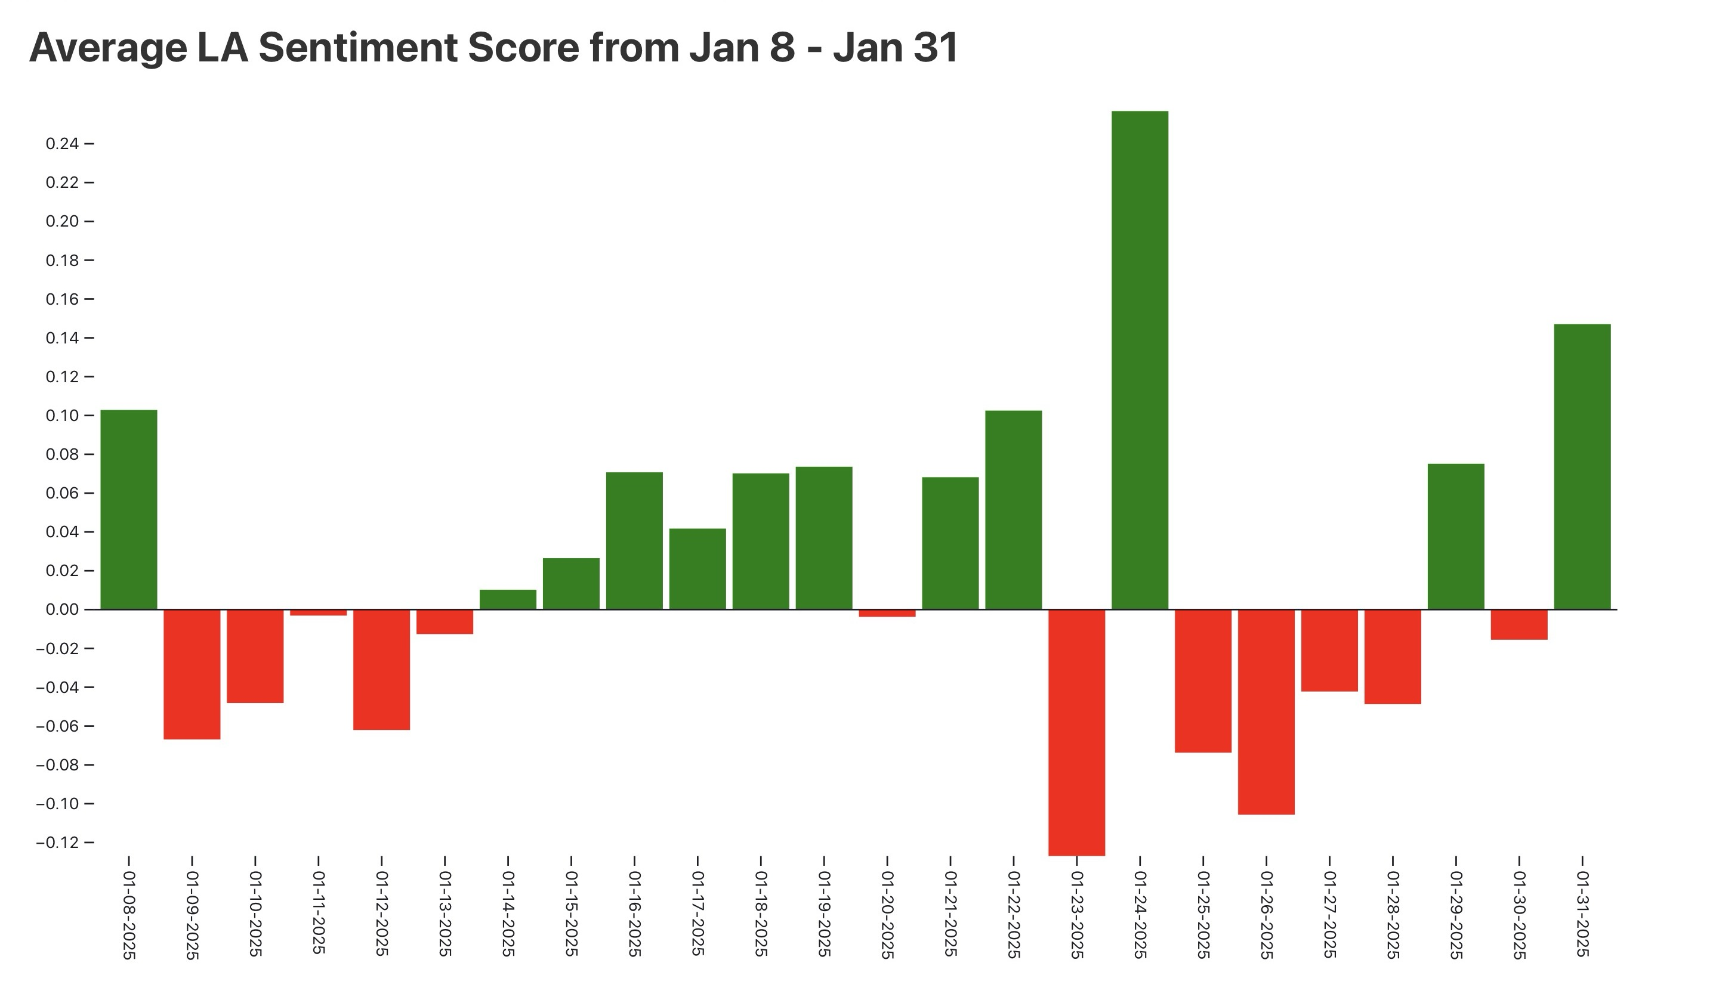Valence Aware Dictionary and sEntiment Reasoner), a sentiment analysis tool that is specifically designed for analyzing social media texts, which is a pre-trained model that provides valence scores for text. As a proof of concept, he ran [this analysis](https://observablehq.com/d/d420571a21c5c871) to compare local (Missoula MT) sentiment scores from 2020-2025.

He is currently working on fine-tuning a more robust transformer-based model, RoBERTa. For instance, instead of just analyzing the valence of the words in the Reddit post, this model will allow for more nuanced aspects of sentiment in human language which can be derived from the context of the sentence. After fine-tuning RoBERTa, it will be able to detect sentiments such as frustration, political bias, blame, solution-seeking, spreading news, sarcasm, fear or panic, and seeking help or answers.

**#12: Upload images/tables/charts/graphics that support Y2 activity 1.4.2.a1 milestones.**

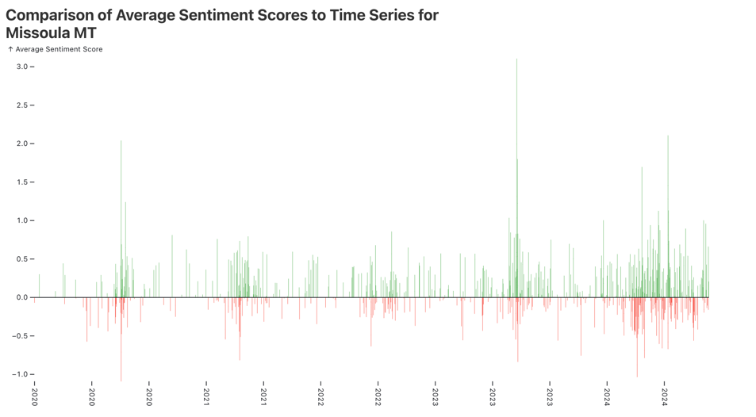

**#13: What will the status of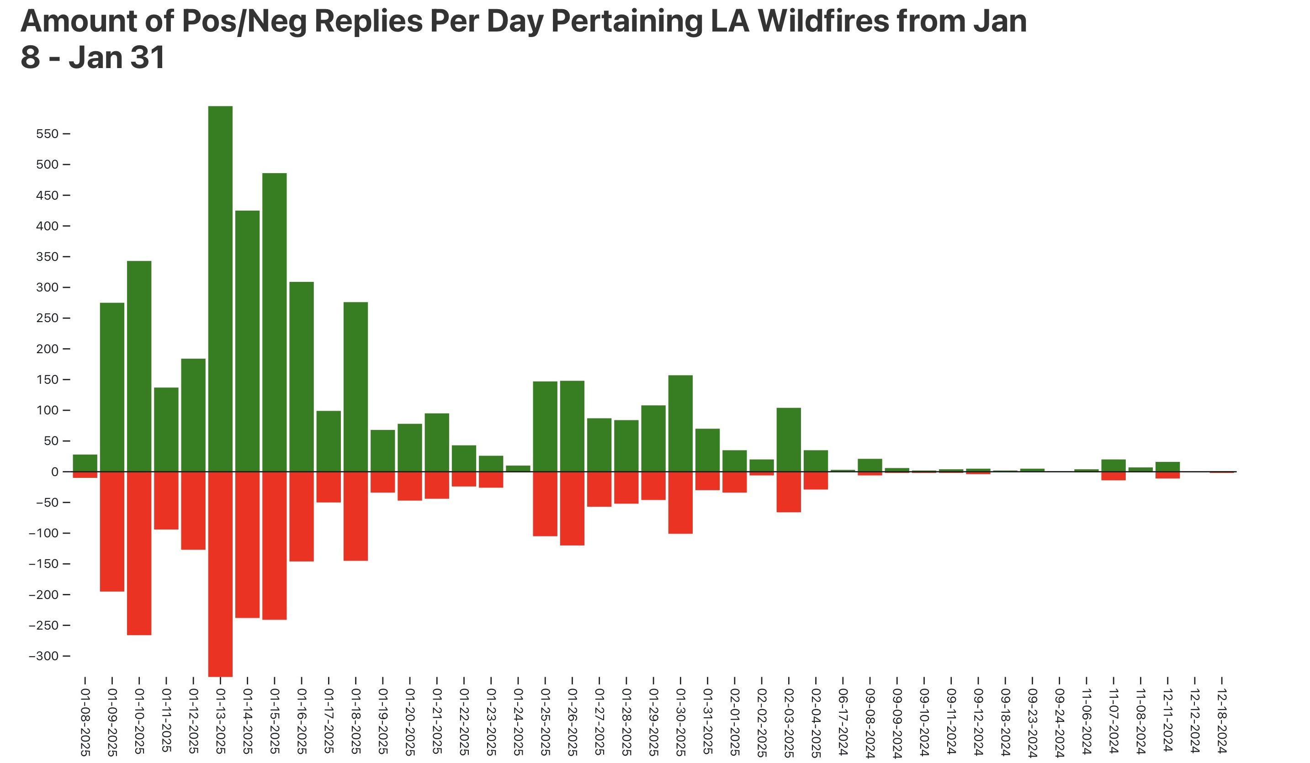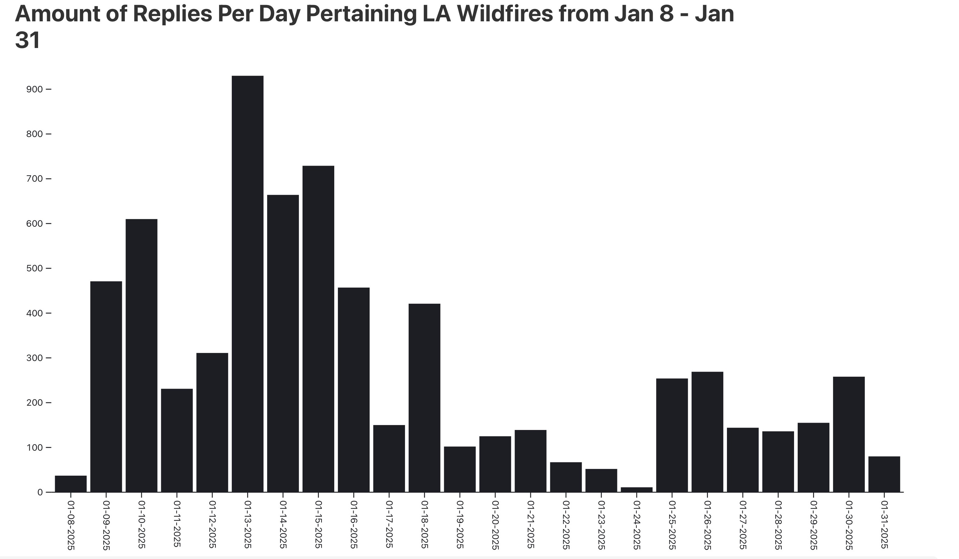 this milestone be by 7/31/25?**

On Schedule (to be complete by 7/31/25)

**#14: If you selected “Behind Schedule” explain why.**

N/A

**#15: Describe the involvement of any students, postdocs, and early-career faculty in the advancement of this activity and if applicable, any outreach and/or dissemination efforts.**

This milestone is led by Dr. Lucy Owen. Dr. Owen was hired as an assistant professor in the computer science department in the Fall of 2024.

The student focused on this task is Joseph Cartwright, an undergraduate computer science student at the University of Montana. He received a semester internship on the SMART FireS project for the 2025 spring semester.

**#16: Detail in narrative format any planned progress toward this activity that will occur between the report submission date and the end of the reporting period (4/30/25-7/31/25).**

Between 4/30/25 and 7/31/25, Dr. Owen and Joseph Cartwright will work to better model wildfire and prescribed fire Reddit data. We will continue to work with Dr. Ryan James at Reddit to best understand current Reddit analysis practices.

Big Picture / Wrap-Up

I think this project has been scaled down quite a bit from its initial conception. So I’m not sure what to write here. Also, in case you need it I have interacted with the following PIs to discuss this project:

Jesse Johnson, Katrina Mullan, and Libby Metcalf.