output: word_document: md_document: variant: markdown_phpextra+backtick_code_blocks

The U.S. Census Bureau estimates that residents were living in metro New Orleans as of July 2023, a percent decrease from April 2020.[1] The metro area now has percent of its 2000 population of 1,337,726. In this brief, we examine demographic data released by the U.S. Census Bureau and identify important changes in metro area parishes since 2000 (or the best benchmark available).

## Race/Ethnicity

According to the U.S. Census Bureau’s 2023 population estimates, there are now 120,876 fewer Black residents living in New Orleans (Orleans Parish) compared to 2000, and there are 23,503 fewer White residents as well as 14,531 more Hispanic residents.[2]

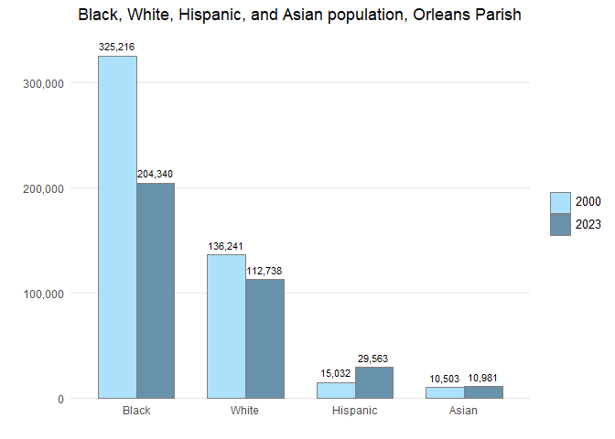

In Orleans Parish, the share of the 2023 population that is Black — while lower than in 2000 when it was 67 percent — continues to represent the majority of city residents at 56 percent. The share of Hispanic residents in the city increased from 3 percent in 2000 to 8 percent in 2023; the share of Asian residents increased from 2 percent to 3 percent; and the share of White residents increased from 28 percent to 31 percent. Meanwhile, Hispanic, Asian, and Black populations increased as a share of the total population in Jefferson, St. Bernard, St. Charles, and St. John the Baptist parishes. In fact, the number and share of Hispanics have increased in all seven parishes in the metro area since 2000.

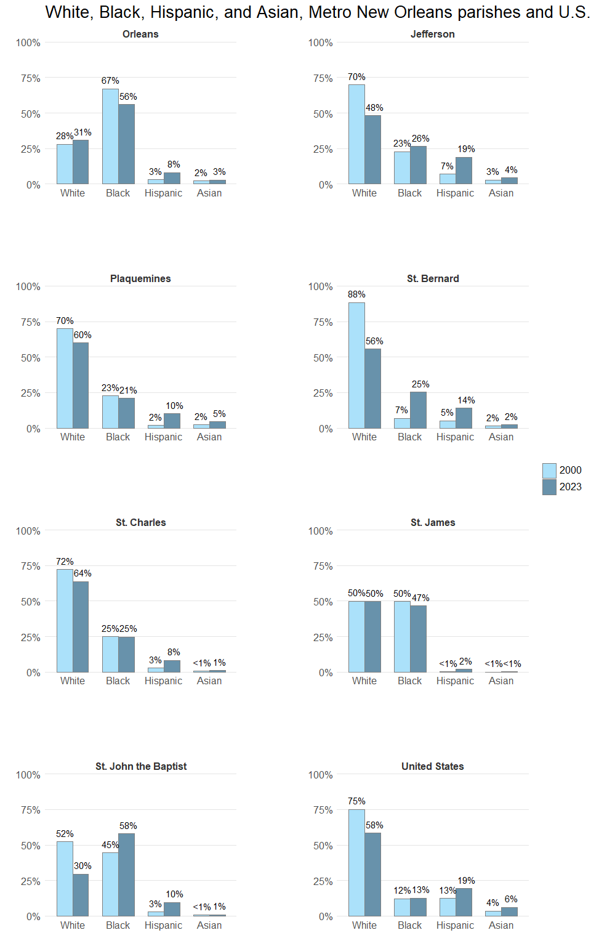

Between 2000 and 2023, the number of Hispanics in Jefferson Parish increased by 47,578 reaching over 19 percent of the total parish population. Orleans Parish and St. Tammany Parish gained 14,531 and Hispanics, respectively, such that the Hispanic share of the population grew to 8 percent in both of these parishes.

As of July 2023, there were Hispanics in the metro area, representing percent of the metro population. This is up from 2000 when there were , representing percent of the metro population. Despite these recent gains, the Hispanic share of the population in metro area parishes is below the average for the United States, which has grown from 13 percent to 19 percent of the total U.S. population over these 23 years.

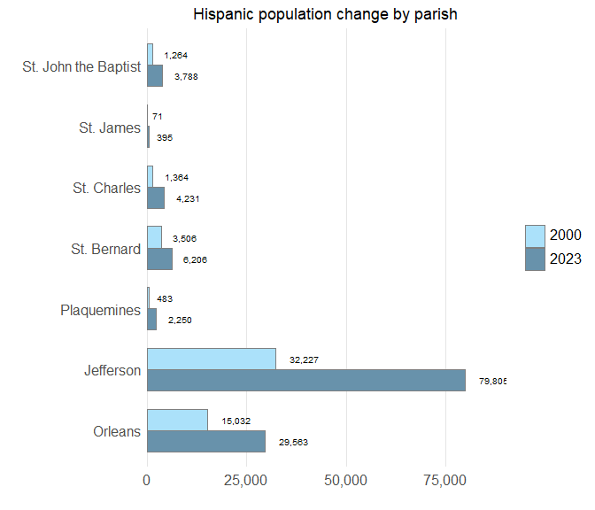

The number of Hispanics in the New Orleans metro has grown every year since Hurricane Katrina. From 2010 to 2020, the Hispanic population accounted for the majority of the metro area’s growth, increasing by 44,136, while the total population increased by . Since 2020, the overall population declined but the Hispanic population continued to grow. From 2020 to 2023, the metro area gained another 894 Hispanic residents while losing a total of residents.

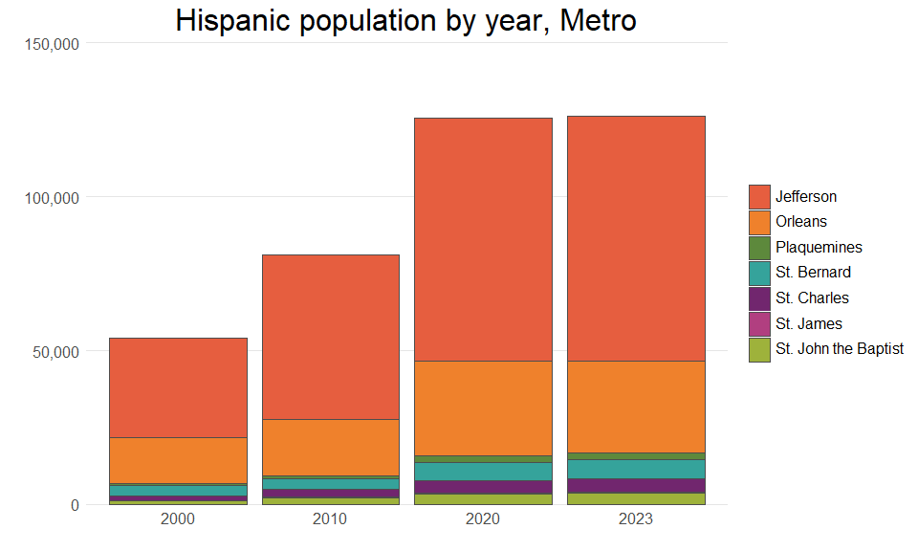

Hispanic is an umbrella term comprising multiple nationalities and ethnicities. Researchers have shown that most Hispanics prefer to identify by nationality rather than by pan-ethnic terms such as “Hispanic” and “Latino.”[3] The nationalities of Hispanics residing in metro New Orleans are quite distinct from the national Hispanic profile.

In 2023, the largest Hispanic group in metro New Orleans was Honduran, representing 29 percent of the Hispanic population. In comparison, Hondurans represent only 2 percent of the national Hispanic population. These figures point to metro New Orleans as a hub of Honduran migration.

Not to be ignored, the Mexican population represents 16 percent of the Hispanic population in metro New Orleans. Nevertheless, the Mexican population is much less prominent in the metro than nationally, where it represents 58 percent of the Hispanic population.

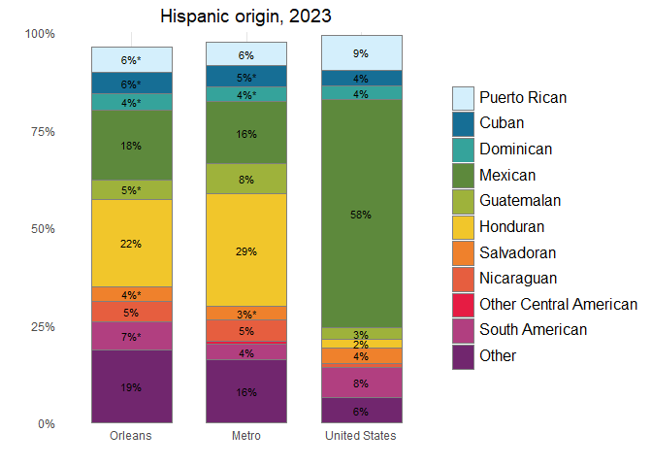

## Population by age and household types

The progression of the baby boomers through the age groups, along with falling birth rates, has brought massive changes to the metro — and indeed the whole country — with many more changes yet to come.[4] Looking at the total population in the metro by five-year age groups for 2000 and 2023, the baby boomers are like a demographic tidal wave. According to the American Community Survey, the median age of the metro has risen to 40 in 2023 from 34.8 in 2000.

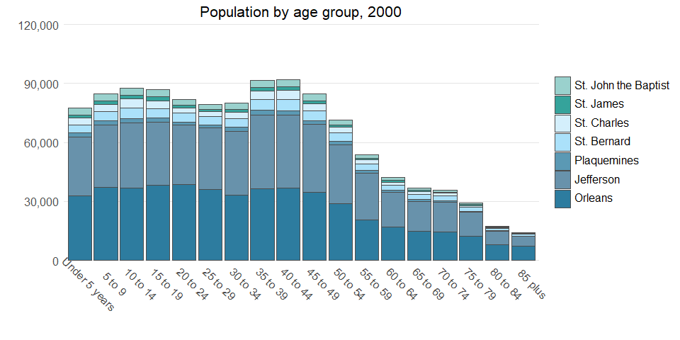

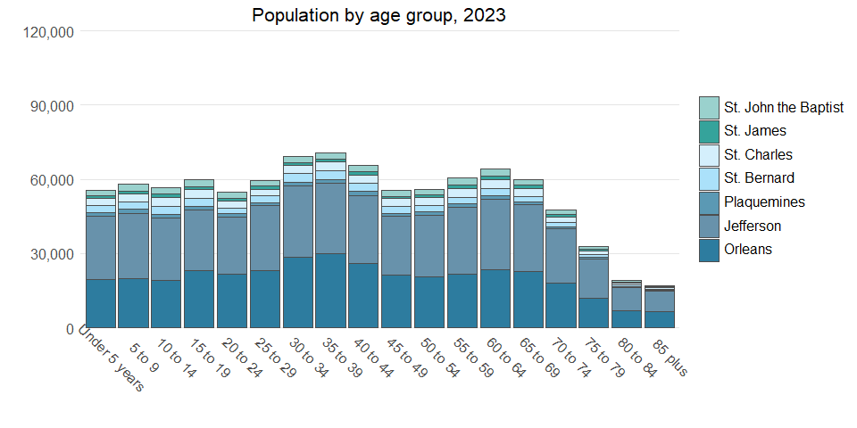

Meanwhile, the share of households with children is shrinking while the share of individuals living alone is growing — both across the metro and nation. As of 2023, 22 percent of households in metro New Orleans included children, down from 33 percent in 2000. Between 2000 and 2023, the percent of St. Tammany households with children declined from XX percent to XX percent; the percent of Jefferson households with children declined from 33 percent to 23 percent; and the percent of Orleans households with children declined from 30 percent to 20 percent.

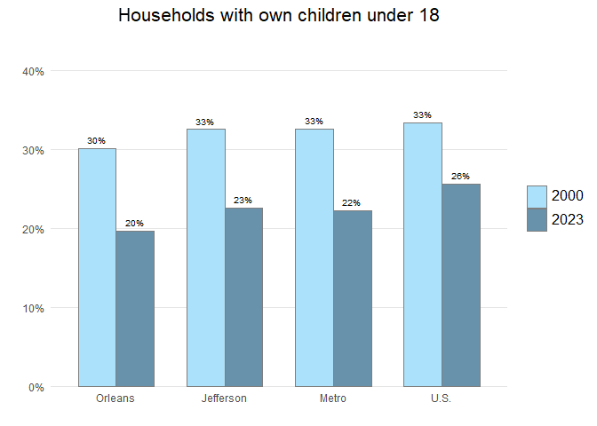

As households with children have declined, the share of single-person households has grown in the metro and nationwide. The metro area share of individuals living alone grew from 28 percent in 2000 to 36 percent in 2023 — similar to the trend for Jefferson Parish where the share of householders living alone grew from 27 percent to 34 percent. The increase was larger in Orleans Parish, which jumped from 33 to 42 percent.

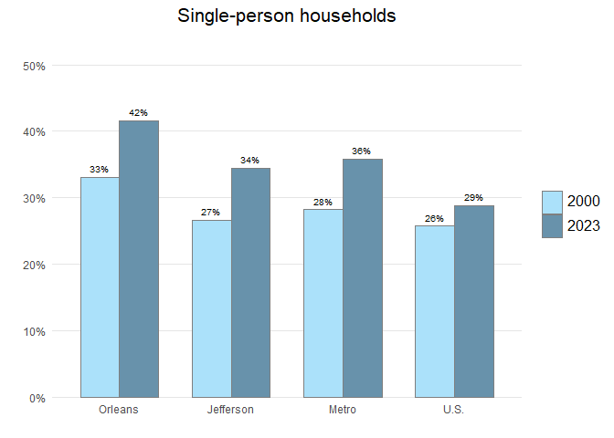

While the metro has regained much of the post-Katrina population losses, youth population is substantially lower than pre-Katrina levels. The metro had 303,054 children under 18 years in 2000 and only 206,918 in 2023. Much of this loss was driven by Orleans Parish, where the population under 18 has declined to 70,990 from 129,167. The under 18 population is now 22 percent of the metro population, down from 27 percent in 2000.

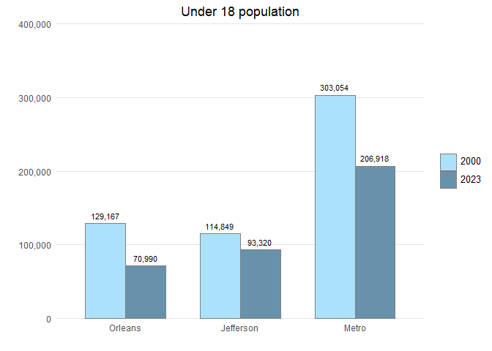

## Educational attainment, income, and employment

Educational attainment is an important determinant of household incomes, workforce skills, and regional resiliency.[5] In New Orleans, 45 percent of adults 25 and older had at least a bachelor’s degree in 2023 — higher than the U.S. average of 36 percent, and up from 26 percent in 2000. The overall metro area share of adults with a bachelor’s degree grew from 23 to 35 percent — lower than the national average of 36 percent.

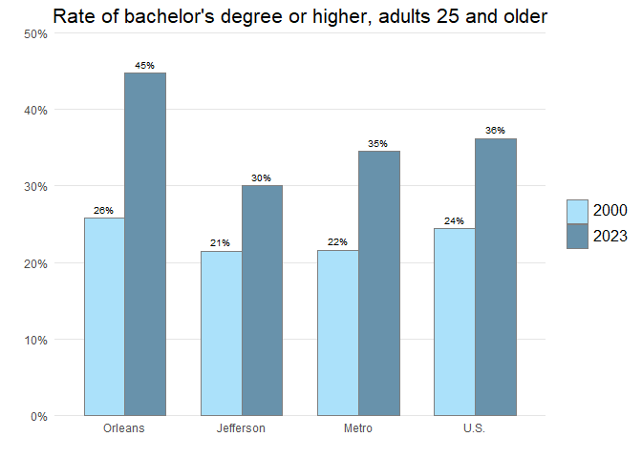

The share of New Orleans adults who have a bachelor’s degree has grown across racial and ethnic groups since 1980. But while 72 percent of White adults in New Orleans have a bachelor’s, only 27 percent of Black adults have a bachelor’s as of 2023. The share of White adults in Orleans Parish who have a bachelor’s degree is substantially higher than the U.S. or metro area overall: 72 percent of White adults in New Orleans have a bachelor’s degree while that number is 43 percent or lower in neighboring parishes and the nation. Only 23 and XX percent of Black adults have a bachelor’s degree or higher in Jefferson and St. Tammany, respectively.

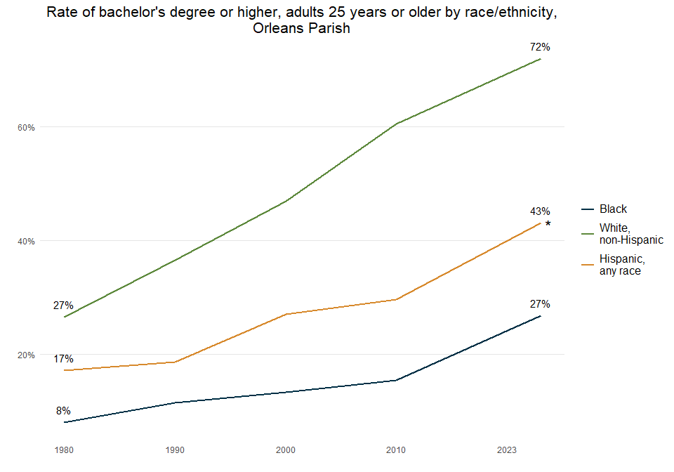

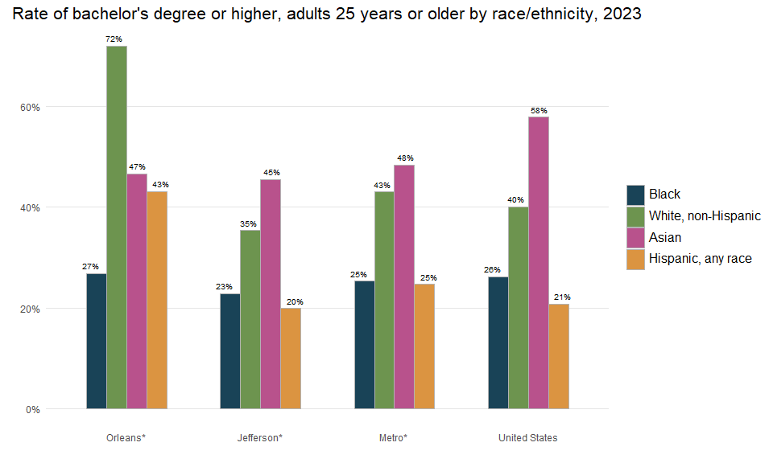

The metro area increase in the share of adults with a bachelor’s degree or higher has been coupled with a decline in the share of adults with less than a high school degree. The proportion of adults 25 years and older with less than a high school education declined across all three of the largest parishes, leading to a metro-wide decrease from 15 percent in 2000 to 12 percent in 2023. In the city of New Orleans, the share of adults with less than a high school degree fell from 25 percent to 9 percent.

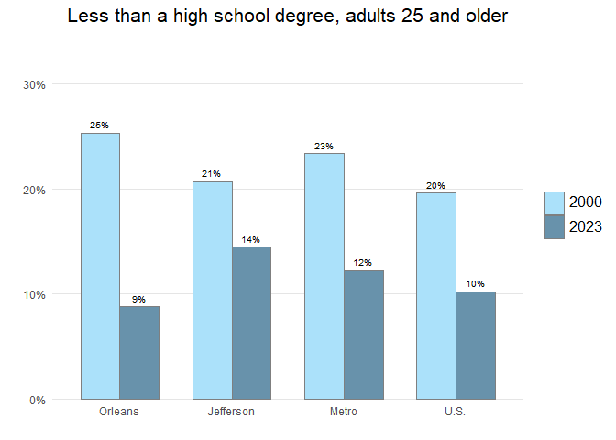

The 2023 median household income of $61,000 for the metro, $61,085 for Jefferson Parish, and $55,580 for the city of New Orleans are significantly lower than the U.S. median of $77,719.

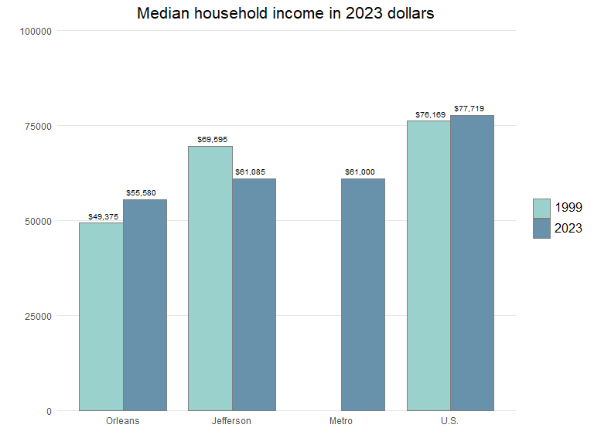

In 1979, households with higher incomes were disproportionately in the parishes surrounding New Orleans, while lower income White, Hispanic, and Black households were more likely to live in the city.[6] By 2023, these patterns had changed with higher income White households more often living in the city such that income disparity within the city has escalated. In 2023, Black households in New Orleans had a median income of only $38,092, while Hispanic households were at $56,992 and White households at $97,494.

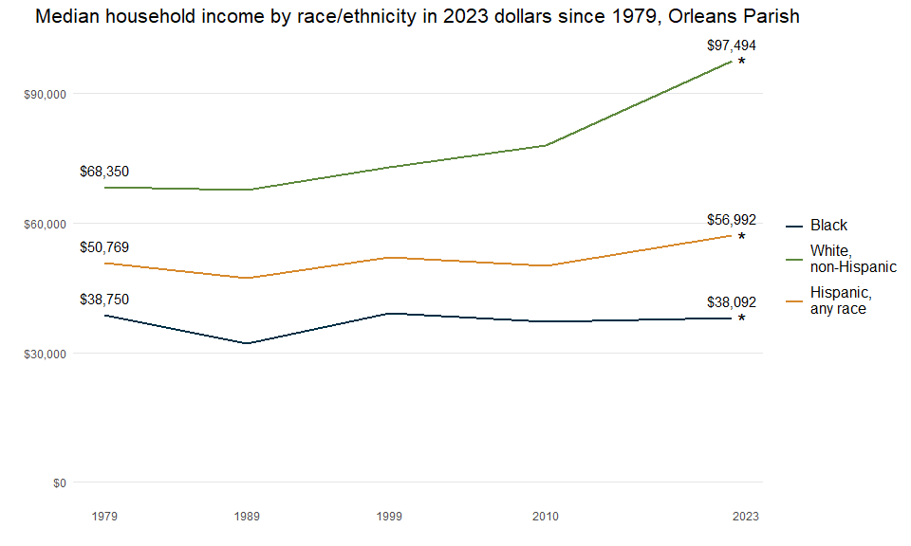

In 2023, Black households in New Orleans have incomes 61 percent less than White households. In St. Tammany, Black households have a median income of XX which is XX percent less than White households in that parish. In Jefferson, Black households have a median income of $40,198 which is 45 percent less than White households in that parish. Hispanic households have a median of $61,117 across the metro which is relatively consistent across the three largest metro parishes.

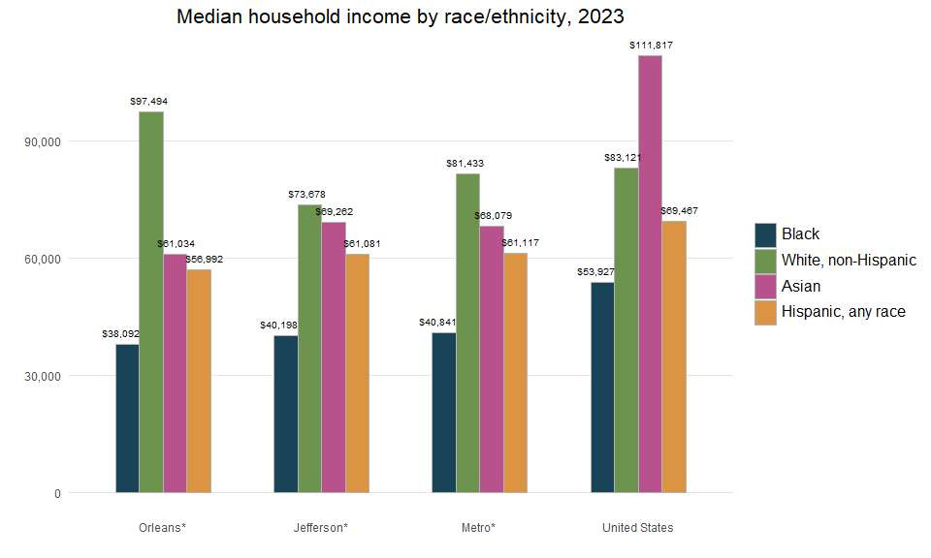

Lorem ipsum dolor sit amet, consectetur adipiscing elit. In massa lacus, vehicula sed nibh ac, sollicitudin accumsan urna. Aenean sit amet hendrerit purus. In ut augue tincidunt tellus tempus volutpat sed at nulla. Sed tempus ex felis, a convallis sapien ultricies sed. Donec tortor urna, sodales a laoreet sed, mollis ac erat. In vestibulum et dolor at rutrum. Duis quis ex ante. Suspendisse potenti. In tempus ipsum purus, sed maximus diam pharetra eget. Quisque justo arcu, ornare eu vulputate quis, semper sit amet felis. Curabitur sit amet metus nibh. Nam ultrices nunc nec erat rhoncus tincidunt. In imperdiet venenatis lobortis.

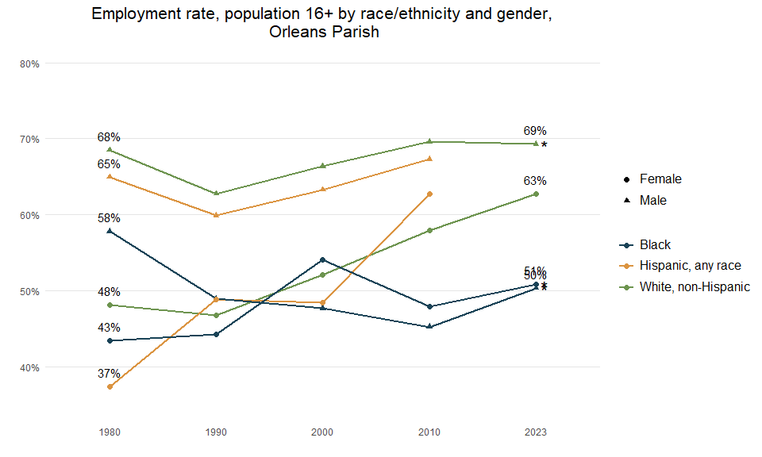

Lorem ipsum dolor sit amet, consectetur adipiscing elit. In massa lacus, vehicula sed nibh ac, sollicitudin accumsan urna. Aenean sit amet hendrerit purus. In ut augue tincidunt tellus tempus volutpat sed at nulla. Sed tempus ex felis, a convallis sapien ultricies sed. Donec tortor urna, sodales a laoreet sed, mollis ac erat. In vestibulum et dolor at rutrum. Duis quis ex ante. Suspendisse potenti. In tempus ipsum purus, sed maximus diam pharetra eget. Quisque justo arcu, ornare eu vulputate quis, semper sit amet felis. Curabitur sit amet metus nibh. Nam ultrices nunc nec erat rhoncus tincidunt. In imperdiet venenatis lobortis.

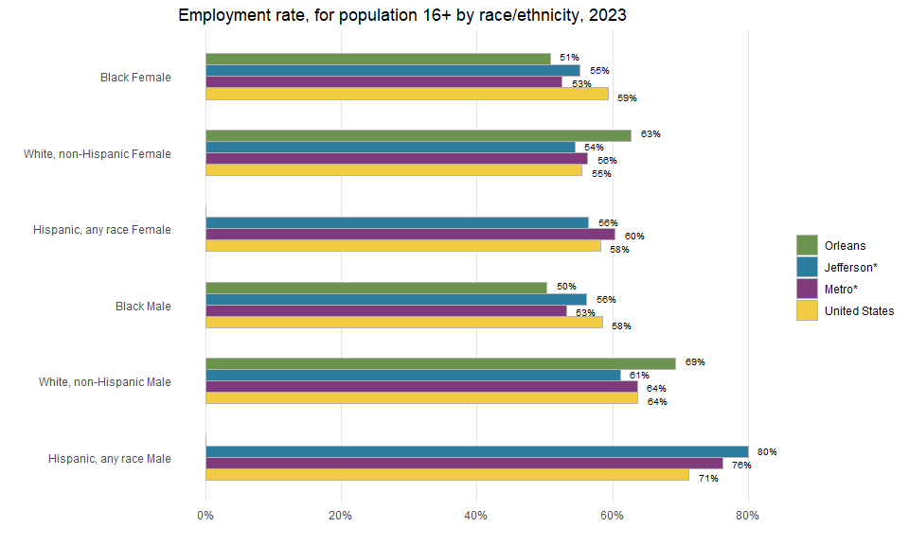

## Poverty and access to vehicles and internet

A high share of residents living below the poverty level indicates the economy is not providing many residents with the ability to meet their most basic needs, including food, housing, and transportation. The poverty rate in New Orleans decreased from 28 to 23 percent between 1999 and 2023 while the Jefferson Parish poverty rate increased from 14 to 17 percent. Across the U.S., the poverty rate increased by one percentage point between 1999 and 2023.

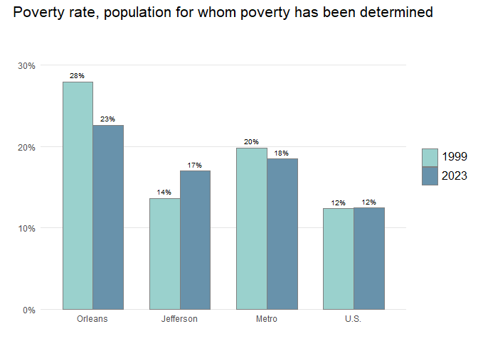

The poverty rate for Black New Orleanians spiked when the 1980s “oil bust” hit, jumping from 37% in 1979 to 42% in 1989. White New Orleanians were not similarly affected. The poverty rate for White New Orleanians remained at roughly 12% in 1979 and in 1989. Large disparities in the poverty rate continue to be evident at all geographic levels. For example, in metro New Orleans 26 percent of Black people and 22 percent of Hispanic people live in poverty compared to 10 percent of White people and 20 percent of Asian people.[7]

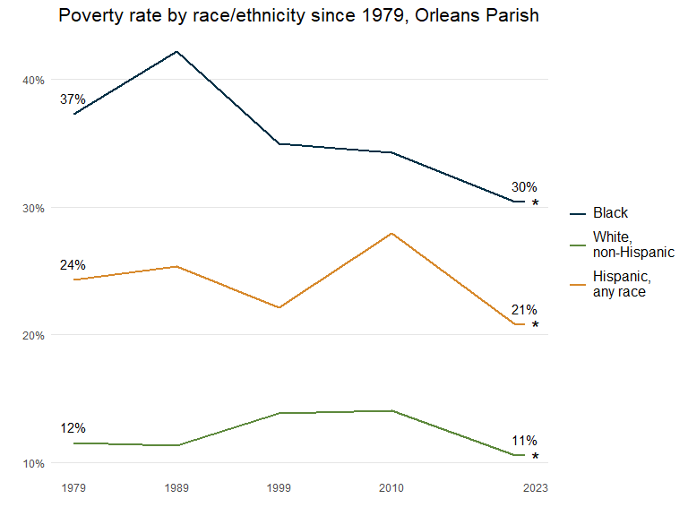

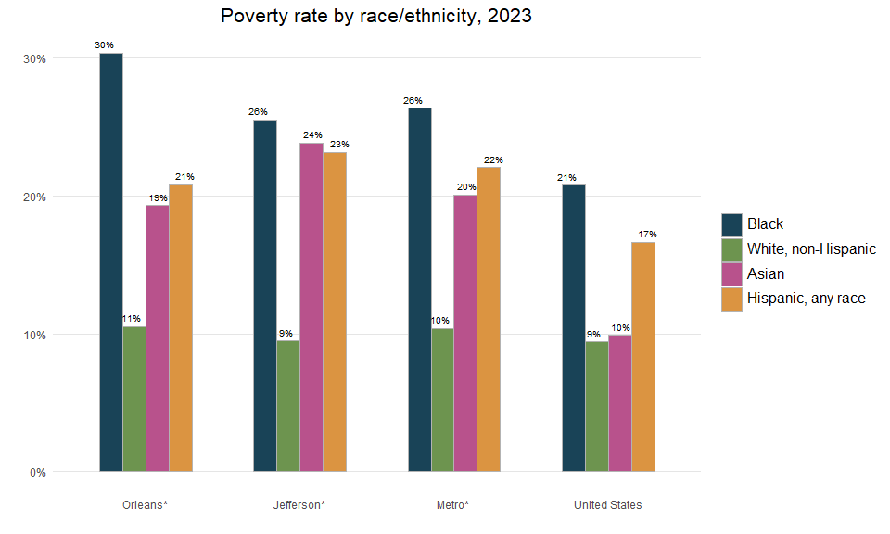

Like the overall poverty rate, the child poverty rate in New Orleans decreased between 1999 and 2023. The child poverty rate of across the Metro area in 2023 is higher than the U.S. child poverty rate.

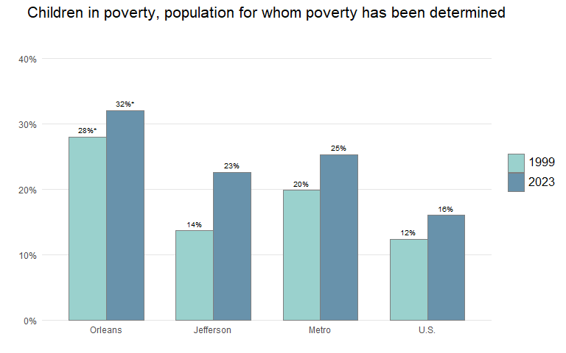

In Orleans Parish, about half of all Black children live in poverty while 4 percent of White children are poor. In New Orleans, child poverty rates peaked in 1989 for Black children and have fallen slightly such that they are now virtually the same as in 1979 with one in two Black children living in poverty in 2023. The poverty rate for White children has declined from one in 10 children in poverty in 1979 to about one in 50 in 2023.

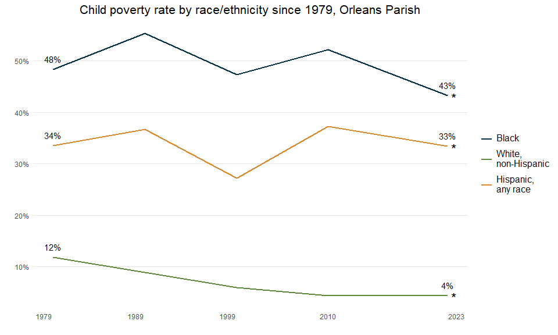

Orleans Parish’s very low rate of 4 percent child poverty for White children stands in stark contrast to the 51 percent rate for Black children. While in Orleans, poverty rates for Black children are 10 times higher than for White children, in Jefferson Parish Black children experience poverty at a little over 3 times higher rates than White children – which is a disparity on par with the national average. In metro New Orleans, 31 percent of Hispanic children live in poverty – statistically no different from the national rate.

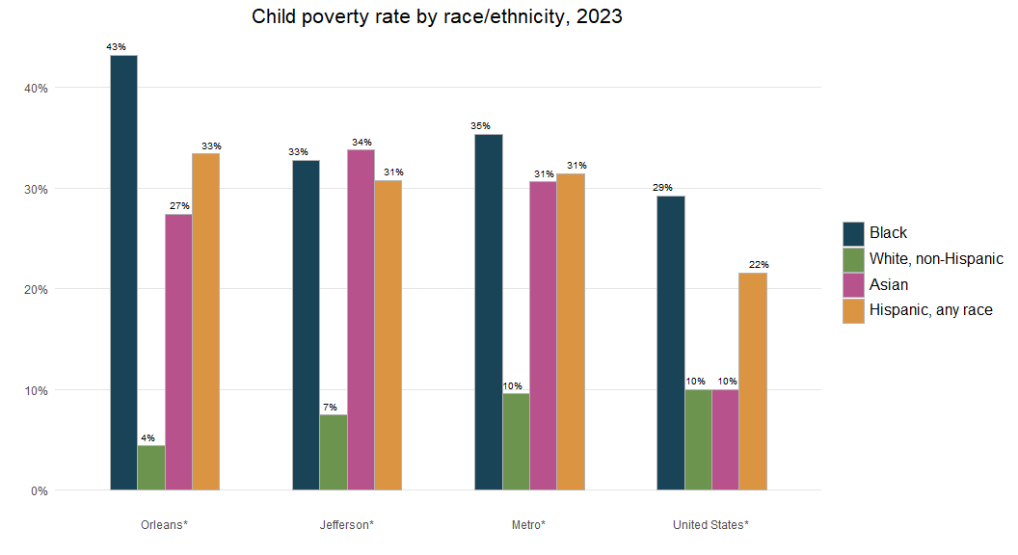

Post-Katrina, the share of New Orleans households without access to a vehicle dropped from 27 percent in 2000 to 18 percent in 2023. Nonetheless, at 18 percent, New Orleans’ share is more than twice as high as in neighboring parishes, indicating the importance of a robust public transportation system and comprehensive evacuation plan.

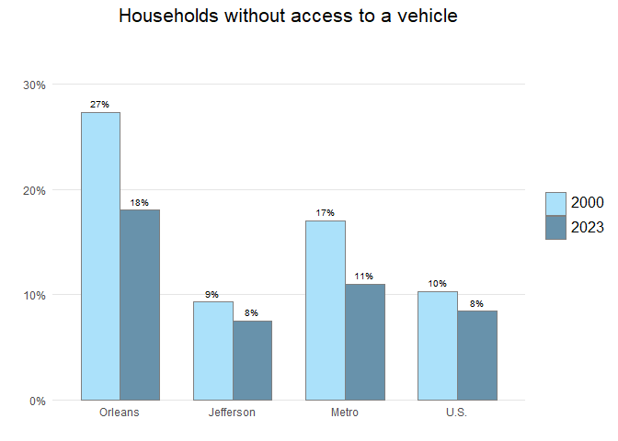

Internet access is an important indicator of access to information. Studies have shown that without broadband, computer access, and encompassing technology training services, workers and students are at a disadvantage in the job market and education system.[8] Only 76 percent of households in Orleans Parish and only 72 percent of households in Jefferson Parish are connected to the internet through a home-based internet service, such as broadband (cable, DSL, or fiber), satellite, or dial-up service, compared to 80 percent nationwide. St. Tammany is above the national average at percent of households connected to the internet by a home-based service internet connection. Internet access without a subscription refers to households that only have access through group access locations such as school, work, a library, or coffee shop.

An increasingly common way to access the internet is through a smartphone or some other cellular device. While, in general, smartphone access contributes positively to lessening the Digital Divide, having access only through a smartphone restricts ability to fully leverage the internet to complete common tasks such as writing and researching a resume, registering your kids for school, analyzing data about your neighborhood, or creating content for an internet business. In Orleans Parish, 13 percent of households only have access through a smartphone, compared to 12 percent nationwide.

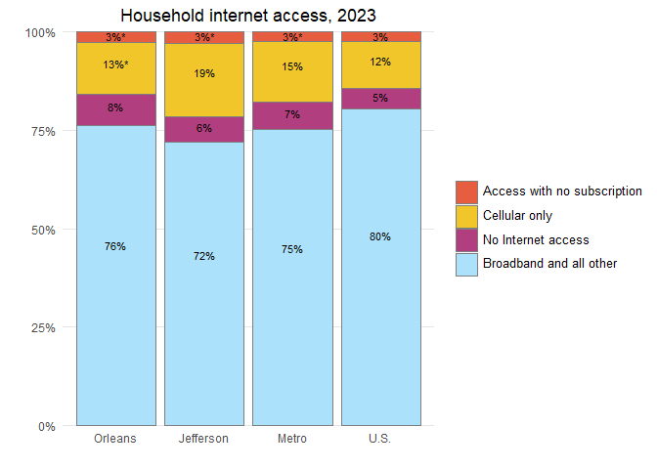

## Foreign-born population and geographic mobility

A rising foreign-born share of the population may reflect expanding economic opportunities for both high-skilled and low-skilled workers.[9] That share of the population has grown in all three of the most populous metro parishes since 2000, led by a 6.5 percentage point gain in Jefferson Parish. By 2023, fully 14 percent of Jefferson Parish population was foreign-born, similar to the U.S. share. In Orleans Parish the foreign-born share of the population increased by 2.5 percentage points between 2000 and 2023 while St. Tammany saw an increase of percentage points.

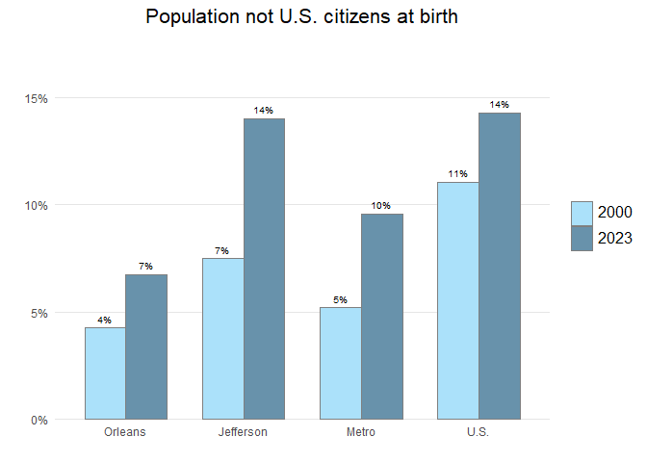

Like the foreign-born population, a rising share of the population who moved into Orleans Parish in the past year may reflect expanding economic opportunities. The most frequent reason people move long distances, such as from one state to another state, is for job opportunities.[10] In addition, the young and well-educated are more likely than others to move long distances.[11] In 2023, 5 percent of the population in Orleans Parish had moved into the parish in the past year, up from 3 percent in 2004. Over 65 percent of the new movers into Orleans Parish came from outside the state of Louisiana. In Jefferson Parish, the share of the population who were new movers into the parish was 5 percent in 2004 and has not significantly changed.

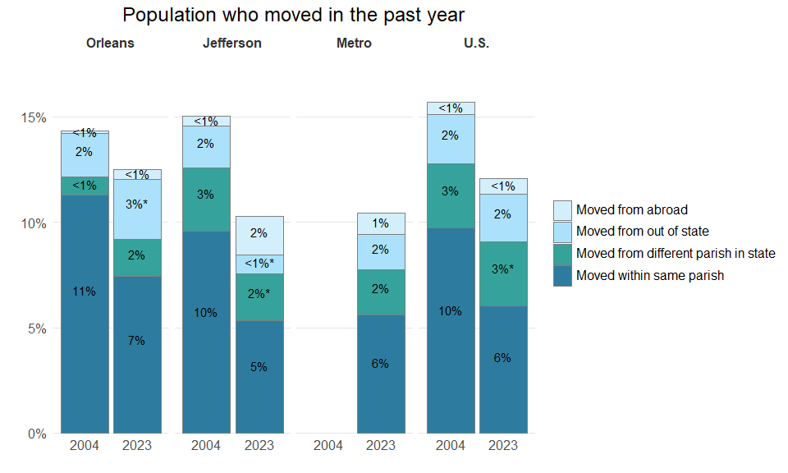

## Homeownership

Homeownership rates across the U.S. have fallen since 2000 from 66 to 65 percent in 2023. Homeownership rates have held steady in St. Tammany around percent since 2000. In contrast, homeownership rates in New Orleans have increased slightly, but remain lower than neighboring parishes at 56 percent.

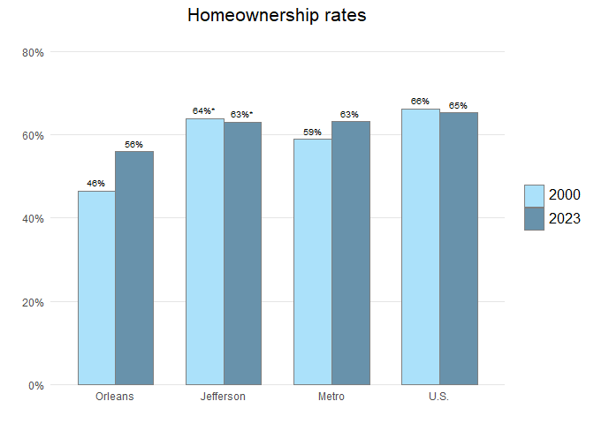

Homeownership rates among Black householders in New Orleans made consistent progress between 1970 and 2023, increasing from 27 percent to 50 percent. Still, the difference in homeownership rates between Black and White people in 2023 was significant, with only 50 percent of Black householders in New Orleans owning their homes compared to 64 percent of White householders.

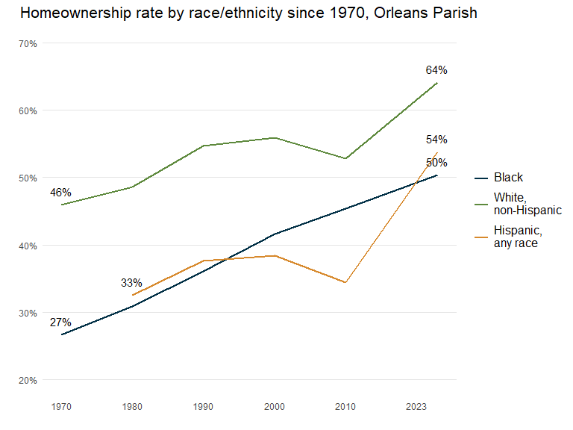

Metro homeownership rates mirror national rates, with just over 63 percent of all householders owning their homes and White homeownership rates about 24 percentage points higher than rates for Black homeownership. This disparity is smaller in Orleans Parish, where only 64 percent of White householders own their homes. Homeownership in St. Tammany outstrips Orleans, Jefferson, and the metro overall, with percent of all householders owning their home: a rate of XX percent for Black householders, XX percent for White householders, and XX percent for Hispanic householders.

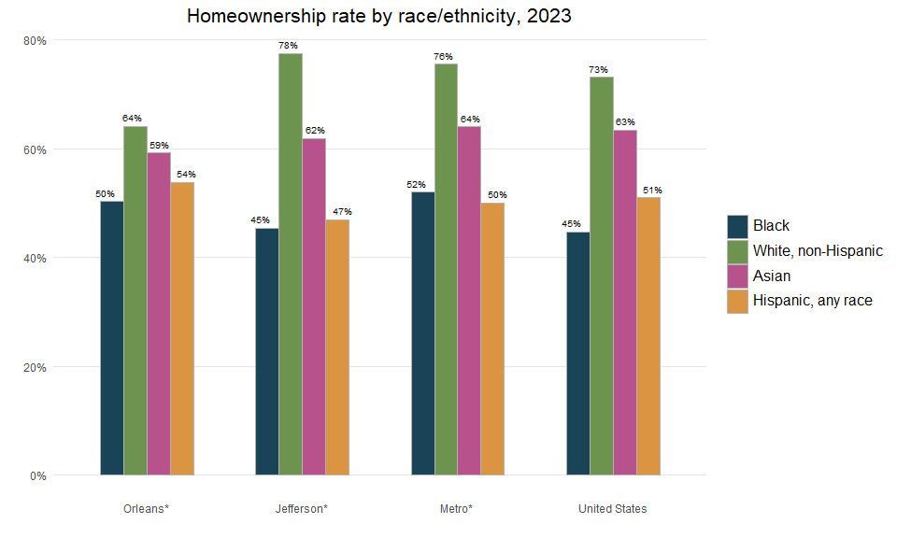

Homeowners without a mortgage own their homes free and clear of any type of loan. A high share of such homeowners usually indicates residents living in the same house for long periods of time and helps shield neighborhoods from foreclosures. The proportion of metro area homeowners without a mortgage has increased from 35 to 46 percent between 2000 and 2023, driven by changes in Orleans and Jefferson. The share of homeowners without a mortgage jumped from 33 to 44 percent in Orleans and from 35 to 46 percent in Jefferson. One reason for the surge may be that homeowners who returned after Katrina used insurance or Road Home proceeds to pay off their mortgage principal. In fact, Orleans and Jefferson received the first and second largest number of Road Home Option 1 Grants among all Louisiana parishes.[12]

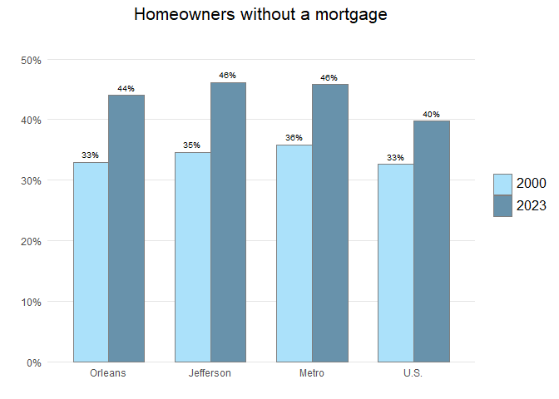

## Housing costs and affordability, housing stock, and commuting

High housing costs can limit a region’s ability to attract and retain the workforce essential for a healthy economy.[13] Severe housing cost burdens of more than 50 percent of household income indicate a serious problem in housing affordability. In 2004, the share of severely cost-burdened renters in New Orleans and the U.S. was 24 and 24 percent, respectively. In the 19 years since, that share has spiked to 34 percent in Orleans while growing to only 26 percent nationally. In Jefferson Parish, the share of renters paying more than 50 percent of household income on housing and utilities is 32 percent in 2023.

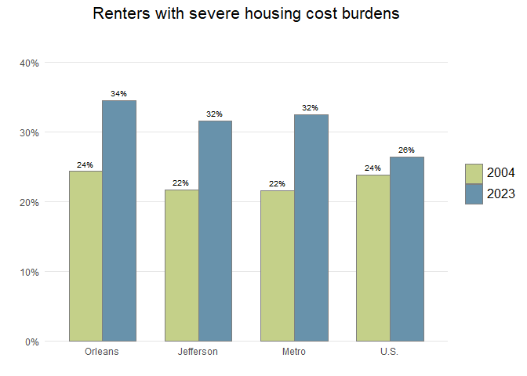

The share of homeowners paying more than 50 percent of household income on their mortgage, taxes, utilities, and insurance is only 13 percent across the metro area. There is a clear gap between the rate of housing cost burden for renters vs. homeowners, and that gap has widened.

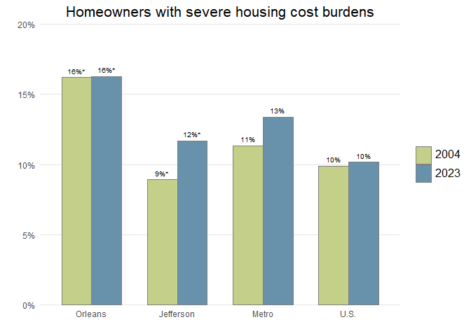

The surge in the share of severely cost-burdened renters in New Orleans is reflective of the surge in the median gross rent (rent plus utilities) in the city. From 2004 to 2023, monthly rent plus utilities rose from $917 to $1,203 in New Orleans, a 31 percent increase after adjusting for inflation. Meanwhile, median gross rents increased 25 percent nationwide.

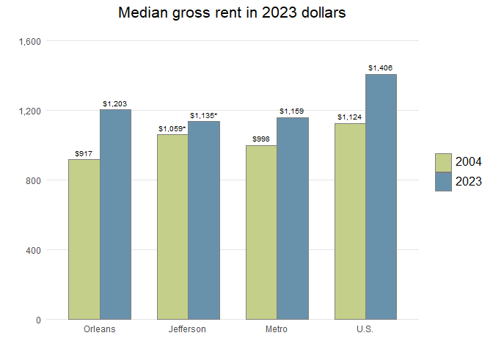

America’s aging housing stock represents both a potential problem and an opportunity. Older homes are less energy-efficient and more expensive to maintain.[14] Moreover, research has shown that lead poisoning in children is correlated strongly with residing in pre-1950 homes.[15] Conversely, in New Orleans, many older homes are protected by preservation laws that have helped retain the historic character of the city.

In Orleans Parish, fully 37 percent of all housing units are in pre-1950 structures. Meanwhile, in Jefferson Parish, 71 percent of the housing stock was built in the 1950s, 1960s, 1970s, and 1980s, and just 21 percent of housing stock has been built since 1990. In contrast, in St. Tammany, the majority of housing units are in structures that have been built since 1990.

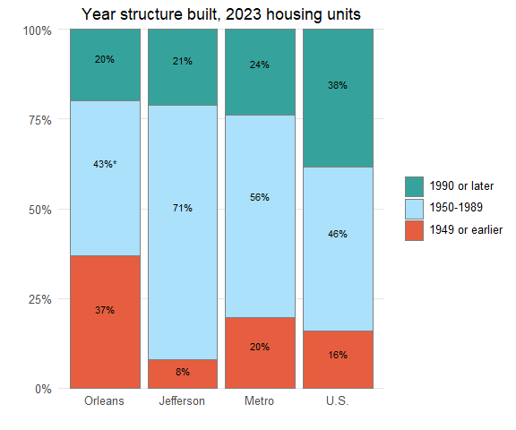

A metro region is partially defined by the commuting patterns of its residents. Commuting has been studied more and more as its costs and burdens (physical, mental, familial, etc.) are uncovered.

Nationwide and across the New Orleans metro, there has been a sizable increase in people working from home since the COVID-19 pandemic struck. In New Orleans, the share working at home rose from 3 percent in 2000 to 16 percent in 2023, while the share using public transportation declined sharply from 2.5803^{6} percent in 2000 to 4 percent in 2023. Working from home is somewhat less common in Jefferson (7 percent) than in New Orleans or across the nation (18 percent).

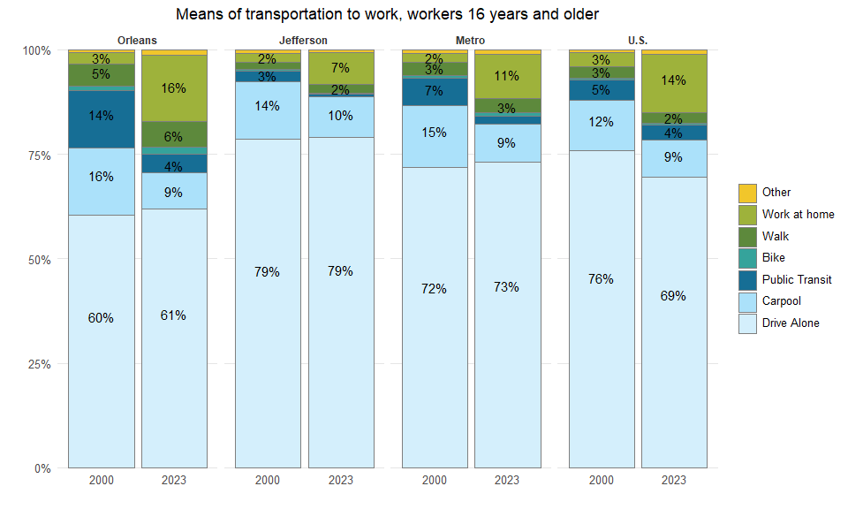

## Data Sources / Methodology

Data on race/ethnicity and age is from the Census Bureau vintage 2023 population estimates and Census 2000 Summary File 1 (SF1). Other demographic data is from the Census 2000 Summary File 3 (SF3) and American Community Survey 2004, and 2023 (single-year files).

Statistical tests of significance were computed at the 95% confidence level for all data from the American Community Survey and Census 2000 SF3. An “*” indicates that differences between two time periods or geographies are not significant, and therefore are the result of sampling variability rather than real change in characteristics of the population.

The significance tests require both estimates and their standard errors. Standard errors for the ACS estimates were calculated using formulas from section seven, “Understanding Error and Determining Statistical Significance” available at: <https://www.census.gov/content/dam/Census/library/publications/2018/acs/acs_general_handbook_2018.pdf>.

Standard errors for Census 2000 SF3 data were calculated using formulas from Chapter 8 of the Technical Documentation available at: <https://www2.census.gov/programs-surveys/decennial/2000/technical-documentation/complete-tech-docs/summary-files/sf3.pdf>.

Standard errors for Census 2000 and Census 2010 SF1 data are zero.

## Endnotes

1. The eight-parish New Orleans metro includes Jefferson, Orleans, Plaquemines, St. Bernard, St. Charles, St. James, St. John the Baptist, and St. Tammany. From 2003-2012, the New Orleans metro was comprised of seven parishes, excluding St. James. In 2023, the official definition of the New Orleans metro area changed to exclude St. Tammany. Later this year, when the Census Bureau releases 2023 ACS data, we’ll publish data according to the new 7-parish metro area definition which excludes St. Tammany.
2. Throughout this brief, when referring to Population Estimates and Projections data, “Black,” “Asian,” and “White” refer to individuals who report to be only one race and not Hispanic. However, “Hispanics” can be of any race(s). When using American Community Survey data, “Black” and “Asian” are inclusive of “Hispanics”.
3. Taylor, P., Lopez M. H., Martinez, J., and Velasco, G. (2014). When Labels Don’t Fit: Hispanics and Their Views of Identity. Retrieved October 3, 2014 from <http://www.pewhispanic.org/2012/04/04/when-labels-dont-fit-hispanics-and-their-views-of-identity>.
4. Plyer, A. and Ortiz, E. (2011). Drivers of housing demand: Preparing for the impending elder boom. Retrieved July 8, 2013 from <http://www.datacenterresearch.org/reports_analysis/drivers-of-housing-demand>.
5. Julian, T. and Kominski, R. (2011). Education and synthetic work-life earnings estimates. Retrieved February 8, 2023 from <https://www.census.gov/library/publications/2011/acs/acs-14.html>; U.S. Department of Housing and Urban Development. (2012). Conceptualizing and measuring resilience. Retrieved September 18, 2012 from <http://www.huduser.org/portal/periodicals/em/winter12/highlight2.html#title>.
6. Plyer, A. and Gardere, L. (2018), The New Orleans Prosperity Index: Tricentennial Edition. Retrieved October 17, 2021 from <https://s3.amazonaws.com/gnocdc/reports/ProsperityIndex.pdf>.
7. Difference between Black and Hispanic not statistically significant at a 95% confidence level.
8. Vigdor J. and Ladd, H. (2010). Scaling the Digital Divide: Home Computer Technology and Student Achievement. Retrieved February 8, 2021 from <http://citeseerx.ist.psu.edu/viewdoc/download?doi=10.1.1.849.6663&rep=rep1&type=pdf>.
9. De Jong, G.F., Graefe, D.R., Hall, M., and Singer, A. (2001). The geography of immigrant skills: Educational profiles of metropolitan areas. Retrieved February 8, 2021 from <https://www.brookings.edu/research/the-geography-of-immigrant-skills-educational-profiles-of-metropolitan-areas/>.
10. Based on surveys conducted by the U.S. Census Bureau, employment-related reasons are the most frequent reason for inter-county moves of greater than 50 miles. For example, among people in the United States who moved over 500 miles, 52 percent moved for an employment-related reason compared to 23 percent for a family-related reason and 22 percent for a housing-related reason. Employment-related reasons include a new job or job transfer, to look for work, to be closer to work, retirement, and other job-related reasons. See U.S. Census Bureau. (n.d.). Geographic Mobility: 2011 to 2012 (Table 27). Retrieved February 8, 2021 from <https://www.census.gov/topics/population/migration/data/tables/cps.2012.html>.
11. Based on surveys conducted by the U.S. Census Bureau, people 25 to 29 years old were more likely than other age groups to be movers from a different county, state, region, or country. And people with a professional or graduate degree were also more likely than other educational groups to be movers from a different county, state, region, or country. See U.S. Census Bureau. (n.d.). Geographic Mobility: 2011 to 2012 (Table 1). Retrieved September 23, 2013 from <https://www.census.gov/topics/population/migration/data/tables/cps.2012.html>.
12. State of Louisiana Office of Community Development. (2013). The Homeowner Assistance Program Week 375 Situation & Pipeline Report.
13. Plyer, A., Ortiz, E., and Pettit, K. (2009). Post-Katrina housing affordability challenges continue in 2008, worsening among Orleans Parish very low income renters. Retrieved September 17, 2013 from <http://www.datacenterresearch.org/reports_analysis/housing-affordability>.
14. Joint Center for Housing Studies of Harvard University (2013). The US Housing Stock: Ready for Renewal. Retrieved October 10, 2014 from <http://www.jchs.harvard.edu/sites/jchs.harvard.edu/files/harvard_jchs_remodeling_report_2013.pdf>.
15. Roberts, J.R., Hulsey, T.C., Curtis, G.B., and Reigart, J.R. (2003). Using Geographic Information Systems to Assess Risk for Elevated Blood Lead Levels in Children. Retrieved October 10, 2014 from <http://www.ncbi.nlm.nih.gov/pmc/articles/PMC1497528/pdf/12766217.pdf>.