CONTENT QUALITY ASSURANCE AUDIT
Products Deep Dive
Articulate Rise 360 module — editorial and design review
Module | Products Deep Dive
Review link | https://360.articulate.com/review/content/737cabbf-b4ee-4c62-8ce6-0d9a16527cd6/review
Review date | 2026-08-03
Screens with findings | 36
Numbered findings | 152
Additional observations | 8
Sources of truth | PayPal Style Guide (PayPal_Style_Guide_Final.pdf) and standard English usage. No storyboard or source content document was supplied, so content accuracy against source could not be checked; items needing source verification are called out explicitly.
Method | Every lesson was opened in a desktop browser at 1400 px wide and read top to bottom. Every accordion, tab, flashcard and quiz question was opened and answered. Colours were sampled from the rendered page.

How to read this report
Findings are grouped by the screen they appear on, in the order a learner meets them. Each screen shows a real screenshot of the module with every issue circled and numbered in red. Directly below the screenshot, each number has a comment and a reason.
The comment is written so it can be copied straight into a review tool as-is. The reason is written in plain English.
Nothing in this report has been posted to the Rise 360 review link.

Findings by lesson
Lesson | Findings
Lesson 1 of 12 — Introduction | 5
Lesson 2 of 12 — In Person Payments | 17
Lesson 3 of 12 — No-Code Solutions | 35
Lesson 4 of 12 — Subscriptions | 6
Lesson 5 of 12 — PayPal Pay Later | 7
Lesson 6 of 12 — Virtual Terminal | 2
Lesson 7 of 12 — API and Integration | 10
Lesson 8 of 12 — PayPal Payment Flow | 23
Lesson 9 of 12 — The Fastlane Experience | 18
Lesson 10 of 12 — Product Availability by Region | 17
Lesson 11 of 12 — Quiz | 10
Lesson 12 of 12 — Summary | 2

Lesson 1 of 12 — Introduction

B1.1 Introduction to PayPal Products
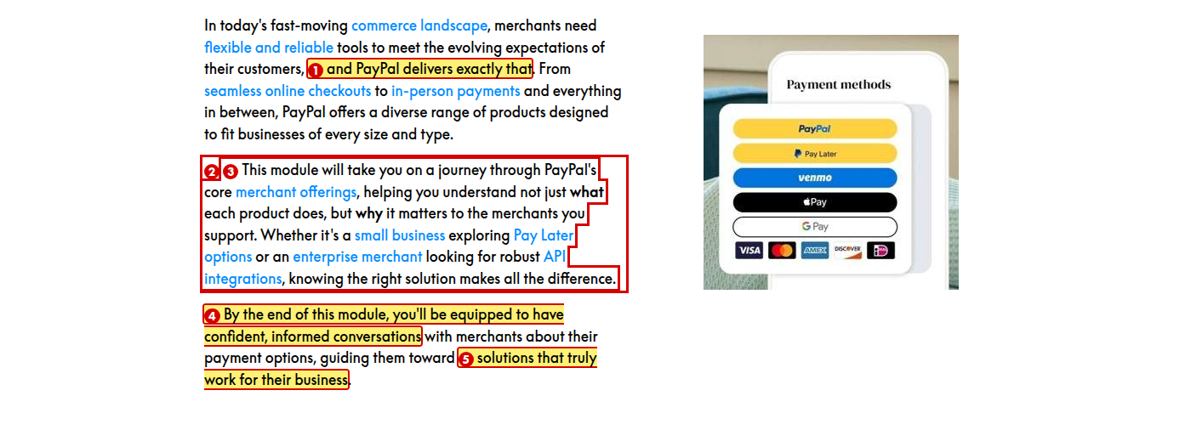
1. Change “and PayPal delivers exactly that” to “and PayPal provides them”
Reason: “Delivers exactly that” is vague marketing language.
2. Change to “This module covers PayPal’s core merchant products”
Reason: “Take you on a journey” is filler. Use plain language.
3. Change to “Whether a merchant is a small business exploring Pay Later options or an enterprise looking for robust API integrations, knowing the right solution makes all the difference.”
Reason: The opening clause has no subject that connects to the rest of the sentence, so it dangles.
4. Delete this sentence
Reason: The Objectives block immediately below already begins “By the end of this module, you should be able to:”. The same promise is made twice on one screen.
5. Change “their business” to “their businesses”
Reason: “Merchants” is plural, so the noun should be plural.

Lesson 2 of 12 — In Person Payments

B2.1 Introduction to In Person Payments
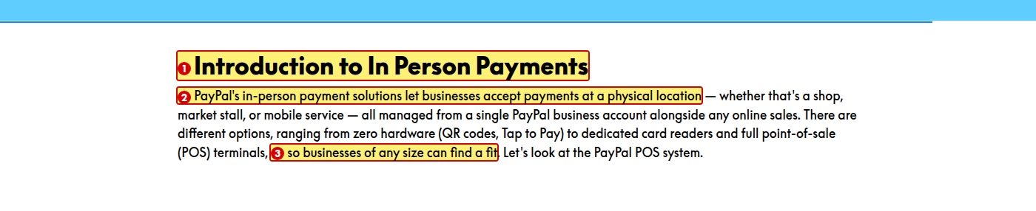
1. Change “In Person Payments” to “In-Person Payments” in the lesson title, the course menu and this heading
Reason: Hyphenate the compound adjective. The In-Person Payments with PayPal module writes it with a hyphen.
2. Split this sentence into two: “PayPal’s in-person payment solutions let businesses accept payments at a physical location — a shop, a market stall, or a mobile service. Everything is managed from a single PayPal business account, alongside any online sales.”
Reason: The sentence runs to 40 words and uses two dashes. Prefer short, simple sentences.
3. Change “can find a fit” to “can find an option that suits them”
Reason: “Find a fit” is informal.

B2.2 PayPal POS System (Zettle)
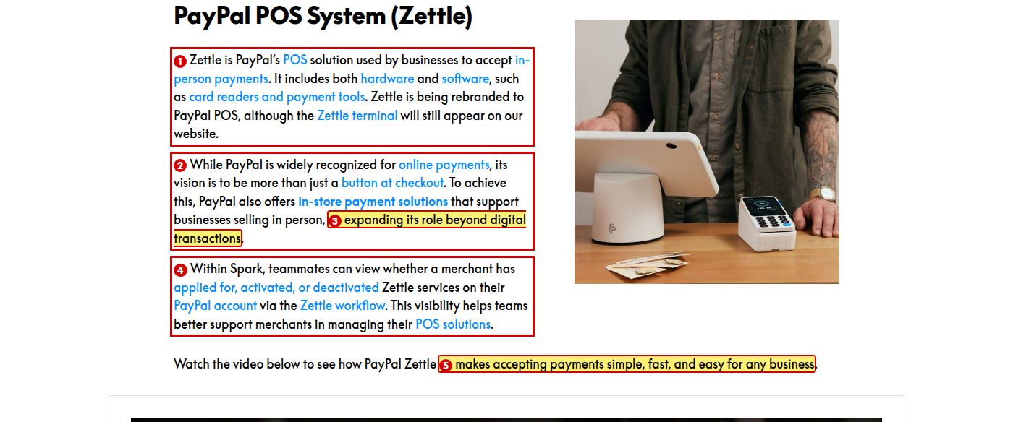
1. Change to “although the Zettle Terminal name will still appear on the PayPal website”
Reason: “Our website” is vague in a training module, and “Terminal” is part of the product name.
2. Change “its vision” to “our vision”
Reason: The style guide says to refer to PayPal as “we” or “our”. The previous sentence already says “our website”, so the paragraph switches person.
3. Change to “expanding our role beyond online payments”
Reason: The style guide says to use “payment” or “purchase” rather than “transaction”.
4. Change “via the Zettle workflow” to “in the Zettle workflow”
Reason: “Via” is more formal than needed.
5. Change to “makes accepting payments simple and fast for any business”
Reason: “Simple” and “easy” mean the same thing here.

B2.3 Benefits of PayPal POS and Merchant Pain Points
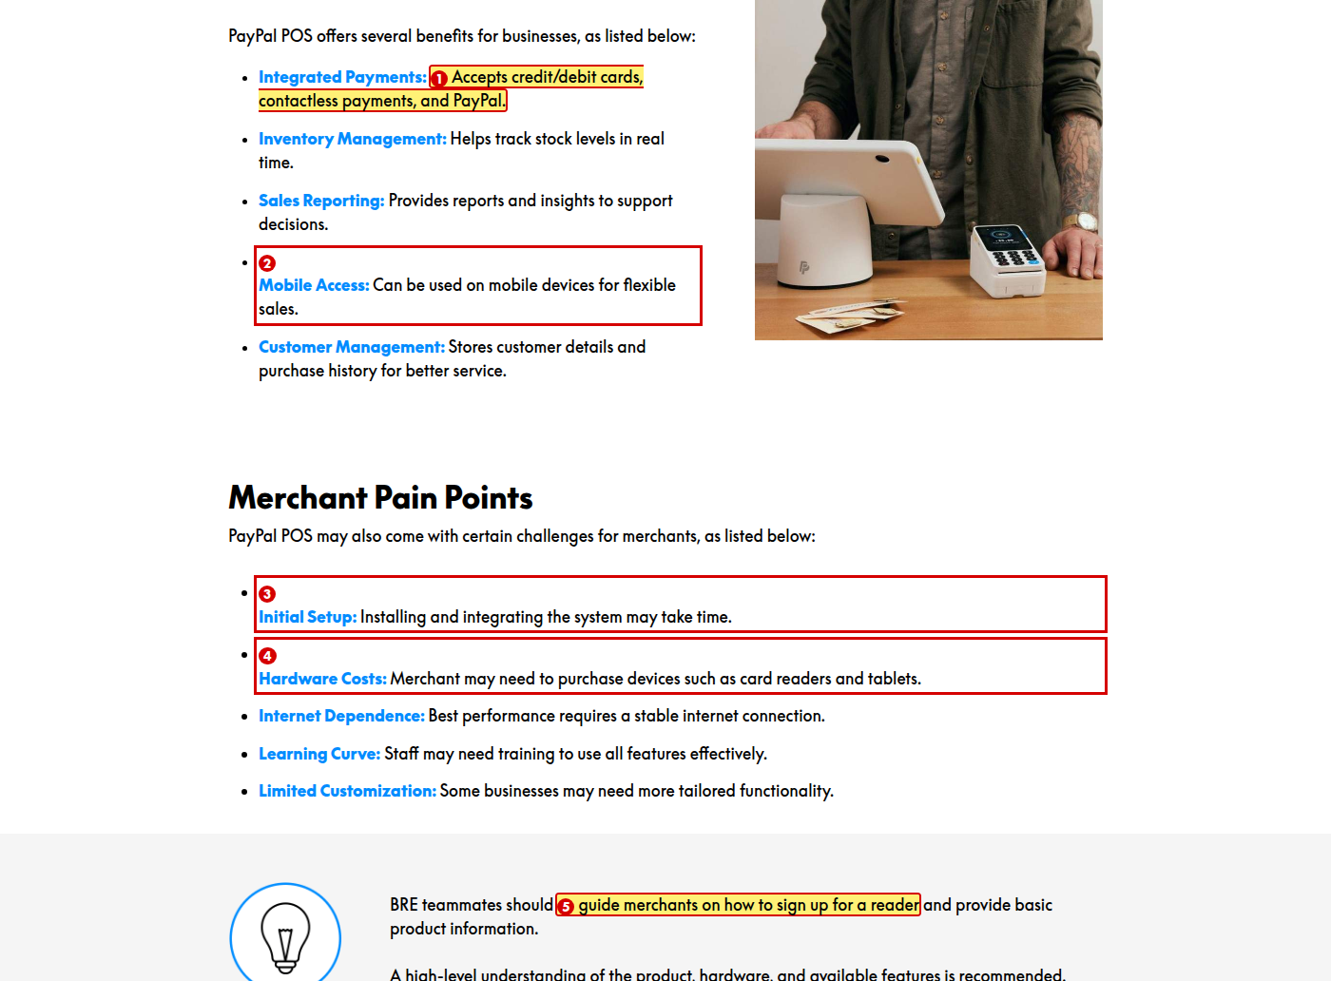
1. Change “credit/debit cards” to “credit and debit cards”
Reason: A slash reads as “or”. Spell out the connecting word.
2. Change to “Mobile Access: Works on mobile devices for flexible sales.”
Reason: Parallelism. The other four bullets start with an active verb (“Accepts”, “Helps”, “Provides”, “Stores”); this one is passive.
3. Change to “Initial Setup: Merchants may need time to install and integrate the system.”
Reason: Parallelism. The other four bullets begin with the person or thing affected; this one begins with a gerund.
4. Change to “Hardware Costs: Merchants may need to buy devices such as card readers and tablets.”
Reason: “Merchant” should be plural, and “buy” is simpler than “purchase”.
5. Spell out “BRE” on first use
Reason: Acronyms must be expanded the first time they appear. “BRE” is never explained in either module.

B2.4 Zettle market availability note
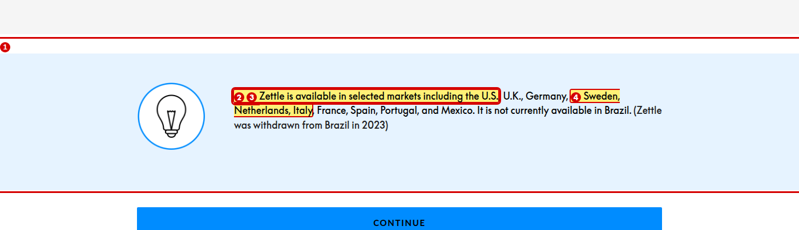
1. Change to “Zettle was withdrawn from Brazil in 2023 and is not available there.”
Reason: The two sentences say the same thing, and the bracketed sentence has no full stop inside the closing bracket.
2. Correct either this note or the table in Lesson 10 — the note lists the U.S. as available, while the table shows “Zettle (POS): U.S. ❌ Withdrawn 2023” and “LATAM ✅ MX + BR only”
Reason: The two lessons state opposite facts for the U.S. and for Brazil. A learner cannot tell which is right.
3. Change “selected markets including” to “selected markets, including”
Reason: A comma is needed before “including”.
4. Change “Netherlands” to “the Netherlands”
Reason: Definite article is missing.

Lesson 3 of 12 — No-Code Solutions

B3.1 No-Code Solutions introduction
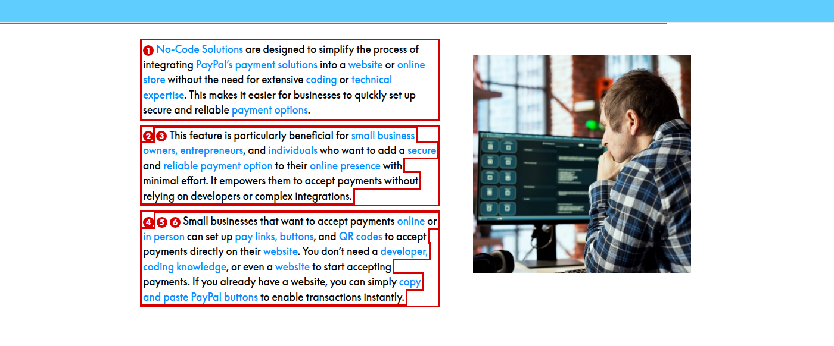
1. Change to “without extensive coding or technical expertise”
Reason: “The need for” adds nothing to the sentence.
2. Change “This feature is particularly beneficial for” to “No-Code Solutions are particularly useful for”
Reason: No-Code Solutions is a set of tools, not a single feature.
3. Change to “an easy way to take payments on their website”
Reason: “Secure and reliable payment option” appears in the sentence directly above. Avoid repeating the same phrase.
4. Change to “can set up Pay Links, buttons, and QR codes on their website”
Reason: “Pay Links” is capitalised elsewhere as a product name, and “accept payments” appears twice in the same sentence.
5. Change “transactions” to “payments”
Reason: The style guide says to use “payment” or “purchase” rather than “transaction”.
6. Change to “Merchants don’t need a developer, coding knowledge, or even a website to start accepting payments. If they already have a website, they can copy and paste PayPal buttons to start taking payments straight away.”
Reason: The module addresses the teammate as “you”, so “you” here reads as though the teammate is the merchant.

B3.2 No-Code Solution — Buttons
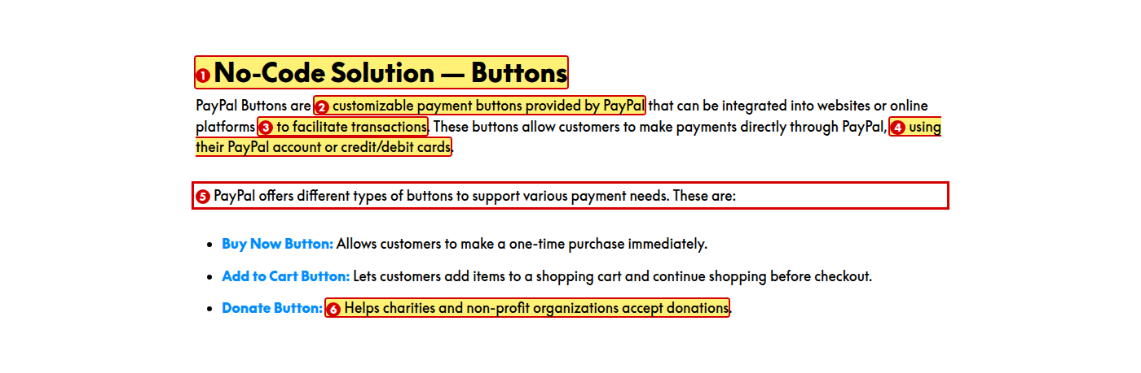
1. Change “No-Code Solution — Buttons” to “No-Code Solutions — Buttons”
Reason: The rest of the module uses the plural “No-Code Solutions”.
2. Change to “customizable payment buttons”
Reason: “PayPal Buttons” already says who provides them.
3. Change “to facilitate transactions” to “to take payments”
Reason: The style guide prefers “payment” to “transaction”, and “facilitate” is more formal than needed.
4. Change “credit/debit cards” to “a credit or debit card”
Reason: A slash reads as “or”. Spell out the connecting word.
5. Change to “PayPal offers three types of buttons:”
Reason: “These are:” is a filler sentence, and naming the number helps the reader.
6. Change “non-profit” to “nonprofit”
Reason: The style guide spells it “nonprofit”, with no space and no hyphen.

B3.3 Pay Links tab
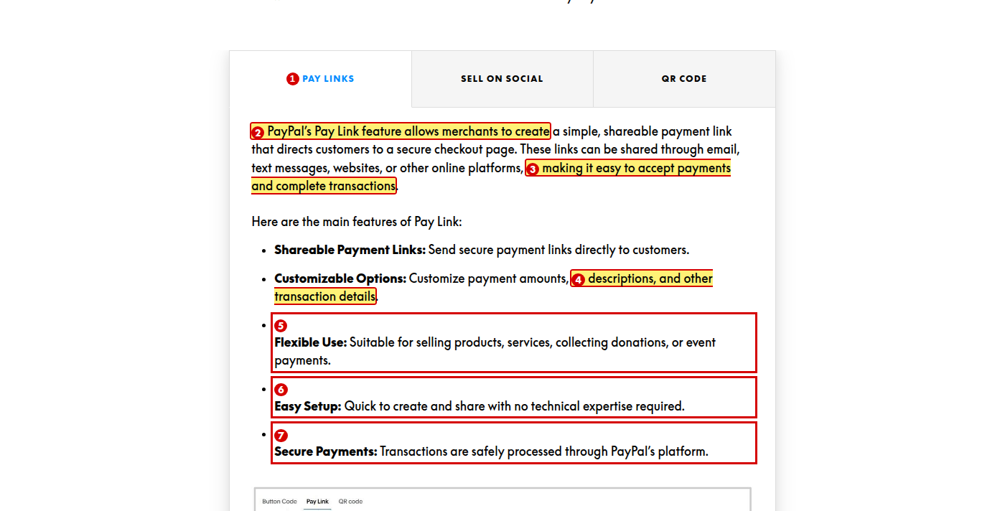
1. Change the tab labels to title case: “Pay Links”, “Sell on Social”, “QR Code”
Reason: The style guide reserves ALL CAPS for acronyms and job titles.
2. Change the tab label to “Pay Link”, or change the body text to “Pay Links”
Reason: The tab label is plural and the body text is singular for the same product.
3. Change to “making it easy to accept payments”
Reason: “Accept payments” and “complete transactions” say the same thing, and the style guide prefers “payments”.
4. Change “transaction details” to “payment details”
Reason: The style guide prefers “payment” to “transaction”.
5. Change to “Flexible Use: Use them to sell products and services, collect donations, or take event payments.”
Reason: Parallelism, twice over. The five bullets mix instructions, adjectives and passive sentences, and within this bullet the series mixes “selling products, services” with “collecting donations” and “event payments”.
6. Change to “Easy Setup: Create and share a link in minutes, with no technical expertise required.”
Reason: Parallelism. Start the bullet with a verb, as the first two bullets do.
7. Change to “Secure Payments: PayPal processes every payment securely.”
Reason: The sentence is passive, and the style guide prefers “payment” to “transaction”.

B3.4 Sell on Social tab
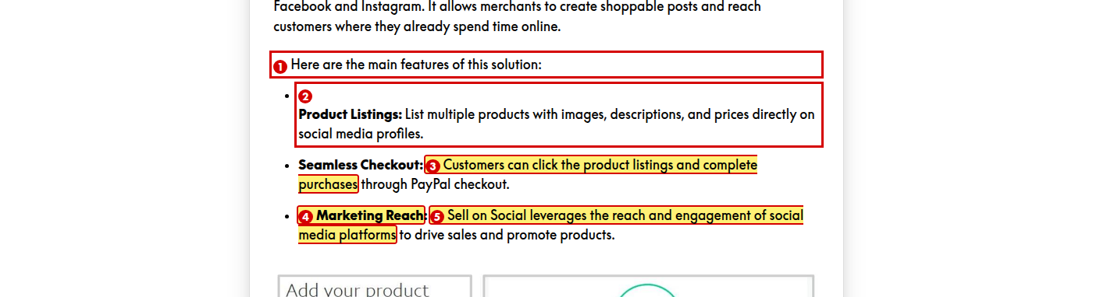
1. Change “of this solution” to “of Sell on Social”
Reason: The other two tabs name the product. Keep the pattern the same.
2. Change to “Product Listings: Merchants can list multiple products with images, descriptions, and prices on their social media profiles.”
Reason: Parallelism. The other two bullets describe what happens; this one gives an instruction.
3. Change to “Customers can click a product listing and complete the purchase”
Reason: The singular reads more naturally and matches “a product listing”.
4. Add two more features to this tab
Reason: This tab lists three features while the other two tabs list five each, so the interaction feels unbalanced.
5. Change “leverages” to “uses”
Reason: “Leverages” is jargon. The style guide asks for jargon-free language.

B3.5 QR Code tab
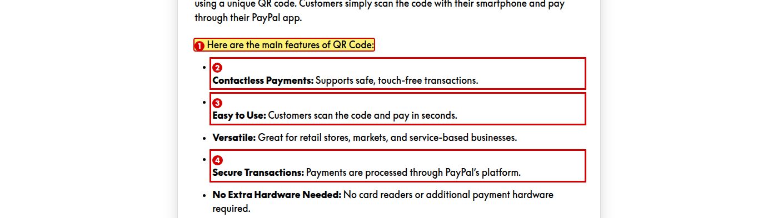
1. Change to “Here are the main features of QR Code payments:”
Reason: The article is missing — “features of QR Code” reads as an incomplete phrase.
2. Change “transactions” to “payments”
Reason: The style guide prefers “payment” to “transaction”.
3. Change the labels “Easy to Use” and “Versatile” to noun phrases such as “Simple Setup” and “Wide Use”
Reason: Parallelism. Three labels are noun phrases (“Contactless Payments”, “Secure Transactions”, “No Extra Hardware Needed”) and two are adjectives.
4. Change to “Secure Payments: PayPal processes every payment securely.”
Reason: The label says “Transactions” but the sentence says “Payments”, and the sentence is passive.

B3.6 Merchant Pain Points, Benefits and note
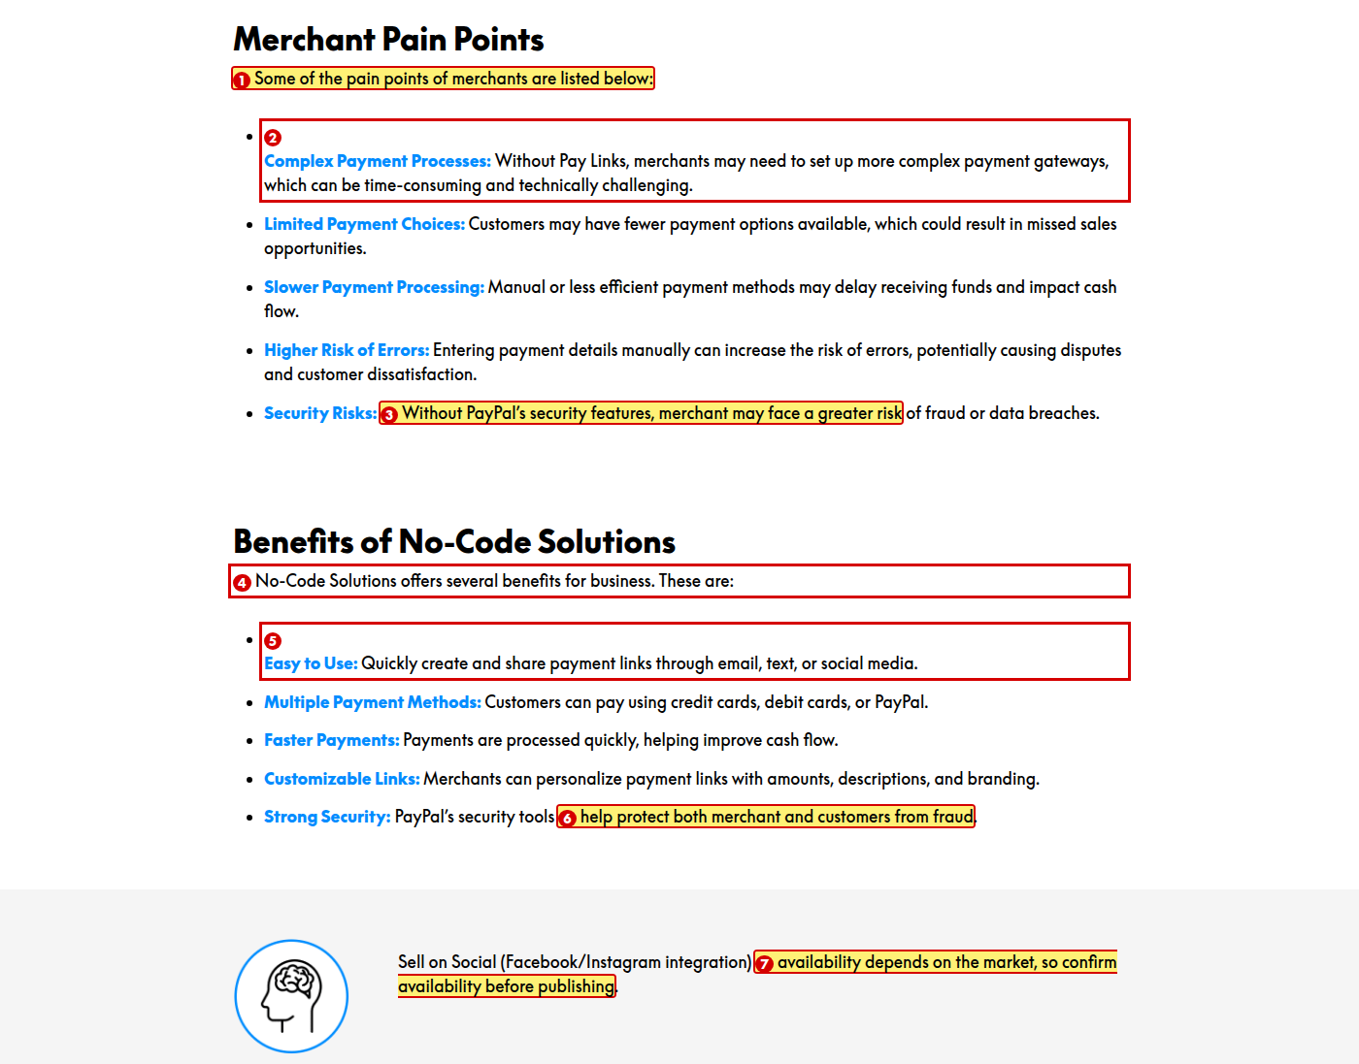
1. Change to “Merchants may face the following pain points:”
Reason: The original is indirect and wordy.
2. Change “Without Pay Links” to “Without no-code tools”
Reason: This section covers all the no-code solutions, not just Pay Links.
3. Change “merchant may face” to “merchants may face”
Reason: “Merchant” should be plural.
4. Change to “No-Code Solutions offer several benefits for businesses:”
Reason: Three problems in one line. “Solutions” is plural so the verb is “offer”, “business” should be plural, and “These are:” is a filler sentence.
5. Change the label “Easy to Use” to a noun phrase such as “Simple Setup”
Reason: Parallelism. The other four labels in this list are noun phrases.
6. Change “both merchant and customers” to “both merchants and customers”
Reason: “Merchant” should be plural to match “customers”.
7. Change to “Sell on Social (Facebook and Instagram) is not available in every market. Check availability for the merchant’s market.”
Reason: Two problems. “Before publishing” is an instruction to the course author, not to the learner, and “availability” appears twice in one sentence.

Lesson 4 of 12 — Subscriptions

B4.1 Subscriptions overview and pain points
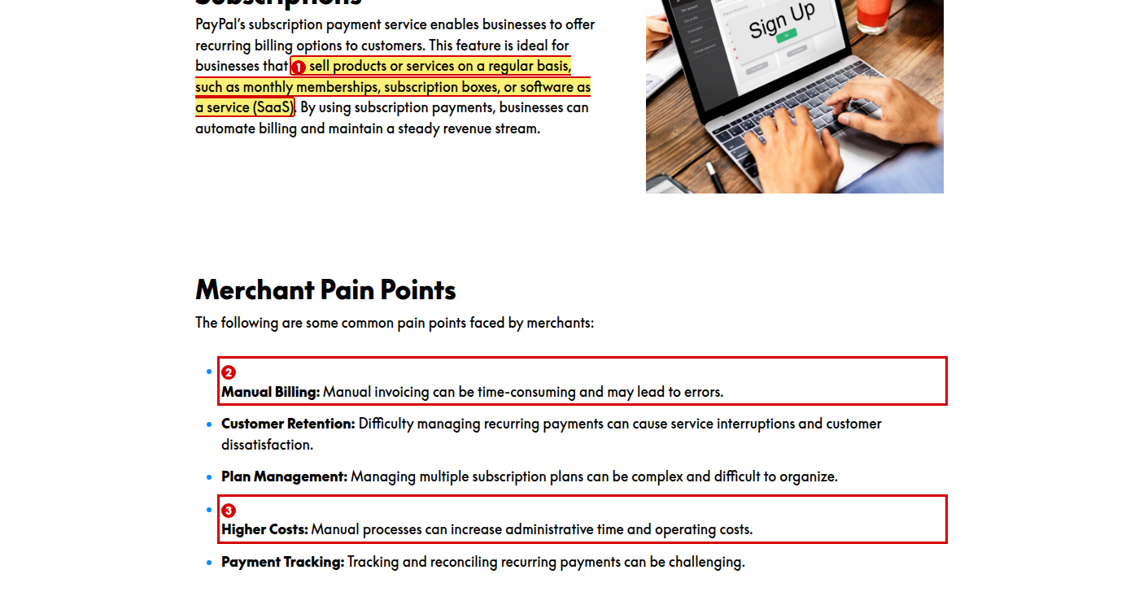
1. Change to “sell products or services regularly, such as gyms, subscription box sellers, or software-as-a-service (SaaS) providers”
Reason: The examples name business types, not products or services, so they do not match the sentence they follow. Also “on a regular basis” is simply “regularly”.
2. Change to “Manual Billing: Invoicing by hand takes time and can lead to errors.”
Reason: “Manual” appears in the label and again in the sentence.
3. Change to “Higher Costs: Working by hand increases admin time and operating costs.”
Reason: “Manual processes” repeats the wording of the first bullet in the same list.

B4.2 Benefits of Subscriptions and video lead-in
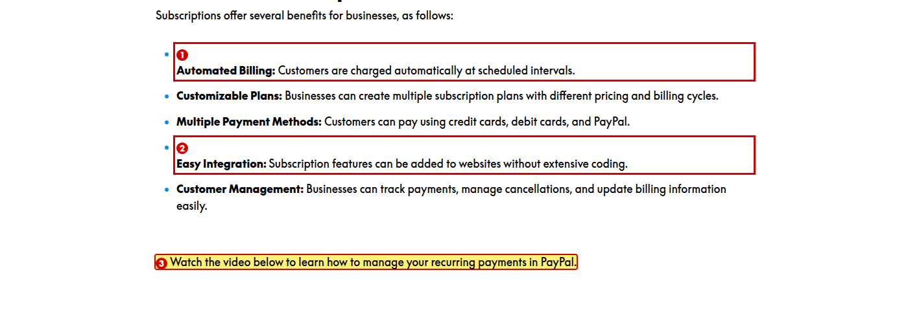
1. Change to “Automated Billing: PayPal charges customers automatically at set intervals.”
Reason: The sentence is passive. The other bullets say who does what.
2. Change to “Easy Integration: Merchants can add subscription features to their website without extensive coding.”
Reason: The sentence is passive.
3. Change to “Watch the video below to see how merchants manage recurring payments in PayPal.”
Reason: “Your recurring payments” suggests the teammate has them. The module is about supporting merchants, not about the learner's own account.

Lesson 5 of 12 — PayPal Pay Later

B5.1 Installment Payments: PayPal Pay Later — opening section
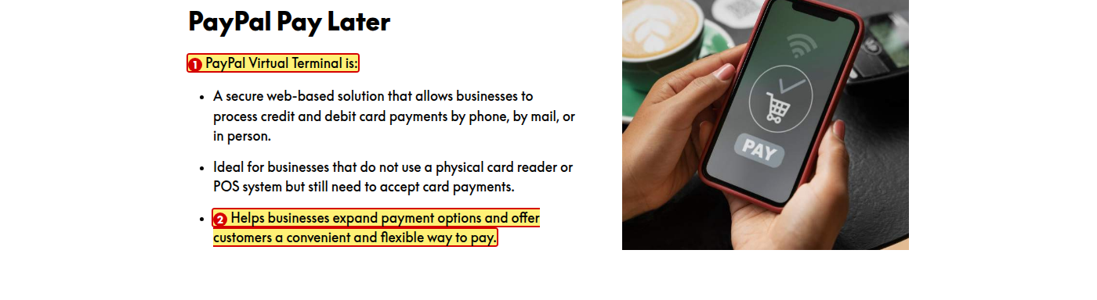
1. Replace “PayPal Virtual Terminal is:” and the three bullets below it with a description of PayPal Pay Later
Reason: This is the wrong product. The opening section of the Pay Later lesson describes Virtual Terminal, and the identical text appears again in Lesson 6. This is the most serious error in the module.
2. If the stem “… is:” is kept, change this bullet to “A solution that helps businesses expand payment options and offer customers a convenient, flexible way to pay.”
Reason: Parallelism. “Virtual Terminal is: Helps businesses…” does not read as a sentence — the third bullet does not follow the stem, unlike the first two.

B5.2 Key Features of PayPal Pay Later and availability note
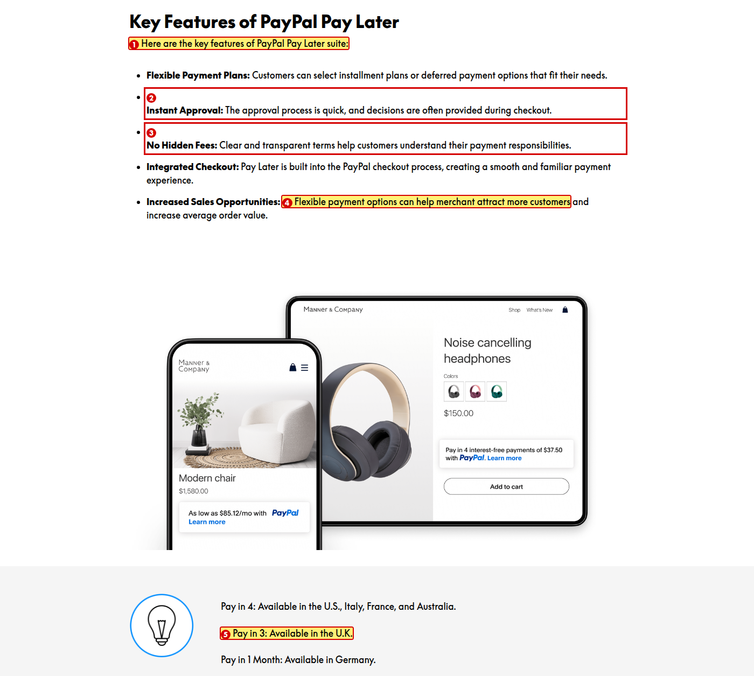
1. Change to “Here are the key features of the PayPal Pay Later suite:”
Reason: Definite article is missing.
2. Change the label “Instant Approval” to “Fast Approval”
Reason: The label says “Instant” but the sentence says “quick” and “often”, which is weaker than instant.
3. Change “Clear and transparent terms” to “Clear terms”
Reason: “Clear” and “transparent” mean the same thing here.
4. Change “help merchant attract” to “help merchants attract”
Reason: “Merchant” should be plural.
5. Correct either this note or the table in Lesson 10 — the note says Pay in 3 is available in the U.K. and does not list Pay in 4 there, while the table shows “Pay Later — Pay in 4: U.K. / EMEA ✅ UK + select EU”
Reason: The two lessons give different availability for the U.K. A learner cannot tell which is right.

Lesson 6 of 12 — Virtual Terminal

B6.1 Virtual Terminal

1. Add “Merchant Pain Points” and “Benefits of Virtual Terminal” sections to this lesson
Reason: Every other product lesson has a description, pain points, benefits and a note. This lesson has only a description and one screenshot, so it is much thinner than its siblings.
2. After fixing Lesson 5, confirm this is the only place Virtual Terminal is described
Reason: The same three points currently appear at the top of the PayPal Pay Later lesson.

Lesson 7 of 12 — API and Integration

B7.1 Lesson opening and Why This Matters
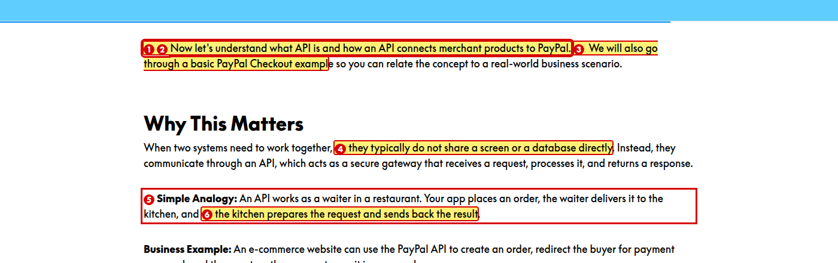
1. Spell out API, and later JSON and OAuth, on first use
Reason: Acronyms must be expanded the first time they appear. “API” is never expanded anywhere in the module.
2. Change to “Now let’s look at what an API is and how it connects merchant products to PayPal.”
Reason: The article “an” is missing before “API”, and “understand what … is” is wordy.
3. Change “We will also” to “We’ll also”
Reason: Use positive contractions to sound natural and conversational.
4. Change to “they don’t usually share a screen or a database”
Reason: Use contractions, and “typically” is simply “usually”.
5. Change “works as a waiter” to “works like a waiter”
Reason: “Works as a waiter” means it is employed as one. “Like” makes the comparison.
6. Change “prepares the request” to “prepares it”
Reason: The sentence switches from “order” to “request” for the same thing.

B7.2 How APIs Work and Typical API Flow
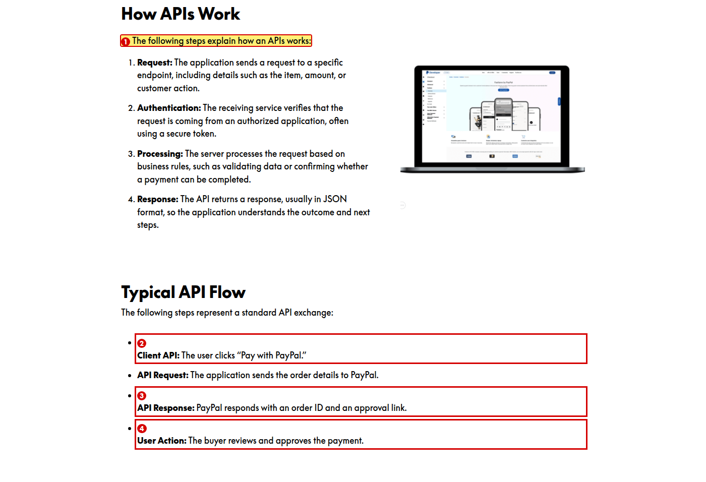
1. Change to “The following steps explain how an API works:”
Reason: “An APIs works” mixes singular and plural.
2. Change the label “Client API” to “User Action”
Reason: The step describes what the user does, not a client API. The label does not match its content.
3. Add a final step for capturing the payment
Reason: The flow stops at approval, while Lesson 8 shows capture as the final step. The two flows do not match.
4. Rename the four labels so they follow one pattern, for example “User Action”, “API Request”, “API Response”, “Buyer Approval”
Reason: Parallelism. “Client API” does not follow the pattern of the other three labels, and “User Action” is used for the last step while the first step is also a user action.

Lesson 8 of 12 — PayPal Payment Flow

B8.1 PayPal Payment Flow and End-to-End Process
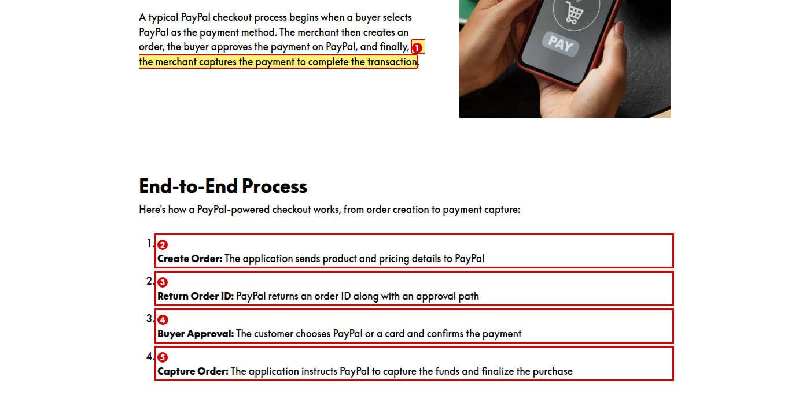
1. Change “complete the transaction” to “complete the purchase”
Reason: The style guide says to use “purchase” or “payment” rather than “transaction”.
2. Add full stops to these four bullets, or remove them from the other bullet lists in the module
Reason: These bullets have no full stops while every other labelled bullet list in the module ends with one.
3. Change “approval path” to “approval link”
Reason: Lesson 7 calls it an approval link. Use one term for the same thing.
4. Change “The customer chooses” to “The buyer chooses”
Reason: The label says “Buyer” but the sentence says “customer”.
5. Change “capture the funds” to “capture the money”
Reason: The style guide says to use “money”, not “funds”.

B8.2 Key Terms
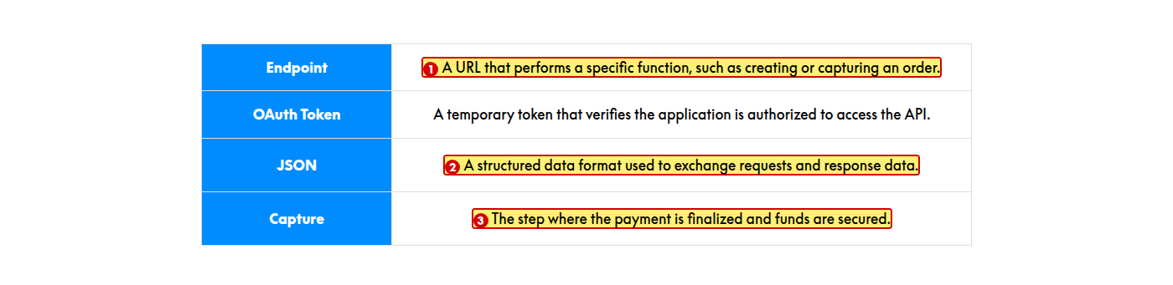
1. Change to “A web address that a specific function is called on, such as creating or capturing an order.”
Reason: A URL is an address; it does not perform a function.
2. Change “requests and response data” to “request and response data”
Reason: The two words in the pair should match — one is plural and one is singular.
3. Change to “The step in which the payment is finalized and the money is secured.”
Reason: “Where” refers to a place, not a step, and the style guide says to use “money”, not “funds”.

B8.3 Security and Best Practices
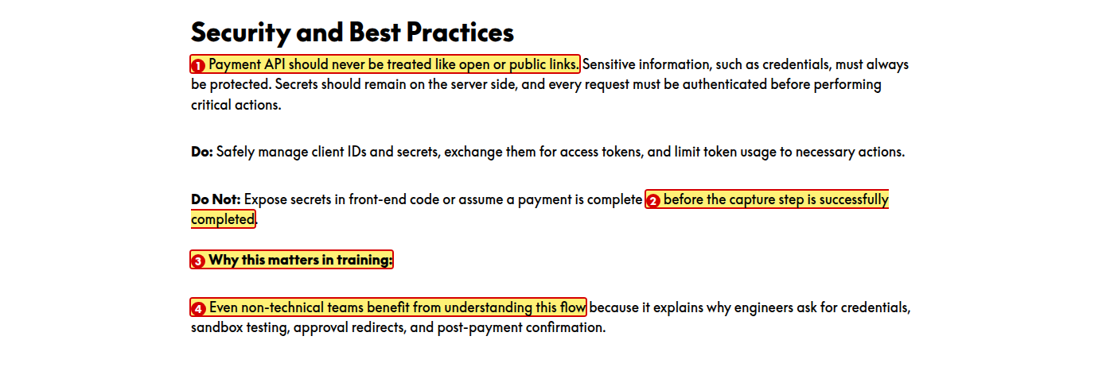
1. Change “Payment API” to “Payment APIs”
Reason: “API” should be plural to match “links”.
2. Change to “before the capture step succeeds”
Reason: “Complete” and “completed” appear in the same sentence.
3. Put this on its own line as a heading, and change it to “Why This Matters in Training”
Reason: It runs on from the end of the “Do Not” paragraph, and the earlier heading in this lesson uses title case (“Why This Matters”).
4. Delete this paragraph or rewrite it for the learner
Reason: The paragraph speaks to the course designer about why the topic is in the course, not to the learner.

B8.4 Types of API — Classic API tab
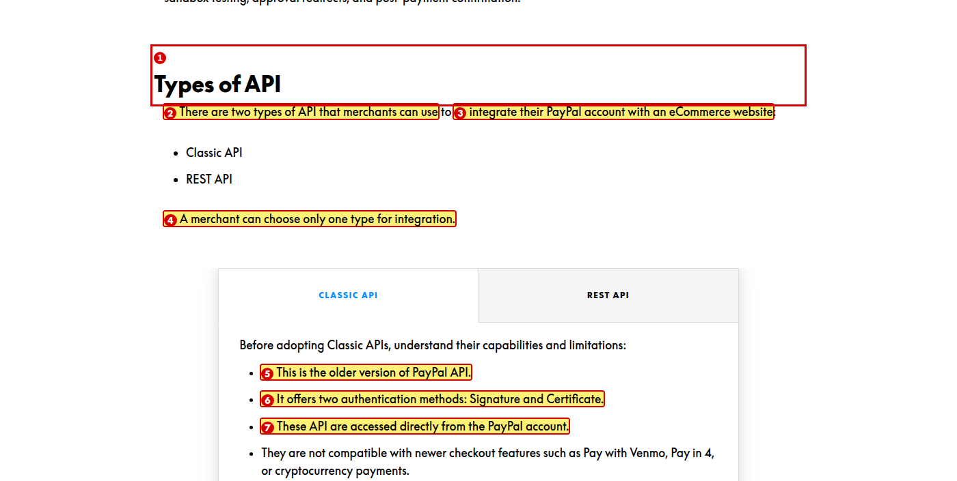
1. Move the “Types of API” section into Lesson 7, “API and Integration”
Reason: This section explains what the two API types are, which belongs with the API lesson. It currently sits at the end of the PayPal Payment Flow lesson, after the payment flow, key terms and security sections.
2. Change “two types of API” to “two types of APIs”
Reason: “Types of” takes the plural.
3. Change “eCommerce” to “e-commerce”
Reason: The same lesson writes “e-commerce” in the Business Example above. Use one spelling.
4. Add a lead line here, above the tabs, for example “Select each tab below to compare the two API types.”
Reason: The style guide requires a lead line before any interactive element. Lesson 3 has one before its tabs; this interaction has none.
5. Change to “Classic APIs are the older version of the PayPal API.”
Reason: The definite article is missing before “PayPal API”, and the bullet needs a clear subject.
6. Start each bullet the same way, for example “Classic APIs are…”, “Classic APIs offer…”, “Merchants access…”
Reason: Parallelism. The four bullets start with “This is”, “It offers”, “These API are” and “They are”, so the reader has to work out what each one refers to.
7. Change to “Merchants access these APIs directly from their PayPal account.”
Reason: “API” should be plural, and the passive sentence is clearer in the active voice.

B8.5 Types of API — REST API tab
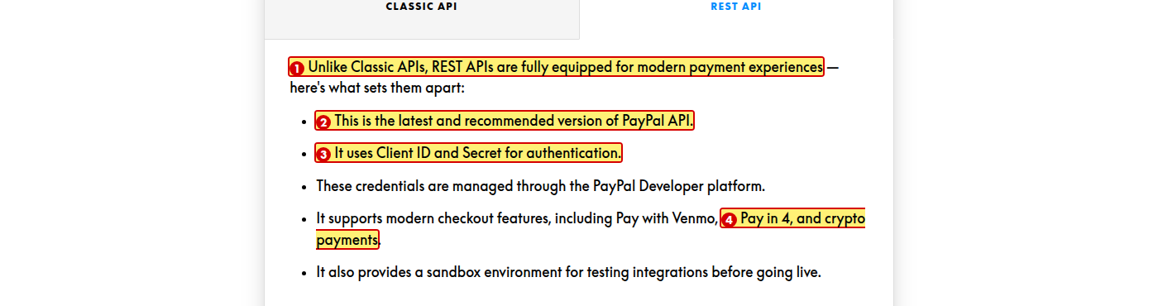
1. Change to “Before choosing REST APIs, understand their capabilities:”
Reason: The Classic API tab uses a short lead-in; this one is much longer and uses a dash. Keep both tabs the same shape.
2. Change to “REST APIs are the latest and recommended version of the PayPal API.”
Reason: Definite article is missing before “PayPal API”.
3. Change to “They use a Client ID and Secret for authentication.”
Reason: The article is missing before “Client ID”, and the subject should match the other bullets.
4. Change “crypto payments” to “cryptocurrency payments”
Reason: The Classic API tab uses “cryptocurrency”. Keep one term.

Lesson 9 of 12 — The Fastlane Experience

B9.1 Fastlane by PayPal
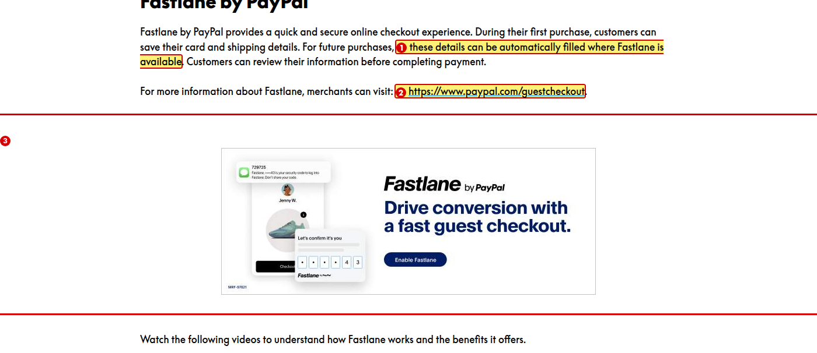
1. Change to “Fastlane fills in these details automatically where it is available”
Reason: The sentence is passive. The style guide prefers active voice.
2. Change “merchants can visit: https://www.paypal.com/guestcheckout.” to “merchants can visit the **PayPal guest checkout page**.”
Reason: Every other link in the module uses a label. A raw web address is harder to read and to hear on a screen reader.
3. Replace this marketing graphic with a screenshot of the Fastlane experience
Reason: The image is merchant-facing marketing with an “Enable Fastlane” button that does nothing in the module.

B9.2 How to Get Started with Fastlane
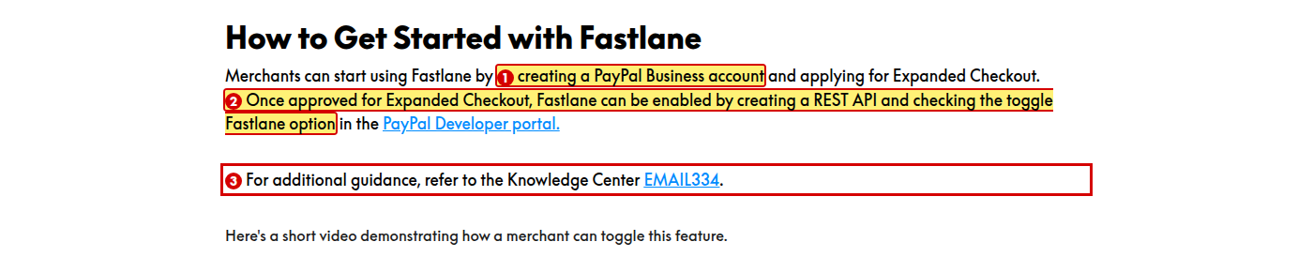
1. Change “PayPal Business account” to “PayPal business account”
Reason: The style guide says to lowercase “business account”.
2. Change to “Once the merchant is approved for Expanded Checkout, they can enable Fastlane by creating REST API credentials and turning on the Fastlane toggle in the PayPal Developer portal.”
Reason: Three problems. As written, Fastlane is the thing being approved; “checking the toggle Fastlane option” is garbled; and merchants create API credentials, not an API.
3. Change to “refer to the Knowledge Center article EMAIL334”
Reason: The word “article” is missing. The note at the end of this lesson writes it correctly.

B9.3 Consumer Queries — FAQ accordion
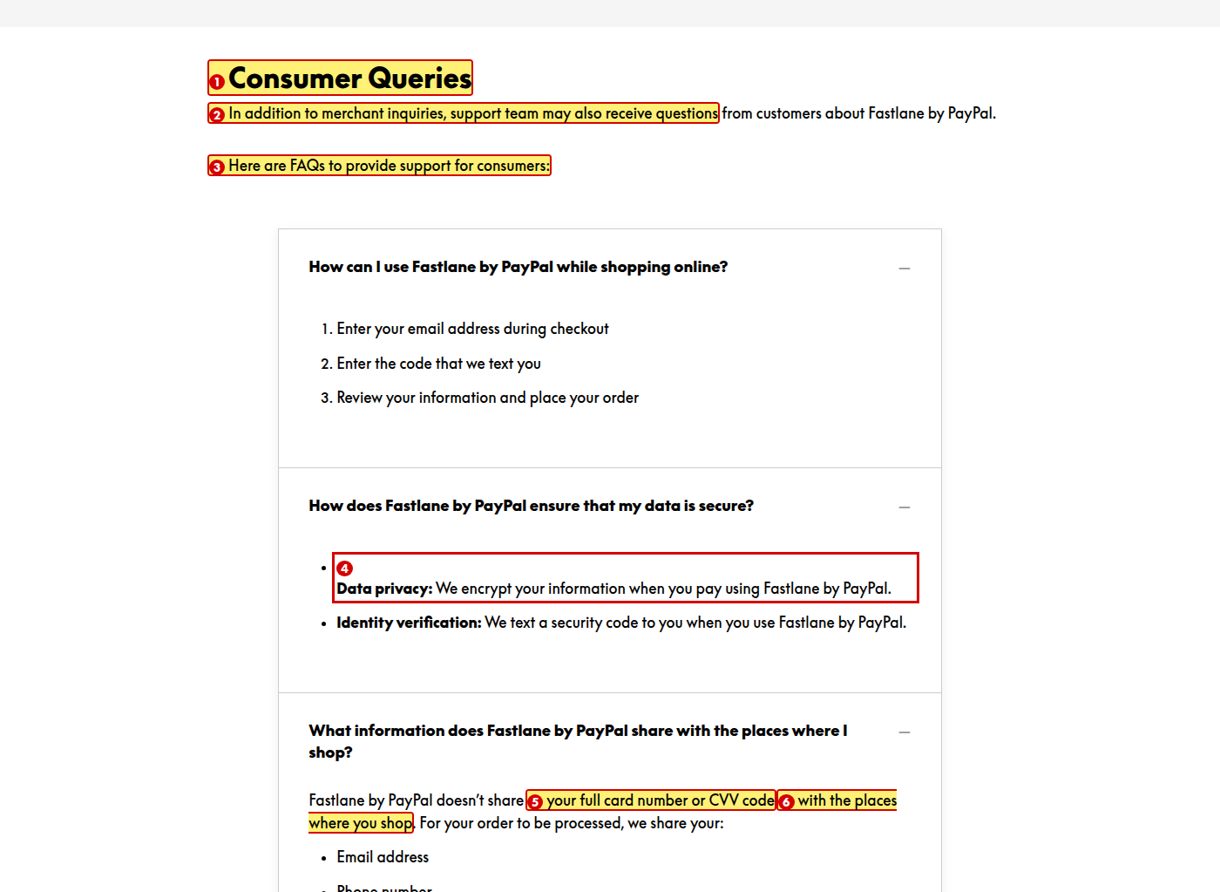
1. Change the heading to “Customer Queries” and use “customers” throughout the section
Reason: The section uses “consumer” in the heading and “customers” in the body for the same people.
2. Change “support team may also receive” to “the support team may also receive”
Reason: Definite article is missing.
3. Change to “Here are the FAQs you can use to support customers:”
Reason: The article is missing and the phrasing is indirect.
4. Change “Data privacy” and “Identity verification” to “Data Privacy” and “Identity Verification”
Reason: Every other labelled bullet in the module uses title case.
5. Change “CVV code” to “CVV”, and spell out CVV on first use
Reason: The last “V” in CVV already stands for “value”, so “code” repeats it. Acronyms must also be expanded on first use.
6. Change “the places where you shop” to “the stores where you shop”
Reason: “Places” is vague.

B9.4 Consumer Queries — remaining FAQ panels
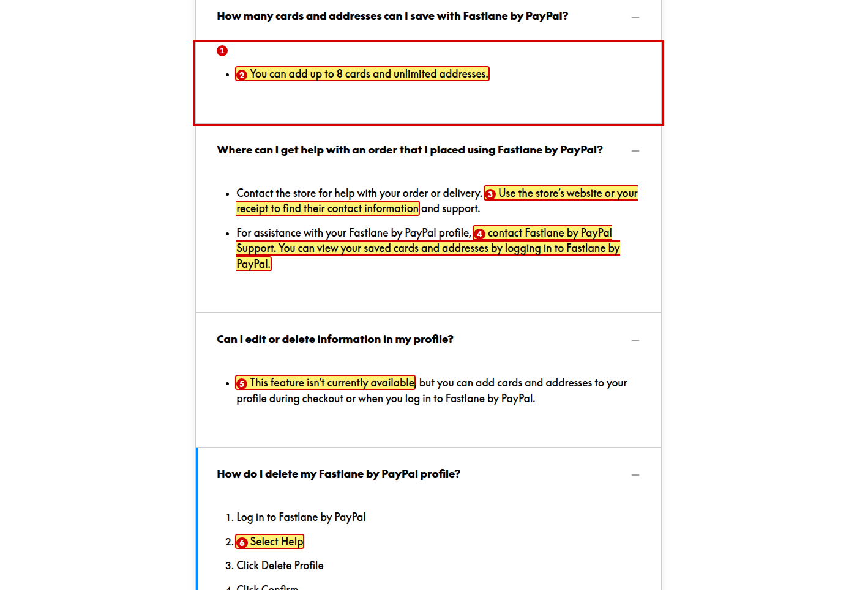
1. Remove the bullet and show this answer as a plain sentence
Reason: A list with only one item is not a list.
2. Change “8 cards” to “eight cards”
Reason: The style guide says to spell out numbers one to nine.
3. Change “their contact information” to “its contact information”
Reason: “Store” is singular, so the pronoun should be “its”.
4. Change to “contact Fastlane Support. You can view your saved cards and addresses when you log in.”
Reason: “Fastlane by PayPal” appears three times in two sentences.
5. Change “isn’t” to “is not”
Reason: The style guide says to avoid negative contractions where they hide the word “not”, especially in status messages.
6. Use one verb for all four steps, for example “Select”, and format “Help”, “Delete Profile” and “Confirm” in bold
Reason: The list mixes “Select” and “Click” for the same kind of action, and the style guide says clickable actions are formatted in bold.

Lesson 10 of 12 — Product Availability by Region

B10.1 Product availability table — header and first rows
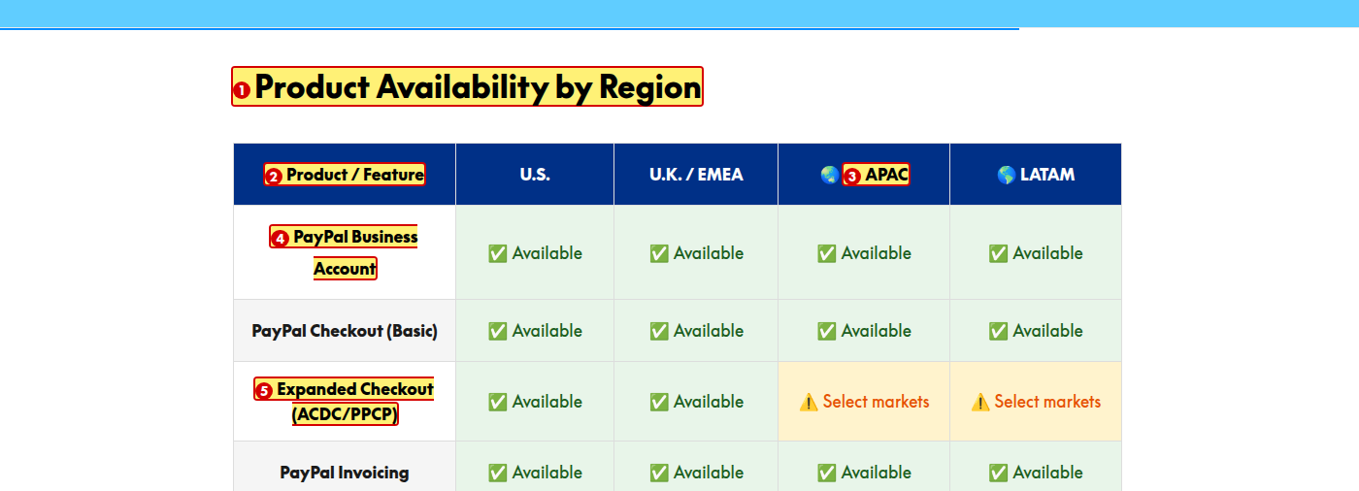
1. Delete this heading
Reason: The lesson title directly above already says “Product Availability by Region”.
2. Add a lead line above the table, for example “Use the table below to check which products are available in a merchant’s region.”
Reason: The style guide requires a lead line that connects an element to the surrounding content. The table appears with no introduction.
3. Remove the 🌏 and 🌎 emoji from the APAC and LATAM headings, or add matching emoji to U.S. and U.K. / EMEA
Reason: Two of the four region headings carry an emoji and two do not.
4. Change “PayPal Business Account” to “PayPal business account”
Reason: The style guide says to lowercase “business account”.
5. Spell out ACDC and PPCP, or remove them
Reason: Neither acronym is explained anywhere in the module.

B10.2 Product availability table — remaining rows
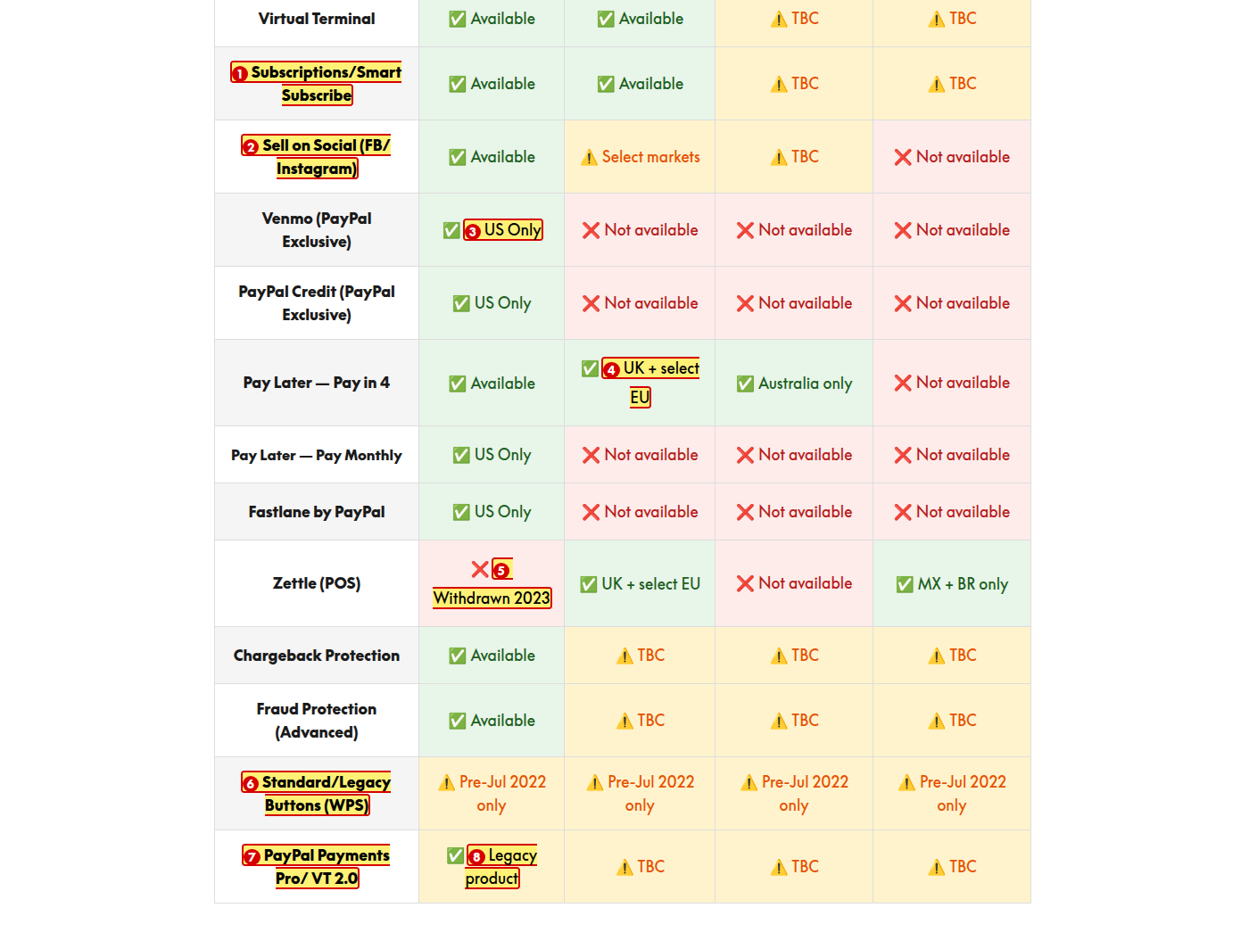
1. Introduce Smart Subscribe in Lesson 4, or remove it from this table
Reason: Smart Subscribe appears only here and is never explained.
2. Change to “Sell on Social (Facebook and Instagram)”
Reason: There is a stray space after the slash, and “FB” is an informal abbreviation. Lesson 3 writes both names in full.
3. Change “US Only” to “U.S. only”
Reason: The column heading uses “U.S.” with periods, and “only” does not need a capital.
4. Change “UK + select EU” to “U.K. and select EU markets”, and “MX + BR only” to “Mexico and Brazil only”
Reason: The table mixes full country names, two-letter codes and plus signs for the same kind of information.
5. Correct either this row or the note in Lesson 2 — this table shows Zettle withdrawn in the U.S. and available in Mexico and Brazil, while Lesson 2 says Zettle is available in the U.S. and was withdrawn from Brazil
Reason: The two lessons state opposite facts. The U.S. and Brazil entries appear to have been swapped.
6. Spell out WPS, or remove it
Reason: The acronym is not explained anywhere in the module.
7. Change to “PayPal Payments Pro and Virtual Terminal 2.0”
Reason: There is a stray space after the slash and “VT” is not defined.
8. Change “✅ Legacy product” to “⚠️ Legacy product”
Reason: “Legacy product” is not an availability status, and the green tick tells the learner the product is fully available.

B10.3 Table legend
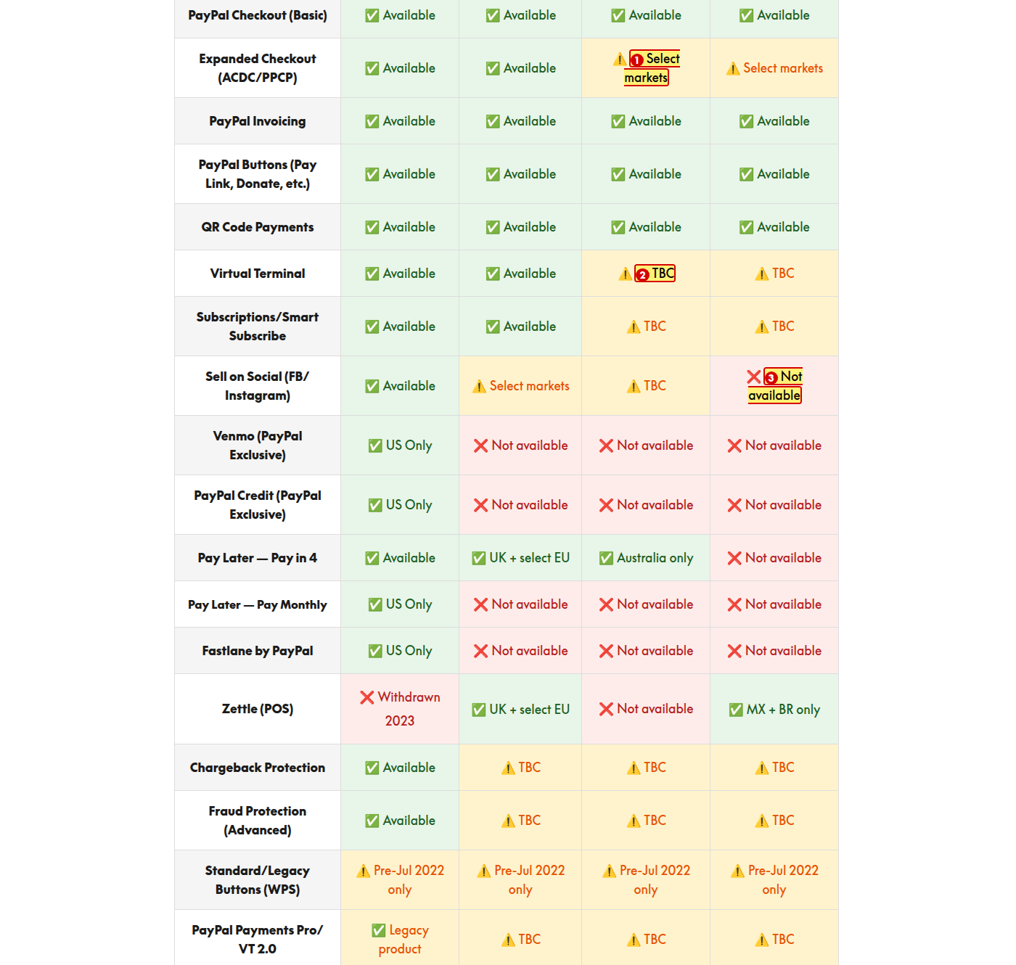
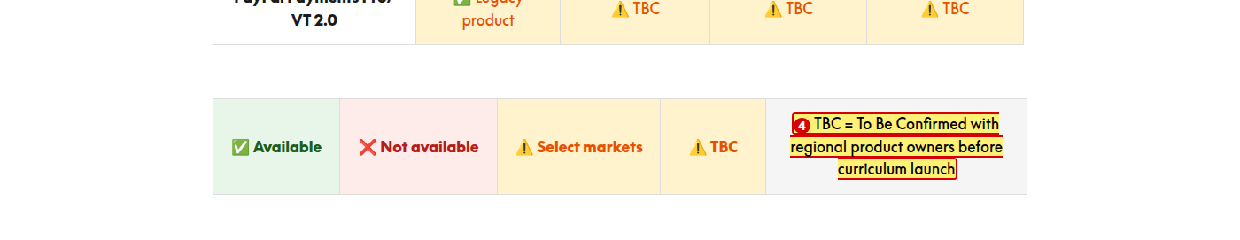
1. Use a different symbol for “TBC” than for “Select markets”
Reason: The same warning symbol marks both, so the legend does not tell the two apart.
2. Check the contrast of the orange “TBC” text on the amber fill and the red “Not available” text on the pink fill
Reason: These colour combinations look below the 4.5:1 minimum contrast ratio for body text.
3. Replace the green, pink and amber cell fills with the brand palette, or use symbols and text on a white background
Reason: The green (#E8F5E9), pink and amber fills are not in the brand palette (White #FFFFFF, Black #000000, PayPal Blue #003087, Bright Blue #60CDFF).
4. Change to “TBC = to be confirmed”
Reason: “With regional product owners before curriculum launch” is a note to the course team, not to the learner.

Lesson 11 of 12 — Quiz

B11.1 Quiz introduction

1. Change to “This quiz will test how well you can support merchants with PayPal products.”
Reason: “Products Deep Dive” is the name of the module, not something a learner supports.
2. Change “This quiz comprises 5 questions.” to “Answer all five questions”
Reason: Two problems. Parallelism — the other two bullets are instructions while this one is a statement. Also numbers one to nine are spelled out.
3. Remove the full stops from all three bullets
Reason: The style guide says bulleted lists in training modules should not end with periods.

B11.2 Question 1 of 5
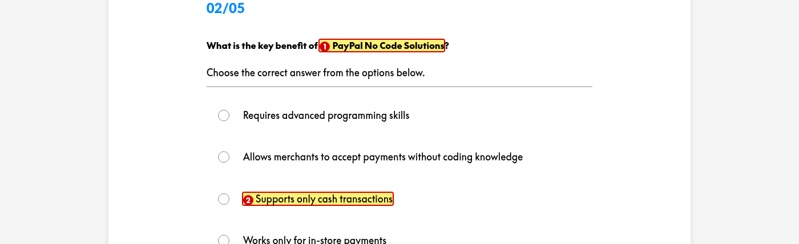
1. Change “No Code Solutions” to “No-Code Solutions”
Reason: Lesson 3 hyphenates it. The same change is needed in the Question 3 options.
2. Change “cash transactions” to “cash payments”
Reason: The style guide says to use “payment” rather than “transaction”.

B11.3 Question — “Which PayPal product allows customers to split payments into installments?”

1. Change “APIs & Integration” to “APIs and Integrations”
Reason: The style guide says to avoid ampersands in web text, and the lesson itself is called “API and Integration”.

B11.4 Question — “Which PayPal feature helps speed up checkout…?”

1. Replace “Shopping Cart” with a PayPal product covered in the module, such as “Subscriptions”
Reason: Shopping Cart is not one of the products taught, so it is not a fair answer option.

B11.5 Question — “What is the primary purpose of PayPal APIs and Integrations?” and feedback
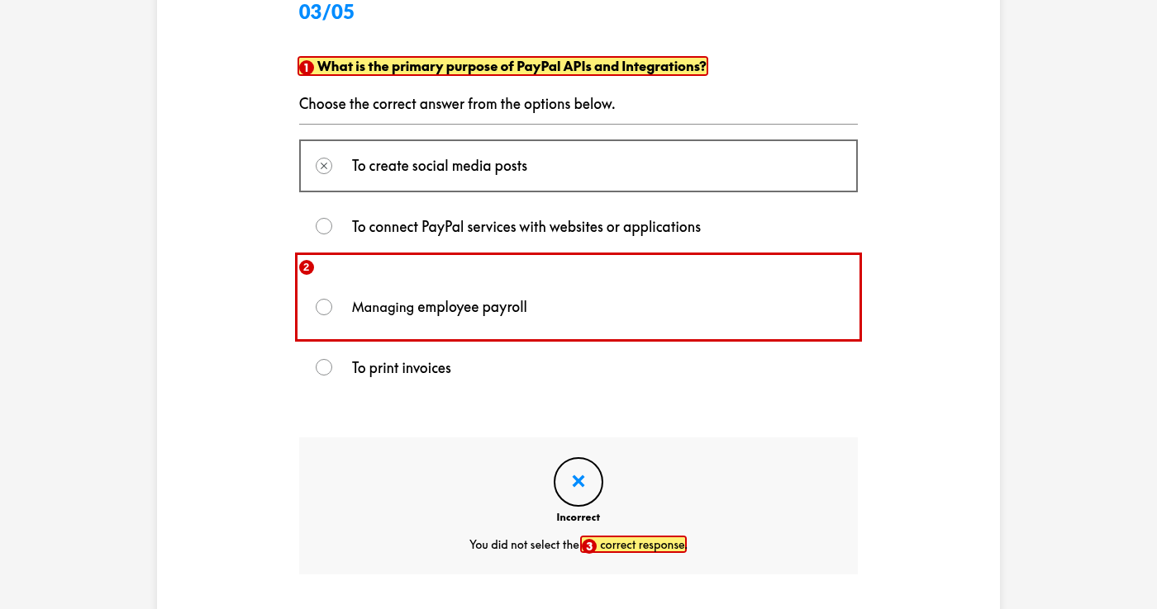
1. Use one name for this topic across the module — “APIs and Integrations”
Reason: The lesson is called “API and Integration”, a Question 3 option says “APIs & Integration”, and this question says “APIs and Integrations”.
2. Change “Managing employee payroll” to “To manage employee payroll”
Reason: Parallelism. The other three options start with “To” plus a verb; this one starts with a gerund.
3. Add specific feedback for each question explaining why the answer is right or wrong
Reason: Every question shows the same generic message, so a learner who answers incorrectly is told nothing that helps them learn.

Lesson 12 of 12 — Summary

B12.1 Wrap-Up
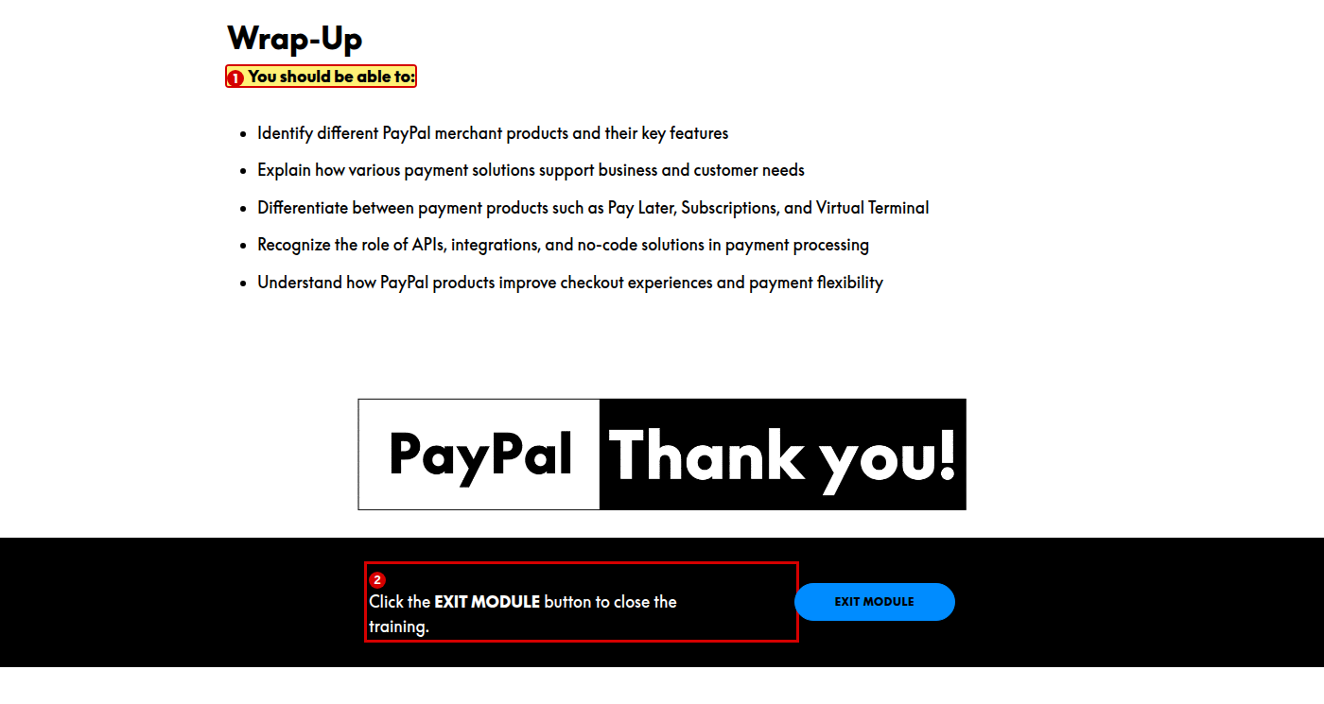
1. Change “You should be able to:” to “You should now be able to:”
Reason: The style guide sets this exact wrap-up phrase. The word “now” is missing.
2. Format “EXIT MODULE” in bold
Reason: The style guide says clickable actions are formatted in bold.

Other observations
These items sit outside the numbered, screen-by-screen findings. They are module-wide patterns, instructional-design notes, or points that need someone else to confirm a fact.
1. Two different table header colours across the curriculum
The Lesson 10 table header uses PayPal Blue #003087, which is correct. The top navigation bar uses #0070CC and the In-Person Payments with PayPal module uses #008CFF for its table headers. Neither of those is in the brand palette (White #FFFFFF, Black #000000, PayPal Blue #003087, Bright Blue #60CDFF). Standardise on #003087.
2. Tab labels are set in ALL CAPS
Tab labels render as “PAY LINKS”, “SELL ON SOCIAL”, “QR CODE”, “CLASSIC API” and “REST API”. The style guide reserves ALL CAPS for acronyms and job titles.
3. Product lessons are uneven in depth
In Person Payments, No-Code Solutions and Subscriptions each have a description, pain points, benefits and a note. PayPal Pay Later has no pain points, and Virtual Terminal has only a description and a screenshot. Consider a consistent structure for every product lesson.
4. Lesson 7 API flow does not match Lesson 8
Lesson 7 gives a four-step API flow that ends at buyer approval. Lesson 8 gives a four-step flow that ends at capture. The two are describing the same process and should agree.
5. No lead line before the Classic API / REST API tabs
Lesson 3 correctly introduces its tabs with “Click the tabs below…”. The tabs in Lesson 7 appear with no lead line, which the style guide requires.
6. Authoring notes left in the published module
Three pieces of text address the course team rather than the learner: “so confirm availability before publishing” (Lesson 3), “Why this matters in training…” (Lesson 8), and “TBC = To Be Confirmed with regional product owners before curriculum launch” (Lesson 10).
7. Cross-module consistency
This module writes “In Person Payments” without a hyphen; the In-Person Payments with PayPal module hyphenates it. This module’s quiz says “from the options below”; the other says “from the list below”. Both modules omit “now” from the wrap-up phrase, and neither expands “BRE”.
8. Video playback could not be verified
The self-hosted MP4 videos would not play in the audit browser, although the files themselves are served correctly. This is a limitation of the audit environment, not a defect in the module. Please confirm playback manually.

