Rough guide, last edited 2017-10-04 by Dylan.

General Notes:

-Steps 1-8 describe MPLab and circuit setup. Step 9 describes sample communication methods.

To use I2C:

1. Power circuit board. (with external power supply. 5.00 volts, at least 10 mA (roughly). It is a good idea to limit the circuit to 100 mA or less, to avoid frying the board in case of short-circuit.) **USB-Arduino-CapBoard** will do. Plug PICkit 3 into PC.
2. Open Pic project <PIC_I2C> in MPLab X IDE. Right-click on source files and only “include” the one you want to download to the PIC.

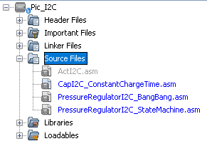

1. Edit I2C_ADDRESS as necessary



1. Download to device using "Make and Debug Program Device Project". Will give you message in a debug console like “Error….” Or “compile successful”. If error, try debugging. Consider righ-clicking your Project (<PIC_I2C> in step 2 picture), and selecting “clean and build”, ~~or adding a blank line at the beginning of your source file (this is witchcraft, do only as last resort)~~, and repeating this step.

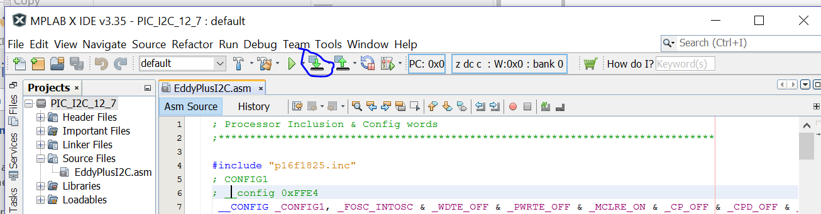

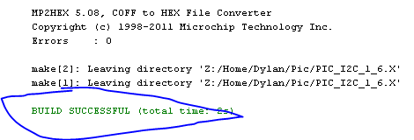

1. Once it shows “build successful”, the console will clear and begin showing things like “connecting to MPLAB PICkit 3”, “programming download” or “Device ID=”. Place the metal leads of the red PICkit 3 on the 5 circular pads of your circuit board, pressing firmly (but not firm enough to break them).

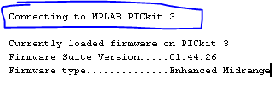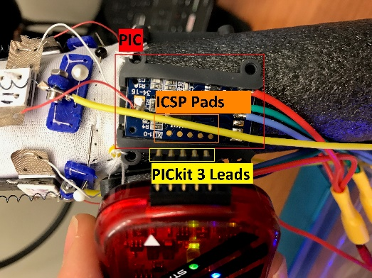

1. Programming is complete when console displays “verify/program complete”.

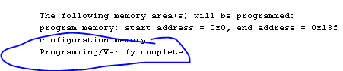

1. Optional: lift leads off of pads; power-cycle circuit. (I.e. unplug Arduino and re-plug in.) This re-initializes the charge time.
2. Now, connect the appropriate SDA & SCL pins to a I2C circuit (“bus”). Arduino: A4 (SDA)=blue, A5(SCL) = green.
3. Ready to communicate! Check the PIC firmware you just downloaded for an explanation of available interface/commands. Options:
   1. Arduino. Use the Arduino driver for your PIC firmware, or the sample Arduino Wire library code.
   2. PC-Arduino. Use your favorite python IDE (such as PyCharm) to interface with an arduino over Serial, which will communicate with the PIC. Example: Eddy’s class in “arduinoPortCopy”. Uses PySerial. Dylan and/or Jennifer may maintain a version. Dylan wrote an interface which implemented this class. (I.e. you need a program to initialize an instance of the class, which will communicate with Arduino, then the PIC.)

Appendix 1: PicIt3 Pinout

