Inter-Party Correlations of Presidential Candidates

Question:
Is there a correlation of support by geographic region for presidential candidates from each political party? That is, when votes are binned geographically, is there a correlation subsisting between certain Democratic candidates and certain Republican candidates?

A follow-up question is to find what could be explainer for these correlations. Are the demographies of geographic regions good explainers for the correlation between candidates?

Results:
We find that Clinton and Trump are significantly positively correlated by county, as are Sanders and Kasich. Clinton and Trump parallel each other across counties; where she loses, so does Trump, and vice versa. The same is true for Sanders and Kasich.

Pearson’s correlation:
 | Trump | Cruz | Kasich
CLINTON | 0.2589055 | -0.1880496 | -0.3068590
SANDERS | -0.2628806 | 0.1361428 | 0.3706787

Secondarily, with a brief survey of a select few demographic statistics, we find that average income is a significant correlating factor for both Clinton and Trump. They both have a negative correlation with this demographic vector, and their degree of correlation is very similar.

 | Demographic | Correlation
SANDERS | Average Income | 0.31193076
CLINTON | Average Income | -0.25038124
SANDERS | Black % | -0.71270709
CLINTON | Black % | 0.70915473
SANDERS | BADeg % | 0.33671156
CLINTON | BADeg % | -0.26912278
SANDERS | Population Density | -0.01229776
CLINTON | Population Density | 0.03040000
SANDERS | Unemployed % | -0.37714946
CLINTON | Unemployed % | 0.36266264

 | Demographic | Correlation
TRUMP | Average Income | -0.27925591
CRUZ | Average Income | -0.13686460
KASICH | Average Income | 0.30518283
TRUMP | Percent Black | 0.28670189
CRUZ | Percent Black | -0.18882399
KASICH | Percent Black | -0.17016754
TRUMP | BADeg % | -0.42130375
CRUZ | BADeg % | -0.03325156
KASICH | BADeg % | 0.27681193
TRUMP | Population Density | 0.03214142
CRUZ | Population Density | -0.12127528
KASICH | Population Density | 0.13788560
TRUMP | Unemployed % | 0.48690111
CRUZ | Unemployed % | -0.25882038
KASICH | Unemployed % | -0.00677367

Interpretation:
These finding are in contrast to a common story told about the presidential primary. The prevailing narrative in mass media is that Sanders and Trump have the same “base.” It is said that they each appeal to a certain strain of working-class populist-leaning disgruntled voters. While it may yet be true that they appeal to the same sort of sentiments, we find that it is Clinton, not Sanders, which has a strong positive correlation with Trump’s success rate. In fact, Sanders has a negative correlation to Trump.

One flaw with this study is that it only has county-level data for its analysis. We find that the counties which choose Trump are those which choose Clinton, and this does not speak for the individual voters that cast the votes. In order to make a thorough comparison of Trump’s and Sanders’s support, we would need exit-poll data for the actual voters. Nevertheless, this geographic correlation of Clinton and Trump goes some of the way toward undermining the common story that Clinton and Trump are speaking to very different people. Given the assumption that counties have a kind of homogeneous ethos or worldview among their constituents, these results can be interpreted to imply that the same “sort” of people favor Trump and Clinton.

Method:
Voting records were gathered at the county level. Each democratic candidate and republican candidate were then compared pairwise for correlation (excluding cases where candidates had dropped out of the race). From this pairwise comparison, we have a summary table of the total correlation.
In order to find a demographic explainer, I then correlated each candidate’s voting result with demographic data by county. The selected variables were: Percent Unemployed, Percent Black, Average Income, Population Density, and Percent BA Degree. The degree of correlation for each of these variables could then be compared across political parties to see whether, e.g., Clinton and Trump have a similar degree of correlation for certain demographic variables.

Data:
Voting data was obtained through scraping the NY Times’s reporting on the primary elections. They have the number of votes for each candidate, grouped by county. Since our focus is on how well a candidate does in a county, all county voting data were normalized to a percentage of the total county’s party votes.

That is, if in county XYZ there were 10 votes for Clinton, 80 votes for Sanders, 5 votes for O’Malley, and 5 votes for other persons, then a row in our dataset will have:

COUNTY | Sanders | Clinton | O’Malley | Other
XYZ | 0.8 | 0.1 | 0.05 | 0.05

With the same normalization done for republicans, these two datasets can then be joined on the county ID, and then correlated.

Lastly, the demographic data was gathered from 2014 Census records, which was also joined on county ID.

Selected plots:
Pairwise plots of selected candidates:
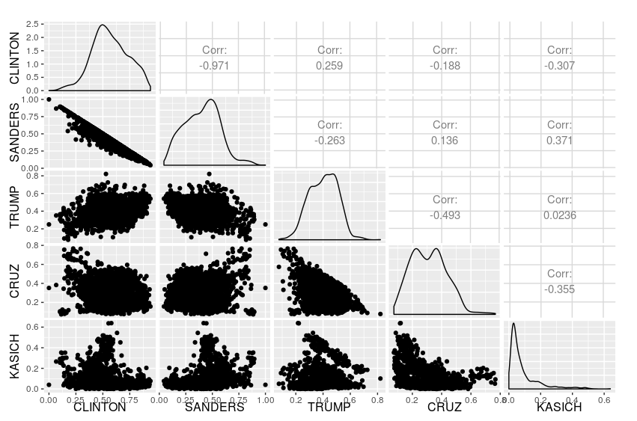

Clinton by Trump (with Kasich as color)
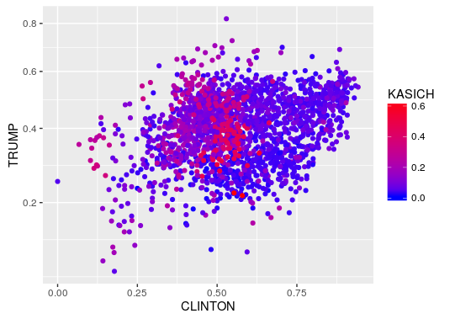

Sanders by Kasich with smoothing line of best fit:
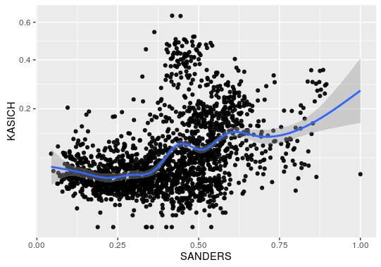

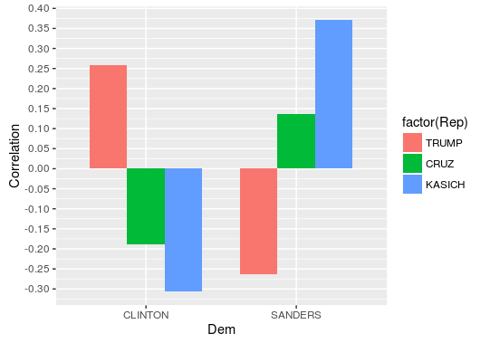
Pairwise inter-party correlations:

Demographic correlations:
