Read-write news: Increasing trust in media through data literacy

Open government data initiatives and data science advances provide data journalists with more capa­bilities to explain the world than ever before, yet data and evidence are becoming less relevant in public discussion. One of the possible reasons for this is that data driven articles and reports are often opaque, non-experts find results difficult to interpret and verify, and creating data-driven reports is limited to a small number of specialists[1].

In this paper, we present novel ways of presenting data analyses and argue that they have the potential to reverse this trend. Our method is based on two principles. First, the data presentation must encourage the reader to question their assumptions about the data and thus encourage critical thinking. Second, the data analysis must be transparent and this transparency must encourage the reader to question the provenance of data and correctness of the analysis.

# 1. Visualizations that encourage critical thinking

The first way of encouraging critical thinking about data has been widely adopted by newsrooms such as the New York Times [X,Y]. It presents the reader with a visualization that asks them to make a guess before showing the actual results. The guess can be completing the rest of the time series [X], comparing two options [X] or estimating the proportions such as in our shown presented in Figure 1. This way of presenting data encourages an active approach to data – readers need to make their assumptions about the topic explicit, before they are confronted with the data.

|  |  |
| --- | --- |
|  |  |

**Figure 1.** The visualization presents the breakout of the UK government expenditure. Readers are first asked to make a guess by dragging the bars (left), before they are presented with the actual data (right).

# 2. Reports that encourage verifying data provenance

The visualizations presented in the previous section provide a widely adopted mechanism for presenting data in a way that encourages readers to question their assumptions. We aim to extend the scope of this approach to similarly encourage readers to question and actively explore provenance of data and the transformations that have been used to produce the resulting visualization.

In order to be able to trace the provenance, we argue that the visualization must be backed by a fully reproducible script that accesses data from an external source. We then explore ways of presenting a (partial view of) the script and tracing the data through the transformations that were applied. Figure 2 shows an example, embedding a simple data table showing 2016 events in the UK related to leaving the European Union. The example in Figure 2 shows the script in a program code form, however this is only one of the possible presentations. The same script can be presented in a form shown in Figure 2.

|  |  |
| --- | --- |
|  |  |

**Figure 2.** The source behind a table reads events from Wikipedia and searches for “Leave the EU” (left).   
When users navigate through the source code, they see a preview illustrating the individual steps (right).

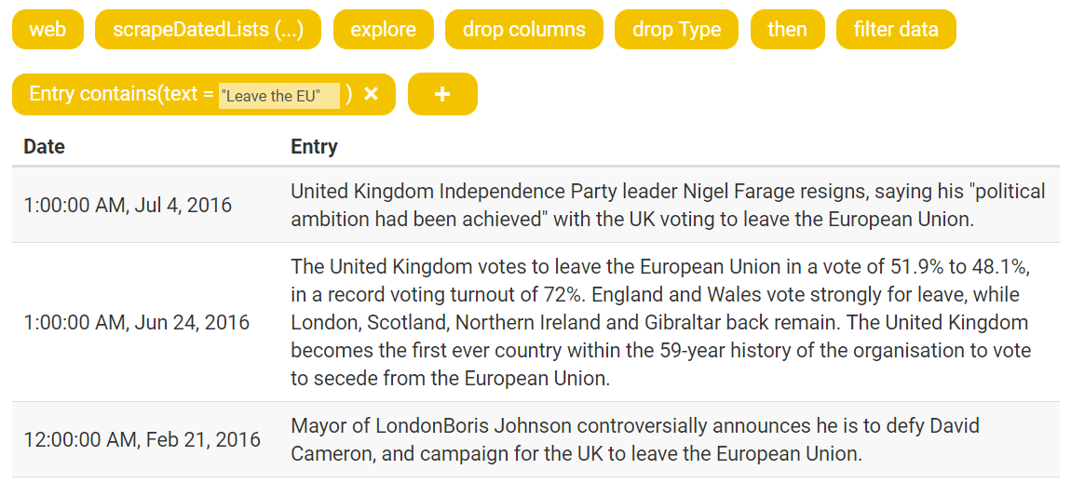

**Figure 2.** An alternative view of script behind a table, which shows a sequence of transformations   
and automatically generates table showing the result of the whole script.

# 3. Can read-write news increase trust

We argue that new way of presenting data analyses can both increase the trust in news and also encou­rage more critical reading. The first is achieved by presenting not just the final result of an analysis (such as a chart), but by documenting and publishing steps leading to the analysis (such as an explorable script). The second is achieved by letting the reader to “write the news”. We explored this idea in the context of presenting raw numerical results (Section 1) and we extend this principle to a more complex scenario of presenting the data analysis (Section 2).

# References

TBD

1. TODO: This is an assumption – can we back it with something? Or should we just say that we assume this?