TheGamma user study (1)

The Gamma is a simple programming environment for data exploration that aims to be accessible to non-experts such as journalists. TheGamma is text-based like typical programming languages. In the study, we’ll be using TheGamma in a simple split-screen environment. You see your code on the left and a data visualization automatically generated for the results on the right.

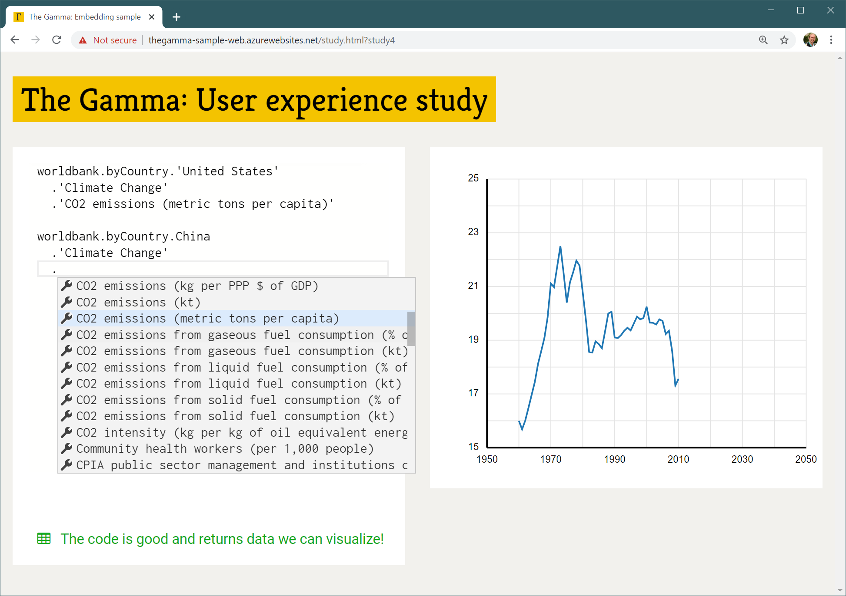

Most of programming in TheGamma is done through a single interaction principle – choosing a member from a list of members offered by the environment. A program is just a path that starts with a data source (such as “worldbank”) and follows through the data to find e.g. “CO2 emissions (metric tons per capita)” of a country such as “United States” as in the above example. You can construct programs by typing the data source name (such as “worldbank”) and then repeatedly typing “.” and choosing one of the offered items – either by clicking or via keyboard arrow keys and “Enter”.

In this study:

1. You will first watch a brief presentation explaining TheGamma using a sample data source.
2. You will be asked to try solving a similar problem using another data source
3. We will discuss your experience, difficulties and things you learned

The problem:

The “expenditure” data source provides access to information about the UK government spending over several years. Your goal is to compare government spending on “Defence” and “Public order and safety”. The data source will require you to specify whether you want to display data “in terms” of nominal or adjusted value or in terms of GDP – use spending in terms of GDP.

To get started, open <http://bit.ly/turing-study-1> in your web browser!