TheGamma user study (2)

The Gamma is a simple programming environment for data exploration that aims to be accessible to non-experts such as journalists. TheGamma is text-based like typical programming languages. In the study, we’ll be using TheGamma in a simple split-screen environment. You see your code on the left and a data visualization automatically generated for the results on the right.

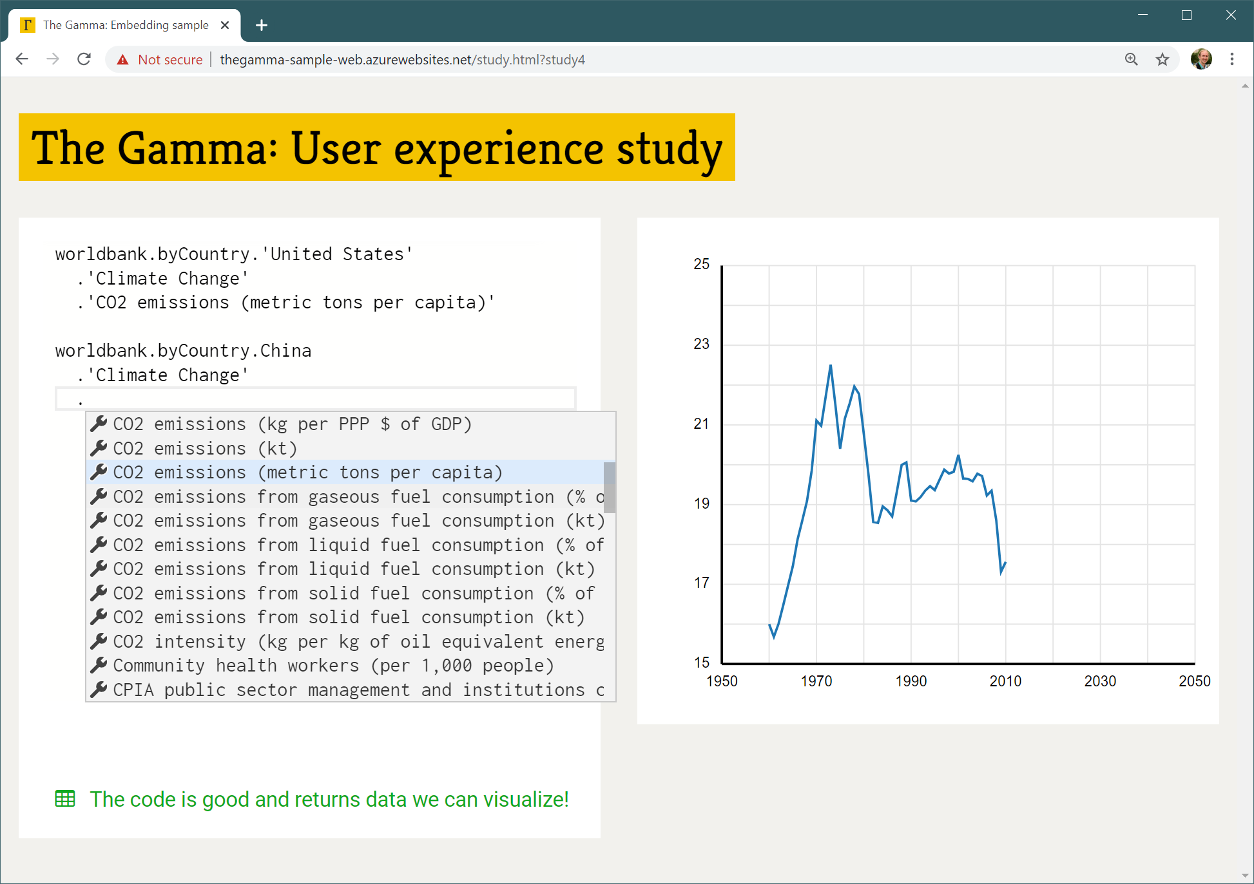

Most of programming in TheGamma is done through a single interaction principle – choosing a member from a list of members offered by the environment. A program is just a path that starts with a data source (such as “worldbank”) and follows through the data to find e.g. “CO2 emissions (metric tons per capita)” of a country such as “United States” as in the above example. You can construct programs by typing the data source name (such as “worldbank”) and then repeatedly typing “.” and choosing one of the offered items – either by clicking or via keyboard arrow keys and “Enter”.

In this study:

1. You will first watch a brief presentation explaining TheGamma using a sample data source.
2. You will be asked to try solving a similar problem using another data source
3. We will discuss your experience, difficulties and things you learned

The problem:

The “lords” data source provides access to information about expense claims for September 2019. The data source allows you to perform various operations on the data such as filter and sort it. First, sort the data by Travel Costs to see who spends the most on travel. Second, modify your program to first filter the data to only consider House of Lords members whose County is “London” and then sort the result by Travel Costs.

To get started, open <http://bit.ly/turing-study-2> in your web browser!